Conflicts of interest
Policy and procedure for contracted Ofsted Inspectors

Contents
Conflicts of interest policy statement 3
Policy principles 3
Scope of policy 3
Policy summary 4
Conflicts of interest procedure 4
Introduction 4
Definition 5
Financial conflicts including professional activity outside Ofsted 5
Conflicts with Ofsted’s values 6
Conflicts in inspection activity 7
Conflicts of interest process map 9
Process 10
Step 1 − Declaring a conflict 10
Step 2 – Considering the declaration 11
Step 3 – Reaching a decision 11
Step 4 – Challenging the decision 12
Step 5 - Reviewing decisions and declaring changes 13

Conflicts of interest policy statement

Policy principles
- Ofsted expects anyone employed, engaged by or working on behalf of the organisation to conduct themselves with or exhibit:
- integrity
- selflessness
- accountability
- openness
- honesty
- objectivity
- impartiality, and
- leadership.
- Those who work on behalf of Ofsted must not put themselves in a position where previous or current employment, personal relationships or private interests conflict, or could be perceived to conflict, with these values. Ofsted’s approach to all potential conflicts, whether real or perceived, is to:
- always disclose at the earliest opportunity
- agree arrangements to manage the conflict
- prohibit activity when necessary.
- Properly managed, individuals with declared personal interests should be able to conduct their business without restriction, particularly when they use their time and talents for the benefit of the community. However, any conflict, whether real or perceived, that is not managed appropriately can severely jeopardise individual reputation as well as Ofsted’s public standing and trust in our judgements. Therefore, all those in scope of this policy and procedure must uphold their professional obligation to declare any potential conflict of interest immediately and adhere to any conditions or measures put in place to manage this.

Scope of policy
These policy principles cover those individuals contracted as Ofsted Inspectors (OIs). This policy and procedure should be read in conjunction with the:
- Information assurance policy on the Engagement and Information Hub for inspectors
- ‘Conduct on inspection’ section within the common inspection framework.

Policy summary
- There are three general areas of conflict:
- financial conflicts, including professional activity outside Ofsted
- conflicts with Ofsted’s values
- conflicts in inspection activity.
- These conflicts can also arise from interests of household members, friends, colleagues and anyone with whom there was/is an association.
- All potential conflicts must be assessed to determine whether they can proceed alongside work for Ofsted without affecting the integrity and reputation of Ofsted, the individual, and the inspection process. Measures or conditions may be implemented to minimise and manage any conflict. Failure to declare, whether intentionally or unintentionally, or any continued action contrary to the established conditions/measures, will be investigated and managed with sanctions up to and including termination of contract.

Conflicts of interest procedure

Introduction
- This procedure applies to contracted OIs only. All Ofsted staff, including employees and contingent labour, should instead refer to the standard Conflicts of interest procedure.
- All conflicts and potential conflicts, whether actual or perceived, must be disclosed immediately and updated on a regular basis. If an OI is in any doubt or requires further advice, they must speak to their regional support team for schools or further education and skills or the OI coordinator (the administrator) for early years before undertaking any activity that could be impacted by the potential conflict of interest.
- Any activity that may contravene the provisions of this policy and procedure is deemed to be a potential conflict of interest and must be declared.
- As detailed in the policy statement, individuals with declared conflicts are often able to conduct their business without restriction. The purpose of this document is to ensure that all actual or perceived conflicts are declared in good time to enable Ofsted to consider them, thus helping to protect the individual and the organisation.
- For ease of reference, tables detailing those conflicts or potential conflicts that must be declared are listed in this document. It should be noted, however, that this list is not exhaustive. OIs are expected to apply good judgement in assessing whether any non-listed activity may also represent an actual or perceived conflict. Each situation should be considered on its own merits.

Definition
- A conflict of interest arises where an OI or their household members or close friends or colleagues have a private interest that might influence, or be reasonably perceived to influence, their judgement in carrying out their duties, including making inspection judgements.
- As well as real conflicts of interest, it is important that OIs are aware of the perspective of others and, therefore, any interests that could be perceived to give an appearance of bias or where misuse of position could reasonably be inferred must also be declared.
- In Ofsted, conflicts of interest are grouped by, but not limited to, three types as detailed in the policy statement. More detail on each type of conflict is provided below.

Financial conflicts including professional activity outside Ofsted
- A financial conflict is a personal pecuniary interest or financial interest of close associates, colleagues, household members or friends that may be affected by Ofsted’s work. All such conflicts, whether real or at risk of being perceived, must be declared.
- Financial conflicts must be declared but can usually proceed alongside work for Ofsted as long as the integrity and reputation of Ofsted is protected and damage to the individual’s reputation is avoided.
- Those involved in awarding contracts must be particularly careful to ensure that they are not influenced, nor could be perceived to be influenced, by an association with any of those contracting with Ofsted.
- OIs must only use the ‘Ofsted Inspector’ title while undertaking work on Ofsted’s behalf. The title ‘Ofsted Inspector’ must not be used in any other context or used to procure other work.

Financial conflicts, including professional activity, which MUST be declared (including that of household members and close friends)
Any financial interest in a provider Ofsted inspects or regulates or organisation with which Ofsted contracts or financial interest in an organisation that competes with a provider being inspected.
Any employment or volunteer work, paid or unpaid, including leadership roles in charities and trusts (including multi-academy trusts).
Ownership, personal share or financial interest in a provider of a service to a provider that Ofsted inspects that could be perceived to be impacted by Ofsted’s judgements.
Previous, present or future consultancy work, including goods and services to the provider or any linked provider (including other schools within a multi-academy trust).
Paid and unpaid engagements, academic papers, advisory work, journalism, etc., in any medium, including written or spoken, outside the work for Ofsted.
Membership of local or national regulatory or professional bodies or advisory committees.
Public service appointments, for example Magistrate, Justice of the Peace or Special Constable.
Editing and/or publishing books, articles or letters in newspapers, magazines or on the internet including personal views or memoirs.
Participation in any interviews or broadcasts (including online broadcasts and blogs).
Undertaking lecturing, teaching, tutoring or training, paid or unpaid.
* The list above is for illustration only. The overall test is against the principles set out in the policy, which must be applied in all circumstances.

Conflicts with Ofsted’s values
- OIs must act at all times in a way that is consistent with Ofsted’s set of values:
- putting children and learners first
- achieving excellence
- behaving with integrity
- valuing people’s differences.
- It is vital that Ofsted protect its ability to inspect without fear or favour. OIs must declare any personally held faith, beliefs or membership/participation in groups or associations that may cause an actual real or perceived bias of inspection and regulation practice or judgements. The same applies to any religious or non-religious requirements or activity, which has the potential to give rise to any actual or perceived bias or perception of less favourable treatment among those we inspect.
- It is important to be aware that personal presentation, dress and behaviour can all give rise to perceived conflicts. OIs must therefore declare anything that could give rise to a perceived conflict with their work duties or perceived impact on their ability, impartiality or judgement. The dress code provides more information on acceptable standards of dress in Ofsted.
Conflicts with Ofsted’s values which MUST be declared (including that of household members and close friends)
Any membership of political or pressure groups, including the online presence of any of these groups.
Formal or informal but active membership of a society, affiliation or social network/group that may cause a perceived bias or conflict of interest.
Any personally held faith, beliefs or membership / participation in a religious, anti-religious or political group which may cause a real or perceived bias of inspection and regulation practice or judgements.
Standing for, or holding, elected office (this will not normally be agreed).
Canvassing on behalf of a political party or on behalf of a candidate for election (this will not normally be agreed).
Any personal workplace relationship, such as romantic involvement, with an Ofsted employee, OI, supplier or contractor.
* The list above is for illustration only. The overall test is against the principles set out in the policy, which must be applied in all circumstances.

Conflicts in inspection activity
- OIs should not accept work or undertake inspection or regulation activity with a provider where past, present or future employment, engagement, allegiance or relationship suggests an actual or perceived bias or any personal benefit. If an OI sits on a governing body or committee of a provider, they will not be permitted to inspect that provider or any linked providers.
- Unless asked to do so as part of their role with Ofsted, OIs must not use the ‘Ofsted Inspector’ title or Ofsted’s branding in any activity, especially those that include speaking publicly on matters related to the work of, or within areas of interest to Ofsted. Ofsted does not support the notion of preparing for inspection. Therefore, OIs who provide this type of service (‘mocksteds’) will be unable to continue in their role as an OI. This is because it creates a fundamental conflict of interest with all areas of inspection activity. This also includes speaking publicly about how to prepare for inspection.

Conflicts in inspection activity which MUST be declared (including that of household members and close friends)
Any previous employment with all providers that Ofsted inspects and regulates, including chains, groups and multi-academy trusts.
Any other work, professional contact, voluntary work or advisory work with a provider in the last six years.
All providers attended as an employee, service user or pupil/learner.
Previous job applications to providers inspected and/or regulated by Ofsted and to any multi-academy trust.
* The list above is for illustration only. The overall test is against the principles set out in the policy, which must be applied in all circumstances.

Conflicts of interest process map
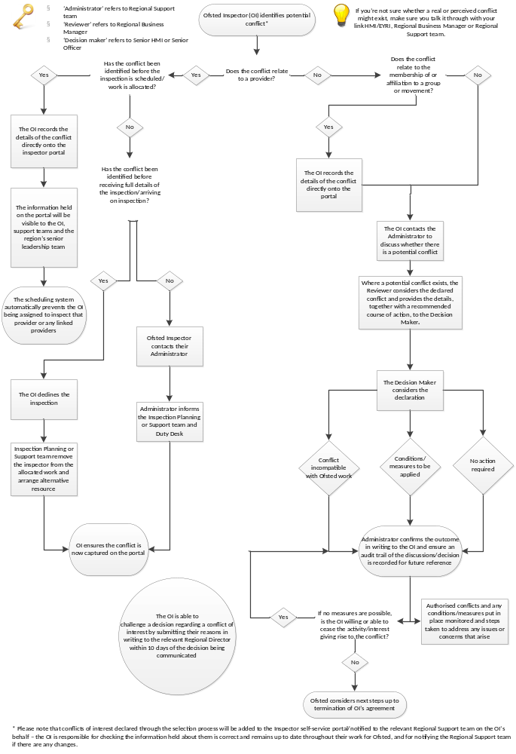

Process

Step 1 − Declaring a conflict
- At the time of selection, it is expected that OIs will declare all potential conflicts of interest in order for Ofsted to fully assess whether they will be able to effectively perform an inspector role. In addition, OIs must immediately bring any changes to declared conflicts of interest or new conflicts to the attention of the administrator, who will work with the regional business manager (the reviewer) and the senior HMI (the decision maker) to determine whether the conflict affects the individual’s ability to continue to inspect.
- OIs must keep their information, including conflicts of interest with providers, up to date on the Inspector self-service portal. This information will only be visible to the individual inspector, their regional business manager, link HMI, senior HMI and regional director. The inspection planning team will only be notified where a conflict exists, but not of the nature of the conflict.
- If the inspector is uncertain whether a real or perceived conflict of interest exists, they must discuss it with the administrator, in liaison with the reviewer.
- If a conflict relates to a provider, the OI should enter the conflict into the Inspector portal, which will automatically prevent them being assigned to a provider with which they have an association, or a linked provider.
- There is a small possibility that links between providers may change in the period between being scheduled for an inspection and the inspection taking place. Therefore, OIs are responsible for continuously ensuring that there is no real or perceived conflict of interest before undertaking an inspection event or any work for Ofsted. They are responsible for declining inspections where they feel there may be a real or perceived conflict.
- If an OI realises a conflict may exist between being scheduled to complete an inspection and receiving the full details of the inspection, or upon receiving the full inspection details, they should contact the administrator who will inform the relevant teams. The OI will be removed from the inspection and another inspector will conduct the inspection. The OI must ensure that the conflict is recorded in the Inspector portal immediately.
- Occasionally, a conflict of interest may occur unexpectedly during an inspection, for example, meeting a former close colleague during an inspection. Where this happens, the lead inspector, in liaison with their duty desk, must be informed immediately and a decision taken whether to remove the individual from that inspection. The regional director or deputy director, early years operations should be informed at the earliest opportunity.
- Any conflicts of interest that relate to membership or affiliation to a group or movement must be entered into the Inspector portal and also discussed with the administrator who will then complete a ‘Declarations of conflicts of interest’ form.
- All other potential conflicts should be discussed with the administrator who will complete a Declarations of conflicts of interest form and determine next steps to be taken, as appropriate.

Step 2 – Considering the declaration
- All conflicts submitted to the administrator will be recorded on the Declaration of conflicts of interest form and considered by the reviewer. The reviewer will provide the details, together with a recommended course of action, to the decision maker. In the schools and further educations and skills remits, the link HMI will also be notified and provided with the opportunity to input any relevant information.
- When assessing the declaration, the reviewer and decision maker must consider whether:
- the interest affects the inspector’s ability to meet the requirements of their agreement, for example whether the interest has a negative impact on the overall scheduling of inspections
- any restrictions required to manage the conflict would prevent applicants from undertaking the full range of duties – OIs must be able to undertake the minimum requirement of working days in their individual agreement
- information relating to the current or future work of Ofsted or a provider being inspected, other than information that is already in the public domain, could be disclosed because of the conflict or would be perceived as likely to be disclosed because of the conflict
- the interest is likely to bring Ofsted into disrepute or if the interest may give rise any reasonable concerns that Ofsted’s judgement or independence could be compromised
- there is likely to be potential damage to the reputation of the inspector that would damage their credibility or their perceived judgement
- the inspector could be or be seen to be unfairly using the knowledge obtained through their Ofsted agreement for personal gain or the gain of another employer

- the interest would cause any increase in costs or administration for Ofsted, cause a reduction in efficiency or put an unreasonable burden on other OIs or Ofsted’s employees.

Step 3 – Reaching a decision
- It may be possible to manage a conflict of interest by implementing measures or conditions to mitigate or minimise the risk, for example by avoiding certain providers, altering schedules, or reorganising inspection teams. The decision maker should also consider whether measures/conditions should be time-limited. The outcome, together with any measures/conditions or restrictions, including any effective dates, should be recorded by the administrator on the Declaration of conflicts of interest form for future reference.
- The decision maker will ensure that:
- the OI is informed in writing of the decision
- an audit trail of the discussions/decision is recorded for future reference by the administrator
- any conditions/measures put in place are clearly explained and reasons provided
- any conditions/measures agreed are implemented and their effectiveness monitored
- where it is not possible to put in place measures to manage the conflict, the OI is given a full explanation for the decision and the next steps, including the right to challenge the decision.
- If the OI is permitted to continue an interest alongside their work for Ofsted, with or without measures/conditions, the decision maker must ensure that:
- no information relating to the current or future work of Ofsted or the providers Ofsted inspects may be disclosed, other than information that is already in the public domain
- the interest may not be advertised or promoted in any way that refers to Ofsted, its employees or stakeholders
- the interest must not result in improper conduct, for example, through the use of Ofsted time, titles or contacts.
- If a conflict cannot be managed, the inspector should be asked to stop the interest. Where this is not possible and the inspector intends to continue with the conflicting interest, Ofsted may take steps up to and including terminating the agreement. Each situation will be dealt with on a case by case basis.

Step 4 – Challenging the decision
- If the OI is dissatisfied with the decision regarding any conflict of interest, they have the right to challenge that decision. The OI must set out, in writing, their reason(s) for challenging the decision. This should be submitted to the decision maker who made the original decision within 10 working days of the notification of the decision.
- Challenges should be considered and responded to in writing by the regional director or deputy director, early years operations. Wherever possible, the outcome of the challenge and the reason for the decision will be communicated in writing within 10 working days of receipt of the letter challenging the original decision.
- In certain circumstances, further action and/or investigation may be necessary. In these cases, the OI will be informed of this in writing and will receive the decision as soon as is reasonably practicable.

Step 5 − Reviewing decisions and declaring changes
- The link HMI, senior HMI or Senior Officer should monitor any declared interests and mitigating conditions/measures to ensure that they are, and remain, appropriate and effective.
- OIs are required to keep their declaration of conflicts up to date and declare to their administrator any change in circumstances or new interests before or as soon as they occur.
- Authorisation, once given, may be withdrawn if Ofsted’s changing requirements make this necessary or if the additional activity impacts adversely on the OI’s ability to fulfil the requirements of their agreement with Ofsted.

The Office for Standards in Education, Children's Services and Skills (Ofsted) regulates and inspects to achieve excellence in the care of children and young people, and in education and skills for learners of all ages. It regulates and inspects childcare and children's social care, and inspects the Children and Family Court Advisory and Support Service (Cafcass), schools, colleges, initial teacher training, further education and skills, adult and community learning, and education and training in prisons and other secure establishments. It assesses council children’s services, and inspects services for children looked after, safeguarding and child protection.
If you would like a copy of this document in a different format, such as large print or Braille, please telephone 0300 123 1231, or email enquiries@ofsted.gov.uk.
You may reuse this information (not including logos) free of charge in any format or medium, under the terms of the Open Government Licence. To view this licence, visit www.nationalarchives.gov.uk/doc/open-government-licence, write to the Information Policy Team, The National Archives, Kew, London TW9 4DU, or email: psi@nationalarchives.gsi.gov.uk.
This publication is available at www.gov.uk/government/organisations/ofsted.
Interested in our work? You can subscribe to our monthly newsletter for more information and updates: http://eepurl.com/iTrDn.

Piccadilly Gate
Store Street
Manchester
M1 2WD

T: 0300 123 1231
E: enquiries@ofsted.gov.uk
W: www.gov.uk/ofsted
No. 170021
© Crown copyright 2017

