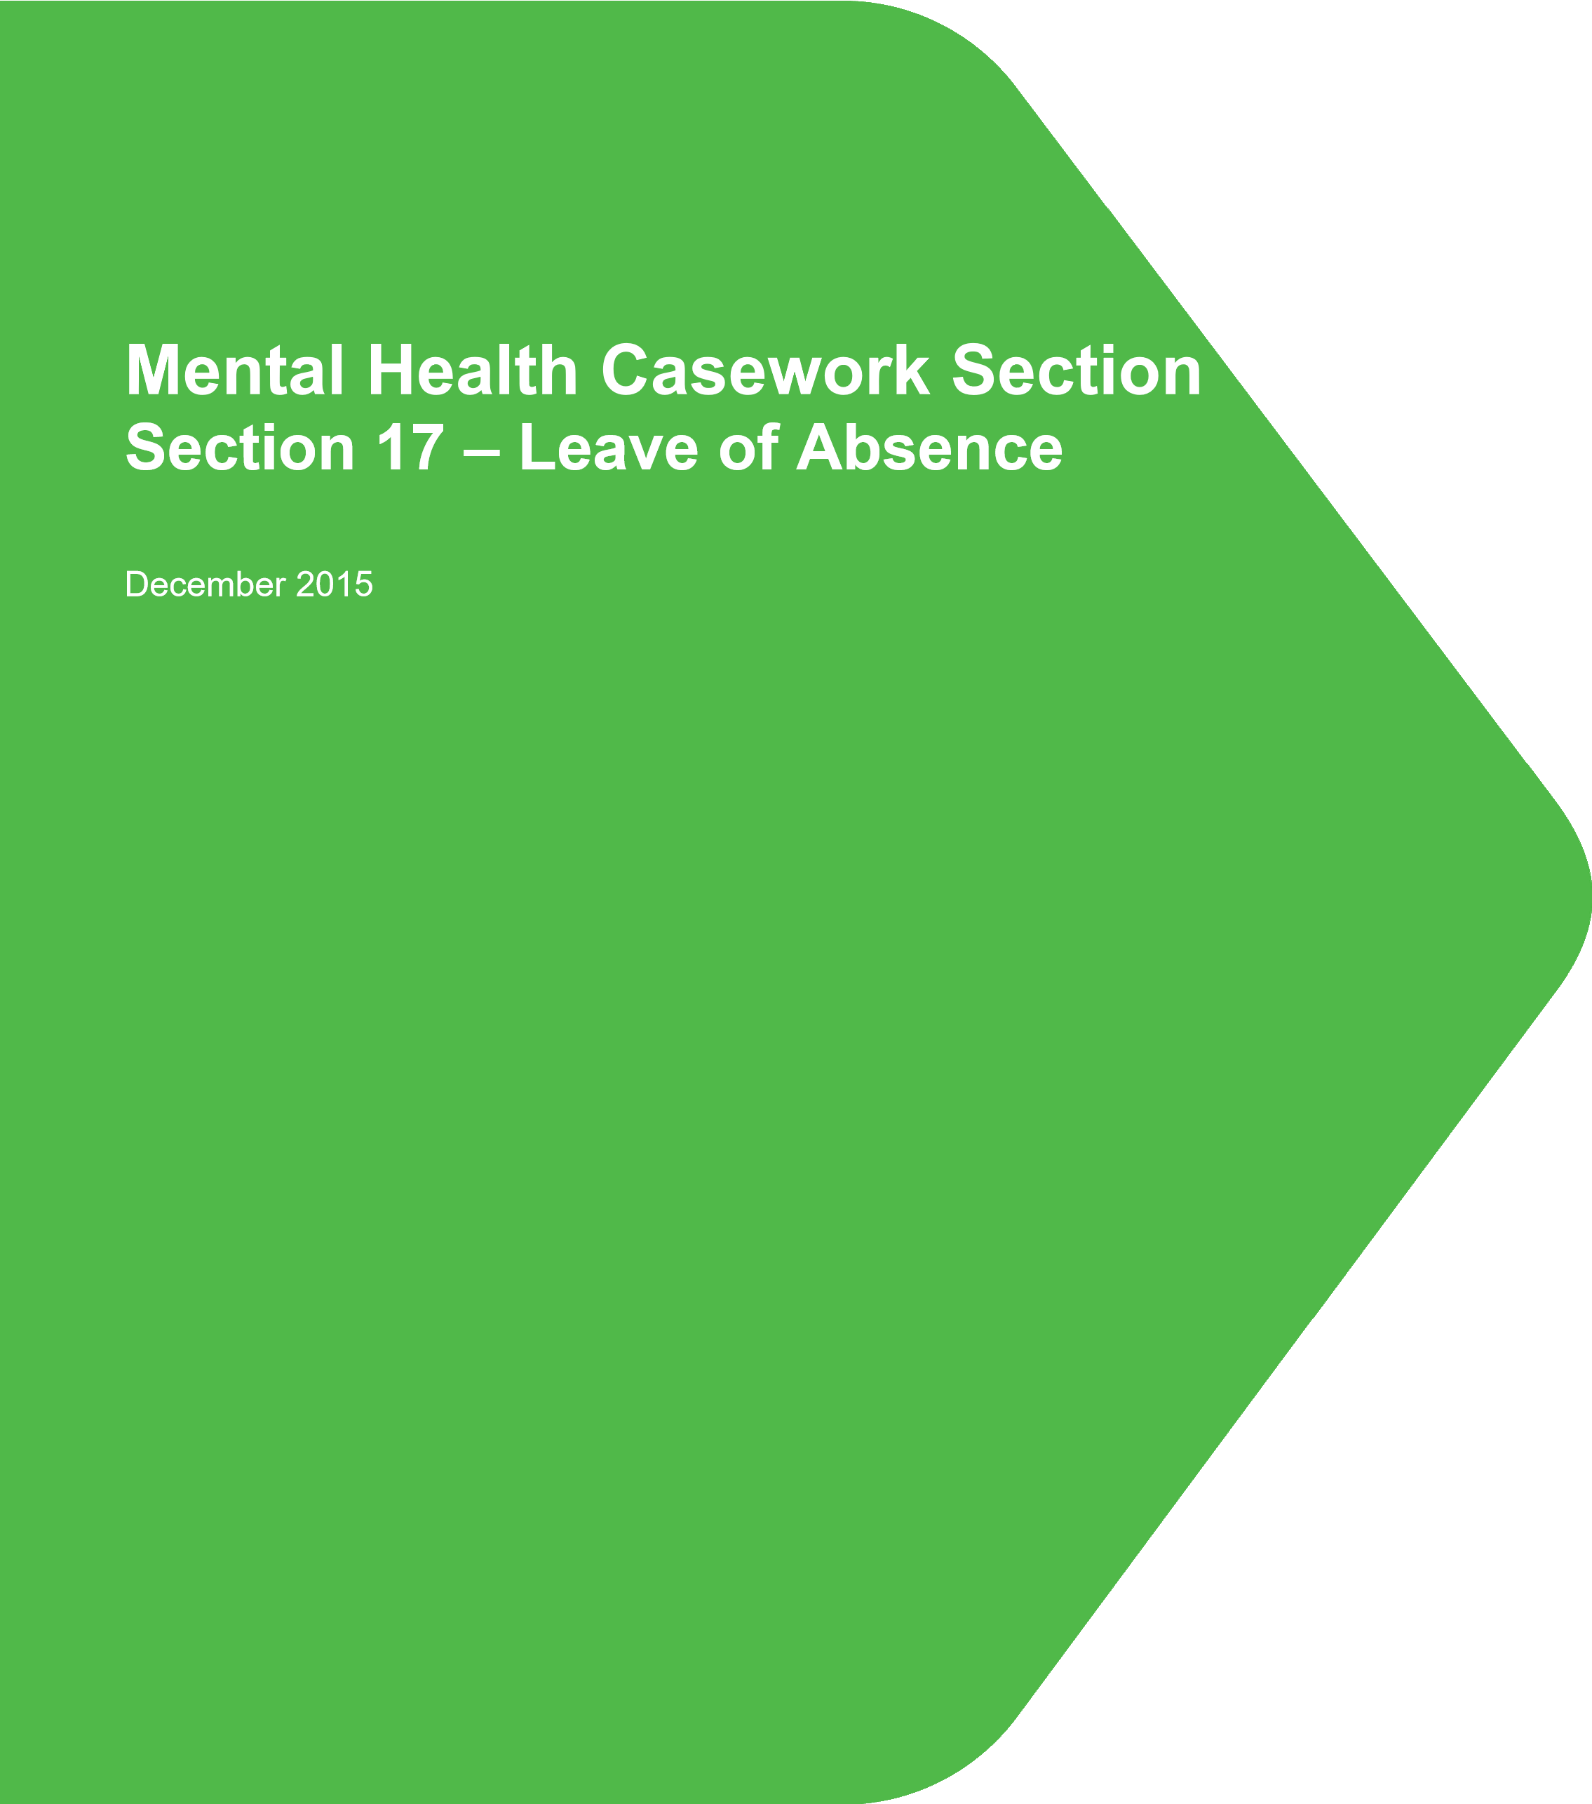

Contents Page no

Legal provisions
Secretary of State’s powers to consent to section 17 leave 2

Policy On Section 17 Leave for Restricted Patients 2

Leave Request Form 2
Specific Types of Leave:
Ground Leave 4
Escorted Community Leave 4
Unescorted Community Day Leave 5
Overnight Leave 5
Holiday type Leave 5
Leave outside England and Wales 5
Scotland 5
Northern Ireland 6
Compassionate Leave 6
Leave for the purposes of medical treatment 6
Exceptions to a general permission for medical leave 7
Leave for emergency medical treatment 7

Reports on Completed Leave 8

Withdrawing Consent for Leave 8

Leave for Court Proceedings 9

Leave to attend Court for legal proceedings other than criminal 10

Prisoners subject to directions under section 45A or transferred under 10
Sections 47 & 48 of the Mental Health Act 1983
Indeterminate Sentence Prisoners 11

Victims 12

LEGAL PROVISIONS

1. Section 41(3)(c)(i) of the Mental Health Act 1983 requires a responsible clinician to obtain consent from the Secretary of State before granting section 17 leave to a restricted patient. No such patient may leave the hospital or unit named on the authority for detention without such consent.

POLICY ON SECTION 17 LEAVE FOR RESTRICTED PATIENTS

- The Secretary of State recognises that well thought out leave, which serves a definable purpose and is carefully and sensitively executed, has an important part to play treating and rehabilitating restricted patients. It also provides valuable information to help responsible clinicians, and the Secretary of State, in managing the patient in hospital, and to all parties, including the Tribunal, when considering discharge into the community.

- To help responsible clinicians provide all the information required by the Secretary of State to assess escorted or unescorted leave proposals, a leave request form is available on https://www.gov.uk/government/collections/mentally-disordered-offenders and at Annex A. Responsible clinicians should also submit any additional information that they consider would assist the Secretary of State to reach a decision.

- The Secretary of State expects leave programmes to be designed and conducted in such a way as to preserve public safety and, where appropriate, respect the feelings and fears of victims and others who may have been affected by the offences. To this end, there is an expectation that victims, through contact with Victim Liaison Officers where victims are participating with the Victim Contact Scheme, will be asked for their views on leave. Victims may request that provisions be put in place to prevent contact with the patient, such as an exclusion zone.

- The Secretary of State will often consent to programmes which give responsible clinicians an element of discretion as to leave arrangements. However, there will be circumstances where consent is given on the understanding that the responsible clinicians will limit leave or add certain conditions, for instance, when a patient needs to visit a proposed discharge placement, or where leave at the responsible clinician's discretion is not appropriate for reasons of risk or sensitivity.

- Once agreed, the Secretary of State’s consent to leave remains in operation unless the circumstances of the patient’s health or other factors change the risk assessment. This means that the responsible clinician should make a careful risk assessment of the patient before each instance of leave. If there are any doubts that the leave should take place, it should be stopped. The responsible clinician should inform the relevant caseworker in Mental Health Casework Section immediately should any change occur that affects the basis on which the Secretary of State’s consent has been given, particularly any factor that changes a patient's risk.

LEAVE REQUEST FORM

- To help ensure that the Secretary of State receives all of the information necessary to take a decision, a leave request form is provided for responsible clinicians (see Annex A).³ In addition to the details below, the form also asks for a report on leave already taken to be attached and contact with the Victim Liaison Officer, if there is one. This should be supplemented with any additional information that the responsible clinician considers would assist the Secretary of State. Examples of such information would include additional material which explores the context, purpose and therapeutic benefits of proposed leave. Additional requests for progress reports on leave will only be made by MHCS if and when the caseworker requires further information.

- In support of any request for leave for a restricted patient, the Secretary of State requires the following information:

- the aims of the proposal and the anticipated benefits for the patient’s treatment and/or rehabilitation;

- the potential risk of harm to the public, taking into account the nature and adequacy of safeguards. Responsible clinicians must also consider any other risk factors which apply individually to the patient, particularly any risks to victims and their families, consulting with the Victim Liaison Office where appropriate.;

- any potential public concerns or media attention, and any measures proposed in response to such concerns;

- any concerns which have been expressed, or are likely to be expressed, by victims of the offences committed by the patient, or by families of the victims. In addition, any measures proposed in response to such concerns; and

- where leave for rehabilitation purposes is proposed, a plan of the periods of leave which are being requested for the patient, setting out: - the destinations of the leave;
  - length of absences from the hospital;
  - the escorting arrangements, where applicable;
  - the part which the individual leaves will play in the overall treatment plan;
  - what, specifically, each instance of leave will seek to achieve;
  - how the leave will be monitored, whether by escorting staff or through the patient’s own report or both; and
  - how the success or otherwise of the leave will be assessed and measured.
  - any incidents of abscond or escape.

9. MHCS aims to make a decision on all requests for community leave as soon as possible on receipt of all relevant information. Clinical teams should note that relevant information may extend to details that are additional to that provided on or with the application form. For patients who have had any ground leave or previous community leave, a report on this leave is needed to assess any further application for leave.

3 A shorter version of the form is available for requests for leave for the purposes of medical treatment (see para 19 below).

SPECIFIC TYPES OF LEAVE

‘Ground Leave’

- The responsible clinician has complete discretion to allow the restricted patient access to the grounds of the hospital or unit in which the detention authority requires his detention. The detention authority means here the hospital order, hospital direction, transfer direction, warrant of recall or letter agreeing to trial leave or transfer. That authority may name a complete hospital, a named unit within a hospital, or a specific level of security within a hospital. It is for the hospital or unit to define its own geographical boundaries. If the responsible clinician wants to allow the patient beyond the boundaries of the hospital or unit named on the detention authority, then he needs the Secretary of State’s agreement. So, for example, if the responsible clinician has a patient whose order states a particular Unit as the place in which the patient is detained and the responsible clinician wants to allow access to the grounds of the Hospital, an application for section 17 leave into the community must be submitted to the Secretary of State.

- If the responsible clinician wishes to allow the patient to access wider hospital grounds, beyond the hospital or unit named on the detention authority, MHCS may consider using section 19 to transfer him to a wider range of units. However there is often little difference in public safety terms between access to a whole hospital and to the community at large, so such requests should always be accompanied by a robust risk assessment and be carefully scrutinized.

- Where the detention authority names an entire hospital, the responsible clinician’s discretion extends to all the facilities the hospital comprises. This may include non secure step-down facilities outside the hospital perimeter.

Escorted Community leave

13. If the Secretary of State has given consent for escorted leave to take place, the patient will remain in the custody of the escort who has powers to convey and restrain the patient. It is for the hospital to assess the number of escorts required and the level of training and experience such staff must have. In certain cases, typically where the Secretary of State is giving consent for compassionate or medical leave to a patient who would not otherwise leave the hospital, consent may be granted with additional requirements. These may include a specified number of escorts, or other conditions such as requiring travel directly to and from the venue without intermediate stops, or requiring secure transport.

Unescorted community day leave

14. The Secretary of State will generally agree to unescorted leave at the responsible clinician’s discretion when satisfied that the patient is sufficiently rehabilitated to respect the conditions of leave, behave safely in the community and abide by the time limits set for return to hospital. Hospitals are reminded that unescorted community leave is the point at which the MAPPA that ‘owns’ the case should be notified that a MAPPA eligible offender is approaching the stage at which discharge is possible. Part 2 of the MAPPA 1 form should be used for this purpose.

Overnight leave

- As patients approach the stage of their rehabilitation where they are close to discharge, it is common for responsible clinicians to ask for overnight leave. As with any application for leave, the Secretary of State will only consent to overnight leave if satisfied the proposal does not put the patient or others at risk. The Secretary of State will consider each application for overnight leave on its merits, but may require that the number of nights away from the detaining hospital is limited where this is necessary for the safe rehabilitation and testing of the patient.

- Where the Tribunal has made a deferred conditional discharge and the proposed discharge address is a hostel or other housing placement, which insists on a minimum period of overnight assessment of the patient, the Secretary of State will consider any request for overnight leave in the context of that decision, so as not to frustrate the proposed discharge. Nonetheless, the Secretary of State will not grant permission for leave unless he is satisfied that it does not put the public, or patient, at risk.

Holiday type leave

17. As set out above, the Secretary of State expects programmes of section 17 leave to be designed and conducted in such a way as to preserve public safety and, where appropriate, respect the feelings and possible fears of victims and others who may have been affected by the offences. When considering any request for overnight leave to activity centres or any facility offering "holidays" or whose description gives the impression that it is a holiday centre, particular scrutiny will be given to the expected therapeutic benefits of such leave, the proposed arrangements for any escorts and the availability of support for the patient should they become unwell.

Leave outside England and Wales

Scotland

18. Section 17 leave to Scotland from England and Wales can be permitted subject to appropriate assessments of risk. Escorts from both Scotland and England & Wales have the necessary powers of custody in both jurisdictions. Explicit agreement for the period of leave will be sought from the Scottish Executive.

Northern Ireland

19. Section 17 leave to Northern Ireland may also be permitted subject to appropriate assessments of risk with escorts from England & Wales having powers under the MHA to take into custody any patient who absconds or escapes. For unescorted leave, the patient may similarly be taken into lawful custody should it become necessary, with the intention of returning them to England & Wales.

Compassionate leave

20. Leave may sometimes be sought for compassionate reasons for patients who would not otherwise qualify, either on risk grounds or because they have been in hospital for too short a time to have been assessed for community leave, for example to visit a terminally ill relative or to attend a funeral. These applications tend by their nature to be urgent and will be dealt with as a priority. The Secretary of State will look sympathetically on such requests, but must still be satisfied with the risk management arrangements in place.

Leave for the purposes of medical treatment

21. There are occasions when restricted patients are required to attend medical appointments for assessment or treatment. Secretary of State permission is required for a restricted patient to attend such appointments outside the secure hospital, unless permission for escorted or unescorted community leave at the responsible clinician’s discretion has been previously granted, and that permission has not been revoked. In the event that a patient is required to attend a medical appointment outside the secure hospital, the responsible clinician should submit a formal request. If satisfied that attendance is necessary and that the risk management arrangements, including physical security are sufficient, the Secretary of State will issue a general permission for a specific patient, subject to the exceptions outlined below, for medical leave to be taken at the responsible clinician’s discretion. Requests for Secretary of State permission to allow restricted patients to attend medical appointments/treatment should contain:

- Initial reasons for the appointment/treatment

- Clear evidence that any risk factors have been addressed.

- A full risk management plan including any physical security arrangements.

- Current mental state and compliance.

- Risk of absconding.

- Details, if applicable, of whether the appointment will take the patient into any exclusion zone or into the proximity of any victim

- Further information if there are unusual circumstances e.g. likely to attract national media interest

A form is available for requests for medical leave (see Annex B) although it is acceptable for an email or other communication to be sent, providing it contains all the relevant information.

22. The Secretary of State permission will be a general consent enabling the responsible clinician to arrange for the patient to attend medical appointments when necessary. Any appointments or treatment received by the patient should be recorded and included in the Annual Statutory Report submitted to the Ministry of Justice. If there are incidents of the leave being misused or evidence of behaviours which pose a risk to the public or patient, the leave must be suspended and the Ministry of Justice (MHCS) informed immediately.

NB. It remains the responsibility of the responsible clinician to immediately suspend the general permission for medical leave if there are concerns that the patient’s behaviour causes a risk to others or to the patient themselves.

Exceptions to a general permission for medical leave

23. Applications for patients who are considered by the Secretary of State to pose an increased risk to the public will require permission to be obtained for specific appointments as the arrangements will need to be individually agreed, including the duration of the permission. The Secretary of State will indicate whether applications are in this category when he responds to the responsible clinician’s initial request. Leave will be granted for the purposes specified in the request for medical leave and in line with a proposed risk management plan. Any changes to the need for the leave or the plan must be notified to the MHCS Casework Manager in writing. Further advice should be obtained from the MHCS Casework Manager.

Leave for emergency medical treatment

24. Aside from routine medical appointments or treatment, there may be occasions when a patient needs to receive urgent or emergency treatment. This will include acute medical emergencies such as heart attack, stroke, serious burns or penetrative wounds but may also include situations which are not life threatening but still require urgent treatment e.g. fractures. Although Secretary of State consent should be obtained wherever possible, it is recognised that patients may have to attend hospital at very short notice. Responsible clinicians may use their discretion, having due regard to the emergency/urgency being presented and the management of any risks. MHCS must however be notified, as soon as is practicable, that the patient has been taken to hospital, what risk management arrangements are in place and must be kept informed of developments, especially the return of the patient to the secure hospital/unit. Outside office hours, hospitals should notify the out of hours switchboard. If the patient is high profile or there are unusual circumstances, the switchboard will contact the MHCS duty officer.

REPORTS ON COMPLETED LEAVE

25. In order to consider any request for leave, the Secretary of State will require an up to date report on all previous leave taken. In giving consent for leave, the Secretary of State will consider whether additional reporting is required, and any such requirement will be set out in the letter granting consent for leave. A form is available for reports on completed (see Annex C). This form may also be used to report changes in the patient’s circumstances such as:
- a change or cessation of medication;
- self harming;
- the involvement of the patient in an incident in, or outside, the hospital;
- abuse of substances; or
- the added stress of bad news from outside or from another stressful occasion.

26. Notwithstanding requests for specific reports on leave, details of progress made on community leave should always form part of the annual statutory report.

WITHDRAWING CONSENT FOR LEAVE

- There will be occasions when it is necessary for the Secretary of State to withdraw consent for leave under section 17. This may be as a result of a patient not complying with conditions of leave, or because their behaviour or actions indicate a real or potential increase in risk to others or themselves. A responsible clinician may also take action to suspend a patient’s leave for similar reasons and must advise the relevant caseworker in MCHS immediately. .

- In making this decision, the Secretary of State will consider matters such as:
- whether the patient’s condition has relapsed or, if the problem was a behavioural one.
- whether the incident that caused leave to be rescinded was a “one-off”;
- whether or not the patient was the main instigator and, if they were, whether the patient shows appropriate remorse which has been consistent and sustained as has a further period of stable behaviour; and
- What the factors were which contributed to the infraction, and how they have been addressed so as to reduce the risk both of any recurrence and of its severity & impact were it to recur.
- any plans that might have been put in place by the responsible clinician requiring the patient to demonstrate certain behaviours before leave can be reinstated.

MHCS is always willing to discuss the best course of action in an individual case.

LEAVE FOR COURT PROCEEDINGS

- Where a court directs the attendance of a patient, the Secretary of State will rarely refuse consent to leave under s.17. However consent for leave must still be sought. For those patients detained under Section 48 of the Act, general permission will be provided on the assumption that legal proceedings will inevitably need to be completed. This will take the form of a formal notification, on admission, advising that ‘Secretary of State permission for the attendance at court for the purposes of legal proceedings is given’.

- With regard to patients detained under sections 37/41 and sentenced prisoners transferred under sections 47/49 the following details will be required:

- Date(s) when attendance is required.

- Details of the Court, including location.

- Reasons for attendance.

- Whether consideration has been given to the patient attending the hearing via a video-link.

- Arrangements for transporting the patient to court, including physical security e.g. number of escorts/secure van/necessity for handcuffs.

- Details, if applicable, of whether attendance will take the patient into any exclusion zone or into the proximity of any victim.

- Further information if there are unusual circumstances e.g. likely to attract national media interest.

An email to the Mental Health Caseworker will suffice. The expectation is that providing all the relevant information is received, permission will be granted within 48 hours.

Leave to attend Court for legal proceedings other than criminal

- Some restricted patients may be required to attend court for purposes other than criminal proceedings, for example to attend the Family Court. Secretary of State permission is also required for this purpose and the details above should similarly be provided by email, giving as much prior notification as possible.

- Where a patient’s attendance is not strictly required but is voluntary or may be seen as useful to the administration of justice, the Secretary of State will consider all applications on merit.

- Restricted patients should not attend a court hearing unescorted without the Secretary of State’s express agreement.

Restricted patients who become the subject of Police enquiries while an inpatient

34. Occasionally a patient may be the subject of police interest, for example if an alleged offence has taken place while in hospital, or if earlier allegations come to light and are then to be investigated. Were that to occur while the subject is in Prison, the Police are permitted to arrest an individual and take them to a Police station for questioning, returning them to the prison thereafter. In a parallel manner, if the Police decide to arrest a restricted patient in hospital and take them to a Police station for questioning, the consent of the Secretary of State is not necessary. It will, however, be the responsibility of the Police to transport the patient between Police station and hospital and prior to this occurring the Police should be informed in writing that the person is a detained patient subject to the provisions of the Mental Health Act and who must be returned to the unit at the conclusion of questioning. Arrangements should also be made for an appropriate adult to accompany and assist the patient at the police station as necessary. The MHCS should be informed of the matter in advance of the circumstances, and of the patient’s return to hospital.

PRISONERS SUBJECT TO DIRECTIONS UNDER SECTION 45A OR TRANSFERRED UNDER

SECTIONS 47 AND 48 OF THE MENTAL HEALTH ACT 1983

Patients Transferred under section 47/49 or patients subject to section 45A directions

- As a general rule, a patient who was sentenced and directed to hospital by the Court under section 45A or who has transferred from prison under section 47/49 will not be permitted leave in the community while detained under the Mental Health Act in hospital where he or she would not have been given such leave whilst in prison. The presumption for many of these patients is that their care pathway will see their return to prison to continue their sentence rather than release into the community. However as this is not always the case, and because leave can form a part of a patient’s treatment, discretion is needed and the Secretary of State will consider requests for community leave on an individual basis.

- As with all patients, when considering a request for community leave for a transferred prisoner, the Secretary of State will always have in mind the ongoing protection of the public. Factors relevant to this consideration include any history of absconding or escape. For transferred prisoners, it will be necessary to review their history in prison and in hospital. Careful consideration will be given to the potential increase in the patient’s risk and the likelihood of them being in the community without the necessary supervision and support. .

Escorted leave

- Escorted leave may be an important part of treatment and rehabilitation for directed and transferred prisoners. When applying for such leave, responsible clinicians should always have in mind the general principles set out in paragraphs 2 - 6 above and must ensure, if granted, that the leave is conducted in such a way as to safeguard public confidence in the restricted patient system. Responsible clinicians also need to bear in mind that the granting of escorted leave to transferred prisoners should not be taken as an indication that unescorted leave will follow. However, unescorted leave may be appropriate where a patient is going to be released into the community e.g.
if the prison sentence is about to expire.

Compassionate leave

- Requests for leave for compassionate reasons will be considered in line with paragraph 20 above.

Unescorted leave

- As with escorted community leave, the Secretary of State will consider the particular circumstances of the request carefully and in particular will consider the patient’s offence history, any incidents of abscond or escape, progress in hospital, the therapeutic benefit of the leave and the potential risk posed by the patient to themselves or others. The Secretary of State takes the view that, in general, transferred prisoners should not have unescorted leave in the community from secure hospitals where that they would not receive such leave from prison,

Overnight leave

- Overnight leave will be considered in line with the policy outlined in paragraph 39 above.

Indeterminate Sentence Prisoners

41. Transferred or directed indeterminate sentence prisoners fall into 2 categories:

“Technical Lifers”

42. These are prisoners whom the Secretary of State agreed, exceptionally, to manage as if the Court had made a restricted hospital order instead of a life sentence. The process was ended in 2005, so the number of such prisoners in hospital has diminished. Applications for section 17 leave for technical lifers should be treated as if they were detained under sections 37 and 41.

Other Indeterminate Sentence Prisoners

43. Most indeterminate sentence prisoners in hospital will be serving life sentences or indeterminate sentences for public protection. They will be subject to hospital directions or transfer directions. Generally their release will ultimately be ordered on licence by the Parole Board. If the Secretary of State is asked to consider a request for leave, the responsible clinician must also address the question of why the patient should not be remitted to prison.

VICTIMS

- Under the Domestic Violence, Crime and Victims Act 2004 (DVCVA) where a restricted patient was sentenced on or after 1 July 2005, victims of serious violent and sexual offences have the right to information on key developments in a patient’s progress and to make representations about discharge conditions, from the National Probation Service (NPS) under the Victim Contact Scheme. Where victims do not statutorily qualify, they may be made part of this scheme on a discretionary basis.

- When the Secretary of State gives permission for section 17 community leave, information may be passed onto victims on a discretionary basis. From April 2014, victims who have opted into the VCS will be informed if permission for community leave, whether escorted or unescorted, is granted by MHCS, unless there are exceptional reasons why they should not be told.

- Victims of offences committed by restricted patients will receive information via the Victim Liaison Officer. Victims of offences committed by unrestricted patients will receive information from the hospital managers or clinicians.

ANNEX A

Leave application for restricted patients

Mental Health Casework Section
Please send the completed form to the Mental Health Casework Section at

MHCSmailbox@justice.gov.uk

Patient’s basic details
Full name of patient

Date of birth

MHCS reference

Location of index offence

Responsible clinician’s details
Responsible clinician

Address

Telephone number

Fax number

Email address

Leave proposal
Please note that any leave taking place outside the designated security perimeter of the named unit, hospital or ward requires Secretary of State approval unless the hospital has a current agreement with the Mental Health Casework Section specifically devolving agreement to the Responsible Clinician.
Type of leave proposed Compassionate Escorted community
Overnight Unescorted community
Other (please specify)
Previous types of leave taken Compassionate Escorted community
Overnight Unescorted community
Other (please specify)

Report on current leave (frequency, duration, destination, purpose and conduct)

Please give details of the leave proposal, including:
• the purpose of the leave • full address of the leave destination
•

if escorted, the number of escorts
•
e leave plans, if proposal agreed
•

means of transport, if any
•

views of care team, if different

futur

Patient’s condition
Mental state – please describe the patient’s mental state, including:
- how long the patient has been stable • what insight, if any, the patient has into his or her illness

Behaviour – please describe the patient’s behaviour, including any incidents of:
- aggression • self-harm • substance abuse
State what effect these have had on the patient and how they will be addressed.

Compliance – to what extent does the patient:
- accept the treatment programme? • comply with medication?

Risk
Risk to victims and others – what is your assessment of the risk (including further offending, or a possible encounter) that the patient would present to:
• past victims? • any specific group? • the public in general? How do you propose to address these risks?

Victim Consideration & VLO contact – have you contacted the VLO to get the victim’s views on unescorted leave (please give full and frank account of victim’s views)
Name of VLO: Tel. No. Date of Contact:

Risk of absconding – what is your assessment of the patient’s current risk of absconding? How do you propose to address this risk?

Responsible clinician’s signature

Date

ANNEX B

Medical Leave application for restricted patients
Mental Health Casework Section

Please send the completed form to the Mental Health Casework Section at:
MHCSmailbox@justice.gov.uk

With immediate effect, each occasion of leave for medical appointments or treatment will require the written consent of the Ministry of Justice. If the Secretary of State has previously granted permission for escorted or unescorted community leave at the Responsible Clinician’s discretion, and that permission has not been revoked, no further application for leave is required.

Patient’s basic details
Full name of patient

Date of birth

MHCS reference

Location of index offence

Responsible clinician’s details
Responsible clinician

Address

Telephone number

Fax number

Email address

Leave proposal
Please note that any leave taking place outside the designated security perimeter of the named unit, hospital or ward requires Secretary of State approval unless the hospital has a current agreement with the Mental Health Casework Section specifically devolving agreement to the Responsible Clinician. Type of medical leave proposed Hospital Dental Other

Other (please specify)

Reason(s) for appointment:
(The precise nature of the treatment required)

Address of hospital/clinic/surgery etc:

Date(s) of appointments – if available
(Will follow up appointments be required?)

Escorting and transport arrangements (please specify if handcuffs will be used):

(Number of escorts and details of transport that will be used)

Current mental state and compliance:
(Whether in your clinical opinion the problem necessitates a medical appointment?)

Is the leave likely to bring the patient back to the area of the index offence or near to victim(s) of the offence?

Risk of absconding:

Responsible clinician’s signature

Date

Where section 47 of the Crime (Sentences) Act 1997 applies.
Historically, MHCS had entered into agreements with some hospitals for some restricted patients to take leave beyond the hospital perimeter, for the purposes of accessing wider grounds or local shops. These agreements are no longer in force.

