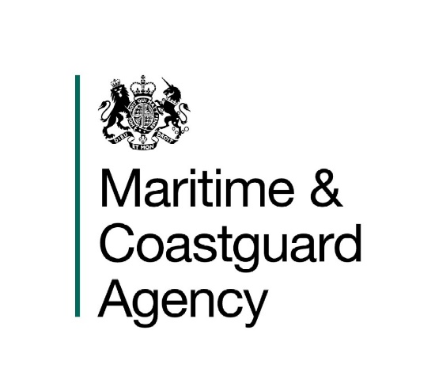
Maritime and Coastguard Agency Log

609 ()

Class IX Tugs Under 500GT - Guidance for Exemption from the Carriage of a Rescue Boat

Notice to all owners and operators of Class IX tugs of under 500GT, tug manufacturers and classifcation societies.

This notice should be read in conjunction with SI 1999 No 2721, the Merchant Shipping (Life-Saving Appliances For Ships Other Than Ships Of Classes III – VI(A)) Regulations 1999.

Summary
This notice provides guidance for owners and operators applying for an exemption from the carriage of a rescue boat for Class IX Tugs of Under 500 Gross Tonnes (GT). This notice sets out the factors that the MCA (on behalf of the Secretary of State) will take into account when considering whether to grant an application for such an exemption.

- Introduction

  - The MCA recognises that for some designs of Class IX Tugs under 500GT there are safety benefits associated with not carrying a rescue boat and therefore recovering the man-overboard (MOB) directly onto the tug itself. In this scenario the tug must be highly manoeuvrable, with the necessary equipment to support recovery of the MOB. By not carrying a rescue boat, the tug may benefit from a greater visibility from the navigating bridge and there may be fewer deck obstructions for towing operations.

  - This notice contains best practices which must be achieved for a Class IX Tug under 500GT which seeks to be exempted from the carriage of a rescue boat. All applications will be reviewed by the vessel’s local MCA Marine Office using the MCA procedure for considering a request for exemption.

- Existing regulations for carriage of a rescue boat

  - Ships of Class IX are defined as tugs and tenders (other than ships of Classes II, II(A), III, VI and VI(A)) which proceed to sea but are not engaged on long international voyages.

  - Regulation 65(6) and (7) of the Merchant Shipping (Life-Saving Appliances For Ships Other Than Ships Of Classes III to VI(A)) Regulations 1999 (“the Regulations”) require ships of Class IX under 500 gross tons to carry:

“(6) …at least one rescue boat, or inflated boat fitted with an engine. A lifeboat may be accepted as a rescue boat, provided that it also complies with the requirements for a rescue boat.

(7) Each lifeboat, rescue boat and inflated boat shall be served by its own launching appliance.”

  - Regulation 85(3) of the Regulations provides the MCA (on behalf of the Secretary of State) with the authority to exempt a Class IX tug of under 500GT from the requirement to carry a rescue boat if the MCA is satisfied that compliance with that requirement is either impracticable or unreasonable in the case of that ship. The exemption may be granted subject to particular terms which are specified in the exemption.

- Categories of water and types of operation

  - This guidance has been written with the following categories of water and types of operation in mind and therefore an exemption may be applied for by a Class IX tug of under 500GT when:

    - initiating or concluding a port towage operation outside of categorised waters. This provision is under the caveat that there should be a clear benefit to safety (e.g. the tow is initiated or concluded at a safer distance from a lee-shore).
    - conducting transit voyages outside of categorised waters, so long as the vessel does not conduct any operations such as towing, or the carriage of passengers or cargo. It is best practice for additional MOB safety precautions to be taken by the company prior to commencement of a transit voyage (e.g. prohibition of any work on an open deck).

  - The categorisation of UK waters is defined in MSN 1837 (M) Amendment 2 categorisation of waters.

  - Exemptions from the carriage of a rescue boat will not be granted for vessels which conduct operations outside of categorised waters, other than for the reasons given in 3.1.

- Conditions for an exemption

  - The following conditions must be met before an exemption may be granted:

    - The vessel should be highly manoeuvrable.
    - There should be clear visibility from the helm position to the MOB recovery position. The attending surveyor may consider whether the use of CCTV is an acceptable method for achieving visibility of the MOB recovery position on the vessel. In such cases the CCTV shall have servicing and maintenance plans, which are included in the owner/operator’s safety management system.
    - The vessel shall be fitted with appropriate MOB recovery equipment, which shall be operated to the satisfaction of the attending surveyor. All MOB equipment shall be included in the vessel’s maintenance system.
    - The MOB recovery position shall be positioned close to the waterline and away from underwater obstructions.
    - The owner/operator’s safety management system shall include MOB procedures and drills, and each member of the crew, in particular the helmsman, must have conducted recent MOB drills.
    - The owner/operator’s safety management system shall include instructions for the crew in the event of a MOB, and shall include mitigations to restrict the occurrence of a MOB such as by promoting clear deck policies whilst towing.

  - Insufficient manning on a vessel is not a reason to grant an exemption from the carriage of a rescue boat.

- Procedure for applying for an exemption

  - In order to apply for an exemption a tug owner/operator must first contact their local MCA Marine Office. It is recommended that when seeking an exemption from the carriage of a rescue boat, the owner/operator initially provides the following information:

    - particulars of their vessel and details of their operations with respect to section 3 of this notice. (For example, this information would include the existing certification held by the vessel, the operating area for the vessel and the locations that towing operations are conducted); and
    - evidence to support their compliance with the conditions in section 4 of this notice. (For example, this evidence may include: vessel drawings showing LSA arrangements, MOB risk assessments, vessel operating procedures, maintenance & servicing procedures for MOB equipment, etc.)

  - All requests to apply an exemption will be reviewed by the MCA. An application may be rejected if it does not show compliance with the information provided in this notice.

More Information

Ship Standards
Maritime and Coastguard Agency,
Bay 2/23
Spring Place,
105 Commercial Road,
Southampton,
SO15 1EG.

Tel : +44 (0) 203 8172000.
e-mail: shipstandards@mcga.gov.uk.

Website Address: www.gov.uk/government/organisations/maritime-and-coastguard-agency .

General Enquiries: infoline@mcga.gov.uk

File Ref: Insert MCA File Reference

Published: Printers to Insert
Please note that all addresses and
telephone numbers are correct at time of publishing.

© Crown Copyright 2019

Safer Lives, Safer Ships, Cleaner Seas.

