UK Science and Innovation Network Case Study

Bacteria, boats and biomedicine: SIN supports new UK-Singapore partnership on biofilms

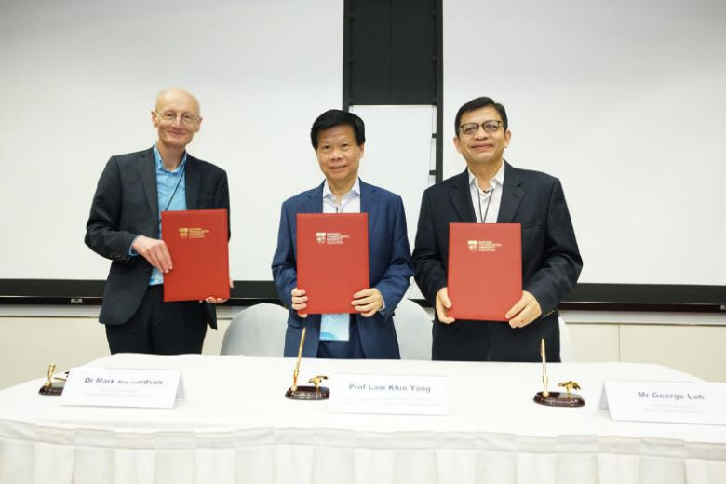
SIN support to the National Biofilms Innovation Centre (NBIC) led to the signing of two Memoranda of Understanding with the Singapore Centre for Environmental Life Sciences Engineering (SCELSE) and the Singapore National Biofilm Consortium (SNBC). These agreements will facilitate joint R&D programmes, sharing of knowledge and expertise, researcher exchanges and trade between the UK and Singapore, strengthening our global positions in biofilms research and innovation.

Developing a global network

Biofilms are central to our most important global challenges (including antimicrobial resistance, food safety and water security) and exert significant economic, social and environmental impact. NBIC was launched in 2017 to bring together the best of UK research and businesses to drive the translation of biofilms research into innovative solutions to industry’s unmet needs. Recognising the benefits of working closely with global academic partners, NBIC visited Singapore in February 2018 through SIN support to participate in a joint workshop with SCELSE, where they identified complementary areas for strategic R&D collaboration to bring their partnership to the next level.

One year on…
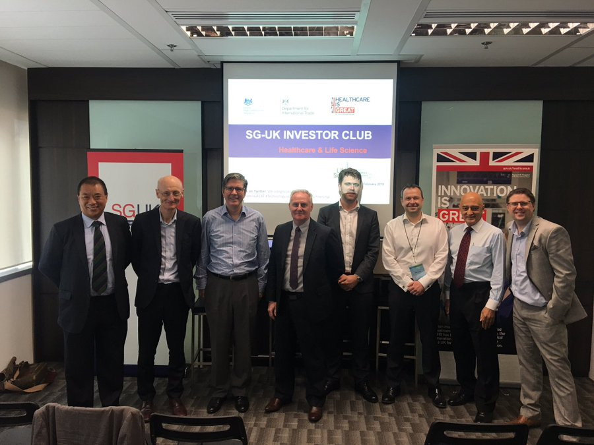
In February 2019, SIN supported a second visit by NBIC leadership and three of their industry partners (Bioquell, Fourth State Medicine and Varicon Aqua) to Singapore. They showcased the UK’s global leadership in biofilms and investment offer in Health and Life Sciences by participating in a biofilms research and industry symposium and a UK-Singapore Investor Club, which SIN organised with the Department for International Trade (DIT). Finally, NBIC took part in a launch ceremony where they signed two MoUs with SCELSE and SNBC, paving the way for a truly academic-industry partnership that will cement the UK and Singapore as global leaders in biofilms research and innovation.

SIN Singapore Contact: Jade Chung, Science and Innovation Officer, jade.chung@fco.gov.uk


