
IN THIS ISSUE:

- India and Iran

- India and South Korea
MONTHLY TRADE REPORT

INDIA TRADE POLICY TEAM
DECEMBER 2018 - JANUARY 2019

- India and Iran: India and Iran have reportedly agreed to an interim arrangement in which India will pay Iran in Indian Rupees for oil imports and Iran will use the rupee payments, received in escrow accounts, to then purchase food/medicine and other goods from India including soybean. India had secured a temporary waiver from the US’s

sanctions until April 2019. Iran was India's second biggest supplier of crude oil until 2010-11. It has climbed up since to the third spot, as Iran is said to be a lucrative supplier for Indian refineries due geographical proximity and 60 days of credit for purchases (not offered by other suppliers). The bilateral goods trade increased 7.8% to $13.8 billion in 2017-18, of which 81% was Iran’s oil exports. Reports suggest India will continue to import oil from Iran within permissible limits (300,000 barrels per day). It will also procure oil and gas from the US whilst India’s top refiners are exploring annual contracts with the US, as it is willing to double its oil supplies to India (from $3.8 billion currently) at favourable terms. Further, India’s Ambassador to the US Harsh Vardhan Shringla was reported stating that India has committed to buy $5 billion worth of oil and gas annually and $18 billion defence equipment (under implementation) from the US.

- India and South Korea: The 7th round of India – South Korea Comprehensive Economic Partnership Agreement (CEPA) negotiations were held in South Korea on 11-13 December 2018. The CEPA review started in 2015. Both sides are looking to conclude negotiations soon, particularly given the mutually agreed target to increase bilateral trade to $50 billion by 2030. Apart from tariff reductions, the two countries are currently exploring cooperation in sectors of mutual interest such as IT service capabilities, AI, start-ups, infrastructure, investment and IPR as well as Internet of Things Policy. During this round, a delegation from the Indian sugar industry actively pushed for raw sugar exports from India. They reportedly had positive discussions with the Korean Sugar Refineries. In July 2018, the CEPA was upgraded through an early harvest package with tariff reductions on 11 items such as beer, jellies and marmalades, coffee rubber, among others. Further negotiations are scheduled for 2019. Since CEPA came into force in 2010, the total goods trade between the two countries grew by 67% to $20.8 billion in 2017-18. However, of this, about $16.3 billion comes from South Korean high value exports including electrical machinery, Iron and steel, power-generating machinery, plastics, pearls

and precious stones and organic chemicals. India’s goods exports are about $4.4 billion including mineral fuels, aluminium, organic chemicals, iron, and steel.
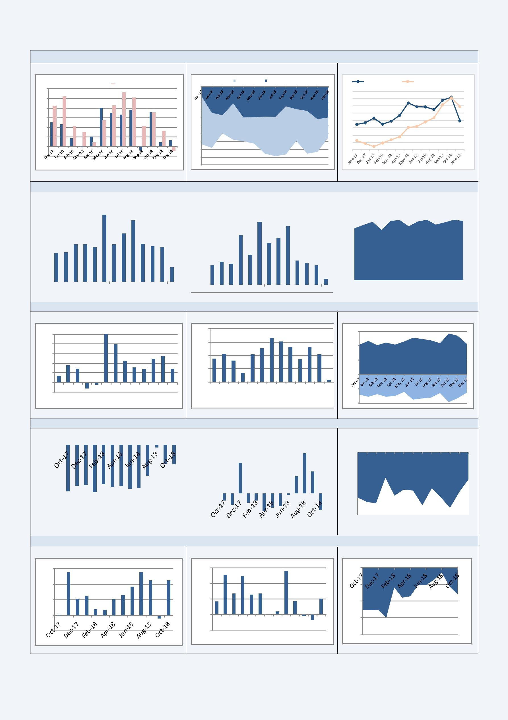
Merchandise trade: exports/imports / trade balance

Export/Imports growth (% y/y)

Exports Y/Y % Imports Y/Y %

30

25

20

15

10

5

0

-5

Trade balance ($bn)

Trade Balance | Non-oil Trade Balance

0

-2

-4

-6

-8

-10

-12

-14

-16

-18

-20

Global Oil Price vs. Rupee Depreciation ($)

Brent Crude Oil Prices | Rupees per US dollar (Right Axis)
85 | 75
80 | 73
75
70 | 71
65 | 69
60 | 67
55
50 | 65
45 | 63

Services trade: exports / imports / trade balance
Export growth (% y/y) |  |  |  |  |  |  |  | Imports (% y/y) |  |  |  |  |  |  |  |  | Trade balance ($bn)
 | 40 |  |  |  |  |  |  |  | 60 |  |  |  |  |  |  |  | 8
 | 30 |  |  |  |  |  |  |  | 50 |  |  |  |  |  |  |  | 6
 | 30 |  |  |  |  |  |  |  | 40 |  |  |  |  |  |  |  | 6
 | 20 |  |  |  |  |  |  |  | 40 |  |  |  |  |  |  |  | 4
 | 20 |  |  |  |  |  |  |  | 30 |  |  |  |  |  |  |  | 4
 | 10 |  |  |  |  |  |  |  | 20 |  |  |  |  |  |  |  | 2
 | 10 |  |  |  |  |  |  |  | 10 |  |  |  |  |  |  |  | 2
 | 0 |  |  |  |  |  |  |  | 10 |  |  |  |  |  |  |  | 0
 | 0 |  |  |  |  |  |  |  | 0 |  |  |  |  |  |  |  | 0
 | Nov-17 |  |  | May-18 | Nov-18 |  |  |  | 0 |  |  |  |  |  |  |  | Nov-17 |  |  | May-18 |  |  | Nov-18
 |  |  |  | May-18 |  |  |  |  | Nov-17 |  |  | May-18 | Nov-18
Petroleum Oil Lubricant (POL) trade Export growth (% y/y)

100
80
60
40
20
0 | Jan-18 | Feb-18 | Mar-18 | Apr-18 | May-18 | Jun-18 | Jul-18 | Aug-18 | Sep-18 | Oct-18 | Nov-18 | Dec-18
Dec-17
-20

Imports (% y/y)

80

60

40

20

0

Dec-17 | Jan-18 | Feb-18 | Mar-18 | Apr-18 | May-18 | Jun-18 | Jul-18 | Aug-18 | Sep-18 | Oct-18 | Nov-18 | Dec-18

Trade balance ($bn)

15,000

10,000

5,000

0

-5,000

-10,000

Gold trade

Export growth (% y/y) |  |  |  |  |  |  |  |  |  |  |  |  |  |  |  |  | Imports (% y/y)
0.00 |  |  |  |  |  |  |  |  |  |  |  |  |  |  |  |  |  | 100.00
-50.00 |  |  |  |  |  |  |  |  |  |  |  |  |  |  |  |  |  | 100.00
-50.00 |  |  |  |  |  |  |  |  |  |  |  |  |  |  |  |  |  | 50.00
-100.00 |  |  |  |  |  |  |  |  |  |  |  |  |  |  |  |  |  | 0.00
-150.00 |  |  |  |  |  |  |  |  |  |  |  |  |  |  |  |  |  | -50.00

Trade balance ($bn)

0
0 | Oct-17 |  | Nov-17 | Dec-17 | Jan-18 | Feb-18 | Mar-18 | Apr-18 | May-18 | Jun-18 | Jul-18 | Aug-18 | Sep-18 | Oct-18
-1
-2
-3
-4

Non-oil/Non gold trade Export growth (% y/y)

30

20

10

0

-10

Imports (% y/y)

30
20
10
0 | Oct-17 | Nov-17 | Dec-17Jan-18Feb-18Mar-18Apr-18May-18Jun-18Jul-18Aug-18Sep-18Oct-18
-10 | Oct-17 | Nov-17

Trade balance ($bn)

0

-2

-4

-6

-8

Data Sources : Government of India and Reserve Bank of India official statistics

For further information, please contact – Sakshi.jain@fco.gov.uk

Read our analysis on the India Economic Share Point

