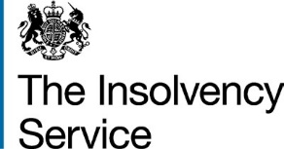

Online Debt Solutions (ODS) online service

Guidance for debt advisers

May 2016

As you hopefully already know, from 06 April the bankruptcy application process moved online, and the power to issue bankruptcy orders passed to the Insolvency Service adjudicator.
Over the past 18 months we have been working hard to develop the new online application, and from 06 April our new service will officially be live!
This means that individuals looking to go bankrupt will no longer have to go to the courts. Instead, they will be able to complete their online bankruptcy application in their own time and from any location they choose.
Through our testing, we have made sure that the application is user friendly enough for individuals to complete on their own. However, we know that bankruptcy is a scary thing for people and that they often rely on you as debt advisers to help them through this difficult time.
The information contained in this pack should help you better assist individuals who come to your for help or information. However, if you require anything further please:
- email iel.onlinedebtsolutions@insolvency.gov.uk
- call 0300 678 0015

Table of contents

Section | Page
Application process | 3
Help for assisted digital users | 7
About the adjudicator | 7
New processes | 8
Transitional arrangements | 9
Frequently asked questions | 10
Appendix 1: paying by cash | 13
Appendix 2: refund policy | 14
Appendix 3: ODS factsheet – what you need to complete the application | 15
Appendix 4: application screenshots | 19
Application process

In order to apply for bankruptcy, each applicant will:
- Start their application by creating an account with the Insolvency Service via the central Government website, GOV.UK

- Use the application number we email them to sign into their application

- Complete the application in their own time, signing out and returning to their application as many times as they'd like
- Pay the £680 bankruptcy fee either online or in cash
- Electronically submit their completed application
- Receive an email once a decision has been made on their application
- Sign into their application to check the decision and find out about next steps

More information about these steps can be found on pages 4 to 6.
Screenshots of the application can be found in appendix 4.

- Start the application

Come 06 April, the online application will be available from GOV.UK.

As a first step, we’ll ask applicants to:
- enter some basic information about themselves
- provide an email address where we can contact them throughout the application process and their bankruptcy
- choose and answer 3 security questions

We’ll ask applicants 1 of their security questions each time the sign into their application

With regards to email addresses, we strongly suggest users provide an email address that they, a friend or a family member can easily access as we will be sending them important information via email at various times throughout the application process.

Applicants who don’t have access to an email address can ask us to post them all correspondence. To do this, they simply need to click continue without entering in an email address. We’ll then give them the option to provide a postal address instead. However, they will still have to complete the application online. More information about how we are working to support those who struggle to get online can be found on page 7.

Once the applicant has created their account we will either post or email them their unique application number. They will use this number to sign into their application so it’s important they not share it with others.

- Sign into an application

To help an applicant log into their application:
- visit https://apply-for-bankruptcy.service.gov.uk
- enter their 12 digit application number
- answer 1 of their 3 security questions

If they can’t remember the answer to a security question, they should try logging in again. We’ll randomly ask them one of their three questions each time.

Further help for those who are struggling to log in can be found at: https://apply-for-bankruptcy.service.gov.uk/Application/Show/ApplicationDetailsHelp

- Complete the application

The new online application has 8 sections. They need to be completed in chronological order as this allows us to pull information through from previous sections to save the user re-entering details they have already told us.

You are welcome to complete the application for the applicant or help them complete it on their own.

There is a save and logout function, so applicants can leave their applications and come back later. Applicants can also take as long as they like to complete and submit their application.

- Pay the fee

The cost of going bankrupt online is £680. This is made up of the:
- new £130 adjudicator fee (replacing the current £180 court fee)
- £550 bankruptcy deposit

The fee can be paid:
- online by debit, credit and prepaid cards
- by cash at any Natwest branch

Applicants shouldn’t use their own credit cards to pay their bankruptcy fee.

Third parties can also make payments on the applicant’s behalf either by card or online. We won’t be accepting cheque payments from applicants or from third parties.

To arrange a third party payment, the applicant needs to first obtain a payment reference number by:
  - signing into their application
  - selecting the ‘Make a payment’ button
  - clicking the ‘Have someone else make a payment on my behalf’ link at the bottom of the page

Each applicant’s payment reference number begins with the letters ‘ADJ’ and is linked to that individual’s application. It can be used multiple times by multiple individuals looking to make third party payments.

Once they have their payment reference number, the applicant simply needs to give the payment reference number to the third party and ask them to visit: https://apply-for-bankruptcy.service.gov.uk/third-party-payment.

Paying by instalments is available for all those paying the fee online. The minimum online payment amount is £5 and can be paid in as many instalments as needed.

Paying by instalments isn’t available for cash payments. Instead the applicant or third party must pay the full £680 fee in a single payment by visiting their local Natwest branch. More information about making cash payments can be found in appendix 1 or by logging into an application, selecting ‘Make a payment’, and clicking the ‘I can’t pay by card’ link at the bottom of the page.

Information about our refund policy can be found in appendix 2 or by logging into an application, selecting ‘Make a payment’, and clicking the ‘Refund policy’ link on the right hand side of the page.

- Submit the application

Once an applicant has completed all 8 sections of the application and paid the full fee, they will be able to submit their application electronically directly to the adjudicator.

After clicking submit, the applicant will be asked to verify certain information about themselves, including that:
- they are the person named in the application
- the information provided is accurate to the best of their knowledge
- they consent to a credit search being run using the details provided in the application

The application won’t go to the adjudicator until the applicant confirms these statements.

Even if you have completed the online application on the individual’s behalf, it’s important that they read (or are read) and agree to these statements before continuing.

- Notification

Once an application has been submitted, it will be reviewed by the adjudicator within 28 days. The adjudicator may contact the applicant directly during this time if there are questions about information contained in the application or about the individual’s identity. If they do need to contact the applicant, the adjudicator will then have an additional 14 days to make a decision about that application.

Using the information provided in the bankruptcy application, the adjudicator can choose to either accept or refuse an application. Once a decision has been made, the applicant will receive either an email or a letter informing them that a decision has been reached and asking them to sign into their application to find out more.

For security reasons we will never include information about the adjudicator’s decision in the email or letter. Instead, all documentation relating to an individual’s application and subsequent bankruptcy will be located within their bankruptcy application account. They can access this information at anytime by visiting https://apply-for-bankruptcy.service.gov.uk and signing in as always using their 12 digit application number.

- What happens next

When an individual signs in, they will be taken to an overview page which shows the current status of their application and any documentation connected with their case. If the individual’s application is successful, the adjudicator will upload the bankruptcy order here.

If the individual’s application is refused for any reason, the adjudicator will upload a document which will contain an explanation about why the application was refused and information about what the individual can do next.

We have developed a new review and appeal process for those whose applications are refused. More information regarding this new process can be found on page 8 of this document.
If an individual’s application is successful, their application and bankruptcy order will be passed directly to the Official Receiver (OR) without the applicant needing to do anything. Someone from the ORs office will contact them within 2 weeks regarding next steps.

Help for assisted digital users
From 06 April, the paper bankruptcy application form will no longer be available. We have made this move as part of the Government’s wider commitment to providing more digital services.
While we believe that the new online application process will be easier and more convenient for mot people, we appreciate that some people don’t have access to the internet and/or struggle with using computer.
We have worked with such users throughout the development of the online application to make it as easy to use and possible, and we have also designed the application so that friends/family/debt advisers can easily complete sections on the applicant’s behalf, with their approval. The draft application will be as a PDF, for those who find it easier to review in hard copy.
We will be offering support to all those who need help with the new application via the Insolvency Service Enquiry Line. Trained Enquiry Line staff will be available 9am to 5pm, Monday to Friday to explain the new application process and give guidance to applicants. They will also be able to complete the application on someone’s behalf if that individual doesn’t have access to the internet or the digital skills to complete an application themselves and doesn’t have access to any other means of assistance.
Anyone can contact the Enquiry Line by:
- emailing insolvency.enquiryline@insolvency.gov.uk
- calling 0300 678 0015

About the adjudicator’s office

Along with the changes to the application itself, a new stand alone unit of the Insolvency Service called the adjudicator’s office has been created and an Adjudicator has been appointed to lead the unit.
The new Adjudicator role isn’t a judicial one. The role has been specifically created to make decisions about bankruptcy applications from individuals applying for their own bankruptcy.
All other routes into bankruptcy where judicial input is required will continue to be heard at court, such as a creditor applying for another person’s bankruptcy.
Liz Thomas has been appointed as the Adjudicator. She is a deputy director at the Insolvency Service and, as a former official receiver, has considerable experience in bankruptcy matters. Liz will be supported in her new role by a team of well trained staff.
New processes

Appeals and reviews
Not every application will be successful, so we have designed a new process for reviewing and escalating refused applications.
When an application is first refused by the adjudicator, the applicant will have 14 days to ask the adjudicator to review their application again. If the adjudicator doesn’t receive a review request within 14 days, a review won’t take place and the application will remain refused.
As part of the review, the adjudicator will re-evaluate at the individual’s application but won’t consider any new information. The outcome of the review will be either to:
- make a bankruptcy order
- confirm the initial decision to refuse the application
If their application remains refused after a review, the applicant will be made aware of the reasons for the decision.
They will then have the option to appeal to the court within 28 days of the outcome of their adjudicator review. If the applicant doesn’t submit an appeal request to the court within the 28 days, their application will remain refused and there will be no further action they can take.
To request an appeal, the individual needs to submit form N161 to their local court that deals with bankruptcy related matters. Form N161 can be found at: http://hmctsformfinder.justice.gov.uk/HMCTS/FormFinder.do.
The court will charge for this. Information about court fees can be found at: https://www.gov.uk/court-fees-what-they-are.
Like the adjudicator, the court also won’t consider any new information as part of the appeal. They will review the existing application and decide whether to make the order or uphold the adjudicator’s decision.
If the court decides to make the order, the individual needs to provide a copy to the adjudicator within 28 days. If the court upholds the adjudicator’s decision, the individual’s only recourse is to apply again should their circumstances change.

Persons at Risk of Violence (PARV) orders
PARV is a new process that, from 06 April, will replace the existing Address Withheld order process for bankruptcy related matters. Just like Address Withheld orders, PARV orders protect individuals who are at risk of violence should their address details be published in the London Gazette, Individual Insolvency Register, etc.

To apply for a PARV order, an individual needs to:
- start their bankruptcy application - once they have started their application they can apply for a PARV at any time
- fill in form 7.1A which can be found at: https://www.gov.uk/government/publications/application-notice-insolvency-form-71a
- submit the form to their local court that deals with bankruptcy related matters, which can be found via court finder: https://courttribunalfinder.service.gov.uk/search/
- attend a court hearing where a judge will make a decision on their PARV order application
Individuals will have to go to court if they want to apply for a PARV order. It’s possible that the court will waive the application fee given the vulnerable nature of individuals applying for PARV orders. However, it is always worth confirming this with the court.
If an individual has submitted a PARV order application, they shouldn’t submit their bankruptcy application until a decision has been made by the court.

Transitional arrangements

The change to the new online application will happen just after midnight on 06 April 2016.
The courts will accept any petitions presented before or on 5th April 2016, regardless of the date of hearing.

No petitions will be accepted by the court after 05 April 2016, but if a case has already been accepted but not heard or adjourned on or before 5th April 2016 it will continue to be dealt with by the court.

Any individuals who have started a paper bankruptcy petition but haven’t submitted it to the court by 05 April will need to start again using the new online form.

Frequently Asked Questions

Why do people need a more accessible debt solution?
The Money Advice Trust published a report in October 2009 on debt and mental health which concluded that ‘indebtedness is often followed by mental health problems’ and therefore obtaining faster access to debt relief would relieve the debtor sooner of financial, psychological and physiological consequences of over-indebtedness.

Is the Insolvency Service going to help people through the new process?
The Insolvency Service Enquiry Line will be able to explain the process and give guidance to applicants. They will also be able to complete the application on someone’s behalf if that individual doesn’t have access to the internet or the digital skills to complete and application themselves and doesn’t have access to any other means of assistance.

Why can’t people have the option to apply on a paper form?
The Government is committed to providing more digital services and this new process was a measure in the Enterprise and Regulatory Reform Act 2013.
It was designed to provide an electronic administrative route into bankruptcy and remove the need for paper forms.

If someone doesn’t have access to the internet, how can they apply for bankruptcy from 06 April onwards?
They can get help from a third-party, ie a friend, relative or approved debt advisor.
The system is designed to allow the form to be filled out on the applicant’s behalf but with the applicant’s approval.
The applicant must check that the application data is accurate and is responsible for submitting the application themselves.

Are there any fee remissions for people on benefits?
No, there are no fee remissions but the fee can now be paid online in instalments with a minimum instalment of £5. There is no restricted time period for these payments so applicants can make payments when they can.

Why has fee remission been removed?
The policy behind the change is that those benefitting from debt relief should pay for the cost of administering it.
Unfortunately the administration costs around remissions are disproportionate, and given the system needs to be financially self-sustaining, any reduction in costs for some applicants would result in higher costs for others.

Why are you allowing individuals to pay their bankruptcy fee using a credit card?
This is a new service which is being developed to be more accessible and easier to complete than the existing debtor petition for bankruptcy to the courts. Online payments provide applicants with the ability to submit payments at the same time as their application. Card payments will make it easier for individuals and are more cost effective than receiving and handling cash payments would be.
In line with the Government’s digital by default strategy government services are increasingly being made available online and in doing so the expectation is that this includes the ability to make online payments. We don’t intend for individuals to pay for their own bankruptcy using a credit card and discourage such actions. However, allowing card payments better facilitates third party payments from friends and families and from charities.

Has any consideration been given to whether this change will create extra work for the debt advice sector?
There will be some modest familiarisation costs for those involved in the provision of debt advice, which is expected whenever new legislation is introduced.
However, it should be noted that it’s only the mechanics of the bankruptcy application that will change. The advice given by debt advisors will continue to be provided on a case by case basis.

Why should this new process only be available to one group of debtors?
Debtor applications by their very nature are made voluntarily and are, therefore, very rarely contested.
This is not the case for creditor applications, and so the new process isn’t considered to be appropriate in other cases.

What level of consultation has been done on this new process?
Views have been invited over several years from a range of interested parties, from the debt advisory sector to the private sector.
Consultation started in 2007 with the paper ‘Bankruptcy: Proposals for Reform of the Debtor Petition Process’.
Further consultation took place in 2009 with the paper ‘Reforming Debtor Petition Bankruptcy and Early Discharge’.
A final consultation paper was issued in November 2011 entitled ‘Reform of the Process to Apply for Bankruptcy and Compulsory Winding Up’.

Are there any plans to take other routes into bankruptcy out of the Courts?
No, the consultation responses received showed support for other routes into bankruptcy, such as creditor petitions, to remain within the court system.

Will courts still issue certificates of discharge from 06 April onwards?
Only for bankruptcy petitions made by creditors or for individual bankruptcy petitions submitted to the court before 06 April.
The certificate of discharge will be issued by the Official Receiver for all individual bankruptcy petitions determined by the adjudicator or issued by the court on appeal (against the adjudicator’s decision),

Will the Official Receiver charge for a certificate of discharge?
The Official Receiver doesn’t currently charge to issue a letter of discharge.
Planned October 2016 changes to the insolvency rules will allow the Official Receiver to charge a fee for issuing a certificate in the future.

Is the online application based on the new Standard Financial Statement?
The income and expenses part of the online application is based on the Standard Financial Statement (SFS).
The adjudicator will use this information as a headline ‘surplus/deficit’ figure which will assist her in her determination on whether or not to make a bankruptcy order.

Appendix 1: paying by cash
Both applicants and third parties can pay the bankruptcy fee in cash at any NatWest branch.
Before anyone can make a cash payment, the applicant first needs to:
- log into their application
- select the ‘Make a payment’ button
- click the ‘I can’t pay by card’ link at the bottom of the page
Here, we will provide them with the sort code and account number for our NatWest account and with a payment reference number for the transaction. These details must be used by the applicant or by a third party who is paying the fee on their behalf.
Paying by instalments isn’t available for cash payments. Instead the applicant or third party must pay the full £680 fee in a single payment.
Whoever is paying the fee should make sure to ask for a receipt from the NatWest cashier showing the amount paid and the ADJ payment reference number as proof of payment.
Once made, it will take us 5 days to process the cash payment and update the individual’s online bankruptcy fee balance appropriately. The applicant can check their bankruptcy fee balance at anytime by logging into their application.

Appendix 2: refund policy

Refunds before submitting an application

If an applicant decides they don’t want to submit their application they need to sign in and select the ‘discard my application’ link found on the right hand side of the application overview page.

An application can’t be discarded once it has been submitted.

If an applicant discards their application they’ll receive a full refund of the money they have paid. Anyone who made an online payment on their behalf will receive a full refund directly from the Insolvency Service. We don’t pay interest when issuing refunds.

Online payments will be refunded directly to the cards the payments came from. If the fee was paid in cash, we’ll issue a refund to the applicant via bank transfer or cheque.

If the cash payment was made by a third party, it’ll be the applicant’s responsibility to make sure the individual who made the payment gets their money back.

Refunds take up to 21 days to process.

Refunds after submitting an application

Applicants can’t request a refund once they have submitted their application.

However, in the unlikely event that the adjudicator refuses their application we’ll refund £525 of the fee (£550 for applications submitted on or after the 21 July 2016 fee change). The remaining £130 makes up the fee for considering the application and can’t be returned. We don’t pay interest when issuing refunds.

If several parties have made online payments towards an applicant’s fee, we will refund the last £525 paid (£550 for applications submitted on or after the 21 July 2016 fee change).

For example, for a refund of £525, if the applicant paid the first £250 while a family member paid the remaining £405:
- the family members would get the full £405 back
- the applicant would get £120 back

Online payments will be refunded directly to the cards the payments came from.
If the fee was paid in cash, we’ll issue a refund to the applicant via bank transfer or cheque.

If the cash payment was made by a third party, it’ll be the applicant’s responsibility to make sure the individual who made the payment gets their money back.

Refunds take up to 21 days to process and will only be processed once the review and appeal process has been completed.

Appendix 3: ODS factsheet

What you need to complete the application:

□ Personal information
- your full name
- your address
- if renting, your landlord’s name and address
- previous addresses going back 3 years
- your National Insurance number
- information about who lives with you
- information about any dependants you have

□ Employment: you’ll need to provide details about your employment, including:
- information about all your employers over the last 12 months (including if you were a director of a company)
- information about any self-employed businesses you have had in the last 3 years
- information about any non-limited partnerships you have had in the last 3 years

□ Trading information: if you have been self-employed or a partner in a non-limited partnership you’ll need to provide:
- your business’s trading name
- your business’s trading address
- the date your business started trading
- if it’s no longer trading, the date your business stopped trading
- VAT and tax references numbers
- information about all your business partners
- information about any employees currently working for you
- information about any past employees who claim you owe them money
- information about any accountants you have used

□ Bank details
- all bank account numbers and sort codes in your name, (including joint accounts)
- how much money is in each account
- the date each account was opened
- information about any joint owners

□ Assets: you’ll need to provide detailed information about any assets you own, including:
- properties
- vehicles (including vehicles you have recently sold and vehicles you use but don’t own)
- pensions or life insurance policies
- other assets or possessions you own

□ Properties: if you own any properties you’ll need to provide:
- the property address
- a description of the property (eg number of bedrooms, ownership type, etc)
- information about who lives there
- the current value of the property
- the date you bought it
- information about any joint owners
- information about all mortgages and loans secured against the property

□ Vehicles: if you own, have recently sold or regularly use any vehicles you’ll need to provide:
- the vehicle’s make and model
- the registration number
- the vehicle’s current value
- information about who owns the vehicle
- information about what you use the vehicle for
- the address where the vehicle is kept overnight
- information about any finance outstanding on the vehicle

□ Pensions and insurance policies: if there are any pensions or insurance policies in your name you’ll need to provide:
- the policy provider’s name and address
- information about the type of policy
- the policy number
- the date you took out the policy
- the current value of the policy
- information about any payments you’re getting from the policy

□ Other assets of possessions: you’ll need to provide descriptions and a current value for:
- any cash you have
- items or possessions you own worth more than £500 each (eg TV, computer, furniture, bicycle, etc)
- compensations or legal claims in your name (eg insurance or PPI claims, etc)
- trust or wills you receive/will receive money from
- stocks, shares and investments in your name
- if you’re self-employed, any assets you use for your business
- any money you’re owed (eg personal loan, tax refund, etc)

□ Money you owe: you’ll need to provide information about everyone you owe money to (‘creditors’), including:
- each creditor’s name and address
- how much you owe them
- the type of debt (eg credit card, loan, etc)
- the date the debt started
- the reason for the debt (eg wedding, home improvements, etc)
- information about any assets each creditor has taken or sold to cover your debts
- information about any attachment or earnings each creditor has against you, including how much they take from your income

□ Income and expenses: you’ll need to provide details about your household’s regular monthly income and outgoings, including:
- income from your job
- income from benefits
- income from pensions
- the rest of your household’s income from their jobs, benefits and pensions
- how much you to contribute to all your household’s living costs (eg household bills, groceries, transportation, childcare, leisure, etc)

□ Legal action: you’ll need to provide details about divorces, legal separations, dissolved civil partnerships and legal claims you’re involved in, including:
- court details
- reference number
- reason for your claim
- date the process finished (if applicable)
- information about any division of assets
- information about any solicitors you have used

□ Your debt history: you’ll need to provide details about your debt history including:
- how and when you first got into debt
- debt relief options you have used in the last 2 years (eg Debt Relief Order, Debt Management Plan, Individual Voluntary Arrangement)
- extra payments you have made to some creditors but not others in the last 2 years (‘preferential payments’)

□ Debt relief options: if you have used other debt relief options in the last 2 years you’ll need to provide:
- date the debt relief option started
- reference number for bankruptcies and Debt Relief Orders

□ Preferential payments: if you have made extra payments to some creditors but not others in the last 2 years you’ll need to provide:
- the creditor’s name and address
- their relationship to you
- the date you made the payment
- the payment amount
- information about any assets you gave them

Appendix 4: application screenshots

This appendix contains a selection of screenshots which together show the full application process.

- Application start page

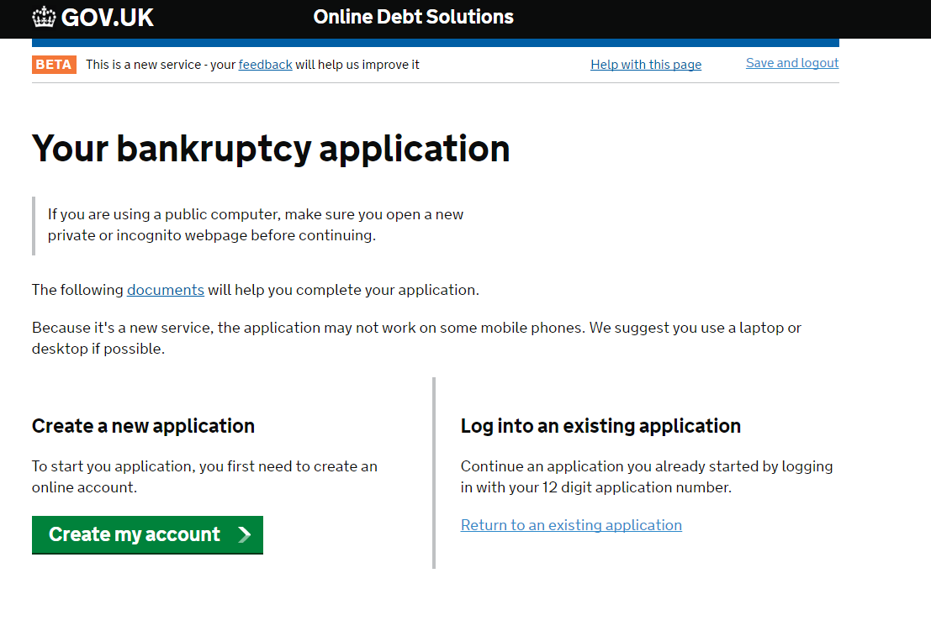
- Creating an account

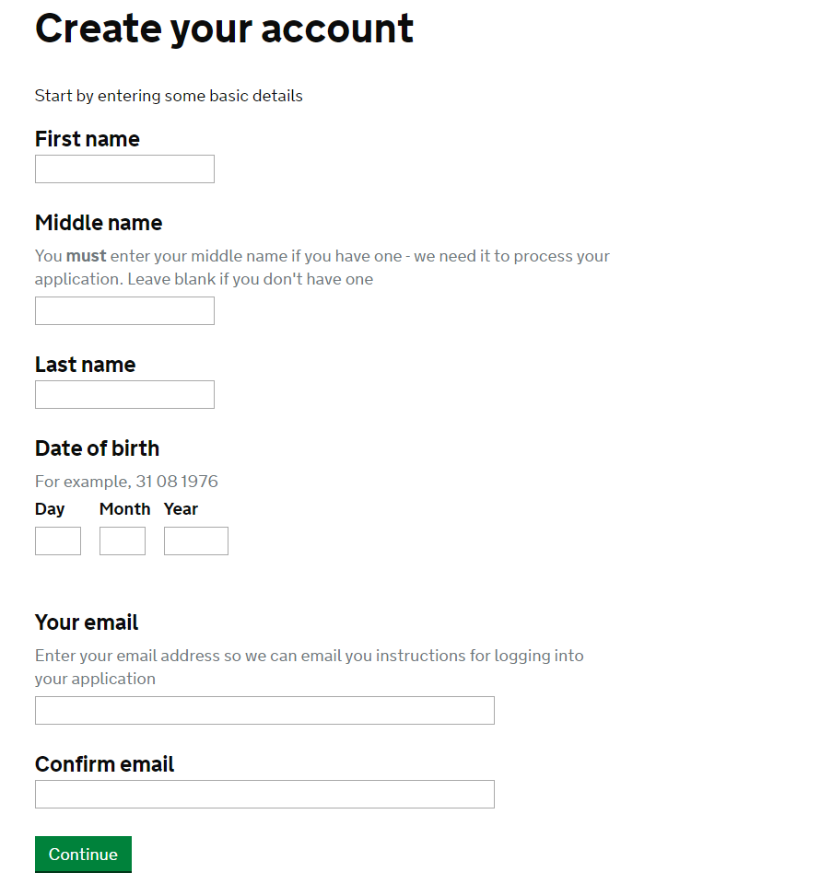

- The application overview page

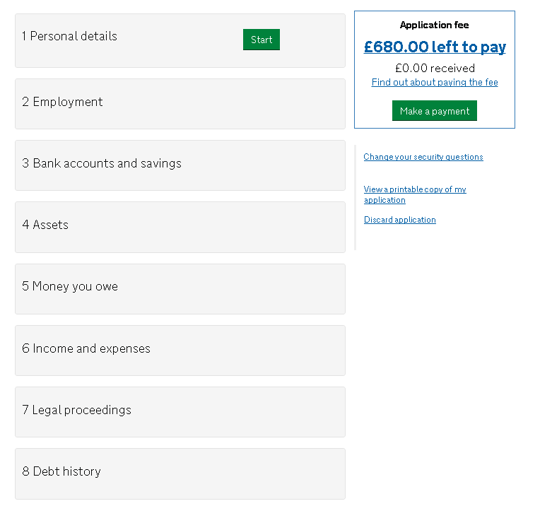

- A summary of the questions asked in the personal details section

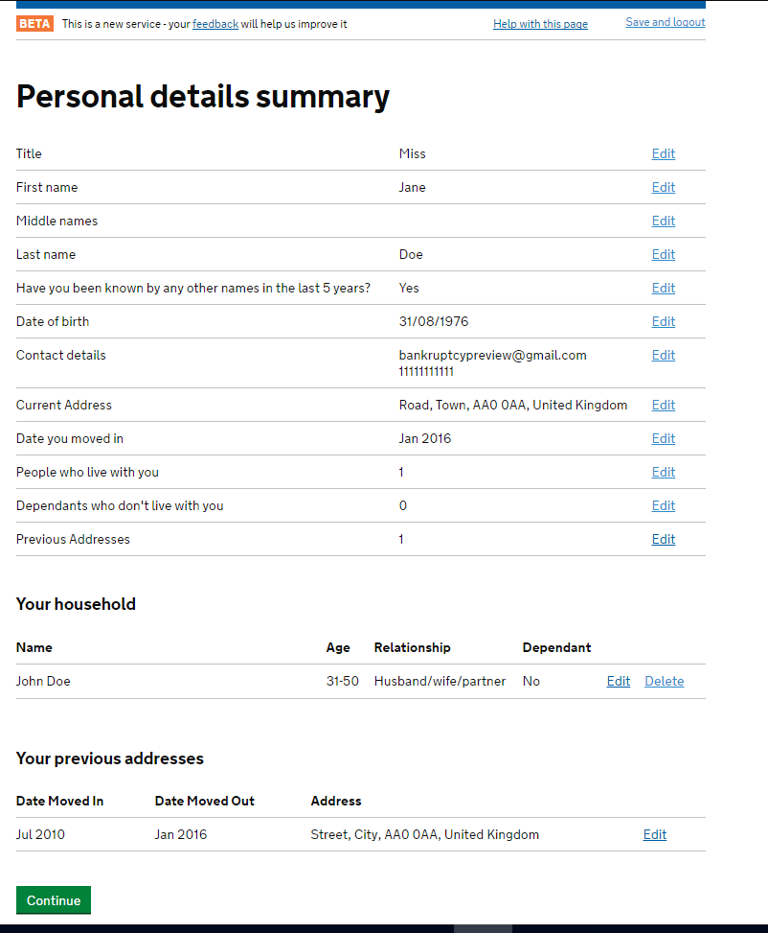

- Employment section overview page

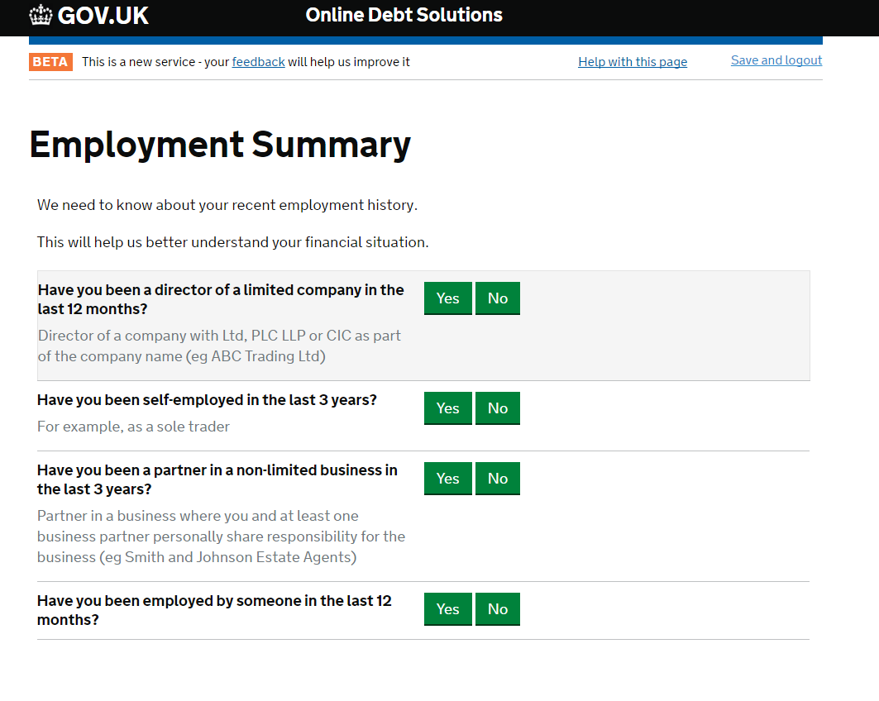

- First page of the bank accounts and savings section

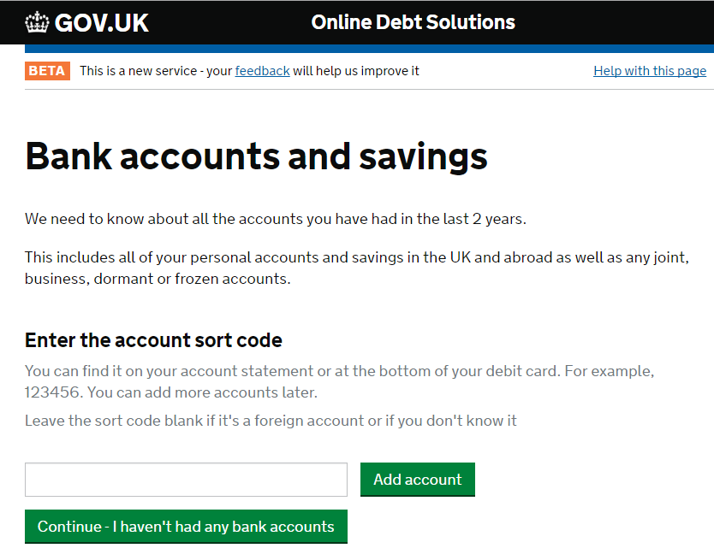

- Bank account details

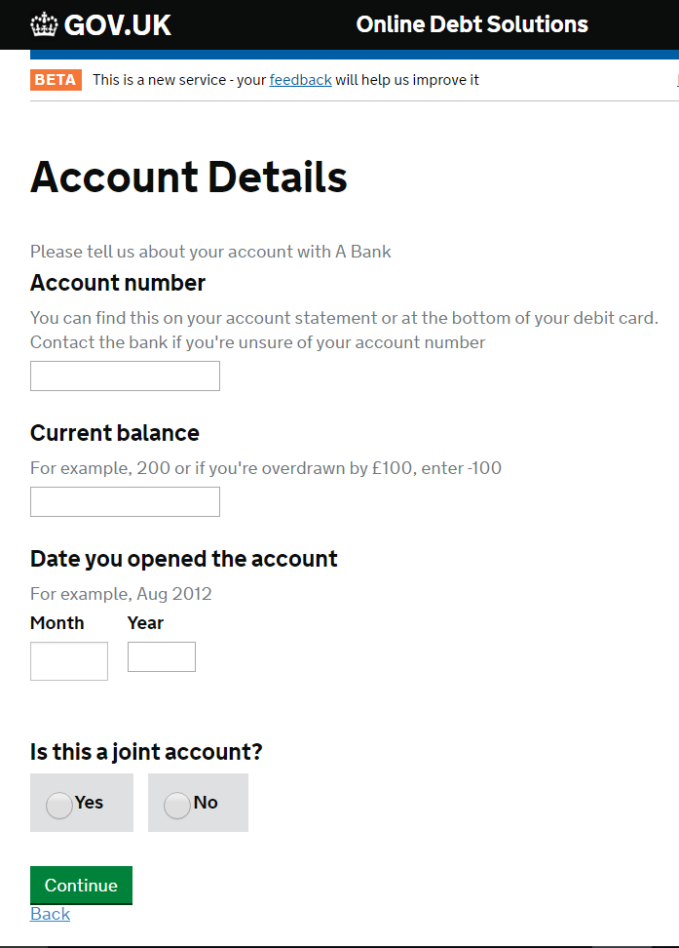

- Assets section overview page

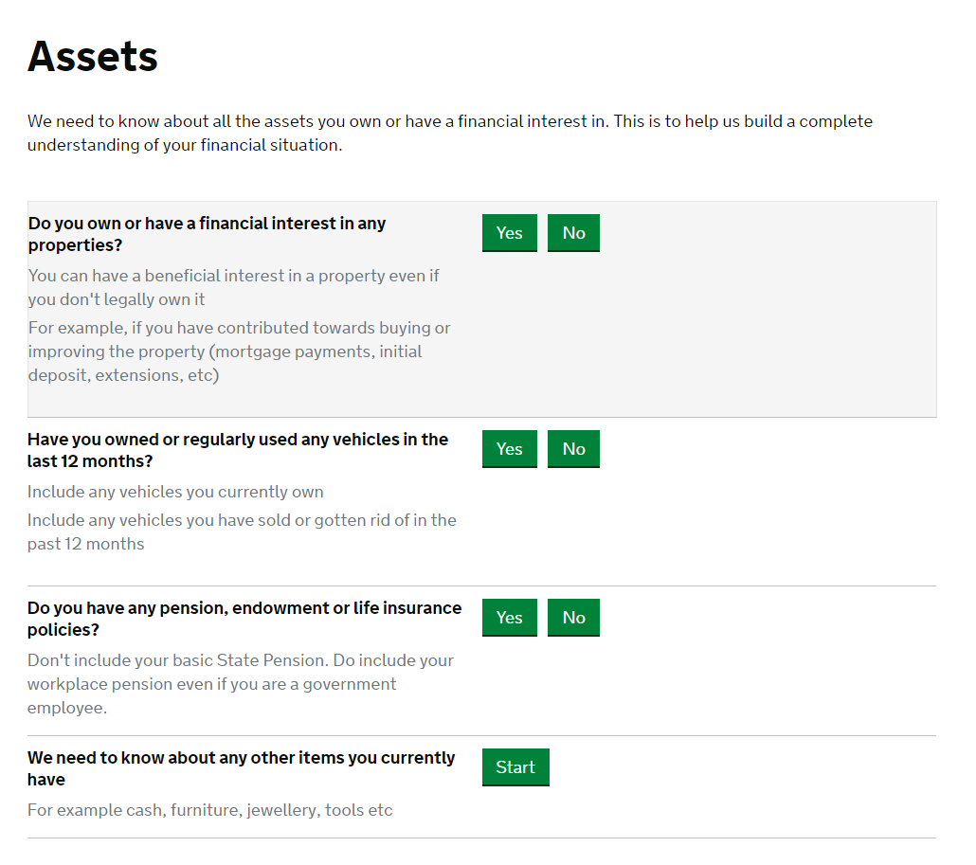

- Your other items overview page

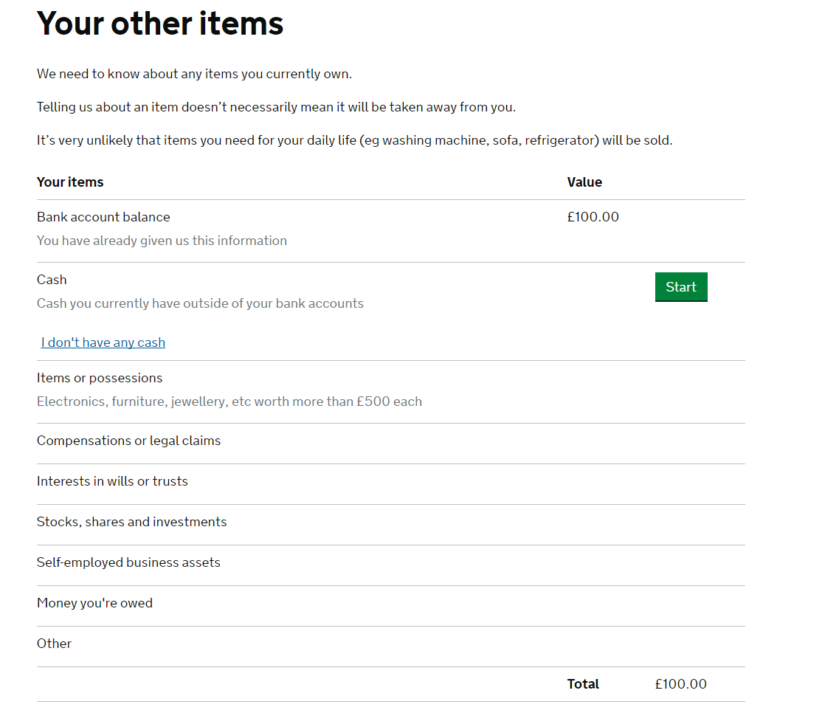

- First page of the money you owe section

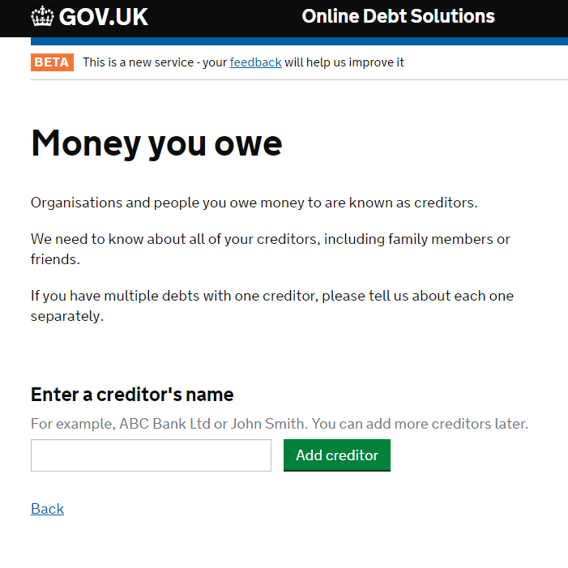

- Amount you owe details

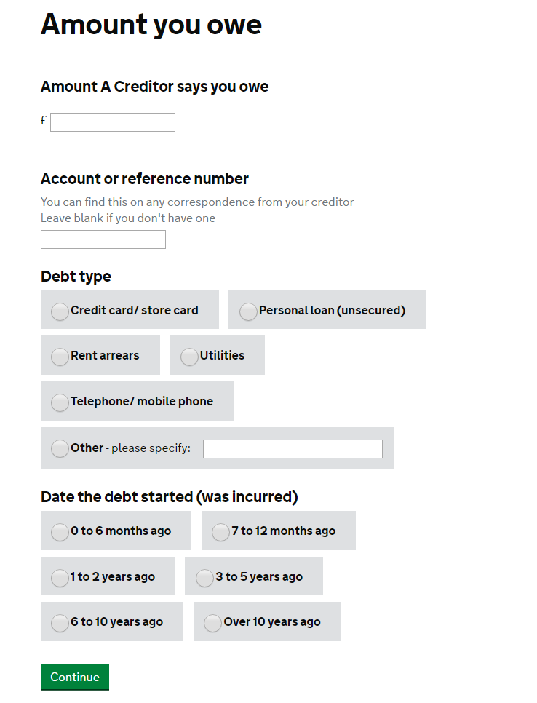

- Income and expenses overview page

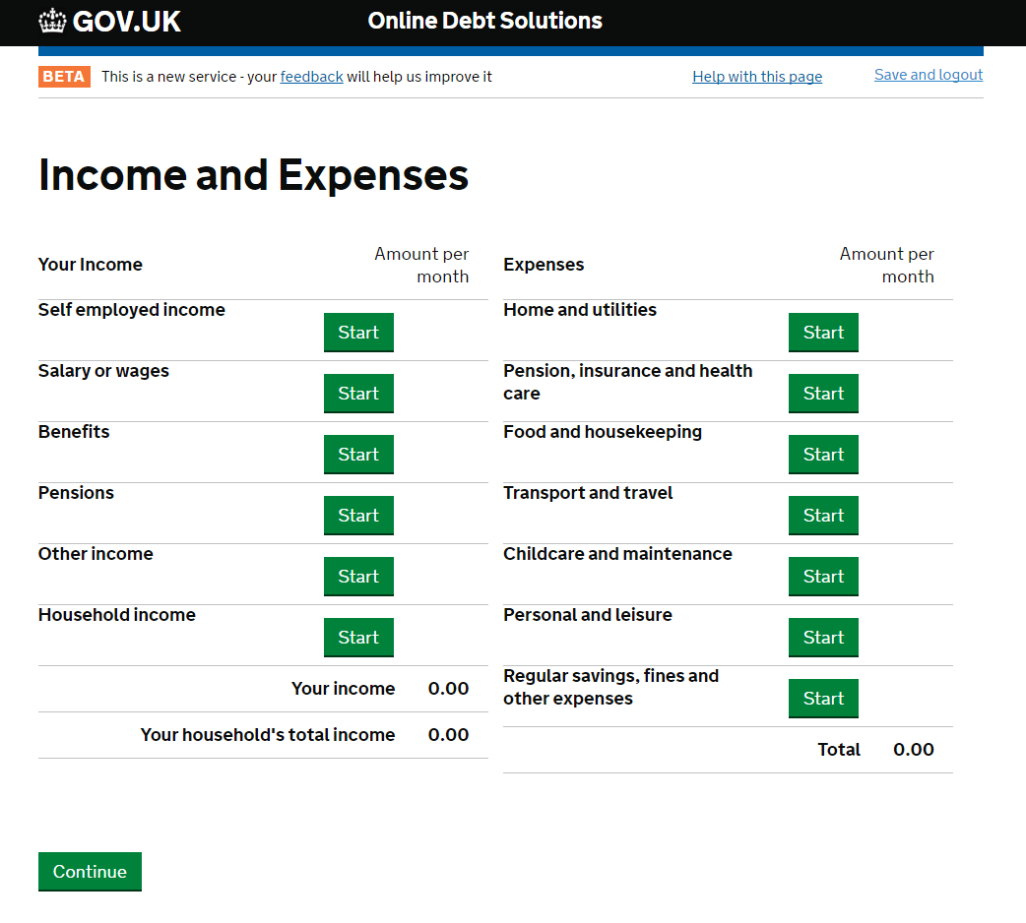

- Legal proceedings overview page

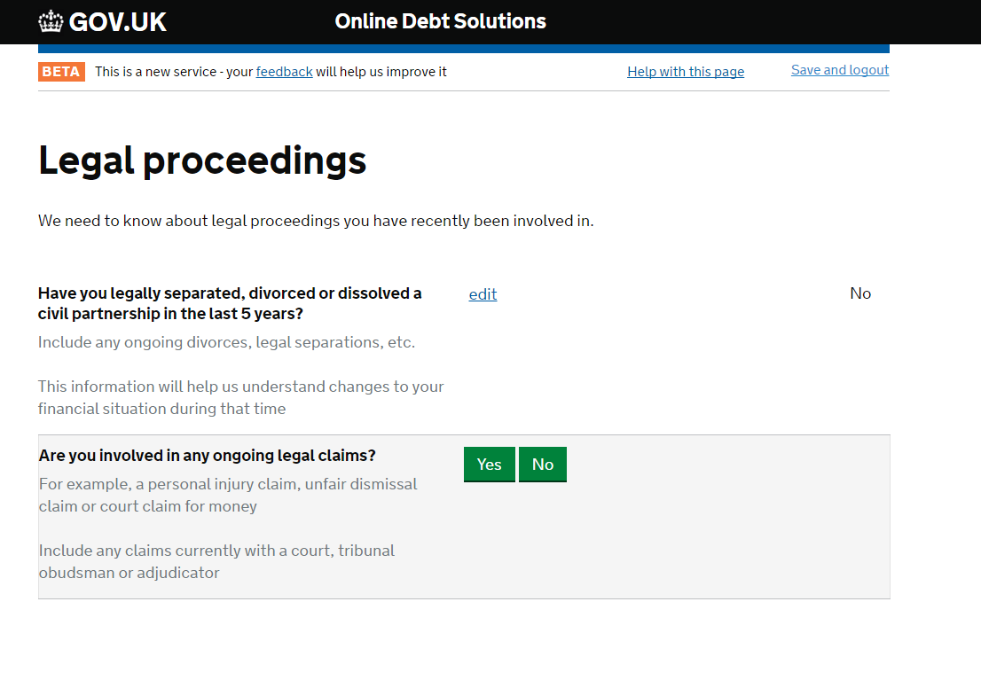

- Debt history overview page

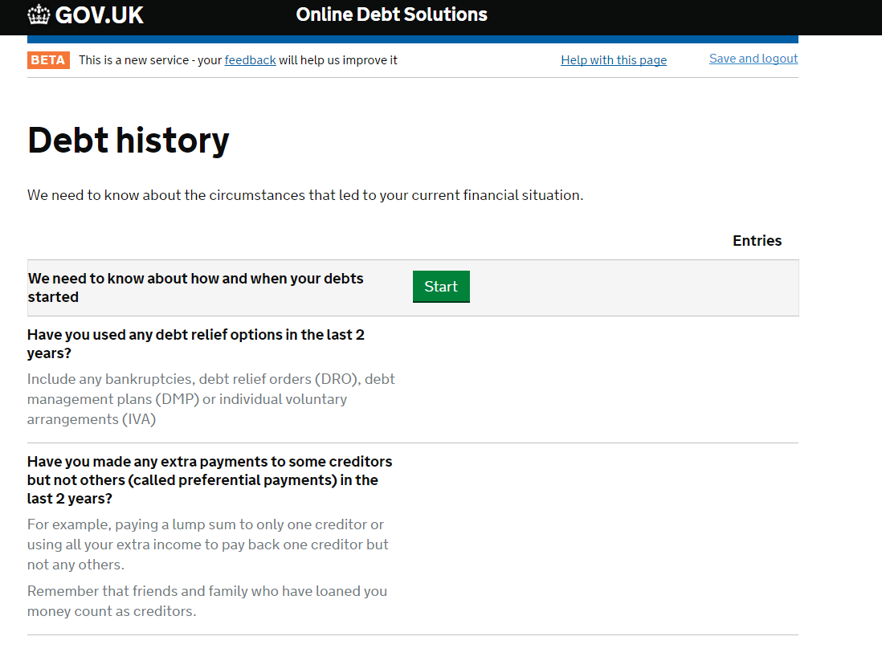

- Make a payment page

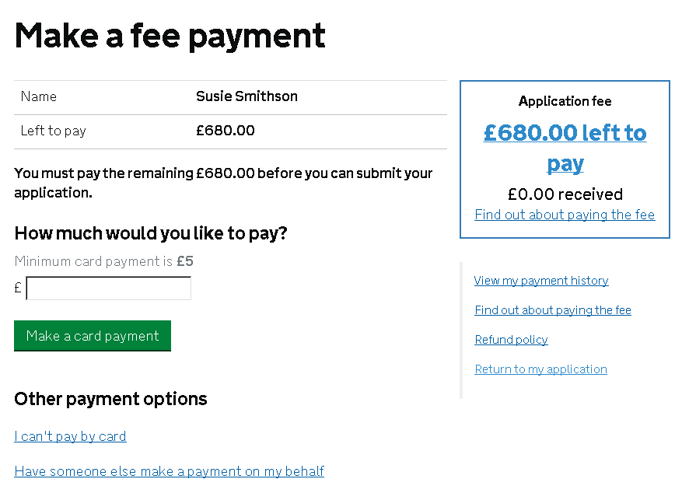
- Have someone else pay on my behalf page
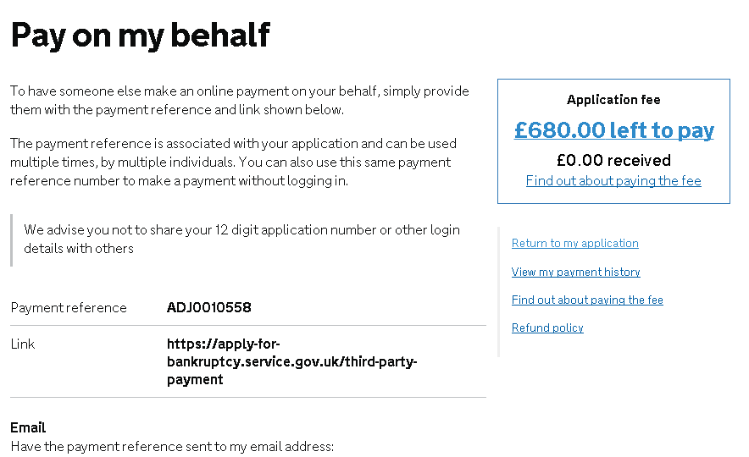
- Cash payment page



