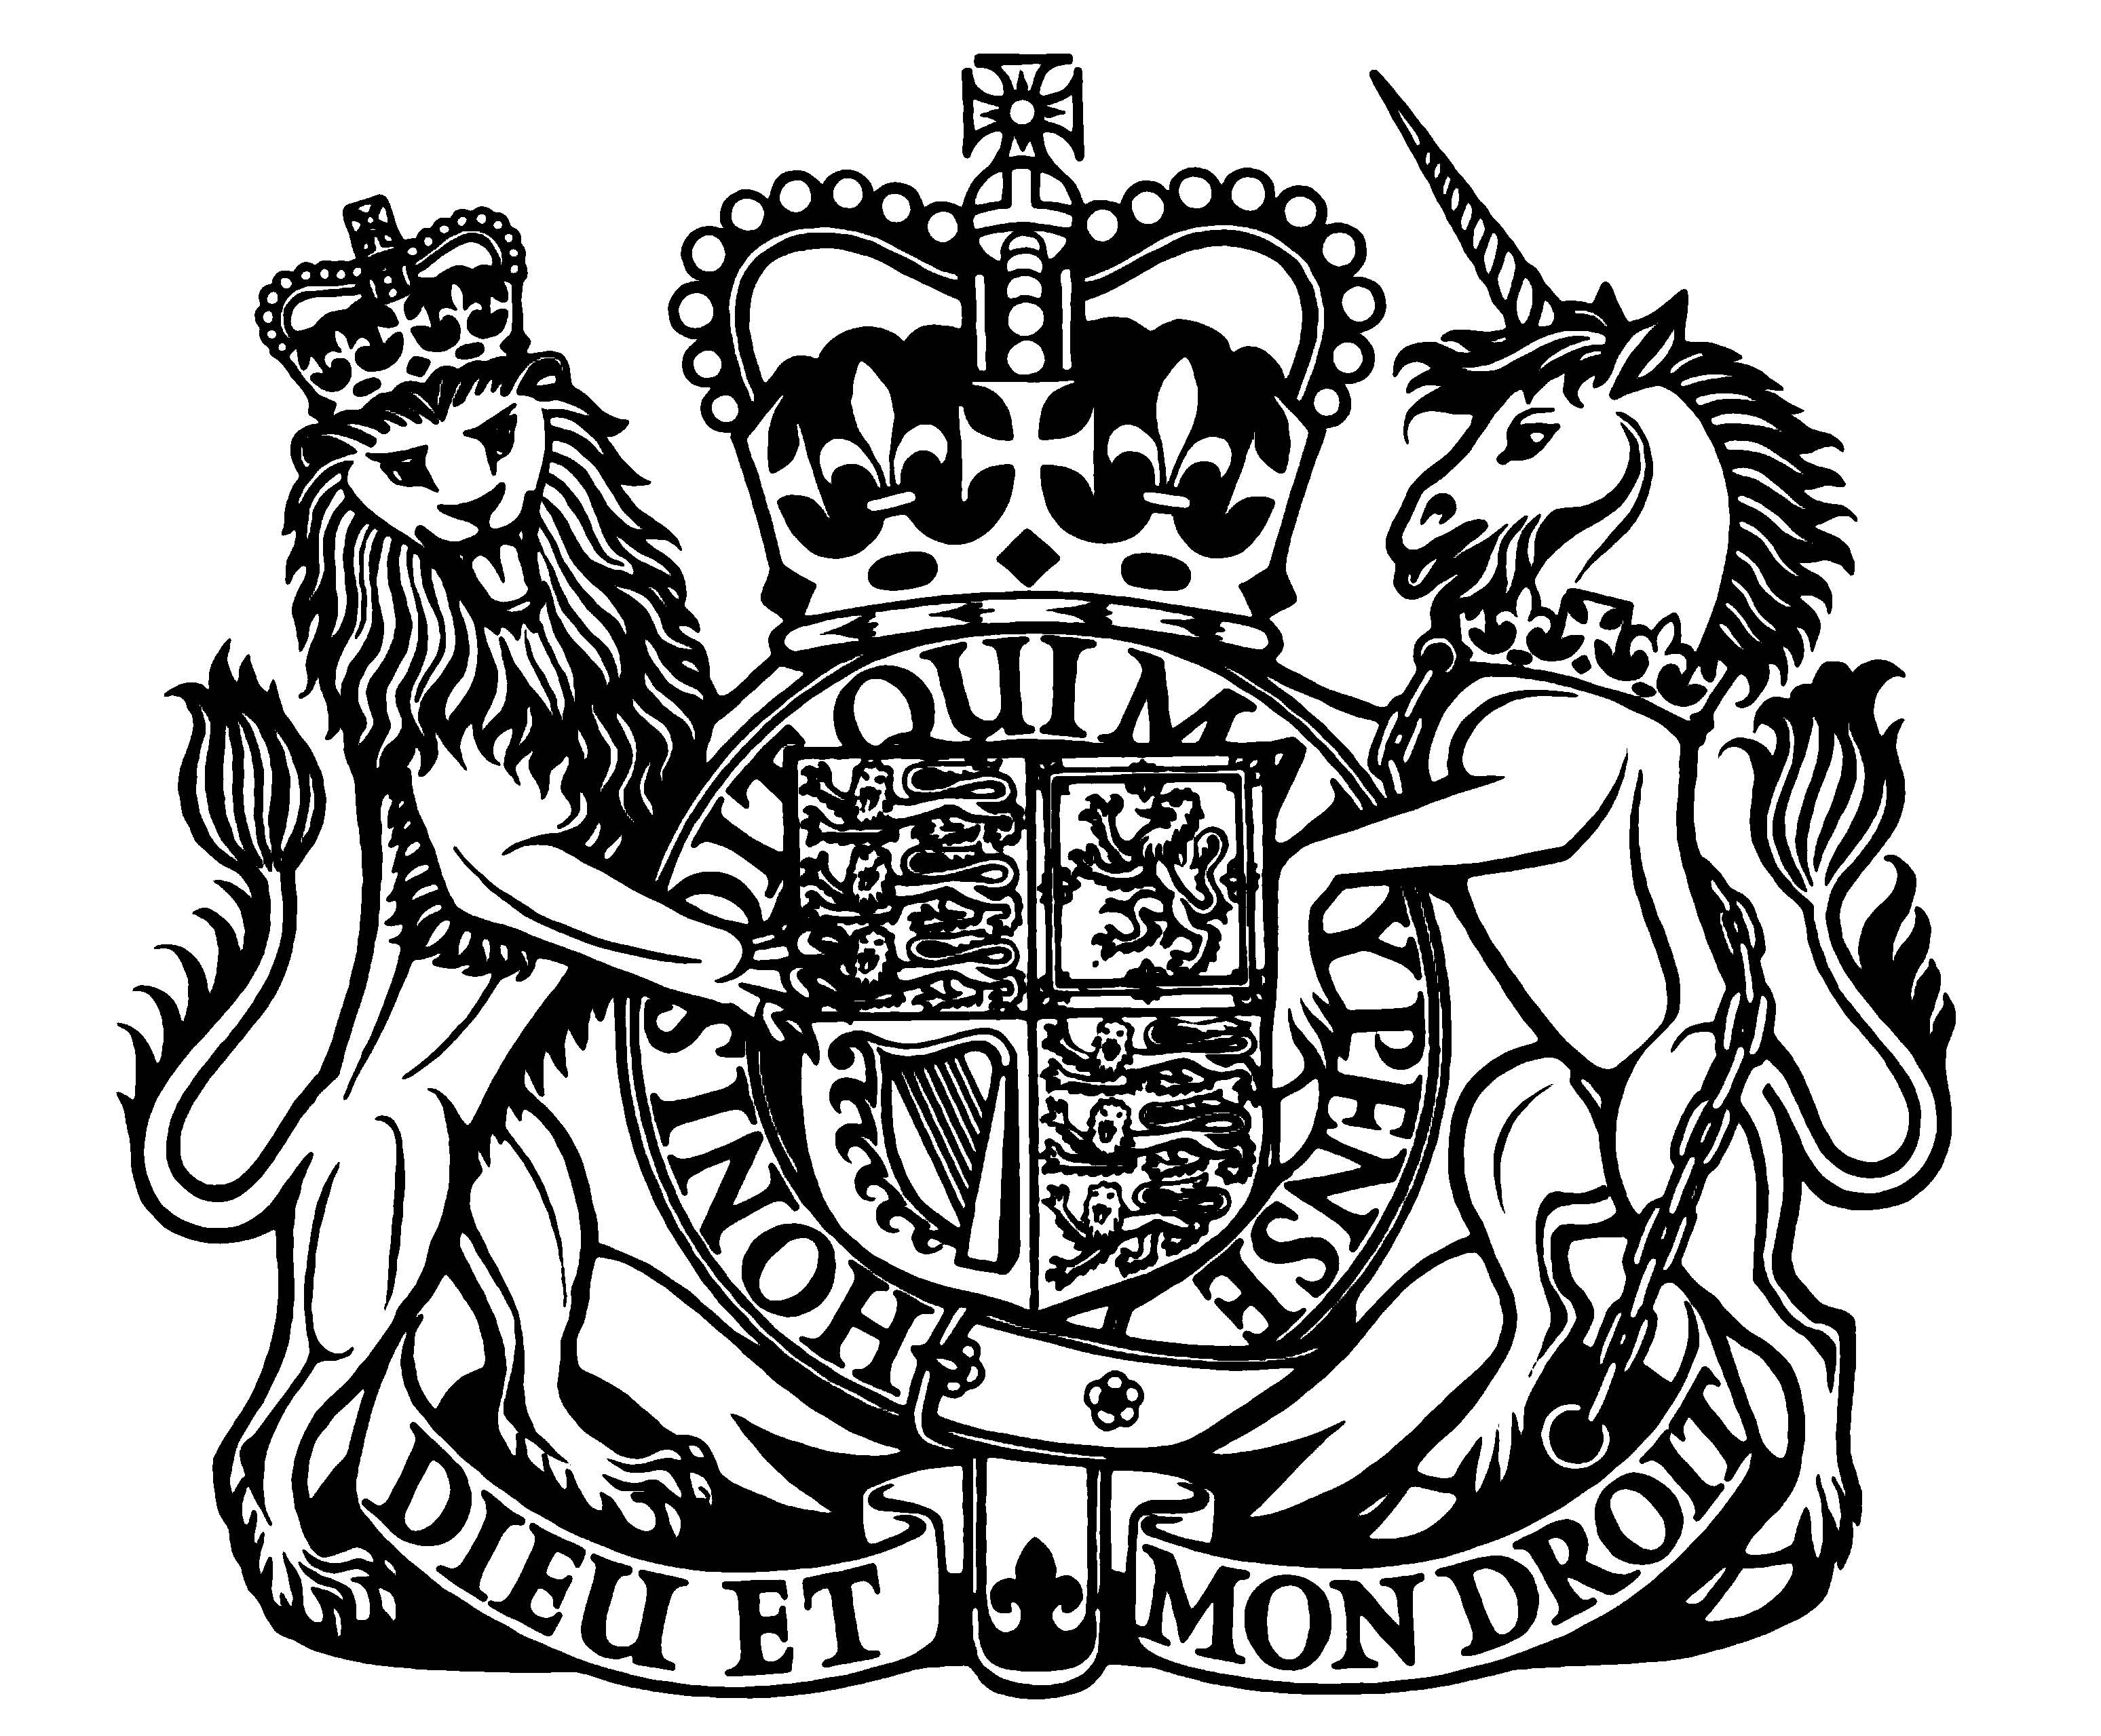
DEPARTMENT FOR CULTURE, MEDIA AND SPORT


BROADCASTING
An Agreement Between Her Majesty’s Secretary of State for Culture, Olympics, Media and Sport and the British Broadcasting Corporation
Presented to Parliament by the Secretary of State for Culture, Olympics, Media and Sport by Command of Her Majesty February 2011
Cm 8002 £6.00
© Crown Copyright 2011
You may re-use this information (not including logos) free of charge in any format or medium, under the terms of the Open Government Licence. To view this licence, visit http://www.nationalarchives.gov.uk/doc/open-governmentlicence/ or write to the Information Policy Team, The National Archives, Kew, London TW9 4DU, or e-mail: psi@nationalarchives.gsi.gov.uk.
Any enquiries regarding this publication should be sent to us at enquiries@culture.gov.uk
This publication is also available on http://www.official-documents.gov.uk/
ISBN: 9780101800228
Printed in the UK by The Stationery Office Limited on behalf of the Controller of Her Majesty’s Stationery Office
ID 2411261 02/11 8302 19585
Printed on paper containing 75% recycled fibre content minimum.
An Agreement Between Her Majesty’s Secretary of State for Culture, Olympics, Media
and Sport and the British Broadcasting Corporation
THIS DEED is made the11th February BETWEEN:
(1) HER MAJESTY’S SECRETARY OF STATE FOR CULTURE, OLYMPICS, MEDIA AND SPORT (“the Secretary of State”) and
(2) THE BRITISH BROADCASTING CORPORATION whose chief officeis at Broadcasting
House, Portland Place, London W1A 1AA (“the BBC”)
THIS DEED WITNESSES that the Secretary of State and the BBC agree with one another as
follows:–
1. Status of this Agreement as a “Framework Agreement” for BBC Charter Purposes
This is a Framework Agreement made for BBC Charter Purposes. It amends the Framework Agreement of July 2006, CM6872 (“the 2006 Agreement”), which has previously been amended by the Framework Agreement of March 2010, CM7853.
2. Amendment of clause 75 of the 2006 Agreement
(1) In clause 75 of the 2006 Agreement, for paragraph (2)(a) (which lists activities for which the BBC may not use sums paid by the Secretary of State out of television licence fee revenue) there shall be substituted—
“(a) those carried on for the purposes of any Commercial Service, any services of a description mentioned in paragraph (7), or any service (apart from the World Service) aimed primarily at users outside the UK;”
(2) Paragraph (3) of that clause (which allows television licence fee revenue to be used for making the World Service available within the UK, and is now unnecessary) shall be deleted.
THE CORPORATE SEAL OF THE SECRETARY OF STATE FOR CULTURE, OLYMPICS, MEDIA AND SPORT
}JEREMY HUNT
affixed to this deed is authenticated as the corporate
(L.S.)
seal of the Secretary of State for Culture, Olympics, Media and Sport by-
ANDREW RAMSAY
}(L.S.)
A duly authorised official in the Department for Culture, Media and Sport
THE CORPORATE SEAL OF THE BRITISH BROADCASTING CORPORATION
is affixed to this deed.
SIR MICHAEL LYONS Chairman
MARK THOMPSON Director-General
Published by TSO (The Stationery Office) and available from:
Online www.tsoshop.co.uk
Mail, Telephone, Fax & E-mail
TSO PO Box 29, Norwich, NR3 1GN Telephone orders/General enquiries: 0870 600 5522 Order through the Parliamentary Hotline Lo-Call 0845 7 023474 Fax orders: 0870 600 5533 E-mail: customer.services@tso.co.uk Textphone: 0870 240 3701
The Parliamentary Bookshop
12 Bridge Street, Parliament Square London SW1A 2JX Telephone orders/General enquiries: 020 7219 3890 Fax orders: 020 7219 3866 Email: bookshop@parliament.uk Internet: http://www.bookshop.parliament.uk
TSO@Blackwell and other Accredited Agents
Customers can also order publications from:
TSO Ireland 16 Arthur Street, Belfast BT1 4GD Tel 028 9023 8451 Fax 028 9023 5401
