Consumer Proposition - Outline Report
Digital Radio Action Plan Report

Our aim is to improve the quality of life for all through cultural and sporting activities, support the pursuit of excellence, and champion the tourism, creative and leisure industries.

Contents
Section 1: Foreword 4
1.1 Introduction 4
1.2 Background to Consumer Proposition Outline Report 4
Section 2: Steering Board Decision 5
Section 3: Consumer Proposition Outline Report 6

- Foreword
  - Introduction

The Market Preparation Group is responsible for making recommendations on the development of a cross-industry strategy to raise public and industry awareness and understanding of digital radio and any future Radio Switchover. The Group’s objectives include the development of a strategic communications plan, monitoring and reporting on digital radio data and research, and developing a compelling consumer proposition for digital radio.
The Group is chaired by Jane Ostler, Communications Director at Digital Radio UK. The Group comprises representatives of DCMS, the Consumer Expert Group (CEG), RadioCentre, the BBC, Ofcom, Intellect, Retra, and the Society of Motor Manufacturers & Traders (SMMT).

  - Background to Consumer Proposition Outline Report

The terms of the Outline Consumer Proposition are set out in task 3.2 of the Digital Radio Action Plan, ‘Consumer Proposition’.
The Outline Consumer Proposition summarises: (i) the work undertaken to develop a consistent way of communicating digital radio, and (ii) the steps required to strengthen the existing range of benefits and communicate these to consumers.
The Outline Plan was agreed by the Market Preparation Group in September 2011.
- Steering Board Decision
The Consumer Proposition Outline Report was considered by the Steering Board in September 2011. The Board agreed with the recommendation that, if possible, further research should be conducted around the content proposition.
The Board in particular noted the research within the report showing how consumers interact with digital radio and how it may be possible to strengthen that interaction.
Overall the Board agreed that the report helped illustrate the proposition currently on offer to consumers regarding Digital Radio, and where that offer needs to be strengthened.

- Consumer Proposition Outline Report
- DIGITAL RADIO ACTION PLAN TASK:
“Working with industry, set out a compelling consumer proposition for digital radio, including benefits, consistent description of the range of services, functionality and receivers.”
This work has a number of strands:
- For the purpose of optimising communications (with the aim of building awareness and understanding of the benefits of digital radio);
- To help to strengthen the digital radio proposition (ensuring that the development of digital radio product features, and the content proposition, are matched with consumer expectations).

- COMMUNICATIONS PROJECT:
This is important and timely work because there has never been consistent industry messaging about digital radio to consumers from industry as a whole: broadcasters, manufacturers and retailers.
Public information that presents digital radio in a consistent way is important to build awareness and understanding of the benefits. We need to understand what messages are compelling and motivating for a broad range of consumers, and also the hierarchy of that messaging and how it should be tailored for different audiences (e.g. non-digital listeners, vehicle purchasers).
An initial project has been undertaken with Digital Radio UK and the BBC working with a strategic agency. The agency was asked to review all current research and develop proposition areas which would resonate with consumers and could result in consistent industry-wide communications.
- To drive awareness of the benefits of listening to the radio via digital means
- Create a framework for the consistent communication of these benefits that drives clarity and encourages behavioural change
The brief set by DRUK and BBC to the agency was to answer the consumer question: “What is digital radio and what will it do for me?”

A development process was agreed, to include relevant stakeholders (below).

The agency reviewed all existing consumer research on benefits and features of digital radio, and has developed some areas for testing. The result will be a consistent message idea, to be used in consumer communications campaigns, at retail, and at vehicle retail.
Research shows that people love digital radio if they have it already, but if they don’t have digital radio, they do not understand the benefits.
A stakeholder workshop was held on 12 July to refine these ideas in preparation for consumer research. A wide range of stakeholders was invited: manufacturers, retailers, representatives from BBC, marketing representatives from commercial radio.
Focus groups were held in three UK locations with a range of age groups and radio listening habits (analogue listeners, new digital listeners and experienced digital listeners), to find out which proposition territory was most motivating, and which could encompass the broadest range of benefits.
In summary, the research found:
- For non-digital listeners there was some awareness of the benefits but motivation was needed.
- Digital listeners highlighted more choice and ease of use as key benefits.
- Sound quality was cited as a benefit by all groups – but interestingly, described in emotional terms in relation to content (‘like being part of the conversation’);
- “Radio Comes Alive” was the proposition area which was most motivating to all groups (including listeners and non-listeners), and could encompass the broadest range of benefits. It suggested the benefits of better sound quality but also communicated the benefits of choice and advanced features.
- It also strikes the right tone: to the respondents the phrase gave the sense of a re-launch for digital radio, rather than a revolution, as well as having the potential to drive digital listening - motivating listeners and non-listeners alike [See Appendix 1].
Based on this work, the BBC and DRUK are in the process creating an agency brief (to be shared with stakeholders) with the intention of agreeing a communications approach for a campaign to launch in Q4 2011. This campaign will run until a Government decision in mid-2013. This approach will also involve a hierarchy of messaging in relation to benefits which can be used by the whole industry in communications – in advertising and point of sales. It will talk about the benefits of digital radio in a consistent way, with targeted messages for different consumers as appropriate. This work is industry-led.
This consumer proposition work will also form the basis of publicly-funded consistent messaging with regard to the benefits of digital radio, in the lead-up to switchover.
- RANGE OF SERVICES
Digital radio offers listeners the FM stations they currently have, plus digital versions of FM stations, and digital-only stations. In most areas of the UK listeners can get around 20 additional stations on digital than on an analogue radio. However, there is a lack of awareness of the additional stations available.
Research conducted for the NGW/Channel 4 bid for the D2 multiplex in 2007 found that there was consumer appeal for specialist and niche services on DAB.
DCMS research for the Cost Benefit Analysis conducted in March 2011, covered consumers’ radio ownership, listening habits and attitudes towards digital radio, showed that consumers valued the breadth of choice (number of stations added to speciality stations) very highly – together these were valued at £9.55, only just below sound quality (see page 5).
The research also showed that less than half (49.9%) of non-digital listeners agreed that digital radio had more stations of interest (see charts below).

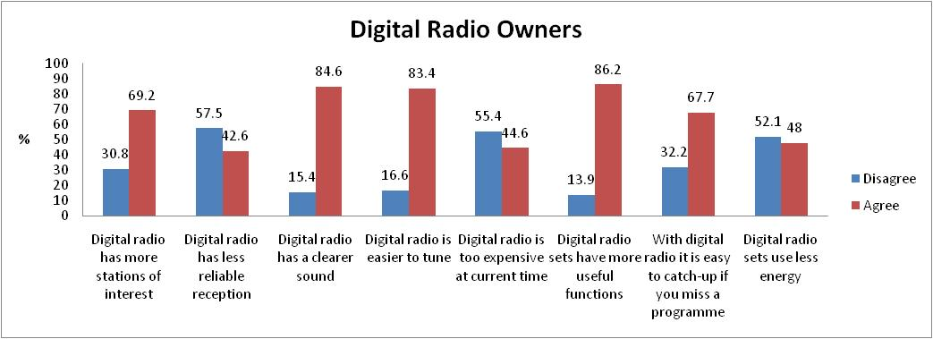
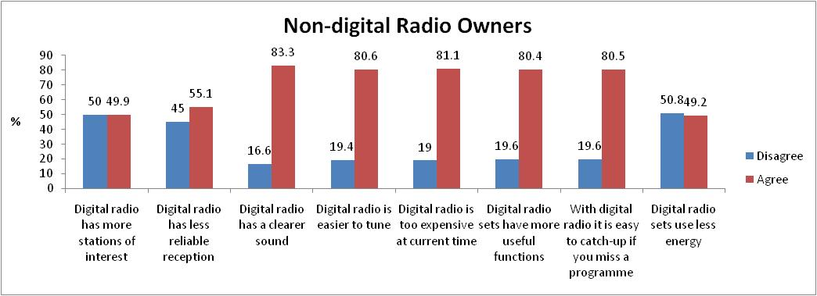

(source: DCMS Research – Digital Radio Switchover: Consumer Research to support the Cost Benefit Analysis: London Economics/YouGov, March 2011)
While there is a very wide choice of general and specific music stations it should be noted that there are currently no national dedicated DAB stations which offer:
- Dedicated country, folk, and world music stations;
- ‘Must-have’ digital-only sports programming e.g. Championship coverage (Sports is a known motivator for digital conversion, like the Bundesliga on digital radio in Germany);
- Dedicated childrens’ radio station (FunKids is on London DAB and online, and Radio 4 Extra offers family programming during certain hours);
- National 24-hour news station (the equivalent of BBC News or Sky News on the radio) to cover breaking stories and in-depth news;
- National non-English stations;
- Nor is there a dedicated comedy offer (like Comedy Central on TV) or arts programming.
This is by no means an exhaustive list. More research is necessary to understand whether listeners perceive there to be content offer gaps; discussions with the broadcasters as to the commercial viability of any such services; and with Government and Ofcom to understand if any regulatory changes might be required.
- TECHNOLOGY DEVELOPMENTS: FUNCTIONALITY AND RECEIVERS
In order to inform industry developments it is important to understand consumer views about what they expect from digital radio. Recent research is highly informative in this respect, including the DCMS Consumer Research to inform the Cost benefit analysis conducted in March 2011.
Consumers’ willingness to pay for the attributes of digital radio was explored. One of the attributes for digital radio was “you can listen live, and pause/rewind broadcasts using your radio set.” Excepting sound, pause and rewind functionality was the most highly-valued attribute by all age groups. Older age groups (60-69 and 70+) valued this functionality more than the average. In addition pause and rewind functionality was more valued by lower socio-economic groups than the average (see table from DCMS research below).
Table 2: WTP for the attributes of digital radio (£)
 | D1:  Tuning | D2:  Information display | D3:  Pause/ rewind | D4:  Number of stations | D5:  Speciality stations | D6:  Sound
All consumers | 6.34 | 7.22 | 7.82 | 5.80 | 4.75 | 9.88
By age group:
18-29 | 5.65 | 6.62 | 6.78 | 5.99 | 5.37 | 7.64
30-39 | 6.74 | 7.41 | 7.55 | 6.49 | 5.95 | 8.76
40-49 | 6.25 | 7.24 | 8.05 | 6.38 | 4.76 | 10.12
50-59 | 6.71 | 7.28 | 8.27 | 5.66 | 3.97 | 11.25
60-69 | 6.66 | 6.54 | 7.84 | 4.28 | 2.56 | 10.99
70+ | 5.27 | 7.37 | 8.47 | 3.46 | 3.16 | 12.64
By gender:
Female | 5.40 | 6.94 | 7.55 | 5.05 | 4.05 | 9.68
Male | 7.28 | 7.53 | 8.11 | 6.59 | 5.48 | 10.10
By socio-economic group:
Upper middle | 6.74 | 6.41 | 7.61 | 4.77 | 4.08 | 9.42
Middle | 6.75 | 7.22 | 7.84 | 5.66 | 4.55 | 9.74
Lower middle | 6.51 | 7.21 | 7.49 | 6.32 | 5.23 | 9.13
Skilled working | 5.55 | 6.63 | 6.59 | 5.52 | 4.66 | 8.48
Working | 5.25 | 7.32 | 8.33 | 5.39 | 4.00 | 10.91
Lowest | 5.70 | 7.12 | 8.52 | 5.07 | 4.36 | 11.36
By region:
Rural | 6.94 | 7.59 | 9.32 | 5.38 | 4.37 | 12.41
Town/ fringe | 6.49 | 6.48 | 7.63 | 5.50 | 4.71 | 9.45
Urban | 6.20 | 7.22 | 7.62 | 5.87 | 4.78 | 9.61
By ethnicity:
Not white British | 5.57 | 6.74 | 6.79 | 5.32 | 5.49 | 8.76
White British | 6.48 | 7.32 | 8.01 | 5.90 | 4.62 | 10.11

Only a small proportion of currently available digital radios currently offer this functionality:
- Pure: 6 out of 21 radios
- Roberts: 5 out of c. 40 radios

There is also an opportunity to develop common terminology across the industry (in communications and on radio sets) about key features such as pause, rewind and record, ultimately leading to a proposed ‘digitalradio+’ mark. These features are desirable and so should become more prevalent, and should be actively promoted by industry.
This is currently under discussion with radio manufacturers and will help to build consumer understanding of the features. This work should ultimately result in a consistent roadmap for digital radio.
- NEXT STEPS
Further research is required on any content gaps that could strengthen the digital radio proposition and be commercially viable for industry. It is proposed that this research is conducted by DCMS in early 2012 as part of the Cost Benefit Analysis, to be communicated with industry in the lead-up to the Government decision on switchover.
More discussion with industry is required on how to present technology developments to consumers (eg pause, rewind and record, EPG). These discussions have been initiated and the first meeting to discuss with Intellect’s Digital Radio Group is on 29 September.

APPENDIX 1: CONSUMER PROPOSITION SUMMARY OF RESEARCH

