INDEPENDENT RECONFIGURATION PANEL

MEMBERSHIP

All Panel members are public appointees.

Chairman
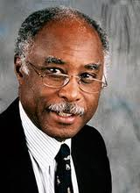 | Bernard Ribeiro is a former consultant surgeon at Basildon University NHS Trust where he was a pioneer in the introduction of several ground-breaking procedures, notably the use of keyhole surgery. He served as President of the Royal College of Surgeons from 2005 to 2008 and has been a major participant in the restructuring and modernisation of surgical training and the introduction of a new surgical curriculum for all surgical trainees in the UK. He was made a life peer in 2010 sitting on the Conservative benches and is also Chairman of the Research Review Panel, Pelican Cancer Foundation.

Members
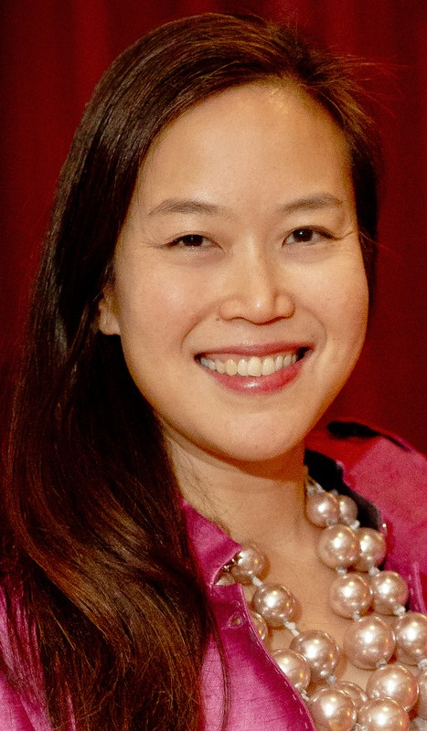 | Shera Chok is a GP in east London and Medical Director for Tower Hamlets GP Care Group. In a diverse career, she has also been Associate Medical Director at Derbyshire Community Health Services NHS Foundation Trust, Director of Primary Care at Barts Health NHS Trust and Medical Director for NHS Lambeth. She has undertaken international humanitarian aid roles in Sudan, Laos, Greece and Indonesia. Shera is a clinical member of the Panel.
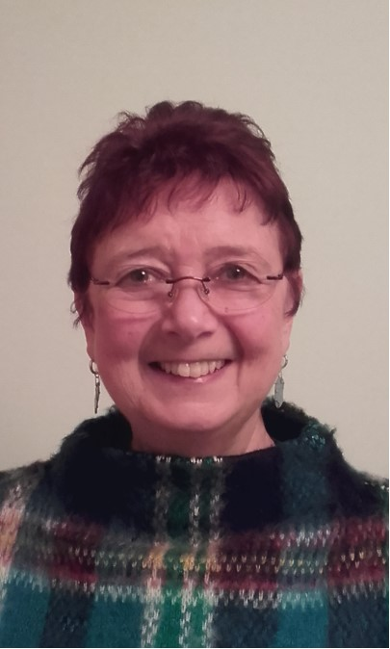 | Diane Davies worked in senior management posts in the NHS before leaving to care for members of her family living with complex medical conditions, disabilities and mental health issues. She now works as an “expert by experience”, supporting Care Quality Commission inspections. She is a volunteer patient and carer representative with the NHS Leadership Academy and with local health and social care initiatives, including Sheffield’s Citizen Reference Group. Diane is a lay member of the Panel.
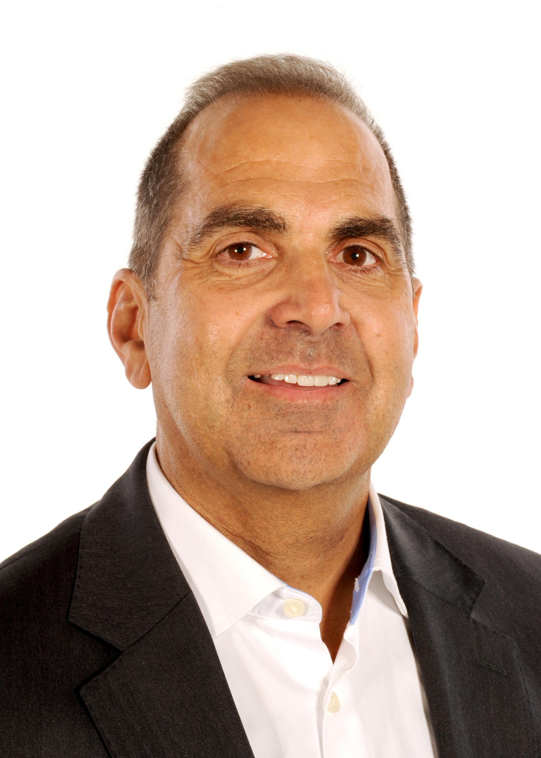 | Stephen D’Souza is a consultant in vascular and non-vascular interventional radiology at Lancashire Teaching Hospitals NHS Trust. He is the interventional radiology lead for the reconfiguration of vascular services in the Lancashire and Cumbria network. He is a member of the Royal College of Radiologists and sits on the College’s Clinical Radiology Service Review Committee and Professional Support and Standards Board. He is also a member of the British Society of Interventional Radiologists. Stephen is a clinical member of the Panel.
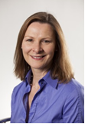 | Mary Elford is Vice Chair of East London NHS Foundation Trust which provides mental health and community services. She is a non-executive director of Health Education England, a lay council member of the General Pharmaceutical Council and also sits on the National Advisory Committee for Clinical Excellence Awards. She previously worked for the John Lewis Partnership in a range of senior roles. Mary is a lay member of the Panel.
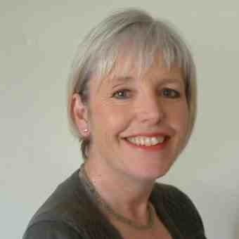 | Rosemary Granger has been a leadership coach and independent consultant since 2010 working with the NHS and local authorities. In 19 years NHS service before that, she gained provider, commissioner, health authority and strategic health authority experience at director level. She is a trustee for Mental Health North East, a third sector mental health umbrella organisation. Rosemary is a managerial member of the Panel.
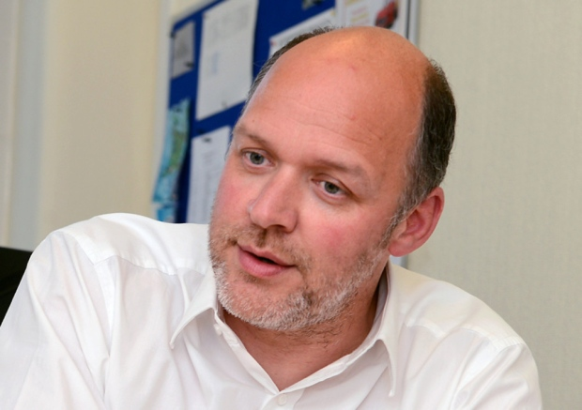 | Simon Morritt is Chief Executive of Chesterfield Royal NHS Foundation Trust. Simon joined the NHS in 1989 and held posts in Manchester, Wakefield and Doncaster before becoming Chief Executive of Doncaster Primary Care Trust (PCT) in 2000. He went on to become Director of Performance at West Yorkshire Strategic Health Authority and then Chief Executive of Bradford and Airedale Teaching PCT and Sheffield Children’s NHS Foundation Trust before taking up his current post. Simon is a managerial member of the Panel.
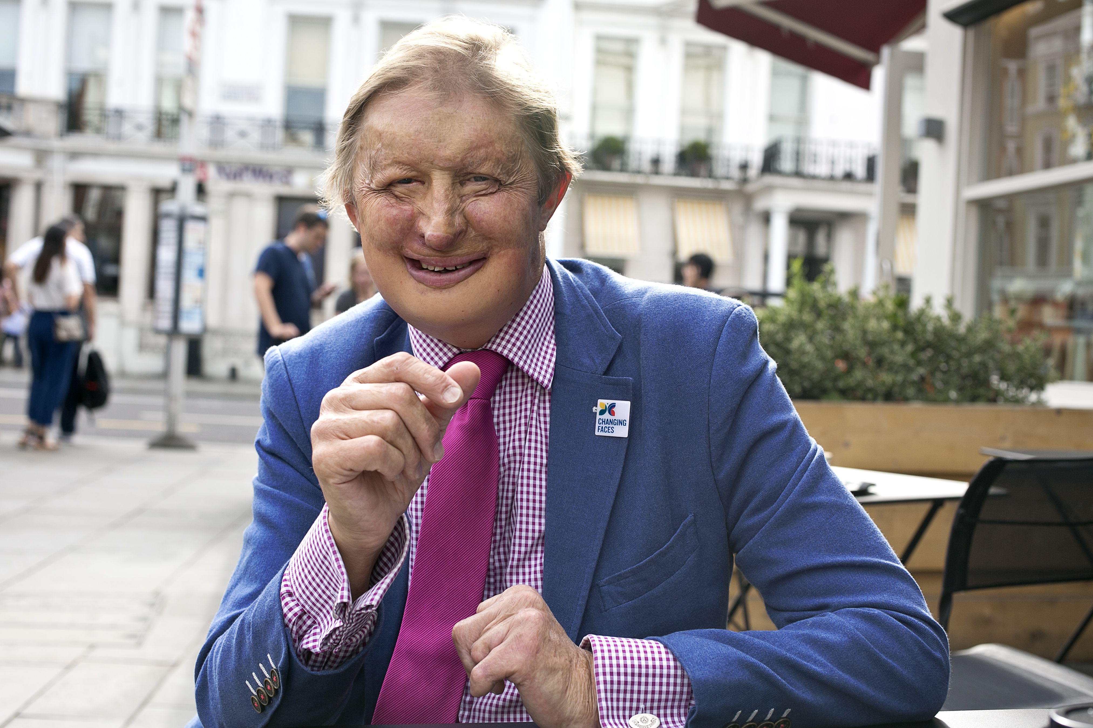 | James Partridge is the founder and was, until September 2017, Chief Executive of Changing Faces, the UK charity supporting and representing people with disfigurements. Before setting up Changing Faces, James worked as a health economist in public health in the NHS and then followed business and academic interests. He served as a Lay Member on the first Appraisal Committee of NICE and chaired the NHS Equality Awards. He is also a Director of Dining with a Difference, a disability consultancy company. James is a lay member of the Panel.
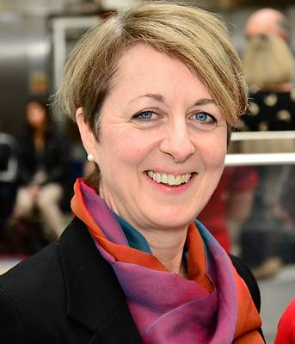 | Zoe Penn is executive Medical Director of Chelsea and Westminster Hospital NHS Foundation Trust. She is a consultant obstetrician and previously served on the expert panel for the Kings Fund report Safer Births and with the National Clinical Governance Support team. She sits on the London Clinical Senate and North West London Clinical Board. Zoe is a managerial member of the Panel.
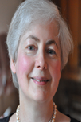  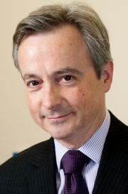 | Linn Phipps is an independent consultant with a specialist interest in patient and public engagement, effective health scrutiny by local government and addressing health inequalities. She chairs NHS England’s Stakeholder Forum for Patient Online and is a member of its Digital Transformation in Primary Care Domain Board. She is Deputy Chair of Healthwatch Leeds, serves on two NICE committees, and has over 17 years’ experience as a NED/Chair in NHS primary care and secondary mental health services. Linn is a lay member of the Panel.  Anthony Schapira is a consultant neurologist and Head of the Department of Clinical and Movement Neurosciences at University College London (UCL). He is Professor of Neurology at the National Hospital for Neurology and Neurosurgery and at the Royal Free London Hospital. He is Vice Dean of UCL and the Director of the Royal Free Campus as well as leading a large programme of research into Parkinson’s disease. Anthony is a clinical member of the Panel.
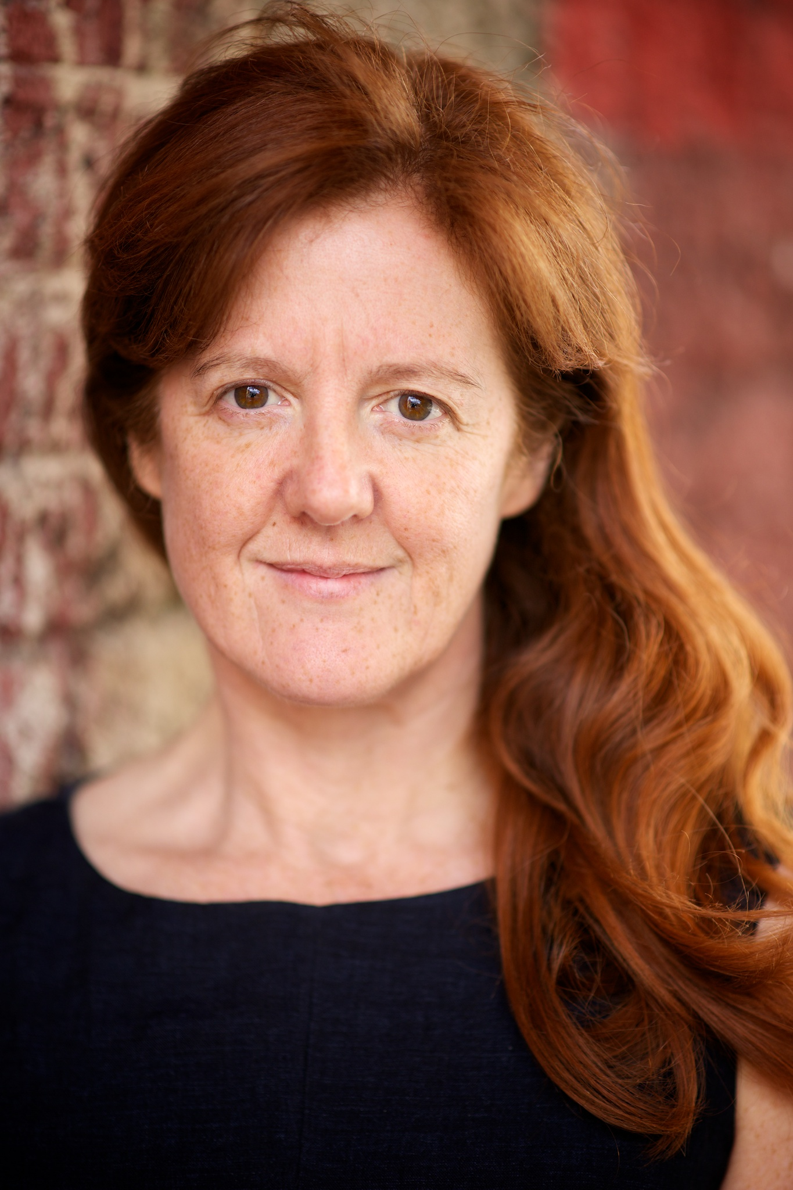 | Suzanne Shale is an independent consultant in healthcare ethics, patient safety and healthcare leadership. She has many years of experience presenting lay views about priorities for healthcare having worked with a number of prominent medical bodies including NHS England, the Academy of Medical Royal Colleges and the General Medical Council. She is a trustee of Action Against Medical Accidents and a member of the Advisory Panel of the Healthcare Safety Investigation Branch. Suzanne is a lay member of the Panel.
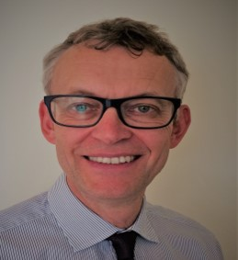 | Mark Taylor stepped down as Chief Officer of NHS North Norfolk CCG in 2016 having spent over 30 years in variety of senior leadership roles in the NHS. He now works part time for a GP Federation as well as delivering training events for clinicians moving into management roles. His previous posts include a large mental health trust and working jointly for a PCT and county council on the integration of NHS and social care. He is a volunteer for Age UK, the National Carers Trust, as well as being a Trustee of Julian Support, a major mental health provider in East Anglia. Mark is a managerial member of the Panel.
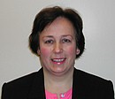  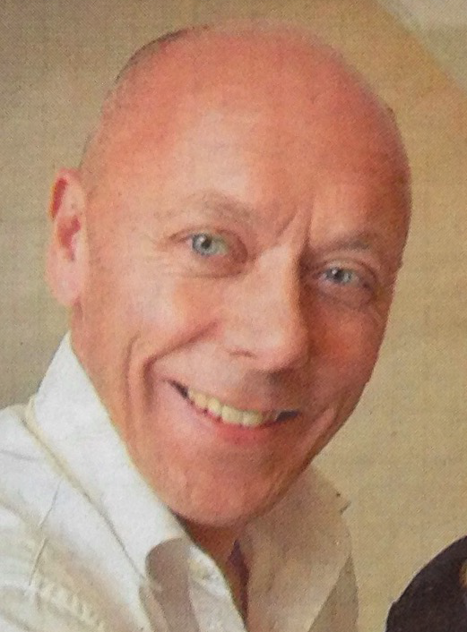 | Helen Thomson has 38 years’ experience in the NHS including 20 years at board level as a chief nurse and latterly as deputy chief executive. She has experience of acute, community, maternity and mental health services. She is currently interim CEO at Stockport NHS Foundation Trust. She is an associate of the Florence Nightingale Foundation, a university governor and a trustee of a local charity caring for severely disabled adults. Helen is a clinical member of the Panel.  Miles Wagstaff is a consultant paediatrician and neonatologist at Gloucestershire Hospitals NHS Foundation Trust where he was Clinical Director and then Specialty Director for Children’s Services for five years and is now the lead clinician for planned care. He is a member of the NICE Guideline Development Group and Expert Advisors Panel and a member of the South West Clinical Senate. He is also a member of the executive board for the South West Neonatal Network. Miles is a clinical member of the Panel.
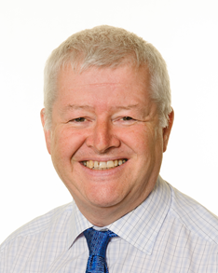 | John Wilderspin is a former NHS chief executive with extensive experience as a provider and commissioner of health services. He has led a number of large national programmes, working with clinicians, patient representatives, NHS organisations and local government to improve services and develop leadership skills. John has a particular interest in joint working between the NHS and local government to deliver more integrated services. He now works as a coach and consultant, and is a Governor of Treloars’, a nationally regarded school and college for physically disabled young people. John is a managerial member of the Panel.

Appointed through an open process of advertisement, sifting, interview and Ministerial approval in line with the Commissioner of Public Appointments code of practice and Cabinet Office guidelines.

