

SECRETARY OF STATE REPORT
ON DISABILITY EQUALITY

DEPARTMENT FOR CULTURE MEDIA AND SPORT

Easier-to-Read Summary
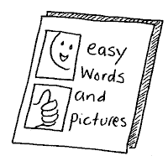

The pictures for this document came from Change Picture Bank and “Speaking Up” Resources
“Speaking Up” is a charity that supports and empowers people with learning difficulties, disabilities and mental health problems to speak up for themselves.

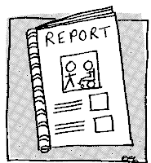
SUMMARY
This report has been done by Andy Burnham - the Secretary of State for the Department for Culture, Media, and Sport.

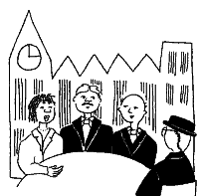
The Department for Culture, Media and Sport is part of the Government. It looks after some of the services that the Government pays for like sports activities, museums, art galleries, the National Lottery, the media and the 2012 Olympics.

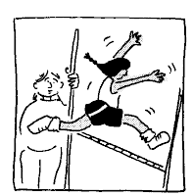

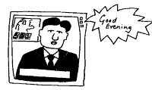
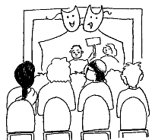
=

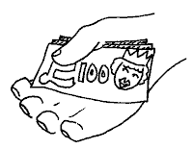
The Department for Culture, Media and Sport gets its money from the Government so it is a public authority.


This report also includes information about the Olympic Games and Paralympic Games, which is being led by Tessa Jowell, the Government Minister for the Olympics.

About the Department for Culture, Media and Sport (DCMS)

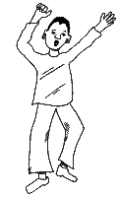
The Department for Culture, Media and Sport wants to make everyone’s lives better. We do this by:

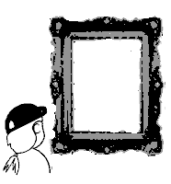
- Making sure people have the chance to take part in cultural and sporting activities (art galleries, museums, sports clubs and the Olympics)

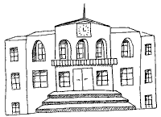
- Making sure that people want to visit different parts of England if they want to (Tourism and heritage (looking after old buildings))

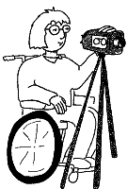
- Making sure that people can express themselves through creative and leisure activities (the media such as TV, radio and film, fashion and the National Lottery)

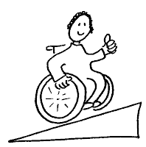
We try to make sure that everything we do is accessible to everyone and that anyone can get involved whatever their sex, disability or ethnic background.
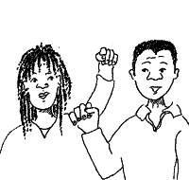
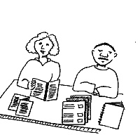
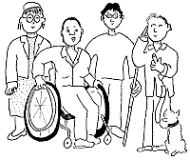

= =


Our target was to get more people involved in sports and cultural activities by the end of March 2008 – especially people who have not taken part in these activities before. We will put the numbers of people who took part on our website on 11th December 2008.
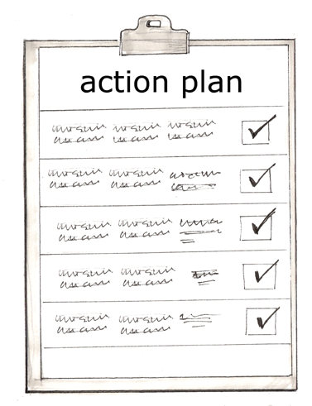
Departmental Strategic Objectives (DSOs)

We have agreed a new set of objectives (a list of things we plan to do) for 2008-2010. These are:

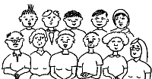

- Opportunity: Encourage more people to take part in and enjoy culture, media and sport activities


- Excellence: Support people to do their best in culture, media and sport activities
- Economic impact: Make sure that we are making the most of ways to make money from our activities
- Olympics: Make sure that the Olympic Games and Paralympic Games go well and that we can carry on providing sports activities for everyone afterwards

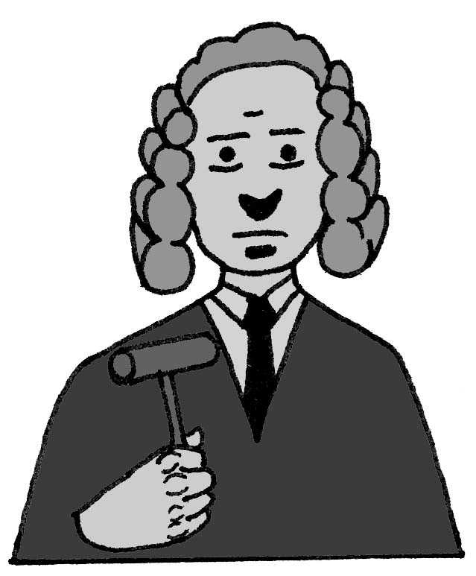
About the Disability Equality Duty

All public authorities, including the Department for Culture, Media and Sport have to do certain things under the Disability Equality Duty law (2006). They have to:

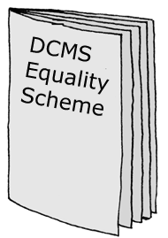
- Write a Disability Equality Scheme and make it available to everyone – you can find the DCMS Equality Scheme Easier-to-Read summary at
- http://www.culture.gov.uk/reference_library/publications/5084.aspx

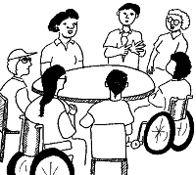
- Involve disabled people in writing and updating their Disability Equality Scheme

- Write a report every year on how they are making sure their services involve disabled people and meet their needs

The Department for Culture, Media and Sport has paid special attention to make sure that the work they oversee is meets the needs of disabled people.

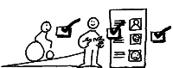

About our Report

The Department for Culture, Media and Sport looks after lots of different sorts of organisations. These are listed in Annex 1.
These organisations are all funded by the Government so they have to make sure that disabled people can use their services.

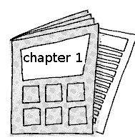
The full easier-to-read report (to follow) has a chapter for each different organisation that we sponsor. They cover the arts, museums and libraries, sport, broadcasting, the 2012 Olympic Games and Paralympic Games etc. The different areas we cover are called our Sectors.

The chapters tell you how each of our sectors and the organisations that we sponsor do different things to make their services accessible for disabled people.

The chapters also tell you what they plan to do to make sure more disabled people can take part.

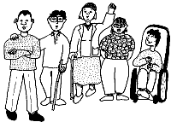
Involving Disabled People

To write our report we consulted with groups of disabled people.

The Department for Culture, Media and Sport has a Disability Reference Group and they were asked to look at the report early on.


We also asked another group - Equality 2025. They are a group of disabled people who give advice to the Government.

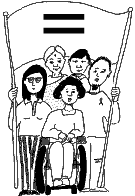
What We Found Out

When we were writing our report we looked at disability equality in all of our sectors or organisation types.

We looked at what the sectors have done, what has worked well, and what they could do better.

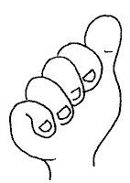

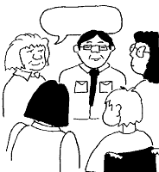
We found out that some organisations are doing well and that we need to share what they have learnt with the others.

We also found out that we need to fill up the gaps in our knowledge so that we can involve all disabled people in what we do.

When we spoke to our Disability Reference Group they said that we needed to look at the following things:

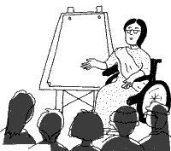
- Employees and disabled staff should have good disability awareness training so that everyone can be confident and feel like they belong.

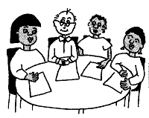
- The top Managers should take the lead on including disabled people so that everyone follows their lead.


- When we advertise for Trustees and Board Members we should put the adverts in lots of different places so that disabled people will see them and apply for them. We should also make sure that we look at what skills people have and train them so they can get involved in our Board.
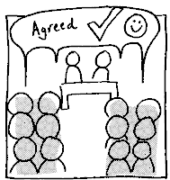

- We should involve disabled people in making decisions at all levels so that there is better access to our services and get their help in dealing with conflicting priorities for example improving access and conserving our heritage.
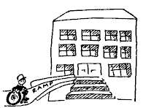


- We should look at where we are doing well to involve disabled people and find out what makes those services good at involving disabled people.
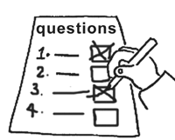

- We should keep getting feedback on how are how doing to make sure we keep making our services better for disabled people.

What Happens Next?

The Department for Culture, Media and Sport wants to make a positive difference to people’s lives.

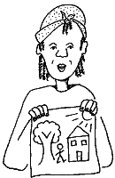
We want to make sure that everyone has the chance to get involved in the arts, culture and sports activities and be the best they can.

We have already done some work to help more people access our services – some of these things are:

Excellence in the Arts
Another report called “Supporting Excellence in the Arts: From Measurement to Judgment” told us about some work we needed to do to make our Arts sector better.

As part of this new work we want to make sure that everyone knows about Arts and cultural activities (like museums and art galleries) and can join in.

For example, we will ask teams of people to look at the different museums and see whether everyone can access them.

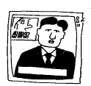
Digital Switchover

We want to make sure that everyone can use digital TV and radio if they have the right equipment (like a digital TV box or a freeview box).

To make sure everyone knows when TV goes digital, we have told the BBC to set up the Switchover Help Scheme. This helps lots of people who are 75 years old or over, or who have a severe disability, or are registered blind or partially-sighted.

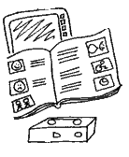
The Scheme gives people support including equipment, help with getting the equipment up and running and help afterwards if they need it.
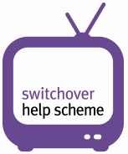
Digital UK has also set up a programme that will help other people including people with sensory, mobility and/or dexterity impairments, learning difficulties, those who experience mental health problems and those who are socially isolated. http://www.helpscheme.co.uk

Olympic Games and Paralympic Games

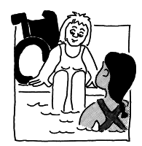
The London 2012 Olympic Games and Paralympic Games will be accessible to everyone.

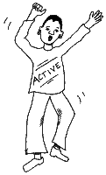
The Olympic Games and Paralympic Games will make sure disabled people are included and can take part. It will also encourage other people to have positive attitudes towards disabled people.

The Paralympic Games will give us a chance to help and encourage more disabled people to get involved in sports – before and after the Games.

The Government has a target of getting 2 million more people active by 2012. This includes people with disabilities.

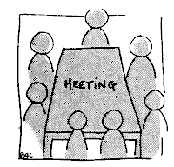
Public Appointments

We want to have more disabled people on our Boards as Trustees and Board Members.

We have an action plan on how to get more disabled people on our Boards and we will carry on with that action plan.

We will tell everyone how we are doing with this in our annual progress report each year.

Our Research

We have done a survey called Taking Part since 2005.
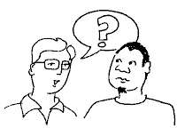
We understand that the information we got from our Taking Part survey does not tell us about the problems which different disabled people have in taking part.

The main reason that disabled people don't take part in our activities is health but there are also other reasons which are similar to non-disabled people (like money, transport and information).
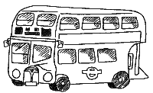
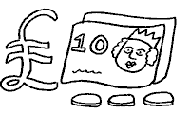
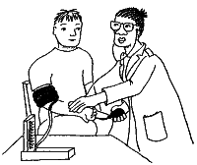
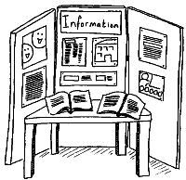

We want to find out more about what stops disabled people from taking part so we are going to run some focus groups which include lots of different people with disabilities as well as non-disabled people from black and ethnic backgrounds, people of different ages and people of different sexes.

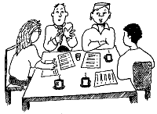
These focus groups will help us to find out how we can make sure we are including everyone.

Our Joint Research Board is also looking at what things affect peoples involvement in our activities – like how far away the leisure centre is from their home, what work they do and other issues.

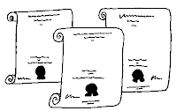
UN Convention on Disability Rights

Recently the Government said that it would sign up to the UN Convention on the Rights of Disabled People.

This Convention will try to make sure that all disabled people around the world will have the same rights as non-disabled people and be treated equally.

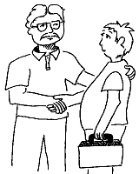
Working with other departments and organisations

Our report shows how we have worked in partnership with other Government departments and organisations.

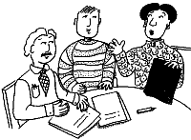
We will carry on working closely with staff at the Office of Disability Issues through their Disability Equality Duty Working Group so that we can learn from each other how to make sure disabled people are treated equally.

The organisations or public bodies that we fund (like the Arts Council and Sport England) get their money from the Government so they have to do their own work to make sure they are including disabled people.

We will make sure we give them information and advice on how they can include everyone in what they do.

We will also support them to work together and learn from each other.

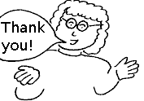
Thank you to...
The members of our Disability Reference Group -David Bonnett, June Bretherton, Colin Chaytors, Chris Hammond, Sir William Lawrence, Ruth Myers, Bob Twitchin and Tim Reedy (member of staff).

The full easy-read version of this report will be available on the Department for Culture, Media and Sport’s (DCMS) website at www.dcms.gov.uk
ANNEX 1

DCMS SPONSORED BODIES

(The organisations we look after)

Advisory Committee on Historic Wreck Sites (ACHWS)
Advisory Committee on National Historic Ships
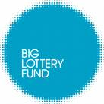
Advisory Committee on the Government Art Collection

Advisory Council on Libraries
Arts Council England
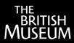
Big Lottery Fund
British Broadcasting Corporation (BBC)
British Library
British Museum
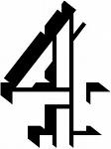
Channel Four Television Corporation
Commission for Architecture and the Built Environment (CABE)

Culture East Midlands*
Culture North East *
Culture Northwest *

Culture South East *
Culture South West *
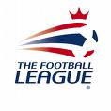
Culture West Midland*
English Heritage
Football Licensing Authority
Gambling Commission
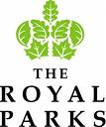
Geffrye Museum
Historic Royal Palaces
Horniman Public Museum and Public Park Trust
Horserace Betting Levy Appeal Tribunal for England & Wales

Horserace Betting Levy Board
Horserace Totalisator Board (The Tote)
Imperial War Museum
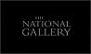
Legal Deposit Advisory Panel
Living East
Museum of London
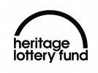
Museum of Science and Industry in Manchester
Museums, Libraries and Archives Council
National Gallery
National Heritage Memorial Fund (including Heritage Lottery Fund)

National Lottery Commission
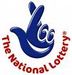

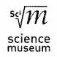
National Maritime Museum
National Museum of Science and Industry
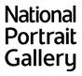
National Museums Liverpool
National Portrait Gallery
Natural History Museum

Olympic Delivery Authority
Olympic Lottery Distributor
Public Lending Right
(including Public Lending Right Advisory Committee)
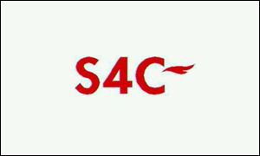
Reviewing Committee on the Export of Works of Art
Royal Armouries

Sianel Pedwar Cymru (S4C)

Sir John Soane's Museum

Spoliation Advisory Panel
Sport England
Tate
Theatres Trust

Treasure Valuation Committee
UK Film Council
UK Sport
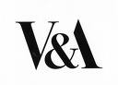
Victoria and Albert Museum

VisitBritain
VisitEngland
Wallace Collection
Yorkshire Culture

*to be wound up at the end of 2008/09

