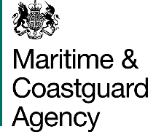
MSF 4701 Rev 1118
Register of UK Vessels Part III
(Small Ships Register)
All applications

What is your application for? Please tick one or more of the following:
New registration Re-registration Change of ownership
Change of vessel details
1: DETAILS OF VESSEL

Name of Vessel
Official Number

Please tick:
Barge Dinghy Inflatable Motor Cruiser Motor Sailor
Motor Yacht Rowing Boat Sailing Yacht Sports Boat Wet Bike Other or Pleasure Vessel _{(Please give details below)}

Make/Model of Vessel
Overall Length (metres)
Number of Hulls |  | Hull Identification Number (HIN)
Radio Call Sign |  | MMSI
Is the vessel registered under the Part I of the United Kingdom ship register? | Yes No
Has the vessel ever been registered on the Small Ships Register? Yes No
(if NO is ticked, please proceed to Section 2 now).
SSR Number (should be permanently marked on/affixed to the vessel)
Date of Expiry of Certificate of Registration
Are you the owner recorded on the Certificate of Registration? | Yes No
If NO, when did you acquire the Vessel? (Date) | DD / MM / YYYY
2: DETAILS OF REGISTERING OWNER(S) AND DECLARATION
Total number of owners to be registered
Please enter the name and address where ordinarily resident and the Nationality of every owner (not previous owners). All correspondence in connection with Small Ships Registration will be sent to the primary owner listed on this form.
All owners are required to sign and date the declaration section. If there are more than two owners, then they must provide their details on a separate sheet.
Title (not compulsory) _____________
Full Name ___________________________________
Address _____________________________________
____________________________________________
____________________________________________
Postcode ____________________________________
Telephone number ____________________________
Email address ________________________________
Nationality ___________________________________
If you are an EU/EEA citizen, are you established within the meaning of Articles 48 and 52 of the EU Treaty?
Yes No

Title (not compulsory) _____________
Full Name _____________________________________
Address ______________________________________
_____________________________________________
_____________________________________________
Postcode _____________________________________
Telephone number ______________________________
Email address _________________________________
Nationality ____________________________________
If you are an EU/EEA citizen, are you established within the meaning of Articles 48 and 52 of the EU Treaty?
Yes No

Please read the following declaration and complete the section below it if you agree.
- I confirm that I am eligible to be the owner of a small vessel under regulation 89 (Persons qualified to be the owners of a small vessel to be registered on Part III of the Register)
- I confirm that the vessel is entitled to be registered on Part III of the Register in accordance with regulation 90 (British connection)

I understand that it is an offence to knowingly or recklessly make a false statement in order to obtain registration and hereby declare that, to the best of my knowledge, the details given in this application form are correct.
Signature __________________________________
Name (PRINT) ______________________________
__________________________________________
Date ______________________________________

DD / MM / YYYY
Signature__________________________________
Name (PRINT) ______________________________
__________________________________________
Date ______________________________________

DD / MM / YYYY

Your Information
3: PRIVACY NOTICE
We collect personal information about you to carry out our official duty and to keep the UK ship register up to date and to make sure our services are planned to meet the vessel owner’s needs.
For more information on how we use your information please see our privacy policy available on our website https://www.gov.uk/government/organisations/maritime-and-coastguard-agency

When completed, send this form via email or post together with the correct fee, and any enclosure to:
Small Ships Register,
Registry of Shipping and Seamen,
Anchor Court,
Keen Road,
Cardiff,
CF24 5JW,
UK.
Email: ssr.registry@mcga.gov.uk Telephone: 020 39 085201
Notes for Guidance (To be retained by the applicant)

- What is Part III of the Register?
Part III (commonly called the Small Ships Register – SSR) is for ships, which want only simple registration; it does not register ‘title’ and you cannot register mortgages on this part of the Register.

It provides an inexpensive, simple registration, which proves the ship’s nationality (a kind of passport).

- What is a small ship?
A small ship is one which is less than 24 metres (79 feet) in overall length.

The following ships cannot be registered on Part III
- Those owned by a company
- Those over 24 metres in length
- Fishing or submersible vessels

- Who may register a small ship?
A small ship may be registered if all of the owners are ordinarily resident in the UK:-
- British Citizens
- Persons who are nationals of a European Union or Economic Area country other than the United Kingdom and are established* in the UK
- British Dependant Territories citizens; British Overseas citizens; persons who under the British Nationality Act 1981 and are British subjects; persons who under the Hong Kong (British Nationality) Order are British Nationals (Overseas), and
- Commonwealth citizens not falling within those paragraphs.

*Established – It is not sufficient to live in the UK to be ‘established’ in accordance with Articles 48 and 52 of the EU Treaty. To be ‘established’ a person must make an economic contribution to the UK by being the proprietor of a business, being employed, or having very recently retired from such employment, i.e. within the last 6 months. If you have any doubts about your ‘establishment’ you should consult the Registry.

- What does ‘ordinarily resident’ mean?
For the purposes of registering a ship it means living in the UK for a significant part of the year. A person may be considered to be ordinarily resident in the country in which they live for a period of, or periods which collectively amount to 185 days or more in a twelve month period.

- Can my ship be registered on Part 1 and Part III?
Ships cannot be on more than one part of the Register at any one time. If you have Part I registration it is to your advantage to keep your ship registered on Part I rather than transfer it to the SSR. If you wish to transfer from one part of the Register to another, it will be necessary to close the ship’s current registration before the transfer can be made.

Further information can be obtained from:-

Register of Shipping & Seamen – Small Ships Register
Maritime and Coastguard Agency
Anchor Court, Keen Road E-mail: SSR.registry@mcga.gov.uk
CARDIFF, CF24 5JW Tel: 020 39 085201

- How long does SSR registration last?
Registration on Part III of the Register lasts for 5 years. The date of expiry is shown on the ship’s certificate of registry. You may apply to renew the ship’s registration up to 3 months before the certificate expires. Registration ceases immediately if a ship is sold or any details change which appear on the certificate of registry. Where this happens, the registered owner must return the certificate with a brief explanation of the circumstances of any change. You must also notify the Registry of any change of address.

- Ship Names
Ships will not be registered if they have undesirable or offensive names or which may cause confusion; e.g. if prefixed by FV or HMS. Names such as ‘SOS’, ‘MAYDAY’ or ‘LIFEBOAT’ will not be allowed. Ships must have a name before they can be registered.

- Measuring the Ship
In most cases owners my measure the overall length of the ship themselves (asked on the application form under VESSEL DETAILS). ‘Overall length’ is the distance between the foreside of the foremost fixed structure and the aft-side of the aftermost permanently fixed structure of the ship. The diagrams below show between which points on most ships the measurements should be made. On multi-hulled craft, the longest hull should be measured. If you are in difficulty or require advice on measuring craft of novel design, you may seek assistance from the Royal Yachting Association at: RYA House, Romsey Road, Eastleigh, SO50 9YA.

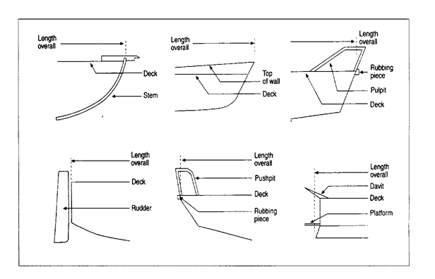

- Definitions
Sailing Yacht – boat primarily propelled by sails (larger than a dinghy) with a fixed keel or cabin.
Motor Yacht – large boat largely propelled with an engine either steam or internal combustion including cabin cruisers.
Dinghy – all types of dinghy including rowboats and small sailing vessels without a fixed keel or cabin.
Motor Sailer – boat propelled by engine or sails with a keel and cabin.
Inflatable – including rigid and non-rigid types.
Sportsboat – including powerboats and launches.
Barge – all types including houseboats.
Wet Bike – including jet skis, etc.
Motor Cruiser – all types of motor driven vessels which are not described above.
Rowing Boat – all types of vessels propelled by oars.
Other Vessel Type – anything which does not easily fit into the above types.

