Childcare providers and inspections
This release contains:
- The number of Ofsted registered childcare providers and places, and their most recent inspection outcomes on 31 March 2018.
The number of childminders registered with Ofsted has continued to decrease. | There were 41,700 childminders registered with Ofsted on 31 March 2018. This was down by 600 (1%) since 31 December 2017, and by 15,700 (27%) since 31 August 2012.
The number of non-domestic providers has increased slightly. | There were 27,200 childcare providers on non-domestic premises on 31 March 2018. There were more non-domestic joiners than leavers between 31 December 2017 and 31 March 2018.
More than nine in 10 providers on the Early Years Register were judged to be good or outstanding. | The proportion of childcare providers on the Early Years Register judged to be good or outstanding was 94%. This has been consistent since 31 August 2017, but represents an increase of 20 percentage points since 31 August 2012.
The proportion of childminders judged to be good or outstanding is nearing that of non-domestic providers. | On 31 March 2018, 94% of childminders were judged good or outstanding compared with 95% of non-domestic providers. This gap has narrowed by one percentage point since 31 December 2017.
- The number of providers that have registered with Ofsted (joiners) and the number of providers that have left (leavers) between 31 December 2017 and 31 March 2018.

Figure 1: Overall effectiveness of active early years registered providers at their most recent inspection over time
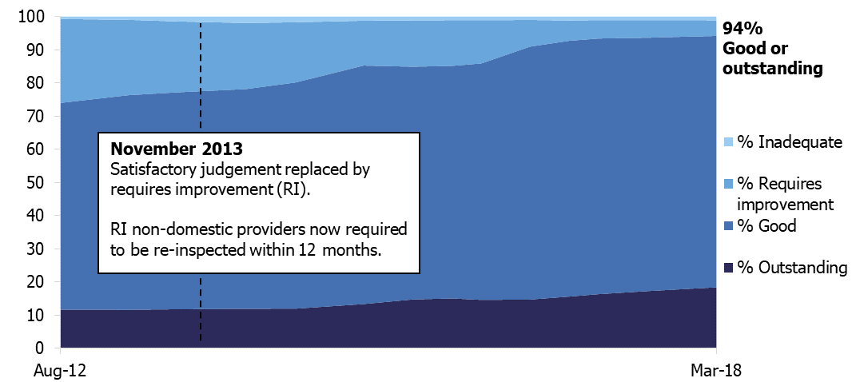

Contents
Introduction 3
Number of providers 4
Number of places 5
Inspection outcomes 7
Childminder agencies 10
Notes 10
Glossary 11
Further information 15

Acknowledgements
Thanks to the following for their contribution to this statistical release: Lucy Conway, Louis Noble, Tristan Browne, Helen Woodley, Jade Price-Stephens.

Introduction
The early years and childcare sector is primarily made up of private nurseries, pre-schools and childminders. These are categorised into four provider types:

Type of provider | Description
Childcare on non-domestic premises | Nurseries, pre-schools, holiday clubs and other private provision on business premises, usually registered on the Early Years Register (EYR) because they look after children aged 0 to 5.
Childminders | People who are paid to look after one or more children they are not related to in someone’s home. The majority are registered on the EYR because they look after children aged 0 to 5, but those who look after 5 to 7 year olds need to register on the Childcare Register (CR).
Childcare on domestic premises | Where four or more people look after children together in someone’s home. The majority are registered on the EYR and some are registered on the CR, depending on the age of the children they look after.
Home childcarers | Nannies who care for children aged 0 to 18 wholly or mainly in the child’s own home. They are not required to register with Ofsted but may choose to do so on the Voluntary Childcare Register (VCR).

Childcare on non-domestic premises and childminders make up the majority of early years provision registered with Ofsted. Further information about provider types is available in the Glossary.

Childcare in early years also occurs in the schools sector. This takes place in maintained nursery schools (state-run nurseries), early years provision within maintained schools and academies, and within independent schools.

For more information on maintained school inspections and outcomes, please refer to Ofsted’s official statistics on maintained schools and academies inspections and outcomes: www.gov.uk/government/collections/maintained-schools-and-academies-inspections-and-outcomes-official-statistics.

For more information on non-association independent schools inspections and outcomes, please see Ofsted’s management information release on non-association independent schools: www.gov.uk/government/statistical-data-sets/non-association-independent-schools-inspections-and-outcomes-management-information.

Please note that Ofsted only inspect non-association independent schools. Association independent schools are inspected by the Independent Schools Inspectorate (ISI) – www.isi.net – or the School Inspection Service (SIS) – www.schoolinspectionservice.co.uk.

Number of providers
Changes in provider numbers, by provider type
There were 79,700 childcare providers registered with Ofsted on 31 March 2018. This is down by 1% (800) since 31 December 2017, and down 17% since 31 August 2012 when there were 96,200 providers.

- Childminders: 41,700 providers on 31 March 2018, down 600 since 31 December 2017. This continues a downward trend, with 27% fewer providers than at 31 August 2012.

- Childcare on non-domestic premises: 27,200 providers on 31 March 2018, up by fewer than 50 since 31 December 2017. Numbers are fairly stable over time, having decreased by just 2% since 31 August 2012.

- Home childcarers: 10,600 providers on 31 March 2018, a decrease of 200 since 31 December 2017. Numbers are fairly stable over time and at a similar level to those seen on 31 August 2012.

- Childcare on domestic premises: these are not included in Figure 2 as there is only a very small number registered with Ofsted (200 on 31 March 2018).

Factors influencing changes in provider numbers
Overall, childcare provider numbers have decreased steadily since August 2012. This can be attributed to a large decrease in childminders, a small decrease in non-domestic providers, and no notable change in the number of home childcarers (Figure 2).

The decline in the number of childminders is due to more providers leaving than joining the childcare sector. For example, 1,300 childminders left the sector in December 2017 to March 2018, and 800 joined – a net decrease of 600¹. The childminders who left the register during this period had been registered for around nine years on average. Around three quarters of leavers were registered for longer than three years and almost a quarter were registered for between one and three years (based on the assumption that they left the register on 31 March 2018).

Figure 2: Total number of childcare providers registered with Ofsted on any register over time, by provider type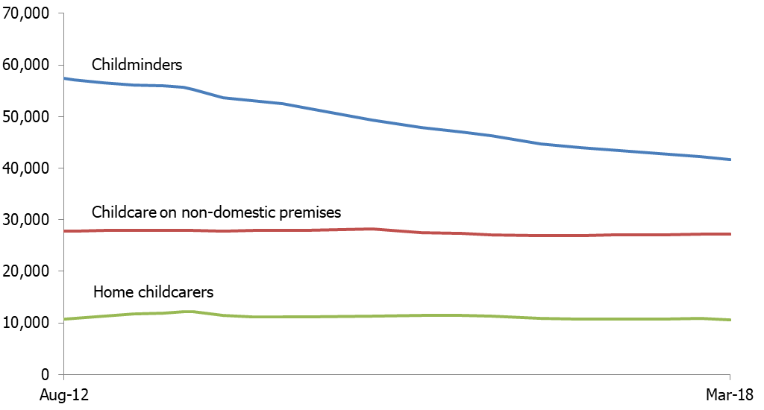

The number of non-domestic providers has increased slightly since 31 December 2017, with a larger number of providers joining than leaving the sector. Since March 2015, the number of non-domestic providers has decreased by 3%. This could be explained in part by the legislative change introduced in May 2015, making schools exempt from registration on the Early Years Register if they look after children aged two or over. As a consequence many schools providing childcare for two year olds are not on the Early Years Register.

Number of places
Registers and places
On 31 March 2018, 81% of Ofsted registered childcare providers were on the Early Years Register (EYR). The remaining 19% were not on the EYR, and so only appeared on the voluntary (VCR) and/or compulsory (CCR) parts of the Childcare Register. More information about the different register types is available in the Glossary.

It is important to note that:
- Childcare places data refers to all places offered by providers on the EYR for children aged under eight years old. Most providers on the EYR are also registered on the Childcare Register (CR) because they look after children up to the age of eight years old. Therefore, the number of places in the early years age range (0–5 year olds) is likely to be lower.
- While the majority of providers on the EYR have places information recorded, for some providers estimates have been calculated. For more information on the estimation process, see ‘Number of places’ in the Glossary.
- For non-domestic providers, their number of places reflects the number of children they intend to provide childcare for at any one time. Providers have no maximum limit on the number of places they can offer, as long as they have a suitable ratio of staff to children.
- For childminders, the maximum number of places that they can offer if they do not have any assistants is six. All childminders are recorded as offering six places at registration. This is updated at inspection. On 31 March 2018, 72% of childminders on the EYR were registered as offering six places. The total number of childminder places available may be lower.

In summary, it is likely that the data for non-domestic providers is more representative of the number of places they provide in practice than it is for childminders.
Providers and places
Looking at the number of childcare places by provider type, on 31 March 2018:

- Childcare on non-domestic premises: offered 80% (1.0 million) of all childcare places, which is an increase of two percentage points since August 2012.

- Childminders: offered 19% (252,100) of all places, a decrease of two percentage points since August 2012.

- Childcare on domestic premises: offered less than 1% (4,900) of places. These are not shown in Figure 3 due to the small number of places offered.

Despite decreasing numbers of childminders, the number of childcare places has remained broadly stable since August 2012 (Figure 3). While childminder places decreased slightly between December 2017 and March 2018, there was a larger increase in the number of places offered by childcare on non-domestic premises, which resulted in an overall increase of over 1,000 places. On 31 March 2018, there were 1.3 million childcare places offered by providers on the EYR.

Figure 3: Childcare places on the Early Years Register over time, by provider type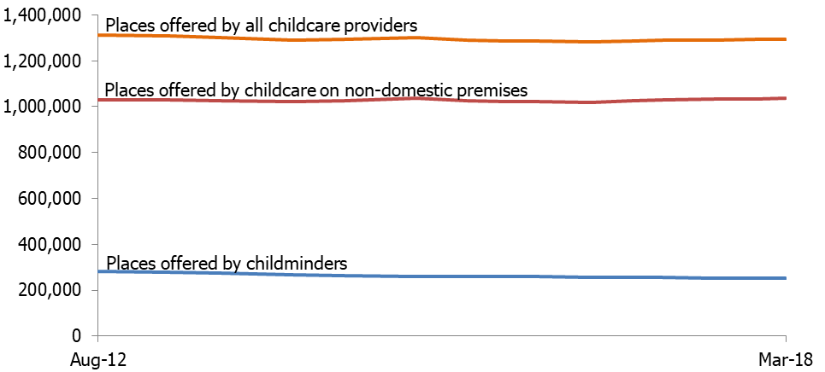

Childminder provider numbers have decreased by 27% since 31 August 2012, but the number of places offered by childminders has only decreased by 11%. This means that each individual childminder is offering a higher number of places on average, even though there are fewer childminders and places overall.

On 31 August 2012, the average number of places offered by childminders on the Early Years Register was 5.1, whereas on 31 March 2018, the average was 6.3. However, for reasons outlined earlier in this section, the majority of childminders are registered as offering six places. This average takes into account childminders with assistants, who are permitted to offer more than six places.
Introduction of 30 hours free childcare
Since 1 September 2017, working parents of three and four year olds in England have been eligible for 30 hours of free childcare. There were an estimated 294,000 children in a 30 hours place in the spring term, representing 89% of all eligibility codes issued to parents for that term.
This may have contributed to the slight rise in the number of Early Years Register places in childcare on non-domestic premises.

Inspection outcomes
New providers joining the Early Years Register (EYR) are normally inspected within 30 months of registration. The ‘Being inspected as a childminder or childcare provider’ guidance (www.gov.uk/ofsted-inspection-childcare-provider) provides more information about inspection. On 31 March 2018, 80% of the 64,400 providers on the EYR had been inspected, with the remaining 20% yet to be inspected. The majority of providers not yet inspected joined the EYR within the last two years.

Proportion of providers on the EYR judged good or outstanding
On 31 March 2018, 94% of childcare providers on the Early Years Register were judged to be good or outstanding. This was in line with the previous two releases (August and December 2017), and a substantial increase from 31 August 2012 when the proportion was 74%. This increase can be attributed to a steady rise in the proportion of providers judged good, with only a small increase in the proportion of providers judged outstanding (Figure 1). This change is discussed, in further detail, below.

Looking at the two main provider types on 31 March 2018 (Figure 4) :
- Childcare on non-domestic premises: 95% were judged to be good or outstanding at their most recent inspection, the same proportion as the end of December 2017. This was made up of 73% of childcare on non-domestic premises judged good and 22% judged outstanding.

- Childminders: 94% were judged good or outstanding, an increase of one percentage point since the end of December 2017. This was made up of 78% of childminders judged good and 16% judged outstanding.
Figure 4: Percentage of childminders and non-domestic providers judged good or outstanding at their most recent full inspection over time
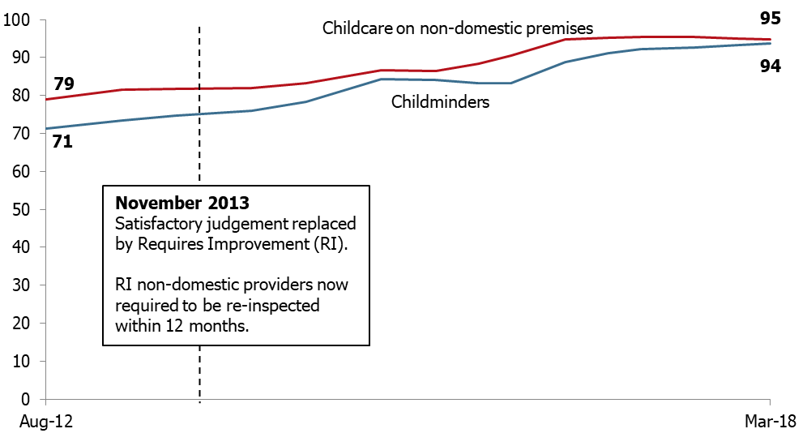
Changes in the proportion of childminders judged good or outstanding
Since the beginning of August 2016, Ofsted has prioritised inspections for childminders who had been previously judged requires improvement (RI) or inadequate.

On 31 March 2018, 90% of childminders who had previously received a judgement of RI or inadequate, improved to good or outstanding. This improvement has a double effect: as the number of good or outstanding childminders increases, the number of RI or inadequate childminders decreases.

Other factors that have influenced this upward trend in the longer term are:

- Providers are more likely to be judged good or outstanding at their first inspection than they were in August 2012.
- Providers leaving the sector are more likely to have had inspection judgements of RI or inadequate than those that remain.

Changes in the proportion of childcare on non-domestic premises judged good or outstanding
Over time, the proportion of childcare on non-domestic premises judged good or outstanding has seen a steady increase. Part of this increase can be attributed to a change in the childcare inspection policy. Since November 2013, all childcare on non-domestic premises judged requires improvement must be re-inspected within 12 months. This means that non-domestic providers have had more opportunity to demonstrate improvement than they did previously.

Regional inspection outcomes
On 31 March 2018, all regions had fairly similar proportions of providers judged good or outstanding. The North West and the South West had the highest proportions (96%) and London the lowest (91%).
On a national level, 95% of non-domestic providers were judged good or outstanding compared with 94% of childminders – a gap of one percentage point, compared with two percentage points seen on 31 December 2017. This indicates that the gap is narrowing.

Across the regions, non-domestic providers had a higher or similar proportion of providers judged good or outstanding compared with childminders. The South West region was the only exception, where the proportion of childminders judged good or outstanding was higher than non-domestic providers (Table 1).

Table 1: Percentage of childminders and non-domestic providers judged good or outstanding on 31 March 2018, by region
Region | Childcare on non-domestic premises (%) | Childminder (%)
England | 95 | 94
North West | 95 | 93
North East | 98 | 95
Yorkshire and The Humber | 96 | 94
East Midlands | 94 | 94
West Midlands | 95 | 93
East of England | 95 | 95
London | 92 | 90
South East | 95 | 95
South West | 95 | 96

Additional information on local authorities and parliamentary constituencies can be found in the provider level data file which accompanies this release.

Childminder agencies
Childminder agencies were introduced in September 2014, enabling new childminders to choose to register with Ofsted directly or register with an agency. Existing childminders could also choose to deregister with Ofsted and register instead with a childminder agency. Childminder agencies have the responsibility of inspecting the childminders who are registered with them, with Ofsted inspecting the childminder agencies.

Childminder agencies are only eligible for inspection when they have childminders on roll and there are only two overall effectiveness inspection outcomes: ‘Effective’ and ‘Ineffective’. On 31 March 2018, eleven childminder agencies were registered with Ofsted. Of these, seven had childminders on roll and were therefore eligible for inspection. Four childminder agencies have been inspected to date and all have been judged ‘Effective’.

Data for childminder agencies is available from the provider level data file on the page for the Official Statistics release on 31 March 2018:
www.gov.uk/government/collections/early-years-and-childcare-statistics.

Notes
An explanation about main uses of this data, further contextual information and the arrangements for quality assurance is provided in the methodology and quality report which accompanies this release.

The methodology and quality report also provides information on the strengths and limitations of the statistics.
Revisions to previous release
The provisional data in the previous release related to inspections which took place between 1 September 2017 and 31 December 2017 and were published by 31 January 2018. A revised list of inspections in this period is provided in Tables 14–19 of the ‘Childcare providers and inspections charts and tables’ document for this release. This revised data includes 11 inspections that were published by 30 April 2018 (that were not published by 31 January 2018).

These revisions did not result in any changes to the main findings identified in the previous publication.
Revisions to data in this publication are published in line with Ofsted’s revisions policy for official statistics, which can be found here: www.gov.uk/government/publications/ofsted-standards-for-official-statistics.
Common Inspection Framework (CIF)
Inspections from 1 September 2015 were carried out under the Common Inspection Framework (CIF), meaning that the inspection judgements are common across the Early Years, Schools and Further Education and Skills remits. Ofsted evaluates the overall quality and standards of the early years provision in line with the principles and requirements of the early years foundation stage statutory framework. Inspectors judge the overall effectiveness of the early years provision, taking into account four judgements:
- quality of teaching, learning and assessment;
- personal development, behaviour and welfare;
- effectiveness of leadership and management;
- outcomes for children.

Ofsted is required to inspect all providers who were on the Early Years Register (EYR) on 1 August 2016 at least once by 31 July 2020. Providers who have registered after this date will normally be inspected within 30 months of registration.

Glossary

Under the Childcare Act 2006 (www.legislation.gov.uk/ukpga/2006/21/contents) childcare providers register on either or both of two registers:

- Early Years Register (EYR)
The EYR is for providers who care for children in the early years age group, from birth to 31 August following their fifth birthday. Registration is compulsory for such providers and they must meet the requirements of the early years foundation stage (EYFS).
All providers on the EYR are inspected on a four year cycle. The last inspection cycle ran from 1 September 2012 through to 31 July 2016. The current inspection cycle runs from 1 August 2016 through to 31 July 2020.

- Childcare Register (CR)
The CR is for providers who care for children from birth to 18 years. It has two parts:
- Compulsory Childcare Register (CCR) – for providers caring for children from 1 September after the child's fifth birthday up until their eighth birthday.

- Voluntary Childcare Register (VCR) – for providers for whom registration is not compulsory, for example nannies, or providers who care for children aged eight and over.
Providers who are registered on either part of the Childcare Register do not need to submit their places information to Ofsted.
For providers registered on the Childcare Register, Ofsted inspects a sample of 10% of active providers per year.
Venn diagram showing the Ofsted registers for childcare providers
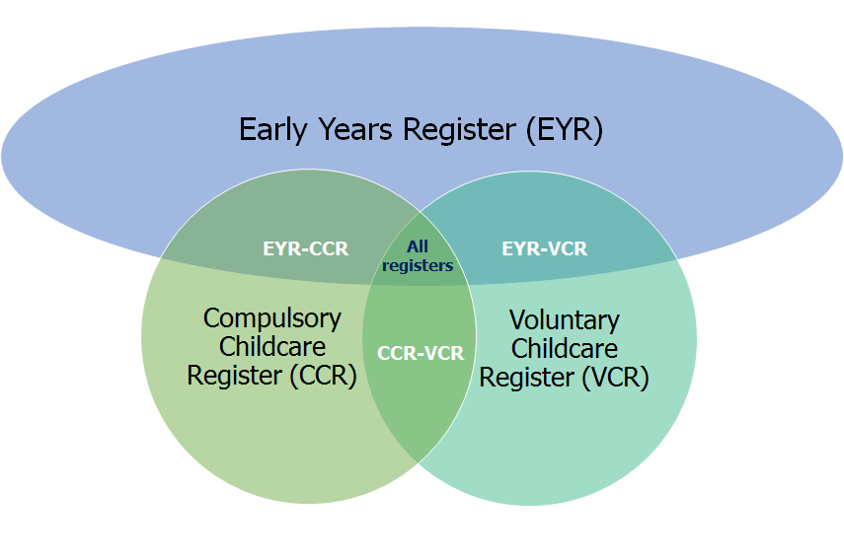

Early years foundation stage (EYFS)
The EYFS is the statutory framework for the early education and care of children from birth to 31 August following their fifth birthday: www.gov.uk/government/publications/early-years-foundation-stage-framework--2.

Childcare providers
Childcare providers care for at least one individual child for a total of more than two hours in any one day. This is not necessarily a continuous period of time. They must register on the CCR to care for children under the age of eight, although there may be some exceptions to this. They can register on the VCR to care for older children.
Domestic premises
These are any premises which are wholly or mainly used as a private dwelling, i.e. someone’s home.

Childcare providers on domestic and non-domestic premises
If four or more people look after children at any one time in someone’s home, they are providing childcare on domestic premises, not childminding. Childcare providers on non-domestic premises are people or organisations providing care for individual children in premises that are not someone’s home. These premises can range from converted houses to purpose-built nurseries.
Childminder
This is a person who is registered to look after one or more children, to whom they are not related, for reward. Childminders work on domestic premises alongside no more than two other childminders or assistants. They must register if they care for children under the age of eight, and can choose to register if they care for older children. They care for:
- Children on domestic premises that are not usually the home of one of the children unless they care for children from more than two families, wholly or mainly in the homes of the families.

- At least one individual child for a total of more than two hours in any day. This is not necessarily a continuous period of time.
Childminder agencies
Childminder agencies were introduced in September 2014 as an option for childminders to register with. Childminders who register with an agency no longer need to register or be inspected by Ofsted, although the agency itself will receive an inspection.

Childminder agencies are only eligible for inspection by Ofsted when they have childminders on roll. Childminder agencies have the responsibility of inspecting the childminders who are registered with them.

Home childcarers
Home childcarers are usually nannies who care for children of any age up to their 18th birthday wholly or mainly in the child’s own home, and care for children from no more than two families. They are not required to register with Ofsted but may choose to do so on the voluntary part of the Childcare Register.

Inspection cycles
All providers on the Early Years Register which were registered before the start of Ofsted’s four year inspection cycle are inspected within the cycle. The previous inspection cycle ran from 1 September 2012 to 31 July 2016. The current inspection cycle runs from 1 August 2016 to 31 July 2020. New providers joining the EYR are normally inspected within 30 months of registration. For providers on the CCR, a sample of 10% of active providers are inspected per year.
No Children on Roll (NCOR)
If there are no children present on the day of the provider's inspection, they receive an NCOR inspection. The inspector will make a judgement on the ‘Overall quality and standards of the early years provision’, with three possible outcomes:
- met
- not met - actions
- not met - enforcement action

Number of places
Registered places are the number of children that may attend the provision at any one time. Registered places are not the number of places occupied, nor the number of children who may benefit from receiving places through providers offering sessions at different times of the day. Place numbers are only collected for providers on the EYR. Provider type averages are used to estimate the number of places for a very small number of providers whose place numbers are not available at the time of the analysis. There may also be small discrepancies in totals due to rounding.

Joiners and leavers
Joiners are childcare providers that have registered with Ofsted during this reporting period. Most of these are new registrations, but Tables 3–4 and Chart 1 within the ‘Childcare providers and inspections charts and tables’ document also include providers with re-activated registrations and those that have changed provider type or register. At local authority or regional level, this may also include providers that have relocated into a new geographical area.
Leavers are mostly childcare providers that have left Ofsted during the reporting period. Most of these are resignations, but some are also providers that have had their registration cancelled or have changed provider type or register. At local authority or regional level, this may also include providers that have relocated out of a geographical area.

Further information
Ofsted publishes information on the inspection of early years providers on the gov.uk website:

www.gov.uk/government/collections/early-years-and-childcare-statistics

www.gov.uk/government/publications/common-inspection-framework-education-skills-and-early-years-from-september-2015

www.gov.uk/government/publications/framework-for-the-regulation-of-provision-on-the-childcare-register.

Contact for comments or feedback
If you have any comments or feedback on this publication, please contact Anita Patel on 03000 130 914 or Anita.Patel@ofsted.gov.uk.

The Office for Standards in Education, Children's Services and Skills (Ofsted) regulates and inspects to achieve excellence in the care of children and young people, and in education and skills for learners of all ages. It regulates and inspects childcare and children's social care, and inspects the Children and Family Court Advisory and Support Service (Cafcass), schools, colleges, initial teacher training, further education and skills, adult and community learning, and education and training in prisons and other secure establishments. It assesses council children’s services, and inspects services for children looked after, safeguarding and child protection.
If you would like a copy of this document in a different format, such as large print or Braille, please telephone 0300 123 1231, or email enquiries@ofsted.gov.uk.
You may reuse this information (not including logos) free of charge in any format or medium, under the terms of the Open Government Licence. To view this licence, visit www.nationalarchives.gov.uk/doc/open-government-licence, write to the Information Policy Team, The National Archives, Kew, London TW9 4DU, or email: psi@nationalarchives.gsi.gov.uk.
This publication is available at www.gov.uk/government/organisations/ofsted.
Interested in our work? You can subscribe to our monthly newsletter for more information and updates: http://eepurl.com/iTrDn.

Piccadilly Gate
Store Street
Manchester
M1 2WD

T: 0300 123 1231
Textphone: 0161 618 8524
E: enquiries@ofsted.gov.uk
W: www.gov.uk/ofsted

© Crown copyright 2018

Numbers are rounded to the nearest 100.
The proportion of childminders on the Early Years Register (EYR) offering six places on 31 December 2017 was 71%. In our previous main findings, this proportion was calculated using childminders on any register. These figures have now been revised to be consistent.
Places numbers of less than one million are rounded to the nearest hundred. Places numbers of more than one million are rounded to the nearest 100,000.
The average number of places for childminders on the Early Years Register (EYR) on 31 December 2017 was 6.3 and on 31 August 2017 was 6.2. In previous main findings, these averages were calculated using childminders on any register. These figures have now been revised to be consistent.
Department for Education, 30 hours free childcare, England, Spring term 2018 https://www.gov.uk/government/statistics/30-hours-free-childcare-spring-term-2018
Percentages may not sum due to rounding.
Announcement of update in early years inspection policy from Her Majesty’s Chief Inspector (August 2013): https://www.gov.uk/government/news/ofsted-calls-for-swift-improvement-in-pre-schools-and-nurseries

