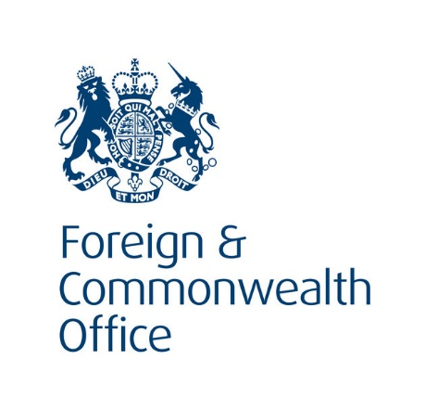
List of funeral directors in Zambia
Prepared by British High Commission Lusaka
www.gov.uk
The following list of funeral directors has been prepared by the British High Commission Lusaka for the convenience of British Nationals who may require this service and assistance in Zambia. It is provided on the understanding that we (the British High Commission) do not assume or undertake any legal responsibility, to you, or those affected, if you choose to take it into account when instructing a local funeral director.
Further and alternatively, we cannot accept any liability to any person or company for any financial loss or damage arising from the use of this information or from any failure to give information.
Our aim is to provide our customers with as much relevant information to enable them to make better informed decisions but our lists are not recommendations and should not be treated as such.

List of funeral directors in Zambia
Updated: November 2018
This list is in alhabetical order.
Ambassador St Ann’s Funeral Home

Funeral Director: Kelvin Ngolofwana
Mumbwa Road, P O Box 35192 Lusaka
Tel: +260 211 286258/286904
Fax: +260 211 287611/287528
Email: info@uniturtle.com
Website: www.uniturtle.com/st-anns

This company has told us the following things:

- they have English speaking staff
- some staff can also speak a few local languages and someFrench
- they specialise in funeral services and repatriation, local burials, cremations, exhumation
- they have experience of representing British nationals
- they can’t offer payment plans but they are able to give flexible terms of payment
- areas/regions of the country they provide services for: all 10 provinces in Zambia
- Affiliated to the local regulatory authority in Zambia –PACRA and Zambia Revenue Authorities

FSG (Zambia) Ltd trading as Ideal Funeral Parlour
Plot 170 Luanshya Rd Industrial, P O Box 32432, Lusaka, Zambia
Tel: +260 211 220039,
24 hours: 0955 218290/0958 218242
Life Assurance: 0953 426546/ 0955 218249

Email: sales@fsg.co.zm; mutalem@fsg.co.zm

Website: http://www.fsg.co.zm

This company has told us the following things: {complete as required}

- they have English speaking staff
- they specialise in funeral services, repatriations, funeral insurance policies
- they have experience of representing British nationals
- staff speak English and local languages
- they can offer repayment plans
- areas/regions of the country they provide services for: Whole of Zambia & the rest of Southern Africa

Feedback Form for Customers
If you do decide to use any of the funeral directors on this list, we would like to hear from you. While there is no obligation on your part to provide feedback on the services you receive, any feedback you can give us is helpful.
Once completed, please return the form to the British High Commission by post to P O Box 50050 Lusaka or by email to LusakaConsularEnquiries@fco.gov.uk . An electronic version of the form is available at www.gov.uk/government/world/zambia Thank you for your help.
- Name of firm: Name of funeral director:

- Date of contact:
Are any of the details on our list regarding this provider wrong? (e.g. address, telephone number, etc.)
Please circle the appropriate boxes below:
(a) If the service provided English speaking services, how would you rate the standard of English?

Excellent | Good | Average | Poor | Very Poor
(b) How would you rate the professionalism of the staff?
Excellent | Good | Average | Poor | Very Poor
(c) How would you rate the overall service received?
Excellent | Good | Average | Poor | Very Poor

- Do you have any other comments?

We would like to share this information with other customers but if you would prefer it not to be seen by others please tick the box □
Feedback provider’s name: | Tel. No.:
Email: Date:

