Philippa Hird
Chair NHS Pay Review Body
Office of Manpower Economics
Fleetbank House
2-6 Salisbury Square
London
EC4Y 8JX
21 November 2018
Dear Ms Hird,

I am writing firstly to express my thanks for the NHSPRB’s invaluable work which informed its report and observations for the 2018-19 pay round and secondly, to formally commence the 2019-20 pay round. In particular, I would like to thank you and your members for your support as the partners completed the Agenda for Change negotiations. It was important that the Review Body had an opportunity to see the final agreement as part of your report to government.

You are aware that the reforms were agreed by all parties. I am pleased that the final agreement takes on board recommendations and observations the Review Body has made in a number of its reports over recent years for achieving a balanced package of reforms.

The NHS Staff Council is at the early stages of an extensive work programme and will work with its partners to develop the new terms, conditions and guidance to support implementation of some of the most significant reforms since Agenda for Change was first introduced in 2004.

You are aware that over the period of the multi-year pay deal (2018-2019 to 2020-2021) we will not ask the NHSPRB to make any pay recommendations. We will however, as agreed, ask your members to monitor the implementation of the deal and its impact over the duration of the agreement. We will also ensure that your members continue to receive data on the state of recruitment, retention and motivation as part of the public sector annual pay rounds.

This year, the NHSPRB is invited to make observations on evidence you receive from the NHS Staff Council and other parties on implementing the Agenda for Change pay agreement.

I am also asking the NHSPRB to consider issues that have been raised regarding the difficulties of recruiting and retaining IT staff. I would welcome your observations on the labour market issues and your recommendations, including any case for a national recruitment and retention premium.

As always, whilst your remit covers the whole of the United Kingdom, it is for each administration to make its own decisions on its approach to this year’s pay round and to communicate this to you directly.

We would welcome your report by week commencing 6 May 2019.

Yours ever,
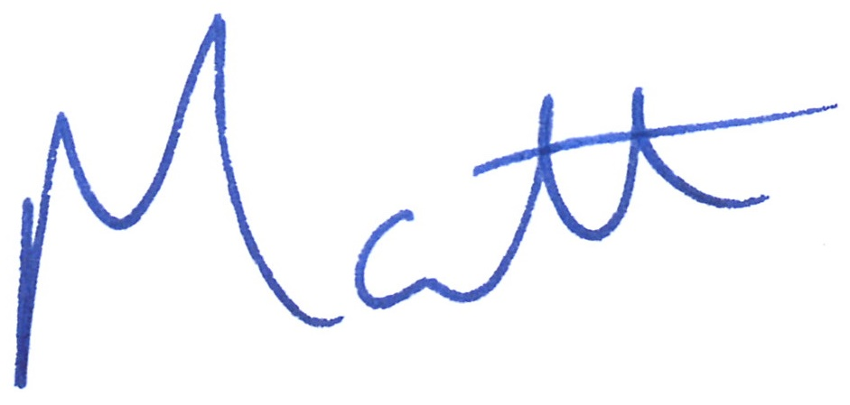
MATT HANCOCK

