  Office of the Secretary of State for Wales  Swyddfa Ysgrifennydd Gwladol Cymru |  | Gwydyr House | Tŷ Gwydyr  London | Llundain  SW1A 2NP  T 020 7270 0534  E walesofficefoi@walesoffice.gsi.gov.uk  W www.walesoffice.gov.uk  Our ref: 18 FOI 142  22 October 2018
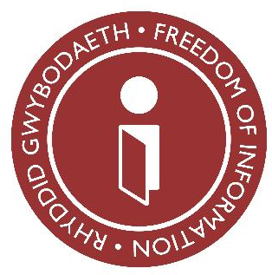
Dear,

FREEDOM OF INFORMATION ACT REQUEST

Thank you for your email of 4 October 2018 requesting information about the Office of the Secretary of State for Wales. You asked for information regarding incidents of staff bullying over the last 3 calendar years (up to and including September 2018). We have handled your request under the Freedom of Information Act 2000.

There have been no reported incidents of staff bullying during this period and therefore no formal action was required.

You may ask for an internal review if you are unhappy with our response to your request. The internal review would be carried out by someone who did not deal with your request, who would re-assess how the Department handled it. Requests for an internal review should be received within two months of our response. If you wish to do this, please write to:

Freedom of Information Team
Wales Office
Gwydyr House
Whitehall
London SW1A 2NP

Email: walesofficefoi@walesoffice.gsi.gov.uk

If you remain dissatisfied after an internal review decision, you have the right to apply to the Information Commissioner’s Office under Section 50 of the Act. You can contact the Information Commissioner’s Office at the following address:

Information Commissioner’s Office
Wycliffe House

Water Lane
Wilmslow
Cheshire
SK9 5AF

If you have any queries about this letter, please contact me at the above address. Please remember to quote the reference number above in any future communications.

Yours sincerely

Freedom of Information Team

