Proposals for Standards for Children in the Youth Justice System 2019
This document should be read in conjunction with the draft Standards for Children in the Youth Justice System and accompanying consultation paper, which explains the background to the consultation, proposals for the new Standards and next steps.
You are invited to respond to the review using this template. Responses must be received by the YJB by 26 November 2018.
Responses should be sent by email to CBU@yjb.gov.uk

Your name
If responding on behalf of an organisation, name of the organisation for which you are responding
Your telephone number
Your email address

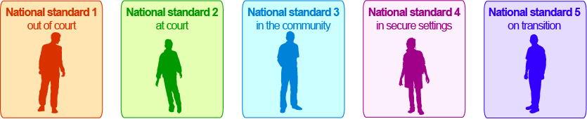

1. The proposed National Standards for Children in the Youth Justice System have been designed to give local authorities the flexibility to provide quality services to children to best meet their needs. To what extent do they achieve this?
Not at all | Partially | Mostly | Fully | Don’t know
☐ | ☐ | ☐ | ☐ | ☐

Additional comments:

2. Do you consider that the National Standards for Children in the Youth Justice System 2019 address the minimum youth justice functions?
These are out of court, at court, in communities, in secure settings, and on transition and resettlement
Not at all | Partially | Mostly | Fully | Don’t know
☐ | ☐ | ☐ | ☐ | ☐

Additional comments:

3. The Standards are intended to move away from processes management to an outcomes focus, to what extent has this been achieved?

Not at all | Partially | Mostly | Fully | Don’t know
☐ | ☐ | ☐ | ☐ | ☐

Additional comments:

4. The Standards are intended to achieve a better understanding of accountability between YOT Management Boards and YOTS, to what extent has this been realised?

Not at all | Partially | Mostly | Fully | Don’t know
☐ | ☐ | ☐ | ☐ | ☐

Additional comments:

5. Do you consider that children with protected characteristics under the Equalities Act 2010 will be impacted by the YJB’s proposal to change National Standards?

Protected characteristics are: age, disability, gender reassignment, marriage and civil partnership, pregnancy and maternity, religion or belief, sex and sexual orientation.
Not at all | Partially | Mostly | Fully | Don’t know
☐ | ☐ | ☐ | ☐ | ☐

Additional comments:

6. The Standards specify the minimum expectations for managing justice services for children and young people across five functions. Please explain any obvious gaps or omissions.

7. Any other comments

