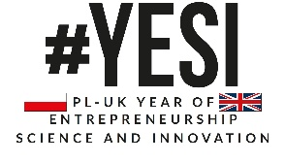

UK Science and Innovation Network Case Study

UK-PL Science Forum showcases the strength of bilateral relations in research and innovation
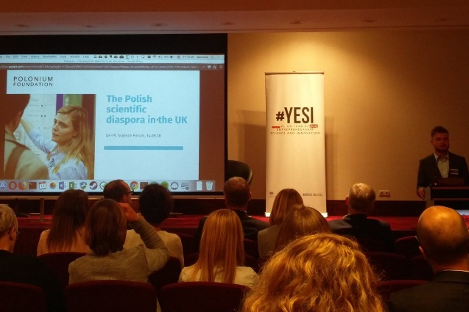
On 13th and 14th September 2018, UK Science & Innovation Network in Poland, in collaboration with British Embassy, Polish Ministry of Science and Higher Education and Top500 Innovators Association organised UK-PL Science Forum in Warsaw. This was the highlight of PL-UK Year of Entrepreneurship, Science and Innovation (YESI), agreed at UK-Poland intergovernmental consultations last December.

The Forum was a 2-day event with 3 workshops and a reception organised on the first day, followed by the main conference with presentations and plenary sessions the following day. Throughout the whole event there was an Innovation Showcase of 18 UK-Polish success stories.
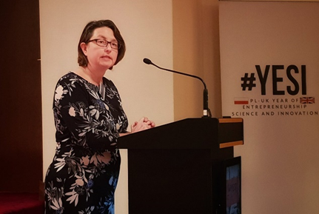
The main conference was opened by Sebastian Skuza, Undersecretary of State at the Polish Science Ministry and Dr Sharon Ellis, BEIS International Science and Innovation Director. They both underlined the importance of bilateral collaboration in research and innovation and willingness for this relationship to expand.
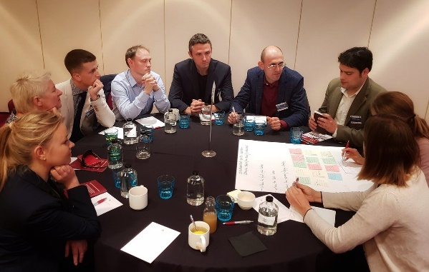
The three workshops focused on UK and Polish collaboration in European Research and Innovation Programmes, Innovation Management and Venture Camps. Panel discussions covered trends, opportunities and challenges in science cooperation between the UK and Poland, building innovation-friendly eco-systems and current and future collaboration in higher education.
Senior representatives of the leading UK and Polish research and innovation institutions, including the Royal Society, Innovate UK, Universities UK International, the Polish National Science Centre, Polish Academy of Sciences, and National Centre for Research and Development took part.
There was over 200 participants, including over 50 from the UK. The forum generated extensive social media engagement, with 73k impressions on the Embassy’s twitter account and 497 Twitter uses of #YESI.
The forum demonstrated the strength of our bilateral links on science and innovation, as well as palpable enthusiasm from both UK and Polish participants to do even more together.
We will continue our Year of Entrepreneurship, Science and Innovation with joint research workshops on Future Cities and Artificial Intelligence to be organised by UK Science and Innovation Network in Poland, British Council and Polish Ministry of Science and Higher Education in Warsaw and Oxford in November 2018.
SIN Poland contact: malgorzata.kielminska@fco.gov.uk
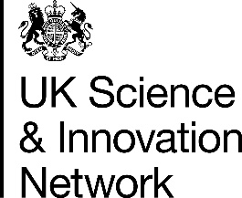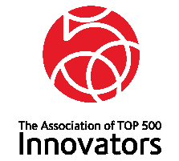

https://www.gov.uk/government/news/year-of-entrepreneurship-science-and-innovation-launched-in-poland

