Department for Environment, Food and Rural Affairs  Welsh Government  Animal and Plant Health Agency (http://www.gov.uk/apha/)  The Eggs and Chicks (England) Regulations 2009  The Eggs and Chicks (Wales) Regulations 2010 |  |  |  |  |  | 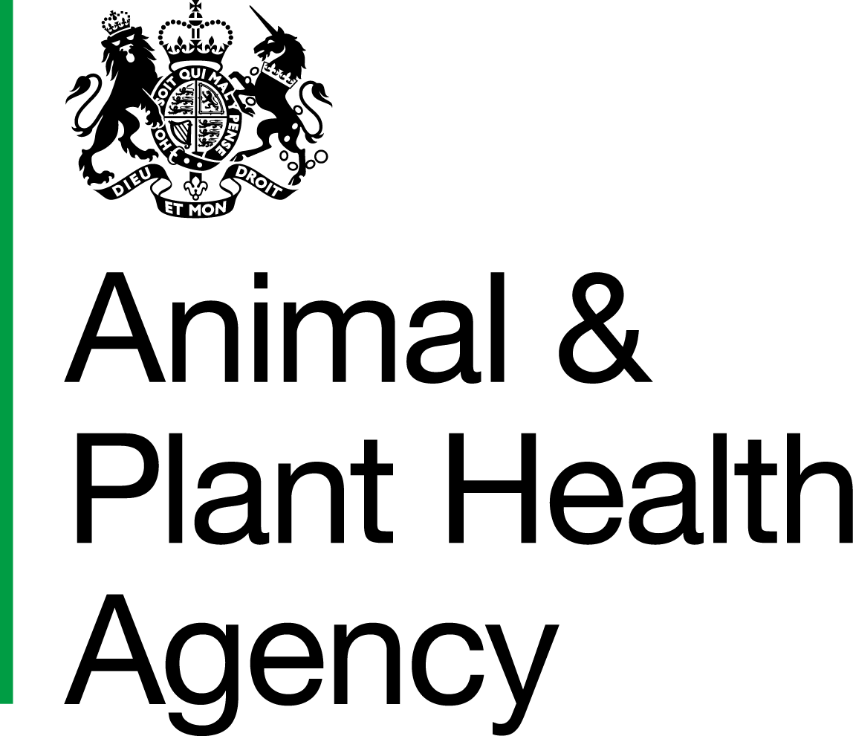
Application for Registration of an Egg Packing Centre
- Please read the Explanatory Leaflet (EMR01) carefully before completing this form. Any enquiries should be addressed to the appropriate Egg Marketing Inspectorate Administration Centre.  - Use black ink and block letters |  |  | Office Stamp
 |  |  | Tel No.
Section A: Applicant Details
Name
Address
 | Postcode
Tel No.
Address of premises to which you wish registration to apply (if different from above)
 | Postcode
Tel No.
An application is required for each packing centre you wish to register.
Each packing centre registered will normally be given a separate number according to location.
Section B: Marketing Requirements
Which production type(s) are you wishing to seek registration to market your eggs? (*delete as appropriate)
*Organic/*Free Range/*Barn/*Eggs from Caged Hens
(a) Details of producers supplying ungraded eggs
Name
Address
 | Postcode
(b) If you produce your own eggs then state:
- No. of hens
- No. and size of house(s)
(c) If ‘Free Range’ area of land available to hens: (plus OS field reference numbers)
(d) Specify day(s) egg grading will take place:
4. Do you wish to use the term ‘Extra’?  (Refer to leaflet EMR01.) |  |  |  |  |  | Yes / No
5. Do you wish to indicate the production origin of your eggs?  (Refer to leaflet EMR01.) |  |  |  |  |  | Yes / No
Section C: Details of packing centre
6. What is the weekly average throughput of the packing centre for:
 |  |  |  |  | Boxes of 360 eggs packed
(a) own ungraded production?
(b) ungraded eggs purchased from producers and other sources?
(c) graded eggs from other sources?
7. Give a description of the premises used for grading, packing and storage of eggs. Include if possible, the size of building(s), type of construction, lighting and ventilation facilities.
Section D: Machinery and equipment
8. Give description of machinery and equipment for candling and grading
Declaration
*I/We apply for registration of
*my/our packing centre and
*I/We declare that the information given in this form is correct to the best of my/our knowledge and belief.
(*Delete as appropriate)
Applicants should be aware that they will need to contact their local Environmental Health Department as they now have input on approval under EC Hygiene Regulations.

Signature |  | Status
Name in  block letters |  | Date

Using and sharing your information
How we use your personal data is set out in the Egg Marketing Inspectorate privacy notice: https://www.gov.uk/government/publications/animal-and-plant-heath-agency-privacy-notices/egg-marketing-inspectorate-privacy-notice

Location of Egg Marketing Administrative Centres

Forward any application(s) or paperwork to Animal and Plant Health Agency (APHA) at the appropriate Administrative Centre. If you have any queries, then address these to your local Administrative Centre listed below:
If your premises are in England, your Administrative Centre is:  Egg Marketing Business Support Team  Customer Service Centre  Animal and Plant Health Agency  County Hall  Spetchley Road  Worcester  WR5 2NP  Telephone: 03000 200 301  Email: CSCOneHealthEggmarketing@apha.gov.uk | If your premises are in Wales, then contact your Egg Marketing Inspector via the:  Animal and Plant Health Agency  Penrallt Offices  Caernarfon  Gwynedd  Wales  LL55 1BN  Telephone: 0300 303 8268

APHA is an Executive Agency of the Department for Environment, Food and Rural Affairs and also works on behalf of the Scottish Government, Welsh Government and Food Standards Agency to safeguard animal and plant health for the benefit of people, the environment and the economy.

