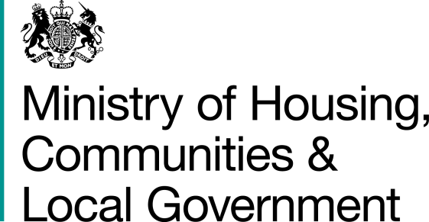

Supporting Families Against Youth Crime

Application form

Please email your form to families.team@communities.gsi.gov.uk no later than 23:45 on Friday 7th December

Applicant(s)

1.1 Local Authority name(s)
(in whose name the application is being made)

1.2 Contact name and main role  (a) name  (b) main role | (a) | (b)
1.3 Address

1.4 Telephone number  (a) organisation  (b) contact | (a) | (b)
1.5 Email address of contact

Sign off

 | Organisation | Name and signature
2.1 Local Authority Section 151 officer (required)
2.2 Director of Children’s Services (required)
2.3 Police force or Police and Crime commissioner (required)
2.4 Troubled Families Coordinator (required)
2.5 Other partners (VCS, education settings) (desirable)

Please ensure answers do not exceed the stated word limit.
Additional attachments will not be accepted.

Evidence of local need
Please set out evidence that gang and youth crime is an issue in the area or has potential to be an issue in your area. Please use data to illustrate your point for example crime data or risk factors such as school exclusions.

Maximum 300 words

Please add your response here

Proposed intervention
Please outline the detail of your proposed intervention and cover the following questions.
- What is the nature of your proposed intervention?
- How is this consistent with the principles of the Troubled Families programme?
- How will you ensure the intervention is targeted at those families who are at greatest risk?
- What’s the evidence for your intervention – why do you think it’ll work?
- How does this intervention represent additionality to your existing Troubled Families Programme?

Maximum 700 words

Please add your response here

Benefits, monitoring and evaluation
What are the benefits that your intervention aims to achieve? These could be early indicators of success such as improved resilience of children or a reduction of school exclusions.
- How many young people and parents / carers will benefit from the proposed intervention?
- What data will you capture to evidence these benefits?
- What local evaluation do you propose to evaluate the efficacy of your intervention?
- How will this initiative support developing the right approach in the future?
Maximum 700 words

Please add your response here

Partnership working and deliverability of the proposal
We will expect proposals to demonstrate the capacity and resource to deliver the interventions including
- What support do you have from partners?
- Evidence of viable delivery partnerships with the voluntary and community sector
- The capacity to deliver at pace
- How will this support your overall approach and work together with other initiatives? Have you applied for example to the Early Intervention Youth Fund?
- Robust arrangements for required staff to be in place
- A high-level implementation plan (which can be attached, and not included within word limit)
Maximum 500 words

Please add your response here

Budget breakdown

 | Financial year 18/19 | Financial year 19/20
Proposed funding to VCS organisations | £
Cost type 1 (e.g. staffing)
Cost type 2 (e.g. evaluation)
Cost type 3
(e.g. training)

Total funding | £ | £

Add additional rows as required

For bids from one local authority, the bid maximum is £500,000. You should clearly state the money that will go to other partners and set out any plans for sustaining the initiative.

