UK Standards for Microbiology Investigations

Deoxyribonuclease test

Acknowledgments
UK Standards for Microbiology Investigations (UK SMIs) are developed under the auspices of Public Health England (PHE) working in partnership with the National Health Service (NHS), Public Health Wales and with the professional organisations whose logos are displayed below and listed on the website https://www.gov.uk/uk-standards-for-microbiology-investigations-smi-quality-and-consistency-in-clinical-laboratories. UK SMIs are developed, reviewed and revised by various working groups which are overseen by a steering committee (see https://www.gov.uk/government/groups/standards-for-microbiology-investigations-steering-committee).
The contributions of many individuals in clinical, specialist and reference laboratories who have provided information and comments during the development of this document are acknowledged. We are grateful to the medical editors for editing the medical content.
For further information please contact us at:
Standards Unit
National Infection Service
Public Health England
61 Colindale Avenue
London NW9 5EQ
E-mail: standards@phe.gov.uk
Website: https://www.gov.uk/uk-standards-for-microbiology-investigations-smi-quality-and-consistency-in-clinical-laboratories
PHE publications gateway number: 2018493
UK Standards for Microbiology Investigations are produced in association with:
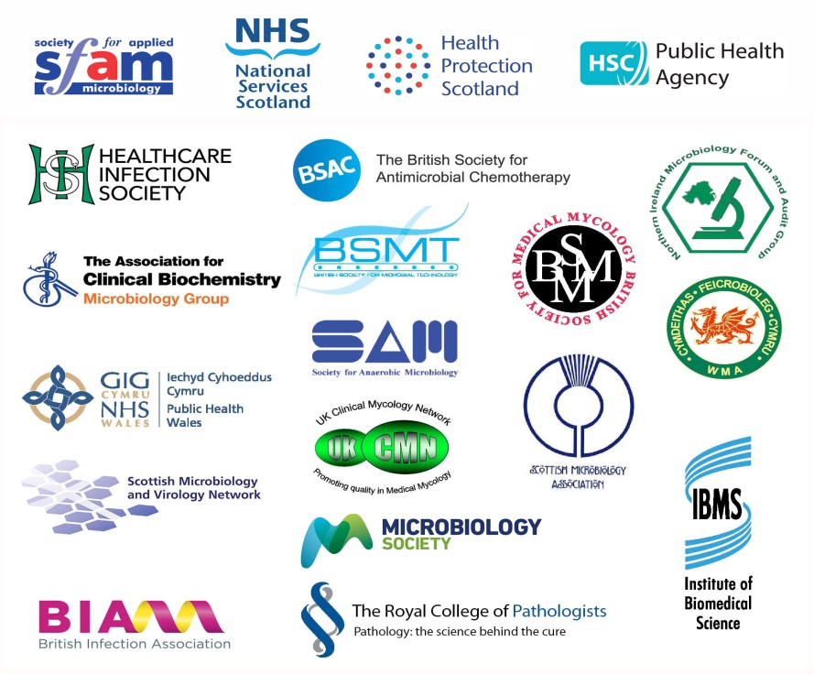
Logos correct at time of publishing.
Contents
Acknowledgments 2
Contents 3
Amendment table 4
Scope of document 7
Introduction 7
Technical information/limitations 7
1 Safety considerations 9
2 Reagents and equipment 9
3 Quality control organisms 9
4 Procedure and results 9
Appendix: Deoxyribonuclease test 12
References 13

Amendment table
Each UK SMI method has an individual record of amendments. The current amendments are listed on this page. The amendment history is available from standards@phe.gov.uk.
New or revised documents should be controlled within the laboratory in accordance with the local quality management system.
Amendment number/date | 9/11.09.18
Issue number discarded | 3
Insert issue number | 4
Anticipated next review date* | 11.09.21
Section(s) involved | Amendment
Whole document. | Document updated.  Technical limitations/information updated with subheadings.  References updated with grades.  Flowchart updated.  Quality control organisms updated.

∗Reviews can be extended up to five years subject to resources available.

UK SMI#: scope and purpose
Users of UK SMIs
Primarily, UK SMIs are intended as a general resource for practising professionals operating in the field of laboratory medicine and infection specialties in the UK. UK SMIs also provide clinicians with information about the available test repertoire and the standard of laboratory services they should expect for the investigation of infection in their patients, as well as providing information that aids the electronic ordering of appropriate tests. The documents also provide commissioners of healthcare services with the appropriateness and standard of microbiology investigations they should be seeking as part of the clinical and public health care package for their population.
Background to UK SMIs
UK SMIs comprise a collection of recommended algorithms and procedures covering all stages of the investigative process in microbiology from the pre-analytical (clinical syndrome) stage to the analytical (laboratory testing) and post analytical (result interpretation and reporting) stages. Syndromic algorithms are supported by more detailed documents containing advice on the investigation of specific diseases and infections. Quality guidance notes describe laboratory processes which underpin quality, for example assay validation.
Standardisation of the diagnostic process through the application of UK SMIs helps to assure the equivalence of investigation strategies in different laboratories across the UK and is essential for public health surveillance, research and development activities.
Equal partnership working
UK SMIs are developed in equal partnership with PHE, NHS, Royal College of Pathologists and professional societies. The list of participating societies may be found at https://www.gov.uk/uk-standards-for-microbiology-investigations-smi-quality-and-consistency-in-clinical-laboratories. Inclusion of a logo in an UK SMI indicates participation of the society in equal partnership and support for the objectives and process of preparing UK SMIs. Nominees of professional societies are members of the Steering Committee and working groups which develop UK SMIs. The views of nominees cannot be rigorously representative of the members of their nominating organisations nor the corporate views of their organisations. Nominees act as a conduit for two way reporting and dialogue. Representative views are sought through the consultation process. UK SMIs are developed, reviewed and updated through a wide consultation process.
Quality assurance
NICE has accredited the process used by the UK SMI working groups to produce UK SMIs. The accreditation is applicable to all guidance produced since October 2009. The process for the development of UK SMIs is certified to ISO 9001:2008. UK SMIs represent a good standard of practice to which all clinical and public health microbiology laboratories in the UK are expected to work. UK SMIs are NICE accredited and represent neither minimum standards of practice nor the highest level of complex laboratory investigation possible. In using UK SMIs, laboratories should take account of local requirements and undertake additional investigations where appropriate. UK SMIs help laboratories to meet accreditation requirements by promoting high quality practices which are auditable. UK SMIs also provide a reference point for method development. The performance of UK SMIs depends on competent staff and appropriate quality reagents and equipment. Laboratories should ensure that all commercial and in-house tests have been validated and shown to be fit for purpose. Laboratories should participate in external quality assessment schemes and undertake relevant internal quality control procedures.
Patient and public involvement
The UK SMI working groups are committed to patient and public involvement in the development of UK SMIs. By involving the public, health professionals, scientists and voluntary organisations the resulting UK SMI will be robust and meet the needs of the user. An opportunity is given to members of the public to contribute to consultations through our open access website.
Information governance and equality
PHE is a Caldicott compliant organisation. It seeks to take every possible precaution to prevent unauthorised disclosure of patient details and to ensure that patient-related records are kept under secure conditions. The development of UK SMIs is subject to PHE Equality objectives https://www.gov.uk/government/organisations/public-health-england/about/equality-and-diversity.
The UK SMI working groups are committed to achieving the equality objectives by effective consultation with members of the public, partners, stakeholders and specialist interest groups.
Legal statement
While every care has been taken in the preparation of UK SMIs, PHE and the partner organisations, shall, to the greatest extent possible under any applicable law, exclude liability for all losses, costs, claims, damages or expenses arising out of or connected with the use of an UK SMI or any information contained therein. If alterations are made by an end user to an UK SMI for local use, it must be made clear where in the document the alterations have been made and by whom such alterations have been made and also acknowledged that PHE and the partner organisations shall bear no liability for such alterations. For the further avoidance of doubt, as UK SMIs have been developed for application within the UK, any application outside the UK shall be at the user’s risk.
The evidence base and microbial taxonomy for the UK SMI is as complete as possible at the date of issue. Any omissions and new material will be considered at the next review. These standards can only be superseded by revisions of the standard, legislative action, or by NICE accredited guidance.
UK SMIs are Crown copyright which should be acknowledged where appropriate.
Suggested citation for this document
Public Health England. (2018). Deoxyribonuclease test. UK Standards for Microbiology Investigations. TP 12 Issue 4. https://www.gov.uk/uk-standards-for-microbiology-investigations-smi-quality-and-consistency-in-clinical-laboratories
Scope of document
This test is used to determine the ability of an organism to produce deoxyribonuclease (DNase), an enzyme which is capable of degrading deoxyribonucleic acid (DNA)¹. The DNase test should be used in conjunction with other tests for the identification of S. aureus.
The thermonuclease test is described in TP 34 - Thermonuclease test.
This UK SMI should be used in conjunction with other UK SMIs.
Introduction
The test is used primarily as a supplementary presumptive test to distinguish pathogenic staphylococci which produce large quantities of extracellular DNase. The DNase reacts with media containing DNA with the resulting hydrolysis of the DNA. The oligonucleotides liberated by the hydrolysis are soluble in acid and in a positive reaction, the addition of hydrochloric acid results in a clear zone around the inoculum. Due to the precipitation of DNA by hydrochloric acid, in a negative reaction, the solution becomes cloudy. In contrast to hydrochloric acid, toluidine blue produces much more clearly delineated zones of DNase activity².
Most strains of Staphylococcus aureus hydrolyse DNA and give positive reactions in this test, but some MRSA strains do not and some strains of the coagulase negative staphylococci may give weak reactions such as Staphylococcus capitis. Some strains of Staphylococcus intermedius are DNase positive. Subspecies of Staphylococcus schleiferi are DNase positive and produce heat stable nucleases³.
This test also aids in the differentiation of closely related genera within the Klebsiella-Enterobacter-Serratia division of Enterobacteriaceae and several other pathogens, including Pseudomonas aeruginosa^{3,4}.
Serratia and Moraxella species also produce deoxyribonuclease.
Technical information/limitations
Spot Inoculation
Spot-inoculate strains, including controls, so as not to overlap.
1M Hydrochloric acid (HCl) procedure
There are some disadvantages that limit the usefulness of the 1M Hydrochloric acid (HCl) procedure; the 1M HCl is bactericidal for staphylococci in either isolated colonies or in heavier, more confluent growth. Once the HCl has been applied, the test must be read within 5 minutes and cannot be continued by reincubation^{1,5}.
Concentration of toluidine blue O
Optimum expression of DNase activity depends upon an exact concentration of toluidine blue O (TBO) in the TBO flooding solutions. Therefore, strict attention must be paid to the dye content of commercially available TBO powders; TBO concentrations must reflect actual dye concentrations. Calculations must include a conversion factor that accounts for the true dye content of commercial preparations^{2,3}.

Alternative DNase test agar media
The Methyl green – DNase test agar is an improved, highly sensitive alternative agar medium that could be used in place of the traditional DNase test agar. The use of this agar media is based on the modification of Jefferies et al procedure¹. It supports growth of both Gram positive and Gram negative bacteria. In this scenario, the DNase producing organisms depolymerises the DNA substrate in the medium followed by the methyl green fading into a colourless compound which is exhibited as distinct clear zones around growth against the green background. Fading does not happen instantly, it takes about 4 to 6hrs incubation for this to occur³. Its main advantage is that it does not require reagent addition as it is contained within the already prepared agar medium.
1 Safety considerations⁶⁻²³
Refer to current guidance on the safe handling of all organisms and reagents documented in this UK SMI.
All work likely to generate aerosols must be performed in a microbiological safety cabinet.
Hydrochloric acid is a highly corrosive substance. The hazards of solutions of hydrochloric acid depend on the concentration. Personal protective equipment such as rubber or PVC gloves, protective eye goggles, and protective clothing and shoes are used to minimise risks when handling hydrochloric acid.
The above guidance should be supplemented with local COSHH and risk assessments.
Compliance with postal and transport regulations is essential.
2 Reagents and equipment
Discrete pure bacterial colonies growing on solid medium.
DNase test agar.
Bacteriological straight wire/loop (preferably nichrome) or disposable alternative or disposable Pasteur pipette.
1M hydrochloric acid^{1,3}
Note: Some manufacturers will refer to this acid as “1N hydrochloric acid”. They both mean the same thing.
OR
0.01% to 0.05% toluidine blue O solution²
3 Quality control organisms
Positive control
Staphylococcus aureus NCTC 6571 or NCTC 12973
Negative control
Staphylococcus haemolyticus NCTC 11042
Note: These strains have been validated by NCTC to give this result.
4 Procedure and results
For all methods the surface moisture from the DNase test agar plates must be dried and each plate divided into sections by drawing lines on the bottom of the plate. There are two types of inoculation that can be done. They are as follows: spot inoculation or the band or line streak inoculation³. For the step by step procedure on how to perform these inoculations, refer to UK SMI Q 5: Inoculation of culture media for bacteriology.

Spot inoculation³
- touch a colony of the organism under test with a loop and inoculate it onto a small area of the DNase test agar plate, in the middle of one of the marked sections to form a thick plaque of growth 5-10mm in diameter after incubation. It also helps to stab the agar as well as plate out on the surface
- incubate the plate at 37°C for 18-24hr

Band or line streak inoculation³
- use a heavy inoculum and draw a line 3-4cm long from the rim to the centre of the DNase test agar plate
- incubate the plate at 37°C for 18-24hr
4.1 Detection of DNase activity by flooding with hydrochloric acid¹
- flood the plate to a depth of a few millimetres of 1M hydrochloric acid to precipitate unhydrolysed DNA
- leave the plate to stand for a few minutes to allow the reagent to absorb into the DNase test agar plate
- decant excess hydrochloric acid and then examine against a dark background
- always compare the zone around the test strain with the control zones
- unhydrolysed DNA is precipitated and produces a white cloudy area in the agar because of the reaction of HCl with DNA salts in the DNase test agar plate

Positive result
Colonies surrounded by clear zones comparable in width to that around the DNase positive control.

Negative result
No zone of clearing or a zone narrower than the DNase positive control.
OR
Cloudy precipitate around colony and throughout DNase test agar plate.
4.2 Detection of DNase activity by flooding with toluidine blue O (TBO) solution^{2,3}
- flood the plate to a depth of a few millimetres of TBO to complex with either hydrolysed or unhydrolysed DNA
- leave the DNase test agar plate to stand for 3-5 minutes
- decant excess TBO and examine immediately
- always compare the zone around the test strain with the control zones
- read at 5 minute intervals for up to 30 minutes
- TBO forms a complex with hydrolysed DNA to produce bright pink zones surrounding colonies on a royal blue background. DNase-negative organisms produce no change in the background colour

Positive result
Bright pink zones surrounding colonies on a royal blue background comparable to that around the DNase positive control.

Negative result
No change in background colour.
Appendix: Deoxyribonuclease test

References
Modified GRADE table used by UK SMIs when assessing references

Grading of Recommendations, Assessment, Development, and Evaluation (GRADE) is a systematic approach to assessing references. A modified GRADE method is used in UK SMIs for appraising references for inclusion. Each reference is assessed and allocated a grade for strength of recommendation (A-D) and quality of the underlying evidence (I-VI). A summary table which defines the grade is listed below and should be used in conjunction with the reference list.

Strength of recommendation | Quality of evidence
A Strongly recommended | I Evidence from randomised controlled trials, meta-analysis and systematic reviews
B Recommended but other alternatives may be acceptable | II Evidence from non-randomised studies
C Weakly recommended: seek alternatives | III Non-analytical studies, for example, case reports, reviews, case series
D Never recommended | IV Expert opinion and wide acceptance as good practice but with no study evidence
 | V Required by legislation, code of practice or national standard
 | VI Letter or other

1. Jeffries CD, Holtman DF, Guse DG. Rapid method for determining the activity of microorganisms on nucleic acids. JBacteriol 1957;73:590-1. C, III

2. Waller JR, Hodel SL, Nuti RN. Improvement of two toluidine blue O-mediated techniques for DNase detection. JClinMicrobiol 1985;21:195-9. B, II

3. MacFaddin JF. Deoxyribonuclease and Thermonuclease Tests. Biochemical Tests for Identification of Medical Bacteria. 3rd ed. Philadelphia; 2000. p. 137-59. B, III

4. Pimenta FP, Souza MC, Pereira GA, Hirata R, Jr., Camello TC, Mattos-Guaraldi AL. DNase test as a novel approach for the routine screening of Corynebacterium diphtheriae. LettApplMicrobiol 2008;46:307-11. B, II

5. Gerceker D, Karasartova D, Elyurek E, Barkar S, Kiyan M, Ozsan TM et al. A new, simple, rapid test for detection of DNase activity of microorganisms: DNase Tube test. JGenApplMicrobiol 2009;55:291-4. B, II

6. European Parliament. UK Standards for Microbiology Investigations (UK SMIs) use the term "CE marked leak proof container" to describe containers bearing the CE marking used for the collection and transport of clinical specimens. The requirements for specimen containers are given in the EU in vitro Diagnostic Medical Devices Directive (98/79/EC Annex 1 B 2.1) which states: "The design must allow easy handling and, where necessary, reduce as far as possible contamination of, and leakage from, the device during use and, in the case of specimen receptacles, the risk of contamination of the specimen. The manufacturing processes must be appropriate for these purposes". 1998. A, V

7. Official Journal of the European Communities. Directive 98/79/EC of the European Parliament and of the Council of 27 October 1998 on in vitro diagnostic medical devices 1998. 1-37. A, V

8. Health and Safety Executive. Safe use of pneumatic air tube transport systems for pathology specimens. 2009. A, V

9. Department for Transport. Transport of Infectious Substances, 2011 Revision 5. 2011. A, V

10. World Health Organization. Guidance on regulations for the Transport of Infectious Substances 2017-2018. 2017. A, V

11. Home Office. Anti-terrorism, Crime and Security Act. 2001. A, V

12. Advisory Committee on Dangerous Pathogens. The Approved List of Biological Agents. Health and Safety Executive 2013. 1-35. A, V

13. Advisory Committee on Dangerous Pathogens. Infections at work: Controlling the risks. Her Majesty's Stationery Office 2003. A, V

14. Advisory Committee on Dangerous Pathogens. Biological agents: Managing the risks in laboratories and healthcare premises. Health and Safety Executive 2005. A, V

15. Advisory Committee on Dangerous Pathogens. Biological Agents: Managing the Risks in Laboratories and Healthcare Premises. Appendix 1.2 Transport of Infectious Substances - Revision. Health and Safety Executive 2008. A, V

16. Centers for Disease Control and Prevention. Guidelines for Safe Work Practices in Human and Animal Medical Diagnostic Laboratories. MMWR Surveill Summ 2012;61:1-102. B, IV

17. Health and Safety Executive. Control of Substances Hazardous to Health Regulations. The Control of Substances Hazardous to Health Regulations 2002 (as amended). HSE Books,. 2013. A, V

18. Health and Safety Executive. Five Steps to Risk Assessment: A Step by Step Guide to a Safer and Healthier Workplace. HSE Books,. 2002. A, V

19. Health and Safety Executive. A Guide to Risk Assessment Requirements: Common Provisions in Health and Safety Law. HSE Books,. 2002. A, V

20. Health Services Advisory Committee. Safe Working and the Prevention of Infection in Clinical Laboratories and Similar Facilities. HSE Books 2003. A, V

21. British Standards Institution (BSI). BS EN12469 - Biotechnology - performance criteria for microbiological safety cabinets 2000. A, V

22. British Standards Institution (BSI). BS 5726:2005 - Microbiological safety cabinets. Information to be supplied by the purchaser and to the vendor and to the installer, and siting and use of cabinets. Recommendations and guidance. 2005. 1-14. A, V

23. Department of Health. Transport of Infectious Substances. Best Practice Guidance for Microbiology Laboratories. Department of Health. 1-13. 2007. A, V

# Microbiology is used as a generic term to include the two GMC-recognised specialties of Medical Microbiology (which includes Bacteriology, Mycology and Parasitology) and Medical Virology.

