UK Standards for Microbiology Investigations

Aesculin hydrolysis test
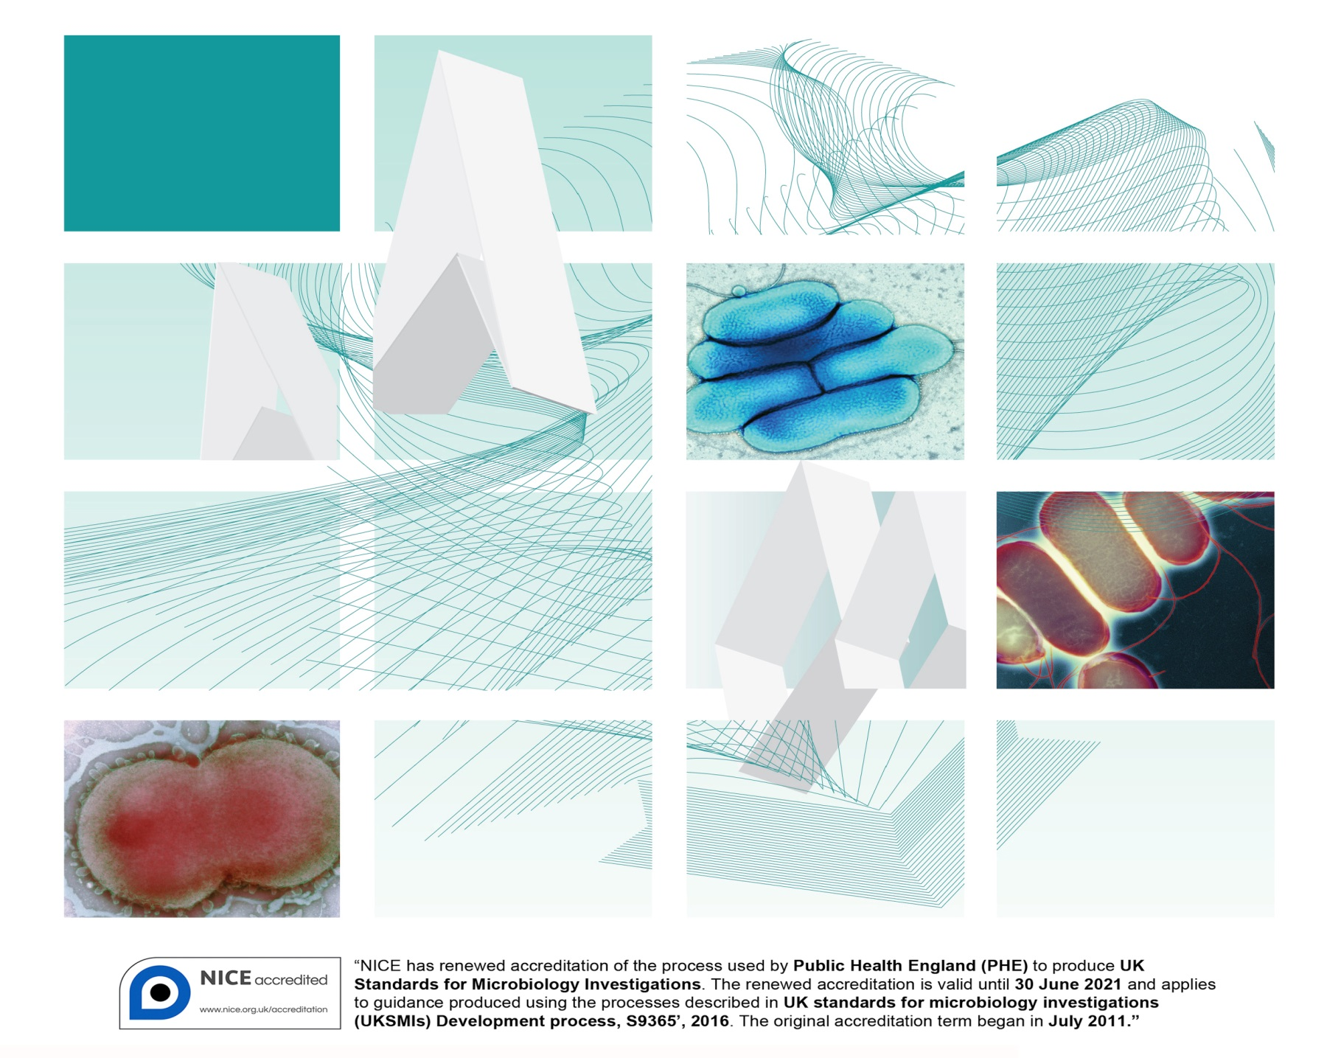

Acknowledgments
UK Standards for Microbiology Investigations (UK SMIs) are developed under the auspices of Public Health England (PHE) working in partnership with the National Health Service (NHS), Public Health Wales and with the professional organisations whose logos are displayed below and listed on the website https://www.gov.uk/uk-standards-for-microbiology-investigations-smi-quality-and-consistency-in-clinical-laboratories. UK SMIs are developed, reviewed and revised by various working groups which are overseen by a steering committee (see https://www.gov.uk/government/groups/standards-for-microbiology-investigations-steering-committee).
The contributions of many individuals in clinical, specialist and reference laboratories who have provided information and comments during the development of this document are acknowledged. We are grateful to the medical editors for editing the medical content.
For further information please contact us at:
Standards Unit
National Infection Service
Public Health England
61 Colindale Avenue
London NW9 5EQ
E-mail: standards@phe.gov.uk
Website: https://www.gov.uk/uk-standards-for-microbiology-investigations-smi-quality-and-consistency-in-clinical-laboratories
PHE publications gateway number: 2018493
UK Standards for Microbiology Investigations are produced in association with:
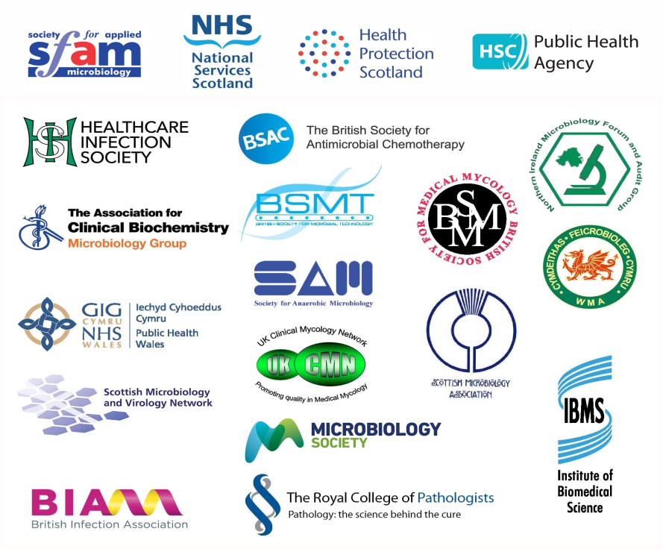
Logos correct at time of publishing.
Contents
Acknowledgments 2
Contents 3
Amendment table 4
UK SMI: scope and purpose 5
Scope of document 7
Introduction 7
Technical information/limitations 8
1 Safety considerations 9
2 Reagents and equipment 9
3 Quality control organisms 9
4 Procedure and results 9
Appendix: Aesculin hydrolysis test 11
References 12

Amendment table
Each UK SMI method has an individual record of amendments. The current amendments are listed on this page. The amendment history is available from standards@phe.gov.uk.
New or revised documents should be controlled within the laboratory in accordance with the local quality management system.
Amendment number/date | 7/10.09.18
Issue number discarded | 3
Insert issue number | 4
Anticipated next review date* | 10.09.21
Section(s) involved | Amendment
Whole document. | Document updated.  Technical limitations/information updated with subheadings.  Flowchart updated with information on shorter incubation times for some organisms.
References. | References updated with grades.

∗Reviews can be extended up to five years subject to resources available.

UK SMI#: scope and purpose
Users of UK SMIs
Primarily, UK SMIs are intended as a general resource for practising professionals operating in the field of laboratory medicine and infection specialties in the UK. UK SMIs also provide clinicians with information about the available test repertoire and the standard of laboratory services they should expect for the investigation of infection in their patients, as well as providing information that aids the electronic ordering of appropriate tests. The documents also provide commissioners of healthcare services with the appropriateness and standard of microbiology investigations they should be seeking as part of the clinical and public health care package for their population.
Background to UK SMIs
UK SMIs comprise a collection of recommended algorithms and procedures covering all stages of the investigative process in microbiology from the pre-analytical (clinical syndrome) stage to the analytical (laboratory testing) and post analytical (result interpretation and reporting) stages. Syndromic algorithms are supported by more detailed documents containing advice on the investigation of specific diseases and infections. Quality guidance notes describe laboratory processes which underpin quality, for example assay validation.
Standardisation of the diagnostic process through the application of UK SMIs helps to assure the equivalence of investigation strategies in different laboratories across the UK and is essential for public health surveillance, research and development activities.
Equal partnership working
UK SMIs are developed in equal partnership with PHE, NHS, Royal College of Pathologists and professional societies. The list of participating societies may be found at https://www.gov.uk/uk-standards-for-microbiology-investigations-smi-quality-and-consistency-in-clinical-laboratories. Inclusion of a logo in an UK SMI indicates participation of the society in equal partnership and support for the objectives and process of preparing UK SMIs. Nominees of professional societies are members of the Steering Committee and working groups which develop UK SMIs. The views of nominees cannot be rigorously representative of the members of their nominating organisations nor the corporate views of their organisations. Nominees act as a conduit for two way reporting and dialogue. Representative views are sought through the consultation process. UK SMIs are developed, reviewed and updated through a wide consultation process.
Quality assurance
NICE has accredited the process used by the UK SMI working groups to produce UK SMIs. The accreditation is applicable to all guidance produced since October 2009. The process for the development of UK SMIs is certified to ISO 9001:2008. UK SMIs represent a good standard of practice to which all clinical and public health microbiology laboratories in the UK are expected to work. UK SMIs are NICE accredited and represent neither minimum standards of practice nor the highest level of complex laboratory investigation possible. In using UK SMIs, laboratories should take account of local requirements and undertake additional investigations where appropriate. UK SMIs help laboratories to meet accreditation requirements by promoting high quality practices which are auditable. UK SMIs also provide a reference point for method development. The performance of UK SMIs depends on competent staff and appropriate quality reagents and equipment. Laboratories should ensure that all commercial and in-house tests have been validated and shown to be fit for purpose. Laboratories should participate in external quality assessment schemes and undertake relevant internal quality control procedures.
Patient and public involvement
The UK SMI working groups are committed to patient and public involvement in the development of UK SMIs. By involving the public, health professionals, scientists and voluntary organisations the resulting UK SMI will be robust and meet the needs of the user. An opportunity is given to members of the public to contribute to consultations through our open access website.
Information governance and equality
PHE is a Caldicott compliant organisation. It seeks to take every possible precaution to prevent unauthorised disclosure of patient details and to ensure that patient-related records are kept under secure conditions. The development of UK SMIs is subject to PHE Equality objectives https://www.gov.uk/government/organisations/public-health-england/about/equality-and-diversity.
The UK SMI working groups are committed to achieving the equality objectives by effective consultation with members of the public, partners, stakeholders and specialist interest groups.
Legal statement
While every care has been taken in the preparation of UK SMIs, PHE and the partner organisations, shall, to the greatest extent possible under any applicable law, exclude liability for all losses, costs, claims, damages or expenses arising out of or connected with the use of an UK SMI or any information contained therein. If alterations are made by an end user to an UK SMI for local use, it must be made clear where in the document the alterations have been made and by whom such alterations have been made and also acknowledged that PHE and the partner organisations shall bear no liability for such alterations. For the further avoidance of doubt, as UK SMIs have been developed for application within the UK, any application outside the UK shall be at the user’s risk.
The evidence base and microbial taxonomy for the UK SMI is as complete as possible at the date of issue. Any omissions and new material will be considered at the next review. These standards can only be superseded by revisions of the standard, legislative action, or by NICE accredited guidance.
UK SMIs are Crown copyright which should be acknowledged where appropriate.
Suggested citation for this document
Public Health England. (2018). Aesculin hydrolysis test. UK Standards for Microbiology Investigations. TP 2 Issue 4. https://www.gov.uk/uk-standards-for-microbiology-investigations-smi-quality-and-consistency-in-clinical-laboratories
Scope of document
The test is generally used to differentiate enterococci from streptococci^{1,2}. It may be used as a presumptive test for other organisms for example Listeria species, Bacteroides fragilis group and Enterobacteriaceae.
This UK SMI should be used in conjunction with other UK SMIs.
Introduction
The aesculin hydrolysis test is used to determine the ability of an organism to hydrolyse the glycoside aesculin to aesculetin and glucose in the presence of 10-40% bile¹. The bile inhibits growth of most Gram positive cocci other than Enterococcus species and Streptococcus species as well as anaerobic bacteria and most facultative anaerobes. The aesculetin combines with ferric ions in the medium to form a dark brown or black phenolic complex.
The chemical equation for the hydrolysis of aesculin is as follows:

Aesculin + acid aesculinase β-D-glucose + Aesculetin
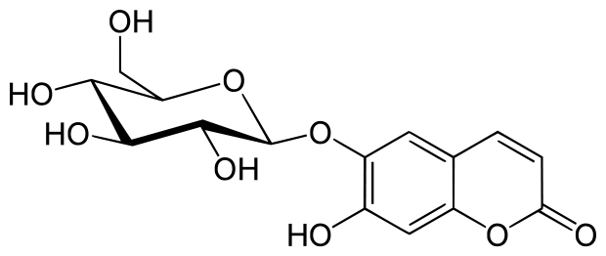
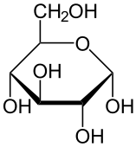 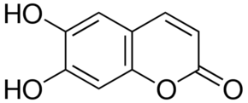
C₁₅H₁₆O₉ C₆H₁₂O₆ C₉H₆O₄

Aesculetin + Fe³⁺ Phenolic iron complex (Black or dark brown colour)
C₉H₆O₄ Ferric ions

Technical information/limitations
Other organisms that hydrolyse aesculin
Non-group D streptococci and other genera eg Aerococcus and Leuconostoc species may give a positive result. Some strains of Leuconostoc and most strains of Pediococcus also have D antigen^{3,4}.
Strains of Lactococcus, Leuconostoc and Pediococcus (isolated from human infections) can give presumptive positive results which could be errorneous⁵.
Some group D streptococci, such as S. mutans, may display a weakly positive result. While they hydrolyse aesculin, they usually do not grow well in the presence of bile^{6,7}. Due to varying nutritional requirements, some strains may be encountered that grow poorly or fail to grow on this medium.

Incubation times
The length of incubation times may vary depending on amount of growth, colony size, reaction and selectivity and so are subject to local evaluations and validations by laboratories. Studies have shown that for this test, additional re-incubation for negative test results is recommended^{1,8,9}.

Difficulty in interpretation of test
A heavy inoculum on bile aesculin agar may cause interpretation of the test difficult to read. Excess inoculum decreases the ability of the bile to inhibit growth of other Gram positive organisms that may hydrolyse aesculin¹.

1 Safety considerations¹⁰⁻²⁶
Refer to current guidance on the safe handling of all organisms and reagents documented in this UK SMI.
All work likely to generate aerosols must be performed in a microbiological safety cabinet.
The above guidance should be supplemented with local COSHH and risk assessments.
Compliance with postal and transport regulations is essential.
2 Reagents and equipment
Discrete bacterial colonies growing on solid medium.
Bile aesculin agar plate/slope⁸.
Bacteriological straight wire/loop (preferably nichrome) or disposable alternative.
3 Quality control organisms
Positive control
Enterococcus faecalis NCTC 12697
Negative control
Streptococcus agalactiae NCTC 8181
Note: These strains have been validated by NCTC to give this result.
4 Procedure and results^{1,8,9}
4.1 Aesculin plate/slope
- using sterile loop, pick one or two colonies from an 18-24 hr culture
- streak or spot inoculate a bile aesculin plate or slope. It also helps to stab the agar as well as plate out on the surface
- incubate at 35-37°C for 18- 24hr if presumptive test for Enterobacteriaceae is required. However, it should be noted that some organisms such as Enterococcus species produce positive results rapidly within 4hr¹
- examine for the presence of a dark brown to black halo around the bacterial growth
- re-incubate further for another 48hr if testing for streptococci or enterococci (optional). However, incubation times may be shortened subject to local evaluations and validations

Positive result
Presence of dark brown or black halos surrounding colonies on plate.
On slope, the dark brown to black colour diffuses onto the slope and onto translucent to white colonies.

Negative result
No colour change on the bile aesculin agar plate/slope or when blackening of less than one half of the medium occurs after 72hr.
Appendix: Aesculin hydrolysis test

*The reference strains have been validated by NCTC for the test shown.
The flowchart is for guidance only.
References
Modified GRADE table used by UK SMIs when assessing references

Grading of Recommendations, Assessment, Development, and Evaluation (GRADE) is a systematic approach to assessing references. A modified GRADE method is used in UK SMIs for appraising references for inclusion. Each reference is assessed and allocated a grade for strength of recommendation (A-D) and quality of the underlying evidence (I-VI). A summary table which defines the grade is listed below and should be used in conjunction with the reference list.

Strength of recommendation | Quality of evidence
A Strongly recommended | I Evidence from randomised controlled trials, meta-analysis and systematic reviews
B Recommended but other alternatives may be acceptable | II Evidence from non-randomised studies
C Weakly recommended: seek alternatives | III Non-analytical studies, for example, case reports, reviews, case series
D Never recommended | IV Expert opinion and wide acceptance as good practice but with no study evidence
 | V Required by legislation, code of practice or national standard
 | VI Letter or other

1. MacFaddin JF. Bile Esculin (Aesculin) Hydrolysis Tests. Biochemical Tests for Identification of Medical Bacteria. 3rd ed.: Lippincott Williams and Wilkins; 2000. p. 8-26. A, III

2. Swan A. The use of a bile-aesculin medium and of Maxted's technique of Lancefield grouping in the identification of enterococci (group D streptococci). JClinPathol 1954;7:160-3. B, III

3. Facklam R, Hollis D, Collins MD. Identification of gram-positive coccal and coccobacillary vancomycin-resistant bacteria. JClinMicrobiol 1989;27:724-30. B, III

4. Ruoff KL. Leuconostoc, Pediococcus, Stomatococcus, and miscellaneous gram-positive cocci that grow aerobically. In: Murray P R, Baron E J, Pfaller M A, Tenover F C, Yolken R H, editors. Manual of CLINICAL MICROBIOLOGY. 7th ed. Washington DC: American Society for Microbiology; 1999. p. 307-15. B, III

5. Facklam RR, Sahm DF, Teixeira LM. Enterococcus. In: Murray PR, Baron EJ, Pfaller MA, Tenover FC, Yolken RH, editors. Manual of clinical microbiology. 7th ed. Washington DC: American Society for Microbiology; 1999. p. 297-305. B, III

6. Sabbaj J, Sutter VL, Finegold SM. Comparison of selective media for isolation of presumptive group D streptococci from human feces. ApplMicrobiol 1971;22:1008-11. B, III

7. Chuard C, Reller LB. Bile-esculin test for presumptive identification of enterococci and streptococci: effects of bile concentration, inoculation technique, and incubation time. JClinMicrobiol 1998;36:1135-6. B, III

8. Facklam RR. Comparison of several laboratory media for presumptive identification of enterococci and group D streptococci. ApplMicrobiol 1973;26:138-45. B, III

9. Facklam RR, Moody MD. Presumptive identification of group D streptococci: the bile-esculin test. ApplMicrobiol 1970;20:245-50. B, III

10. European Parliament. UK Standards for Microbiology Investigations (UK SMIs) use the term "CE marked leak proof container" to describe containers bearing the CE marking used for the collection and transport of clinical specimens. The requirements for specimen containers are given in the EU in vitro Diagnostic Medical Devices Directive (98/79/EC Annex 1 B 2.1) which states: "The design must allow easy handling and, where necessary, reduce as far as possible contamination of, and leakage from, the device during use and, in the case of specimen receptacles, the risk of contamination of the specimen. The manufacturing processes must be appropriate for these purposes". 1998. A, V

11. Official Journal of the European Communities. Directive 98/79/EC of the European Parliament and of the Council of 27 October 1998 on in vitro diagnostic medical devices 1998. 1-37. A, V

12. Health and Safety Executive. Safe use of pneumatic air tube transport systems for pathology specimens. 2009. A, V

13. Department for Transport. Transport of Infectious Substances, 2011 Revision 5. 2011. A, V

14. World Health Organization. Guidance on regulations for the Transport of Infectious Substances 2017-2018. 2017. A, V

15. Home Office. Anti-terrorism, Crime and Security Act. 2001. A, V

16. Advisory Committee on Dangerous Pathogens. The Approved List of Biological Agents. Health and Safety Executive 2013. 1-35. A, V

17. Advisory Committee on Dangerous Pathogens. Infections at work: Controlling the risks. Her Majesty's Stationery Office 2003. A, V

18. Advisory Committee on Dangerous Pathogens. Biological agents: Managing the risks in laboratories and healthcare premises. Health and Safety Executive 2005. A, V

19. Advisory Committee on Dangerous Pathogens. Biological Agents: Managing the Risks in Laboratories and Healthcare Premises. Appendix 1.2 Transport of Infectious Substances - Revision. Health and Safety Executive 2008. A, V

20. Centers for Disease Control and Prevention. Guidelines for Safe Work Practices in Human and Animal Medical Diagnostic Laboratories. MMWR Surveill Summ 2012;61:1-102. B, IV

21. Health and Safety Executive. Control of Substances Hazardous to Health Regulations. The Control of Substances Hazardous to Health Regulations 2002 (as amended). HSE Books,. 2013. A, V

22. Health and Safety Executive. Five Steps to Risk Assessment: A Step by Step Guide to a Safer and Healthier Workplace. HSE Books,. 2002. A, V

23. Health Services Advisory Committee. Safe Working and the Prevention of Infection in Clinical Laboratories and Similar Facilities. HSE Books 2003. A, V

24. British Standards Institution (BSI). BS EN12469 - Biotechnology - performance criteria for microbiological safety cabinets 2000. A, V

25. British Standards Institution (BSI). BS 5726:2005 - Microbiological safety cabinets. Information to be supplied by the purchaser and to the vendor and to the installer, and siting and use of cabinets. Recommendations and guidance. 2005. 1-14. A, V

26. Department of Health. Transport of Infectious Substances. Best Practice Guidance for Microbiology Laboratories. Department of Health. 1-13. 2007. A, V

# Microbiology is used as a generic term to include the two GMC-recognised specialties of Medical Microbiology (which includes Bacteriology, Mycology and Parasitology) and Medical Virology.

