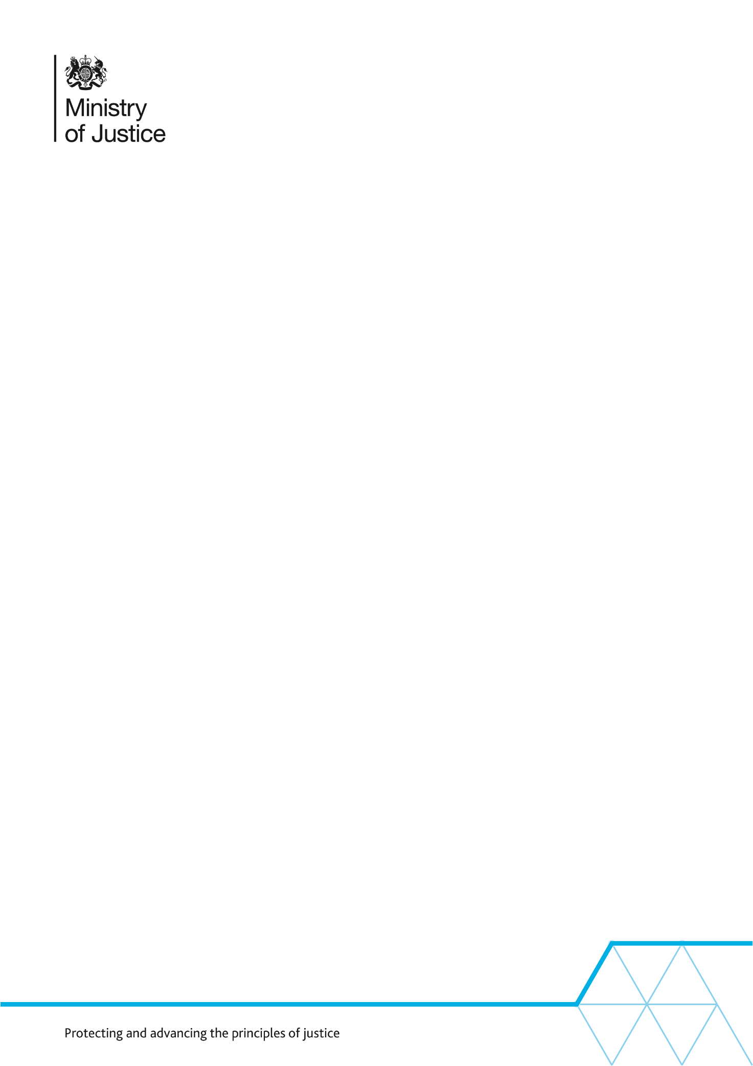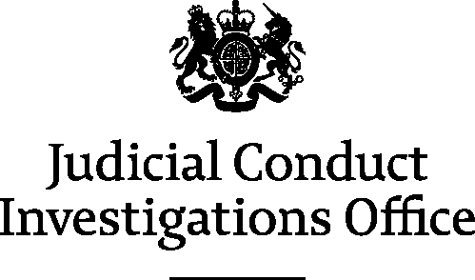

**Judicial Conduct Investigations Office**

**Records Retention and Disposition Schedule**

1. This schedule has been drawn up following consultation between staff in the Judicial Conduct Investigations Office and staff working for the Ministry of Justice (MoJ)’s Departmental Records Officer (DRO).
2. The MoJ uses Records Retention and Disposition Schedules (RRDSs) to manage its compliance with its statutory obligation to destroy records that are not selected for permanent preservation[1]. JCIO records are not selected for permanent preservation.
3. The JCIO’s work is governed by Judicial Discipline (Prescribed Procedures) Regulations 2014 and supporting rules. This schedule is split into two sections:
   1. Records which are specific to the JCIO’s work
   2. Records which are held by various teams within the MoJ and its associated bodies and where a common retention and disposition policy is applied.
4. While the Independent Inquiry into Child Sexual Abuse (IICSA) continues its investigations, the moratorium on the destruction of records of potential interest to IICSA remains in place: All government departments and their associated bodies (in common with other public sector bodies) are required to comply with the moratorium. All business areas should apply the moratorium to any records covered by the following criteria:
   1. documents which contain or may contain content pertaining directly or indirectly to the sexual abuse of children or to child protection and care
   2. the document types include, but are not limited to, correspondence, notes, emails, and case files, regardless of the format in which they are stored (digital, paper, CDs, etc)
   3. for the purposes of this instruction, the word “children” relates to any person under the age of 18
   4. further information about the moratorium is available on IICSA’s website at: <https://www.iicsa.org.uk/news/chair-of-the-inquiry-issues-guidance-on-destruction-of-documents>.
5. As part of its commitment to transparency, this schedule will be published on the MoJ’s webpage: <https://www.gov.uk/government/publications/record-retention-and-disposition-schedules>

| **No.** | **Record type** | **Retention and disposition** |
| --- | --- | --- |
| **Records unique to JCIO** | | |
| 1 | Enquiries and general correspondence | Destroy two years after date of last record. |
| 2 | Judicial conduct complaints which have been rejected or dismissed. | Destroy five years after date of last record.[2] |
| 3 | Judicial conduct complaints which have been upheld. | Review five years after file closure.   * If file is to be destroyed, retain only final submission containing outcome of complaint   Destroy all records 50 years after the date of last record. |
| 4 | Press statements published on the JCIO website about cases in which a sanction has been issued to a judicial office holder | For disciplinary action involving a sanction short of removal from office - remove after one year.  For removal from office - remove after five years. |
| 5 | JCIO policies | Review after five years; destroy if no longer relevant.  Then review annually until no longer needed. |
| **Records managed by a common retention and disposition policy** | | |
| 6 | Parliamentary questions[3] | Folders are closed annually  Destroy one year after folder closed |
| 7 | Ministerial correspondence[4] | Destroy five years after date of response unless there is ongoing correspondence |
| 8 | Publications, business plans and annual reports | Destroy five years after date of last record. |
|  |  |  |
| 9 | Local management information: accommodation; security; personnel records; reference material | Destroy three years after date of last record. |
| 10 | Freedom of Information Act and Data Protection Act responses[5] | Destroy three years after the date of the last correspondence unless requests are investigated by the Information Commissioner (ICO).  ICO investigations should be reviewed four years after last correspondence/folder closed.  Retain or destroy. |
| 10 | Policy documents | Review after five years; destroy if no longer relevant. |
| 11 | Litigation documents[6] | Destroy six years after date of last record. |

Philip Dawkins

Departmental Records Officer   
Ministry of Justice   
102 Petty France, London SW1H 9AJ

**Signed: 24 May 2018**

Date of Original Issue of RRDS: 2007 (for the Office for Judicial Complaints)

Supersedes previous edition dated: June 2014

1. Public Records Act 1958 s.3(6)
2. Retention period reduced from 50 years on 24 May 2018 following review of records that must be kept in order to identify vexatious complainants.
3. Added on 24 May 2018 to be consistent with other MoJ schedules
4. Added on 24 May 2018 to be consistent with other MoJ schedules
5. Amended 24 May 2018 to be consistent with other MoJ schedules
6. Added on 24 May 2018 to be consistent with other MoJ schedules