Title:  The proposed merger of the Gambling Commission and the National Lottery Commission  IA No:  DCMS056  Lead department or agency:  Department for Culture, Media and Sport  Other departments or agencies:  Gambling Commission
  Impact Assessment (IA)
  Date: 26/06/2012
  Stage: Draft
  Source of intervention:
  Type of measure:
  Contact for enquiries:
  Stuart Roberts
  020 7211 6099
Summary: Intervention and Options | RPC:

Cost of Preferred (or more likely) Option: OPTION 1
Total Net Present Value | Business Net Present Value | Net cost to business per year | In scope of One-In, One-Out? | Measure qualifies as
£0.33m | £0.00m | £0.00m | Out of Scope | N/A
What is the problem under consideration? Why is government intervention necessary?
The Government has committed to increasing the accountability and reducing the number and cost of public bodies. Ministers believe that merging the Gambling Commission (GC) and National Lottery Commission (NLC) will help achieve this aim while preserving the appropriate and effective regulation of gambling and the National Lottery and delivering other organisational benefits. A provision to merge the two bodies was therefore included in the Public Bodies Bill which received Royal Assent in December 2011. The creation of a single regulator should ensure that regulation continues to protect the public, particularly in light of rapid change and innovation in the overall gambling market, while allowing regulated sectors to flourish in order to deliver the public benefits outlined above. The Government believes the merged body will be well placed to advise on gambling and National Lottery matters; make evidenced based regulation easier to achieve and create synergies in understanding game and technological developments.

What are the policy objectives and the intended effects?
Over time, the co-location of the two existing bodies (which has already occurred) and the merger will both generate cost savings which should help reduce pressures on existing sources of funding, although this will be offset initially by transitional costs. The merger will continue to protect the public (by ensuring that all gambling including the National Lottery continue to be conducted fairly and openly, are crime free and do not put children or vulnerable people at risk) and subject to that, to permit gambling and maximise the National Lottery’s returns to good causes while securing the benefits from concentrating the expertise on gambling regulation.

What policy options have been considered, including any alternatives to regulation? Please justify preferred option (further details in Evidence Base)
- The power to merge bodies under the Public Bodies Act 2011 allows Ministers to merge bodies in a group. Section 2 of the Act provides for two options, which are considered here. A third option of “do nothing” is also considered. Abolition of the NLC and the transfer of its powers and functions to the Gambling Commission.
- Abolition of both of these bodies and the creation of a new one with the functions and duties of the previous two entities.
- Do Nothing: no merger or abolition of either body, the Gambling Commission and NLC remain as two independent body corporates.
The Evidence Base outlines the costs and savings of each option and indicates that Option 1 is the most financially viable option, and is therefore is the Government’s preferred option.

Will the policy be reviewed? Yes If applicable, set review date: 04/2016

Does implementation go beyond minimum EU requirements?
Are any of these organisations in scope? If Micros not exempted set out reason in Evidence Base. | Micro | < 20 | Small | Medium |  | Large
What is the CO₂ equivalent change in greenhouse gas emissions?  (Million tonnes CO₂ equivalent) |  |  | Traded:  N/A |  | Non-traded:  N/A
I have read the Impact Assessment and I am satisfied that, given the available evidence, it represents a reasonable view of the likely costs, benefits and impact of the leading options.
Signed by the responsible : |  | Date:

Summary: Analysis & Evidence Preferred Option (Option 1)
FULL ECONOMIC ASSESSMENT
Price Base Year 2009 | PV Base Year 2012 | Time Period 10 Year | Net Benefit (Present Value (PV)) (£m)
Price Base Year 2009 | PV Base Year 2012 | Time Period 10 Year | Low: | High: | Best Estimate: 0.33m

COSTS (£m) | Total Transition  (Constant Price) Years |  | Average Annual  (excl. Transition) (Constant Price) | Total Cost  (Present Value)
Low |  | 2
High |  | 2
Best Estimate | 0.8m | 2 |  | 0.8m
Description and scale of key monetised costs by ‘main affected groups’
The Gambling Commission and National Lottery Commission are non-departmental public bodies, the former funded by licence-holders’ fees, the latter through the Consolidated Fund as reimbursed by the National Lottery Distribution Fund. Over the ten-year appraisal period, the merger of the two existing bodies will have generated net cost savings of £0.33m which should help reduce pressures on existing sources of funding. Table 4 of this impact assessment displays these figures in summary. The costs of co-location have been absorbed by existing income from the two bodies. The full cost of delivery of existing Gambling Commission fee-funded services on a financial year basis remains unaffected as a result of the co-location or the merger. There are therefore no monetised costs to be calculated with regards licence fees.
Other key non-monetised costs by ‘main affected groups’
No other costs to consider.
BENEFITS (£m) | Total Transition  (Constant Price) Years |  | Average Annual  (excl. Transition) (Constant Price) | Total Benefit  (Present Value)
Low |  | 2
High |  | 2
Best Estimate | 0.00 | 2 | 0.1m | 1.1m
Description and scale of key monetised benefits by ‘main affected groups’
Over the ten-year appraisal period, the merger of the two existing bodies will have generated net cost savings which should help reduce pressures on existing sources of funding, including fees. By 2020/21, the net saving (taking into account the costs incurred and savings made from the merger during that period) will be approximately £0.33 million in real terms.
Other key non-monetised benefits by ‘main affected groups’
None
Key assumptions/sensitivities/risks Discount rate (%) |  |  |  |  | 3.5

BUSINESS ASSESSMENT (Option 1)
Direct impact on business (Equivalent Annual) £m: |  |  | In scope of OIOO? | Measure qualifies as
Costs: 0.00 | Benefits: 0.00 | Net: 0.00 | NO | Zero Net Cost

Summary: Analysis & Evidence Option 2
FULL ECONOMIC ASSESSMENT
Price Base Year 2009 | PV Base Year 2012 | Time Period 10 Year | Net Benefit (Present Value (PV)) (£m)
Price Base Year 2009 | PV Base Year 2012 | Time Period 10 Year | Low: | High: | Best Estimate: -0.04m

COSTS (£m) | Total Transition  (Constant Price) Years |  | Average Annual  (excl. Transition) (Constant Price) | Total Cost  (Present Value)
Low |  | 2
High |  | 2
Best Estimate | 1.2m | 2 |  | 1.1m
Description and scale of key monetised costs by ‘main affected groups’
The Gambling Commission and National Lottery Commission are non-departmental public bodies, the former funded by license-holders’ fees, the latter through the Consolidated Fund as reimbursed by the National Lottery Distribution Fund. It is expected that the costs incurred from Option 2 will be greater than those of Option 1, but with the same amount of savings being achieved by each of these two options. The additional costs involved with Option 2 are explained further in the Evidence Base. By the end of the ten-year appraisal period, it is expected that Option 2 will have incurred net costs of £0.04m in real terms. T Table 7 of this impact assessment displays these figures in summary. No increase in licence fees, or increase in funding from the Consolidated Fund, would be required to finance the net costs from the option of abolishing the two bodies and creating a new body corporate. This is because the savings that will be realised from the co-location of NLC staff with the Gambling Commission (co-location has already occurred) over the appraisal period will be larger than the additional costs incurred from Option 2. The savings and costs of co-location alone are presented as an annex. The full cost of delivery of existing Gambling Commission fee-funded services on a financial year basis remains unaffected as a result of the co-location or the merger. There are therefore no monetised costs to be calculated with regards license fees.
Other key non-monetised costs by ‘main affected groups’
No other costs to consider.
BENEFITS (£m) | Total Transition  (Constant Price) Years |  | Average Annual  (excl. Transition) (Constant Price) | Total Benefit  (Present Value)
Low |  | 2
High |  | 2
Best Estimate | 0.00 | 2 | 0.1m | 1.1m
Description and scale of key monetised benefits by ‘main affected groups’
Table 4 of this impact assessment displays these figures in summary. No increase in licence fees, or increase in funding from the Consolidated Fund, would be required to finance the net costs from the option of abolishing the two bodies and creating a new body corporate. This is because the savings that will be realised from the co-location of NLC staff with the Gambling Commission (co-location has already occurred) over the appraisal period will be larger than the additional costs incurred from Option 2.
Other key non-monetised benefits by ‘main affected groups’
None
Key assumptions/sensitivities/risks Discount rate (%) |  |  |  |  | 3.5

BUSINESS ASSESSMENT (Option 2)
Direct impact on business (Equivalent Annual) £m: |  |  | In scope of OIOO? | Measure qualifies as
Costs: 0.00 | Benefits: 0.00 | Net: 0.00 | No | Zero Net Cost

Summary: Analysis & Evidence Option 3
FULL ECONOMIC ASSESSMENT
Price Base Year 2009 | PV Base Year 2012 | Time Period 10 Year | Net Benefit (Present Value (PV)) (£m)
Price Base Year 2009 | PV Base Year 2012 | Time Period 10 Year | Low: 0.0m | High: 0.0m | Best Estimate: 0.0m

COSTS (£m) | Total Transition  (Constant Price) Years |  | Average Annual  (excl. Transition) (Constant Price) | Total Cost  (Present Value)
Low |  | 0
High |  | 0
Best Estimate | 0.0m | 0 | 0.0m | 0.0m
Description and scale of key monetised costs by ‘main affected groups’
The Gambling Commission and National Lottery Commission are non-departmental public bodies, the former funded by license-holders’ fees, the latter through the Consolidated Fund as reimbursed by the National Lottery Distribution Fund. The pursuit of Option 3 would represent a ‘do nothing’ option in that there would be no further action taken with regards the NLC and Gambling Commission beyond that of fully realising co-location savings. Consequently, there would be no savings generated in addition to those recognized through co-location. Option 3 would mean that the costs of options 1 and 2 would also be avoided. However, a cost of around £50,000 nominal has been assumed to account for the engagement with stakeholders that the two bodies would have to undertake in order to explain that the merger was no longer to be pursued and that co-location would be the only policy option. No increase in licence fees, or increase in funding from the Consolidated Fund, would be required to finance the net costs from the do nothing option. This is because the savings that will be realised from the co-location of NLC staff with the Gambling Commission (co-location has already occurred) over the appraisal period will be larger than the stakeholder engagement costs incurred from Option 3. The full cost of delivery of existing Gambling Commission fee-funded services on a financial year basis remains unaffected as a result of the co-location or the merger. The savings and costs of co-location alone are presented as an annex. There are therefore no monetised costs to be calculated with regards license fees.
Other key non-monetised costs by ‘main affected groups’
No other costs to consider.
BENEFITS (£m) | Total Transition  (Constant Price) Years |  | Average Annual  (excl. Transition) (Constant Price) | Total Benefit  (Present Value)
Low | N/A | 0 | 0.0m | 0.0m
High | N/A | 0 | 0.0m | 0.0m
Best Estimate | 0.00 | 0 | 0.0m | 0.0m
Description and scale of key monetised benefits by ‘main affected groups’
No benefits on top of those realised by way of co-location.
Other key non-monetised benefits by ‘main affected groups’
None
Key assumptions/sensitivities/risks Discount rate (%) |  |  |  |  | 3.5

BUSINESS ASSESSMENT (Option 3)
Direct impact on business (Equivalent Annual) £m: |  |  | In scope of OIOO? | Measure qualifies as
Costs: 0.00 | Benefits: 0.00 | Net: 0.00 | Yes | OUT

Evidence Base

Introduction and problem under consideration

Legislative background

- The legal power by which the government proposes to merge the Commissions comes from the Public Bodies Act 2011 and, specifically, Section 2 of that Act. That power is broad enough to allow additional provisions to be made that deal with practical or consequential matters necessary to give proper effect to the merger. It is not broad enough to allow any modifications to existing statutory duties and functions which do not follow from the merger to be made to either Commission or the way in which either Commission operates. It is the Government’s intention for the merged body to retain the existing duties and functions of the Gambling and National Lottery Commissions.

- The Gambling Commission has a remit covering Great Britain and the National Lottery Commission covers the United Kingdom. The Government does not envisage any problems in the merged organisation covering different jurisdictions in respect of different functions. It does not, therefore, propose to amend the scope of territorial responsibility for these functions which, in any case, would go beyond the scope of the 2011 Act.

- The National Lottery Commission is a Non-Departmental Public Body (NDPB) responsible for licensing and regulating the National Lottery. In January 2012 it moved from its previous central London office when its lease ended there to co-locate with the Gambling Commission in Birmingham. At the same time, it also introduced shared services, provided by the Gambling Commission, for all its administrative functions. It has six non-executive Commissioners and currently employs 15 staff (reduced from 34 – including all administrative functions - in 2010/11). Its annual expenditure in 2011/12 was £4.5m (including costs of relocation). The NLC is funded through the Consolidated Fund, which is reimbursed by the National Lottery Distribution Fund (NLDF), net of any fees paid into the Consolidated Fund by the National Lottery operator.

- National Lottery games consist of draw-based games, such as Lotto, and Scratchcards. Both forms can be played at retailers and online (where scratchcards take the form of Interactive Instant Win Games). Since the first draw in November 1994, the National Lottery has raised over £27 billion for good causes. The Lottery is operated by Camelot UK Lotteries Ltd, under a licence granted in 2009 following a full, international competition. The present licence was initially granted for a 10 year period, ending in January 2019. This has recently been extended to January 2023.

- The NLC operates at arm’s length from government and its decisions are independent. It has a Board of at least five Commissioners appointed by the Secretary of State for Culture, Media and Sport, who also appoints the Chair. At present, it has seven Commissioners, including the Chief Executive. It meets monthly to make decisions about new Lottery licences and other developments.

- The NLC has the following functions:
- Running the competition process to select the operator of the Lottery, and granting the operator’s licence (which may include such conditions as the NLC considers appropriate).
- Licensing each game that the operator wishes to promote, under such conditions as the NLC considers appropriate.
- Reviewing the terms of the Licences it issues and granting consents under those licences in response to changing circumstances or proposals from the Licensee (for example, in cases of change of ownership; organisational structure; introduction of new technologies or to facilitate significant investment).
- Checking that the operator meets the conditions of its licences and taking enforcement action where conditions are not met. The range of available actions include financial penalties, seeking an order from the High Court, and in extreme cases, revocation of licences.
- Checking that the operator, those who financially benefit from the National Lottery and those who manage its business are fit and proper.
- Its overriding statutory duties are to exercise its functions in a manner it considers will:

  - ensure that the National Lottery, and every lottery that forms a part of it, is run with all due propriety;
  - ensure that the interests of every participant in the lottery are protected; and
  - Subject to these two duties, maximise the amount of money available to good causes.

- The Gambling Commission was set up under the Gambling Act 2005 to regulate commercial gambling in Great Britain and became fully operational on 1 September 2007. It is an independent non-departmental public body sponsored by DCMS. It has xx employees, mostly based in Birmingham, but including over xx compliance and enforcement managers working across Great Britain. It currently has a Board of eight Commissioners appointed by the Secretary of State, including the Chief Executive.

- The GC has a budget of £12m (2010/11) which is entirely funded through licence fees paid by gambling operators.

- The GC regulates arcade operators, bookmakers, bingo operators, casino operators, gaming machine and gambling software suppliers, lottery operators (but not the National Lottery operator) and British-based remote gambling operators. The GC does not regulate spread betting (which is a Financial Services Authority responsibility).

- The GC has a statutory duty to permit gambling in so far as the Commission thinks it is reasonably consistent with the licensing objectives:
- preventing gambling from being a source of crime or disorder, being associated with crime or disorder or being used to support crime,
- ensuring that gambling is conducted in a fair and open way, and
- protecting children and other vulnerable persons from being harmed or exploited by gambling.
and to provide advice to government (both levels) on gambling and its regulation.

- The GC issues: operating licences to organisations and individuals who are providing facilities for gambling; and personal licences to certain individuals working within the industry. The GC also imposes licence conditions and publishes codes of practice (LCCP) after consultation which sets out the manner in which facilities for gambling should be provided. It has legal powers to deal with licensed operators who do not comply with the LCCP including unlimited fines, suspensions or revocations of licences. The GC also has the powers to investigate and prosecute illegal gambling under the Gambling Act 2005 and initiate criminal proceedings in relation to cheating.

Rationale for intervention and policy objectives

- The Government has committed to increasing the accountability and reducing the number and cost of public bodies. Ministers believe that merging the Gambling Commission (GC) and National Lottery Commission (NLC) will help achieve this aim while preserving the appropriate and effective regulation of gambling and the National Lottery and delivering other organisational benefits. A provision to merge the two bodies was therefore included in the Public Bodies Bill which received Royal Assent in December 2011.

- The National Lottery currently produces a public benefit of around £1.6 billion a year for good causes. The regulated Gambling industry is worth £9.9 billion to the UK economy (25% of this comprises of National Lottery GGY), generates over £1.4 billion a year in duty (including the National Lottery) and employs 122,533 people (head count). The creation of a single regulator should ensure that regulation continues to protect the public, particularly in light of rapid change and innovation in the overall gambling market, while allowing regulated sectors to flourish in order to deliver the public benefits outlined above.

- The Government believes the merged body will be well placed to advise on gambling and National Lottery matters; make evidenced based regulation easier to achieve and create synergies in understanding game and technological developments. Bringing the National Lottery and gambling regulation together in the same body should help ensure a common regulatory response to similar issues and risk factors (although the public benefits of the National Lottery and returns to good causes can justify certain regulatory standards being set at a higher level).

- Over time, the co-location of the two existing bodies (which has already occurred) and merger will generate cost savings which should help reduce pressures on existing sources of funding, although this will be offset initially by transitional costs. Details of estimated costs and savings of the proposed merger are set out herein.

- The Government made clear during the passage of the Public Bodies Bill that it will be important for the merged body to demonstrate impartiality in how it regulates different sectors, in particular the National Lottery and the gambling industry. The governance arrangements of the merged organisation should ensure adequate separation of duties and a firewall to be put in place where genuine conflicts might exist.

- Providing the necessary assurance that these issues can be effectively and transparently managed might include: delegating certain Commissioners to take decisions and make recommendations in relation to the National Lottery; establishing a dedicated team to lead on National Lottery issues in order to ensure familiarity and expertise in relation to the Licence and how it operates (thereby allowing those individuals to be isolated from any issues of commercial confidentiality) and ensuring that the way the new organisations works and its decisions are open to scrutiny to reassure stakeholders that there is no conflict.

- The Government has considered whether these requirements should be set out in statute through the 2011 Act order, but has decided that this is neither necessary nor desirable. Experience of other regulators suggests that such structures need flexibility in order to respond to changing regulatory good practice and respond to issues that arise post-merger in a relatively quick and responsive manner. There are also mechanisms in place to ensure appropriate oversight, including the Management Agreement that the DCMS is developing with each of its arms-length bodies.

- While Ministers believe that regulators should be independent of Ministerial intervention on operational matters, the Secretary of State would also retain his current powers of direction over the National Lottery. In relation to gambling, the Secretary of State can impose licence conditions and make regulations prescribing the parameters within which the GC operates. Those powers would continue after merger.

Options

- The power to merge bodies under the Public Bodies Act 2011 Act allows Ministers to merge bodies in a group in Section 2 of the Act:

(a) to abolish all the bodies or offices in the group, create a new body corporate or office and transfer some or all of the functions of the abolished bodies or offices to the new one, or

(b) to abolish all but one of the bodies or offices in the group and to transfer some or all of the functions of the abolished bodies or offices to the remaining one.

The three options presented herein are therefore as follows;

Option 1: Abolition of the NLC and the transfer of its functions to the Gambling Commission.

Option 2: Abolition of both bodies and the creation of a new one with the functions and duties of the previous two entities.

Option 3: Do nothing. Neither the merger of the NLC with the Gambling Commission, nor the abolition of both bodies and the creation of a new, single body corporate are pursued. The Gambling Commission and NLC remain as two independent body corporates. Only co-location is completed.

- The Government’s preferred option is to use the powers in the 2011 Act to implement the proposals outlined in this consultation and to merge the two bodies by abolishing the NLC; transferring its powers to the Gambling Commission. Option 1 above is therefore the Government’s preferred option.

Benefits and costs

Proportionality and methodology

- The benefits and costs of these options are outlined and summarised in the tables below. To provide context to the economic assessment of options 1 and 2, the savings and costs of the co-location of NLC staff within Gambling Commission offices are also provided at Annex 2. It should be noted however that there is no cross-over between the figures estimated for the co-location and those estimations provided with regards the three options. That is, the costs and savings of each option considered here are entirely in addition to the costs and savings realised fromc o-location.

OPTION 1: Abolition of the NLC and the transfer of its functions to the Gambling Commission.

Tables 1 and 2: Summary of costs from the merger of the NLC with the Gambling Commission.

The tables below indicate the anticipated costs associated with the merger of the NLC and Gambling Commission, for financial years 2013/14 and 2014/15. No costs are expected to be incurred with regards Option 1 in any other financial year. The figures are based upon costs from the merger alone, over and above the savings and costs from co-location indicated in the annex. The figures below do not incorporate discounting and are presented as nominal values. However, for the summary tables net present values are provided.

Table 1: Costs from merger 2013/14



Table 2: Costs from merger 2014/15



Table 3: Savings from the merger of NLC with Gambling Commission

All costs in the table below have been extracted from the NLC 2011/12 Budget. The savings indicated below are expected to be realised in each of the financial years covered by the approasial period. The additional first year costs in the right-hand column have been incorpoated into the costs shown in Table 1.



Notes to table 3

- It is assumed there will be a single board of nine Commissioners for the merged body, resulting in an additional two Commissioners required for the merged body who will be salaried at the current Commissioner rate. There will be a corresponding increase in travel and subsistence to reflect the Board meetings being based in Birmingham, and an additional part-time Personal Assistant support will be required for the expanded Board arrangements. However, the number of Commissioners on the Board of the merged body would represent a reduction on the current total number of Commissioners (Gambling Commission and NLC numbers combined), thus providing for potential savings as indicated in the table above. As stated in the consultation document, savings would accrue from reductions in remuneration, travel and subsistence and recruitment costs.

- The consultation document states that savings will accrue from a reduction in senior management numbers within the meged body. On top of the salary savings that will be realised as a result of co-location alone (as shown in the annex), the savings from Senior Executive salaries that will result from the merger itself are shown in Table 3. It is assumed there will be a single Chief Executive within the merged body and redundancy costs arising from the reorganisation have been captured within the merger transition costs (Tables 1 and 2). As indicated in the consulatation document, the cut in costs will not be fully proportionate to the reductions in senior management numbers, as some of the responsibilities of the departing staff will need to be absorbed by continuing functions. For example, it is assumed that additional support will be required for there being a single Chief Executive, and that there will need to be additional PA support and additional advisory services to the Chief Executive.

- There will be a single set of audited financial accounts for the merged body. It is assumed that additional fieldwork will be required to review and audit the merged body due to the added complexity, so fully proportionate savings are not possible. Additional first year costs are assumed as a result of the accounting audit work for the merged body.

- There will be a single internal audit programme for the merged body and a single Audit Committee. The internal audit plan will reflect the additional regulatory areas within the merged body, and will therefore incur additonal audit fees. Additional first year costs are assumed, to cover governance assurance work for the new merged body.

- There will be a single, outsourced payroll provider and pension administrator. Significant savings will accrue from this arrangement, with only marginal costs for there being additional employees. Additional first year costs will be incurred to cover payroll consultancy work to merge the separate payrolls.

- There will be a single annual report for the merged body. Additional printing costs will arise through the production of a larger annual report document.

- There will be a single Corporate Affairs team. It is assumed that public relations contingency will be absorbed by the existing Corporate Affairs resource, although specialist advice etc. may be required, so fully proportionate savings may not be possible.

- There will be a single Corporate Affairs team. Ongoing maintenance and development will be required for web pages relating to the National Lottery, so fully proportionate savings will not be possible. Additional first year costs are assumed to cover the migration of NLC web content to a single merged-body website.

- Going ahead with the merger will also avoid a small amount of cost that would otherwise be required for engagement with stakeholders in order to explain that the merger was no longer to be pursued and that co-location would be the only policy option.

Longer-term savings will also accrue from the merger, through the synergising of the inspection, compliance and enforcement functions of the merged body. For example, economies of scale may emerge with regards regulatory issues such as speed of play and underage gambling, where the distinctions between some aspects of lotteries and other types of gambling are becoming less clear cut due to the increased use of internet-based instant-play lottery games. There will also be small savings on DCMS sponsorship costs for the new merged body. As these savings are anticipated to be relatively small and realised over a longer term than the periods presented in the tables above, it is not appropriate to attempt to quantify the extent of these benefits.

The savings generated by the merger will be offset to some degree in the early years by:

- the diversion of senior resource from normal regulatory business into extracting the economies of scale and melding the organisations into one, and

- costs arising from transitional arrangements, including staff resource to manage the process, a degree of double-banking initially to ensure continued delivery of e.g. lottery revenue and GC savings/quality improvements while transfer of knowledge and experience takes place and any redundancy costs arising from the merger of activities.

Such costs are captured within the figures in tables 2 and 3 above; for example, the costs indicated with regards to stakeholder engagement on the merged body, the migration of IT systems and the transition from NLC to Gambling Commission working practices all incorporate senior staff resource costs, and are shown in Tables 1 and 2. Further costs from transitional arrangements etc. with regards audit and web development are shown in Table 3. There will also be minimal rebranding costs involved, but which can be absorbed by the savings made.

Table 4 below summarises the projected total savings and costs from the merger of the NLC with the Gambling Commission over the ten-year appraisal period. . The individual annual figues below are presented as nominal values, but discounting has been applied to the nominal total in order to provide a net present value total.

Table 4: Summary of savings and costs from merger (option 1) (2009 prices)



For Option 1, the overall saving over the appraisal period is £0.33m NPV.

OPTION 2: Abolition of both bodies and the creation of a new one with the functions and duties of the previous two entities

Tables 5 and 6: Summary of costs from the abolition of the Gambling Commission and NLC with the creation of a new body corporate incorporating the functions of both previous entities

The figures in the table below give an indication of the savings and costs associated with the second option of abolishing both existing bodies and transferring the functions of both into a new body corporate, for financial years 2013/14 and 2014/15. No costs are expected to be incurred with regards Option 2 in any other financial year. The total savings that might accrue from this option are considered to be the same as the savings for Option 1, and are therefore described in Table 3 above and the accompanying notes. There will be some costs associated with Option 1 that are also relevant for Option 2, and of course some that are peculiar to each option. In the Table below, the Cost Descriptions (left-hand column) that are specific to Option 2, are annotated with notes provided below the table. Those not marked with an asterisk are relevant to both options although, where indicated in the Notes column, some of those costs may be higher for Option 2. Notes are also provided in these instances. The figures are based upon costs from Option 2 alone, over and above the savings and costs from co-location indicated in the annex. The figures below do not incorporate discounting and are presented as nominal values. However, for the summary tables net present values are provided.

Table 5: Costs from Option 2 (2013/14)



Notes to Table 5

- All employees of the Gambling Commission and NLC would need to sign new contracts to the new body corporate. The cost shown here reflects anticipated effort required by staff, in particular human resource and finance, to implement and complete the process of re-contracting all employees. The figure also incorporates some anticipated legal effort involved in the commissioning of new contracts.

- Stakeholder engagement and organisational transformation costs for the merged body under Option 1 was projected at around £150,000. For the second option of abolishing both bodies and creating a new one, such costs are likely to be significantly higher due to the additional time and effort required to explain the more significant changes in identity of both organisations. Under Option 2 there will be a requirement for intensive stakeholder engagement just before the point of transition (i.e. engaging with stakeholders immediately prior to the transition from two bodies to the new body corporate, to remind them of key dates and other necessary information). Under Option 1, it is expected that the transition from having two separate bodies to a merged one is likely to be smoother and significantly easier than Option 2 in terms of engagement and transformation.

- Advice notes produced by the Gambling Commission and NLC will need to be re-branded to reflect the new body corporate identity. The re-branding and re-development of application forms and guidance notes for licence applications will make up the majority of the costs incurred in this area.

- While there will be a single set of audited financial accounts and a single internal audit programme for the new body corporate, additional fieldwork will be required to review and audit the new body due to the added complexity. The accounting audit work for the new body corporate is likely to be more intensive than that for a merged body (given that both entities would go out of exsistence rather than just one). The internal audit plan would have to reflect the additional regulatory areas within the merged body, and will therefore incur additonal audit fees. There would also be costs to cover governance assurance work for the new body.

- The existing internal IT systems would need to be overhauled to ensure full adaptation to the new corporate identity of the new body. Costs will therefore inevitably be higher than the costs of just migrating NLC IT systems to the Gambling Commission’s IT systems under Option 1. Additional transitional costs of £50,000 assumed for the adaptation of Gambling Commission systems.

- See also the “Additional first-year transitional costs” in the right-hand column of table 3 for Option 1. The costs reflected therein would also be applicable to Option 2. However under Option 2, website development costs (not reflected in Note E above which refers only to internal IT system changes) are likely to be around £80,000 rather than £20,000 as projected for Option 1. This is because more effort would need to be deployed to ensure that the GC and NLC websites fully reflected the new corporate identity. Payroll and pension costs are expected to be higher under Option 2 than Option 1, at around £20,000 due to the additional consultancy work that may be required to cover the transition of all GC and NLC staff to the pension/payroll provision for a new body corporate.

Table 6: Costs from Option 2 (2014/15)



Notes to Table 6

- Continuing stakeholder enagagement costs in the year after merger, as resource will need to be deployed to ensure effective stakeholder education.

- Contingency IT costs for continuing with internal IT redevelopment.

Table 7 below summarises the projected total savings and costs from the abolition of the NLC and the Gambling Commission and the creation of a new body corporate, over the ten-year appraisal period. The individual annual figues below are presented as nominal values, but discounting has been applied to the nominal total in order to provide a net present value total.

Table 7: Summary of savings and costs from option 2 (2009 prices)

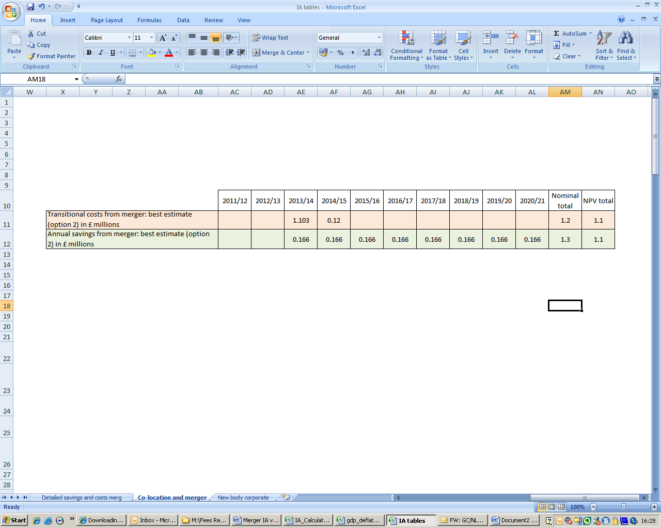

For Option 2, the overall cost over the appraisal period is projected at £0.04m NPV.

OPTION 3: Do Nothing

Pursuit of this option would mean that the NLC and Gambling Commission neither merged, nor were abolished in order to create a new body corporate under the Public Bodies Act. The co-location of the two organisations would however continue to completion with all saving and costs recognized (co-location of NLC staff with GC staff has already occurred).

Consequently, there would be no savings generated in addition to those recognized through co-location. Option 3 would mean that the costs of options 1 and 2 would also be avoided.

Aggregate impact on the gambling sector at the firm level and on micro and small businesses

Not applicable: None of three options would require an increase in revenue from the licensed industry in order to fund the option. Between the financial years 2011/12 and 2014/15 inclusive, the co-location (which has already occurred) will have generated net cost savings which should help reduce current and future pressures on existing sources of funding. The savings from co-location alone would be greater than any of the net costs of Options 2 or 3. There is therefore no impact on licensees that are either micro or small businesses.

Summing up and policy conclusions

A cost/benefit summary of each option is provided below in Table 9 .

Table 9

Option 1: Benefit summary | Value / £
Total costs (best estimate) | 0.8m
Total benefit (best estimate) | 1.1m
Total overall benefit (NPV) | 0.33m

Option 2: Cost summary | Value / £
Total costs (best estimate) | 1.1m
Total benefit (best estimate) | 1.1m
Total overall cost (NPV) | -0.04m

Option 3: Cost summary | Value / £
Total costs (best estimate) | 0.0m
Total benefit (best estimate) | 0.0m
Total overall cost (NPV) | 0.0m

Specific Impacts Tests

Economic and financial

The proposals will not have any impact upon the licensed gambling industry itself. Specifically, the merger of the NLC and Gambling Commission will not impact upon the gambling industry’s gross gambling yield, the tax revenue generated by the industry, nor the levels of employment within the industry.

Social

All of the current statutory duties of the both the NLC and the Gambling Commission will remain in full with the merged body. Sufficient resource for the execution of those duties has been considered, and it is therefore considered that that there will be no detrimental impact on either the Licensing Objectives of the Gambling Commission or of the objectives of the NLC. The public benefit derived from the National Lottery itself (£1.6 billion per annum distributed to good causes, from the revenue generated by the lottery itself) will not be affected by the merger of the National Lottery’s regulator with the Gambling Commission.

Environmental

None

Annex 1: Post Implementation Review (PIR) Plan
A PIR should be undertaken, usually three to five years after implementation of the policy, but exceptionally a longer period may be more appropriate. If the policy is subject to a sunset clause, the review should be carried out sufficiently early that any renewal or amendment to legislation can be enacted before the expiry date. A PIR should examine the extent to which the implemented regulations have achieved their objectives, assess their costs and benefits and identify whether they are having any unintended consequences. Please set out the PIR Plan as detailed below. If there is no plan to do a PIR please provide reasons below.
Basis of the review: [The basis of the review could be statutory (forming part of the legislation), i.e. a sunset clause or a duty to review , or there could be a political commitment to review (PIR)];
Ongoing Arms Length Body sponsorship. In addition, the Cabinet Office requires triennial reviews of ALBs.
Review objective: [Is it intended as a proportionate check that regulation is operating as expected to tackle the problem of concern?; or as a wider exploration of the policy approach taken?; or as a link from policy objective to outcome?]
To ensure that the merged body operates effectively and efficiently and that the benefits of merger are realised.

Review approach and rationale: [e.g. describe here the review approach (in-depth evaluation, scope review of monitoring data, scan of stakeholder views, etc.) and the rationale that made choosing such an approach]
A combination of ALB sponsorship tools will be used, including regular sponsorship meetings between senior officials and the Chair of the merged body and the Minister; a formal Management Agreement and an annual review of fee levels.

In addition, regular contact with those who are regulated and other key interests.
Baseline: [The current (baseline) position against which the change introduced by the legislation can be measured]
The IA sets out the expected financial baseline.
Success criteria: [Criteria showing achievement of the policy objectives as set out in the final impact assessment; criteria for modifying or replacing the policy if it does not achieve its objectives]
Whether the expected longer term savings set out in the Impact Assessment are achieved. Also, regulatory practice demonstrates that evidenced based regulation is easier to achieve and advice to Government on gambling issues shows benefits of synergies in understanding game and technological developments.

Failure to achieve the objectives would be addressed through reviewing the organisational arrangements of the merged body.
Monitoring information arrangements: [Provide further details of the planned/existing arrangements in place that will allow a systematic collection systematic collection of monitoring information for future policy review]
Cost information is set out in the annual report and review and during annual reviews of licence fees.
Reasons for not planning a review: [If there is no plan to do a PIR please provide reasons here]

Annex 2: Summary of savings and costs from the co-location of NLC and Gambling Commission staff.

The tables below indicate the anticipated savings and costs associated with the co-location of NLC employees into Gambling Commission offices, for each financial year between 2011/12 to 2014/15. The figures below do not incorporate discounting and are presented as nominal values. As the savings and costs of co-location itself are entirely distinct from the savings and costs associated with any of the Options 1, 2 or 3, and are provided for context only without having bearing on the consideration of these options, it is not necessary to provide net present values to the co-location figures here.




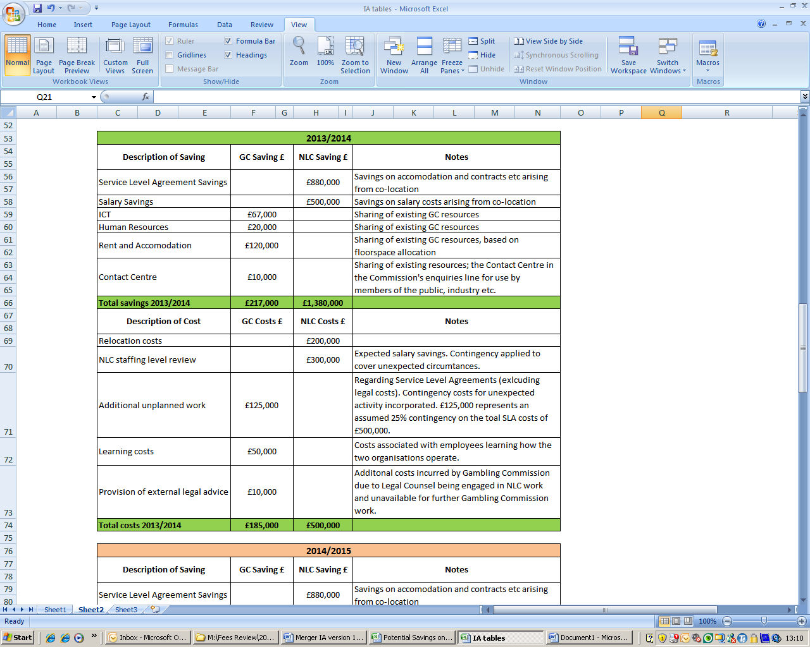


http://www.legislation.gov.uk/ukpga/2011/24/contents/enacted/data.htm

