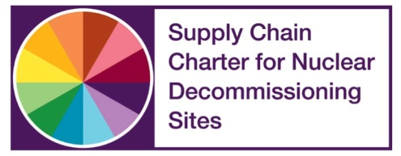
Application Form
NDA Estate Supply Chain Awards 2018 –
Best technical innovation to benefit an NDA Business

Name: | Job Title:
Email: | Tel:
Company Name:
- Company Type: Tier 2 Yes/No* : Tier 3/4 Yes/No* : SME Yes/No* * delete those not applicable
Project/Contract/Initiative Title:

NDA Business (client):
Name: Email: Telephone: Site:
Please provide a brief executive summary to introduce the award application (no more than 100 words):

Your submission should include information and responses to the following:
- What were the aims and objectives of the project, contract or goal?
- What was the technical innovation/technique and how was it developed from concept through to successful implementation within the NDA Estate?
- What challenges were envisaged or experienced and how were these overcome?
- Had this technology/technique been used previously? – New to world, new to sector, new to UK, or existing technology/technique used or combined in a new way?
- What approaches or solutions had previously been used or considered which helped to lead to a more innovative solution being conceived?
- Who were the parties involved in developing and implementing the technical innovation and what were their roles?
- What benefits have been realised as a result of the successful implementation of the technical innovation?
- How will the innovation support the future nuclear decommissioning programme?
It is important that every entry relates in some way to the benefits achieved. Benefits may be “hard” (for example, cost savings or reduced lead times) or “soft” (for example, improved processes).
Claimed benefits should be recent and supported by facts and figures. Entrants are strongly advised to include validation of these from stakeholders – clients, other suppliers, and so on.
This should be a joint application between the solution provider and the end-user for the solution within the NDA Estate. The award is to recognise both the innovation and collaboration required to take innovation through to successful implementation within the NDA Estate.
Note: Your written submission must be no more than 1200 words total including this page plus up to four single-sided sheets of supporting material. Please include a publishable photo that represents the technical innovation (ideally landscape 960 x 640).

