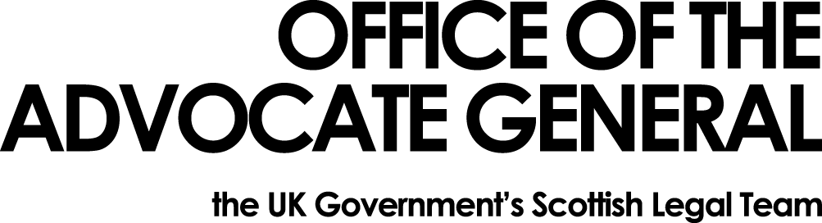

Subject Access Request form

Please supply the information about me I am entitled to obtain under a subject access request under the General Data Protection Regulation* ( i.e. a request to be informed whether or not my data is being held by your organisation, and , where that is the case, access to the personal data and other information as is required to be supplied under Article 15 of the General Data Protection Regulation.

My full name is:
My address is:
My contact telephone number is:
My email address is:
Other information that will help identify me:
Information required. (Please be specific and include relevant dates as this will help us in identifying whether we have your data.)

I look forward to hearing from you

Regards

[Your name and signature]

We may ask you to send proof of your identity before processing your request

* Regulation (EU) 2016/679 of the European Parliament and Council of 27 April 2016

