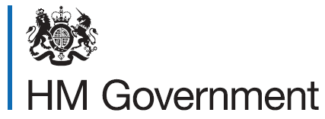
Self-employment declaration form

Free meals in further education (FMFE) – self-employment eligibility declaration form
This form is for completion by self-employed parents claiming FMFEeligibility for the student. Parents should provide evidence demonstrating that they are in receipt of Universal Credit (such as their Universal Credit award letter), that they are self-employed (such as their company registration form or tax return) and that their net earned income has not exceeded either £616.67 over the previous month, £1,233.34 over the previous two months, or £1,850 over the previous three months. This evidence should take the form of monthly accounts, like those provided on a monthly basis to DWP, supported by actual receipts where requested.

Universal Credit eligibility
I have attached evidence proving that I am in receipt of Universal Credit Y/N
Self-employment status
I have provided evidence proving that I am self-employed Y/N
Earnings
I have provided evidence that my net earnings over the period ___/___/___ - ___/___/___ were £________ Y/N
(If net earnings for the latest month exceed £616.67, fill out details for the latest two months. If net earnings for the latest two months exceed £1,233.34, fill out details for the latest three months)
Declaration
I certify that the information I have provided is complete and correct and understand that it is fraudulent to give false information. I agree that the information provided with this form can be used to check the student’s for FMFE.
Printed Name:
Signature:
Date:

