High Speed Rail:
Investing in Britain’s Future –
Phase Two: The route to Leeds,
Manchester and beyond

Presented to Parliament
by the Secretary of State for Transport
by Command of Her Majesty
January 2013

Cm 8508 £21.25
Photo acknowledgements
Pp 19, 32, 75 Getty Images; p 21 Network Rail; p 35 Peter Barritt / Alamy;
p 40 AKP Photos / Alamy; p 44 eye35.pix / Alamy; p 53 Ian Dagnall / Alamy;
p 77 HS1 Ltd.

The Department for Transport has actively considered the needs of blind and partially sighted people in accessing this document. The text will be made available in full on the Department’s website. The text may be freely downloaded and translated by individuals or organisations for conversion into other accessible formats. If you have other needs in this regard please contact the Department.

© Crown copyright 2013

You may re-use this information (excluding logos) free of charge in any format or medium, under the terms of the Open Government Licence. To view this licence, visit http://www.nationalarchives.gov.uk/doc/open-government-licence/ or
e-mail: psi@nationalarchives.gsi.gov.uk.

Where we have identified any third party copyright information you will need to obtain permission from the copyright holders concerned.

To reproduce maps, contact Ordnance Survey via their website www.ordnancesurvey.co.uk/oswebsite/business/licences/ or write to Customer Service Centre, Ordnance Survey, Romsey Road, Southampton SO16 4GU.

Any enquiries regarding this publication should be sent to us at: Department for Transport
Great Minster House
33 Horseferry Road
London SW1P 4DR

Telephone 0300 330 3000
General email enquiries FAX9643@dft.gsi.gov.uk
Website www.gov.uk/dft

This publication is available for download at www.official-documents.gov.uk and from our website at www.gov.uk/dft

ISBN: 9780101850827

Printed in the UK by The Stationery Office Limited on behalf of the
Controller of Her Majesty’s Stationery Office

ID 2525516 01/13

Printed on paper containing 75% recycled fibre content minimum.
Contents
Foreword 5
A National Strategy for High Speed Rail 7
1 Introduction 15
Part I: Transforming travel 19
2 HS2 – Providing capacity to drive growth 20
3 Rebalancing Britain 25
4 Introducing fast, frequent, reliable services 27
Part II: Regenerating the regions 32
5 Benefits for Manchester, Leeds and beyond 33
6 Route Summary – Western and Eastern leg 55
7 Initial preferences for infrastructure and rolling stock depots 68
8 HS2 to Heathrow 70
9 Costs, funding and value for money 72
Part III: Realising the vision 75
10 Sustainability 76
11 Towards a truly national high speed rail network 83
12 Property and compensation 86
13 Next steps 88
Annexes 91
A: Alternative station options not selected 91
B: List of supporting documents 97
C: Record of confidential engagement 100
D:
Terms of Reference – Network Rail Study on Released Capacity 102
Glossary 104
Foreword 
For Britain to succeed there are some key challenges to which the Government must rise. Chief among these are rebalancing and rebuilding our economy; and generating the growth and jobs that will allow us to compete and win in the 21st century global marketplace.
This will require a break with the past, and in particular a willingness to invest in our transport infrastructure. For decades we have watched other countries modernise and improve their transport networks, while ours have been over-stretched and over-burdened. The further we fall behind, the harder it is for us to compete.
That is why we are committed to high speed rail. HS2 is a project started by the previous government and taken forward by the current one. It is a once-in-a-generation opportunity to transform Britain’s connectivity, capacity and competitiveness. High Speed 2 (HS2) will be a national asset, which is why it is backed by entrepreneurs, passengers, businesses and many local authorities right across Britain. It will slash journey times and improve services between our cities and regions. It will also free up substantial space on the existing railway.
The publication of this document is a vital milestone in the delivery of the project. After consulting on the first phase of HS2 linking London and Birmingham last year, we can now set out our initial preferences for Phase Two, extending the route north of Birmingham to Manchester and Leeds.
This will benefit the economies of the Midlands and North in two ways. Firstly, it will widen opportunities for millions of people by providing direct links to London, the South East and Europe. Secondly, by linking Birmingham, East Midlands, Sheffield, Manchester, Leeds and beyond, it will help merge these city economies into a formidable unit that can provide real competition to London and the South East.
We are determined to get on and deliver HS2. We have already completed the consultation on the route for Phase One. In the year ahead we will begin seeking powers from Parliament to construct the London to West Midlands line. We plan to start construction in 2017 with the first high speed trains in service by 2026, just 13 years from now. And as someone who has served the Department for Transport twice, with a twenty year gap in between, I can say with certainty that 13 years is not long when it comes to transport infrastructure. Children born today will be able to travel at high speed from Birmingham as young teenagers, and all the way up the line to Manchester and Leeds when they reach university age.
I know that this project is controversial. Major infrastructure projects always are. But this is not about short-term popularity. It is about doing what is right for the country in the long-term. I do however recognise that the wider benefits will be of little comfort to those whose properties may be affected by the lines. So I want to be very clear from the start that we will be compensating people fairly.
I am equally committed to minimising the impact of HS2 on local communities and the natural environment. I believe the work we have done on Phase One – where more than half the route will be in tunnels or cuttings – is evidence of that commitment. As a MP of a rural Derbyshire constituency, I am fully aware of the importance of protecting the countryside.
It is also vital that we work to the highest design standards. New bridges, viaducts, tunnels and other infrastructure will be needed for HS2. The Government wants to see designs that are sympathetic to their settings and that demonstrate the best in British design and innovation.
This Command Paper sets out the route, stations and depots which are my initial preferences, based on the work undertaken to date to manage the impact. During the course of 2013, I will launch a public consultation on these options to ensure that the proposals are the best they can be and I have got all the information I need to make my final decisions.
As the Prime Minister said recently, aspiration is the engine of progress and HS2 is a sign of our aspiration for a better, stronger Britain. I believe that we cannot simply hope for a better future; we have to build it – together. It’s a once in a lifetime opportunity and I think we should seize it, for the national benefit. So I hope everyone with an interest in HS2 will join the debate on Phase Two in the months ahead.

The Rt Hon Patrick McLoughlin MP
Secretary of State for Transport
A National Strategy for High Speed Rail
High speed rail
The UK has a proud railway history. Our Victorian pioneers designed and built railways and locomotives which were the envy of the world. They changed the way we travelled and the way we did business. The railway’s success as the first fast, reliable and high capacity form of passenger and freight transport helped power our economy and drive the industrial revolution.
That success story is returning. Every year, the rail network carries over a billion passengers – more than at any time since the Second World War – and over 19 billion tonne kilometres of goods.
But essentially, the current railway is little changed from the one designed by the Victorians. We have a 19th century network straining to support a 21st century economy, with all the inherent limitations that brings.
The biggest problem will be lack of capacity to support economic prosperity over the longer term. Demand for long distance rail has doubled over the past 15 years, and if we do nothing routes will fill up and services will creak at the seams. Current rail journeys no longer reflect the needs of todays’ passengers who need quick connections to access jobs across the region. For example, the current rail journey between Birmingham and Leeds takes nearly as long as the trip from London to Brussels.
It is time to put this right. If we want Britain to thrive and prosper, we have to invest in a modern transport system – and one that will support the requirements of the entire country.
High Speed 2 (HS2) is the biggest infrastructure investment in the UK for a generation. It will provide a network of new high speed lines across Britain – connecting our biggest cities quickly and reliably.
HS2 is one network, being planned and built in two sections. And from the outset being connected to the existing network. Phase One will see a new line run from London Euston to new stations at Birmingham city centre and at the new Birmingham Interchange near Birmingham Airport – offering an alternative to one of the most congested stretches of rail line in the country. And it provides a direct connection onto the existing network beyond Birmingham. So that passengers can benefit from the faster journey to the Midlands, via through trains that will carry them to destinations in the North West and Scotland without having to change.
Phase One will also provide a direct link with Continental Europe through HS1 and the Channel Tunnel. In the future, this could see passengers boarding direct services from cities like Birmingham, Liverpool or Edinburgh to European destinations like Brussels, Paris or Frankfurt.
From day one of Phase One, the new high speed line will improve services to Heathrow Airport, via a change of trains at the new Old Oak Common hub. This will speed passengers to the airport in just 11 minutes. Subject to the Airports Commission report on maintaining the UK’s international connectivity, HS2 could also be extended to serve Heathrow directly. A Heathrow Spur is not in the scope of this Command Paper but could be included in legislation for Phase Two if the timing and the conclusions of the Airports Commission support it. A further consultation would be needed. Work is well underway to introduce the legislation this year which will make Phase One a reality.
This document sets out the Government’s initial preferences for Phase Two of the project, which will unlock the vast potential of HS2 to transform the whole of the United Kingdom. Phase Two will extend high speed lines to Manchester in the North West and to Leeds in the North East, with intermediate stations at Manchester Airport, South Yorkshire and the East Midlands.
The Government has drawn on a number of areas of information in reaching its initial preferences for Phase Two. First, it has carefully reviewed the advice prepared by HS2 Ltd in March 2012. Second, it has considered the reports prepared by delivery partners on the station options. Third, Ministers and officials have visited the route and station options for Phase Two to get the best possible sense of the likely impacts. Fourth, Ministers have held meetings with key political and economic leaders in the cities to discuss the station options and hear first-hand the views from the cities. (The basis of this engagement is described further in Annex C.) Finally, each of these activities has led Ministers to commission further advice, both from HS2 Ltd and from delivery partners. Unless confidentiality has been requested, this material is also being published alongside this document.
Phase Two is not just about services to London. It will also re-draw the rail map of Britain, providing fast services between cities which are not currently well connected.
Further connections onto the existing network will enable passengers in many more regions across Britain to benefit from HS2. High speed trains will continue seamlessly to destinations like Crewe, Liverpool, Wigan, Preston, York, Newcastle, Glasgow, Edinburgh and many others.
A Vision for High Speed Britain
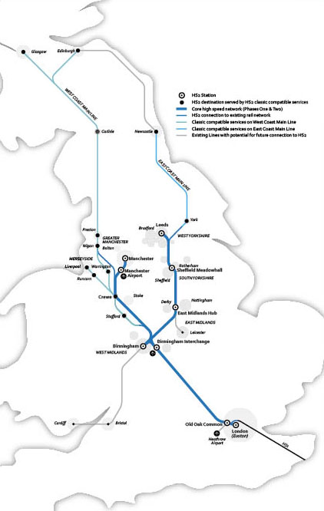
Phase Two Summary
A key focus of this Command Paper is setting out the Government’s initial preferred route with station and depot options for Phase Two of the network, which will extend directly to Manchester and Leeds and provide seamless services to a host of northern and Scottish cities.
This document follows the same approach used for Phase One. It allows for sharing information on the proposals as we identify our preferred route for consultation this year.
In summary our initial preferences are:
Manchester (Piccadilly): A new station would be built alongside the existing station at Manchester Piccadilly in the heart of the city. This would allow easy connections with regional rail services to places such as Salford, Stockport and Bolton. There would also be excellent easy access to the extensive Manchester public transport network, such as Metrolink services to Bury, Altrincham, Eccles and Salford Quays including MediaCityUK. Local and regional buses would be on the doorstep and there would be easy pedestrian access to the city.
Manchester Airport: A new interchange station would provide direct links to Manchester Airport. This station would also give the wider Cheshire area easy access to the high speed rail network, both by public transport and by car – subject to agreeing a suitable funding package with the airport and wider region.
East Midlands (East Midlands Hub): A new station at Toton located between Nottingham and Derby would offer excellent links to East Midlands cities and stimulate growth across the region. The station would be readily accessible by public transport from both Derby and Nottingham. Rail lines could be connected to serve Derby, Leicester, Nottingham and much of the wider East Midlands region. For example, it would be possible for either shuttle or existing services to call at the East Midlands Hub station en route, with a journey time of 12 and 15 minutes from Nottingham and Derby respectively.
The integrated HS2 and classic rail station would mean that passengers are able to benefit from quick and efficient interchanges. The connection to Derby would provide easy access for businesses located in Derby including Rolls Royce, Bombardier and others. The Nottingham Tram system could be further extended to the new station, providing easy access to locations such as Nottingham University, the Boots campus, Queen’s medical centre and other important businesses.
South Yorkshire (Sheffield Meadowhall): A new station at Sheffield Meadowhall would be situated alongside the M1, providing convenient access by road serving Sheffield and the wider South Yorkshire region. This station is well-placed to encourage jobs and growth in Sheffield and already has excellent connectivity with existing public transport networks. Meadowhall currently has a frequent rail service. Up to nine trains per hour run into Sheffield Midland station, with a journey time of as little as five minutes. Trains also connect Meadowhall to Rotherham, Barnsley and beyond to Wakefield, Doncaster, Scunthorpe and stations to Leeds and Manchester. Improved rail access from south west Sheffield to Meadowhall could also be considered, including a frequent service could run between Dore & Totley and Meadowhall. Such measures would undoubtedly benefit travel time from the south west of the city facilitating access to Meadowhall in around 20 minutes from Dore & Totley. Alternatively, potential extensions of the Tram Train could be considered, which would offer scope for additional new stops in south west Sheffield. Meadowhall is already a major bus station and an important calling point on the National Express coach network. A high quality interchange would be provided between HS2 services and rail, tram and bus services. We will work with the region to develop proposals on the connectivity at the HS2 station so that it brings benefits to the whole South Yorkshire region. With the addition of HS2, Meadowhall could become a key regional transport hub, in a location that allows not only quick access from central Sheffield but also from across the region.
Leeds (New Lane): A new station in central Leeds, alongside the South Bank area of the city centre. This would be joined to the existing station via a dedicated pedestrian link, making it just a short walk between the two. This transfer time could be further reduced by the introduction of moving walkways. Leeds station offers connections to a number of regional rail destinations such as Bradford, Halifax and Castleford, as well as to the city’s extensive bus network. There would be immediate access to this station from the M621 (Junction 3), providing connections with the city’s ring roads and regional motorways. There would also be ample car parking provided at the southern entrance for those not arriving on foot or by public transport.
Connecting the UK
In addition to the stations listed above, connections would be provided at various points across the HS2 network onto existing rail lines, enabling high speed trains to continue to nine out of the UK’s ten biggest conurbations. This means the vast majority of the country’s major urban economies would benefit directly from high speed services.
Connections to the existing railway would be built at the northern end of each leg. On the western route, high speed trains would be able to directly serve destinations such as Wigan, Preston, Blackpool, Lancaster, Penrith, Carlisle, Glasgow and Edinburgh. From the eastern route, the high speed line would continue almost as far as York, making it possible for high speed trains to continue directly to places such as Newcastle, Darlington and Durham.
Further south, HS2 would connect with the West Coast Main Line at Crewe, meaning key destinations like Liverpool, Runcorn and Crewe would benefit from direct services. The key rail interchange at Crewe would also be easily accessible for passengers in North Wales and elsewhere. Decisions on the precise services to use high speed rail lines and to maximise the benefits of capacity on other lines will be taken nearer the date when lines would open, so that we can be sure to take account of latest developments. We hope people will share with us their aspirations and ideas for how services could be designed to meet the needs of the country as a whole.
Developing low impact routes
Western route summary: The western leg of the network would serve the proposed stations at Manchester Airport and Manchester Piccadilly. The line would connect with the London to West Midlands leg near Lichfield in the West Midlands, before heading north west past Stafford and on towards Crewe. A connection with the West Coast Main Line would be provided just south of Crewe, with the main line continuing in tunnel under the town heading north. It would cross over the M6 and then the M56 before heading past Warrington to a further connection with the West Coast Main Line south of Wigan. The Manchester stations would be served by a spur off the main line running roughly parallel with the M56 towards Manchester Airport. The airport station would be located between Junctions 5 and 6 of the M56 as the line approaches the main built-up area of Manchester. Heading north from here the line would enter a seven and a half mile tunnel, surfacing a short distance from the new station alongside the existing station at Manchester Piccadilly. The total route length would be 95 miles.
Eastern route summary: The eastern leg would serve stations in the East Midlands, South Yorkshire and Leeds. The line would connect with the London to West Midlands leg to the east of Birmingham, near Junction 4 of the M6, and then follow the M42 corridor north east towards Derby and Nottingham. The East Midlands Hub station would be located between these two cities at Toton, about a mile from the M1. The line would head north, following the M1 corridor as it heads towards South Yorkshire. The station serving this region would be located at Meadowhall alongside the M1, between Sheffield and Rotherham. From here the line would pass to the east of Barnsley and connect to the East Coast Main Line nine miles to the south west of York. As with Manchester, Leeds would be served by a spur off the main line. It would run within the existing Castleford to Leeds railway corridor, passing the southern suburbs of Leeds before rising above street level into the new station at Leeds New Lane. The total route length would be 116 miles.
Heathrow spur and station: As stated in January 2012, the Government believes the HS2 network should link to Heathrow and its preferred option is for this to be built as part of Phase Two. However, the Government has since established an independent Airports Commission, chaired by Sir Howard Davies, to recommend options for maintaining the country’s status as an international aviation hub.
We have therefore taken the decision to pause work on the spur to Heathrow until after 2015 when we expect the Airports Commission to publish its final report. The proposals for the Heathrow spur and station are not planned to be part of the Phase Two consultation. However, there would still be the opportunity to consult separately at a later point and include the Heathrow spur in legislation for Phase Two without any impact on the delivery time if that fits with the recommendations of the Commission.
Next steps
The initial preferences that the Government is outlining in this document are an indication of emerging thinking based on the information and advice that has been available to the Government to date. The Government will now wish to discuss these initial preferences with Members of Parliament, local authorities and station city delivery partners to help it reach a view on what will form the basis of a public consultation.
A public consultation on the routes, stations and depots for Phase Two was originally planned for 2014. However, the Government has decided to speed up this work and now intends to hold a public consultation beginning in 2013 – earlier than originally planned.
As well as recognising the significant opportunities a high speed rail network offers Britain, the Government also acknowledges that major infrastructure projects also have an impact on local communities. We are committed to ensuring a fair deal for those affected by the initial options for Phase Two set out in this document. Hence, a consultation on a scheme to assist property owners affected by Phase Two has been published alongside this Command Paper.

Destinations served by HS2
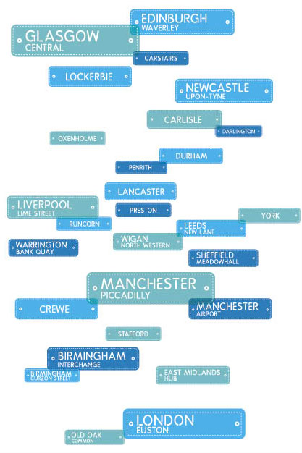

Chapter 1. Introduction
High Speed 2 – A catalyst for High Speed Britain
1.1 Britain is an ambitious nation and we need to plan for the future. That means investing in transport so that people and businesses all over the country can benefit from better opportunities and economic growth. We need less congested roads, better trains and successful airports. We need to provide the right kinds of national infrastructure to avoid the mistake of concentrating growth in the South-East of England.
1.2 HS2 is a central part of this effort. It’s not just a faster railway, but a reliable, high capacity people mover that will link our big cities with London and with each other. It will be built, designed and run as a railway for everyone in Britain – not just the well-off. It will transform people’s journeys; it will take the strain from existing rail and road routes; and it will be quick, simple and comfortable to use. It will support our environmental objectives by opening up space on the railway for freight currently carried on roads. It will provide opportunities for development on under-used brownfield sites and be a catalyst for economic growth in and around our great cities. It will be designed with the best in British design and innovation in mind and an independent Design Panel will shape the look and feel of its structures and stations. It will be linked closely to existing transport routes and lead to more space and better services on existing rail lines. It won’t, of course, solve overcrowding problems everywhere. But a more prosperous Midlands and North will help rebalance growth across the country and ease the burden on the South-East.
1.3 These are the reasons why on 10 January 2012, the Government announced its decision to build a national high speed rail network serving the United Kingdom. After considering many options, the Government set out its plans for a network of high speed lines linking London, Birmingham, Manchester and Leeds, with intermediate stations in the East Midlands and South Yorkshire. This network, known as the ‘Y’ due to its shape, will also include connections to the existing railway, enabling high speed trains to serve a wide range of destinations beyond the high speed network.
1.4 HS2 will also be connected to the Continent through a link to HS1 (High Speed 1) and the Channel Tunnel. This makes direct rail services possible from stations served by high speed trains to key European destinations like Paris, Brussels and Amsterdam. This will build on the success of HS1, which has already transformed travel between the UK and the Continent.
1.5 The benefits of HS2 will be felt right across the UK and it is important these are realised as quickly as possible. We are planning and building the network in two phases, not because one section is more important than the other but because building the whole network in one go would be a massive planning, construction and funding challenge. Like the motorway system, it needs to be built efficiently in stages.
1.6 This first phase will create a high speed link between London and the West Midlands and allow through trains to run onto the West Coast Main Line to serve cities further north. As part of the first phase there will be a new interchange station at Old Oak Common in west London where passengers will be able to connect to Crossrail, the Heathrow Express, the Great Western Main Line and other local public transport. A direct link to the Channel Tunnel via HS1 will also run from the main high speed line at Old Oak Common. From the West Midlands, Phase Two will extend the high speed lines further north, to Manchester on the western leg and to Leeds on the eastern leg.
How can people get involved
1.7 Before deciding to proceed with HS2, the Government carried out one of the biggest consultation exercises it had ever undertaken. The consultation asked a series of questions on the Government’s vision for high speed rail as well as looking at the detailed route for the initial phase between London and the West Midlands. The consultation ran for five months during 2011, and included more than thirty public events along the line of route which attracted more than 30,000 visitors. Around 55,000 responses were received.
1.8 The announcement in January 2012 stated that the Government would set out its initial preferred route, station and depot options for Phase Two. This document fulfils that commitment.
1.9 Further technical work, such as additional design and environmental assessment will now be carried out in relation to these initial Phase Two options.
1.10 The Government alone cannot create HS2. It will take the continuing involvement, assistance and support of many people and organisations. Local Authorities and partners in the redevelopment of areas around the new stations will be vital. Ministers and HS2 Ltd will also be working with Members of Parliament to explain the initial preferences for the route and to make clear what they can do to shape plans for this phase. The Government will give the public the greatest possible opportunity to comment on these proposals and a public consultation is scheduled to be launched this year. This will seek views on route, station and depot options for Phase Two and how they might be further improved.
Expanding the network in the future
1.11 A key part of the Government’s vision for HS2 is to extend the benefits of the project as far beyond the actual network as possible. HS2 will transform the economic geography of the UK, driving regional regeneration and creating opportunities for growth in new areas. The Government has already been considering how journey times to places in the North East and Scotland can be further reduced. Chapter 11 describes the work that we will undertake with Transport Scotland to explore options for cementing HS2’s status as a network that would benefit the whole of the United Kingdom.
Protecting people’s interests
1.12 More immediately, we recognise that by publishing these initial preferred route, station and depot options, blight may be generated affecting those living and working near the proposed lines. The Government has already spent more than £35m helping homeowners along the line between London and the West Midlands, and we intend to provide similar assistance for those likely to be affected by Phase Two. We will now consult on these proposals, which are also summarised in Part III. A separate consultation document containing full details on this subject has been published alongside this Command Paper.
How this document works
1.13 Part I of this document sets out more of the background to the HS2 project. It describes in greater detail the role that high speed rail has to play in meeting the future transport and economic needs of this country. One of the most important factors in realising the full potential of HS2 will be how closely the network is integrated with the cities and destinations it serves. HS2 is not a network that will exist in isolation, but would be woven into the transport fabric of the nation, linking with roads, bus services, tramways, suburban rail networks and major airports. This will naturally require the full support and effort of the cities concerned and we look forward to working with them over the coming months.
1.14 Part II moves on to discuss the detail of the Government’s initial preferred route, station and depot options for Phase Two. HS2 Ltd has been developing and refining a range of options since 2010 to ensure the benefits of HS2 to the UK can be maximised, while keeping the impacts on local communities to a minimum. Its advice to the Government was submitted in March 2012 and set out all the options the company considered, presenting the greatest detail on those options that emerged as the strongest. However, the advice left open a range of station alternatives, so to supplement it, the Government also engaged directly with the cities to be served by HS2. This engagement, which took place on a confidential basis in order to prevent blight on local residents and communities, was crucial in helping Ministers understand the future development plans of the cities concerned and their views on the potential station options, allowing Ministers to optimise the initial preferred options set out in this document.
1.15 The document then looks at the Western and Eastern sections in turn, summarising each of the initial preferred route and station options. It also includes more details on how high speed trains would be able to continue to destinations such as Liverpool, Runcorn, Wigan, Durham, Newcastle, Glasgow and Edinburgh through connections with the existing rail network. It then explains the Government’s position on Heathrow.
1.16 Part III covers the next steps for the project. The Government has an extensive programme of collaboration and partnership working with key stakeholders to take the initial options presented in this document forward. Firstly, we will work informally with MPs, local authorities and station city delivery partners to refine these proposals. This will be followed by a period of extensive public consultation commencing in 2013, designed to give those who wish to comment on the proposals the maximum opportunity to do so. Alongside this, we will continue to work with the regions to develop plans and strategies to maximise the benefits from HS2 both for them and for the national economy.


Chapter 2. HS2 – Providing capacity to drive growth
2.1 A successful, reliable and modern transport network underpins so many elements of our productivity – enabling businesses to get their goods to market, business people to meet, employees to work and leisure travellers to explore the UK. Effective and efficient transport systems help to support the economic potential of communities, cities, regions and the country as a whole.
2.2 Outstanding transport links – at local, regional, national and international levels – also bring wider social benefits. They mean that friends and families can stay connected, that people can fulfil their cultural and leisure aspirations, maintain their independence and widen their horizons.
2.3 Rail travel is a vital part of the Government’s vision for transport. It enables fast and efficient journeys between productive urban centres and supports the efficient functioning of labour markets. Over recent years rail travel has been experiencing remarkable levels of demand growth in almost every sector. In 2011/12 passengers made around 1.5 billion journeys on the rail network, a figure which has almost doubled since 1994/95, and travelled over 35 billion miles. 125 million long distance journeys were made in 2011/12, more than double the 54 million made in 1994/95, and despite the recent recession, demand for long distance rail travel continues to grow year-on-year – a trend which shows no sign of changing.
2.4 Adding new rail capacity is therefore essential, but something that requires careful and long-term planning. The announcement in July 2012 of the Government’s plans for record levels of investment in the railways demonstrates the level of our ambition and commitment to ensuring that rail continues to thrive. This £9.4 billion package will fund enhancements which include:
● a new electric passenger and freight corridor from the south coast to the Midlands and Yorkshire;
● new Intercity Express trains;
● delivery of the Northern Hub to increase capacity and improve connectivity between key cities in the North;
● rail access to Heathrow Airport from the west; and
● over £900 million in flexible funding for smaller schemes.
2.5 It is vital that investment in the existing network continues to ensure it is able to meet the challenges being posed. However, work by Network Rail, as custodian of Britain’s rail network, shows that investment in the existing network alone will not be sufficient to cope with the levels of demand that the inter-city network will face over the next 20-30 years.
The need for action – capacity and connectivity
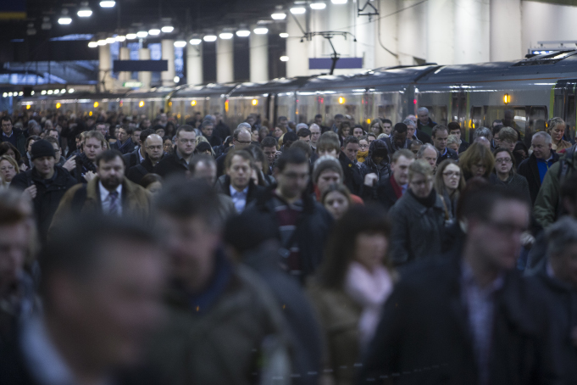
2.6 The central benefit of a national high speed rail network is the extra rail capacity this country needs. With rail demand forecast to continue growing over the coming decades, the rail industry recognises this is likely to outstrip what could be accommodated on the existing network even with substantial programmes of additional investment. By providing a new route for much of the current inter-city rail traffic, HS2 offers the opportunity to improve the operation and timetabling of services on the existing main north-south lines. This will be to the benefit of commuters but also local and regional passengers, as well as freight services. The opportunity to employ ‘released capacity’ in this way, both by enabling additional services to be run and by creating more space on some existing trains, is a major benefit of HS2. Given that the existing lines and services are particularly full during the peak commuting hours each day, this opportunity will be of great value to commuters. At present the volume of commuter and freight services on a number of lines is constrained by the operation of a large number of fast inter-city services. The new long-distance capacity for such services provided by a new line is the best means of ensuring that additional capacity can also be created for commuters and new freight services.
2.7 Network Rail considers that only a new line is capable of providing sufficient capacity to meet forecast growth on the railways.
HS2 – providing transport capacity
HS2 will create new capacity:
- The HS2 network itself will provide high frequency and high capacity services for passengers. Up to 18 trains per hour will run between Britain’s major cities, each carrying up to 1,100 passengers. The London to Birmingham line will effectively double the capacity between London and Birmingham city centres.
- With fast, long distance trains increasingly using the new HS2 network, capacity will be freed up on the existing network for extra commuter and freight services. Key commuter stations, such as Milton Keynes and Northampton, could see around twice as many direct services to central London.
- HS2 will also provide capacity benefits on the road network and at our busiest airports. HS2 is forecast to carry up to 5.4 million passengers every year who might otherwise have travelled by air, as well as seeing up to 9.8 million passengers transfer from the national road network. The contrast that HS2 could have with car journey times is shown in the table below:
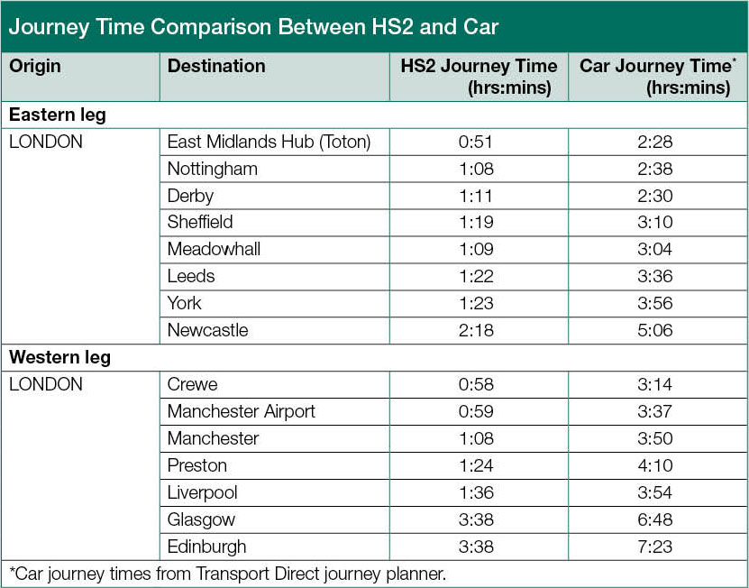

More freight trains using the space freed-up on the existing rail network will reduce lorry traffic on the motorways and help improve air quality.

2.8 The Government agrees that new lines are needed, both to provide more capacity and to free up space on the existing network. Some argue the new lines should be built to the standards and speeds of the existing network. But Government firmly believes that the incremental cost of building lines that are capable of handling high speed trains is well worth the very significant benefits. HS2 Ltd’s work shows that the additional benefits generated by designing a new line to accommodate high speed services would outweigh the additional costs by a factor of more than four to one.
2.9 The benefits from HS2 do not stop with the increased capacity and improved journey times. The capacity that HS2 would release provides an opportunity to accommodate a wide range of competing demands on the network that would otherwise have lost out to inter-city services. Without new capacity, some local and regional journeys would become slower and less reliable and some towns and cities would see their services becoming less frequent and more expensive to operate. With HS2, there’s an opportunity to accomodate services that are beneficial to regional and local economies. Released capacity could also make more room for freight on the existing rail network, meaning fewer lorries on the roads.
2.10 The Government considers that the ‘released capacity’ from Phase Two of the network would be significant. These are not decisions that it would be appropriate, or even possible, to take at this early stage in the project. However, it is important that we begin planning and collecting evidence so that eventually we are able to put that capacity to use in ways that would maximise the benefits for the country. Therefore, the Government has asked Network Rail to undertake a study of the potential capacity benefits for the existing rail network from the advent of HS2 working with Passenger Focus. Terms of reference are at Annex D. Network Rail will involve the cities and representatives of passenger and freight interests in taking this forward over the coming months. Network Rail will report to the Government by summer 2013.

Chapter 3. Rebalancing Britain
3.1 HS2 will provide improved connectivity between the major conurbations in the Midlands and the North, which could help enable these cities to work together more effectively. This could put them in a stronger position to benefit from access to wider markets and with shorter journey times their economies may function as a coherent whole rather than as isolated units.This may also bring benefits from increased competition and specialisation.
3.2 Although the distances between some of these cities are relatively short, rail journeys between them take a disproportionately long time. The fastest services between Sheffield and Leeds currently take around 40 minutes for a journey of little more than 30 miles, and most services take longer than this. Travel time between Leeds to Nottingham is one hour and 45 minutes for a journey that is only 70 miles, with travel times between Birmingham and Manchester taking nearly one hour and 30 minutes and Birmingham to Leeds nearly two hours. With HS2 these journey times would be slashed, with Leeds to Nottingham city centre taking only 46 minutes, an hour less than now. With Birmingham to Manchester and Birmingham to Leeds seeing their journey times halved.
3.3 This could play an important role in helping enhance the potential of the Midlands and the North to act as a counterweight to the economic strength of London and the South East. Companies and employees will be able to access a wider range of opportunities for markets and jobs. Firms may be able to service a number of cities from one office and thus reduce their costs as a result. In the long term, it could help support the specialisation of cities in certain fields – such as building on Leeds’ reputation for legal expertise – by opening the Midlands and North to investment from businesses.
3.4 Not only will the major cities become better connected with better journey times making them seem closer together but the surrounding towns and villages would all see significant benefits through connections into the wider regions.
Fuelling regeneration
3.5 The new station sites will provide a significant opportunity for regeneration and development, both around the station and across the wider region. Station environs will be attractive sites for investment and new development, bringing new jobs to the area as well as new services and amenities for local communities.
3.6 HS2 Ltd has examined and estimated the likely number of jobs supported in the area up to 1km away from the proposed station locations, taking into account the ways in which high speed rail connectivity can act as a catalyst for major employment-generating developments. The analysis shows that Phase Two of HS2 would help to support the creation of some 60,000 jobs in the cities of the Midlands and the North. Up to 10,000 jobs are anticipated in construction; 1,400 in operation and maintenance jobs; and almost 50,000 around the proposed stations. Overall the Government estimates that the HS2 network would support over 100,000 jobs across Britain.
3.7 These transformational benefits have already been seen for example at Stratford City and at Kings Cross Central. Here, development has been an important part of the dividend from the investment made in building new and improved transport infrastructure, including HS1. There have been over 10,000 jobs already created at Stratford City with more being generated as the site develops further after the Olympics. At Kings Cross Central, 22,000 jobs are planned by 2020.
3.8 As well as development around stations, the full benefits in terms of employment are likely to reach much further into the great cities of the Midlands and the North, helping to reshape the country’s economic geography. There is evidence of this happening in France for example, with the service economies of Lille and Lyons developing strongly since the arrival of high speed rail.
3.9 The actual number of jobs generated over the coming decades by HS2 will reflect wider economic factors, but the potential exists for thousands of jobs at each site and many additional jobs in the wider city and region. This will require local authorities, delivery partners and businesses to work in partnership to create a planning, infrastructure and investment environment for growth which harnesses the connectivity delivered by HS2.
3.10 For these reasons, the actual level of jobs created may well be substantially greater than anticipated by HS2 Ltd’s current analysis. The rigour of job creation estimates can be improved over time, as more information becomes available.
Chapter 4. Introducing fast, frequent, reliable services
4.1 A high speed rail network stretching from London through the East and West Midlands and on to Leeds and Manchester will provide a very significant uplift in capacity on some of the busiest stretches of inter-city rail network in the country. As well as providing vital capacity it will also reduce journey times for hundreds of thousands of travellers each week.
Services on HS2
4.2 HS2 will be a new railway network, built to modern engineering standards and using the latest technologies. HS1 and high speed rail networks overseas operate with far higher levels of infrastructure reliability than is achieved on Britain’s existing inter-city rail network. HS1 has operated with an average train delay of just 6.8 seconds. The reliability benefits for passengers using HS2 are likely to be significant.
4.3 HS2 will also be able to support a very high frequency of services, more than can generally be accommodated on the existing network. HS2 will be designed with this specific objective in mind. The lines will be able to accommodate up to 18 trains per hour in each direction.
4.4 HS2 Ltd has prepared an indicative service specification for the network, showing the potential number of trains that could be run between each station per hour. This specification is purely indicative at this stage and was primarily used in the calculation of the Economic Case for HS2. It is not binding on what services will eventually operate on HS2. However, it gives an indication of the scale of the benefits that HS2 would bring to passengers. For example, the current service specification shows:
● Three trains per hour could run from London to each of the destinations Birmingham, Manchester and Leeds, with intermediate stops along the way;
● Two trains per hour could run from London to each of the destinations Liverpool, Newcastle, Glasgow and Edinburgh;
● Two trains per hour could run from Birmingham to Manchester and Leeds; and
● It would be possible to revise some of these services so that they run onto HS1 to serve Paris, Amsterdam, Brussels, the French Alps, Avignon and potentially elsewhere.
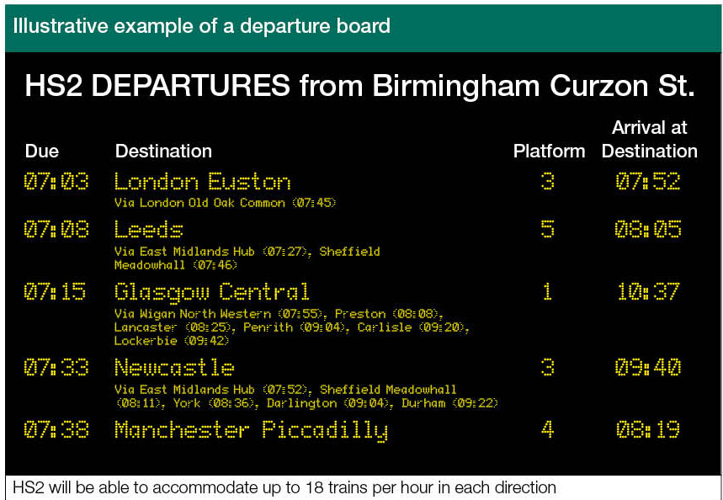
4.5 A key component of the overall service pattern likely to operate on HS2 is that the trains will run both on the HS2 network and then onto the existing rail network, serving a range of other destinations. These trains will travel at high speed on HS2 and then run at conventional speed on the existing network. In this way, HS2 services could run to a very wide range of destinations in the east and west of the country, bringing valuable journey time savings.
4.6 As already mentioned, the indicative service patterns prepared to date are not fixed at this stage. In particular, the Government will want to explore the appetite for other services, including running high speed trains onto other parts of the existing rail network to widen the reach of HS2, where there is a strong case for doing so.
4.7 The latest indicative service specification is available in the report to Government by HS2 Ltd. Potential service patterns will continue to be revised over the coming years until the lines open as we continue to test and refine options for HS2.
Services on the existing network
4.8 Benefits from HS2 do not only arise from running high speed services. An important effect of shifting fast, long-distance services onto a separate, new network is the capacity that this releases on the existing rail network that can then be reused in other ways.
4.9 We must address growth in demand for rail. If we do nothing, the problem of conflicting demand for network space will get worse. Choices will have to be made about how we prioritise space on the networks. This could mean that some towns and cities will see their rail services become less frequent, slower and more expensive to operate, as was the case when the December 2008 timetable, which increased the frequency of long distance West Coast Main Line services, was implemented. Without HS2 there is a risk that some services beneficial to regional economies may be lost.
4.10 Shifting the fastest inter-city services onto the new and separate network in Phase Two of HS2 will release significant amounts of rail capacity. There are options for how that additional capacity can be used. Depending on local transport needs, better connectivity might take the form of more frequent and faster trains which link better with other modes of transport in the area. Studies of the capacity released by Phase One show that it could be possible to transform commuter services into London from Northampton and Milton Keynes, which are not well served by current services. There will be similar opportunities for other towns and cities whose local and regional rail services would no longer have to compete with inter-city services for space on the rail network.

Journey times
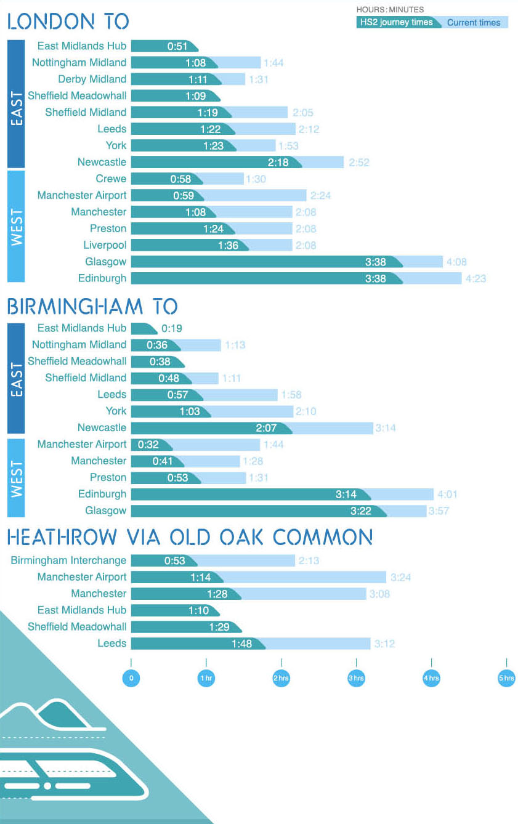

HS2 – speeding up journeys
HS2 would rewrite journey times between Britain’s major cities.
Manchester would be 41 minutes from Birmingham and only 1 hour 8 minutes from London, almost halving the current average rail journey times. Leeds would benefit from similarly dramatic reductions, with Birmingham taking less than 1 hour and London 1 hour and 22 minutes.
The stations in Leeds, Sheffield, the East Midlands and Birmingham would each be separated by a journey of less than 20 minutes, making daily commuting easy and providing a high speed line that would integrate their economies as never before.
Manchester Airport would be 32 minutes from Birmingham and 59 minutes from London. The station serving Birmingham Airport would be 38 minutes from London Euston and would gain better direct rail connections to Leeds, Manchester and other major cities across the UK.
On the east of the country, Newcastle, Durham, Darlington and York would all get faster journeys to London by around 30 minutes compared to today, as well as quicker times to intermediate destinations, including Birmingham.
A large number of towns and cities across the UK not on the HS2 network would also benefit from quicker journeys from HS2 trains that run onto the existing network.
Crewe would have a London journey time of 58 minutes and Liverpool of 1 hour 36 minutes. Towns across the wider North West would also gain quicker journeys from HS2, with direct HS2 trains able to run to Carlisle, Lancaster, Preston, Wigan, Warrington, Chester and Runcorn. North Wales and elsewhere would also have ready access to HS2 at Crewe.
Glasgow and Edinburgh would benefit from up to two trains per hour to London with a journey time as fast as 3 hours 40 minutes, as well as quicker and more frequent services to Birmingham.
There is also scope for new services, not starting or ending in London. Leicester could gain a service towards Leeds from the existing line north, joining HS2 in the East Midlands. Subject to further electrification, and a connection to the high speed line, Bristol could gain services running on the existing line to Birmingham, and then on at high speed towards Leeds and Manchester, Newcastle and Scotland.

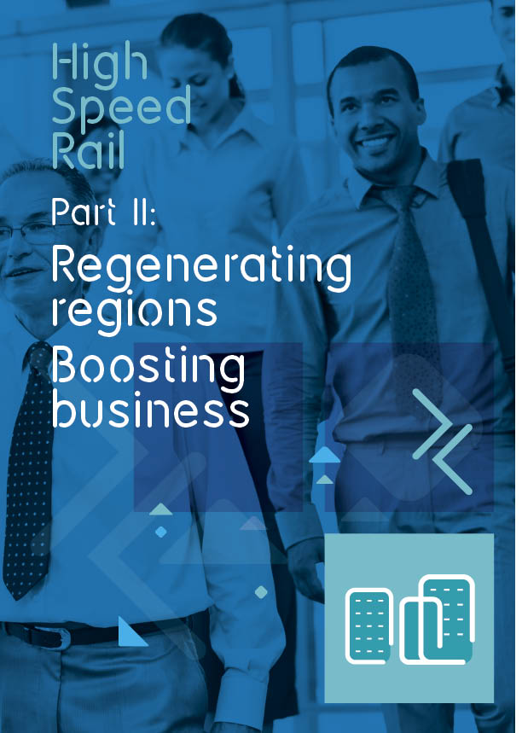

Chapter 5. Benefits for Manchester, Leeds and beyond
5.1 This chapter presents the Government’s initial preferred route and station options for the western and eastern legs of the Y-shaped HS2 network and the basis on which these preferences have been reached. A short summary of why alternative options set out in HS2 Ltd March 2012 advice have not been selected as initial preferences is provided in Annex A.
5.2 As discussed in Chapter 13 (Next steps), these initial preferences will be the subject of a public consultation commencing later this year. Before then, HS2 Ltd will continue to review and potentially refine the options. The Government remains open to new evidence on the options for Phase Two of the network. Only once public consultation has been completed will the Government reach any firm decisions on which route and station options to include in the final scheme proposals.
5.3 The city economies of the Midlands and the North are vital to growing the economy of the country. These cities are rightly proud of their strong industrial heritage particularly in steel, heavy engineering, mining and textiles which was fundamental to the development of Britain in previous centuries.
5.4 But these cities and the regional economies are dynamic – they have not stood still and have developed skilled workforces and lively cultures that continue to attract some of the world’s largest brands. For example, in recent times, the processes of globalisation have seen the South Yorkshire economy restructure to focus on advanced manufacturing and the provision of higher education, leisure and cultural services. Fine architecture and landscapes, as well as important sporting attractions, have supported this shift.
5.5 HS2 will connect the historic powerhouse cities of the Midlands and the North and enable them to develop into a vibrant and competitive unit to counterbalance the South East; as well as creating the potential to open up new commuter markets across the region and bring around two thirds of the population of the North within two hours of London.
Birmingham Curzon St. via HS2
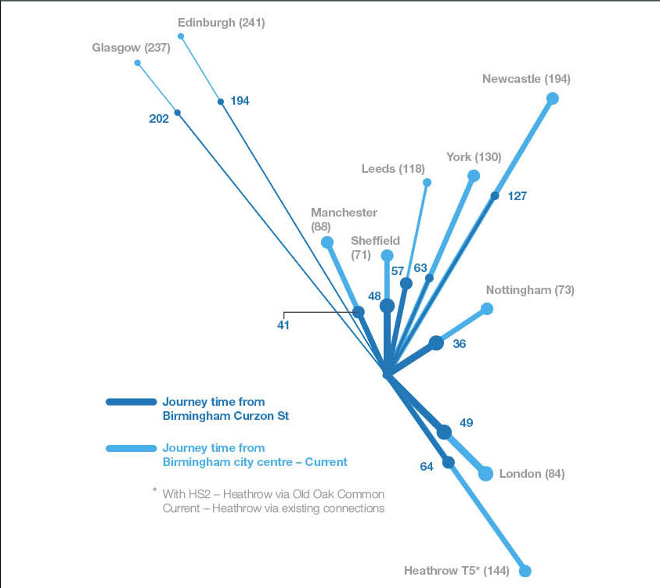

5.6 HS2 is not just for the station cities. The Government attaches a very high priority to ensuring that the towns and cities in the Midlands and the North that cannot readily access HS2 stations are still able to benefit from HS2. Therefore, it has given careful consideration to HS2 Ltd’s advice on serving these markets in reaching its initial preferences.
5.7 Liverpool, Wigan, Warrington, Preston, Chester and Crewe are all strong centres of rail demand, in part through providing a convenient access point to the mainline rail network for their surrounding area. Connections at Crewe and further north near Wigan, would enable HS2 trains to run seamlessly onto the existing network serving a range of destinations and providing journey time savings of at least half an hour and up to an hour. The Government is keen to explore how a connection at Crewe between the existing rail network and HS2 could effectively serve the wider Cheshire and Staffordshire areas, particularly Stoke-on-Trent, through good road and public transport connectivity.
Benefits of the High Speed Rail Network
- Increased capacity to meet future demand – 18 trains per hour in each direction
- Redevelopment and regeneration – supports 100,000 jobs
- Reduced journey times across the high speed rail network – for example in the Midlands and the North slashing an hour from the current journey time from Manchester to London reduced to 1hr 8 mins from 2hrs 8 mins
- Greater connectivity across the Midlands and the North – bringing together 18 cities by 2032/33
- Bringing around two-thirds of the population of the North within 2 hours of London
Manchester – one of the country’s largest conurbations
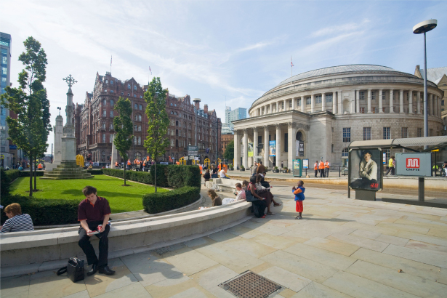
5.8 Greater Manchester has a population of 2.7 million, making it one of the country’s largest conurbations. The city of Manchester is the largest of these, with a population of around 500,000 and over 300,000 jobs, and acts as the principal economic hub for the wider region. In addition, Greater Manchester is home to over 90,000 companies and has highly developed education, culture, leisure and sporting sectors.
5.9 A skilled workforce and dynamic culture have attracted some of the world’s largest brands to make Greater Manchester and its surrounding area a major base for their activities. The UK headquarters of AstraZeneca, Adidas, Kelloggs, Cussons and the Co-Op Group are in the city, among many others. Football clubs including Manchester United and Manchester City attract tourists and generate global revenue streams. The BBC also has a significant presence.
5.10 Manchester is one of the largest centres of inter-city rail demand in the country. The recent upgrade of the existing West Coast Main Line and the planned Northern Hub improvements will provide additional capacity and reduce journey times. However, it is not sufficient for the long-term needs of the city. This strong demand for rail travel, resulting both from the size of the city itself and the fact that passengers from the wider region interchange between services at Manchester means that HS2 would, therefore, be able to serve a large potential market.
Manchester Piccadilly via HS2
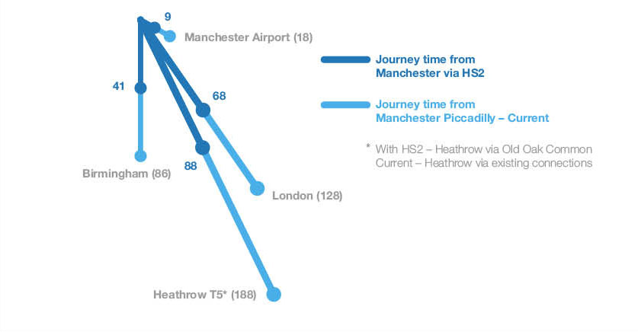

The Government’s initial preferences
5.11 The Government’s initial preferences are for new HS2 stations for:
● Manchester city centre alongside the existing Manchester Piccadilly main line station.
● Manchester Airport, alongside the M56, between Warburton Green and Davenport Green, to serve the airport and the market for rail demand in the south Manchester and the north Cheshire areas subject to agreement of a suitable funding package.
5.12 In addition to the new stations, the Government also supports creating two additional connections from this leg of the HS2 network onto the existing rail network. This could enable wider markets to access HS2 services. These are:
● a connection to the West Coast Main Line, just to the south of the existing Crewe station to provide ready accessibility to HS2 from the Cheshire/North Staffordshire area; to enable HS2 trains to continue north from Crewe to serve Liverpool and intermediate markets, as well as the wider North West; and giving access for North Wales to HS2.
● a connection onto the existing West Coast Main Line to the south of Wigan, near Golborne, to enable HS2 trains to continue northwards to serve Glasgow, Edinburgh and intermediate markets.
5.13 The western leg of the network would need to be supported by depots for maintaining the rolling stock and the infrastructure of the lines themselves. The Government’s initial preference is to build these new depots at Crewe (infrastructure maintenance) and Golborne, south of Wigan (rolling stock).
5.14 We now go on below to describe in more detail what those initial preferences are.
Manchester Piccadilly
5.15 The Government’s initial preference for a city centre station in Manchester is to construct a new HS2 station alongside the existing main line station at Manchester Piccadilly.
5.16 The new city centre station would sit immediately alongside the existing Manchester Piccadilly station, which serves a dense network of routes across northern England and inter-city services to the Midlands, London, Scotland and elsewhere. The HS2 platforms would be parallel to and immediately alongside the existing platforms at Piccadilly. The redevelopment of Piccadilly would also seek to enhance connectivity with the Metrolink, improve road access and add significant new car parking.
5.17 The HS2 project would improve things for all passengers not just those using high speed rail. A bigger station with more facilities and better links with public transport would help the city. These would be good links between HS2 and existing services.
5.18 Opportunities for wider development and regeneration in and around the site would be examined in future masterplanning work – with initial estimates suggesting that development on and around the immediate station site could support over 3,000 housing units and almost 30,000 jobs.
5.19 This work would need to be led by the city, and much would depend on their aims, but HS2 could unlock significant potential for creating a new district around the station and a new gateway into the city. These wider questions about how to integrate the station into the rest of the city would be vital to maximising the benefits of HS2.
Manchester interchange station
5.20 The Government supports integrating the new HS2 network with existing transport infrastructure in the UK and considers that the potential advantages from HS2 serving Manchester Airport could be valuable. Effective integration brings benefits for passengers, means that businesses can operate more efficiently and creates new demand and markets. The Government’s initial preferred site identified for the airport interchange station means that the area south of Manchester, including Stockport and north Cheshire could be served. We would expect to continue to work with the region on plans to ensure that this new station is fully integrated with the existing transport networks.
5.21 Even with Manchester Piccadilly’s current connectivity with the wider region, a HS2 station alongside Manchester Airport could help to further spread the benefits of high speed rail in the North West, as well as create valuable opportunities for passengers to interchange directly between high speed rail services and the airport. The station would also have excellent motorway access. It would sit parallel to the M56, approximately half way between Junctions 5 and 6. The M60 Manchester orbital motorway would be around four miles away and the M6 11 miles away. It would also be possible to extend the Manchester Metrolink network to serve the station directly and to provide a service into the airport.
5.22 There are potential gains from both HS2 and development hopes for the area – including enhancing road access, providing integrated car parking and forecourt facilities. The airport is capable of increasing its passenger volumes if its surface access infrastructure is improved. HS2 could provide opportunities, both directly and indirectly, to achieve this. Direct connections could also be provided with the major new Airport City development and other components of the Manchester Enterprise Zone. Future work with Manchester Airport Group and other Manchester delivery partners would consider the best means of integrating the HS2 station with the Enterprise Zone and the airport itself.
5.23 On this basis, the Government expects that there will be a strong commercial case for the airport to fund significant elements of the HS2 infrastructure, and the Government’s support for the airport station is conditional on that. The region has committed to leading work to draw up a package of innovative funding measures to ensure that the station is affordable. The Government will now work with the airport and wider region to develop clear funding principles and an outline package which would be sufficient for the station to go ahead.
5.24 One potentially important part of the funding package and of the benefits that a HS2 station at the airport could generate is development around the station. Elsewhere on the HS2 network local authorities are developing plans for regeneration around the stations, looking to replicate successes on established high speed rail networks overseas. The nature of the site means that significant development could be introduced around the HS2 station, subject to the aspirations of the local authority and of the wider region. The Government’s view is that sensitive and high-quality development could support significant economic opportunities and drive important social benefits. The Government and HS2 Ltd will, therefore, support the region in its planning for the site and in ensuring that development associated with the station supports the delivery of the HS2 project.
Rail connectivity in Manchester
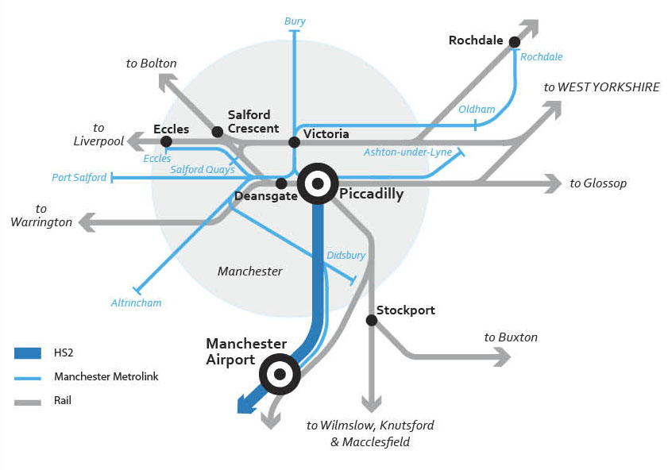
Crewe rail hub – serving Liverpool and the wider North West
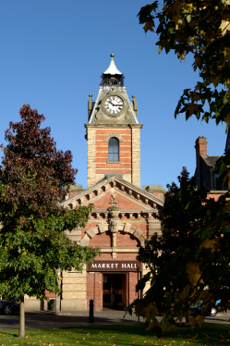
5.25 Given its strategic location on the rail network, the Government’s initial preferred option is for a rail hub at Crewe that could be used to provide frequent, fast services to Liverpool and other key destinations in the North West.
5.26 Crewe represents a potentially advantageous location for HS2 to connect to the existing network. This is further enhanced by its strong connections with a range of important rail markets, which we expect to improve by working with the region as we develop the proposals for HS2. High speed trains would run seamlessly off HS2 onto the existing network at Crewe, offering very competitive rail journey times to and from the Midlands and London. A further wider range of stations would be accessible with a single change of trains at Crewe.
Rail connectivity from Crewe
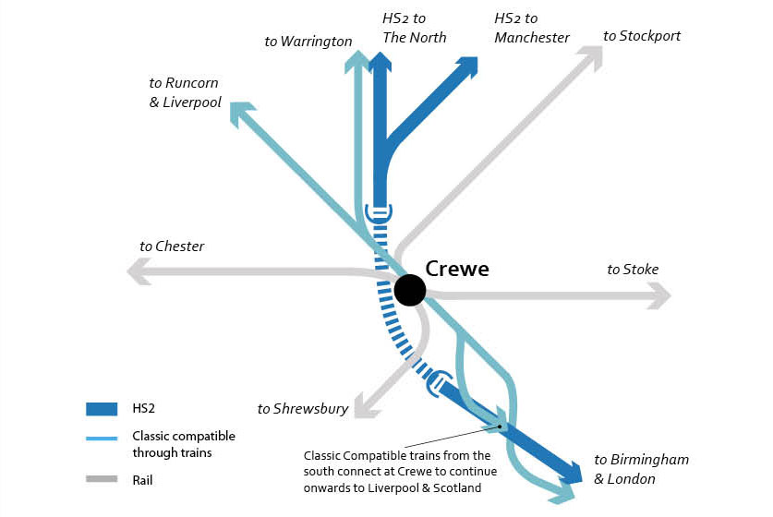
Connection to the West Coast Main Line – serving the North and Scotland
5.27 Providing significant benefits to passengers travelling to and from Scotland is an important part of the case for Phase Two of the HS2 network. All of HS2 Ltd’s analysis of Phase Two options has incorporated the impact on services to and from Scotland. As discussed in Chapter 11, the Government is also keen to look at how Scotland could secure further benefits and improved journey times from high speed rail.
5.28 The Government’s initial preference is to provide a connection near Golborne to the south of Wigan, which would enable journey times to Glasgow and Edinburgh to London of around 3 hours 40 minutes.
5.29 This southerly connection, to the south of Wigan, strikes the best balance between the overall costs and benefits. Issues about further improving journey times to Scotland would need to be considered as part of the work with Transport Scotland.
Serving the East Midlands, South Yorkshire and Leeds
5.30 In this section we briefly set out some of the key facts about the main conurbations to be served by HS2 on the eastern leg.
East Midlands – a geographically and economically diverse region
5.31 The East Midlands contains several major towns and cities as well as a range of market towns, smaller towns and villages. The region has a rich cultural heritage and contains a number of important landscape and natural features, historical sites and buildings. A portion of the Peak District National Park sits within the region and the tourist industry is a growing source of income. HS2 will not only provide enhanced connections from the East Midlands to London and the South East but also to the West Midlands, Yorkshire and the North East.
Rail connectivity in the East Midlands
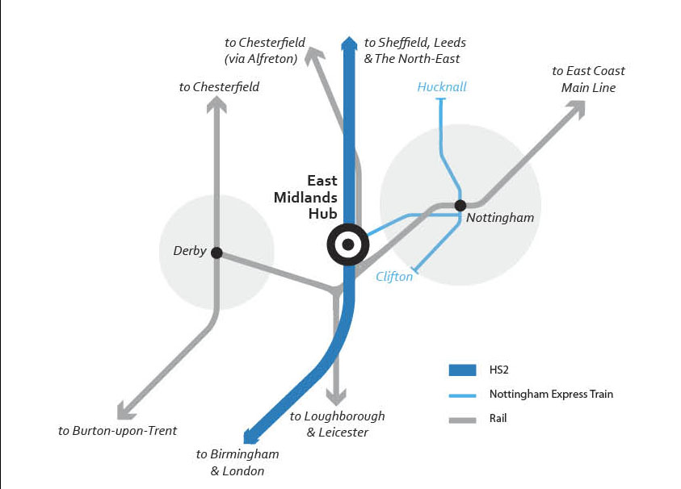

5.32 Nottingham is the largest centre of population and biggest single source of rail demand in the East Midlands. Leicester and then Derby follow, the level of rail demand correlating well with their respective urban populations. However, with the exception of Leicester, journey times to London and the South East are relatively slow for the distances involved.
Nottingham via HS2
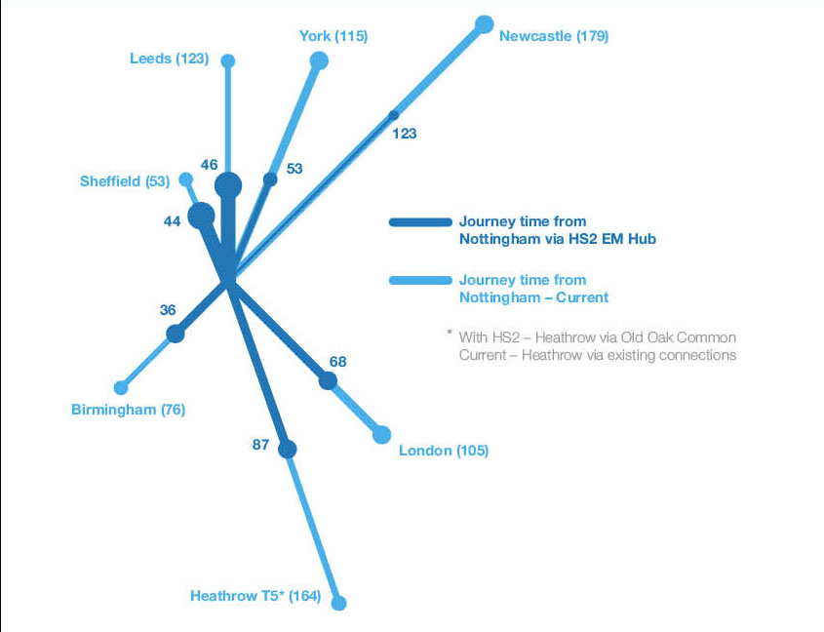

Derby via HS2
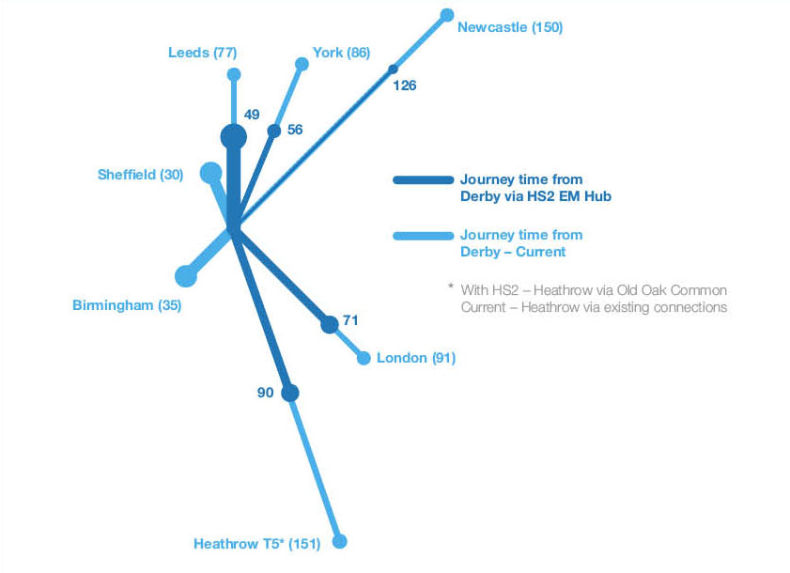

South Yorkshire – a changing economy
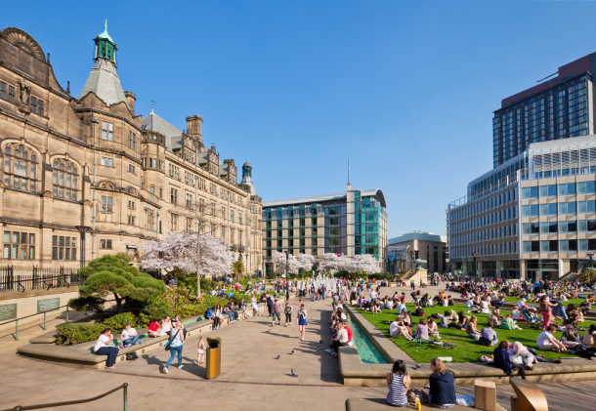
5.33 South Yorkshire, responding to globalisation, has developed a new economy focussed on advanced manufacturing and the provision of higher education, leisure and cultural services. The main urban centres in the South Yorkshire region are Sheffield, Barnsley, Doncaster and Rotherham. In transport terms, the region is currently served by the M1, A1 and M18 motorways; the Midland Main Line, which heads south from Sheffield; and the East Coast Main Line, which serves Doncaster.
5.34 As with the East Midlands, current journey times to London and the South East by the Midland Main Line are relatively poor for the distances involved, although there will be some improvement through the major programme of investment to the Midland Main Line. Doncaster has faster journey times as a result of being on the East Coast Main Line. Travellers from across the region often opt to travel further in order to access rail services at Doncaster given these faster journey times.
5.35 Journey times on HS2 from South Yorkshire to London would be a little over one hour, representing a saving of around an hour on journeys today. The region is also keen to see enhanced connectivity northwards to Leeds and southwards to the Midlands. Journey times to the former could be halved, to less than 20 minutes, and to the West Midlands journey times would be cut by half an hour, to less than 40 minutes.
Rail connectivity in Sheffield
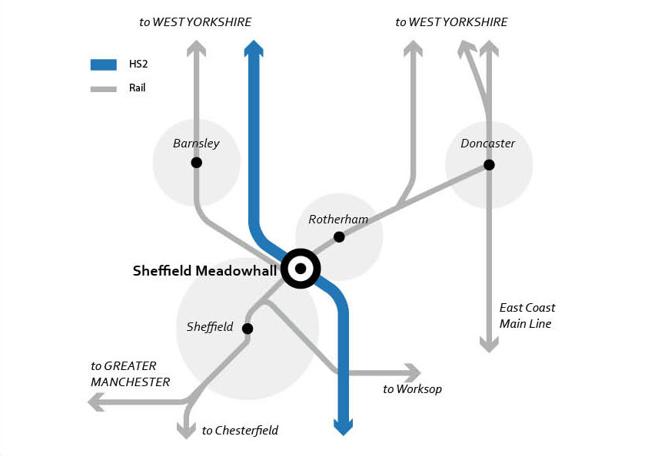

Sheffield via HS2
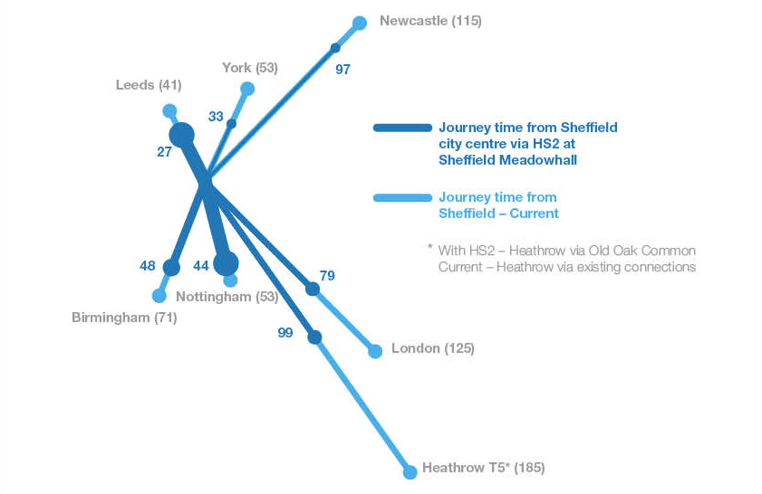

Leeds – one of the most diverse economies in the country
5.36 Leeds metropolitan district has a population of 750,000 and sits at the centre of the wider Leeds City Region with a population of nearly 3 million. Leeds station is one of the busiest stations in the UK outside London and is used by over 25 million passengers annually.
5.37 The 100,000 businesses in the city region generate four per cent of the UK’s economic output. The region’s economy is one of the most diverse in the country, with particular strengths in financial and business services, legal service, healthcare, creative industries, retail and manufacturing. Leeds has been successful in attracting major businesses, including Capita Group, First Direct, KPMG, Asda and a number of global banking institutions. In total, Leeds has over 100,000 jobs in these sectors.
5.38 Leeds also has a strong university sector, with a student population of over 60,000 whilst the wider city region encompasses a further five universities and many colleges. Major sporting and cultural institutions further add to the attractiveness of the city region as a place to live, work, study and visit.
Leeds via HS2
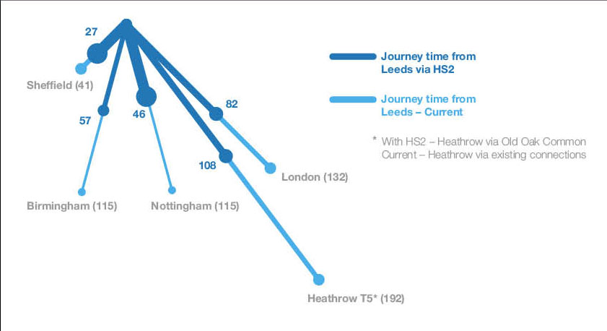

5.39 Leeds would provide the single largest market for HS2 on the eastern leg of the network. The demand for long distance rail services in the city region is concentrated in Leeds city centre, with lower levels of demand from the wider city region. Around one in every five passengers travelling from Leeds to London has interchanged from another service.
The Government’s initial preferences
5.40 The Government’s initial preferences for new HS2 stations are:
● East Midlands at Toton (East Midlands Hub), located between Nottingham and Derby, 1.2 miles from the M1 and close to the A52, with the potential for excellent rail and wider public transport connectivity, opening up the benefits of high speed rail to the wider region;
● South Yorkshire at Sheffield Meadowhall, to the east of Sheffield city centre, adjacent to the M1, serving the wider South Yorkshire area via excellent local and regional rail and road connectivity; and
● Leeds at New Lane, in Leeds city centre to the south of the River Aire and with close links to the existing Leeds City station.
5.41 In addition, the Government also supports creating a connection from this leg of the HS2 network onto the existing rail network to enable wider markets to access HS2 services. This is:
● A connection onto the existing rail network near Church Fenton approximately 9 miles to the south west of York, which would enable HS2 trains to run onto the East Coast Main Line to serve York, Darlington, Durham and Newcastle, bringing significant benefits to North Yorkshire, Tees Valley and the wider North East.
5.42 The eastern leg of the Y network would need to be supported by depots for maintaining the rolling stock and the infrastructure of the lines themselves. The Government’s initial preference is to build these new depots at New Crofton, near Wakefield (rolling stock) and Staveley, near Chesterfield (infrastructure maintenance).
5.43 We now go on below to describe in more detail what those initial preferences are.
East Midlands Hub station at Toton
5.44 The Government’s initial preference for a station serving the East Midlands region would be to construct a new HS2 station on existing railway land in the south west suburbs of Nottingham. Toton has good access to the M1 and could be served by local rail services to Derby, Leicester and Nottingham, as well as bus services and an extension of the Nottingham tram.
5.45 The site of the proposed station is alongside an existing rail freight yard north of Long Eaton. It is just over a mile from Junction 25 on the M1. The A52 (Brian Clough Way) provides good road access to the M1 and Derby to the west and to Nottingham city centre to the east. Car access to the station would be important and would help to open up access to the station from the villages and towns of the wider area that would not have direct public transport access to the site. The station development would include car parking facilities and a dedicated connection from the A52.
5.46 A key advantage of the Toton site is the extent to which the station could be readily accessible by public transport from both Derby and Nottingham but also from much of the wider East Midlands region. The station would be located alongside the existing rail network and would incorporate platforms to accommodate potential connecting rail services from across the East Midlands. For example, it would be possible for trains running between Nottingham and Derby to call at the East Midlands Hub station en route, with a journey time of 12 and 15 minutes from each of these, respectively. Services from Leicester, Loughborough, Hucknall and Mansfield, for example, could all call at the station. The integrated HS2 and classic rail station would mean that passengers are able to benefit from quick and efficient interchanges. The reconfiguration of some rail services across the East Midlands to enhance access to the East Midlands Hub station would need to be considered with the close involvement of the region and Network Rail.
5.47 Nottingham has a growing tram network, with an extension to a park and ride site at Toton currently under construction. A short further extension of around half a mile would allow the tram to call directly at the East Midlands Hub station, providing a direct tram link to the city centre, as well as the University of Nottingham and a number of residential districts and major employers. Local bus services could also be enhanced to serve the station.
5.48 The proximity of the HS2 station to the A52 offers the possibility of good connectivity by local bus to a range of destinations in the Derby, Nottingham and Erewash Valley areas. In addition, the proximity to Junction 25 of the M1 offers the potential for a range of regional coach feeder services to operate to the station. Although these proposals provide good connectivity at the East Midlands Hub, we want to work with the region to develop further the connectivity offering to ensure that the whole East Midlands benefits from this station.
Highway connectivity in the East Midlands
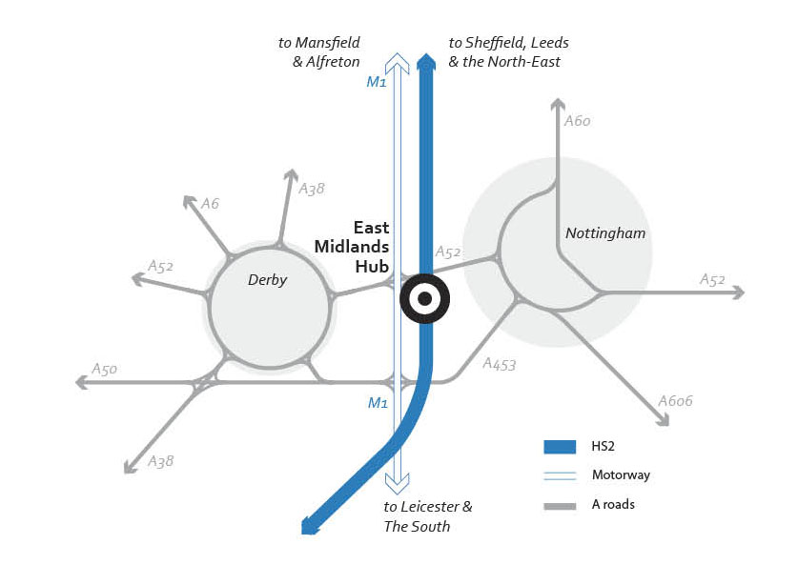

5.49 Given that the proposed station at Toton would be readily accessible to passengers from Derby and Nottingham, HS2 Ltd expect that over three-quarters of passengers from Derby would choose to use HS2 to travel to London and over four-fifths from Nottingham would do so. Its strong public transport connectivity would allow a significant proportion of passengers to access the station by public transport, not only when travelling to and from the cities of Derby and Nottingham but also for the wider East Midlands.
5.50 The East Midlands Hub option would be the best of all the available station options for serving the East Midlands, generating additional benefits of around £500 million over the next best performing option. And by attracting more passengers, it could generate additional fare revenues of around £190 million.
Sheffield Meadowhall
5.51 The Government’s initial preference for a station serving South Yorkshire would be to construct a new HS2 station close to the Meadowhall retail complex to the north east of Sheffield. The site is close to Junction 34 of the M1 motorway and is well served by tram and bus services, as well as by rail services from across the region and beyond.
5.52 Although South Yorkshire stands to benefit from significantly reduced journey times from HS2, the level of demand for rail travel from the region would not make it one of the larger markets for HS2, especially given its position on the network. For example, the market for rail travel to London is estimated as five times greater from Leeds and the North East than from Sheffield. This means that two principles are important in determining how best to serve South Yorkshire within the context of maximising the benefits of the wider network.
5.53 First, serving South Yorkshire alone would support only an infrequent service. We believe passengers would want a more frequent service from this region. This can be achieved by having services calling at South Yorkshire also stopping at other destinations while still delivering highly attractive journey times.
5.54 Second, it is important to balance the increased journey time for running via central Sheffield for those travelling to and from stations north of the region with the benefits for South Yorkshire itself.
5.55 The Government accepts these two principles and on this basis has reached its initial preference for a station in South Yorkshire.
5.56 The site for the proposed Meadowhall station is located between Sheffield and Rotherham, 4 miles north east of central Sheffield and 3 miles south west of the centre of Rotherham and has excellent public transport connectivity.
5.57 The Meadowhall retail complex itself occupies over 1.5 million square feet of floor space, contains approaching 300 stores and attracts over 25 million visitors per year. The presence of the retail complex, as well as other businesses in the area including the Sheffield Arena means that the Meadowhall site would be extremely well connected to Sheffield and the wider city region. The existing Meadowhall Interchange is served by a dense network of trams, trains and buses.
5.58 The Sheffield Supertram, providing a 20 minute journey time into central Sheffield, runs from the existing Meadowhall Interchange into the centre of the city. Trams currently run every 10 minutes during peak times and provide a high capacity and convenient mode for linking up key parts of the city. A new tram stop integrated into the HS2 station would be built.
Public transport opportunities for Sheffield with HS2
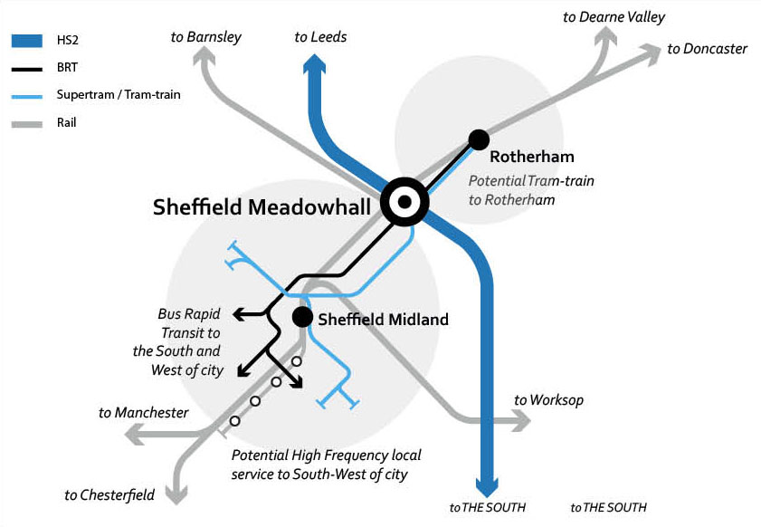

5.59 Meadowhall also currently has a frequent rail service. Up to nine trains per hour all day run into Sheffield Midland station, with a journey time of as little as five minutes. Trains also connect Meadowhall to Rotherham, Barnsley and beyond to Wakefield, Doncaster, Scunthorpe and stations to Leeds and Manchester. Improved rail access from south west Sheffield to Meadowhall could also be considered. Potentially up to six trains per hour could run between Dore & Totley and Meadowhall. Alternatively, potential extensions of the Tram Train could be considered, which would offer scope for additional new stops in south west Sheffield. Meadowhall is already a major bus station and an important calling point on the National Express coach network. High quality interchange would be provided between HS2 services and rail, tram and bus services. We would work with the region to develop proposals on the connectivity at the HS2 station so that it brings benefits to the whole South Yorkshire region.
5.60 The HS2 station at Meadowhall would be situated alongside the M1, providing convenient access by road from the wider region. Work with the Highways Agency and local authorities would be undertaken on the capacity of the motorway network in this area as it already experiences congestion. The Meadowhall area is also served by direct road connections to the city centre.
Highway connectivity in Sheffield
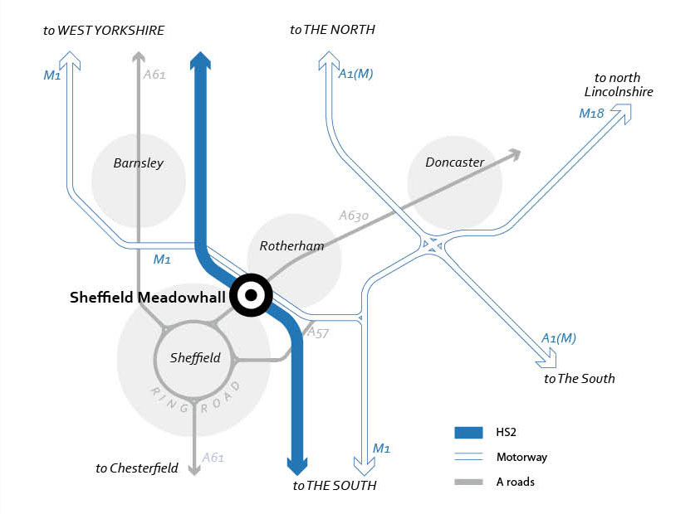

5.61 With the addition of HS2, Meadowhall could become a key transport hub within the region, in a location that allows not only quick access from central Sheffield but also from across the region.
5.62 The Government and HS2 Ltd would work with the region to develop options for potentially exploiting the considerable scope for regeneration and new development on and around the Meadowhall site. The opportunities exist for significant new commercial, retail and residential facilities in the area, which an HS2 station could help to catalyse.
Leeds New Lane
5.63 The Government’s initial preference for a station serving Leeds is to construct a new HS2 station immediately south of the Victoria Bridge over the River Aire, between Bridgewater Place and the Asda headquarters building.
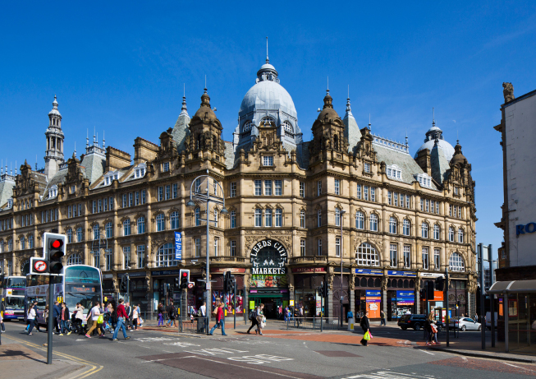
5.64 Located just to the south of the existing station in the city. Given the aspirations in the city for extending the city centre south of the river and to see major new development around this area, a HS2 station located close by could support this refocusing on the city centre and supporting the regeneration in this area. In turn, this would make the station accessible to the important new centres of activity that would develop south of the river.
Rail connectivity in West Yorkshire
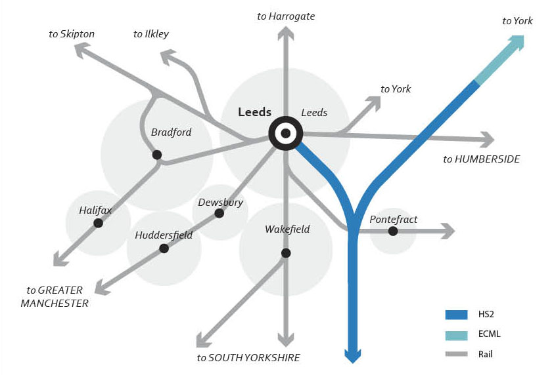

5.65 An important priority for the city council and other delivery partners in Leeds is to mitigate any risks that the introduction of an HS2 station might pose for the city’s development aspirations around the city centre. In particular, the city has developed a regeneration plan for the South Bank area. The Government and HS2 Ltd will work with Leeds City Council to ensure the plans for a new station maximise the opportunity to regenerate this part of the city.
East Coast Main Line connection – serving Newcastle and the wider North East
5.66 As with the western leg of the network, a connection onto the existing rail network plays an important role in delivering the full potential of the scheme. HS2 trains would be able to run onto the East Coast Main Line at the connection point and then run at conventional speed to their ultimate destination. The Government’s initial preferred option that provides the optimum balance between cost, environmental impacts, journey time savings, and the number and size of markets it can serve is to join the national rail network around 9 miles south west of York, near Church Fenton, prior to joining the East Coast Main Line at Colton Junction, around 4 miles from York. The route would head north from the junction for the spur into Leeds, following the M1 and skirting Garforth, before heading east to join the conventional railway near Church Fenton. The route is described in more detail in the following section.
5.67 York is a key centre of rail demand for the wider region. The HS2/East Coast Main Line connection would mean that passengers would be able to board a HS2 train at York station, which would then head south for a short distance of 9 miles on the East Coast Main Line, before joining HS2 and accelerating to full speed completing the rest of the 213 miles to London on high speed rail. York would, therefore, benefit from significant journey time savings, with a journey to London of around 1 hour 23 minutes compared to 1 hour 53 minutes today.
5.68 As well as serving York, the Government’s initial preferred option for the connection would also enable trains to continue to destinations further north on the East Coast Main Line, including Darlington, Durham and Newcastle. As with York, the journey time saving would be around 30 minutes compared to today. The HS2 trains serving these stations in the North East would be designed to be capable of running on both the HS2 and the existing network without modification.

Chapter 6. Route Summary – Western and Eastern leg
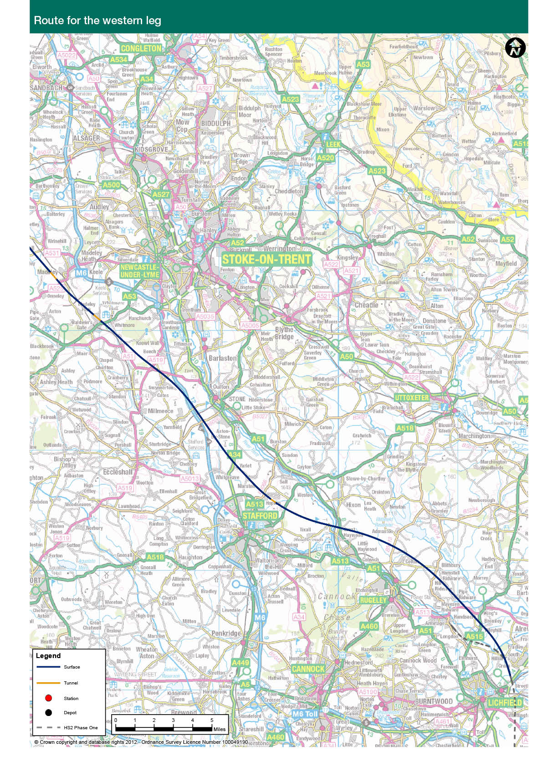
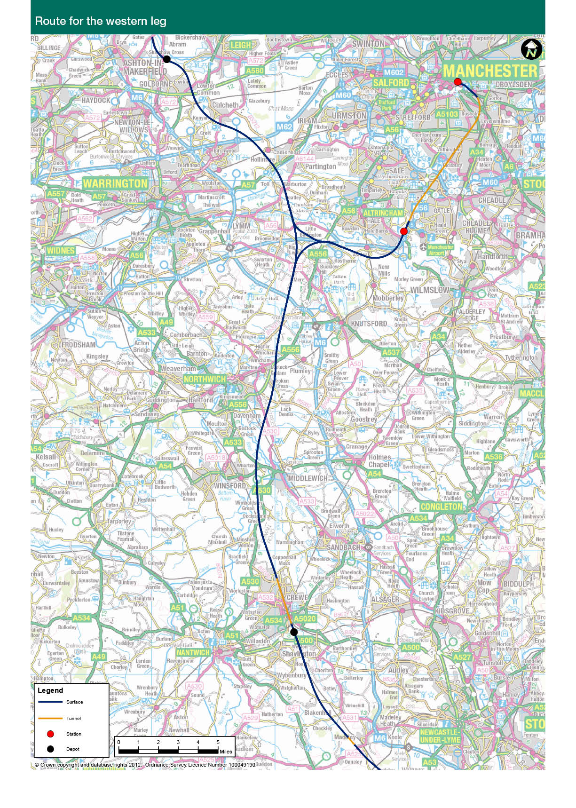
6.1 The reports that HS2 Ltd submitted in March 2012 described the route options they developed, including describing in more detail a set of final options. Having considered their advice, and identified initial preferences for station and depot locations, this chapter describes the initial route preferences made by the Government. We first describe the route for the western leg before describing the eastern leg.
Lichfield to Newcastle-Under-Lyme
6.2 The junction from the Phase One route for the leg to Manchester would be to the north east of Lichfield. Immediately after leaving the junction the Government’s initial preferred route for the line to Manchester would head to the north-west on an embankment, up to 14 metres high and then a bridge to cross the Trent and Mersey Canal. It continues on this path between Handsacre and Kings Bromley on a viaduct and crossing the River Trent, again on viaduct just over one mile in length.
6.3 The line would then be in a mixture of cutting, or on embankment and surface level track heading to the north of Stafford. The route would cross the A51 at Great Haywood and the railway line to Stoke-on-Trent on bridges. It would run to the south of Pasturefields Salt Marsh Special Area of Conservation (SAC), over the River Trent, and then to the south of the village of Hopton, in cutting and green tunnel so as to minimise the visual and noise impacts. The route would head west to the West Coast Main Line before converging with the M6 corridor west of Stone and running parallel with the motorway for a short distance. It would then cross over the M6, passing Swynnerton to the east, then under the A51 and A519 heading to the south-west of Newcastle-Under-Lyme where it would pass under the A53, travelling up to 250mph.
6.4 The Government’s initial preferred option for this route is based on work by HS2 Ltd, that considered a wide variety of options through this area. Three other options were shortlisted: two variants that went to the north of Pasturefields Salt Marsh; and another southern route option between Lichfield and Newcastle-Under-Lyme broadly following the West Coast Main Line corridor.
6.5 Whilst the main driver for considering alternative route options was Pasturefields SAC, the implications of the route refinements extended from Streethay to Millmeece. This presented an opportunity to address some of the other key sustainability and engineering challenges. The new route that was developed would be to the south of the SAC and hence have less impact on it. This route would also require fewer demolitions, have less potential noise impacts and avoid conflict with a railway junction remodelling at Norton Bridge and the Ministry of Defence Stafford development site. Further information on sustainability impacts is included in the Sustainability Summary.
Newcastle-Under-Lyme to Crewe
6.6 After crossing the A53 the route would enter a deep cutting leading to a section of tunnel about half a mile long through the hillside and under Whitmore Heath. It would emerge from the tunnel and head towards the West Coast Main Line, crossing it to the south of Madeley. It would run to the west of Madeley at a distance of approximately half a mile dropping into deep cutting and tunnel, further reducing impacts on the conservation area, and would head northwards towards Crewe parallel to and west of the West Coast Main Line for approximately five miles. Approaching Crewe, the route would be elevated as it continues to follow the West Coast Main Line. It would widen to form multiple tracks. Descending again, both the HS2 route and the West Coast Main Line pass under the A500 and enter Crewe. On entering Crewe, a junction from HS2 to the West Coast Main Line would allow HS2 trains to continue onto the existing network. This would also be the location of a link to an infrastructure maintenance depot, which is planned to the west of the route and the existing Basford Hall sidings. The HS2 route would descend into a cutting and then a two and a half mile tunnel which passes underneath Crewe and would emerge on the northern outskirts of the town, near Parkers Road avoiding demolitions in the Barrows Green area.
6.7 The Government’s initial preferred option for this route is based on work by HS2 Ltd that considered a wide variety of options through this area. A further short-listed option for the route from Newcastle-Under-Lyme was to head to Sandbach along the M6. However, the initial preferred route opens up the benefits of serving Crewe and the wider North West. In general, this route also performs better in sustainability terms.
Crewe to Golborne
6.8 Upon leaving Crewe the route would run immediately adjacent to the West Coast Main Line for 2.5 miles passing through open countryside at surface level. Heading north it would pass between Middlewich and Winsford onto a 745 metre long viaduct over the Trent and Mersey Canal and the River Dane floodplain. Bearing north east the route would run mainly on embankment passing approximately two miles to the east of Northwich before crossing the Altrincham to Chester railway line, the A556 and the A559. The route would then run in either shallow cutting or on the surface for just under two miles before rising onto embankment to cross the M6 to the north of Junction 19.
6.9 After the M6 crossing the route would descend into cutting under the A50 west of Hoo Green, where the spur to Manchester would leave the main route using a grade separated junction. The main route would then approach the M56 passing under it in deep cutting. Line speed at this point would be a maximum of 225mph due to the geographic constraints to the north. North of the M56 the route would cross over the A56 and the Bridgewater Canal to the east of Lymm. After this crossing, the route would continue northwards approaching the Manchester ship canal on a viaduct just under a mile long and reaching 28 metres high to allow navigation clearance for shipping. In addition to the canal, the route would also cross the A57 and the Manchester road between Hollins Green and Cadishead. As the route descends from the viaduct it would cross over the Manchester to Warrington railway line and the M62.
6.10 The route would then bear west broadly following the dismantled railway corridor south of Culcheth in a cutting before rising to cross the Liverpool to Manchester railway line on a bridge. It would then pass under the A580 through the gap between Lowton and Lowton Common and head to the west running to the north of Golborne where a rolling stock maintenance depot is proposed. The route would rise onto a long embankment, crossing over the A573 before connecting back onto the West Coast Main Line using a grade separated junction at Bamfurlong, around two and a half miles south of Wigan. This connection would require the two eastern West Coast Main Line tracks to be realigned to the east so that the high speed lines could pass over them and join the inner two tracks to form a six track railway for a short distance. At this point, through trains would continue to destinations in the North West and Scotland.
6.11 The Government’s initial preferred option for this route is based on the assumption that the benefits of serving the North West through a connection at Crewe and serving people further North and in Scotland should be included in Phase Two. Given this, the route selected here is the best performing option, following the work by HS2 Ltd that considered a wide variety of options through this area.
Approach into Manchester City Centre via Manchester Interchange
6.12 The Government’s initial preferred route to approach Manchester leaves the main line just north of the M6 at Hoo Green and would head eastward over the main route with a maximum speed of 145mph. The route would continue 150 metres to the north of Rostherne Mere running in cutting to the south of the M56. It would follow the terrain passing over Birkin Brook and the Altrincham to Chester railway before heading north east to cross under the M56 at Warburton Green, to the north of the Manchester Airport runways.
6.13 The route would then be in cutting to the west of the M56 running into the interchange station close to the airport and motorway. From the station, the route would continue to head north-east descending into tunnel close to Junction 5 of the M56 for 7.5 miles. The route would resurface north of Longsight alongside the existing railway line into Piccadilly and run in cutting under the A57. It would continue in cutting through Ardwick within the existing rail corridor, elevating to approach Piccadilly station. It would then pass over the inner ring road (Mancunian Way) and approach the new station next to the existing Piccadilly station.
6.14 The Government’s initial preferred option for this route is dictated by its desire to deliver the benefits of an interchange station adjacent to Manchester Airport and the city centre station at Piccadilly. Given this, the route and station options selected here are the best performing options, following the work by HS2 Ltd that considered a wide variety of options through this area.
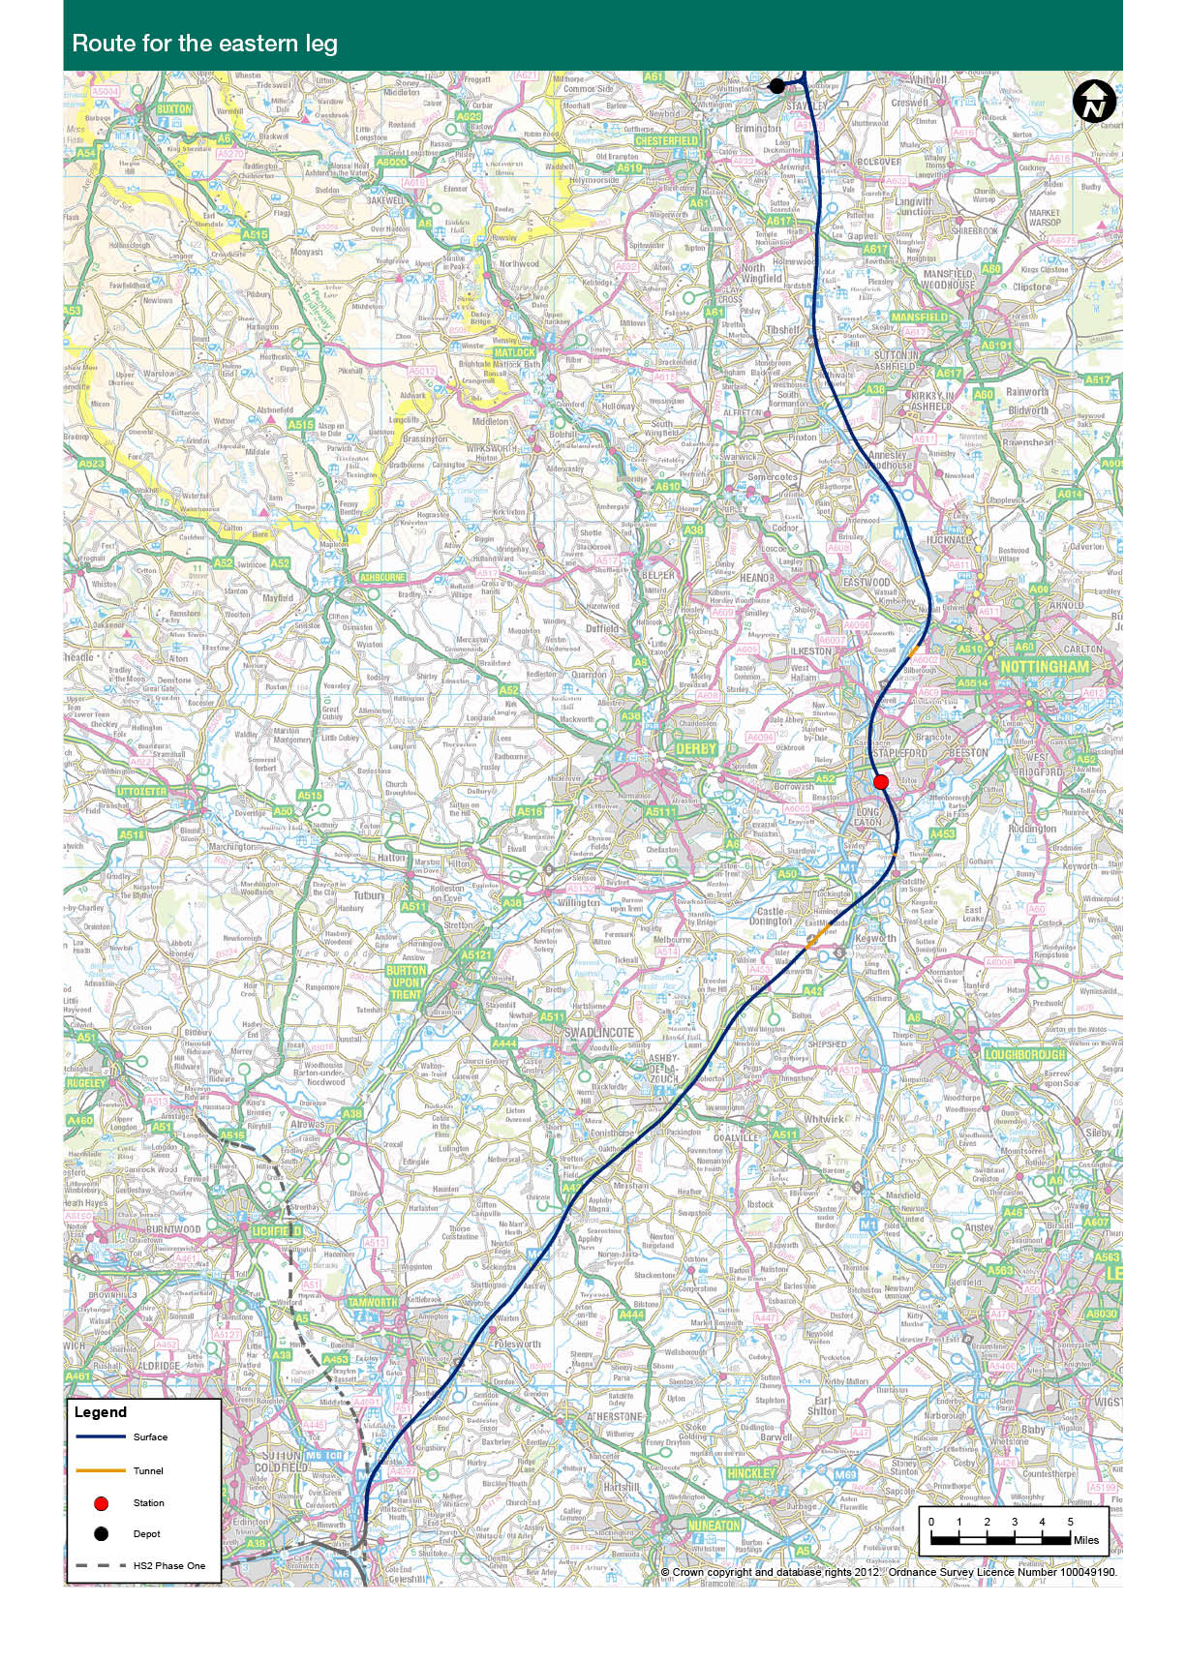
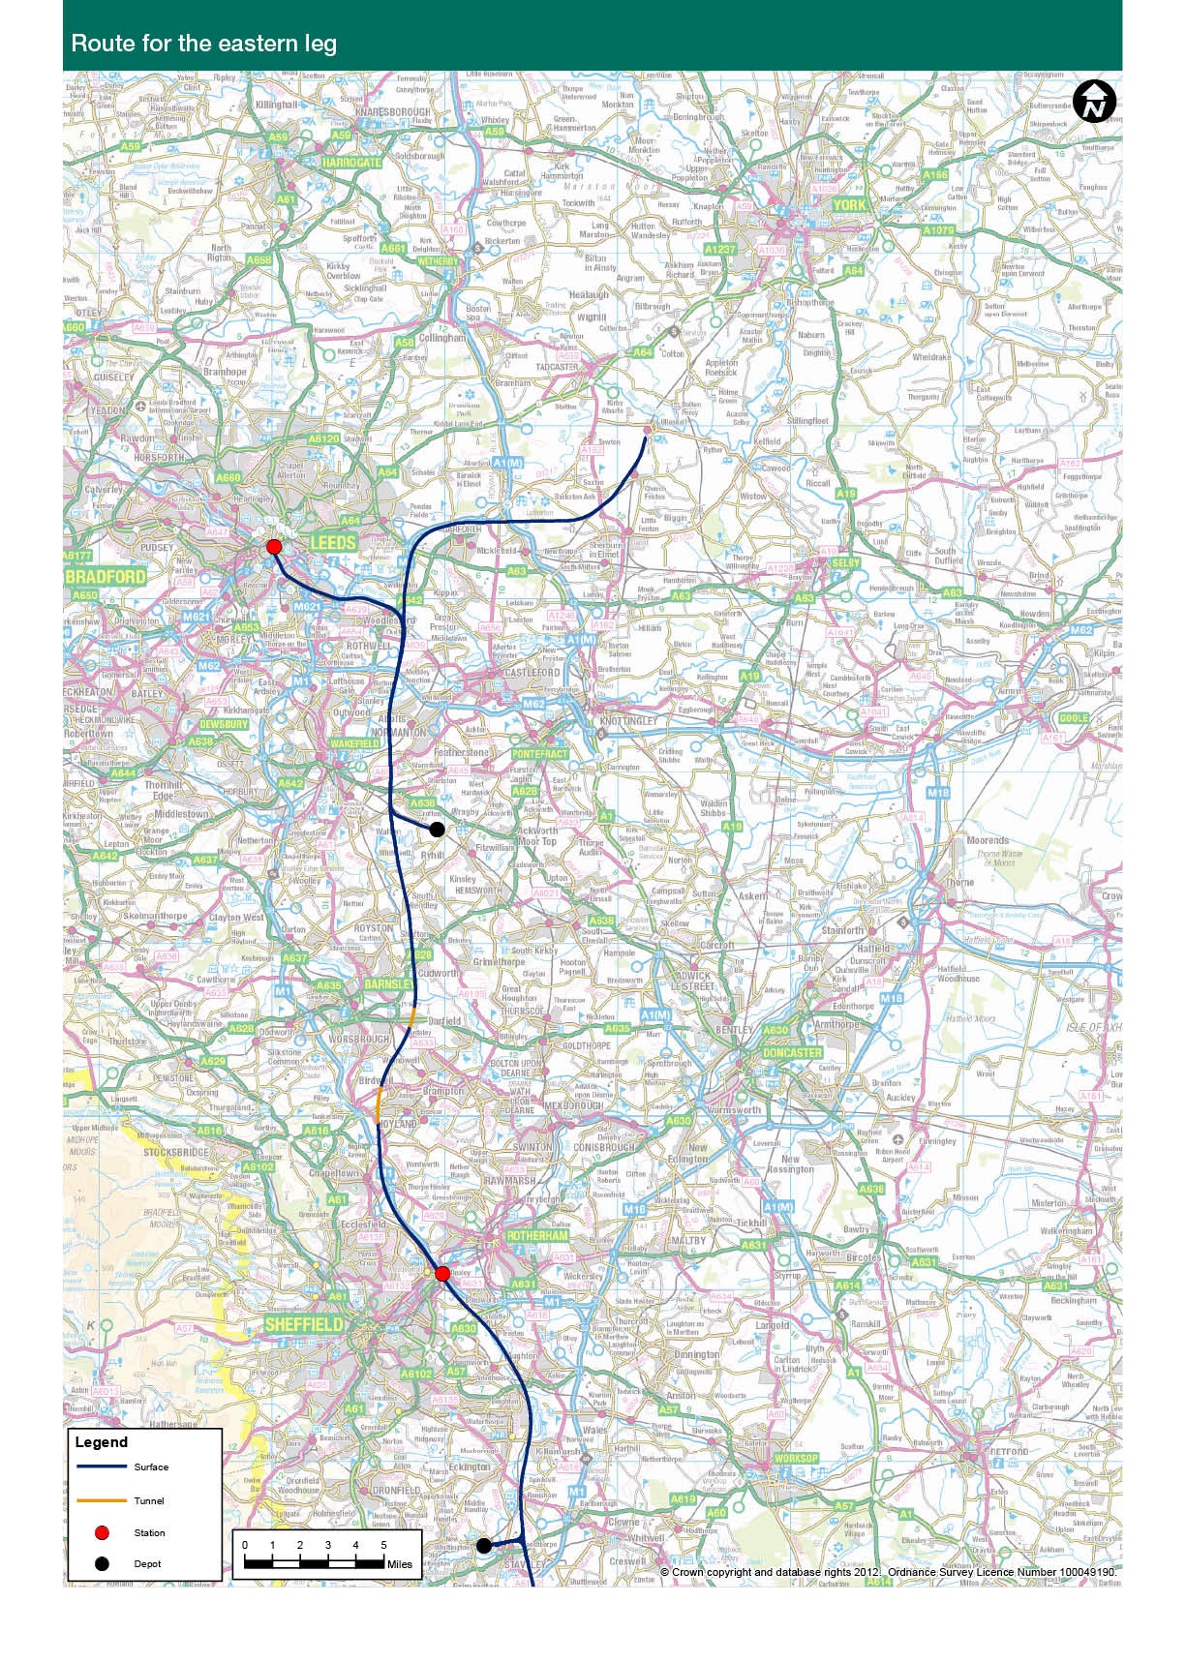
Water Orton to Toton
6.15 The junction for the eastern leg of the Y network would leave the Phase One route at Water Orton just south of the M42. Immediately upon leaving the junction the Government’s initial preferred route for the line would run north east crossing the River Tame at Kingsbury and following closely to the M42/A42 corridor, mostly along its eastern side except for a three mile section near Tamworth. The route would cross the River Mease SAC to the north west edge of Measham and continue along the east side of the A42 past Ashby-de-la-Zouch. Three junctions along this stretch of highway would need to be remodelled along with temporary and permanent realignments at Tamworth and Measham respectively. The route would leave the A42 corridor at Breedon on the Hill and pass under the East Midlands Airport in a 1.2 mile long tunnel.
6.16 Soon after leaving the tunnel the route passes over the M1 motorway at Junction 24 near Lockington to cross the floodplain of the River Soar on a two mile long viaduct, briefly cutting through the Red Hill at Ratcliffe-on-Soar power station before crossing the River Trent and its floodplain on another long viaduct of just over one mile in length. The north end of this viaduct would cross the Trent Junctions that connect the rail routes from Derby, Leicester and Nottingham. From here the route passes through Long Eaton towards the East Midlands Hub station option at Toton.
6.17 The Government’s initial preferred option for this route is based on work by HS2 Ltd that considered a wide variety of options through this area. One alternative route option which was shortlisted was via Derby. Two variants of the route following the M42/A42 corridor were considered, HS2 Ltd has worked with Natural England and the Environment Agency to understand the implications of crossing the River Mease SAC. HS2 Ltd undertook an Appropriate Assessment, the provisional conclusion of which was that the River Mease crossing would not have an adverse effect on the Sac. Natural England has agreed with this conclusion. The Appropriate Assessment will continue through the design process to ensure there are no significant adverse effects.
6.18 The route to the north of Measham is considered more favourable than the other options as it crosses a narrow part of the floodplain and makes a more direct crossing of the river with a shorter viaduct structure. A variant option to the south of Measham would impact a larger number of people with noise than the variant to the north. However the routes are otherwise comparable. The variant to the east of Measham that avoids crossing the SAC designation directly would have the most significant sustainability impacts directly impacting Biodiversity Action Plan habitats, ancient woodlands and a Conservation Area.
Toton to Sheffield
6.19 Through Long Eaton the route occupies the existing low level corridor that provides access to the south of Toton Yard. The tracks on the Trent Junctions and the high level access corridor would subsequently require remodelling to maintain access to the Yard and the wider network. Upon leaving the new East Midlands Hub station at Toton, the Government’s initial preferred route for the line would broadly follow the M1 motorway corridor as far as Staveley in North Derbyshire. The interface with the M1 is not insignificant: in order to accelerate to the necessary high speeds a mile length of the M1 would need to be realigned at Stanton Gate; the motorway would be crossed three times between Tibshelf and Staveley, with temporary realignments of the motorway being required at these crossings; four motorway junctions along this stretch would be affected to a greater or lesser extent.
6.20 As it follows the motorway the route experiences a significant variation in elevation with ground levels ranging from 40m to 190m above sea level. As a result of the frequent change in elevation the route is characterised by a series of deep cuttings and high embankments with bridges and viaducts to cross rivers and infrastructure, the highest of which would be the viaduct over the River Erewash at South Normanton at a height in excess of 30m above the river. There would be a half mile boxed tunnel through the Strelley Conservation Area to the north west of Nottingham.
6.21 The National Trust land in the area of Hardwick Hall is extensive, spanning a mile or more either side of the M1 motorway. To avoid passing through this area would result in a significant increase in cost, disruption and sustainability impact. The Government’s initial preferred route therefore runs as close as is practicable to the M1 along its west side between Tibshelf and Heath, sitting low in the landscape so as to minimise the impact upon these National Trust lands.
6.22 The route leaves the M1 corridor at Staveley where it is proposed to site the infrastructure maintenance depot for the east leg of HS2. From Staveley the route follows the Rother Valley on the way to the station option for South Yorkshire at Meadowhall. The proposed station option at Meadowhall sits on a two and a half mile long viaduct that runs parallel and to the west of the M1 Tinsley viaduct that currently crosses the Don Valley in this location. Rail level through the station would be approximately 20m above the valley floor.
6.23 The Government’s initial preferred option for this route, via the M1, is based on work undertaken by HS2 Ltd that considered a wide variety of options through this area. The route option to serve Sheffield Meadowhall via the M1 is of comparable cost to the alternative Erewash Valley option. However, the latter poses significantly greater risk in terms of capital and maintenance costs and programme with regards to mining issues and historic landfills. The Erewash Valley route also has higher noise impacts than the M1 route.
Sheffield to the East Coast Main Line and York
6.24 North from Meadowhall the Government’s initial preferred route follows the M1 motorway for a short distance, leaving this transport corridor at Chapeltown to head towards the east of Barnsley where the terrain is moderately less challenging than it would be had the route continued to follow the M1. That is not to say that the route is without challenges: as soon as the route leaves the Meadowhall area it will experience a steep climb of 70m over a distance of two miles before passing beneath the M1; tunnels will be required beneath Hoyland (1.3 miles) and Ardsley (0.75 miles); deep cuttings, high embankments and higher bridges and viaducts will be typical.
6.25 Leaving South Yorkshire at Wintersett Reservoir the route would pass New Crofton where the rolling stock maintenance depot is proposed to be sited. It crosses the River Calder and the Aire & Calder Navigation on a viaduct up to 18m high and 0.6 miles long at Altofts. The grade separated junction for the spurs into Leeds and towards York starts once the route has crossed the M62; the York spur continues almost due north crossing once again the Aire & Calder Navigation and then the River Aire to the east of Woodlesford with almost a mile of elevated structures up to 25m above ground level.
6.26 The York spur would continue north, rising out of the Aire Valley passing to the west of Swillington and then following the M1 to swing eastwards passing to the north of Garforth. After crossing beneath the A1(M) the route continues east then north east, passing to the west of Church Fenton before creating a new junction with the existing Leeds to York railway at Ulleskelf. The trains would then briefly run on this line before connecting into the East Coast Main Line at Colton Junction just under 4 miles to the south west of York.
6.27 The Government’s initial preferred option for this route is based on work by HS2 Ltd that considered a wide variety of options through this area. However, HS2 Ltd ultimately concluded that only one of these routes from Sheffield to Leeds was viable. HS2 Ltd then presented two links on to the East Coast Main Line – one via Garforth and one via Castleford. The route via Garforth is in the region of £280 million less expensive than the route via Castleford. This is as a result of the Castleford route to the East Coast Main Line being further from the centre of Leeds resulting in a longer spur and corresponding higher cost. This route also has lower sustainability impacts including lower noise impacts and fewer demolitions.
Approach into Leeds City Centre
6.28 The spur to Leeds crosses the Aire & Calder Navigation heading westwards to skirt past Woodlesford, running between the Navigation and the River Aire. It then crosses the Navigation again before joining the existing Castleford to Leeds railway corridor where it passes beneath the M1 motorway. The Government’s initial preferred route then continues to follow this railway corridor through the light industrial and commercial areas of Stourton and Hunslet, leaving the rail corridor once it has passed beneath Junction 4 of the M621. Upon leaving the rail corridor the tracks rise above the existing street level to terminate at the new station at Leeds.
6.29 As explained in the preceding sections on the station choice for Leeds, the Government’s initial preferred option for this route is dictated by its desire to deliver the benefits of a new station at New Lane in Leeds City Centre.

Chapter 7. Initial preferences for infrastructure and rolling stock depots
Purpose of the maintenance depots
7.1 Separate infrastructure and rolling stock maintenance depots will be required at key points along the proposed route in order for the railway to operate effectively.
7.2 Infrastructure maintenance depots would provide a base for planning and managing infrastructure maintenance activities to keep the railway running safely and efficiently. The track, sleepers, signalling equipment, train power supplies, bridges, tunnels, stations, cuttings and embankments would all require careful maintenance. The depots would also provide a central store and supply point for all the necessary materials for track and signalling maintenance. These depots would also provide maintenance, servicing and stabling facilities for on-track plant and HS2 rescue and recovery locomotives.
7.3 Rolling stock maintenance depots would be used for rolling stock inspections, repairs, cleaning, light maintenance, re-watering and the replenishing of consumables. They would also be a central point for taking deliveries and storing replacement rolling stock parts before they are used, as well as providing sidings for the stabling of trains. The rolling stock depots would be in addition to the proposed Washwood Heath depot that would support both Phases One and Two.
Proposals for depot locations
7.4 Each leg of the Y network will require its own infrastructure maintenance depot and rolling stock maintenance depot.
7.5 HS2 Ltd identified four key factors which needed to be considered when assessing potential site suitability: location, environmental and heritage criteria, site requirements and access to relevant rail routes.
7.6 In addition to the depots already published for the London to West Midlands line, the Government has reached initial preferences for depot locations for the lines to Manchester and Leeds.
Crewe infrastructure maintenance depot (Western leg)
7.7 The Government’s initial preference for the depot would be located approximately half way along the route between the West Midlands and Manchester, south of the existing Crewe station and adjacent to the west side of Basford Hall sidings. It would provide links onto both directions of the short stretch of existing railway line that connects to the West Coast Main Line. The site is already identified for rail connected industrial development and a depot is therefore likely to be supported by local planning policy.
Golborne rolling stock maintenance depot (Western leg)
7.8 This depot would be located to the north of Golborne, around two and a half miles south of Wigan, between the West Coast Main Line and the proposed HS2 route and would be accessible from both ends. This is a convenient location to service trains terminating in Preston, Liverpool and Manchester.
Staveley infrastructure maintenance depot (Eastern leg)
7.9 This depot would be located slightly to the north west of Staveley on the Leeds leg of the route. The depot would sit within a brownfield site. The site is designated for industrial and business use and Chesterfield Borough Council is currently preparing the Staveley Works Area Action Plan. Although the approach to the depot would cross green belt land for approximately one mile, the depot itself would lie within the Area Action Plan.
New Crofton rolling stock maintenance depot (Eastern leg)
7.10 This depot would be located to the east of Wakefield, south of the village of New Crofton on a disused coal disposal plant adjacent to the existing railway line. The site offers good connection to HS2 and the existing electrified rail network providing access to both Leeds and a link to the East Coast Main Line. The site is within an area currently designated as a Regeneration Priority Area.
Employment opportunities
7.11 Locating the depots in areas with existing industrial and redundant railway land would encourage the growth of associated businesses and new jobs locally. We envisage the depots helping to transform previously neglected areas of land. Jobs and apprenticeships would be created during the construction of these facilities, and then at least 500 permanent employees would be required for the four locations in the day to day running of the operations.
7.12 The Government and HS2 Ltd will work with local delivery partners on options for using these depots to leverage in other employment to the area. It is possible that firms in the supply chain who might benefit from proximity to these new depots may be attracted to the area.
Chapter 8. HS2 to Heathrow
8.1 Looking carefully at how Britain’s future high speed rail network and aviation provision would work best together could bring valuable benefits for the country. Britain’s airports and rail network are two of the most important elements of its transport infrastructure, and effective integration could contribute to delivering improved journeys for passengers.
8.2 From 2026, when Phase One opens, rail passengers into Heathrow would start to benefit from significantly faster journey times. This would mark a major improvement in rail access to Heathrow compared with today. Passengers from the Midlands and North would be able to access the Heathrow Express service from High Speed Rail Old Oak Common station, which would provide an 11 minute connection into the airport. Rail journeys from the Midlands and the North would be as much as 50% quicker, involve fewer changes and it would no longer be necessary to travel via central London.
8.3 The Government also supports a direct high speed connection to Heathrow, as there is a case for providing significant rail capacity to the country’s major hub airport. Following a public consultation in 2011, the Government concluded that it was important that HS2 should directly serve Heathrow; that the optimal approach would be via a spur off the main HS2 line and that this should be built as part of Phase Two of the HS2 network, opening in 2032/33.
8.4 Subsequent to this decision, however, in September 2012, the Government launched an independent Airports Commission to identify and recommend options for maintaining the country’s global hub status. The Commission is chaired by Sir Howard Davies and its remit is to bring forward recommendations on how best the country should prepare to meet its long term aviation needs. The Commission will:
● Examine the scale and timing of any requirements for additional capacity to maintain the UK’s position as Europe’s most important aviation hub; and
● Identify and evaluate how any need for additional capacity should be met in the short, medium and long term.
8.5 In doing so, the Commission, will provide an interim report to the Government no later than the end of 2013 setting out:
● its assessment of the evidence on the nature, scale and timing of the steps needed to maintain the UK’s global hub status; and
● its recommendation(s) for immediate actions to improve the use of existing runway capacity in the next five years – consistent with credible long term options.
8.6 By summer 2015, the Commission will publish a final report, for consideration by the Government and Opposition Parties, containing:
● its assessment of the options for meeting the UK’s international connectivity needs, including their economic, social and environmental impact;
● its recommendation(s) for the optimum approach to meeting any need;
● its recommendation(s) for ensuring that the need is met as expeditiously as practicable within the required timescale; and
● materials to support the Government in preparing a National Policy Statement to accelerate the resolution of any future planning application(s).
8.7 Decisions on whether to implement its recommendations will be taken by the next Government, following the May 2015 General Election.
8.8 Having received the Commission’s final report in 2015, the Government elected at the next General Election would wish to review whether the Commission’s recommendations have any implications for its preferred approach to providing connectivity between the UK’s international hub airport and HS2.
8.9 The Government continues to support the principle of integrating HS2 with our country’s airports. We consider however that further work on a link to Heathrow should now await our consideration of the conclusions and recommendation of the Airports Commission. We will therefore pause work on the Heathrow spur until the Commission’s recommendations have been considered.
8.10 To avoid severe disruption to the Phase One line after it has opened, however, the Government would consider carrying out the preparatory construction work needed to preserve the option of our preference serving Heathrow in the future. Including this work now could save significant disruption and cost at a later point.
8.11 The Government following the next General Election will decide on the best way to serve Heathrow and when consultation should take place.

Chapter 9. Costs, funding and value for money
9.1 HS2 would help improve life in Britain and make our economy stronger. The Government is committed to getting the most out of the project – through regeneration around the new stations, by supporting the country’s world-class engineering base and by providing jobs and opportunities for new skills.
9.2 Careful management of the costs of the project is essential. This chapter outlines the measures that HS2 Ltd and the Government are taking to develop robust costs for Phase Two. The Government is also working to secure third party financial contributions. These measures would help to ensure that the project offers value for money for taxpayers, as well as contributing to the capacity and connectivity Britain needs on its transport networks for the 21st century.
Benefits
9.3 HS2 would deliver direct benefits to transport users, both on rail and other transport modes, by improving journey opportunities, journey times and reliability as well as reducing crowding. But the benefits of HS2 go well beyond this. The Government attaches a very high priority to ensuring that the towns and cities in the Midlands and the North will benefit from HS2 in job creation and regeneration, as described in Chapter 5. It would work with regional delivery partners in the station cities and beyond to maximise the opportunities for enhanced connectivity and additional capacity that would drive growth in the regions.
Costs
9.4 The forecast costs, complexity and timeframe of a project of this scale will necessarily evolve as the project progresses. At early stages in a project, when initial cost estimates are being produced, it is necessary to make a number of assumptions about the engineering complexity as the detailed design work has not yet been undertaken. The resulting cost estimates are used to test the feasibility of a project and its individual components.
9.5 A range of factors impact on projected costs. Firstly, as the project progresses through successive design stages and as more detail is understood, increasingly accurate cost estimates would be produced. Secondly, changes to ‘unit costs’ for particular items, such as a mile of tunnel, (e.g. as a result of changes in prices of raw materials or because of more efficient engineering processes) would have an effect. Finally, changes in the scope of a project – such as the introduction of new stations or additional mitigation – would also have an impact on project costs. The costs estimated at this stage are for an initial preferred route which begins the process of engagement. Until we have consulted on these proposals no decisions would be taken on route and station options.
9.6 These three factors – refinement of scheme design, changing unit costs and amended scope – have all affected, and would continue to affect, the forecast cost of Phase Two. In January 2012, when the Government announced its firm backing for Phase Two, the construction costs were estimated at around £16.4 billion (2011 prices). The Government’s initial preferred route, station and depot options for Phase Two are now estimated at around £16.8 billion, without the spur to Heathrow (if the spur is included the costs for Phase Two would rise to around £18.2 billion). This increase in costs reflects an increase in scope – particularly the potential inclusion of a station at Manchester Airport and the connection at Crewe but also refinements and mitigation of the route to lessen its impacts on communities and the natural environment. This cost figure falls within the cost range that HS2 Ltd produced for Phase Two of £15.7 billion to £18.7 billion, reflecting the necessary uncertainty involved in producing costs at this early stage in the project.
Funding and financing
9.7 The preceding chapters have identified a number of areas in which the Government is engaging with third parties to secure funding contributions towards HS2. The Government is following three key principles in relation to the funding of HS2.
9.8 First, due to the scale, complexity and timeframe of the project, our starting assumption is that the funding and financing of HS2 infrastructure would come in large part from central government funds. Whilst our base assumption is that Government is likely to have a central role in driving forward investment in this vital infrastructure for the country we would examine the potential for private financing to reduce the up-front capital demand on the taxpayer and offer value for money.
9.9 Second, however, where there are parties who would benefit directly from the opportunities and the development that HS2 would generate – for example property developers, other major businesses or local authorities on the line of route – it is fair and right that they work collaboratively with the Government on options to support the project financially. Depending on specific circumstances, this might involve the commitment of funds, the commitment of land, or the alignment of local investment plans (for example in regard to HS2 stations) – to maximise the local and national economic and regeneration benefits of HS2.
9.10 Third, financial support from those who stand to benefit from HS2 would help show why this project needs to begin now.
9.11 The Government intends to engage with the cities, a range of businesses and other interests to develop funding options which adhere to these principles. The Government is committed to securing a fair deal for the taxpayer, the cities and other interested parties.
Value for money
9.12 The Government is committed to managing the cost of HS2 and to securing the maximum value for money for the taxpayer investment in the scheme. The latest available estimates suggest that HS2 would return around £2 worth of benefit for every £1 invested. In looking at the likely impacts on their economies, several of the cities to be served by Phase Two have estimated benefits substantially greater than this.
9.13 This is the right approach when an incremental investment can secure far greater and wider benefits. This effect can be seen in relation to both routes and stations. In reaching its initial preferences, the Government has carefully weighed all the available evidence. The proposed inclusion of a station at Manchester Airport, for example, represents the Government’s current view that this could provide valuable benefits for Cheshire and the wider area, and this is why we consider it is right that there should be a significant local contribution to the costs of adding this element to the project.
9.14 The Government does not only look at the value for money of an investment, but considers the overarching business case. It is vital that Government investment decisions draw on all the available evidence, including how an investment can support wider strategic objectives and whether it is affordable and commercially viable. The Government is determined to make decisions on HS2 on the basis of long term national interest and to take full account of all the ways in which HS2 can be used to benefit the great cities of the Midlands and the North.
9.15 As with all major projects, the Government will continue to keep all aspects of the business case for HS2 under review. As a next step, an update of the economic case for HS2 will be published alongside the consultation on Phase Two preferred options in 2013.

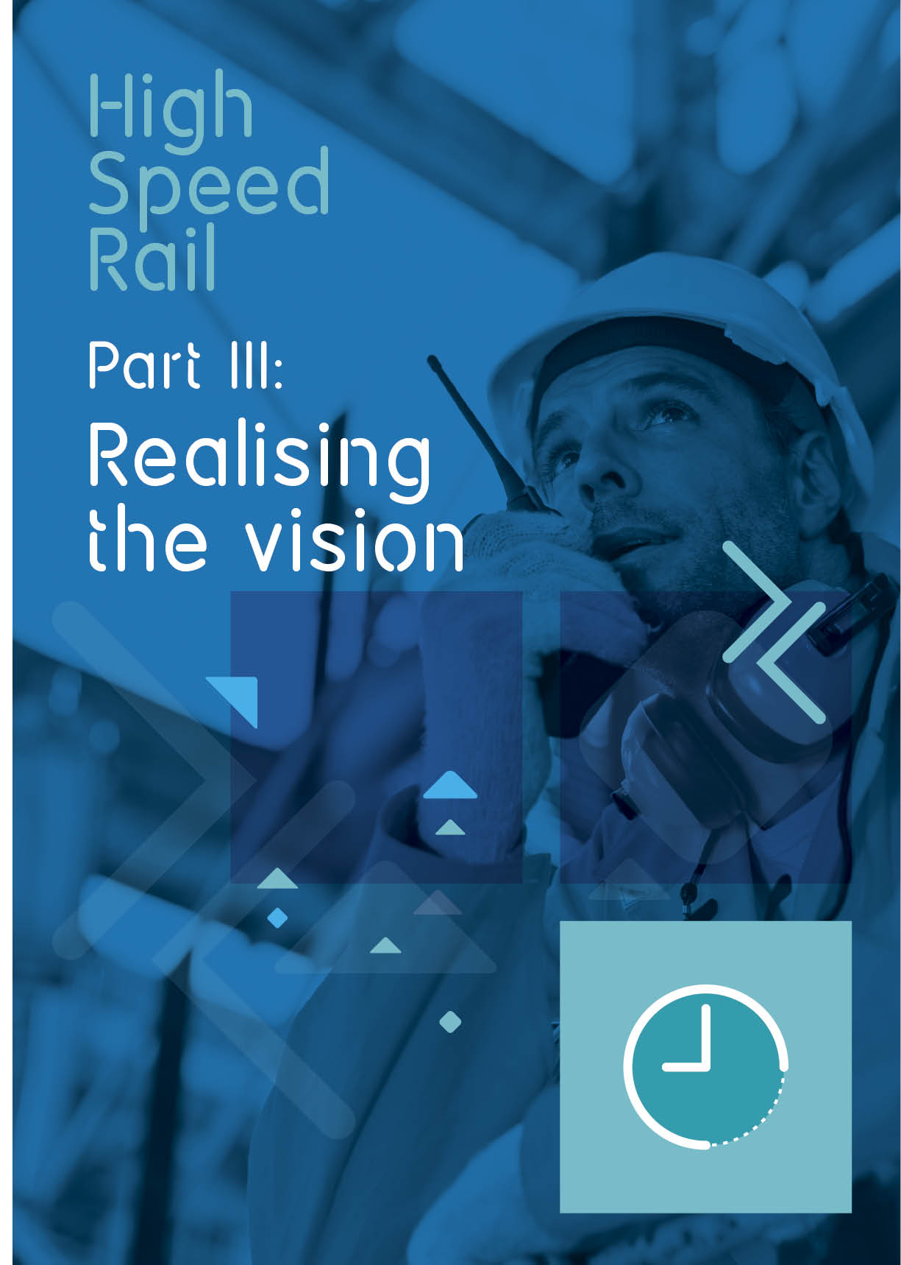
Chapter 10. Sustainability
10.1 Sustainability is one of the prime considerations in assessing options alongside engineering and operational viability, impact on journey times, capacity and financial cost.
10.2 Sustainability embraces considerations of economic development and job opportunities, and effects on communities such as demolitions, noise and air pollution, as well as environmental matters such as landscape and biodiversity, natural environment and climate change. These topics are considered as part of option development through an Appraisal of Sustainability process which incorporates a range of appraisal techniques. Its scope will be expanded at later stages on the basis of additional design detail. The full Appraisal of Sustainability for Phase Two has yet to be completed and will be published at the time of public consultation.
10.3 The Appraisal of Sustainability process for Phase Two corresponds with, and to some extent builds on the approach used for Phase One, which was the subject of an Appraisal of Sustainability during 2009/10 and the findings of which were published in February 2011.
10.4 HS2 Ltd submitted their advice to Government on the options for Phase Two in March 2012, which included an Appraisal of Sustainability Options Report. This has helped the Government to identify an initial preferred scheme for Phase Two. The initial preferred scheme is considered to be the option which best meets overall objectives for passenger demand, cost, ease of build, journey time and sustainability.
10.5 A synopsis of the sustainability impacts of this initial preferred scheme for Phase Two is published in a Sustainability Summary, which sits alongside this Command Paper. Annex A sets out the key documents submitted by HS2 Ltd. It is important to note that there is still more work to do on sustainability. The Sustainability Summary only presents the findings of the Appraisal of Sustainability work undertaken to date to inform the initial preferred scheme.
10.6 HS2 Ltd considered hundreds of possible options for routes and stations for Phase Two. The sifting and selection process involved an increasingly detailed examination of sustainability impacts as the number of options reduced. The options finalised for inclusion in the March 2012 Appraisal of Sustainability Options Report looked at 144 possible whole route combinations for Manchester and 112 for Leeds.
10.7 The Appraisal of Sustainability process draws on an appraisal framework which uses a wide range of sustainability objectives and evaluation criteria to determine the sustainability performance of the options. Each objective or criterion represents one of 18 sustainability topics which are themselves under the four headings set out in the 2005 UK Sustainability Development: Securing the Future report:
● Natural and cultural resource protection and environmental enhancement;
● Creating sustainable communities;
● Reducing greenhouse gas emissions and combating climate change; and
● Sustainable consumption and production.
10.8 During sifting, the Appraisal of Sustainability process concentrated on looking at those aspects most helpful in differentiating one option from another – those more concerned with the potential physical impacts of the proposal on, for example, property and ecology. Once a decision on a preferred scheme for consultation is made this year, the Appraisal of Sustainability will be expanded to cover the route wide issues, for example its carbon footprint.
Overview of the sustainability impacts of Phase Two
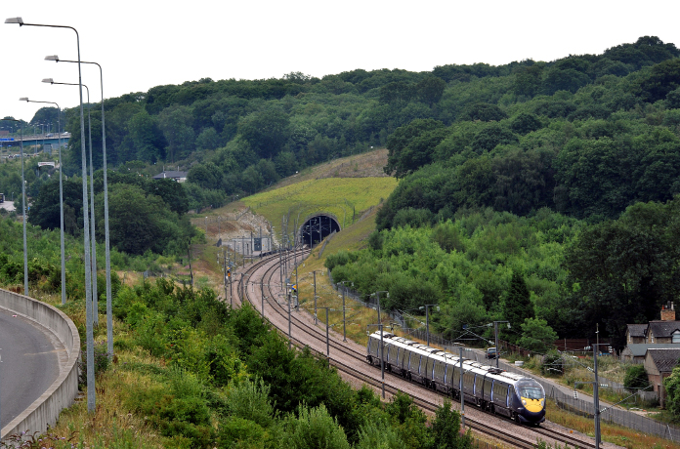
10.9 The scheme has been designed to minimise potential impacts on settlements and properties as well as important environmental and heritage features such as protected habitats, historic sites, rivers and landfill sites wherever possible at this stage of the process. The Government and HS2 Ltd are mindful of their obligations in respect of protected habitats and species at international, national and local levels and are aware of the general duty to protect biodiversity contained in Section 40 of the Natural Environment and Rural Communities Act 2006.
10.10 To help with the development of the scheme and inform the Appraisal of Sustainability, HS2 Ltd has held discussions with key bodies who have statutory environmental responsibilities, including Natural England, the Environment Agency and English Heritage. This engagement would continue to form part of its ongoing development of the proposed preferred route to prepare for public consultation in 2013.
10.11 As with Phase One, the proposed route and design for Phase Two would support the objective of improving the resilience of the rail network to extreme weather events brought about by predicted climate change. Both phases would be designed, built and operated to take account of projected impacts of climate change over the operational lifespan of the scheme. Additional protection would be given to particularly vulnerable parts of the network, such as areas known to be at risk of flooding and landslip, and the sensitive elements of the scheme, such as tunnel entrances and electricity supply locations.
10.12 The Appraisal of Sustainability process has provided guidance to the engineers in designing options, with analysis commensurate with the engineering detail at each stage. This relied on mapping information from third parties, such as statutory environmental bodies and was reliant on a single source of ready digitised information for each environmental feature. The sustainability impacts of the initial preferred scheme are summarised below:
● Landscape and Townscape: The initial preferred route avoids National Parks, Areas of Outstanding Natural Beauty and Registered Parks and Gardens. However, given the scale of the scheme it is inevitable that there will be a number of local landscape and visual impacts and HS2 Ltd will continue to refine the routes where feasible to address these concerns; this will include mitigation measures and compensation options.
● Wildlife and Biodiversity: In terms of nature conservation, there would be no significant impacts on sites of internationally recognised importance. The route has avoided direct impacts on all but one Site of Special Scientific Interest (SSSI): Bogs Farm Quarry nevertheless the integrity of this site would be largely retained. A number of other SSSIs would be close to the route and designs would be progressed to avoid impacts on these, where possible. The route would also directly affect some pockets of characteristic Biodiversity Action Plan habitat including some areas of ancient woodland, and HS2 Ltd would continue to develop ways of reducing these impacts and explore in consultation with appropriate local interest groups and statutory bodies, opportunities for habitat creation and ecological enhancement.
● Heritage: The route would avoid the most highly protected historic features, aside from one scheduled monument at Ratcliffe on Soar. It would pass sufficiently close to four other scheduled monuments to potentially affect their settings. It would avoid Grade I and II* Listed structures, but would potentially require the demolition of eight Grade II Listed structures: three on the western leg and five on the eastern leg although some of these may be avoided or preserved. Seven conservation areas would also be crossed. Registered Parks and Gardens and Historic Battlefields would all be avoided.
● Water Resources: The current scheme proposals would require the diversion of rivers in a number of locations. Seven rivers with larger catchments (termed major rivers) would need to be diverted, all on the eastern leg. In addition, 26 diversions of minor rivers would be required. Continuing design would seek to avoid the need for these and all diversions would be carried out to the requirements specified by the Environment Agency. Potential impacts to groundwater supplies have largely been avoided, although some abstraction points could be affected on the western leg. Appropriate design and construction techniques would be developed to ensure that the groundwater regime does not become polluted and that supplies are maintained in accordance with the requirements of the Water Framework Directive.
● Greenhouse gas emissions: The impact of the proposed scheme on UK greenhouse gas emissions would be appraised and focus on both operational carbon (associated with the net emissions of carbon due to the operation of the scheme and including changes to the extent of road, rail and air travel) and embedded carbon associated with the construction of the scheme.
● Property and Development: The operational scheme is expected to provide 1,400 permanent jobs, with up to 10,000 jobs created during the busiest part of construction. In addition, initial work suggests that opportunities in the close vicinity of stations on the second phase of HS2 would support almost 50,000 jobs and some 5,350 new houses around proposed new stations. The scheme would give rise to an estimated 227 residential demolitions. In addition, it would result in the demolition of five community facilities, 179 commercial properties and 42 industrial properties.
● Noise: The Appraisal of Sustainability thus far has identified those residential areas with the potential to experience noise impacts from high speed trains. Knowing where these areas are, HS2 Ltd would now be able to introduce mitigation into the designs to reduce these impacts as far as possible. The Sustainability Summary includes further information on potential noise impacts and potential for mitigation.
● Soil and land resources: Much of the land crossed by the scheme would be farmland. Of this, just over half a mile is shown on mapping as the highest quality Grade 1 land; a further 30 miles is shown as Grade 2 land. Farmers that are potentially affected would be engaged at early stages. Nine active landfill sites would also be directly affected to some degree. Although large volumes of excavated materials are anticipated during construction, in practice much of this would be utilised for mitigation, within landscaping and noise bunds alongside the route. An estimated 0.8 million tonnes of steel and seven million tonnes of concrete would be required within the permanent infrastructure.
Western leg – key issues
10.13 The western leg would pass close by a number of internationally significant wildlife sites. However, the alignment has been selected, and elements of its design progressed in close liaison with Natural England and the Environment Agency, so that we can be certain that significant impacts to the qualifying interest of these sites would be avoided.
10.14 Between Lichfield and Crewe, the route would use significant lengths of cutting, as well as short tunnels, to fit with the landscape and avoid many of the villages in this part of Staffordshire. The variety and density of cultural and environmental features on the south side of Manchester has required particularly careful alignment of both the main route and of the spur into the city. The historic parkland landscape of Dunham Massey and most of the numerous landfill sites in the Glazebrook Valley have been avoided. However, the high viaduct carrying the railway across the Manchester Ship Canal would affect views from local villages.
10.15 The train depot site near Golborne, south of Wigan, occupies an important strategic location. In an area with a number of environmental designations designs have already sought to reduce the potential impacts on ecology, water, landscape and heritage; continued scheme design would seek to reduce them further. The tunnel under Manchester would ensure that impacts on people and property are kept to a practical minimum, while the new station in Manchester city centre would offer considerable opportunities for development and jobs.
Eastern leg – key issues
10.16 The eastern leg would bear north from Water Orton closely following the M42 and using cutting for much of its length. It would cross over the River Mease, which is an internationally protected habitat. However, the design, developed in liaison with Natural England and the Environment Agency, would ensure that significant impacts to the river and the key species for which it is designated are avoided.
10.17 West of Nottingham the route would use a tunnel to pass beneath Strelley. Although this would help avoid impacts in the long term, the tunnel would cause some temporary disruption during construction. Further north, the route would follow the M1 for much of the next 25 miles. This would help to contain impacts within the transport corridor, although it is likely to require some modifications to the motorway and its junctions, causing temporary disruption for motorists. In common with the M1 motorway, it would pass close to some notable historic sites north of Tibshelf, including Hardwick Hall, Sutton Scarsdale and Bolsover Castle, although potential impacts would be greatly offset by the route’s alignment close to the motorway, as well as by the distance of the views.
10.18 North of Sheffield, the route would use extensive lengths of cutting to reduce impacts. There would be limited localised impacts on landscape and amenity, for example where the route passes the well-used reservoirs West of Ryhill and in crossing the valleys of the Aire and Calder rivers. The connection with the East Coast Main Line has been revised to avoid potential impacts on Towton Battlefield and the use of cutting would help limit noise and visual impacts. The three stations would provide considerable benefits through the interchange opportunities they provide with other transport networks, and particularly at Leeds, through the secondary effects they would have on local development.
Future sustainability appraisal
10.19 At the launch of public consultation in 2013, when the Government intends to announce its preferred scheme, a more detailed Appraisal of Sustainability report on potential sustainability impacts would be published.
10.20 Still further modifications to the scheme design may be required as a result of the consultation and would be accommodated within the proposals submitted to Parliament in the form of a hybrid bill. The bill would include an Environmental Statement, documenting the findings of an Environmental Impact Assessment (EIA).
Minimising construction impacts
10.21 Construction of the lines, stations and associated infrastructure for Phase Two would be carefully planned and managed to minimise any effects on the local environment. In consultation with local authorities and other key bodies, contractually binding conditions covering all aspects of construction would be put in place to regulate how works are conducted at the site. The effects of construction – such as dust, noise or traffic disruption – would be minimised through a combination of careful design, working with the local community and close management of the construction process, including use of best practice techniques.
10.22 Wherever properties were seriously affected or needed to be demolished owners would be fully compensated. Equally, where businesses were affected they would be eligible for compensation which would reflect their relocation costs and their interest in the property.

Chapter 11. Towards a truly national high speed rail network
11.1 HS2 is a transformational project that will bring great benefits in terms of rail capacity, connectivity and reliability, which will help underpin prosperity right across the UK and leave a lasting legacy for generations to come. The previous chapters have described new routes, stations and depots in the Midlands and North of England, but also show how the benefits would not stop at Manchester and Leeds. The beneficial effects of the new national high speed rail network will extend further north, supporting growth, unlocking jobs and boosting the competitiveness of the UK as a whole.
11.2 The Government’s goal is a national network that brings the country closer together. Phases One and Two of HS2 are very significant steps toward this. The Government’s priority is getting the Y network built and showing the major benefits it would bring to passengers and businesses across the country. Scotland would gain from this straight away, but it is also important to start to consider how these benefits could be extended further. This chapter sets out the important work that would be taken forward with Transport Scotland to understand Scotland’s intercity transport needs and how to spread the benefits of high speed rail across the UK.
Vision for a truly national network: Scotland
11.3 Responses to the consultation in 2011 on the Government’s high speed rail strategy, as well as engagement since, shows that there is particular interest in extending the network further north to Edinburgh and Glasgow. The Y network would allow seamless transition of trains onto the West Coast Main Line, with Phase Two expected to reduce the journey times to and from London by at least 30 minutes and up to an hour, without the need to change trains. These better services would help provide benefits to the Scottish economy of around £3 billion.
11.4 Edinburgh, Glasgow and other northern cities would benefit from significant journey time improvements to and from the economic centres in Birmingham and London. HS2 would mean that businesses in these cities would be able to operate more efficiently, increasing their productivity while accessing new markets and labour pools.
11.5 Firms throughout the UK would be able to look to Scotland for business opportunities where previously distance and congestion made this less attractive. Tourism on both sides of the border would be boosted as the UK is opened up to faster, more convenient travel. Scotland’s strong engineering base could also benefit from the employment opportunities that the planning and construction of HS2 would provide.
11.6 The cities of Edinburgh and Glasgow on the central belt of Scotland, provide some of the most heavily used sections of the UK rail network outside of London. The Scottish Government has consistently argued that building the high speed rail network up to Scotland would open it up to more passengers and bring new benefits, while providing the capacity to reduce congestion and improve the passenger experience. Such a proposal could enhance the effectiveness of the whole network, providing further benefits south of the border as well as north. Passengers beyond the rail network could also benefit, when faster journeys see more extensive modal shift between rail and air as the train becomes the mode of choice for more travellers.
11.7 The Government warmly welcomes the enthusiasm and support for high speed rail north of the border including the Scottish Government’s recent announcement taking forward plans for a high speed rail line between Edinburgh and Glasgow. We share a joint vision for faster journeys which bring the constituent parts of our island closer together. The UK and Scottish Governments also share ambitious plans for the existing rail network. The UK Government has announced a set of priorities in its rail investment plans for the next five years while the Scottish Government has clear priorities around, for example, freight growth, modal shift and access into Glasgow. Future plans for high speed rail must respond to the challenges and opportunities that are experienced on the existing network.
Realising the vision: next steps
11.8 The scale and complexity of building Britain’s first high speed rail network means that construction needs to be phased in order to manage costs and delivery. However, it is important that we progress work to develop the network and secure the full benefits of high speed rail for Scotland, whilst making sure the North East benefits too.
11.9 From when HS2 first opens Scotland would benefit from high speed services, although these trains will run for part of their journey on the existing network. The Scottish Government supports taking high speed rail all the way to Edinburgh and Glasgow, and we consider that there is a real case for examining how high speed rail should best serve Scotland in the future.
11.10 The UK Government has been working productively with the Scottish Government over the last two years, and the Department for Transport will now take forward a study in collaboration with Transport Scotland to examine and articulate rail connectivity needs north and south of the border and to consider Scotland’s aspirations for high speed rail. The study will set out the remit for any future work, using as a starting point the completion of the Y network. This work will look at how best to boost capacity and cut journey times to under three hours so that Scotland can gain the most benefit from a High Speed Britain.
11.11 This work could then form a basis for developing the most promising options for additional capacity and journey time improvements on intercity routes between England and Scotland. These options would need to represent value for money for taxpayers, but could include new high speed lines, upgrades to the existing rail network or a combination of these approaches.

Chapter 12. Property and compensation
12.1 The Government is committed to assisting property owners affected by its initial preferred route, station and depot options, as well as the route and station option for Heathrow for Phase Two. This chapter summarises the assistance scheme that the Government proposes to introduce.
12.2 Past experience of similar infrastructure projects, particularly the HS1 line to the Channel Tunnel, suggests that impacts on property markets are at their worst during a project’s early planning and construction stages. With sensitive engineering design, the reality of the impact when schemes are in operation has often turned out to be less than was first feared.
12.3 However, this does not remove the need for the Government to assist property owners, both over the short and longer-term.
Exceptional Hardship Scheme
12.4 At this early stage in the project we are proposing to introduce a non-statutory (i.e. discretionary) Exceptional Hardship Scheme (EHS). This would allow residential and small business owner-occupiers, mortgagees and beneficiaries under the will of a deceased person, with properties close to the Phase Two route to ask the Government to buy their property. The scheme would be available to owners who have a pressing need to sell but cannot do so, or can do so only at a substantially reduced price as a result of the announcement of the route and who cannot wait until such time as the longer-term property assistance schemes have been introduced.
12.5 Successful applicants would have their property purchased by the Government at its un-blighted open market value. This value would be determined by independent valuers chosen from a pool of Royal Institute of Chartered Surveyors qualified valuation firms who have expertise in the local area and specific property type.
12.6 Comprehensive written guidance will be available for those interested in the EHS.
12.7 The Phase Two EHS is intended as an interim measure, which would remain in place until such time as the statutory blight provisions apply.
12.8 A similar approach has been taken by the Government in relation to Phase One of the network (London to the West Midlands). An EHS has been in operation for this section of the network since August 2010. Now that the Government has consulted on and confirmed the routes for this section, longer-term property assistance schemes have been brought forward. We anticipate a similar staged approach being adopted on Phase Two, with the EHS remaining in place until the end of 2016.
Consultation
12.9 A public consultation was launched on 28 January on the proposals for an EHS for Phase Two of the HS2 network. Copies of the consultation document and further details about the proposed EHS are available from:
● http://www.hs2.org.uk
● HS2enquiries@hs2.org.uk
● 020 7944 4908
12.10 The consultation on the Phase Two EHS will close on 29 April 2013.

Chapter 13. Next steps
13.1 A project on the scale of HS2 necessarily involves detailed engagement and planning and lengthy construction. So whilst the Government is working hard to maintain the pace of the project, we will not seek to achieve this by cutting corners. This chapter outlines some of the important milestones in building the lines to Leeds and Manchester.
13.2 It is important that the status of the initial preferences set out in this document are understood. At this very early stage in the process of developing Phase Two no final decisions have been taken on where the routes and stations should be sited. The initial preferences set out in this document are simply an indication of the Government’s current thinking and are based principally on technical advice from HS2 Ltd and discussions that Ministers have held with the political and economic leaders of the cities to be served by this phase of HS2. Before these initial preferences are firmed up and any subsequent decisions are taken, the Government will want to hear from the public, industry experts, environmental NGOs and others.
13.3 The remainder of this chapter sets out the steps that will be necessary to achieve that.
Engagement and consultation
13.4 Following the publication in this document of the Government’s initial route, station and depot preferences for Phase Two a period of ‘informal engagement’ will begin, in preparation for subsequent public consultation.
13.5 Over the coming weeks Ministers will be available to meet Members of Parliament affected by the Phase Two route, station and depot options. This will provide an early opportunity for Ministers to reflect on their initial preferences in the light of any local priorities. In parallel, HS2 Ltd will engage with local authorities affected by the line of route, station city partners and key environment and heritage organisations. This will help inform the Government’s preparations for consultation and help to ensure that interested parties are as well informed as possible.
13.6 A public consultation will follow. We will publish detailed environmental, technical and other information about the routes, stations and depots to ensure that all interested parties can submit informed responses. We anticipate running a substantial programme of consultation events along the length of the proposed routes, at which people will be able to talk to a range of experts and, where possible, have their questions answered.
13.7 As the Government is keen to make progress with the project, we have speeded up the timetable for Phase Two to enable consultation to commence earlier than previously planned. The Government had previously committed to launching a consultation in 2014. We now expect to launch the public consultation on the Phase Two route, station and depot options in 2013. This should allow the Government to announce its final decisions on these options before the end of 2014. A hybrid Bill seeking powers to construct Phase Two would then be brought forward in the next Parliament, following the May 2015 General Election.
13.8 As outlined in Chapter 12, alongside this engagement on route, station and depot options, separate consultation will take place on assistance for property owners affected by the Government’s initial preferred. The consultation on the broad principles of the scheme has been launched alongside the publication of this Command Paper.
Design and technical work
13.9 To enable consultation in 2013 on Phase Two route, station and depot options, initial engineering design work (including options for mitigating the impacts of the lines), environmental appraisal (including noise impacts) and economic appraisal, would be completed. Further detailed work would be published alongside the consultation to ensure that people are able to understand and form a view on the proposition.
13.10 The teams at HS2 Ltd would continue to develop and refine the work across these areas as we then move on from consultation. And these would be supplemented by a number of important further pieces of work. Network Rail is undertaking a study of the potential capacity benefits for the existing rail network from the advent of HS2 (see Chapter 2). The Government also intends to revisit previous work on ‘strategic alternatives’ to high speed rail (such as upgrades to the existing rail network).

Keeping in touch
13.11 HS2 Ltd can be contacted directly via the enquiry line (020 7944 4908), email address (HS2enquiries@hs2.org.uk) or by post:
HS2 Limited
2nd Floor
Eland House
Bressenden Place
London SW1E 5DU
13.12 This Command Paper and all the published supporting documents can be found on the Department for Transport’s website, at www.dft.gov.uk/highspeedrail

Summary: HS2 Programme
Date | Milestone
Jan 2013 | • Publication of the Government’s initial route, stations and depot preferences for Phase Two  • Launch of the consultation on Exceptional Hardship Scheme for Phase Two
Spring 2013 | • Informal Engagement activities including preparation for public consultation for Phase Two  • Consultation on draft Environmental Statement including design refinements for Phase One
2013 | • Consultation on preferred route, stations and depots for Phase Two launches
By end of 2013 | • Hybrid Bill for Phase One submitted to Parliament
End 2014 | • Government’s announcement of final decision on the chosen route, station and depots for Phase Two  • Hybrid Bill process for Phase One continues
2015 | • Commence engineering design, environmental impact assessment and preparation of Hybrid Bill for Phase Two  • Target date for Royal Assent to Hybrid Bill for Phase One, containing legal powers to construct Phase One
Next Parliament | • Deposit of Hybrid Bill for Phase Two
2016/17 | • Construction on Phase One commences

Annex A: Alternative station options not selected
Introduction
In their March 2012 reports, HS2 Ltd set out a small number of final route, station and depot options. Chapters 6 and 7 of this Command Paper described those options that the Government has selected as their initial route, station and depot preferences. In this annex, we briefly describe why the alternative final options that were identified by HS2 Ltd are not being taken forward at this stage in the process.
Western leg – Station options not selected
Alternative city centre stations – Salford Central and Salford Middlewood
As described in Chapter 6, the Government’s initial preferred option of Manchester Piccadilly for a HS2 station in the city is based on work by HS2 Ltd that considered a large number of station options across the city centre. Following the company’s appraisal of potential station options, two further options were shortlisted. Both were located in Salford – one comprised the redevelopment of the existing Salford Central station and the other involved a brownfield site, a short distance to the west of the existing Salford Central station.
Whilst the station and approach to Piccadilly combined would be marginally more expensive to construct than the two Salford options, the additional expense would be significantly outweighed by the benefits it would deliver. Although it is possible to serve a station at the airport as well as Salford, it would necessitate a route with high impacts, and an airport station over 2.5 miles south-west of the airport. Furthermore, the Salford station options would not be on the existing Metrolink network and the connectivity to the wider region by classic rail would be inferior. The view from the city was that the Piccadilly option would maximise the accessibility for potential passengers from across the Manchester City region.
In addition to the other disadvantages, both would involve significant numbers of potential demolitions and risk significant impacts on proposals for regeneration at and around the planned station sites. It is felt, particularly given the long planning horizons involved with a project like HS2, that the aspirations for development could not realistically be accommodated with a major new rail station.
Alternative Manchester Interchange station options
HS2 Ltd’s work on interchange stations around the Greater Manchester region led it to develop a substantial long list of options. Whilst none had the ability of generating benefits to match those of a city centre station in Manchester, they were each capable of serving different markets and spreading the benefits of HS2.
Of the other potential station options that HS2 Ltd considered, each presented particular challenges and none has received the support of the wider region; in some instances the option was expressly opposed by the local planning authority since the locations were also in green belt land which the authorities did not want to release. The primary issue was their ability to serve the wider region and the airport. Under the current assessment, the option selected as the Government’s initial preference performed most strongly on both these counts.
Alternative Manchester Intermediate station options
In Chapter 5 the option of connecting the high speed line just to the south of Crewe was described. The clear benefits that this option provided, particularly in the additional connectivity with the wider North West, led to its selection as an initial preference. During their option development process, HS2 Ltd also tested options for building a new intermediate station on the high speed line between the West Midlands and Manchester. Its analysis suggested that the additional cost associated with building a new HS2 station would be hard to justify given the relatively modest additional benefits that it could secure.
HS2 Ltd developed an option for constructing an HS2 station near to Stoke-on-Trent alongside the M6 motorway. The company’s analysis suggested that the benefits would not outweigh the costs. Stoke-on-Trent City Council developed a further option in this area and suggested that the new station could be built as an addition to the West Coast Main Line connection to the south of Crewe. HS2 Ltd reviewed this proposition, and on this basis the Government’s initial view is that, although it would generate additional benefits for Stoke and its surrounding area, these would fall short of the additional cost such a station would represent for the project. A station alongside the M6 would be good at serving the dispersed rail demand around Stoke-on-Trent and Crewe through its good connectivity with the motorway network. But it would be unlikely to attract a high proportion of passengers to or from the urban areas of Stoke and Crewe themselves, where people would be likely to continue using existing rail connections to London.
Eastern leg – Station options not selected
East Midlands
Serving Leicester
The three cities in the East Midlands region are located some distance from each other, with Nottingham and Derby the closest at some 15 miles apart. Leicester is located approximately 30 miles south of these two cities. HS2 Ltd found in its route design work that serving Leicester on the eastern leg of the HS2 network would be challenging. It would also impose a serious time penalty on passengers heading to all destinations further north. Compared to building a station near Nottingham, HS2 Ltd calculated that this would amount to a loss of benefits for passengers of around £1.6 billion and a reduction in revenue of around £700 million. As well as additional journey time for passengers from Yorkshire and further north, the longer route would also involve extra construction cost of between £400 million and £1 billion and would be likely to generate higher sustainability impacts.
Serving central Nottingham
HS2 Ltd’s assessment of route and station options in the East Midlands included serving central Nottingham. Routes serving the city centre would be costly to develop, with a spur being the most feasible option. However, whilst Nottingham would have generated a larger market on its own than Derby, it would still not justify more than one service per hour to London. Nottingham would therefore be better suited as an intermediate stop rather than as a terminus from a spur. Incorporating a HS2 station into the existing station would also be costly, disruptive and would have significant sustainability impacts.
Alternative city centre station options – Derby Midland
HS2 Ltd’s work produced two final options for the East Midlands. The East Midlands Hub station was the best performing option. The second-best performing option was for a station on the site of the existing mainline rail station in Derby.
This option would require the entire reconfiguration of the existing station, including the tracks, platforms, concourse and forecourt. This would deliver a modernised and efficient station, with enhanced public transport connectivity, and would facilitate easy interchange between HS2 and conventional rail services. A city centre location in Derby would also bring further benefits in terms of existing public transport connectivity to the site and relative proximity to where passengers begin and end their journeys.
However, the complex construction programme required to reconfigure the station would last a number of years. Disruption to existing services could be minimised but some would be inevitable. A high speed station at Derby Midland, although capable of serving Derby and its environs well, would also be less able to serve the wider East Midlands region than the East Midlands Hub station option at Toton. Journey times to and from key areas of demand are better for Toton, particularly given that Nottingham is the much larger source of demand. This means that the East Midlands Hub station option at Toton is forecast to attract over 20 per cent more total demand than the central Derby station.
South Yorkshire
Alternative city centre station options – Sheffield Midland
HS2 Ltd considered a range of options for building the HS2 station at Sheffield Midland, the existing mainline station serving Sheffield. Integrating the HS2 station with the existing mainline station in the city, which provides local, regional and national rail services, as well as the tram, would be an attractive proposition for travellers across the region.
However, HS2 Ltd’s technical work demonstrated that each of the options considered would entail a complex programme of construction, with impacts on rail services over a number of years as the existing station would require major reconfiguration. It would also be necessary to widen the footprint of the station, requiring major excavations into the adjoining Park Hill. This station option could also only be served by a long, and therefore costly, tunnelled approach. Options at Sheffield Midland were therefore not progressed further.
Alternative city centre station options – Sheffield Victoria
HS2 Ltd concluded that the best performing option for a Sheffield city centre station was on the site of the disused Victoria station on the north side of the inner-ring road to the north east of the city centre. A HS2 station here would sit on the railway arches, although the tracks would be further elevated due to the existing constrained nature of the site. The top of the station structure would be approximately 25m above the surrounding street level. The Grade II listed Royal Victoria Hotel would have to be demolished, along with other buildings in the area. New pedestrian bridges, a bus interchange, road access and a diversion of the tram would be necessary.
However, the loop off the main HS2 line necessary in order to serve Victoria would involve over 11 miles of additional track, including a two and a half mile tunnel under the north of the city. The additional infrastructure required for this approach would lead to higher costs of well over £1 billion compared to a station at Sheffield Meadowhall. In addition, three further key disadvantages were identified.
First, a station at Victoria would be some distance from the main line station (Sheffield Midland), constraining interchange between regional rail services and HS2. Whilst tram connectivity would go some way to mitigating this, in order to provide an equivalent level of regional connectivity to a Meadowhall station, the city council and other delivery partners, have suggested reopening the disused Sheffield Attercliffe station located 500m to the east of the Victoria site.
However, whilst such a proposition is likely to provide benefits, it would also involve new costs, well beyond the £1 billion increment already necessary in order to serve central Sheffield.
Second, HS2 Ltd’s analysis of route options for reaching central Sheffield showed significant impacts on a major development site to the south of the city. The site has been identified for major new industrial investment, which the city region views as important to its long-term economic wellbeing. The only available routes that would avoid impacting this site would require extensive residential and commercial demolitions.
Third, HS2 Ltd also found that running services through central Sheffield would add around six minutes to journeys for passengers going to Leeds or further north compared with the more direct route through Meadowhall. Given that demand for rail travel is significantly greater from Leeds than Sheffield, this would reduce the benefits of HS2.
The Government’s initial preference is to build a HS2 station at Meadowhall. However it recognises that the factors involved in determining the best means of serving South Yorkshire are particularly complex. The Government recognises that the option of building a station in the centre of Sheffield would bring benefits, but it would also involve considerable additional cost.
Leeds
Alternative city centre options – Leeds Station North
HS2 Ltd’s technical work on station options generated three final options in the city centre – two immediately south of the River Aire and a third immediately to the north of the existing Leeds station.
Of all the options, Leeds Station North would provide the easiest possible interchange with services at the existing station and would also be located the closest to the existing city centre. However, the site proposed for the station is constrained, and building the HS2 station here would effectively prevent future expansion of the existing Leeds station in the long-term. This would be problematic if demand for rail travel in the region continues to grow as expected, as there are likely to be only limited other options over the long-term for accommodating additional demand. Nor would it be possible to expand the HS2 station in the future.
As well as this issue of future-proofing for increased demand, the Government has not selected Leeds Station North as its initial preferred option for a station serving Leeds for two further main reasons.
First, serving Leeds Station North would involve a longer connection on to the main line that would generate higher impacts on local communities. All the Leeds city centre station options would be served by a spur off the main HS2 line, but given the constraints formed by the existing station and river, it would only be possible to approach this station option from the west. The main HS2 line would run to the east of the city on a north-south orientation heading towards York. Providing a link from this main line through to the Leeds Station North option would require a new line curving through the southern portion of the city. The Government’s initial preferred station option – at New Lane to the south of the Aire – could be served by a more direct and less impactful route. This route would expose fewer properties to increased levels of noise, necessitate fewer demolitions and save travel time.
Second, the longer route and more complex engineering proposition of building the station on the constrained site alongside the existing station would add around £380 million to the cost of serving Leeds. Although the location of this station option – closest to the existing station and city centre – would be likely to generate some additional benefits, it is unlikely these would be sufficient to justify this additional cost.
Alternative city centre station options – Sovereign Street South
HS2 Ltd also developed a third station option for serving central Leeds. This option, known as ‘Sovereign Street South’, would sit a short distance to the east of the New Lane option and approximately 200m south of the existing Leeds station. The passenger concourse would lie immediately to the east of the Asda headquarters building, extending over the River Aire into the area around Sovereign Street, which is proposed for redevelopment.
HS2 Ltd found that this option would not be likely to generate any additional benefits over the New Lane option, nor would it be any cheaper. However, it would provide a passenger concourse capable of directly serving the city centre to the north of the river.
The city has aspirations to regenerate the ‘South Bank’ area of the city, and it was felt that a station option would present a significant challenge to those and other development plans. The station would dissect the South Bank area and it was considered that the effect of this would be to significantly reduce the prospects of maximising the potential of the site for the city. The Government understands this position and agrees with Leeds City Council and HS2 Ltd that this option should not be considered further.

Annex B: List of supporting documents
Options for Phase Two of the High Speed Rail Network (overarching March report) – A Report to Government by HS2 Ltd (March 2012)
This report sets out the proposals and overarching advice to Ministers on the onward legs from the West Midlands to Manchester and Leeds and a direct high speed line serving a station at Heathrow. Also describes options for serving cities beyond the network.
Options for Phase Two of the High Speed Network: Appraisal of Sustainability (March 2012)
A report by Temple-ERM for HS2 Ltd which describes the sustainability impacts of the various options for the route, stations and depots considered by the Secretary of State and from which the initial preferred scheme for Phase Two was determined.
HS2 Cost and Risk Model Report – A Report to Government by HS2 Ltd (March 2012)
HS2 Ltd’s advice to Government on the cost of the Phase Two network and the approach to risk in the cost model based on the post-consultation route for Phase One London to West Midlands and the routes contained in the base proposition within Options for Phase Two of the High Speed Rail Network, which this document supports.
Record of Stakeholder Engagement for Phase Two of the high speed rail network – A Report to Government by HS2 Ltd (March 2012)
This document outlines HS2 Ltd’s approach to engagement with key Phase Two stakeholders and identifies the organisations they have met between March 2010 and March 2012. It is a supporting appendix to the main report Options for Phase Two of the High Speed Rail Network.

Options for Phase Two of the High Speed Rail Network: Approach to Design – A Report to Government by HS2 Ltd (March 2012)
This describes the common approach to the scope and technical requirements for a route engineering and alignment study for Phase Two of the HS2 network. Also introduces the detailed engineering route descriptions presented as three separate reports entitled:
HS2 Engineering Options Report – West Midlands to Manchester
HS2 Engineering Options Report – West Midlands to Leeds
HS2 Engineering Options Report – Heathrow
From Rail Town to High Speed Rail City: A Vision for Crewe (July 2012)
A proposition from Cheshire East Council and Cheshire and Warrington Local Enterprise Partnership Board for a HS2 hub station at Crewe in partnership with HS2.
Derby City Council – Economic Impact of HS2 to Derby – Summary Report (February 2012)
A report by Arup for Derby City Council considering the potential economic impacts of HS2 to Derby and the Derby, Derbyshire, Nottingham and Nottinghamshire Local Enterprise Partnership area.
Sheffield City Council and South Yorkshire Passenger Transport Executive – Maximising the economic impact of HS2 investment in Sheffield (February 2012)
This report and accompanying annexes have been prepared by GENECON LLP on behalf of Sheffield City Council and the South Yorkshire Passenger Transport Executive as a formal response to HS2 Ltd station proposal options for South Yorkshire. The report addresses the strategic economic case for alternative HS2 station locations in Sheffield.
Selecting an initial preferred scheme for Phase Two: Refinement work since March 2012 – A Report to Government by HS2 Ltd (January 2013)
This describes all the route optimisation work carried out since March 2012 along with the sustainability considerations. It provides advice to the Government and describes further options for refinement.
HS2 Phase Two Initial Preferred Scheme: Sustainability Summary (January 2013)
A report by Temple-ERM for HS2 Ltd describing the potential impacts on people and the environment of the Government’s initial preferred scheme for Phase Two, including the preferred route, station and depot options. The document underpins the advice in the Options for Phase Two of the High Speed Rail Network: Appraisal of Sustainability (March 2012) report.
Plan and profile maps (December 2012)
This set of maps provides a depiction of the HS2 Phase Two initial preferred lines of route. The bottom portion of each map depicts the profile of the line in relation to the ground.
High Speed Two: an Exceptional Hardship Scheme for Phase Two (January 2013)
A discretionary purchase scheme for property owners whose properties may be affected by high speed rail links from the West Midlands to Leeds and Manchester and a Heathrow spur – Consultation.

Annex C: Record of confidential engagement
Introduction
Following receipt in March of HS2 Ltd’s route, station and depot advice for Phase Two the Government held a series of confidential listening events with political and economic leaders from the cities and regions that will be served by Phase Two.
The intention to hold these events was publicised in a Parliamentary Written Ministerial Statement from the Government in March. The statement noted,
“An important part of this process will be to consider the views of delivery partners in the cities where HS2 stations may be located, including any underpinning evidence which they have identified. Understanding local desires and plans for development will be crucial in helping me reach initial preferences for station locations. I am particularly keen to ensure that the network best supports the economic potential of the cities and regions it serves, through well-integrated station locations that build on local and regional plans.”
The events focussed on the station options rather than line of route for reasons of blight.
These events were held to enable the Government to hear directly from the cities and regions concerned about their development and regeneration aspirations, so that they could ascertain how best HS2 can support these. Some limited information about the station options contained in HS2 Ltd’s report was presented, to enable partners to respond with their views on each of the station options.
In all instances the discussions took place on the basis of confidentiality. Delivery partners were asked to sign confidentiality agreements. The reason for confidentiality was to prevent blight on local residents and communities. We are very grateful to delivery partners for working with us in this way.
Key organisations in each city and region, usually the city council, were asked by HS2 Ltd to develop a list of appropriate delivery partners for their region.
Record of station listening events
The Government held listening events to discuss station options, as follows:
Leeds – 18 June
Manchester – 18 June
South Yorkshire – 25 June
East Midlands – 25 June
Stoke and Staffordshire – 26 June
Cheshire East – 26 June
Liverpool – 28 June
For those meetings where MPs were not present the Government held additional events for the MPs of each city region, as follows:
Manchester – 9 July
East Midlands – 9 July
Leeds – 12 July
South Yorkshire – 12 July
Following up on the discussion at several of these meetings, delivery partners prepared additional written advice for the Government’s consideration. This advice is being published alongside this document, except where delivery partners have stated reasons for its confidentiality.
Record of additional listening events
In addition to these confidential listening events with the political and economic leaders of the cities and regions concerned, the Government held a small series of further confidential listening events with other interested parties. These events did not discuss any route- or station-specific issues and no information on these matters was presented to participants. These events were as follows:
Key economic and transport industry influencers – To discuss key strategic-level economic and planning issues.
Environmental organisations – To discuss key strategic-level environmental and planning issues and public engagement.
Statutory environmental bodies – To discuss key strategic-level environmental and planning issues.
Site visits
During the period following receipt of HS2 Ltd’s advice the Government visited each of the line of route and station options contained in the report. This enabled it to both better understand each of the options and also, where necessary, to request further work from HS2 Ltd on, for example, amendments to a section of route.

Annex D: Terms of Reference – Network Rail Study on Released Capacity
Future use of the rail network after the opening of Phase Two of High Speed 2 – Terms of Reference
Purpose of the work
To advise the Government on options for the future use of the existing rail network after Phase Two of High Speed 2 has been constructed and is operational.
By providing a new route for much of the current inter-city rail traffic, HS2 offers the means for improving services on the existing main north-south lines. This could enable additional commuter, regional or freight services to use the lines and encourage modal shift. Understanding how this capacity can best be used would be a key factor in understanding how the Government can maximise the potential of HS2.
This work would build on the analysis carried out by Network Rail and Passenger Focus for Phase One of HS2 [London to the West Midlands] to provide a set of scenarios for how rail network capacity could be used once Phase Two of HS2 [construction of the Y-shaped network from Birmingham to Manchester and Leeds] is operational. The outputs of this work would be used as part of the consultation into HS2 Phase Two and to inform future decisions on the use of network capacity in areas and routes where rail usage would be affected by HS2.
Resources & Timescales
The work would be carried out by Network Rail in consultation with industry stakeholders including Passenger Focus with support from DfT and HS2 Ltd. A report would be made to DfT. It is intended that the results would be published at the time of the public consultation on the HS2 Phase Two line of route, station and depot options later in the year.
Consideration
The work would involve:
● Consultation by Network Rail with local, regional and industry stakeholders including Passenger Focus. This consultation could also include the views of other transport users, to understand what kind of train service would encourage modal switch.
● Analysis of the outputs of the Network Rail Long Term Planning Process (LTPP).
● Analysis of future passenger and freight flows and how future capacity might be best used to meet this forecast demand.
● Production of a set of feasible scenarios for the future use of the rail network taking into account the operational constraints of the network and future demand patterns post the introduction of HS2 Phase Two. This could involve options on more frequent trains, less crowding, faster journey times, or a lesser need to change trains for a journey.

Glossary
Airports Commission, The In 2012 the Government launched an independent Commission to identify and recommend options for maintaining the country’s status as an international hub for aviation. The Commission is chaired by Sir Howard Davies.
Appraisal of Sustainability (AoS) A phased appraisal of the extent to which HS2 options support objectives for sustainable development, including reducing greenhouse gas emissions and combating climate change; natural resource protection and environmental enhancement; creating sustainable communities; and sustainable consumption and production.
Area of Outstanding Natural Beauty (AONB) An area of countryside in England, Wales or Northern Ireland whose distinctive character and natural beauty are considered of sufficient value to be designated under the National Parks and Access to the Countryside Act of 1949.
Biodiversity Action Plan (BAP) An internationally recognized program addressing threatened species and habitats and is designed to protect and restore biological systems.
Classic rail The existing non-high speed railway in Britain.
Consultation, The The Government’s 2011 public consultation on a national high speed rail network, described in High Speed Rail: Investing in Britain’s Future (http://highspeedrail.dft.gov.uk/sites/highspeedrail.dft.gov.uk/files/hsr-consultation.pdf)
Delivery Partners Stakeholders such as local authorities and passenger transport executives critical to the delivery of the project with whom we have had discussions in confidence.
East Coast Main Line (ECML) A major mixed-traffic railway route on the eastern side of Britain, linking London, the South East and East Anglia with Yorkshire, the North East Regions and Scotland.
Exceptional Hardship Scheme (EHS) A scheme to help homeowners whose property value may be seriously affected by the ‘preferred route option’ of HS2 and who urgently need to sell.
HLOS High Level Output Specification – sets out information for the Office of Rail Regulation and for the rail industry about what the Secretary of State wants to be achieved by railway activities during railway Control Period 5 (April 2014 – March 2019).
High Speed Rail (HSR) A type of passenger rail transport that operates at speeds higher than the normal speed of rail traffic.
High Speed 1 (HS1) The high speed railway line running from London St Pancras through Kent to the Channel Tunnel (formerly Channel Tunnel Rail Link (CTRL)).
High Speed 2 (HS2) The scheme for a national high speed rail network in Britain, serving London, Birmingham, Manchester and Leeds and a number of intermediate stations, with links to Heathrow Airport and the High Speed 1 line to the Channel Tunnel.
High Speed 2 Limited (HS2 Ltd) The company tasked with providing advice to Government on the introduction of a national high speed rail network in Britain (http://www.hs2.org.uk/)
Hybrid Bill A bill with characteristics of both a public bill and a private bill.
January 2012 Command Paper High speed rail: Investing in Britain’s future – decisions and next steps. The decisions reached by the Government in the light of the Consultation in 2011 and an outline of the immediate next stages of the project (http://www.gov.uk/government/publications/high-speed-rail-investing-in-britains-future-decisions-and-next-steps)
Midland Main Line (MML) A major mixed-traffic railway route linking London and Sheffield via Luton, Bedford, Kettering, Leicester, Derby, Nottingham and Chesterfield.
Network Rail The company that runs, maintains and develops Britain’s tracks, signalling system, rail bridges, tunnels, level crossings, viaducts and 18 key stations (http://www.networkrail.co.uk/)
Phase One A line from London to the West Midlands, including stations in central London (Euston), West London (Old Oak Common), outer Birmingham (Birmingham Interchange) and central Birmingham (Curzon Street). It includes a connection onto the High Speed 1 line to the Channel Tunnel.
Phase Two Lines from the West Midlands to Manchester and to Leeds, including stations in South Yorkshire and the East Midlands, and a direct link to Heathrow Airport.
Risk and optimism bias Allowances for risk and optimism bias are added to the appraisal costs of projects to take account of the tendency for appraisers to be over-optimistic about the costs and other key parameters of projects.
Special Area of Conservation (SAC) Strictly protected sites designated under the EC Habitat’s Directive.
Site of Special Scientific Interest (SSSI) The country’s very best wildlife and geological sites. Natural England has responsibility for identifying and protecting SSSIs.
Value for Money (VfM) A broad-based assessment of all the costs and benefits associated with a potential investment. The costs include not only the financial cost of making the investment but also the ‘non-monetised’ impacts in relation, for example, to the environment and the economy. The benefits include a range of monetised transport benefits (for example, capacity, reliability and journey times) and also wider non-monetised benefits relating, for example, to economic growth. The value for money of a project is considered in light of these and all other aspects of its business case.
West Coast Main Line (WCML) The busiest mixed-traffic railway route in Britain, serving London, the West Midlands, the North West, North Wales and the Central Belt of Scotland.
Y network A national high speed rail network serving London, Birmingham, Manchester and Leeds, developed in two phases, and also including direct links to HS1 and Heathrow.

Office of Rail Regulation, http://dataportal.orr.gov.uk/.
See www.networkrail.co.uk/newlinesprogramme.
See Economic Case for HS2: Updated Appraisal of Transport User Benefits and Wider Economic Benefits, available at http://www.dft.gov.uk/publications/hs2-economic-case-appraisal-update/
Source: Hunt Dobson Stringer: London & Continental Railway, Making Regeneration Happen, February 2008 cited in the 2011 Volterra Report: Economic Impact of High Speed 1.
Updated economic case from HS2 (August 2012) http://www.hs2.org.uk/sites/default/files/inserts/Updated%20economic%20case%20for%20HS2.pdf
Updated economic case for HS2 (August 2012): Explanation of the service patterns www.dft.gov.uk/highspeedrail
The Sustainability Summary can be found at [www.dft.gov.uk/highspeedrail].
The Sustainability Summary can be found at www.dft.gov.uk/highspeedrail.
Updated economic case from HS2 (August 2012) http://www.hs2.org.uk/sites/default/files/inserts/Updated%20economic%20case%20for%20HS2.pdf
High Level Output Specification 2012 – www.dft.gov.uk/publications/hlos-2012.
Further details about the package of property assistance measures proposed for Phase One of the HS2 network can be found at http://highspeedrail.dft.gov.uk/consultations/property-and-compensation-london-west-midlands. A separate consultation on these measures will run until 31 January 2013.
This chapter does not discuss key milestones for Phase One of the HS2 network – the line from London to the West Midlands and the connection to the HS1 line to the Channel Tunnel. The programme for Phase One is presented in other documents, including, at a high level, in the January 2012 Command Paper High Speed Rail: Investing in Britain’s Future – Decisions and Next Steps.
Work on Heathrow now paused, see chapter 8.
Work on Heathrow now paused, see chapter 8.
http://www.dft.gov.uk/news/statements/greening-20120327a.
Work on Heathrow now paused, see chapter 8.
Work on Heathrow now paused, see chapter 8.

