Prepared by:
British Consular Services Portugal
Foreign, Commonwealth & Development Office

Guide: How to order online
Birth, Death and Marriage Certificates issued in Portugal
Click on the link below for the official Portuguese website to order online certificates:
Civil Online
You can apply for online access to birth, death and marriage records held by the civil registration authorities in Portugal by completing the steps set out below. Online access is available for 6 months from the date you submit your request and receive the online access code. The images shown are intended to guide you through the process. The data is fictional. Please note that the international version of the certificate is not available for online access. If you wish to order a certified copy of the international model, you need to contact a Civil Registration Office in Portugal

The website is in Portuguese – you can set up your browser to create automatically an English translation.

Click on “Entrar sem autenticação” on the bottom right hand side of the page (you are not required to register on the site).

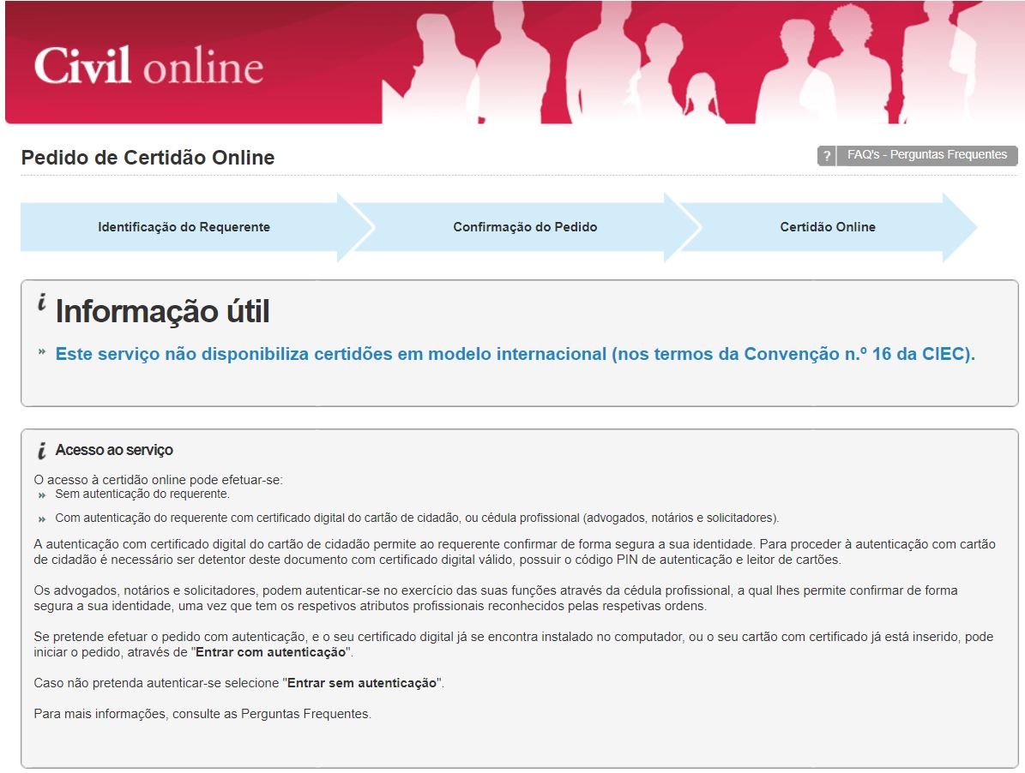

Complete the mandatory fields: Full name, Telephone and E-mail. Select the certificate that you wish to order (in the example we have for you, we selected a death certificate).

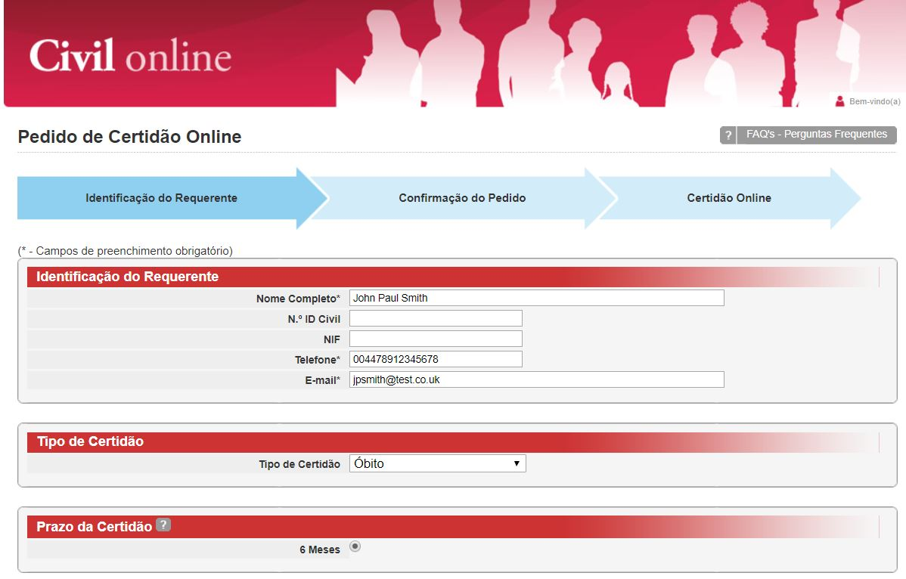

Chose the option “terceiro” if you are requesting access to a certificate relating to someone else, complete the person’s name, date and place of birth, date and place of death (in this example), then click on “Continuar”.
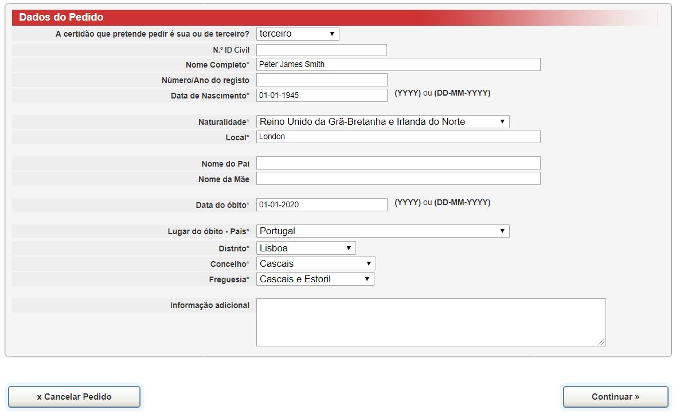
´

You will see confirmation of your request and you will be prompted to pay the fee (€10) via Visa/Mastercard or Multibanco reference. The notes remind you that the certificate in valid for 6 months from the date you conclude your request.

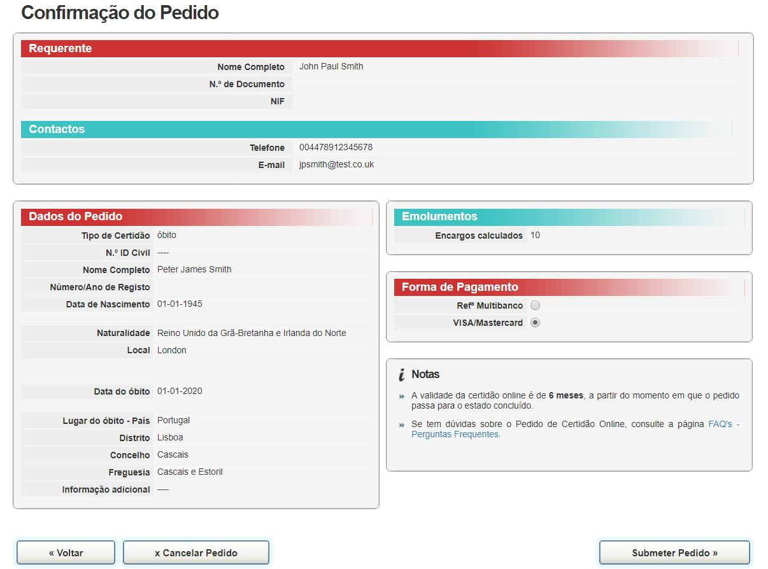

Request submitted – you need to click on “Pagamento” to finalise your order. You will then receive an email with a code to access the certificate online. You can share this code with relevant authorities or the individual who needs to see the certificate.

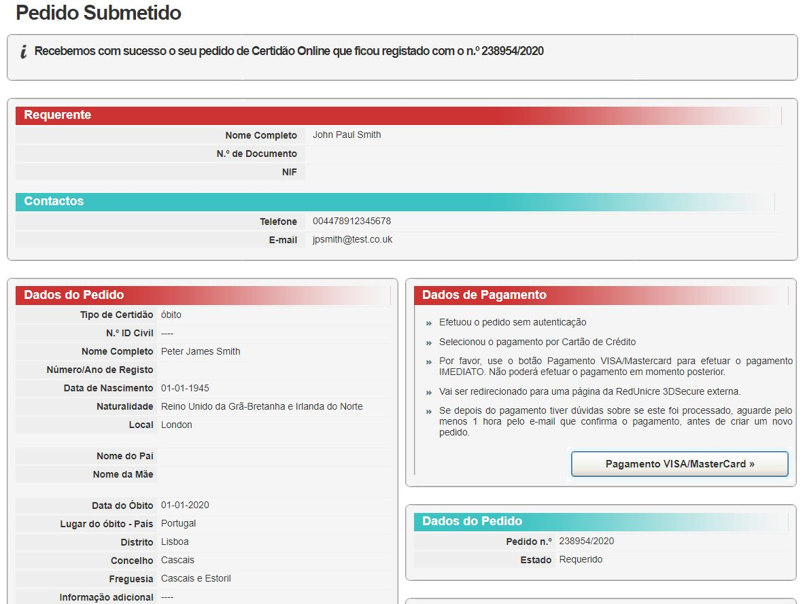

“Notes
- Sharing the access code with any public or private entity, acquired after you order the online certificate, it is legally as valid as presenting a paper copy of the certificate.
- The validity of the online certificate is 6 months, from the time the request is finalised.
- If you have any questions about the Request Online Certificate, see the page FAQ’s
- In case there is an error during payment by VISA/Mastercard, please send an e-mail to civilonline@irn.mj.pt, attaching a screenshot of the error message and the number of the request.”

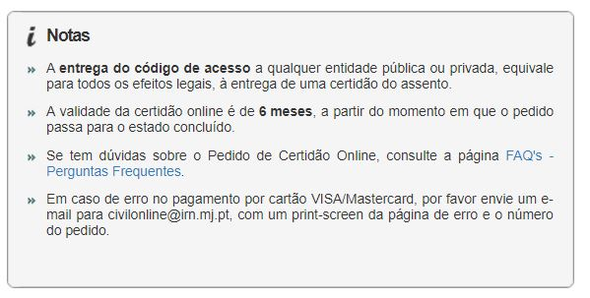

Disclaimer: This information has been prepared by the British Consular Services Portugal for the convenience of UK Nationals who may require to order copies of Portuguese birth, death or marriage certificates online. Our aim is to provide our customers with as much relevant information to enable them to make better informed decisions.

December 2020

