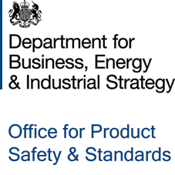

The Office for Product Safety and Standards as a Supporting Regulator for Primary Authority
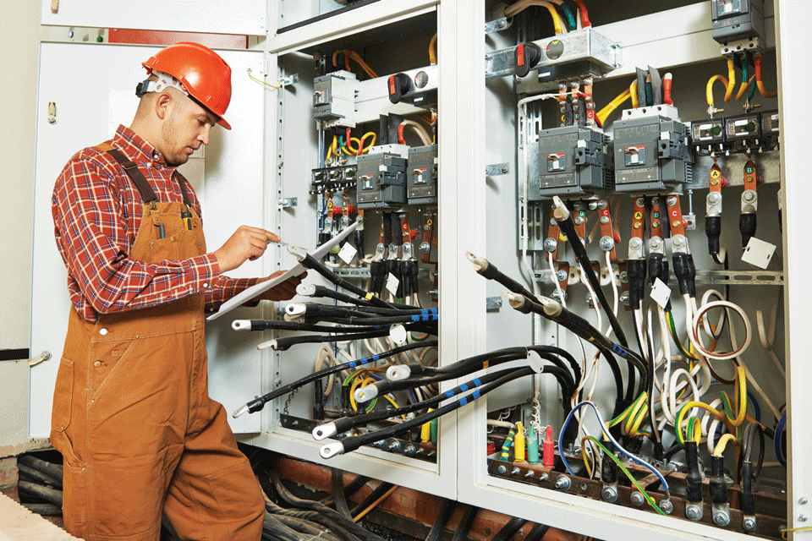
 | 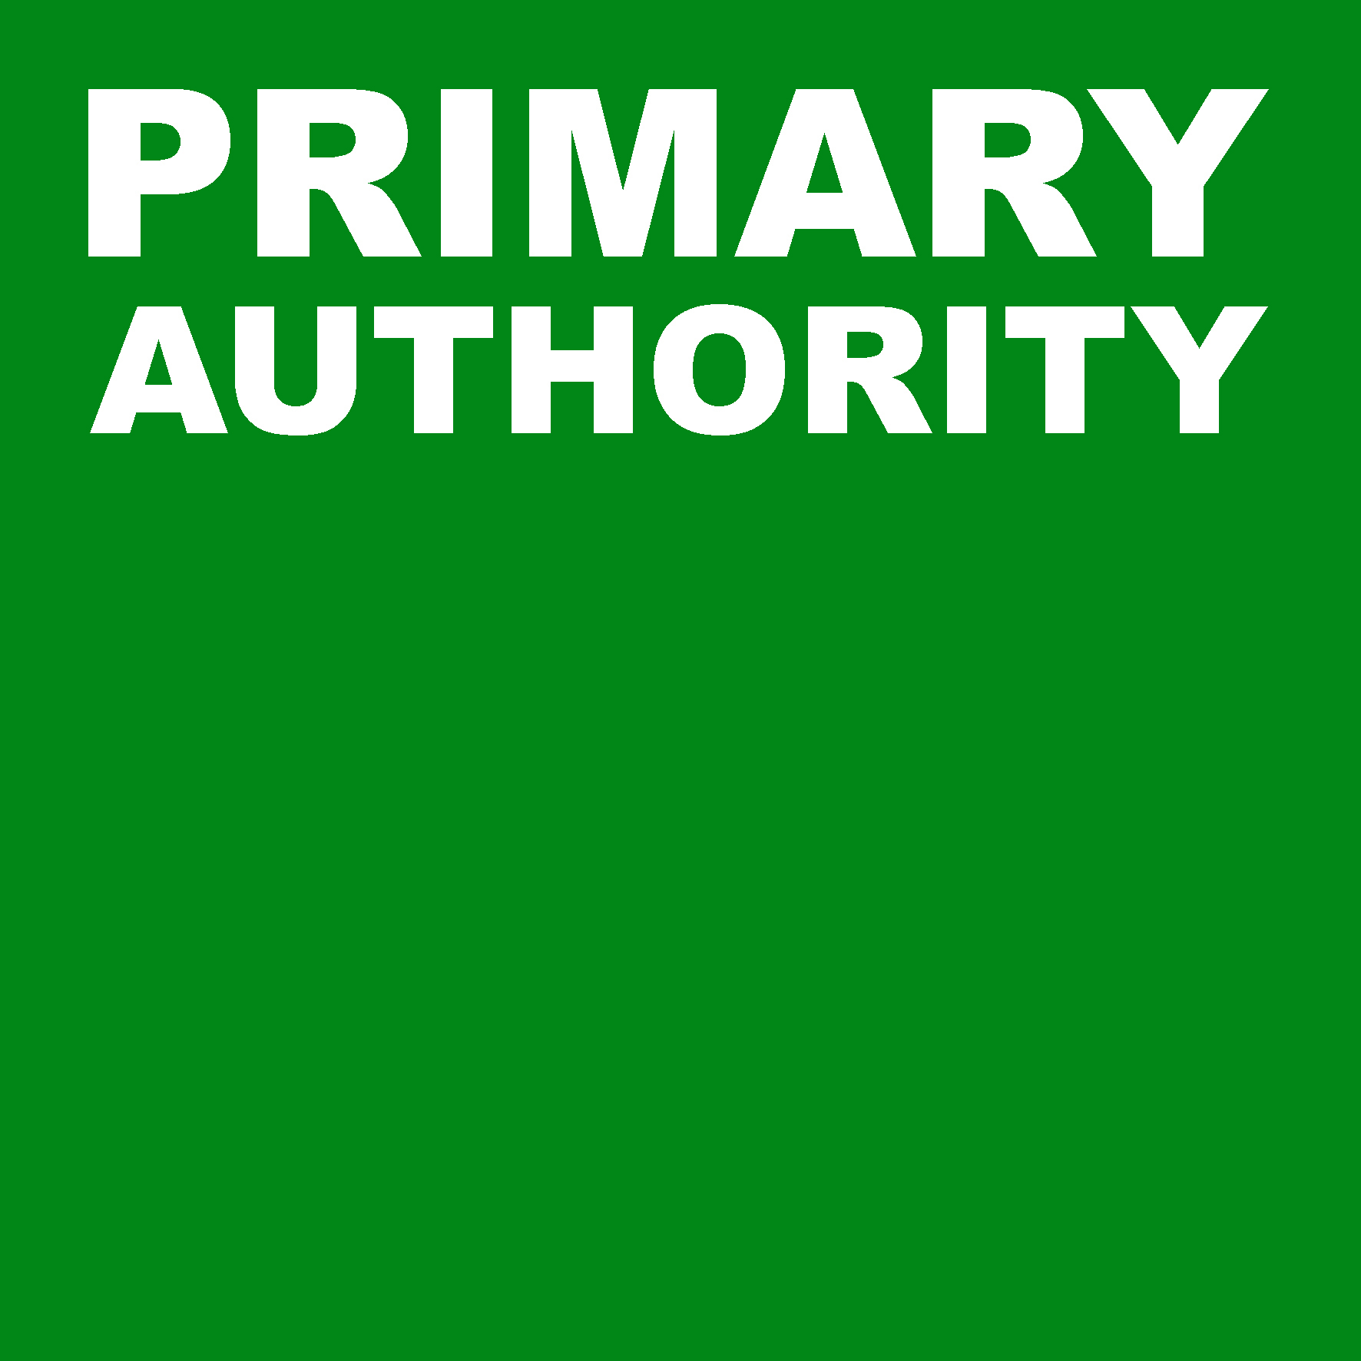 | 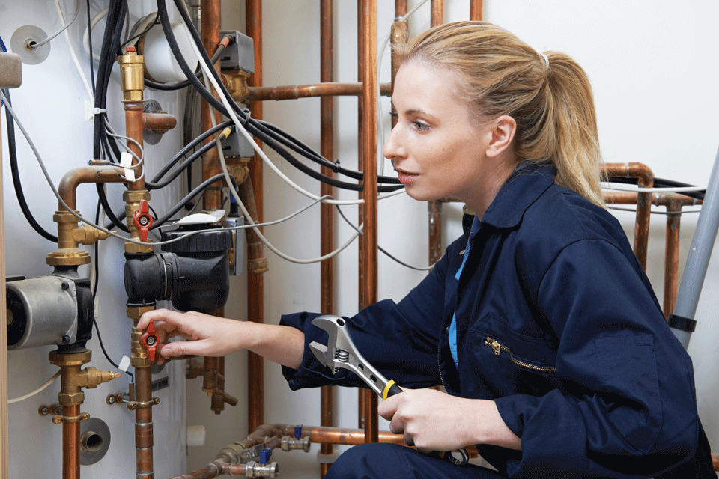
February 2018

Contents
Introduction and background 3
The Office for Product Safety and Standards’ offer 3
Examples of how the Office for Product Safety and Standards can support partnerships as a supporting regulator 4
Annex A: Service Standards 5
Working with you 5
Costings 5
Links to our role as a national regulator 6
Having your say 6
How to contact us 6
Annex B: Request template and flowchart 7
Primary Authority support request template 7
Process flowchart 8

Introduction and background
The Office for Product Safety and Standards (Safety & Standards) is a national regulator, holding policy responsibility in relation to the safety of consumer products and overseeing the UK’s system of weights and measures. In this role Safety & Standards has, and has access to, wide ranging policy and technical expertise on legislation and standards, testing facilities and regulatory expert panels.
National regulators specified as supporting regulators for Primary Authority include the Secretary of State in relation to his role with respect to regulatory functions concerning weights and measures and safety of consumer products. Safety & Standards acts in this capacity on behalf of the Secretary of State.
The role of a supporting regulator fits within Safety & Standards’ wider remit of bringing together policy expertise and practical experience to ensure that regulation is delivered effectively in ways that reduce burdens on business, save public money and properly protect citizens and communities.
This document sets out the approach that Safety & Standards takes to being a supporting regulator. It provides information for primary authorities, businesses and co-ordinators about how support can be provided and provides practical information on the operation of the approach.

The Office for Product Safety and Standards’ offer
Safety & Standards will work with primary authorities and their partner businesses and co-ordinators to agree arrangements to provide support to the primary authority in its provision of Primary Authority Advice or Primary Authority Advice to Local Authorities, or in its development and management of an inspection plan. These arrangements may relate to a single piece of work, such as the preparation or review of specific advice, or they may relate more widely to the primary authority’s partnership work with a business or a group of businesses. Safety & Standards’ involvement as a supporting regulator can bring a range of benefits to the primary authority and the partner business, or group of businesses, such as:
- access to policy and technical expertise for weights and measures and the safety of consumer products providing the most up to date knowledge on regulatory requirements and guidance including any forthcoming changes;
- the ability to agree an interpretation of generic guidance that is tailored to the particular circumstances of the business, or group of businesses, for example, to take account of technological or other innovation;
- improved co-ordination with other regulators utilising links into networks of expertise, such as Expert Panels; regional, national and international regulatory liaison groups; industry groups etc.;
- a wider perspective on inspection plans and national inspection strategies drawing on broad sources of data and intelligence; and
- access to technical facilities such as testing facilities.

Safety & Standards is currently building on its well-established weights and measures capability, and policy expertise on the safety of consumer products, which will enable the benefits of supporting regulator involvement to be fully realised. During this time relationships will be developed with primary authorities to establish the areas where our support is most needed.
In carrying out the supporting regulator role Safety & Standards will be working with the other supporting regulators to share best practice and align processes where appropriate.

Examples of how the Office for Product Safety and Standards can support partnerships as a supporting regulator
Example 1: Tailored support on compliance – new products
Business A has developed a new product and is considering how it complies with the law. Although European Standards cover related products which are already on the market, this new product is not fully covered by any existing standards. Business A asks its primary authority for advice on how to demonstrate that the product is safe and agrees with its primary authority to work with Safety & Standards as a supporting regulator on this request. Safety & Standards works with the business and the primary authority to consider options for assessing the safety of the product and on technical documentation demonstrating that the product is safe. Once a conclusion is reached the primary authority issues Primary Authority Advice that the new product complies with the legislation.
Example 2: Advice on Trade Association guidance
Trade Association B has member businesses which import and manufacture products. Many of the member businesses are small and micro businesses. The Trade Association provides technical expertise, interpreting the relevant British Standards and producing user friendly guidance for its members. Trade Association B is updating this guidance and arranges with its primary authority to work with Safety & Standards as a supporting regulator at an early stage to ensure that the updated guidance takes account of any imminent changes to the legislation or standards. Once the guidance is finalised the primary authority issues Primary Authority Advice to confirm that the guidance is adequate to deliver compliance.
Example 3: Support for an inspection plan
A significant percentage of the goods supplied in the UK are weighed or measured on equipment maintained under contracts. Members of Trade Association C carry out this work to an agreed Code of Practice and the Trade Association can access information on which equipment is properly maintained and compliant. Trade Association C works with its primary authority and Safety & Standards as a supporting regulator to enable Primary Authority Advice and an Inspection Plan to be developed allowing ‘earned recognition’ for businesses which have invested in compliance. Intelligence on businesses covered by the inspection plan is shared with local authorities via the Primary Authority Register, enabling enforcing authority resources to be targeted at those less likely to comply with the law.

Annex A: Service Standards
These Service Standards describe the working arrangements within Safety & Standards for provision of services as a supporting regulator for Primary Authority. They have been written mainly for primary authorities although they may also be of interest to businesses and co-ordinators within the scheme. In this Annex, Safety & Standards are referred to as ‘we’ and the primary authority requesting the support is referred to as ‘you’.
Support will be provided having regard to the Primary Authority Statutory Guidance. We can provide support at an early stage in the development of Primary Authority Advice, Primary Authority Advice to Local Authorities or an inspection plan, or can have more detailed involvement including agreeing a final version. When we have agreed a final version of Primary Authority Advice, Primary Authority Advice to Local Authorities or an inspection plan we will act consistently with this in our dealings with the business or group of businesses.

Working with you
In responding to requests for our services we will provide a nominated contact who will:
- acknowledge your request within 5 working days;
- seek to fully understand the nature of your request;
- seek to gain an understanding of how your partner business, or co-ordinator operates;
- explain what we may or may not be able to do;
- agree timescales, costings and preferred methods of communication with you;
- agree a written summary of working arrangements with you;
- keep you informed of progress throughout our involvement; and
- maintain records of the support provided.
Once support has been provided we will update you on any subsequent changes to legislation, guidance or technology that would significantly change our advice.
In all your dealings with us you can expect, and will receive, an efficient and professional service. Our officers will:
- be courteous and polite;
- always identify themselves by name in dealings with you, and provide you with contact details; and
- provide details of how to discuss any concerns you may have.

Costings
The cost recovery rate of Safety & Standards for support that has been requested by the primary authority is £97 per hour (or part thereof).
This has been calculated having taken into account the guidance issued by HM Treasury in Managing Public Money.

Links to our role as a national regulator
The role of a supporting regulator fits within Safety & Standards’ national regulator remit.
We will use information received to support these regulatory objectives, to further our knowledge and understanding of the regulated business community and individual businesses, and to improve our ability to regulate effectively and efficiently.
We appreciate that not every enquiry we receive will result in supporting regulator work; therefore your details may be passed to other teams within Safety & Standards, for example to discuss sector wide guidance.
Further information is available at:
https://www.gov.uk/government/organisations/office-for-product-safety-and-standards

Having your say
If you are dissatisfied or wish to comment on our service or behaviour, please send us your complaint or comments. Our aim is to resolve any problems or difficulties quickly and fairly. We manage complaints about our service, or about the conduct of our officers, through our Complaints Policy, and you can comment by contacting us using the details below.

How to contact us
To discuss how we can provide supporting regulator support to a partnership or to comment on our service please email pa@beis.gov.uk using the subject heading ‘Supporting Regulator’ or ‘Feedback’ (as appropriate). Alternatively you can call us on 0121 345 1201.

Annex B: Request template and flowchart
- This template is for the use of primary authorities who wish to request support from Safety & Standards as a supporting regulator for weight and measures and the safety of consumer products.
- If you have any queries about completing the document please telephone the Primary Authority Helpdesk on 0121 345 1201.

Primary Authority support request template
Name of primary authority
Contact details of primary authority
(name / telephone number / email address)
Name of partner business or co-ordinator
Business sector or main business activity
Contact details of partner business or co-ordinator
Details of scope of support requested (please be as specific as possible)
Is there existing guidance in relation to this request? |  | Yes / No
If ‘yes’, please give details
Is there existing Primary Authority Advice in relation to this request? |  | Yes / No
If ‘yes’, please give details
Has the business or co-ordinator agreed to this request? |  | Yes / No
Has the business or co-ordinator previously sought advice from Safety & Standards or other body in relation to this request? |  | Yes / No
Please send this completed form to pa@beis.gov.uk

Process flowchart
▼
Primary authority reviews existing guidance to check
whether supporting regulator input is required.
▼
Primary authority contacts Safety & Standards using the template form, clarifying the scope of the support requested, and why any existing guidance is insufficient.
▼
Safety & Standards considers the request and whether it can assist,
giving an initial response within 5 working days.
▼
Primary authority and Safety & Standards have a discussion to ensure the
request is correctly scoped, confirm it is not addressed in another
forum, and estimate the resources and time it requires.
▼
Primary authority clarifies the nature of the support it is seeking.
▼
Safety & Standards confirms the nature of the support that will be
provided along with a timeframe and cost of providing the support.
▼
A written summary of working arrangements is created to include the request, nature of support to be provided, timeframe, costings and confidentiality.
▼
Supporting regulator support provided.
▼
Primary authority issues the Primary Authority Advice produced or
inspection plan developed with Safety & Standards.

Supporting Regulators are specified by R2 and the Schedule of The Co-ordination of Regulatory Enforcement Regulations 2017.
https://www.gov.uk/government/publications/managing-public-money

