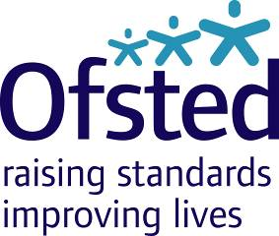
Ofsted Board
Tuesday 26 September 2017
9:00am – 1:00pm, Room 802, Aviation House
Attendees: Julius Weinberg (Chair), Amanda Spielman (HMCI), John Cridland CBE, Linda Farrant, John Hughes, Venessa Willms OBE, Matthew Coffey (Chief Operating Officer), Louise Grainger (Director of Finance, Planning and Commercial), Eleanor Schooling (National Director, Social Care), Sean Harford (National Director, Education), Karen Shepperson (Director, People and Operations), Luke Tryl (Director, Corporate Strategy), Julia Kinniburgh (DfE observer)
Amy Finch (note taker)
Apologies: Paul Snell CBE, James Kempton

Private meeting for Board Members only: 9:00am – 9:30am

Board meeting: 9:30am – 1:00pm
- Welcome, apologies and declarations of interest Chair

Strategy session
- Workforce Strategy Karen Shepperson
- World of work in 2025 and implications for Ofsted
- Early thoughts on workforce models for school inspections to deliver new strategy
- Strategic Risk Register Matthew Coffey/Louise Grainger
- Risk deep-dive: People Karen Shepperson
- Changing the current model of short inspections Matthew Coffey /Matthew Purves
- Strategy Update Luke Tryl
- Current and future research programme Luke Tryl

Operational business
- Minutes, matters arising, action log and forward look Chair
- HMCI update HMCI
- COO update Matthew Coffey
- Education update Sean Harford
- Social care update Eleanor Schooling
- Finance report (Period 4) Louise Grainger
- Medium Term Financial Plan and Spending Review Update Louise Grainger
- Audit and Risk Assurance Committee update Linda Farrant/Louise Grainger
- Update on meeting held 13 September.

- AOB ALL

