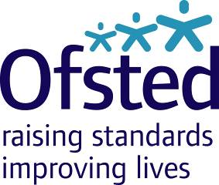
Ofsted Board
Tuesday 16 May 2017
9:00am – 1:00pm, Room 802, Aviation House
Attendees: Julius Weinberg (Chair), Amanda Spielman (HMCI), Linda Farrant, John Hughes, James Kempton, Paul Snell CBE, Venessa Willms OBE, Matthew Coffey (Chief Operating Officer), Louise Grainger (Director of Finance, Planning and Commercial), Sean Harford (National Director, Education), Eleanor Schooling (National Director, Social Care), Luke Tryl (Director, Corporate Strategy), Emma Ing (Regional Director, East Midlands) (observing only), Paul Kett (DfE observer), Amy Finch (Private Secretary to HMCI) and James Bowyer (Board Secretary).
Apologies: John Cridland CBE

Private meeting for Board Members only: 9:00am – 10:00am

Board meeting: 10:00am – 1:00pm
- Welcome, apologies and declarations of interest Chair
- Minutes, matters arising, action log and forward look Chair
- HMCI update HMCI
- COO update: Strategic Performance and Risk Report (Q4) Matthew Coffey
- Education update Sean Harford
- Social care update Eleanor Schooling
- Strategy development Luke Tryl
- Budget and Corporate Plan 2017/18 Louise Grainger
- Finance report (March 2017) Louise Grainger
- Audit and Risk Assurance Committee update Linda Farrant / Louise Grainger
The following is enclosed:
- Audit and Risk Assurance Committee Annual Report 2016/17
- Strategic Risk Register presented to the Committee in March
- Minutes from the meeting on 18 January and draft minutes from the meeting on 15 March
- AOB ALL

