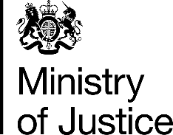 | July 2017

Freedom of Information Act (FOIA) Request – 113147

You asked for the following information from the Ministry of Justice (MoJ):

1. How many indictments have there been for Infanticide under the Infanticide Act 1938 between 2002 and 2016. Please provide your answer in the form of a break-down, year-by-year.

2. How many convictions have there been for Infanticide under the Infanticide Act 1938 between 2002 and 2016. Please provide your answer in the form of a break-down, year-by-year.

3. What was the given sentence for each of the convictions which are provided in answer to question 2.

And

1. How many indictments have there been for Concealing the birth of a child under the Offences Against the Person Act 1861, s.60 between 2002 and 2016. Please provide your answer in the form of a break-down, year-by-year.

2. How many convictions have there been for Concealing the birth of a child under the Offences Against the Person Act 1861, s.60 between 2002 and 2016. Please provide your answer in the form of a break-down, year-by-year.

3. What was the given sentence for each of the convictions which are provided in answer to question 2.

Your requests have been aggregated together, and have been handled under the FOIA.

I can confirm that the MoJ holds the information that you have requested and I have provided it in the attached annex..

