Children’s Social Care in England

This release covers:
- Inspection outcomes for local authority children’s services inspections from November 2013, covering all inspections published by 31 March 2016
- Inspection outcomes for all regulated, and other, children’s social care provision 1 April 2015 to 31 March 2016
- Inspection outcome of most recent inspection, for all regulated, and other, children’s social care provision, as at 31 March 2016
- Information about the providers of children’s social care, including the numbers of providers and places, as at 31 March 2016

Key Points

Two local authorities (LA) have been judged outstanding overall under the framework for inspecting services for children in need of help and protection, children looked after and care leavers (SIF). | Westminster, and the Royal Borough of Kensington and Chelsea have been judged outstanding for Overall effectiveness in their SIF inspections.
Around one quarter of local authorities, of those inspected to date, were judged to be inadequate for the SIF. | Twenty one local authorities were judged to be inadequate.
The inspection judgement profile of children’s homes inspections has seen a substantial improvement this year from last year. | In 2015-16, 75% of all inspections during the year resulted in a good or better Overall effectiveness judgement, compared to 64% in 2014-15.
This has led to an improvement in the inspection judgement profile of children’s homes as at 31 March. | As at 31 March 2016, 79% of all children’s homes had a good or better Overall effectiveness judgement, compared to 70% in March 2015.
Contents
Key Points 1
Introduction 5
Inspection of local authority children’s services 7
Overall effectiveness from November 2013 to March 2016 8
Key judgements from November 2013 to March 2016 10
Children looked after and achieveing permanence sub-judgements (adoption and care leavers) from November 2013 to March 2016 11
Outcomes by local authority type and location for Overall effectiveness from November 2013 to March 2016 12
Inspections of local authorities: some comparisons 14
Reviews of Local Safeguarding Children Boards 17
Overall effectiveness from November 2013 to March 2016 17
All children’s homes 20
Providers and Places as at 31 March 2016 20
Overall effectiveness for all children’s homes 27
Children’s homes inspections in year 2015-16 27
Overall effectiveness for all children’s homes inspections – change since last inspection 29
Regional outcomes for all children’s homes in year 2015-16 30
State of the nation for all children’s homes as at 31 March 2016 32
Sector data for all children’s homes in year 2015-16 34
Interim inspections for all children’s homes in year 2015-16 37
Monitoring visits for all children’s homes in year 2015-16 38
Other social care providers 39
Independent Fostering Agencies 39
Voluntary Adoption Agencies 40
Adoption Support Agencies 41
Residential Special Schools 42
Boarding Schools 44
Further Education (FE) Colleges with residential accommodation 45
Residential Family Centres 46
Residential Holiday Schemes for Disabled Children 47
Secure Training Centres 47
List of Charts 48
List of Tables 48
List of Maps 49
Revisions to previous release 50
Notes 50
Glossary 52

Acknowledgements
Thanks to the following for their contribution to this statistical release: Ania Otczyk; Emily Moreton; Rich Jones; Marc McGreavy; Matt Watts.

Introduction
There were 2,778, providers of children’s social care and providers of residential accommodation for children in boarding schools & further education colleges in England, as at the end of March 2016.
Most of these providers are registered and regulated by Ofsted, and inspected, in the main, by Regulatory Inspectors.
These comprise the following regulated provider types:
- children’s homes (including secure children’s homes and residential special schools dual registered as children’s homes) – receive a full and an interim inspection on an annual cycle and may receive additional concern driven inspections
- residential family centres – receive an inspection in every three year cycle and may receive additional concern driven inspections
- independent fostering agencies – receive an inspection in every three year cycle and may receive additional concern driven inspections
- voluntary adoption agencies – receive an inspection in every three year cycle and may receive additional concern driven inspections
- adoption support agencies – receive an inspection in every three year cycle and may receive additional concern driven inspections
- residential holiday schemes for disabled children – receive an inspection on an annual cycle and may receive additional concern driven inspections
They also comprise the following registered, but not regulated, provider types:
- residential special schools – receive an inspection on an annual cycle and may receive additional concern driven inspections
- boarding schools – receive an inspection in every three year cycle and may receive additional concern driven inspections
- further education colleges with residential accommodation – receive an inspection in every three year cycle and may receive additional concern driven inspections
- secure training centres – receive an inspection on an annual cycle and may receive additional concern driven inspections
Ofsted also inspects the 152 local authorities (LAs) responsible for ensuring and overseeing the effective delivery of social care services for children.
Her Majesty’s Inspectors (HMI) conduct these inspections of local authority services for children who need help and protection, children looked after, and care leavers, under the single inspection framework (SIF). This inspection cycle began in November 2013 and will conclude by December 2017.
In addition to the SIF, and conducted at the same time, HMI conduct reviews of the Local Safeguarding Children Boards (LSCBs) that are responsible for safeguarding, and promoting the welfare of, children.

Inspection of local authority children’s services
There are approximately 11.6 million children living in England, of whom less than five per cent are involved with children’s services. Less than one per cent are children looked after (69,530 children) or on a child protection plan (49,680 children). Children in need make up the largest percentage of those involved with children’s social care: just over 3% of all children in England are classified as children in need (390,960 children). Around two thirds of children involved with social care live in local authorities which have been inspected under the SIF framework.
A map of England showing the make up of the 152 local authorities, by type and by whether they have had a SIF inspection or not is below.

Map 1: Local authorities by type, including SIF inspection status
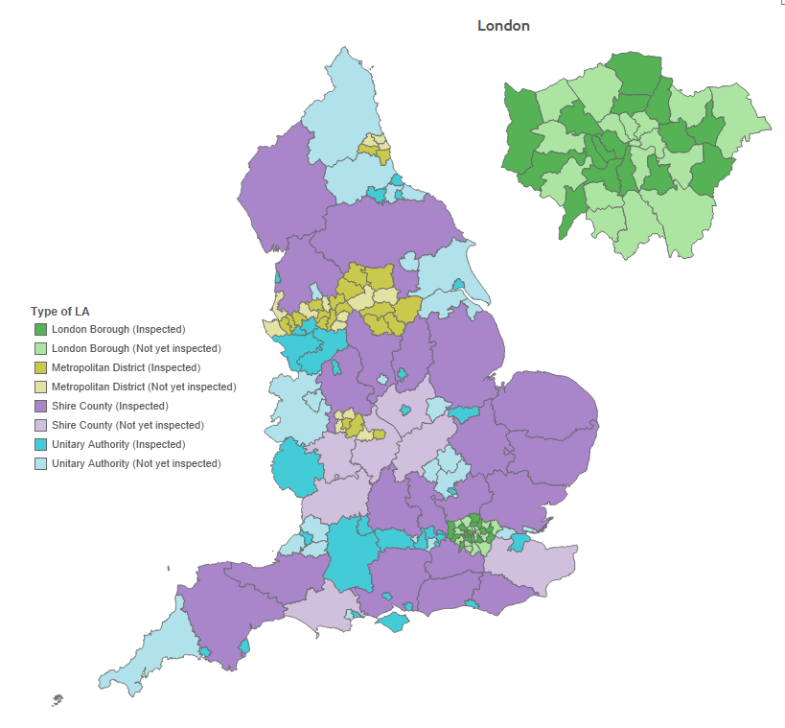

Overall effectiveness from November 2013 to March 2016
For the first time since the start of the SIF inspections, some children in need in England live in authorities judged to have outstanding children’s services. For children in need living in LAs that have received a SIF inspection, there is a one in four chance your authority’s children’s services will have been judged to be good or outstanding, and the same chance that they will have been judged to be inadequate.
There were 87 SIF inspections published by 31 March 2016.
This makes up over half (57%) of all local authorities responsible for children’s social care in England. The picture, therefore, is still only a partial one and is not necessarily representative of the quality of services for all local authorities in the country; however, it is a fuller picture than previously given in June 2015, when only 39% of authorities (59) had been inspected.
Since June 2015, two LAs have been judged outstanding: Royal Borough of Kensington and Chelsea, and Westminster.
The percentage of local authorities judged good or better for Overall effectiveness was around one quarter (26%).
The percentage of authorities judged as requires improvement to be good was 49% (43 authorities).
The percentage judged to be inadequate was one quarter (24%), or 21 authorities.
Chart 1: SIF Overall effectiveness from November 2013 to March 2016
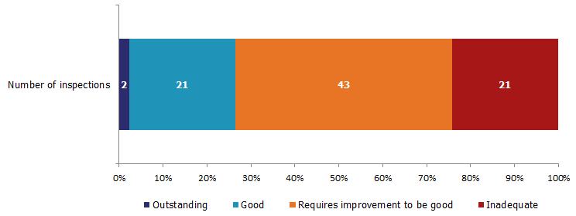

Although just over half of all authorities had been inspected, they included among them some of the very largest in England. Consequently, the 87 are responsible for around two thirds of vulnerable groups of children in the country.

Map 2: SIF inspection Overall effectiveness judgements from November 2013 to March 2016
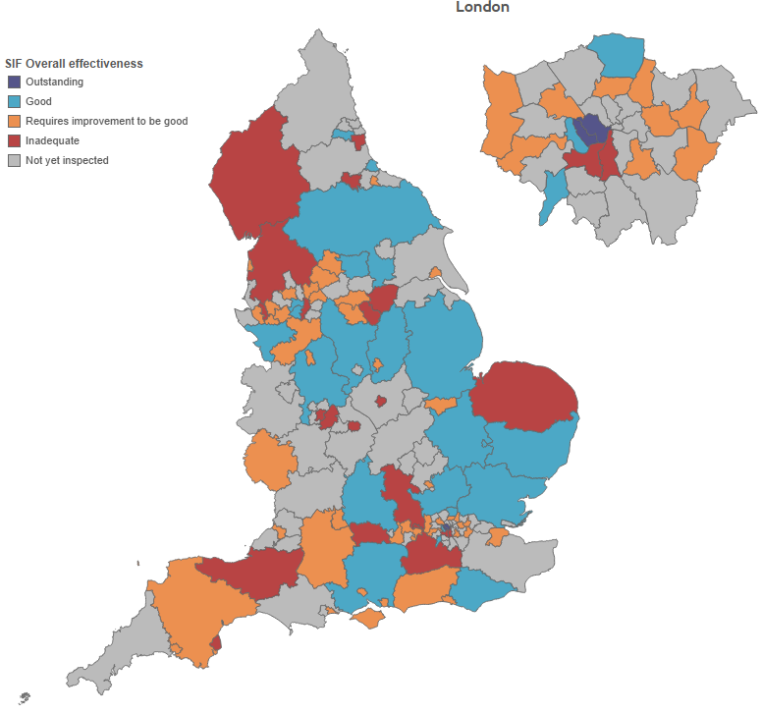

Key judgements from November 2013 to March 2016
The Overall effectiveness judgement for the SIF is derived from three key judgements:
- the experiences and progress of Children who need help and protection;
- the experiences and progress of Children looked after and achieving permanence;
- Leadership, management and governance.
More authorities were rated good or better under the children looked after and achieving permanence key area than in either of the other judgement areas. Just over one third of authorities (30) were judged good or better in this area, compared to just under a third (27) for leadership, management and governance, and just under a quarter (20) for children who need help and protection.
The number of authorities judged outstanding for leadership, management and governance stood at seven, with this area having the highest number of authorities judged outstanding. The majority of these were in London or the South East: Hammersmith and Fulham, Royal Borough of Kensington and Chelsea, Westminster, and Hampshire. The other three were Cheshire West and Chester, Leeds, and Trafford.
Children who need help and protection was the area of weakest performance for the inspected authorities, with over half judged requires improvement to be good (49 authorities, or 56%) and around one fifth (18, or 21%) judged inadequate. This was the only area in which no authorities were judged outstanding.
Leadership, management and governance have around one fifth (18) judged inadequate.
Chart 2: SIF key judgements from November 2013 to March 2016
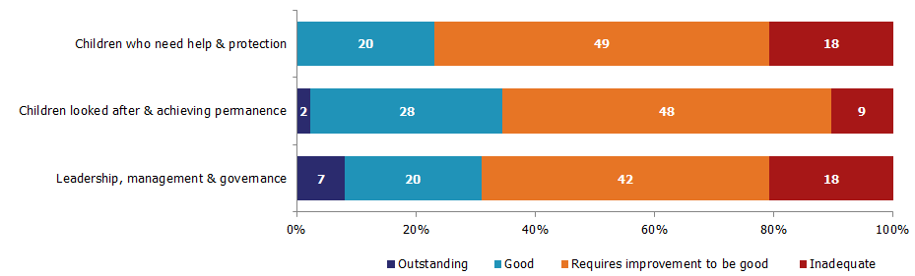
Between June 2015 and March 2016, one local authority, Sunderland, was judged inadequate in all the key judgements and the sub-judgements, bringing the total judged inadequate in all judgements to two, including Birmingham.
Four additional authorities – Buckinghamshire, Rotherham, Slough and Somerset – were judged inadequate for each of the three key judgements.
Ten local authorities have been judged inadequate for both Children who need help and protection and Leadership, management and governance since the SIF inspections began. Four of these were inspected since Ofsted last reported on these inspections – Darlington, Lancashire, Torbay and Wandsworth – and six prior to June 2015: Coventry, Knowsley, Leicester City, Manchester, Sandwell, and Surrey.

Children looked after and achieving permanence sub-judgements (adoption and care leavers) from November 2013 to March 2016
The key judgement area Children looked after and achieving permanence has two sub-judgements: Adoption performance and Experiences and progress of care leavers.
Adoption performance was the area of strongest performance for local authorities, with over half of all inspected authorities (47) judged good or better (Chart 3).

Chart 3: SIF Adoption performance sub-judgement from November 2013 to March 2016
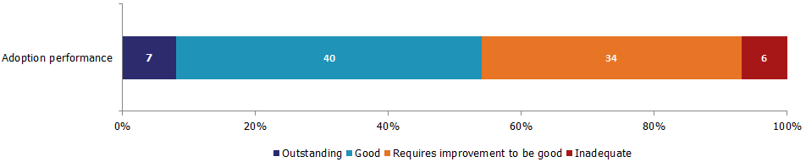
Seven local authorities were judged to be outstanding for adoption performance (Cheshire West and Chester, East Sussex, Hammersmith and Fulham, Hampshire, Royal Borough of Kensington and Chelsea, Lincolnshire, and Westminster) and a further 40 were judged good. Two fifths of authorities (34) were judged requires improvement to be good. Six authorities were judged inadequate, only one more than as at June 2015.
Experiences and progress of care leavers is also a strong area of performance for local authorities, when comparing judgements across all key and sub-judgements.
Two local authorities – Trafford, and Royal Borough of Kensington and Chelsea – were judged to be outstanding and over a third of authorities (30) judged good.
Chart 4: SIF Experiences and progress of care leavers sub-judgement from November 2013 to March 2016
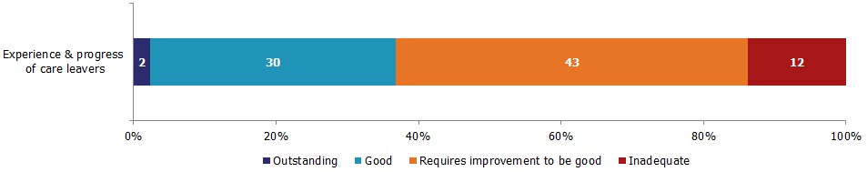

Almost half of authorities (43) were judged as requires improvement to be good. Twelve LAs were judged inadequate.
Of the 12 authorities inadequate in this sub-judgement, four had a requires improvement to be good judgement for Overall effectiveness.

Outcomes by local authority type and location for Overall effectiveness from November 2013 to March 2016
Each region in England varies in terms of geographical size and the number of local authorities within it. Not all regions have been inspected proportionate to the number of authorities within them. The regional picture is, therefore, contingent on those inspections already completed and so is not necessarily yet an accurate reflection of the overall picture of the region, which may improve or worsen over time, and the current data needs to be considered in that light. There is no evidence that the region in which a local authority is situated has an impact on inspection outcome.
The 23 authorities that were judged good or better for Overall effectiveness were spread across eight regions, with no authorities in the South West yet judged good or better. The 21 authorities judged inadequate covered all nine regions.

The smallest region, East Midlands, had the fewest SIF inspections, though as a proportion of the authorities in the region, this equated to just over half (Chart 5).
The two largest regions, London and the North West, had the highest number of inspections, equating to half of all authorities in London, and just under three quarters in the North West. London had the only two authorities judged outstanding for Overall effectiveness.
Of the regions that had eight or more SIF inspections, proportionally London had the most authorities judged good or better for Overall effectiveness: just under a third of the authorities that were inspected in London. The next highest proportion was in the South East region, where a fifth of authorities were judged good. Although the South East also had the second highest proportion in June 2015, the rate has fallen from a quarter then, suggesting that inspections completed in the nine month period since then have been more likely to result in a judgement of requires improvement to be good or lower.
The regions with the greatest number of inadequate judgements were the South East, the North West, and the West Midlands. Though the West Midlands had three inadequate judgements compared to four in the other two regions, this equated to half of their inspections, compared to a quarter of those in the other two regions.
Chart 5: SIF Overall effectiveness judgements, by region
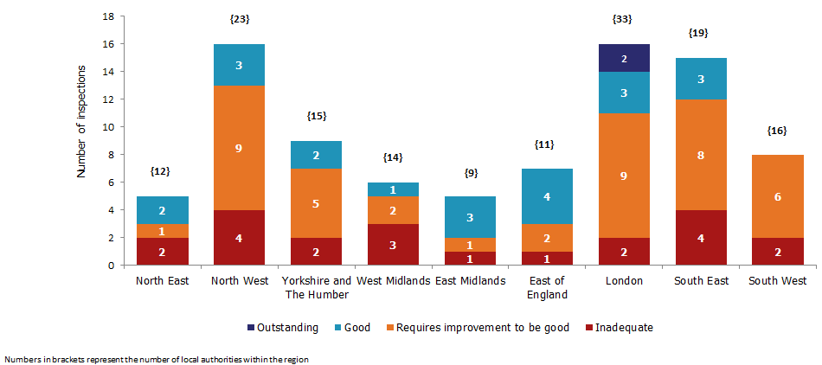

Half (12) of those authorities judged good or better for Overall effectiveness were shire counties; and just under a quarter (five) were London boroughs. Four were metropolitan districts, and the remaining two were unitary authorities. Both of the authorities judged outstanding were London boroughs.

Of the 21 authorities judged inadequate, the types of council were mixed: eight were metropolitan districts, six were shire counties, five were unitary authorities, and two were London boroughs.

Inspections of local authorities: some comparisons
Because of the different frameworks used to inspect local authorities since 2009, it is difficult to compare the SIF Overall effectiveness judgement with those from previous inspection frameworks. The terminology changed from ‘adequate’ judgements, in LA inspections prior to 2013, to ‘requires improvement to be good’ judgements, from 2013 onwards, in the SIF.
There are two key judgements in the SIF inspections, though, where it is possible to draw some comparisons to a previous inspection judgement:
- Children who need help and protection with the Safeguarding or Child Protection inspection outcomes
- Children looked after and achieving permanence with the Looked After Children inspection outcomes
A comparison of the Children who need help and protection key judgement with the latest Child Protection or Safeguarding judgement is shown in Chart 6, below.
The overall comparative picture indicates more decline than improvement in inspection judgements for Children who need help and protection, compared to previous Safeguarding or Child Protection outcomes (Chart 6).
A total of 22 authorities saw an improvement, while 32 declined. Thirty-three authorities remained the same.
For the majority of authorities that improved or declined, the change was by one grade: from adequate to good, for example, or from adequate to inadequate. Only one authority (Royal Borough of Kingston upon Thames) improved from inadequate to good.
A total of 13 out of 18 authorities had not been judged inadequate previously: seven declined from adequate, and six from good (Buckinghamshire, Coventry, Knowsley, Lancashire, Sunderland, and Wandsworth).
Over half of the authorities (18 of 33) that remained the same were those that were judged as requiring improvement to be good (previous inspection adequate) for Children who need help and protection.
Chart 6: Children who need help and protection judgements, change from previous inspection judgement
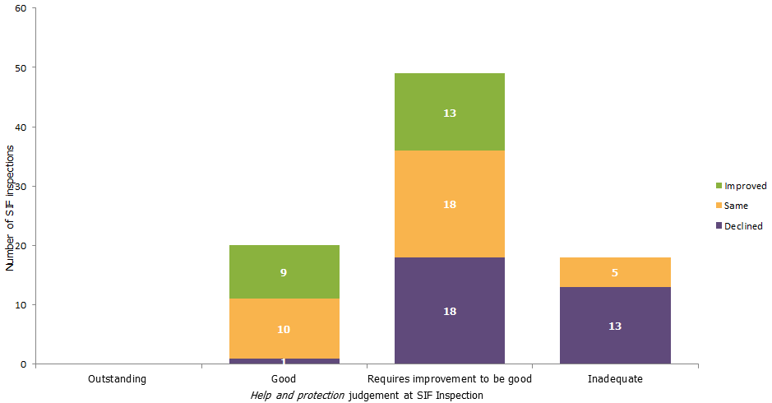

Chart 7 below shows a comparison of the Children looked after and achieving permanence key judgement with the Looked After Children judgement.
Children looked after and achieving permanence is the strongest performing area under this inspection framework, as it was under the Looked After Children inspections. The judgement profile for the Looked After Children inspections contained, by 2012, a much higher proportion of good or better judgements – over half of all local authorities – than did the inspections that touched on Child Protection or Safeguarding. There has been more decline than improvement in SIF judgements for Children looked after and achieving permanence in comparison to previous Looked After Children outcomes. Eighteen authorities improved, while 28 authorities declined (Chart 7).
Over half of the improving authorities (13 of 18) improved to good from adequate/requires improvement to be good. Three improved from inadequate to requires improvement to be good, and the final two improved from good to outstanding (Royal Borough of Kensington and Chelsea, and Westminster).
Of the nine authorities judged inadequate for Children looked after and achieving permanence, five had declined from adequate, two from good, and one (Lambeth) from outstanding.
Around two fifths (20) of the 48 authorities that were judged as requiring improvement to be good for Children looked after and achieving permanence had declined since their last inspection, all of them from good. Norfolk remained inadequate for this judgement from their previous inspection.
Of the four authorities judged inadequate at their last inspection, and subsequently inspected under the SIF, all except Norfolk improved to requires improvement to be good.
Chart 7: Children looked after and achieving permanence judgements, change from previous inspection judgement
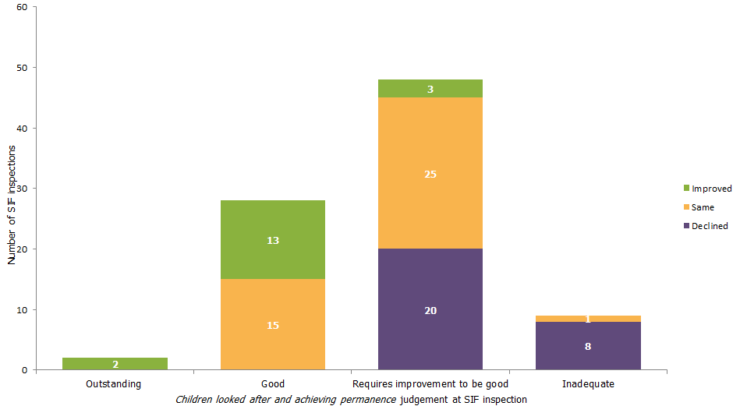

There does not appear to be any correlation between the number of children receiving social care intervention (children in need, children looked after, and children with a child protection plan) and the authority’s overall effectiveness judgement. The pattern of inspection outcomes suggests that it is not necessarily either greater affluence in the local area or a higher financial settlement for the local authority that drives performance. There is no significant correlation between the level of deprivation in a local authority and the inspection outcome.

Reviews of Local Safeguarding Children Boards
Ofsted conducts reviews of Local Safeguarding Children Boards (LSCBs) alongside the SIF inspections of local authority children’s services. Their LSCB Overall effectiveness judgement is not, however, directly comparable to the SIF Overall effectiveness judgement. This review arrangement has been in place since November 2013.

Overall effectiveness from November 2013 to March 2016
More than half the LSCBs reviewed were judged requires improvement to be good. Just over a quarter reviewed were judged good, and most of these were authorities also judged good in the SIF.
There have been 87 reviews of LSCBs published by 31 March 2016, or 57%. As with the SIFs, the picture is still only a partial one and is not necessarily representative of the quality of all LSCBs in the country.
Thirty-one per cent of inspected LSCBs have been judged to be good (27), with none judged outstanding.
The pattern of outcomes for LSCBs is similar to that for local authorities, though with the judgement of good featuring slightly more frequently in this profile. However, it is notable that, although two LAs have been judged Outstanding, there have been no outstanding judgements to date for LSCBs.
Of the two LAs judged to be outstanding, both were judged good for LSCB Overall effectiveness. Nineteen of the additional 25 authorities judged good for LSCB Overall effectiveness were also judged good for SIF Overall effectiveness.
Map 3: Overall effectiveness judgements for LSCB reviews from November 2013 to March 2016
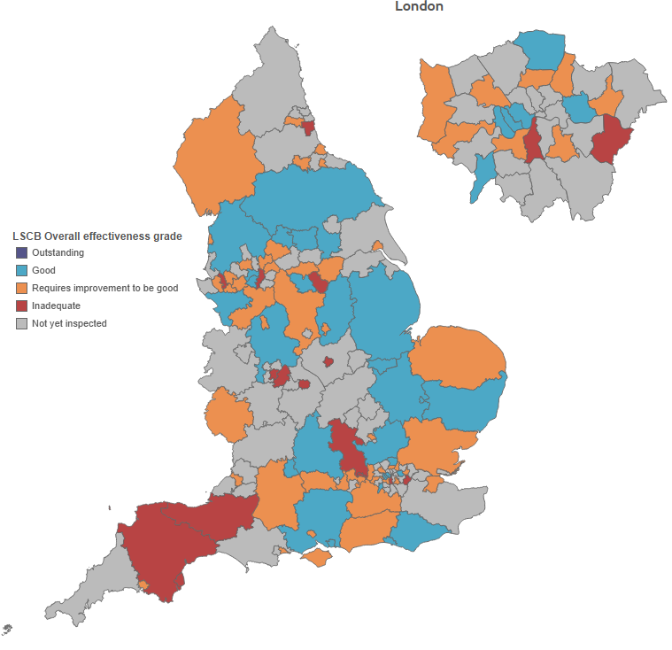
As with overall effectiveness for local authorities, the pattern of outcomes for LSCBs is similar to the Children in need of help and protection sub-judgement for local authorities. All LSCBs judged good were within local authorities where the help and protection judgement was good or requires improvement to be good, with the exception of Lancashire, who were judged inadequate for help and protection. The large majority (12) of the fifteen LSCBs judged to be inadequate were part of LAs with an inadequate help and protection judgement; Bexley, Devon, and Lambeth were the exceptions, judged requires improvement to be good for help and protection.
Chart 8: LSCB Overall effectiveness and SIF Children in need of help and protection judgements
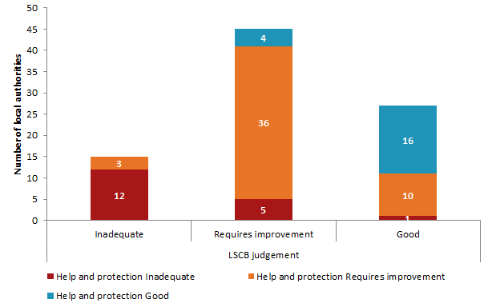

All children’s homes

Providers and Places as at 31 March 2016
A child in a children’s home was most likely to be living in a privately run, for-profit, home. The number of local authority run homes continues to fall. Now more than a fifth of LAs do not run any children’s homes, including almost half the LAs in London. If you exclude short break only homes, then nationally one third of LAs do not run any homes and two thirds of the LAs in London do not. Almost a quarter of homes and one fifth of places are based in the North West; and children in London are most likely to be placed in a home outside their LA of any region in the country. Seven per cent of homes either closed or were re-registered in the year, but new homes opening meant almost no change to the overall number of homes.
Children’s homes, of all types, accounted for nearly three quarters of all social care providers in England at the end of March 2016.
There were 2,071 active children’s homes at the end of the year, almost no change from the previous year (2,074).
Most children’s homes are private sector-run:
- Local authorities ran 452, or 22%, of all homes (Chart 9).
- Private organisations ran 1,438, or 69%, of all homes. These organisations are run for profit.
- Voluntary organisations ran 172, or 8%, of all homes. These are run as non-profit making organisations.

Chart 9: Percentage of children’s homes run by each sector
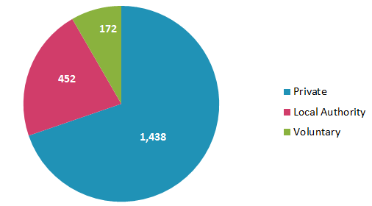
Map 4: All children’s homes by sector and size as at 31 March 2016
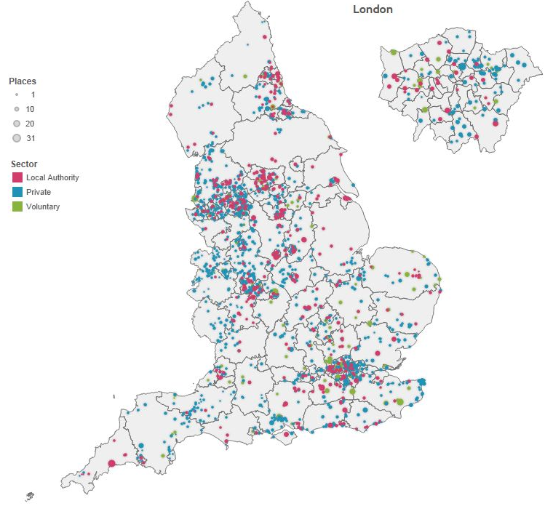

There were 11,639 registered places in all children’s homes, a decrease of just over 1% (134), from the figure at the same time the previous year (11,773).
There were small decreases in the numbers of children’s homes and residential special schools registered as children’s homes compared to the previous year. The number of secure children’s homes remained the same.
In the period 1 April 2015 to 31 March 2016, although the overall numbers of homes and places decreased slightly, this mostly static picture masks some change during the year.
Between 1 April 2015 and 31 March 2016, 142 children’s homes registered and began to operate and offered 602 places. Of these, 47 were re-registrations. In the same period, 145 children’s homes, with 732 places were de-registered, predominately via voluntary cancellations, with one Ofsted-initiated cancellation.
As at 31 March 2016, children’s homes were made up of the following sub-types:
- 1,972 children’s homes, with 8,877 places
- 85 residential special schools registered as children’s homes, with 2,527 places
- 14 secure children’s homes, with 235 places
Table 1: Changes by provision sub-type 31 March 2015 to 31 March 2016
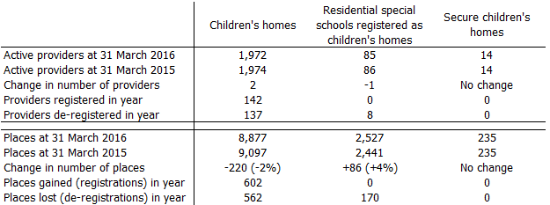

Children’s homes
Children’s homes, excluding secure homes and residential special schools registered as children’s homes, cater for the majority (84%) of children looked after who are in residential care, 5,095 at 31 March 2015. They provide care that meets the various, diverse needs of children looked after. Some specialise in a particular set of needs, such as children on the autistic spectrum or children with behavioural difficulties. They are inspected on an annual cycle.
Around 7% of children’s homes as at 31 March 2016 registered within the year; seven both registered and de-registered within the same year (35 places).
Almost all re-registrations, 46 of 47, were children’s homes. Most of these re-registrations (23) were re-registrations of children’s homes that had de-registered earlier in 2015-16. Of the 23 homes: four moved site, but stayed under the same ownership; 10 changed ownership; and nine were the result of a change in legal status, but kept at least one member of the same ownership group.
Six children’s homes were re-registrations of homes that had closed in 2014-15 and 17 were re-registrations of children’s homes that had closed prior to April 2014.
The regional distribution of homes and the regional distribution of places are not identical.
The regional picture of where children’s homes are located has remained largely unchanged since March 2015, with some very small net increases for almost half the regions (Chart 10). The North West still has almost one quarter of all homes.
Chart 10: Number of children’s homes (a) and places (b) by region

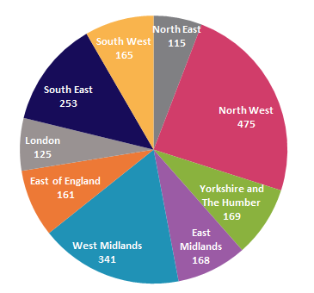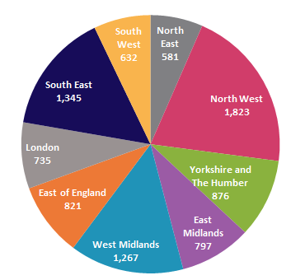

For most regions, there was little change in the number of places between the two years. For the two regions (London, and the South East) that did experience a change in children’s homes places, this was largely accounted for by homes converting from or to “residential special schools registered as children’s homes”. London also gained 30 places through registrations of new children’s homes.

The majority of children’s homes were run by either private or voluntary providers. Private providers ran 1,383 homes (70%), similar to 2015. Seven per cent of homes were run by voluntary organisations (144 homes), an increase of 12 homes from 2015. The remainder (22%) were run by local authorities; the number of LA run homes fell by 5% from 2015. This follows a reduction of 8% from the previous year.

Around 10% of all homes across England are short breaks only homes, accounting for around 14% of all places.

There are 115 local authorities which run some or all of the children’s homes in their area, including short-break only homes. When short-break only homes are not counted, there are 102 local authorities running some or all of the homes in their area (Map 5).
Short break homes make up sizable proportions of homes in two regions: 21% of the available children’s homes places in London, and 22% of those in Yorkshire and the Humber. The region with the largest children looked after population (London) has, therefore, the second fewest homes, and when these short-break homes are excluded, even fewer. This continues to have an impact on the commissioning for the London boroughs.
Map 5: Local authorities which run some or all of the children’s homes within their authority boundary and excluding short-breaks only homes

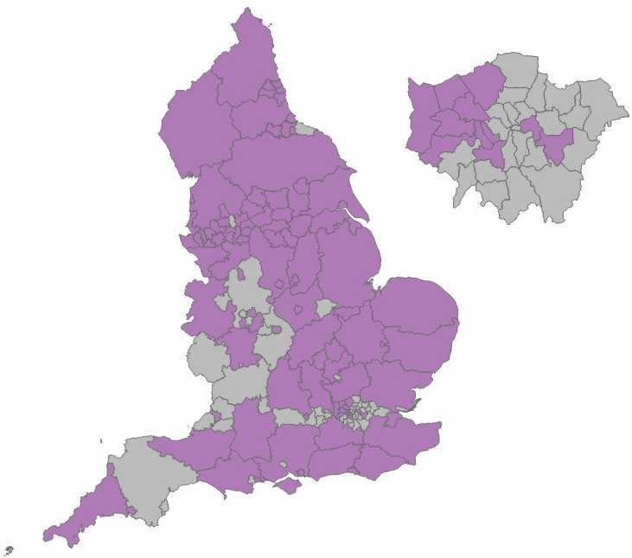

As at 31 March 2016, of the 1,972 active children’s homes, almost one sixth (344) were small (1 to 2 bed) homes.
The regions with the highest number of 1 to 2 bed homes were the North West (136 or 40% of all small homes), the West Midlands (89 or 26%) and the South West (49 or 14%). The majority (90%) of 1 to 2 bed homes were privately-run homes.
Larger children’s homes, with 10 or more beds, made up 3% (65) of children’s homes, excluding residential special schools registered as children’s homes. Just under half (30) of those homes were local authority-run.
The South East had the highest number of children’s homes that had 10 or more beds, at 15 homes (23% of all homes with 10 or more places).
Table 2: Children’s homes at 31 March 2016, by number of beds and region
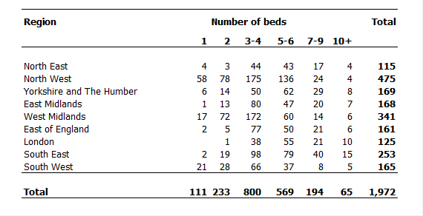

Residential special schools registered as children’s homes
Residential special schools registered as children’s homes are an important sub-group of children’s homes. These homes specialise in educational provision for very vulnerable children, some of whom but not all are children looked after.
This type of home, which is often large in size, tends to be in more rural areas. None are located in the London region. The region with the highest number of residential special schools registered as children’s homes is the South East (17).
All but three of these homes are private or voluntary-run, with almost two thirds (55) run by the private sector.

Secure children’s homes
Secure children’s homes provide services to young people who have placed themselves, or others, at risk of harm. These homes meet the young people’s needs within a secure environment, including residential care, educational facilities and healthcare provision.
All but one of these homes are local authority-run; the sole exception is voluntary-run.

Overall effectiveness for all children’s homes
Children and young people in children’s homes were more likely than the year before to be in a home that received a good or better inspection judgement in the year. They would have also been only half as likely as last year to be living in a home that received an inadequate inspection judgement.
There are two ways to look at information about overall effectiveness:
- In year: this looks at all inspections that took place between 1 April 2015 and 31 March 2016, and what judgement these resulted in; this will include providers that closed before the end of the year, and for some providers will include more than one inspection. Some providers will be excluded as they were not inspected in the year.
- State of the nation: this looks at all providers active on 31 March 2016, and what their most recent inspection judgement was at this date; for each provider, only their most recent full inspection is included. Providers that have not yet had an inspection are included as a separate category; providers inspected prior to 1 April 2015 but not since will have their pre-2015 judgement included.
This section looks first at the In year picture of all inspections within a twelve month period, and then at the State of the nation in terms of homes as at 31 March 2016.

Children’s homes inspections in year 2015-16
There were 2,060 full inspections of all types of children’s homes between 1 April 2015 and 31 March 2016, 114 fewer than in the previous year (Chart 11).
Most of these (1,948) were inspections of children’s homes, while five per cent (97) were inspections of residential special schools registered as children’s homes, and less than 1% (15) were of secure children’s homes.
The majority of inspections (75%) resulted in a good or better Overall effectiveness judgement, with 16% of inspections resulting in an outstanding judgement. Twenty per cent of inspections resulted in a requires improvement to be good judgement, and 5% in an inadequate judgement.
Chart 11: Children’s homes Overall effectiveness judgements 2015-16
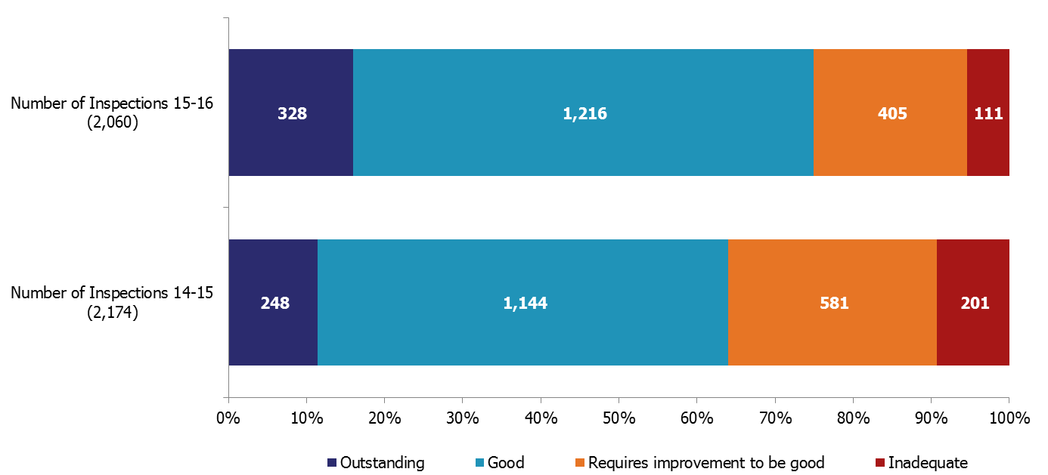
Ninety five homes were judged inadequate at some point in the year. Most (87) were children’s homes, while eight were residential special schools registered as children’s homes.
All but one of the homes found to be inadequate were judged inadequate at their first full inspection of the 2015-16 inspection cycle. One home was originally found to be requires improvement to be good at their first full inspection of the cycle, but concerns necessitated a re-inspection which resulted in the home being judged inadequate.
Over a third of these homes eventually improved to requires improvement to be good, many at their subsequent inspection.
Ten homes were found to be inadequate in two consecutive inspections, and a further three found to be inadequate in three consecutive inspections. Just under half of these improved to either good or requires improvement to be good (six of 13); one resigned; and six remained inadequate at 31 March 2016.

Overall effectiveness for all children’s homes inspections – change since last inspection
Most homes achieved the same inspection judgement as the previous year. If there was a change in inspection judgement, though, it was likely to benefit the children in the home, as more homes improved than declined.
There was a positive shift in the pattern of outcome judgements from the previous year. Looking at all types of children’s homes, 75% of inspections resulted in a good or better Overall effectiveness judgement; an increase from the previous year of 11 percentage points (64% in 2014-15).
There were 1,796 homes inspected in the period 1 April 2015 to 31 March 2016 that had also been inspected in the previous year (91% of all homes inspected in 2015-16 ). Over half of these homes remained unchanged in their judgement (1,008); when there were changes, more homes improved (479) than declined (309) (Chart 12).
Almost all of the homes still judged inadequate at 31 March 2015 were judged requires improvement to be good in 2015-16 (eight of the 10 homes), and one judged good. The other resigned.
Just over a third of the homes judged outstanding in 2014-15 (84 homes) declined, predominately to good (67 homes). Homes previously judged to be good were most likely to remain at good, with those that declined mainly declining to requires improvement to be good (156 out of 184 homes which declined).
Chart 12: Change to Overall effectiveness judgement compared to previous inspection
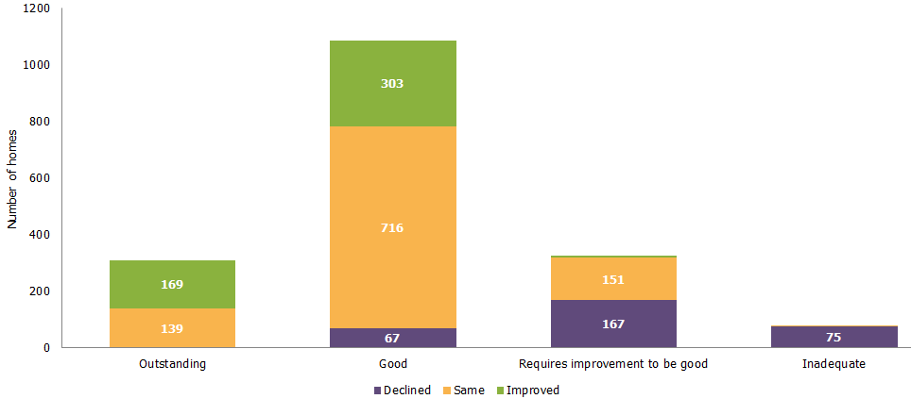

Regional outcomes for all children’s homes in year 2015-16
Children are more likely to be living in a home that has improved from a previous inspection judgement of adequate or lower (to good or better) than in a home that has stayed the same or declined.
The regions with the highest percentage of good or better inspection judgements between 1 April 2015 and 31 March 2016 were the North East (82%), Yorkshire and the Humber (80%), the North West (80%) and the South East (79%) (Chart 13).
The regions with the lowest percentage of inspections resulting in good or better judgements were the South West (56%), the West Midlands (71%) and London (72%). These three regions also saw the highest percentages of homes declining in their overall effectiveness judgements (32% in the South West, and 19% in London and the West Midlands).
The national percentage of good or better homes was 75%.
Chart 13: Children’s homes Overall effectiveness 2015-16, by region

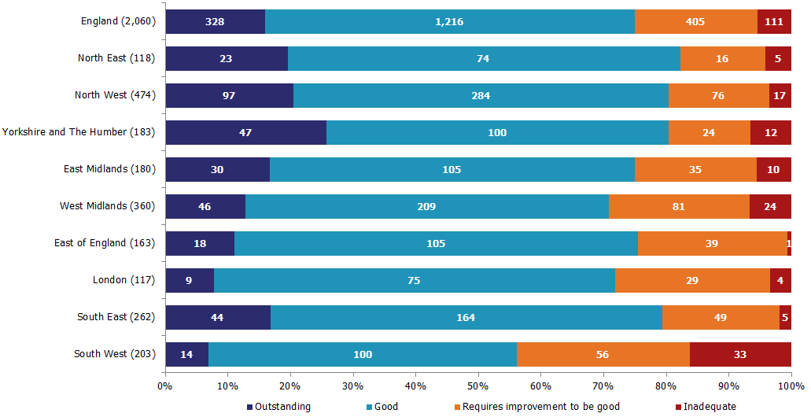
Of the 512 homes judged adequate or lower in 2014-15 and inspected in 2015-16, over half (311 or 61%) are now judged good or better. The East Midlands, South East and the North East showed the most marked improvement with 67%, 66% and 66% respectively. The regions with least improvement were the South West and London, where 53% and 57% improved respectively (Chart 14).
Chart 14: Change for children’s homes previously judged adequate or lower for Overall effectiveness, by region

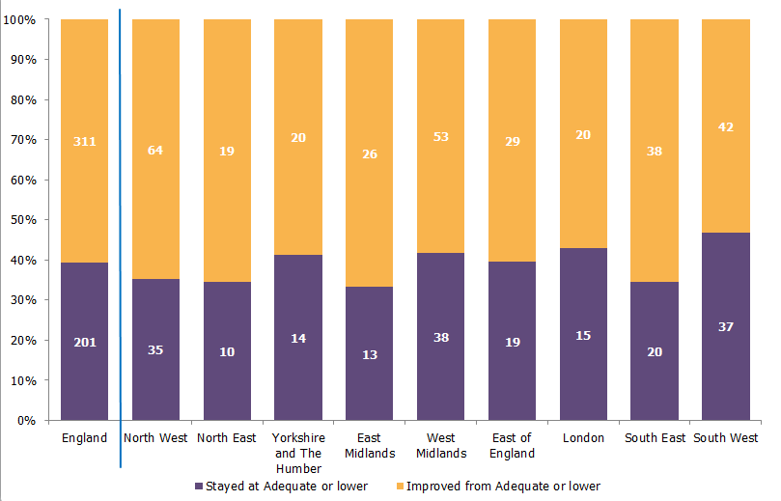

State of the nation for all children’s homes as at 31 March 2016
Over three quarters of homes were good or better at 31 March 2016. Children living in homes in the North East and Yorkshire and the Humber were most likely to be living in good or better homes.
Of the 2,071 active homes of all types as at 31 March 2016, 1,981 had received a full inspection (Chart 15).
Chart 15: Children’s homes latest Overall effectiveness judgement, as at 31 March 2016
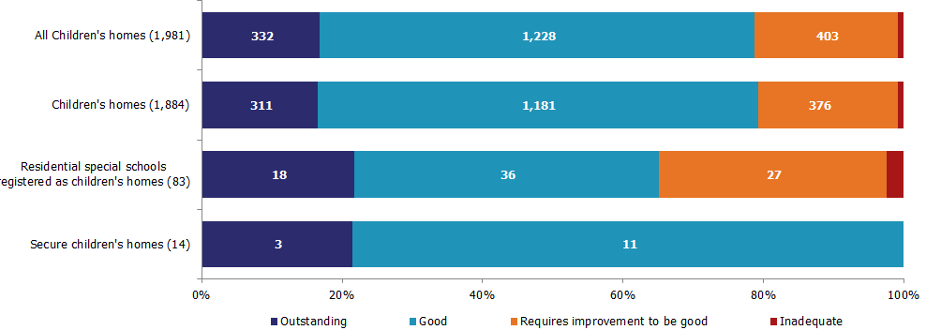
The 31 March 2016 figure of 79% of homes judged good or better is a substantial increase on the 31 March 2015 figure of 70%.

Nationally, local authority-run homes had the same percentage of good or better homes as the voluntary sector (80%) and a higher percentage than the private sector (78%).
All nine health authority-run homes inspected were judged good or better.
The Yorkshire and the Humber region had the highest percentage of good or better homes, at 86%. The North East region had the second highest at 85%. The region with the lowest percentage of good or better homes was the South West (66%) (Chart 16).

Chart 16: Children’s homes latest Overall effectiveness inspection judgement, as at 31 March 2016, by region
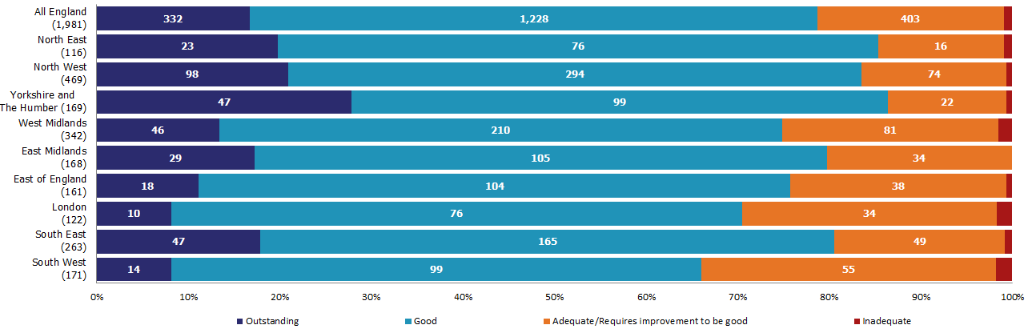

Sector data for all children’s homes in year 2015-16
Generally, homes from one sector type were no more likely to be better or worse than homes from any other sector. However, children living in LA-run homes stood the greatest chance of living in an outstanding home.
Between 1 April 2015 and 31 March 2016, there were 472 inspections of local authority-run homes, 1,403 inspections of privately-run homes, 176 inspections of voluntary-run homes, and nine of health authority-run homes (Chart 17).
Voluntary-run homes, which make up 8% of all children’s homes, had the best performance profile, with a higher percentage of good or better homes, when compared to local authority-run and privately-run homes, which make up 22% and 69% respectively.
Local authority-run homes had a higher percentage of outstanding Overall effectiveness judgements for the period, at 23%, compared to private and voluntary-run homes, with 13% and 17%, respectively.
Eight of the nine health authority-run homes inspected during 2015-16 were judged good and one was judged outstanding.
Chart 17: Children’s homes Overall effectiveness 2015-16, by sector
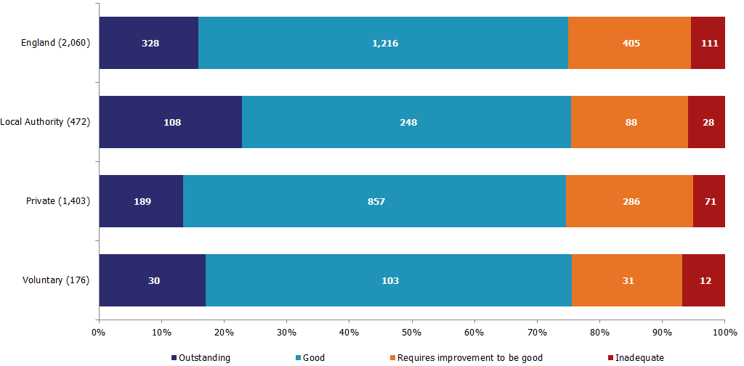
In line with the national sectorial picture, local authority-run homes, when compared with private and voluntary-run homes, had a higher percentage of homes judged good or better in London (83%), the South East (82%), the East Midlands (78%) and the South West (59%) (Map 6).
There were four regions where voluntary and privately-run homes outperformed local authority-run homes and had a higher percentage of good or better homes: the North West (81%), Yorkshire and the Humber (85%), West Midlands (71%) and East of England (77%) (Map 7).

Map 1: Local authority-run children's homes receiving a good or better overall effectiveness judgement at full inspection, by region, in 2014-15
Map 2: Private and voluntary-run children's homes receiving a good or better overall effectiveness judgement at full inspection, by region, in 2014-15

Map 6: Local authority-run children’s homes receiving a good or better overall effectiveness judgement at full inspection, by region, in 2015-16
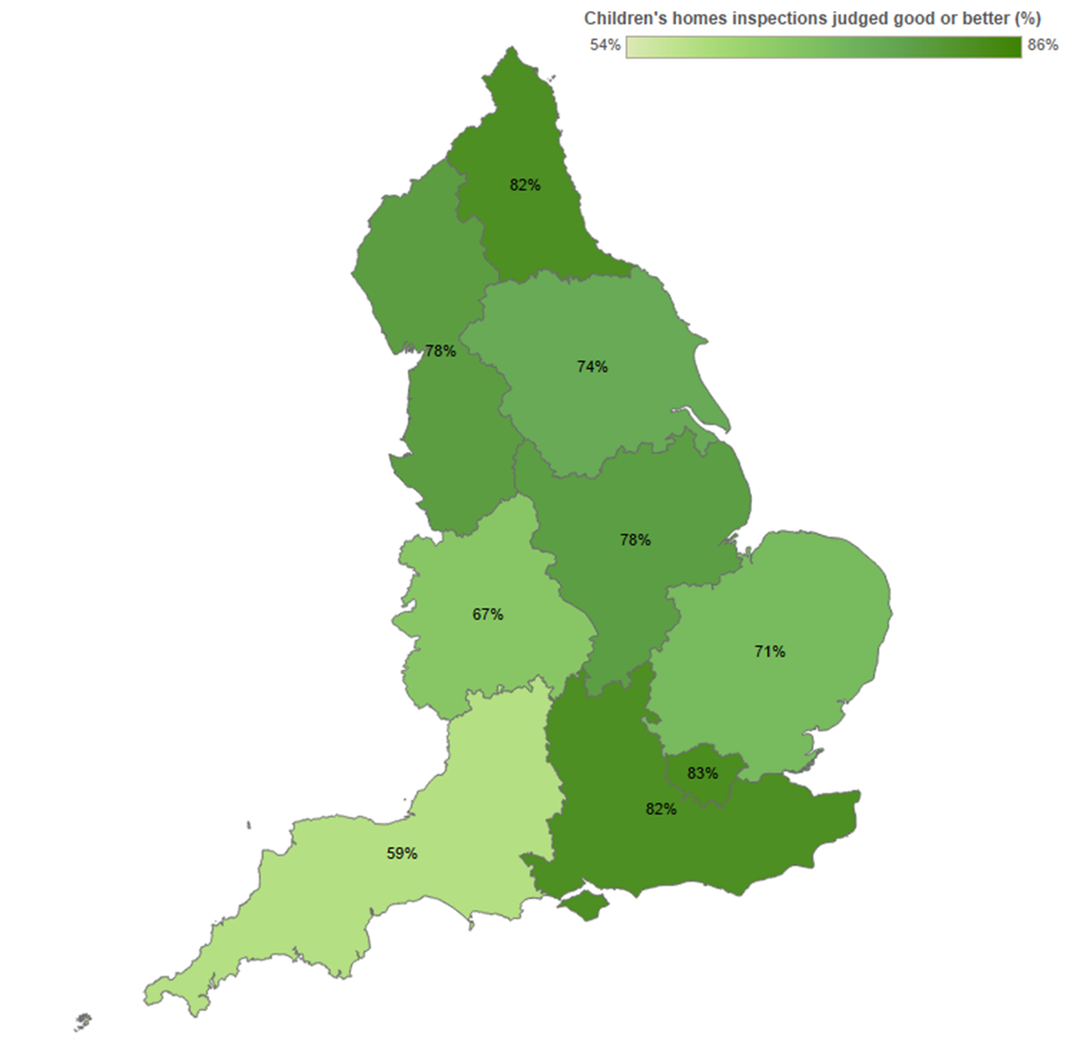
Map 7: Private and voluntary-run children’s homes receiving a good or better overall effectiveness judgement at full inspection, by region, in 2015-16
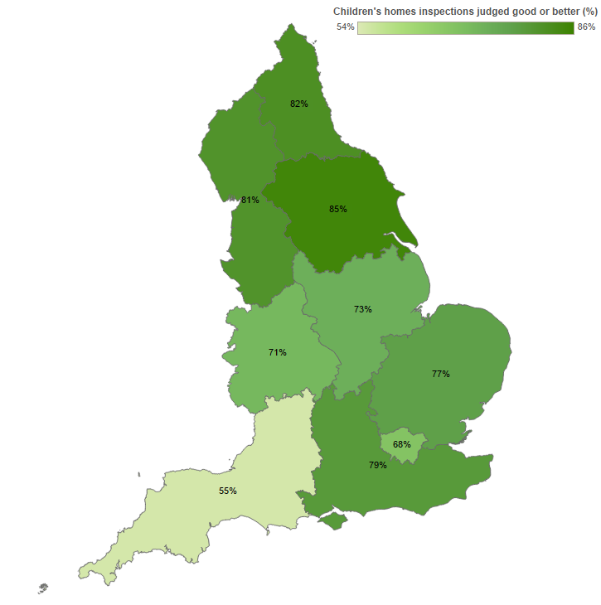

Interim inspections for all children’s homes in year 2015-16
Achieving a Declined effectiveness interim inspection judgement was not a barrier to achieving a good or better Overall effectiveness inspection judgement at their subsequent full inspection.
Between 1 April 2015 and 31 March 2016, there were 1,834 interim inspections of all types of children’s homes. Half of these resulted in Sustained effectiveness judgements, with a third receiving an Improved effectiveness judgement (Chart 18).
There were also 78 (4%) interim inspections that did not result in an inspection judgement, as no children were being cared for at the time of inspection.
Chart 18: Children’s homes interim inspections judgements 2015-16
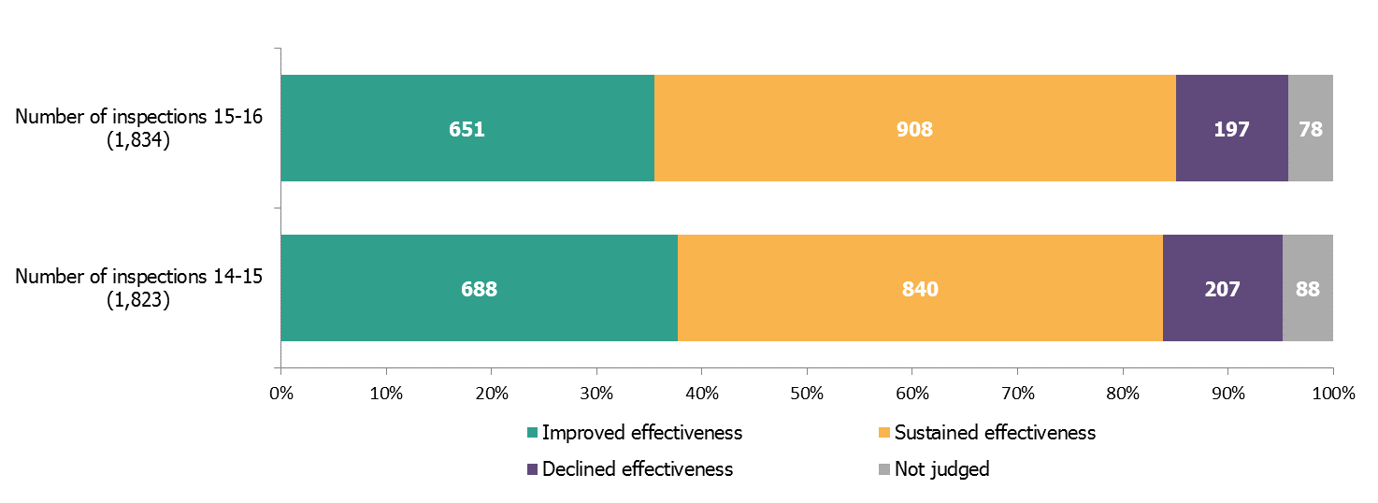

The majority of homes, regardless of their eventual full inspection grade, were judged to have Sustained or Improved effectiveness at the preceding interim inspection (Chart 19).
Chart 19: Interim inspections judgements compared to subsequent full inspection
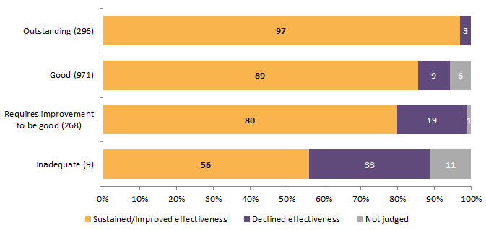

The North East (51%), East Midlands (45%), the East of England (40%), and Yorkshire and the Humber (38%) had the highest percentage of inspections resulting in Improved effectiveness judgements.
London, the East of England, and the South West (15% each) had the highest percentage of inspections resulting in a Declined effectiveness judgement.

Monitoring visits for all children’s homes in year 2015-16
There were 126 monitoring visits carried out to homes of all types during the year. These visits do not result in outcome judgements for the homes.

Other social care providers
More than three quarters of independent fostering agencies were private, for profit, agencies. Children stood a very high probability of being placed through an independent fostering agency judged good or better. Almost all children placed through a voluntary adoption agency were placed through a good or better agency. LAs run by far the most residential special schools at almost half the total number, although this number is falling due to the schools converting to academy status. Young people in further education colleges with residential accommodation were most likely to be in a college judged outstanding than any other grade. The number of residential holiday schemes for disabled children more than doubled in the year, although the numbers are still very small.

Independent Fostering Agencies
An independent fostering agency (IFA) is a voluntary or private organisation that places children with foster carers, on behalf of a local authority. They are inspected on a three year cycle: 2015-16 was the final year of the current cycle.
There were 297 active IFAs in England as at 31 March 2016, compared to 300 the previous year, a 1% fall.
During the year, 21 agencies registered and 24 de-registered.
Over three quarters of IFAs were run by the private sector: there were 234 (79%) private providers and 63 (21%) voluntary providers.
As at 31 March 2016, Ofsted had inspected 277 of the 297 active IFAs.
The judgement profile is a very positive one:
- 39 (14%) having been judged outstanding (Chart 20)
- 196 (71%) having been judged good
- 39 (14%) having been judged requires improvement to be good/adequate
- 3 (1%) having been judged inadequate
Chart 20: Independent fostering agencies’ latest Overall effectiveness judgement, as at 31 March 2016
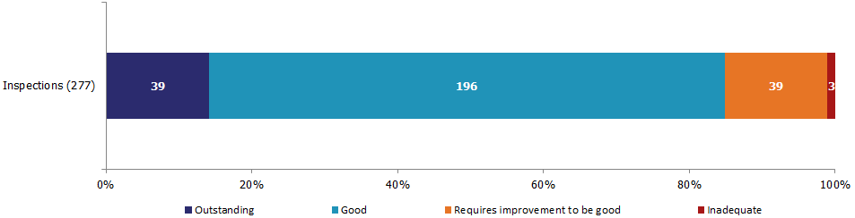
During 2015-16, there were 139 inspections of IFAs:
- 19 (14%) were judged outstanding
- 96 (69%) were judged good
- 20 (14%) were judged requires improvement to be good
- 4 (3%) were judged inadequate
There were 114 IFAs inspected in the period 1 April 2015 to 31 March 2016 that had also been previously inspected. Eighteen per cent (25) of IFAs had no comparable judgement as this year was their first full inspection.

When comparing the grades of IFAs inspected in 2015-16 to their last full inspection, over half (67) remained unchanged in their judgement. Most of these 67 agencies, 64 (96%), stayed good or outstanding.

However, there was more decline than improvement: 14% (16) of agencies improved and 27% (31) declined.

Voluntary Adoption Agencies
A voluntary adoption agency (VAA) is a voluntary organisation that recruits and assesses prospective adopters, and matches them with children who are looked after by a local authority, on behalf of the authority, on a non-profit basis. Some agencies also provide services to adoptees and birth relatives. They are inspected on a three year cycle: 2015-16 was the second year of the current cycle.
There were 42 active VAAs in England as at 31 March 2016, the same figure as the previous year.
Despite the overall number being the same, there was a small change in the providers as two providers registered and two de-registered within a year. One of the newly registered VAAs (in Slough) was previously the local authority adoption agency.
As at 31 March 2016, of the 42 active VAAs, 38 had received a full inspection.
The judgement profile is a very positive one:
- 17 (45%) having been judged outstanding (Chart 21)
- 20 (53%) having been judged good
- 1 (3%) having been judged requires improvement to be good
- None having been judged inadequate
Chart 21: Voluntary adoption agencies’ latest Overall effectiveness judgement, as at 31 March 2016
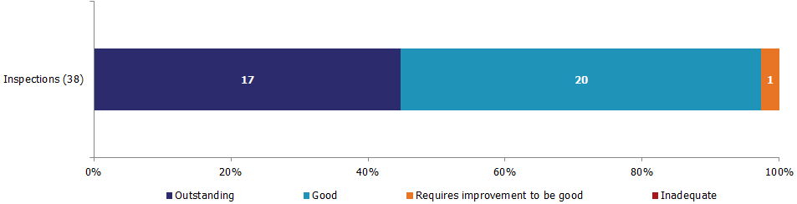
Between 1 April 2015 and 31 March 2016, there were 15 inspections of VAAs. All of the inspections resulted in agencies being judged good or better: seven were outstanding and eight were good.

Adoption Support Agencies
Adoption support agencies (ASAs) undertake work with adopted children or adults, or children who are being prepared for adoption. They are inspected on a three year cycle; 2015-16 was the second year of the current cycle.
As at 31 March 2016, there were 36 active ASAs.
This was a net increase of one provider since last year, as two providers registered and one de-registered during 2015-16.
Approximately two thirds of ASAs (23) are run by the private sector and nearly one third (13) are run by the voluntary sector.
As at 31 March 2016, of the 36 active ASAs, 34 had been inspected by Ofsted.
The judgement profile is an extremely positive one:
- 16 (47%) having been judged outstanding (Chart 22)
- 16 (47%) having been judged good
- 2 (6%) having been judged adequate/requires improvement to be good
- None having been judged inadequate
Chart 22: Adoption support agencies’ latest Overall effectiveness judgement, as at 31 March 2016
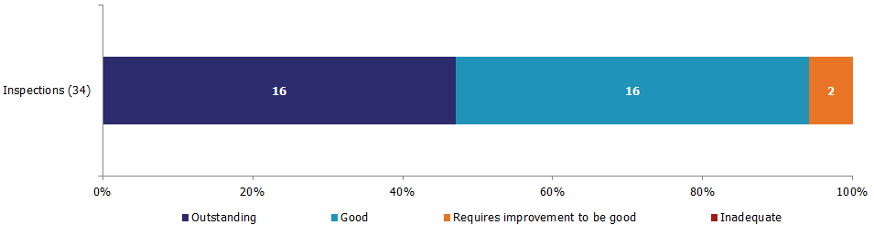
Between 1 April 2015 and 31 March 2016, there were 13 inspections of ASAs.
The majority of inspections resulted in agencies being judged good or better: five were outstanding and seven good. One agency was judged requires improvement to be good.

Residential Special Schools
These are special schools – some non-maintained, some local authority-run, some independent – which provide for very specific needs, often disabilities or special educational needs, and where the children are resident, but the school is not dual registered as a children’s home. They are inspected on an annual cycle for welfare.
As at 31 March 2016, there were 165 active residential special schools, compared to 168 the previous year, a fall of less than 2%.
Despite a drop in the number of schools, there has been an increase in the number of places available. As at 31 March 2016 there were 5,529 places, compared to 5,438 the previous year, an increase of 91 places (2%).
During 2015-16 six residential special schools registered and nine deregistered. The newly registered schools offer 115 places while the deregistered schools offered 243 places.
Almost half of all residential special schools, 79 (48%), are run by local authorities, and 16 (10%) are academies, 14 of which used to be run by local authorities. The private sector run 29 (18%) and the voluntary sector run 41 (25%).
As at 31 March 2016, the judgement profile was a very positive one:
- 71 (43%) having been judged outstanding for welfare (Chart 23)
- 72 (44%) having been judged good
- 19 (12%) having been judged requires improvement to be good
- 3 (2%) having been judged inadequate
Chart 23: Residential special schools’ Overall effectiveness judgement for welfare, as at 31 March 2016
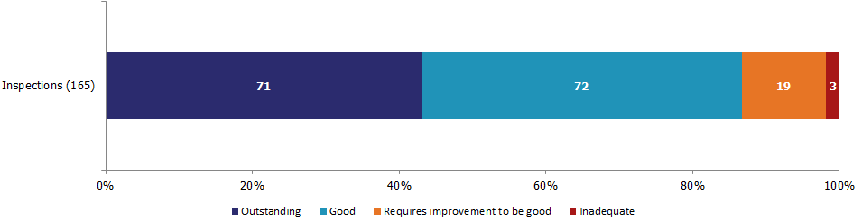
During 2015-16, there were 157 full inspections carried out of residential special schools :
- 64 (41%) were judged outstanding
- 70 (45%) were judged as good
- 20 (13%) were judged as requires improvement to be good
- 3 (2%) were judged as inadequate.
There were 152 residential special schools inspected in the period 1 April 2015 to 31 March 2016 that had also been previously inspected. Five residential special schools had no comparable judgement as this year was their first full inspection.
When comparing the grades of residential special schools inspected in 2015-16 to their previous full inspection, almost two thirds (97) remained unchanged in their judgement. Most of these 97 schools, 92 (95%), stayed good or outstanding. However, overall there was more improvement than decline: 23% (35) of residential special schools improved and 13% (20) declined.

Boarding Schools
Most boarding schools are independent and are inspected by the Independent Schools Inspectorate (ISI) for both education and welfare. The remainder are maintained or independent boarding schools, where both education and the welfare of boarders are the subject of Ofsted inspection; or independent boarding schools, who receive their education inspections by the School Inspection Service and their welfare inspections by Ofsted. They are inspected on a three year cycle: 2015-16 was the second year of the current cycle.

As at 31 March 2016 there were 78 active boarding schools inspected by Ofsted; these provided 10,381 places.
There were five boarding schools offering 508 places that registered to be inspected by Ofsted during 2015-16 and six boarding schools, which offered 166 places that de-registered or moved to the ISI.
As at 31 March 2016, 73 of the 78 schools had received an inspection:
- 15 (21%) having been judged outstanding for welfare (Chart 24)
- 35 (48%) having been judged good
- 14 (19%) having been judged requires improvement to be good/adequate
- 9 (12%) having been judged inadequate
Chart 24: Boarding schools’ latest Overall effectiveness judgement for welfare, as at 31 March 2016
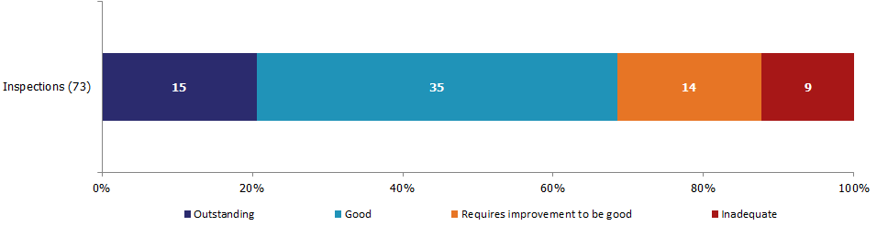
There were 33 full inspections of boarding schools carried out between 1 April 2015 and 31 March 2016.
Six schools were judged to be outstanding, 13 good, seven requires improvement to be good, and seven inadequate.
There were no monitoring visits of boarding schools carried out between 1 April 2015 and 31 March 2016.

Further Education (FE) Colleges with residential accommodation
These are further education colleges that provide, or arrange, residential accommodation for students under the age of 18 years. They are inspected on a three year cycle: 2014-15 was the second year of the current cycle.
As at 31 March 2016, there were 38 further education colleges with residential accommodation, compared to 39 the previous year.
There were 5,485 places, compared to 4,641, a rise of 18%.
There was one new registration of a further education college with residential accommodation during 2015-16 with 145 places; and two colleges de-registered, which had 430 places.
As at 31 March 2016, the judgement profile was a very positive one:
- 20 (53%) having been judged outstanding (Chart 25)
- 11 (29%) having been judged good
- 7 (18%) having been judged adequate/requires improvement to be good
- None having been judged inadequate
Chart 25: Further education colleges with residential accommodation latest Overall effectiveness judgement, as at 31 March 2016
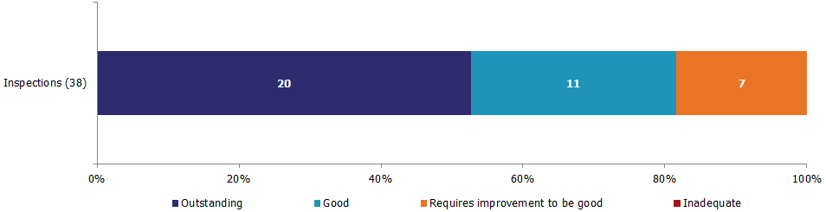
Ten further education colleges with residential accommodation were inspected during 2015-16. Four were judged to be outstanding, three were judged to be good, and three were judged to be requires improvement to be good.

Residential Family Centres
Residential family centres provide accommodation for children and their parents, while the parents’ capacity to respond to the children’s needs and to safeguard their welfare is monitored and assessed. They are inspected on a three year cycle: 2015-16 was the final year of the current cycle.
As at 31 March 2016, there were 37 active residential family centres, compared to 38 the previous year.
As at 31 March 2016, there were 255 places, compared to 257 in 2015, a fall of less than 1%.
There was a net decrease of one residential family centre during 2015-16, as four providers registered and five de-registered. In terms of the numbers of places for these provisions, this was a net reduction of eight places: the five that de-registered had 35 places and the four that registered had 27 places.
Ownership of residential family centres has remained mostly in the private sector, similar to the previous year. All four new providers registered in 2015-16 were private sector, as were the five that de-registered within the year.
As at 31 March 2016, 32 of the active 37 providers had, so far, received an Ofsted inspection.
The judgement profile is a positive one:
- 7 (22%) having been judged outstanding (Chart 26)
- 23 (72%) having been judged good
- 2 (6%) having been judged requires improvement to be good
- None having been judged inadequate
Chart 26: Residential family centres’ latest Overall effectiveness judgement, as at 31 March 2016
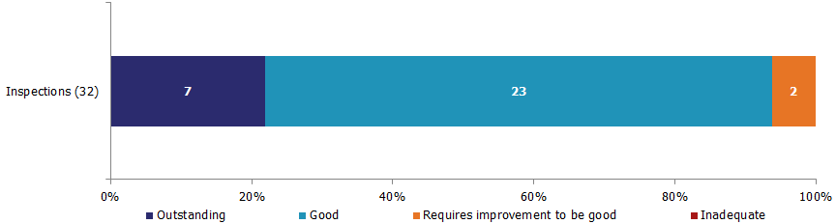

Twenty one inspections of residential family centres were carried out in 2015-16. Four centres were judged outstanding, 15 good and two requires improvement to be good.

Residential Holiday Schemes for Disabled Children
A residential holiday scheme for disabled children provides care and accommodation wholly or mainly for disabled children for a specified period for the purposes of a holiday, or for recreational, sporting, cultural or educational purposes. They are inspected on an annual cycle.
As at 31 March 2016 there were 11 active residential holiday schemes for disabled children compared to six the previous year. Six new schemes registered during 2015-16 and one de-registered within the same year.
Of the 11 schemes, six had been inspected in 2015-16 and five had yet to be inspected since registering. Three schemes were judged outstanding and three were judged good.

Secure Training Centres
Secure training centres offer secure provision for young people aged between 12 to 18 years who meet the criteria for custodial sentence, or who are remanded to a secure setting. They are inspected on an annual cycle.
As at 31 March 2016 there were three active secure training centres compared to four the previous year. They had 232 places in total. Two centres were inspected in 2015-16 and one was judged good and one was judged requires improvement to be good.

List of Charts
Chart 1: SIF Overall effectiveness from November 2013 to March 2016 8
Chart 2: SIF key judgements from November 2013 to March 2016 11
Chart 3: SIF Adoption performance sub-judgement from November 2013 to March 2016 11
Chart 4: SIF Experiences and progress of care leavers sub-judgement from November 2013 to March 2016 12
Chart 5: SIF Overall effectiveness judgements, by region 13
Chart 6: Children who need help and protection judgements, change from previous inspection judgement 15
Chart 7: Children looked after and achieving permanence judgements, change from previous inspection judgement 16
Chart 8: LSCB Overall effectiveness and SIF Children in need of help and protection judgements 19
Chart 9: Percentage of children’s homes run by each sector 20
Chart 10: Number of children’s homes (a) and places (b) by region 24
Chart 11: Children’s homes Overall effectiveness judgements 2015-16 28
Chart 12: Change to Overall effectiveness judgement compared to previous inspection 30
Chart 13: Children’s homes Overall effectiveness 2015-16, by region 31
Chart 14: Change for children’s homes previously judged adequate or lower for Overall effectiveness, by region 32
Chart 15: Children’s homes latest Overall effectiveness judgement, as at 31 March 2016 33
Chart 16: Children’s homes latest Overall effectiveness inspection judgement, as at 31 March 2016, by region 34
Chart 17: Children’s homes Overall effectiveness 2015-16, by sector 35
Chart 18: Children’s homes interim inspections judgements 2015-16 37
Chart 19: Interim inspections judgements compared to subsequent full inspection 38
Chart 20: Independent fostering agencies’ latest Overall effectiveness judgement, as at 31 March 2016 40
Chart 21: Voluntary adoption agencies’ latest Overall effectiveness judgement, as at 31 March 2016 41
Chart 22: Adoption support agencies’ latest Overall effectiveness judgement, as at 31 March 2016 42
Chart 23: Residential special schools’ Overall effectiveness judgement for welfare, as at 31 March 2016 43
Chart 24: Boarding schools’ latest Overall effectiveness judgement for welfare, as at 31 March 2016 45
Chart 25: Further education colleges with residential accommodation latest Overall effectiveness judgement, as at 31 March 2016 46
Chart 26: Residential family centres’ latest Overall effectiveness judgement, as at 31 March 2016 47

List of Tables
Table 1: Changes by provision sub-type 31 March 2015 to 31 March 2016 22
Table 2: Children’s homes at 31 March 2016, by number of beds and region 26

List of Maps
Map 1: Local authorities by type, including SIF inspection status 7
Map 2: SIF inspection Overall effectiveness judgements from November 2013 to March 2016 9
Map 3: Overall effectiveness judgements for LSCB reviews from November 2013 to March 2016 18
Map 4: All children’s homes by sector and size as at 31 March 2016 21
Map 5: Local authorities which run some or all of the children’s homes within their authority boundary and excluding short-breaks only homes 25
Map 6: Local authority-run children’s homes receiving a good or better overall effectiveness judgement at full inspection, by region, in 2015-16 36
Map 7: Private and voluntary-run children’s homes receiving a good or better overall effectiveness judgement at full inspection, by region, in 2015-16 36

Revisions to previous release
Revised data covering the period 1 April 2015 to 30 September 2015 have been released and can be found on the Ofsted website as part of this release: https://www.gov.uk/government/collections/childrens-social-care-statistics.

- The revision of statistics relating to 1 April 2015 to 30 September 2015 from ‘provisional’ to ‘revised’ status includes outcomes relating to a further 110 inspections. These consist of an additional 95 full inspections and 15 interim inspections of children’s homes, which took place in this period and have been published since 15 December 2015.

- Of the additional 95 full inspections, 63 children’s homes received good or better Overall effectiveness judgements and 32 received requires improvement to be good or lower.

- These additional inspections only slightly changed the grade profile presented in the previous provisional data. During this period, the proportion of outstanding judgements decreased by one percentage point to 11%, while the proportion of good, adequate and inadequate judgements remained the same. The grade profile for the year remained the same.

Notes
An explanation about key uses of these data and further contextual information and the arrangements for quality assurance is provided in the accompanying Quality and Methodology report.
The Quality and Methodology report can be found at the following webpage: https://www.gov.uk/government/collections/childrens-social-care-statistics#children-s-social-care-in-england under the heading ‘Children’s social care in England.
Strengths include:
Data benchmarking: where applicable, data is benchmarked against data submitted to the DfE, and generally found to be in line with DfE data.

Comprehensive snapshot of the children’s social care sector: due to the known quality of the data, as well as the inclusion of ONS and DfE data, the data provides a comprehensive picture of children’s social care in England over the last three years.

All required data present: due to the data being Ofsted’s internal data, there is almost no missing data. The one exception is number of children that secure children’s homes are approved to accommodate; in these three instances, numbers are taken from the provider website.

Some limitations include:
Limited comparable data: much of the data held is only held by Ofsted, and therefore cannot be verified against other sources.

Incorrect reporting by providers: in a small number of cases, data supplied by providers does not appear to be accurate (for example, an incorrect postcode). This has minimal impact on this particular SFR, however, and is usually identified during QA.

Further information about strengths and limitations of the statistics can be found in the quality report linked above.

Previously published data regarding LA inspections, children’s social care inspections and providers and places can be found at the following links on GOV.UK https://www.gov.uk/government/collections/childrens-social-care-statistics and in the National Archives http://webarchive.nationalarchives.gov.uk/20141124154759/http:/www.ofsted.gov.uk/resources/statistics.
These pages also contain data on adoption, fostering, children looked after placements and serious incident notifications which the reader may find relevant.

Glossary

Adoption agencies
The focus of all adoption agencies is on placing children successfully into adoptive families who the agency recruits, assesses, prepares and supports, so they will meet the children’s needs and enable them to develop and achieve throughout their lives. The services maintained by local authorities are described in section 3(1) of the Adoption and Children Act 2002. Local authorities place children with adoptive families recruited and approved by themselves, by other local authorities or by voluntary adoption agencies who must register with Ofsted. Adoption agencies may also provide birth records, counselling and intermediary services to adoptees and birth relatives. There are three branches of voluntary adoption agencies in Wales which are inspected by Ofsted because their head offices are in England. These are not included in this publication.

Adoption support agencies
Adoption support agencies are defined by section 8 of the Adoption and Children Act 2002 and provide services to anyone touched by adoption and are registered with Ofsted. This includes counselling and help for children and adults to gain information about their adoption or to trace birth relatives. Adoption support agencies can be either organisations or individuals, and may be contracted by a local authority to provide support services.

Boarding schools
The majority of boarding schools are independent and belong to associations which are members of the Independent Schools Council. As both education and welfare in these schools are inspected by their own inspectorate, Ofsted does not inspect these schools and so they are not included in the data. The remainder are maintained boarding schools where both education and the welfare of boarders are the subject of Ofsted inspection and independent boarding schools which are members of the Bridge Schools Inspectorate or Schools Inspection Service and who receive their education inspections by these organisations and their welfare inspections by Ofsted.

Children’s homes
A children’s home is defined in section 1 of the Care Standards Act 2000, and is an establishment that provides care and accommodation wholly or mainly for children. Children’s homes vary in size and nature. They fulfil a range of purposes designed to meet the different needs of those children and young people who are assessed as needing a residential care placement. Some homes, for example, provide short-breaks which are needed to help support children and their family. Some residential special schools are registered as children’s homes because boarders are resident for more than 295 days per year.

Fostering agencies
Local authority fostering services are defined by section 4 of the Care Standards Act 2000. Local authority fostering agencies and independent fostering agencies recruit, prepare, assess, train and support foster carers. Independent fostering agencies (IFAs) are private companies or charities, which are registered with Ofsted and provide placements to children and young people with foster carers approved by them. IFAs work closely with local authorities to deliver these placements.

Further education colleges with residential accommodation
The care provision of further education colleges that provide, or arrange, residential accommodation for one or more students under the age of 18 years. Ofsted inspects these colleges under section 87 of the children act 1989 as amended by the Care Standards Act 2000. Where a college is registered as a care home, the residential provision is inspected by the Care Quality Commission rather than by Ofsted.

Places
The term ‘places’ used in this report refers to the number of places for which the social care provider has capacity. This number usually will not, therefore, be the same as the actual number of children who are receiving services from the provider. Ofsted holds data relating to places for: children's homes; secure children's homes; residential special schools; residential family centres; boarding schools; and further education colleges. For some of these providers Ofsted does not hold data relating to places. Where this is the case, the number of places has been estimated. For all other provision types, and aggregated provision types, places data is not available.

Providers
Children’s social care providers are those institutions or organisations or agencies that provide services to the relevant children and young people. The providers commented on within this report include children’s homes, secure children’s homes, residential special schools, residential family centres, boarding schools, residential further education colleges, secure training centres, residential holiday schemes for disabled children, adoption support agencies, voluntary adoption agencies, and independent fostering services.

Residential family centres
Residential family centres are defined in section 4(2) of the Care Standards Act 2000 as establishments at which: a) accommodation is provided for children and their parents; b) the parents’ capacity to respond to the children’s needs and to safeguard their welfare is monitored and assessed; and c) the parents are given such advice, guidance and counselling is considered necessary.

Residential holiday schemes for disabled children
A residential holiday scheme for disabled children provides care and accommodation wholly or mainly for disabled children for a specified period for the purposes of a holiday, or for recreational, sporting, cultural or educational purposes. Ofsted inspects these schemes under the Care Standards Act 2000, Part 2 (Extension of the Application of Part 2 to Holiday Schemes for Disabled Children) (England) Regulations 2013.

Residential special schools
Residential special schools are defined in section 59 of the Safeguarding Vulnerable Groups Act 2006. They vary in size and nature. The sector includes large non-maintained special schools which make provision for very specific needs and take children as full boarders from all over the country, to smaller more local providers catering for children with a range of different special needs and disabilities who may be resident at the school only during the week. Some residential special schools are registered as children’s homes because boarders are resident for more than 295 days per year. There are also a small number of independent residential special schools who also tend to cater for children with very specialist needs.

Sector
Sector refers to the type of provider that owns the children’s social care provision.

Academy
These are publicly funded independent schools who are run by trusts.

Health Authority
These are NHS Trust-run.

Local Authority
These are public bodies responsible for the children’s social care provision.

Private
These are for-profit organisations mostly with limited company status. These can also though be individually owned children’s social care provision and run for profit.

Voluntary
These are mostly not-for-profit organisations, mainly with charitable status. These can also be individually owned children’s social care provision and run on a not-for-profit basis.

Secure children’s homes
Secure children’s homes are defined by section 25 of the Children Act 1989. They accommodate children and young people who are remanded or have been sentenced for committing a criminal offence. They also accommodate children and young people who are placed there by a court because their behaviour is deemed to present a significant and immediate threat to their safety or the safety of others, unless they are placed in a secure environment. Ofsted inspections are conducted in accordance with the Care Standards Act 2000 and judgements in reports are made in relation to the outcomes for children set out in the Children Act 2004. The criteria are the same as those used to inspect non-secure children’s homes.

Secure training centres
Secure training centres are defined by section 43(1) (d) of the Prison Act 1952, as amended by Section 6(2) of the Criminal Justice and Public Order Act 1994. Ofsted has the power to inspect under section 146 Education and Inspections Act 2006 and inspects both the care and educational provision for children in three secure training centres. They accommodate young people between the ages of 12 and 17 who have been remanded or sentenced by the courts. The centres are under contract to the Youth Justice Board, which monitors their compliance with requirements. Ofsted does not regulate secure training centres but has an agreement with the Youth Justice Board to inspect care twice a year and education once a year.

If you have any comments or feedback on this publication, please contact the Social Care Data Team on 03000 130020 or socialcaredata@ofsted.gov.uk

© Crown copyright
You may re-use this information (not including logos) free of charge in any format or medium, under the terms of the Open Government Licence. To view this licence, visit http://www.nationalarchives.gov.uk/doc/open-government-licence/ or write to the Information Policy Team, The National Archives, Kew, London, TW9 4DU or e-mail: psi@nationalarchives.gsi.gov.uk

This figure includes three secure training centres, which are not included in the main tables in the accompanying Excel document. They are not in the Excel tables due to the data not being part of the database which the Excel data was taken from. The provisions and their inspections, where applicable, have been manually added to the underlying data in the Excel document.
Each provider type has its own section in this document that talks about the number of providers and where applicable the number of places. A table showing these figures for all provider types can be found in the accompanying Excel document.
Ofsted does not inspect all boarding schools, see p.46 for details.
Department for Education (DfE) guidance, Working together to safeguard children, March 2015 https://www.gov.uk/government/publications/working-together-to-safeguard-children--2
Department for Education National Statistics, Children looked after in England, including adoption, September 2015: https://www.gov.uk/government/statistics/children-looked-after-in-england-including-adoption-2014-to-2015 and DfE National Statistics, Characteristics of children in need: 2014 to 2015, October 2015: https://www.gov.uk/government/statistics/characteristics-of-children-in-need-2014-to-2015
“Vulnerable groups” includes children in need, children with a child protection plan, and children looked after.
Children looked after and achieving permanence has two further sub-judgements: adoption performance; and experiences and progress of care leavers, which are discussed in more detail below.
Four of the seven authorities judged outstanding were inspected in the last nine months: Cheshire West and Chester, Hammersmith and Fulham, Royal Borough of Kensington and Chelsea, and Westminster.
Four of these were inspected in the nine months since this report was last published.
These shire counties cover large areas and this needs to be taken into account when looking at map 1.
Across England, 33 local authorities are London boroughs, 36 are metropolitan districts, 27 are shire counties, and 56 are unitary authorities.
The Safeguarding inspections were from July 2009 to July 2012, and the Child Protection inspections from July 2012 to July 2013.
The Looked After Children inspections were from July 2009 to July 2012. The data also include a handful of Targeted Looked After Children which were conducted in the summer of 2013.
Now “requires improvement to be good” under the SIF
The correlation between deprivation of a local areas and performance was -0.2. Source: Ofsted Social Care Annual Report 2016
One of these reviews was conducted under Section 20 of the Children Act 1989.
Nine homes are also run by health authorities and are excluded from this chart.
It is not always possible to easily distinguish residential special schools registered as children's homes from children's homes and as such changes in the numbers of these homes are sometimes the result of updated information rather than new registrations or de-registrations.
In this release, this sub-type of children’s home means any home that does not fall within the other two sub types below, that is, is not a residential special school registered as a children’s home and is not a secure children’s home. Further details about children’s homes and what they are can be found in the glossary.
Schools that provide accommodation for pupils for more than 295 days each year, including specialist and mainstream schools, must register as a children’s home if, within any two-year period, one child or more, who boards at the school or in lodgings arranged by the school, stays for more than 295 days over any 12-month period within those two years.
Secure children’s homes are defined by section 25 of the Children Act 1989. They accommodate children and young people who are remanded or have been sentenced for committing a criminal offence. They also accommodate children and young people who are placed there by a court because their behaviour is deemed to present a significant and immediate threat to their safety or the safety of others, unless they are placed in a secure environment.
The difference in the number of newly registered places (joiners) and de-registered places (leavers) from 31 March 2015 to 31 March 2016 does not always match the actual change in the number of places over the year. It is not always possible to easily distinguish residential special schools registered as children's homes from children's homes and as such changes in the numbers of places are sometimes the result of updated information rather than new registrations or de-registrations. Second, for all provision types in these data, providers who were active at both the start and end period can also change the number of places they have, these are known as steady state places.
Ofsted (2015) Children looked after placements by English local authorities; https://www.gov.uk/government/statistics/children-looked-after-placements-as-at-31-march-2015
The other was a re-registration of a residential special school registered as a children’s home.
An example of a change in legal status could be where an informal partnership of three people decide to formalise the partnership and become a limited company with the three people becoming Directors of the new company. The people running the home would stay the same but their legal status would change.
The children that receive short-break care-only are a discrete group of children whose needs mainly relate to their disabilities. For the most part, they live with their families and are “looked after” only when they are staying in these short-break homes.
See Ofsted (2015) Children looked after placements by English local authorities p15-21 for further details; https://www.gov.uk/government/statistics/children-looked-after-placements-as-at-31-march-2015
Homes found at some point to be inadequate, or homes for which concerns were raised which required additional inspections.
Homes with no children on roll and with no plans to accept children within the following three months after the inspection would have taken place, were not inspected. Additionally, some homes registered too late in the year to receive a full inspection prior to the end of March.
“Requires improvement to be good” was previously “adequate”, prior to the change in inspection framework in 1 April 2015.
Nine percent (168) of children’s homes inspected in 2015-16 had no comparable judgement in 2014-15. This is because, for example, a provider was registered late in the year and had not yet received their first inspection by the end of the period.
The inspection is the most recent full inspection the provision had received and is not necessarily from 2015-16.
The number and percentage of inadequate homes at 31 March 2016 is lower than the number of inadequate inspections in 2015-16. This is the result of either their registration having been resigned or cancelled or Ofsted having re-inspected the home and found they had improved which resulted in an improved overall effectiveness judgement.
See Inspection of children's homes framework for inspection from 1 April for further details on grading interim inspection findings: https://www.gov.uk/government/publications/inspecting-childrens-homes-framework
This does not include homes with no previous interim inspection judgement: 31 judged outstanding at full inspection; 229 judged good; 123 judged requires improvement; nine judged inadequate.
For residential special schools, boarding schools and further education colleges with residential accommodation, the social care inspection looks at the welfare of the child/young person. The education they receive is not part of the social care inspection. Data on the education inspections of these types of provisions can be found at; https://www.gov.uk/government/collections/independent-schools-inspection-and-outcomes and https://www.gov.uk/government/collections/maintained-schools-and-academies-inspections-and-outcomes-official-statistics
For all provision types in these data, the change in overall places from 31 March 2015 to 31 March 2016 does not necessarily equal the difference between the number of places in newly registered provisions (joiners) and the number of places in de-registered provisions (leavers). This is because provisions which were active at the start of the period and the end of the period may also have changed the number of places they are registered for/estimated to have.
Of the nine schools that de-registered, one did not actually close but it re-registered due to a change in ownership.
Residential special schools are on an annual cycle of inspection. There are nine schools that are not reported as having received an inspection in 2015-16 in these data. Of these nine schools; six were inspected in the year but had not had their inspection report published by 1 May 2016 and three had not been inspected in the year.
http://www.schoolinspectionservice.co.uk/
Source: http://www.g4s.uk.com/en-gb/What%20we%20do/Services/Care%20and%20justice%20services/Childrens%20services/Secure%20training%20centres/

