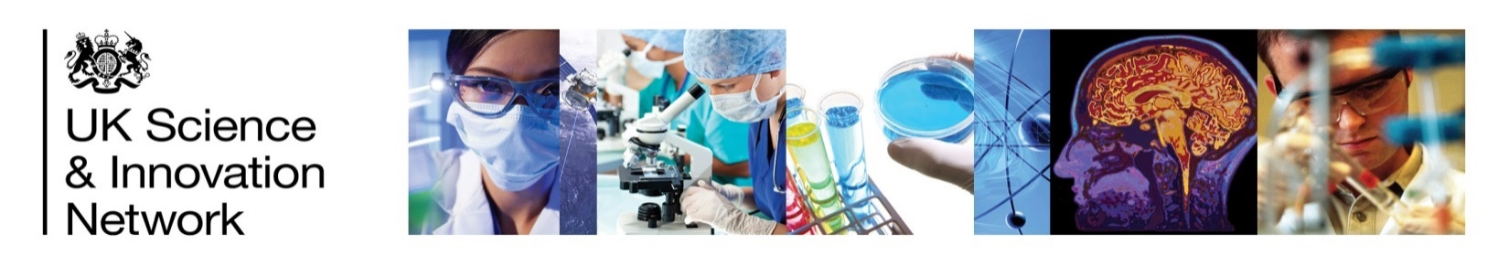
d
[Type a quote from the document or the summary of an interesting point. You can position the text box anywhere in the document. Use the Drawing Tools tab to change the formatting of the pull quote text box.]

Country Snapshot Denmark (DK)
Danish Science and Innovation Landscape
The Global Innovation Index 2020 (GII) ranks DK as the sixth most innovative country among the 131 economies featured. The GII scores high-income group economies on 7 pillars and Denmark performs above average on all pillars compared to other economies in Europe. The 2 top scoring pillars are human capital & research and infrastructure.The area around Copenhagen is a particular hub for innovation and is ranked 54th in the GII’s list of Science & Technology clusters.
Denmark has a strong science base with strong historical roots through the work of scientists such as Niels Bohr and August Krogh. Attractive research systems, human resources and an innovation-friendly environment stands out as Danish strengths according to the European Commission’s European Innovation Scoreboard for 2019.
Based on OECD data, DK is among the top OECD countries in terms of R&D spend as a proportion of GDP with around 3% in 2019 (UK 1.75%). DK is a highly digitalised society with 95.3% of all households having internet access. Life expectancy at birth is 79.1 years.

In terms of PISA (the OECD Programme for International Student Assessment) science performance DK ranks 21 (UK 8) , with a fairly equal distribution for girls and boys. PISA measures 15-year-olds’ ability to use their reading, mathematics and science knowledge and skills to meet real-life challenges. At academic level, DK had 14.125 researchers per 100,000 employed people in 2019 (UK 9.681).

The OECD Main Science and Technology Indicators 2020 show that DK in 2017 had 35.8% women researchers of total researchers (UK 38.6%). The business-financed gross domestic expenditure on R&D as a % of GDP was 1.77 in 2017 (UK 0.90). In comparison, the government-financed gross domestic expenditure on R&D as a % of GDP was 0.82 in 2017 (UK 0.44). Hence private sector contributions make up more than 50% of total R&D investments.

There is political consensus in Denmark to continue the strong focus on science and innovation, and the research infrastructure has been subject to a number of reforms. These include a nationwide merger of universities and research institutions in 2006-07 which left Denmark with 8 universities. The total public research budget for 2021 is DKK 24.6 billion making it a little over 1% of GDP. In comparison, the total UK Government R&D investment will be GBP 14.9 bn in 2021/22. UK target is 2.4% of GDP by 2027 . Thus, increasing budget in 2027 to GDP 22 bn. Since 2016 the Danish public research budget has been fixed at 1% of GDP. The universities receive the largest share directly with DKK 10.6 bn. Second largest are the research councils where public funding for basic research is mainly funded through the Independent Research Fund Denmark (IRFD) and the Danish National Research Foundation (DNRF). DNRF has been instrumental in raising the quality of Danish research to the high levels seen today, by some referred to as ‘the Danish miracle’, as international rankings have seen Denmark accelerate its research performance over time. Denmark has regional offices to guide researchers in EU grant applications As of March 2021 Denmark has attracted 2.6% of the total Horizon 2020 budget which meets the Danish ambition of attracting 2.5% of the total Horizon 2020 budget.

Danish Science and Innovation in a global context
The DK Trade Council under the Ministry of Foreign Affairs and the Danish Ministry of Higher Education and Science are working together to strengthen Danish innovation in partnership with companies and institutions around the globe.

Together with Sweden, Denmark host the European Spallation Source (ESS), one of the largest science infrastructure projects being built in Europe today. Designed to generate neutron beams for science, ESS will benefit a broad range of research, from life science to engineering materials, from heritage conservation to magnetism. The large construction is currently under construction in Lund, Sweden and the ESS Computing Centre is currently (2021) in both operational and design phase, located at the Niels Bohr Institute, University of Copenhagen.

DK are leaders on international efforts to tackle the global health threat from antimicrobial resistance (AMR). In 2018 the Danish Government launched the creation of the International Centre for Antimicrobial Resistance Solutions (ICARS) which is currently embedded in the Danish Ministry of Health but will become independent mid-2021. This independent and self-governing international organisation will be led by an international Board of Directors. ICARS is intended as a platform for generating, assessing and using evidence to support development and implementation of cost effective and context specific solutions to AMR in low and middle income countries.

UK Science and Innovation in Denmark
The UK and Denmark have a strong science relationship with direct links between researchers and businesses in a wide range of areas. One example is the Novo Nordisk Research Centre Oxford which opened in 2018. The centre is is an innovative target discovery and translational research unit with a focus on identifying novel and game-changing therapies for patients with type 2 diabetes and cardiometabolic diseases.

The UK is Denmark’s 2nd largest research partner in numbers of joint projects under Horizon2020. Following agreement that the UK will associate to Horizon Europe we expect these close ties to continue. There is also a strong track record of student exchanges between the UK and Denmark. The life science industry in Denmark is one of the strongest clusters in Europe. Denmark is a European leader in drug development and has the third largest commercial drug development pipeline in Europe in absolute numbers. SIN DK has created a number of bi- and multilateral life science events in recent years aimed at preserving and enhancing the close and decade old tradition for UK-DK science collaboration.

SIN facilitated UK business participation in the 2018 Big Science Business Forum (BSBF), the first ever one-stop-shop for the large European Research Infrastructure Consortiums (ERIC) to meet their suppliers. SIN also project managed and content created the 2019 two-day UK-Nordic-Baltic Innovation Leaders Exchange (ILE2019) in London. This was a direct outcome from UK PMs attendance in the Northern Future Forum (NFF) 2018 for which SIN also delivered content for the PM’s participation on the subject of health tech. The second outcome from the NFF, also created and project managed by SIN, was the 2-day Healthy Ageing symposium in Copenhagen in 2019. SIN showcased the UK National Innovation Centre on Ageing (NICA) and it’s sister organisation VOICE®. SIN DK has been at the heart of the Embassy’s efforts on COVID-19 during the pandemic, for example facilitating close communications between UK and Danish experts in a period when a ‘mink variant’ was discovered in Denmark and caused UK to close borders to DK. Both UK and DK are world leaders in SARS-CoV-2 genome sequencing and in Spring 2021 HMA to Denmark opened a SIN roundtable with UK Genomics Consortium (COG-UK) and its Nordic-Baltic counterparts to share best practise.

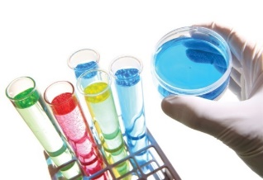
SIN Denmark contacts
Enquiry.Copenhagen@fcdo.gov.uk Science & Innovation Attaché, (Copenhagen)
richard.king2@fcdo.gov.uk Head of Science & Innovation Network, Nordics, Baltics & Russia (Stockholm)
@UKSINet

The information in this document is believed correct at the time of distribution. However, HM Government accepts no liability for any loss or damage incurred as a result of any inaccuracies, howsoever caused.

