
Consistent financial reporting
Instructions for local authorities on how to use COLLECT to submit the return
This document has been withdrawn

March 2015
Contents
COLLECT and Secure Access 3
Return status 5
Return management 5
Return progress 5
Uploading the xml file 6
Viewing the data return 7
Viewing the school data screen 7
The ‘complete’ indicator 8
The ‘federated’ indicator 9
Viewing the query/errors screen 11
Adding notes 13
Submitting a return 14
Exporting a return 15
Launching reports 16
Deleting a return 18
Screen functionality 18
XML generator 21

COLLECT and Secure Access
Access to COLLECT is through the Department’s Secure Access System (SA).
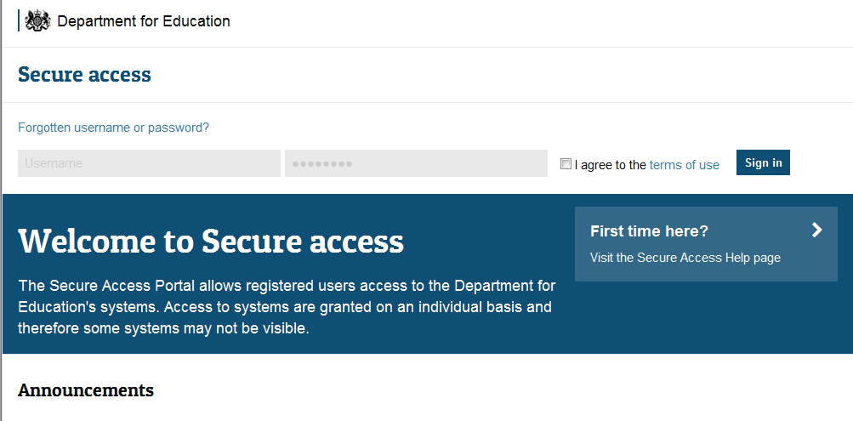
Please note some screen shots may refer to 2014 however the process is the same for the 2015 collection.
If you are a new user and require access to COLLECT, you will need to contact your approver.
Full Secure Access guidance is published on the Secure Access website
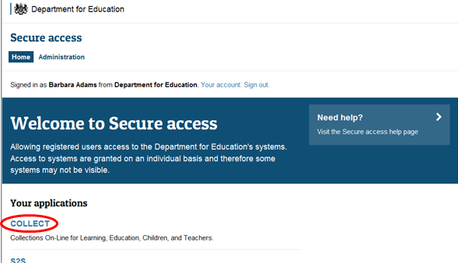
Once successfully logged in, click on the COLLECT link to access COLLECT, as above.
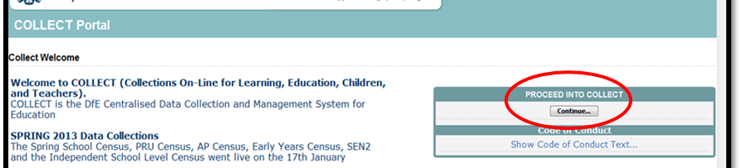
Click on ‘continue’, as above
Select the collection by clicking on the collection name to highlight it (if there is only one it will be automatically highlighted) and then click on the ‘Select Data Collection’ button to open it. If you cannot see the CFR collection, please contact your approver.
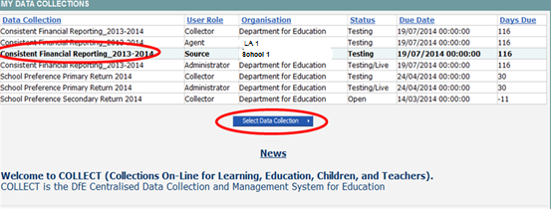

The source (school) main screen will then be displayed.
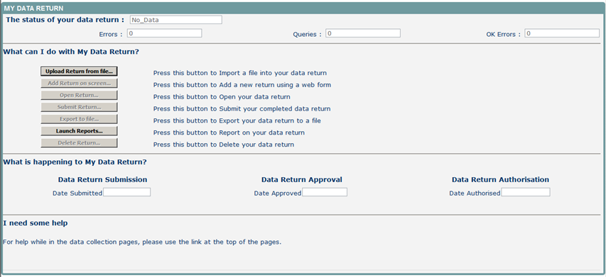
The screen is divided into three main sections:
- Return Status
- Return Management
- Return Progress

Return status
Shows the current status of the return and a breakdown of the errors within it. All information is read only.

Return management
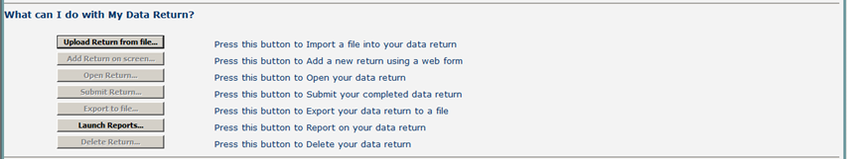
This provides a set of functions that can be used to manage/progress the return. Those with bold text and highlighted borders are available. The availability of the functions is dictated by the status of the return. For example the ‘delete return’ will not be highlighted if no return has been uploaded.

Return progress
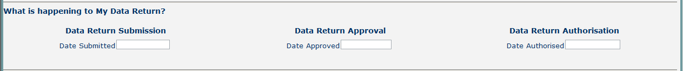
Shows the dates on which the return completed the three process milestones. This section is completed automatically as the return progresses through the workflow process.

Uploading the xml file
You need to upload a file into COLLECT to submit CFR data to the Department. The file will either be extracted from your Management Information System (MIS) or by using the xml generator provided by department for education please see page 24.
To upload your xml file, please select the upload return from file button from the source main screen.
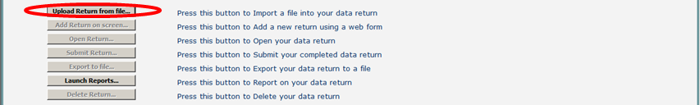
Use the Browse button to locate the CFR file on your computer. This will be suffixed with .xml and it will contain the data return extracted from the MIS or generator. Highlight the file name and click on open to select the return. Then click on the upload button to load the return.
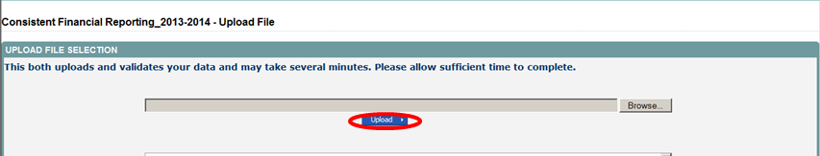
A progress message will be displayed while the upload is taking place.
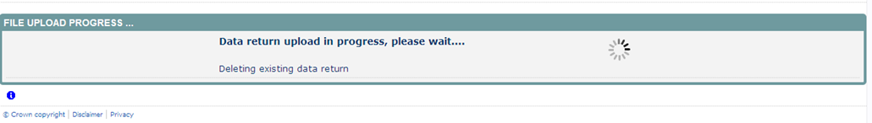
Once the upload has completed, the source main page will be re-displayed and the return status section will updated to “loaded and validated’’ the total number of errors and queries found in the return will be displayed. Additional function buttons will now be available in the return management section.
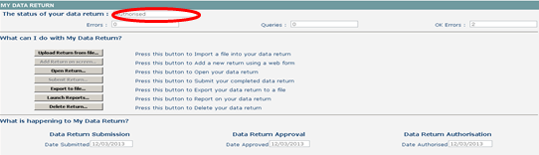

Viewing the data return
Once your return has been loaded into COLLECT, you must open it and check the data is correct and also enter notes against any queries that may be showing.
The data in the xml file which has been uploaded can be viewed on screen by clicking on the open return button.
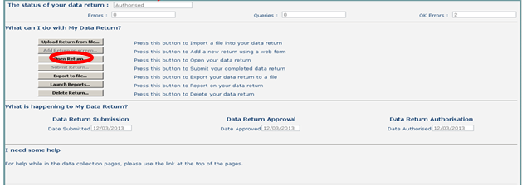
This screen shows the ‘header’ information from the xml file. It also allows you to view the errors and queries associated with that return and the notes associated with that return. (Please note any errors or queries that show on the ‘header’ screen will only relate to the data on that screen and not the whole return).
You can use either the View All links or the grey menu on the left-hand side, to navigate through the return.
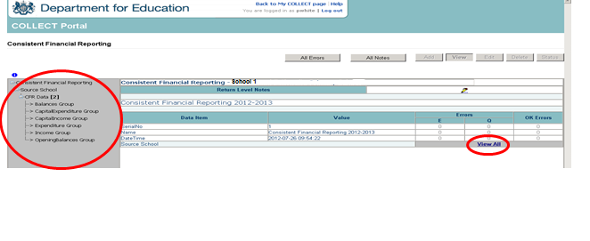

Viewing the school data screen
The first screen you will see after you click View All is the source school screen; this screen shows all the school details from the xml. To move on to the next screen containing the return data, again click on the View All link on this screen.
If you wish to return to the previous screen, use the ‘drill up’ button
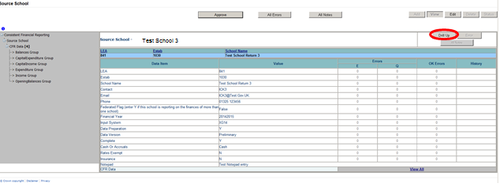

The ‘complete’ indicator
Please note this is a full financial year from 1st April 2014 to 31st March 2015. If your school was not open for the full financial year then this should be completed as ‘N’. If your school changed establishment type midway through the financial year (for example converted to an academy), then you should also complete as ‘N’. If it was open for the full financial year, then enter Y.

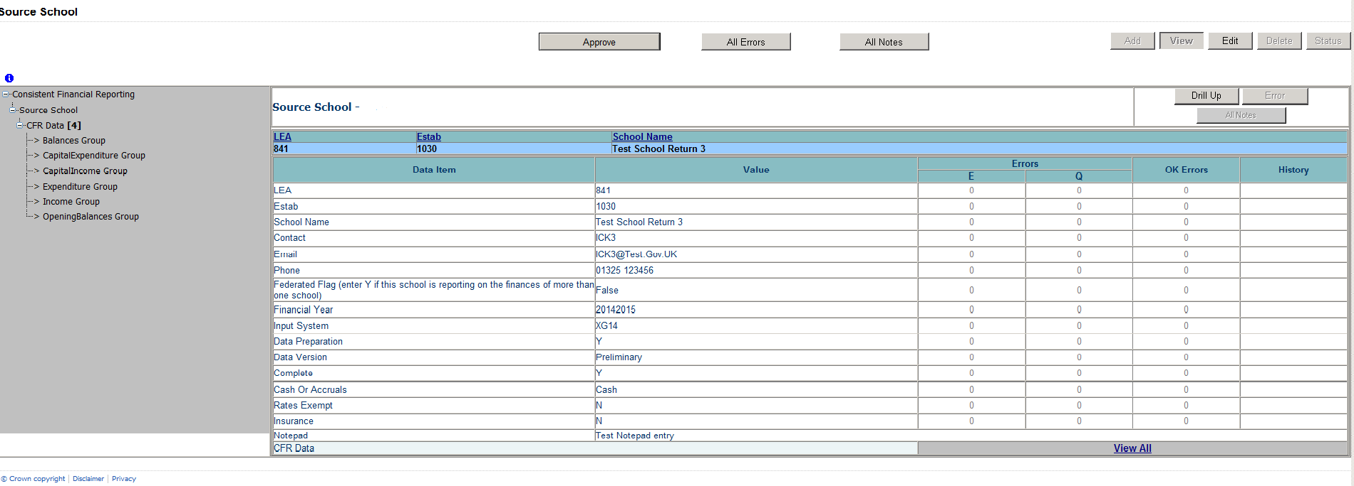

The ‘federated’ indicator
Please note that we will require the information on all the schools in a federation. This field should state whether the school is the ‘hub’ school and the name and establishment numbers of all the schools are entered for that federation into the return level notes.
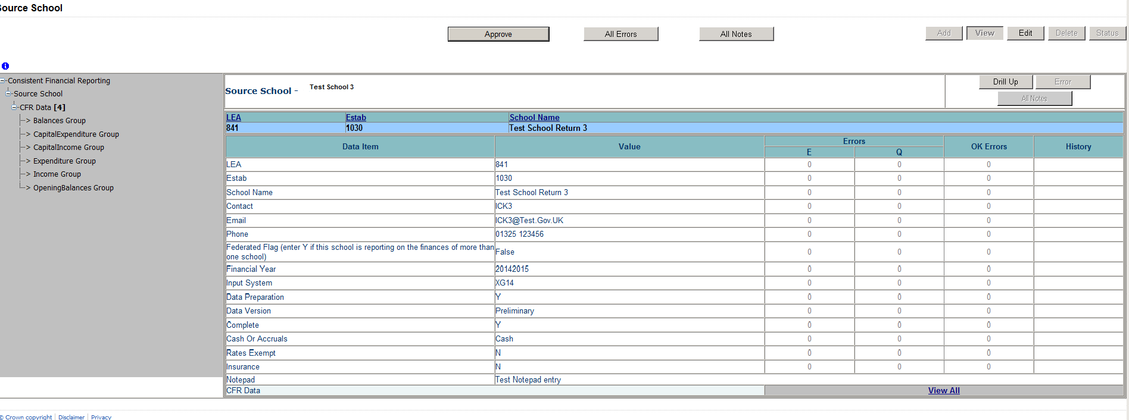
Navigation through screens
The CFR screen shows the opening balances and allows access to the Income, expenditure, capital income, capital expenditure and balances screens. To access these screens just select the relevant column heading (in blue and underlined) or navigate using the grey menu on the left-hand side of the screen.
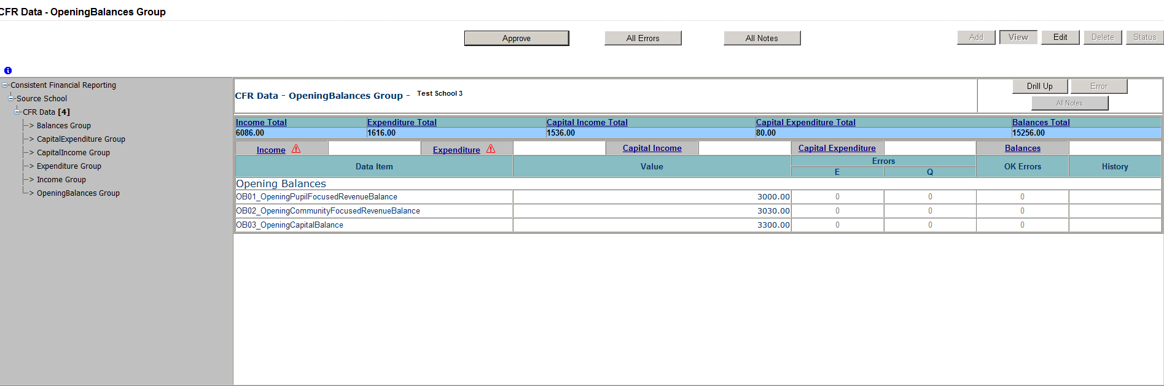
Errors will be displayed in red in the ‘E’ column; queries will be displayed in red in the ‘Q’ column

Viewing the query/errors screen
You will need to try and correct any errors on your return and enter notes against queries before you submit your data to the Local Authority. To view errors and queries on the return please select the ‘all errors’ button and a screen will be displayed containing a list of all the errors on that return. Please see below. You can also access the errors by clicking on a red box in the ‘Q’ or ‘E’ column and details of the query/error will be displayed in a screen.
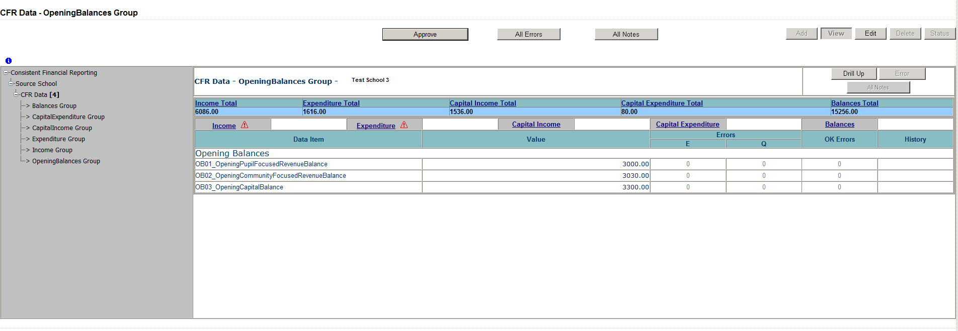NB: By clicking on the red box this will only bring up that particular error or query. We recommend using the all errors button to ensure you do not miss any errors or queries on different parts of the return.
The blade error report screen will then be displayed.
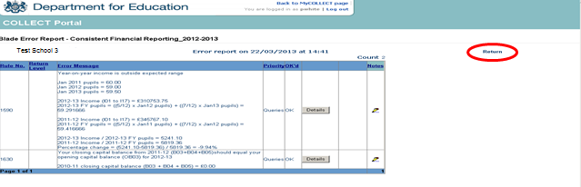
To exit from this errors screen, click on the ‘return’ link to return to the page you were on previously.
Whilst on the blade error report screen, clicking one of the details buttons will display the data item that is in error.
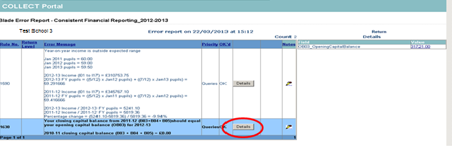

If the error/query is linked to multiple fields, then all these fields will be shown when you press the details button.

Adding notes
You can add your own notes to a query or error that cannot be resolved before submitting the data to the DfE if not already done by the school. Notes can be added to a return from within the ‘all errors’ screen.
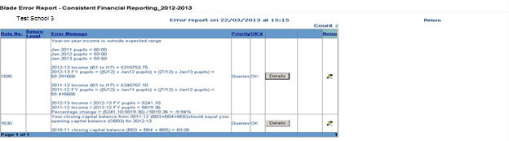
As you can see from the above there is a pencil icon at the end of each row. To add a note relating to a query, click on the pencil icon to be taken to the note page screen.
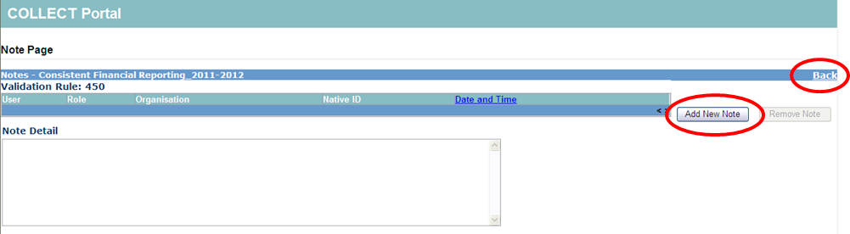
To enter a new note, click on the add New Note button. To go back to the previous screen please select the back link.
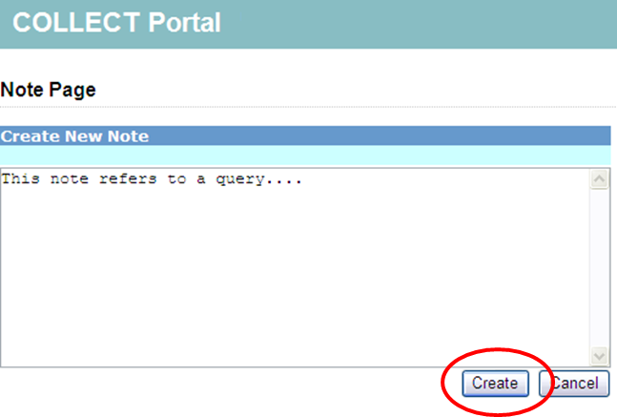
Once you’ve typed in your explanation, click on the create button. This will then save that note against that error/query.
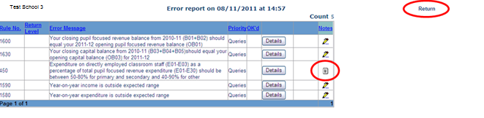You can tell if a note has been placed against a query, as the pencil icon will change to a notepad icon as shown below
To view these notes, click on the notepad icon and you will be taken to the note page screen as described previously.
Please note even though you have entered an explanatory note against the errors and queries they will not disappear from COLLECT until they have been reviewed by the department.
To return to the previous screen, please use the ‘return’ link.

Submitting a return
You will need to press the submit return button to release your data to the authority. They will then know that you have finished adding notes etc and they can check the return and ‘approve’ it (ie release it to the DfE).
A return must be at the ‘submitted’ stage before it can be ‘approved’ by the LA. This is done by selecting the ‘submit return’ button. A progress screen will appear. When this process is complete, the user will be returned to the front screen, the status of the data return will change to ‘submitted’, the ‘submit return’ button will be greyed out, and the ‘date submitted’ will be set.
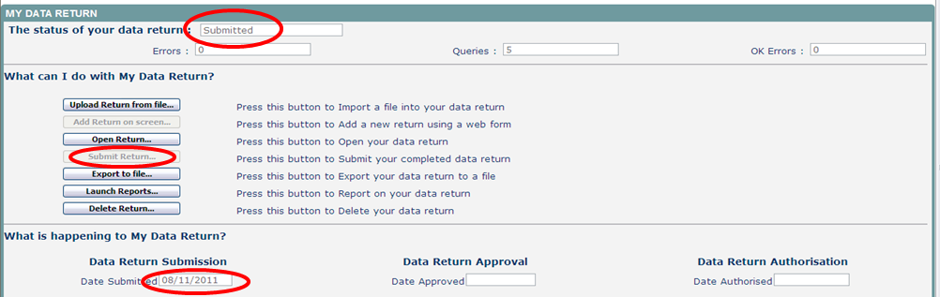

Exporting a return
Once the data has been submitted you can produce an export. An export will show all data submitted in either xml format or csv (spreadsheet). You can then save a hard copy of the submitted data for reference.
To export the data, select the ‘export to file’ button from the front screen.
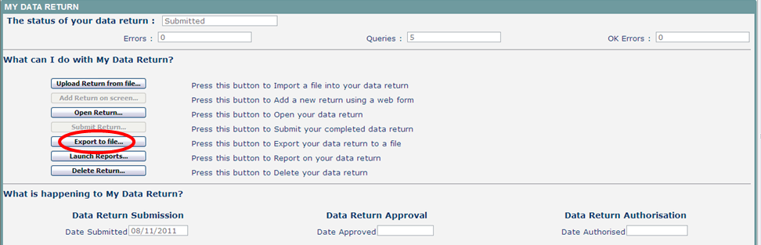
Select the format for the export, csv or xml then select the ‘export’ button. You will be prompted to save or open the export file. Once this has run you will get an option to open or save the export.
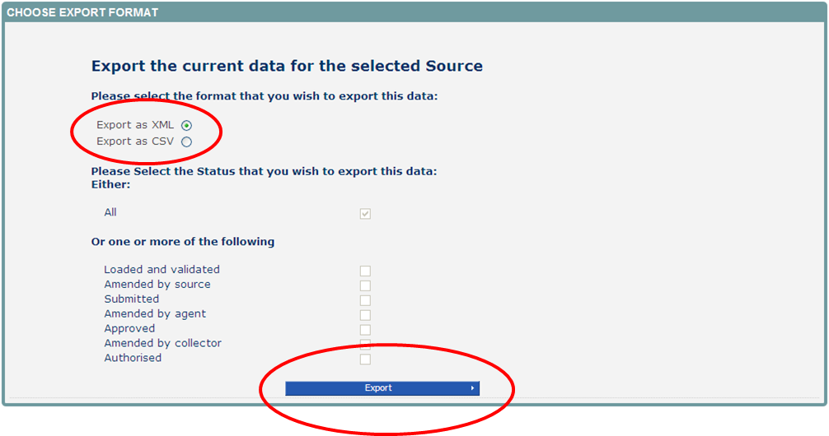

Launching reports
The launch reports option is available for each collection. This is where you can run various reports such as expected lists, error reports and school status reports amongst others.
Select the report you require from the drop down list and select ‘launch report’ button
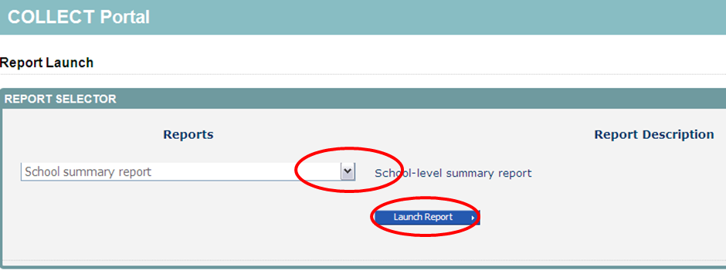
Once the report has been generated, selecting the ‘save as’ icon will bring up a drop-down list of export options. Selecting one will allow you to export the report to excel, csv etc.
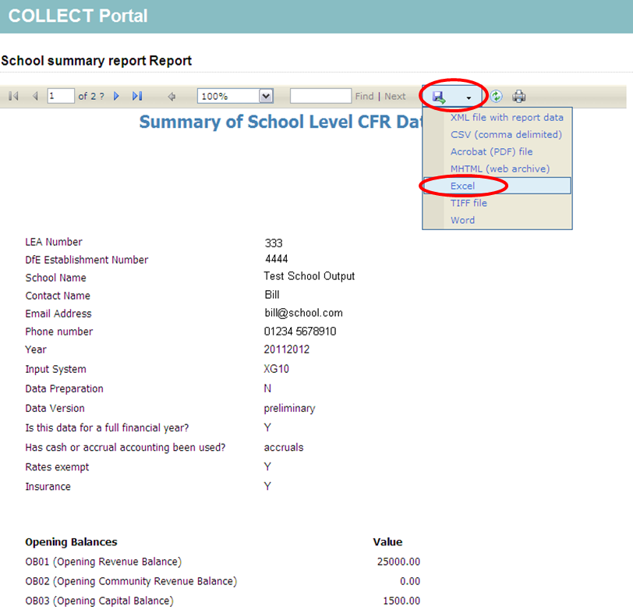
You cannot print or sort the data in the report from COLLECT, you need to export it into excel (for example) to be able to sort or print your data.

Deleting a return
If for any reason you need to delete a return and start again, you can do this from within COLLECT. A return can be deleted by a school or authority. Return to your home screen by selecting the ‘back to my COLLECT page’ link at the top of the screen. Select the delete return button, and this will remove the return from the collection. The status of the return will change to ‘no data’.
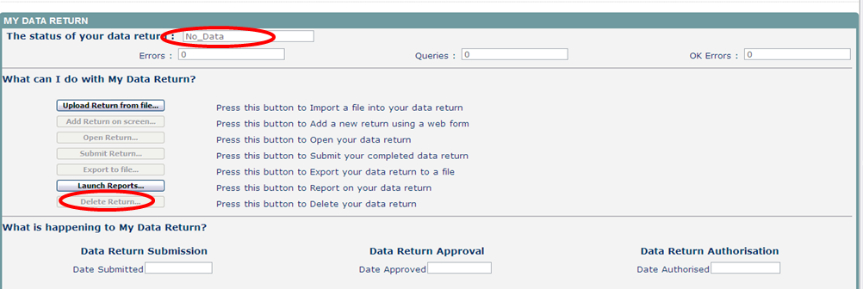

Screen functionality
Before viewing the return it is useful to understand some of the basic controls and screen operations.
Don’t use the browser buttons! When in the data collection, unpredictable behaviour may be experienced if you use the back/forward buttons on your web browser’s toolbar.

Navigation through a return
To navigate through the system, links are provided on all pages either as back or drill up options; please use these links to navigate between screens when using the system.
Control | Usually located | Action
Back to my COLLECT page | All screens within a return except the main page which shows back to home page | Returns you to the main page for your user role (agent, source etc)
Drill Up | Any data screen within a return apart from the header screen | Returns you to the previous data screen
Return | Report screens, e.g. history and errors | Returns you to the previous screen
Back | Notes screens | Returns you to the previous screen
View All | Data entry screens that have additional linked data, e.g. accesses contract details for a workforce member | Takes you to the sub module level details

Mode buttons
Those buttons determine which operation mode the data form on screen is in and which operations are available.
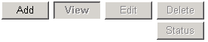
Dark grey text on sunken button with light border = Active ModeBlack Text on button and highlighted border = Available ModeLight grey text on button with light border = Unavailable Mode

Filter bars
Only available on screens that could have a large record set record list. These allow you to sort the records on the screen.

Left-hand menu
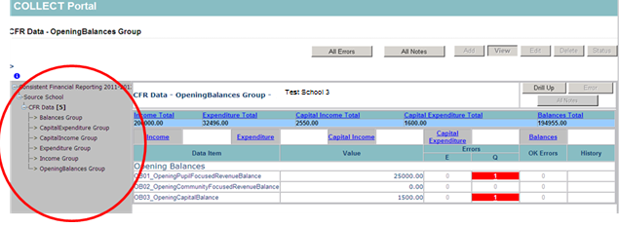The grey left-hand menu can also be used to navigate to different screens
For any further guidance and assistance with the return please contact the EDD Helpdesk by completing a
data collections service request form

XML generator
In some circumstances a school may not have an MIS which enables them to generate the data in an xml format. In these cases there is an excel spreadsheet available which can be populated and used to generate the xml files which can be uploaded into COLLECT.
The first tab in the spreadsheets provided instructions on how to complete and zip the file. One xml file will be generated for each school (line) completed on the spreadsheet. For ease, all the individual .xml files can be zipped into one .zip file and uploaded into COLLECT in one go.
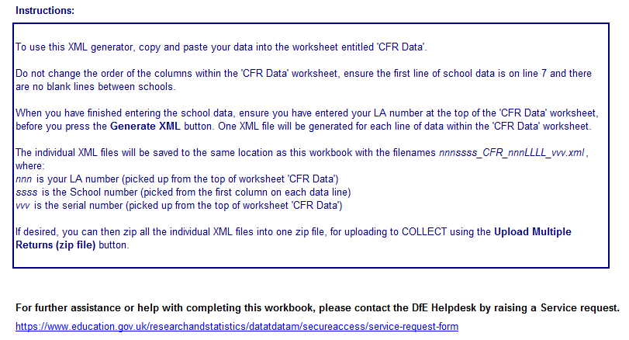

The second tab called CFR data is where the CFR data needs to be copied into, one line per school. The order of the columns is very similar to the format of the previous year’s csv files. The LA number must be entered into the top box (LA number) then the relevant school information entered into the columns below.
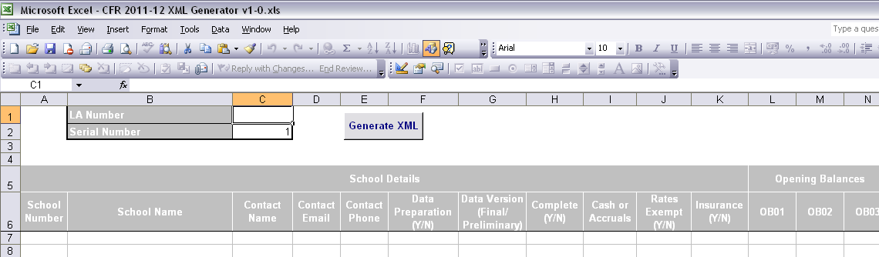
When all the data has been entered then select the ‘generate xml’ button. A message will be displayed to the screen to show how many .xml files have been generated and the directory where they have been saved to.
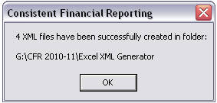
The directory defaults to the folder where the xml generator spreadsheet is stored. The xml file(s) can now be uploaded to COLLECT.
Please note the following:
- Please ensure you complete all fields;
- If a figure is ‘null’ then please enter ‘0’;
- Data preparation – use this if the school has taken part in completing the return;
- Complete - If open a full year
- Rates exempt – ‘Y‘ if exempt; ‘N’ if rates paid;
- Insurance – ‘Y’ if insurance purchased centrally; ‘N’ if school buy it.


© Crown copyright 2015
You may re-use this document/publication (not including logos) free of charge in any format or medium, under the terms of the Open Government Licence v2.0. To view this licence, visit www.nationalarchives.gov.uk/doc/open-government-licence/version/2 or email: psi@nationalarchives.gsi.gov.uk.
Where we have identified any third party copyright information you will need to obtain permission from the copyright holders concerned.
Any enquiries regarding this publication should be sent to the data collection helpdesk.
This document is available to download at www.gov.uk/government/publications.
 Follow us on Twitter: @educationgovuk
 Like us on Facebook: www.facebook.com/educationgovuk

