Boosting Enterprise
in More Deprived Communities

The Baroness Mone OBE


Foreword
I was delighted and honoured to be asked to review how to boost enterprise in the more deprived communities of Great Britain.
Great Britain is a great place to do business. The Government has recognised that it is crucial to support self-employment. This support must work for every community. We are bouncing back from the worst financial crisis in our lifetimes. Driving this rebound is the incredible success of British business.
The rate of self-employment has been increasing for a number of years now and stands at 10% of the working age population. In the 10% most deprived areas, however, people are almost 50% less likely to be self-employed. There are many reasons behind this gap but we need to do all we can to address this disadvantage and ensure that no matter what your background is, if you have a great idea and determination, your business can thrive. It is clear to me that emotional barriers explain a large part of this gap. A lack of confidence, income insecurity and the lack of a network of people well placed to give advice are all issues that can block people from starting up.
The over-riding theme and objective of my review is that boosting self-employment is not just about macroeconomic growth; it’s about transforming people’s life chances. I am proud to make a number of recommendations to achieve that objective, and I am looking forward to continuing in this quest to transform the support for people thinking about starting up in business.
I was keen to tour the whole country to gather evidence for this Review. During my tour, I have met over 75 organisations and over 120 individuals. I am immensely grateful for their time and expertise; I couldn’t have completed this review without them. Following the publication of this Report to Government, I look forward to continuing to work with the retail banking sector in a personal capacity to see what more they can do to boost enterprise in these areas.
If you are self-employed and reading this, I make a plea: I know how valuable your time is but equally I know from my own mentoring how rewarding it can be to help out the next generation of entrepreneurs. I hope you will take the opportunity to see how you can give something back and mentor someone who needs your help and advice. It will make a powerful difference. 
The Baroness Mone OBE
Contents
Page
4 Executive Summary
9 Introduction
14 Challenges facing people who want to start up
18 Current support available
37 What needs to change?
49 Other issues considered by this Review
54 Annex A – business statistics
56 Annex B – NEA statistics
57 Annex C – technical note
63 Acknowledgements

Executive Summary
Entrepreneurship is thriving in Great Britain. There is a record number of businesses and 10% of the working-age population is self-employed. In poorer communities, however, the proportion of working age people who are self-employed is roughly half the national average. In order to understand what barriers exist in these areas, it was vital to speak directly with people starting up businesses and the organisations that support them. Going in person to these areas gave a better insight into the current challenges that people face.
My Review team and I set out on a tour of Great Britain starting with Cardiff and Merthyr Tydfil and stopping off at Pool and Penzance, London, Stockport, Ellesmere Port, Manchester, Bradford, Leeds, Sunderland, Newcastle, Glasgow and Gloucester before holding a series of meetings in Westminster to look in more detail at the tour’s findings.
At each location we met entrepreneurs and organisations that support them, speaking to them about their experiences of starting up. By mid-December we had met over 120 people from 77 different organisations and businesses. The term ‘entrepreneurship’ often invokes an image of a cutting-edge, innovative business. In reality, most businesses are more mainstream, replicable activities with few or no employees. I do not consider that a bad thing. If someone else has succeeded with a business, it indicates that that model can work, so there is less inherent risk.
There is a wide range of reasons behind the gap in self-employment rates between more deprived communities and the national average. In gathering evidence for this Review, I observed a number of emotional and practical barriers that my recommendations address.
Recommendations
1. Mentoring
All business starters should consider seeking a mentor to help them as they begin. Having the experience of someone who’s been there and done it all before is an invaluable resource, and evidence suggests that entrepreneurs who seek advice are more successful. Most importantly, for those who are already self-employed, I encourage you to consider mentoring. I know how precious time can be to those who are self-employed, but equally I know how rewarding it can be to give a little back and help someone else starting out.
2. Improvements to the New Enterprise Allowance (NEA) programme
The NEA is a successful, value for money programme that has resulted in over 70,000 people becoming self-employed. The roll-out of Universal Credit (UC), the strength of the labour market and the renewal of NEA delivery contracts make it a good time to review the design and objectives of the programme. I make the following detailed recommendations:
i. There is a complex landscape of support for entrepreneurs and the NEA is a vital part of this picture. I recommend that a Strategic Enterprise Oversight Group (SEOG) should be created to ensure that the different organisations involved in enterprise support align their programmes to help people more effectively.
Aligning the NEA’s objectives and payment structure with UC self-employment policy.
One of the strengths of the NEA programme is its ‘payment by results’ structure:
10% on attachment
30% on a business plan being accepted
30% on trading starting
30% on the business trading
Improvements can be made, however. The payment stage for business plan approval risks some providers pushing participants to complete template business plans to meet the payment criterion without adequately testing the business proposal. The benefit system is undergoing radical reform, which affects the support given to self-employed people. The UC assessment for those includes an assumed level of earnings, known as the Minimum Income Floor (MIF) which applies to self-employed people from 12 months after starting up in business. The MIF is designed to incentivise claimants to increase their earnings and is set at the equivalent earnings level a full time National Minimum Wage or National Living Wage job. The NEA survey, published recently, highlighted that 58% of businesses reported an average monthly turnover of less than £1,000; 37% below £500. This would likely place them below the threshold created by the MIF. The NEA does not currently have any objectives to encourage participants to aim for this threshold. Jobcentre Plus (JCP) Work Coaches need more preparation for supporting self-employed UC claimants, and guidance around the Gainfully Self-Employed test (GSE – that tests whether the business is a viable and profitable) must be aligned to the new NEA structure. My recommendations are as follows:
ii. Providers’ contracts should be structured to have a more generous final payment when a participant is able to draw a full time minimum wage income or more 12 months after starting trading.
iii. a) Additional self-employment training for JCP staff should be introduced. To complement this, effective communication products for providers and Work Coaches should be developed. This will help prepare staff to administer the Gainfully Self-Employed (GSE) test in UC, and must include the MIF as a central consideration. Since this Review began, I have noted progress in this area.
b) Ahead of the migration of self-employed Tax Credit claimants to UC in 2018, HMRC should implement similar support for now for self-employed people
iv. The scope of the NEA programme should be broadened to accommodate customer testing or test trading.
Taken together these measures may result in a lower absolute number of businesses being created, but because the support will be more intensive and focussed on sustainability these businesses should be higher quality. The next phase of the NEA should focus less on quantity and place more emphasis on quality.
Pre-NEA activity
v. Although we observed some local good practice, there is little consistency in what pre-NEA activities are offered to benefit claimants. This can result in inappropriate referrals, especially of more vulnerable claimants. The Review recommends that JCP, Growth Hubs and NEA providers set up local boards to govern networking, promotion and information sharing to give claimants more insight and encouragement ahead of them taking part in the NEA, and the SEOG should guide local areas on how to do this.
Funding
vi. At present, the maximum funding available per NEA referral is £600. Pre-NEA events can act as a filter to limit the number of inappropriate referrals that would allow an increase in the funding per referral and improve the support provided. Currently, an NEA participant might only meet with a mentor once or twice prior to their business plan being created. More intensive support will be needed to help participants with customer testing or test trading. This will develop higher quality businesses which will be better prepared for the MIF.
NEA awareness and a national prize
vii. There are few programmes that can claim to have radically changed the lives of their participants on the scale of the NEA – no other enterprise scheme currently creates as many businesses. However, more still can be done. Individuals from the most deprived 10% of areas are almost half as likely to be self-employed than the national average. This Review hopes to raise the profile of the NEA with the publication of this report and associated engagements. The Review also recommends the creation of an NEA prize to periodically highlight its success and inspire people thinking of starting up.
viii. Given the relatively short pre-trading period of the NEA programme, the Review recommends that the Government consider whether vulnerable participants are given a longer period to develop their business plans by default.
ix. The majority of participants who have started a business reported that they found the support from their mentors helpful. The survey that supports this view, however, does not include the views of participants who did not start a business. That represents half of the participants of the programme. The quality of mentoring is not routinely assessed, nor is it a requirement of the contract. In future, feedback and quality assessments of mentors and business advisors should be a formal part of the NEA structure.

3. Start-Up Loans
i. Not every NEA business requires external funding, and in many cases it would not be appropriate. However, there has been a 50% fall in the number of start-up loans issued to NEA participants in the two years to December 2015. On investigation, NEA providers and the Start Up Loan Company (SULCo) report that there is confusion about their potential liability when referring NEA participants to the SULCo. These concerns about regulatory implications are affecting the number of NEA participants being referred to SULCo. This needs to be urgently clarified and communicated so that a smooth and consitent referral process can be re-established.
ii. Feedback suggests that there is scope to improve the relationship between NEA providers and SULCo delivery partners. JCP staff also suggested that this is a barrier to businesses taking off. I recommend that there is a greater level of quality assurance in the financial aspects of NEA business plans – SULCo delivery partners rely on this preparation to process their loans.
iii. Officials from the Department for Work and Pensions (DWP) and Business, Innovation and Skills (BIS) should work together with the British Business Bank (BBB) to explore what could be done to incorporate a consideration of how a loan might transform an individual’s life chances in SULCo’s objectives and grant letter, if that individual has a viable business proposal. This reflects the wider social and economic benefits of breaking that person’s benefit dependency. This should be achieved in a way which protects SULCo’s ability to deliver its overall objectives.
4. Localised Support
Responsibility for enterprise support is largely devolved to local areas, via Local Enterprise Partnerships (LEPs) across England, Business Wales and Business Gateway in Scotland. This opens up opportunities for innovation and learning, as well as tailoring support to tackle local issues. The vast majority of NEA businesses (81%) are owner/manager micro enterprises. Some show great potential for growth though, but it is difficult to support the business to grow during the NEA’s six month programme. I recommend that:
- the highest potential NEA start-ups are identified and given a warm handover or directly referred to existing business growth support, such as the network of Growth Hubs that LEPs have created
- data sharing between NEA providers and LEPs should be pursued
- LEPs and Growth Hubs should participate in pre-NEA activity with JCP.
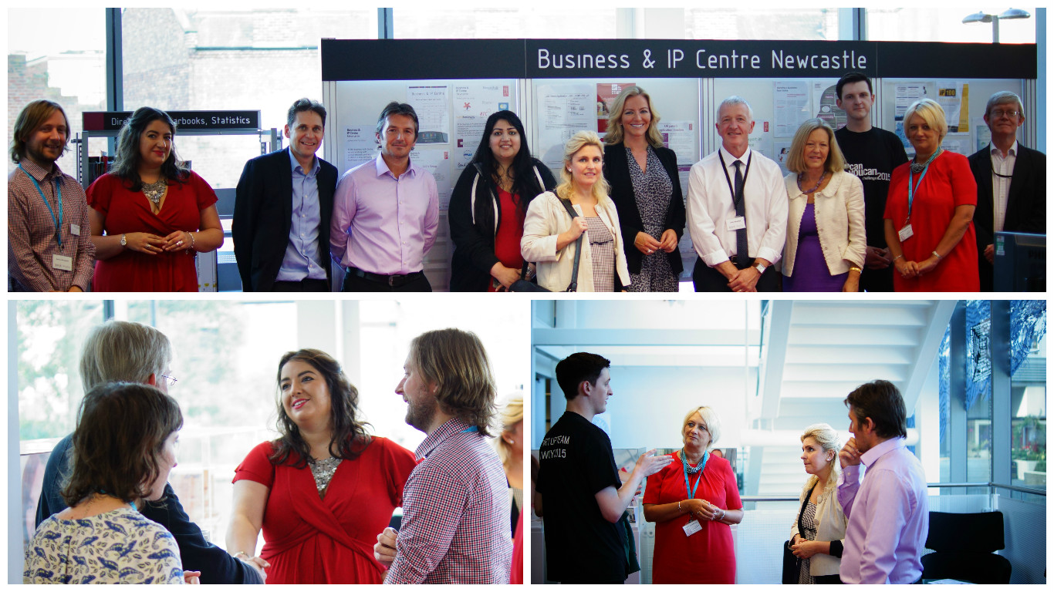
5. Education
I have observed the success of organisations such as The Premier League, The Aldridge Foundation and UnLtd who have created innovative approaches to enterprise education. I encourage school leaders, Local Authorities and the Department for Education to investigate and incorporate this best practice.
6. Banks
Many banks invest in programmes and support for business start-ups; from funding business accelerators to training their staff to mentor businesses.
It is also common to see banks providing offers for new businesses to help them as they start their enterprise. This Review applauds all of the support that can be given to reduce the burden on fledgling business, and recommends that entrepreneurs carefully consider the best deals that can be secured when opening a business account.
The network of Entrepreneurial Spark enterprise hubs provides a strong example of how banks, in this case RBS, can support high quality, intensive enterprise support (see detailed recommendations).
Spurred by this example, I will be working in a personal capacity with leading retail banks to create a nationwide network of bank funded enterprise hubs, independent of Government. Currently, HSBC have committed to identify appropriate locations to pilot this initiative. This project will continue following this Report.

Introduction
The business environment in this country is very strong: there were a record 5.4 million private sector businesses at the start of 2015. That is an increase of 146,000 since 2014 – 1.9 million more than in 2000. This Report has been made possible by the collective input of people creating business opportunities in deprived areas.
At the start of this project, I compared the relationship between deprivation and levels of self-employment and this has drawn a number of stark and clear illustrations, using the Indices of Multiple Deprivation. In Great Britain overall, around 10% of the working age population is self-employed. However, for the most deprived 10% of areas, self-employment stands at just 5.4%.
The levels of self-employment across Great Britain are increasing but this analysis shows that there is still a significant gap.
Self-Employment - nationally and in most deprived 10%
 | National % | Most Deprived 10%
England | 10.3% | 5.6%
Scotland | 8.0% | 3.9%
Wales | 9.0% | 5.0%
GB | 10.0% | 5.4%

With the Government’s commitment to pursuing full employment, we should reflect on what role improving the chance to start a business in a deprived area could play in achieving this. As would be expected, more deprived areas tend to have lower overall employment levels. I hope that work to improve the rate of self-employment will also raise overall levels of employment in the most deprived communities.

There is a wide range of support on offer for people wanting to start a business. In fact, the overall enterprise support landscape is cluttered and can be difficult for people to navigate. This support includes:
  - The New Enterprise Allowance (NEA) is a nationwide programme funded by the Department for Work and Pensions (DWP) that provides mentoring and business planning support for certain benefit claimants over 8-12 weeks and gives access to an allowance for up to six months as a business starts trading.
  - SULCo, through Government funding, provides affordable finance, free mentoring and support for those who cannot obtain funding from alternative sources.
  - Private, voluntary and charity sector support, from start-up accelerators, specialist support for disabled, homeless, deprived areas and other disadvantaged groups. Notable providers include Remploy, Shelter and The Princes Trust.
  - Informal networks - this in particular can be more challenging in deprived areas due to lower concentrations of businesses.
  - Many Work Programme providers have enterprise strands.
  - Educational establishments.
  - Local Growth Hubs and enterprise support in Scotland and Wales.

Self-Employment and the Benefit System

The Government is carrying out an ambitious programme of welfare reform. Universal Credit (UC) is at the heart of these plans, designed to transform the benefits system. It is replacing 6 benefits and tax credits, simplifying processes for claimants and ensuring that work pays. As such, it will be the main income support that low income entrepreneurs will turn to. The most important change, compared to the Tax Credit regime, is the introduction of a 'start-up period' of up to one year to give time for people to establish a business. After this point, the system assumes a claimant's business will be able to provide them with an income at the level of a full time National Minimum Wage.
Financing Self-Employment
The highest profile businesses naturally tend to be the most successful ones, but the world of business is as diverse as the people who create them. The majority of successful businesses, however, are much smaller. In the UK, small businesses account for 99.3% of all private sector businesses and 76% of businesses did not employ anyone aside from the owner (see table in annex A). This Report is designed to promote, mainstream, sustainable self-employment opportunities for individuals, rather than focussing just on creating opportunities for trailblazing ‘disruptive’ and high tech businesses.
Many businesses thrive and prosper with very little or no start-up capital. For instance, an individual starting a business based around their favourite past time will likely possess all the equipment they need to produce a saleable product. The same is true of small-scale service businesses. A window cleaner for instance may be able to set up from savings or informal support from friends and family.

The Role of Government
Public services are under scrutiny to deliver best value, and this is crucial as we recover from the global financial crisis. With so many competing priorities for public funding, the Review is sensitive to ensuring that the support that businesses receive must be effective and value for money. The Government’s commitment to the programmes aimed at supporting enterprise for the most disadvantaged, such as the NEA, is hugely welcome.
The Departments for Work and Pensions (DWP) and Business, Innovation and Skills (BIS) both play key roles in enterprise support. BIS strives to increase the productivity of those businesses that show good potential to grow further. This is sensible and ensures policy is focussed on maximising Gross Value Add (GVA).
It is essential that the benefit system helps rather than hinders enterprise. DWP plays a key role in supporting business creation with programmes that, although less obvious in terms of increasing GVA, have deep and positive consequences for individuals' life chances.
The design of out-of-work benefits including Jobseekers Allowance (JSA), Income Support (IS) and Employment and Support Allowance (ESA) can act as a barrier to claimants wanting to start up. In the case of JSA, DWP expects claimants to be seeking employment via their Claimant Commitment.
Without a specific programme to support people wanting to set up businesses, two barriers exist:
- Claimants’ time is spent applying for and seeking employment.
- Their income would cease immediately if they signed off to start up.
It is to be applauded when any scheme effectively supports a new business to be created, especially when the creation of that business brings the owner out of long-term unemployment, to change not only their life chances but their family’s and sets a positive example for them and for the wider community.

Challenges facing people who want to start up
A summary of our tour and engagement

An analysis of social media was conducted, asking what the barriers individuals face to starting up, by searching for the help that people requested. The main issues encountered were:
Top tier
1. Lack of confidence
2. Loneliness
3. Income insecurity
4. Poor networks/not knowing where to find support/lack of advice

Second tier
5. Space/premises – cost, inflexibility and availability
6. Start-up funding
7. Childcare
8. Short length of support programmes on offer

Third tier
9. Tax
10. Input cost – e.g. utilities
11. Not having an idea
12. Difficulty in dealing with paperwork
13. Long term illness (although self-employment preferable to full-time employment)
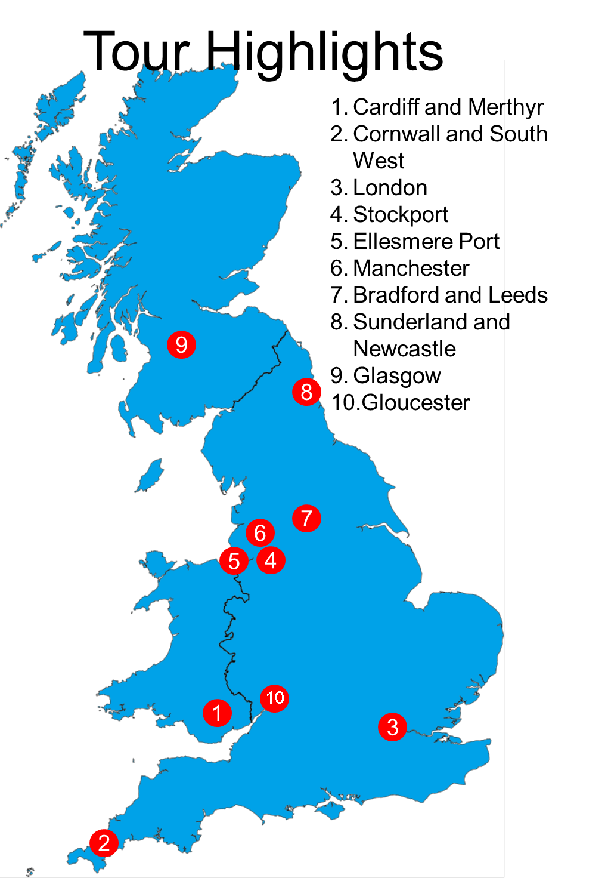
Reproduced from Ordnance Survey map data by permission of Ordnance Survey © Crown copyright 2016, database right, ONS licence number 100036967

Tour Summary
Many people were consulted in the course of this Review. This is a summary of some of the important engagements.
1 – Cardiff and Merthyr Tydfil. This was a meeting with PeoplePlus, which was formed when Avanta’s parent company Staffline took over A4e and the two were integrated and rebranded as PeoplePlus. They have four prime NEA contracts over the country and supply chain contracts in a further three areas. As such, they describe themselves as the largest business start-up operation in the UK – helping over 7,000 new businesses start per year.
Test Trading venue visit, Merthyr Tydfil
Welsh Government and Local Authority joint working on enterprise support via ‘Business Wales’ – a test trading shop and online support.
Merthyr Jobcentre
JCP staff who spoke about how they work with those wanting to start their own businesses.
2 – Pool and Penzance, Cornwall
A number of the small businesses who operate from within the centre.
3 – London
- Westminster Impact Hub
- Start-up loans policy discussion
- NEA policy discussion
- DWP policy officials
- BBA
- Lord Freud meeting
g) London Small Business Centre
h) Centre for Entrepreneurs round table
i) Sir Rod Aldridge
j) Andy Stephenson, Weekend Box (Start Up Loan supported business, from Newcastle)

4&5 – Stockport and Ellesmere Port

- Stockport Business Innovation Centre
Stockport Business Innovation Centre opened in 2008 and was co-funded by Stockport Council and Broadstone Mill Ltd (the landlord) and more recently part financed by the Northwest Operation programme 2007 – 2013 European Regional Development Fund Programme.
- Pop Up in the Port, Ellesmere Port civic centre, run by the Pop Up Business School



6&7 – Manchester, Bradford and Leeds
a) Aim Sky High (ASH) Dance School, Stretford, Manchester
b) Round table discussion at New Economy Manchester Local Enterprise Partnership
- Bradford, SFEDI/Centrepoint enterprise project
- Leeds, Google Digital Garage
8 – Sunderland and Newcastle
- Sunderland, visit to Sunderland AFC Foundation
- Newcastle City Library Enterprise and Intellectual Property Centre

9 – Glasgow
- Harper Macleod Roundtable
- Entrepreneurial Spark
- Laurieston JCP –
- a roundtable of local NEA participants

10 – Gloucester
Gloucestershire Enterprise Ltd visit and roundtable

Current support available
There is a cluttered landscape of enterprise support in Great Britain:
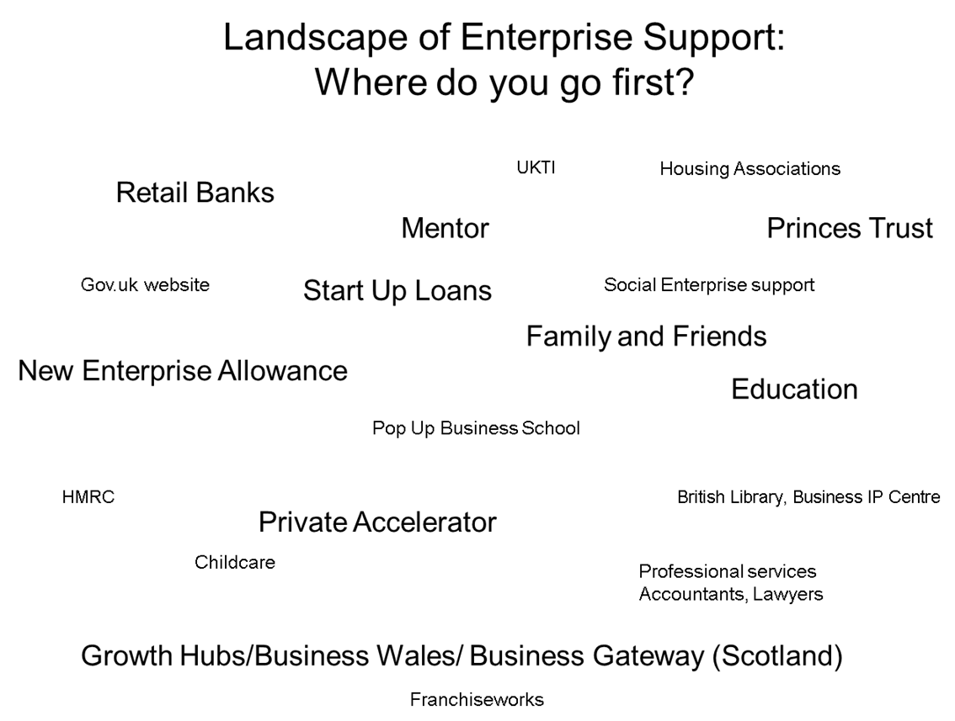

It is vital this support is aligned, accessible and clear. This chapter highlights some of the key schemes, and how they interact.

The New Enterprise Allowance
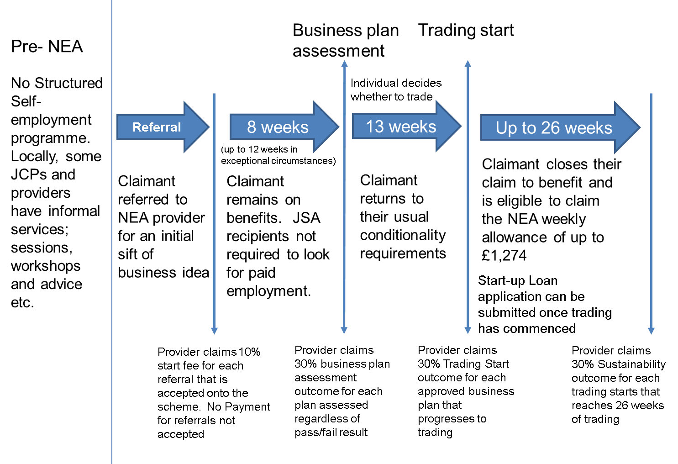
The New Enterprise Allowance (NEA) is the main programme DWP uses to support certain benefit claimants to start businesses. The NEA aims to help unemployed people claiming out of work benefits who wish to start up their own business.
Initially, participants in NEA work with a business mentor to develop their business idea. Once they have started trading and left benefits, or reported a change of circumstance if they are on UC, they receive a weekly allowance.
According to DWP’s December 2015 statistics, over 76,000 businesses have been created from 152,000 individuals starting the programme.
Eligibility:
- NEA is now open to those claiming Jobseeker’s Allowance (JSA), Employment Support Allowance (ESA), Income Support (IS) as a lone parent or because of sickness/disability and some Universal Credit claimants;
- also open to the dependent partners of JSA and ESA claimants.

Mentoring:
NEA participants receive mentoring support for around 8 to 12 weeks while they develop their business plan.
During the mentoring phase:
- Participants will continue to receive their benefits but they are expected to participate fully, show their work coach what they have been doing to develop their business plan and progress their idea. A JSA claimant would no longer be required to look for and apply for work while they are participating on the NEA fully.

Pre-Trading:
- Following business plan approval by a contracted provider, the participant has up to 13 weeks to decide if they want to progress to trading.
Trading:
- Once they begin to trade they can claim the allowance element of the NEA instead of their benefits.
- Paid weekly for the first six months of trading and worth up to £1,274.
- Also eligible to apply for a start-up loan, delivered by the Start-Up Loans Company on behalf of BIS.
Other notable Self-Employment support from DWP:
As part of the Department’s Work Choice programme, that helps people with a recognised disability find and remain in work, support can be provided by the provider to start a business. The Department also provides Access to Work that provides grants to pay for practical support if you have a disability, health or mental health condition.
The Start Up Loans Company (SULCo)
The Start Up Loans programme was created by Government in September 2012, following Lord Young’s report Make Business Your Business (May 2012), with the aim of increasing the rate of business creation and to promote entrepreneurship and self-employment. The scheme is funded and overseen by BIS and the BBB.
The SULCo is a private sector company which delivers the programme in line with the key policy objectives. The scheme offers loans and mentoring support to those recipients who are looking to start their own business, yet due to a number of factors are unable to borrow from the mainstream lenders. Anyone over 18 years of age and living in the UK is eligible to apply. While only one Start Up Loan can be granted per person, multiple applications from the same business are permitted. Loans are offered on a 1-5 year term and set at an annual interest rate of 6%.
SULCo works in partnership with a network of Delivery Partners from across the UK to deliver the scheme. As of December 2015, over 35,000 loans have been drawn down under the scheme resulting in almost £193m worth of lending.
NEA Lending
Since 1st October 2013 SULCo has managed the loan element of the NEA scheme. Specialised NEA partners work closely with applicants on their business plan and personal cash-flow to ensure any agreed funding is both affordable and meets the need of the business.
Lending for the NEA-element of Start Up Loans represents 23% of the total portfolio.
Start Up Loans Lending Over Time
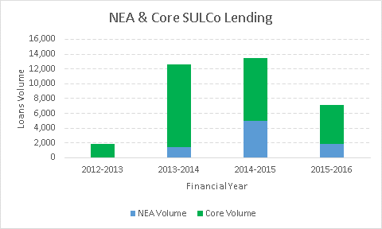


A case study
Name: Nicholas Chick
Business Name: The Galley Delicatessen and Coffee House
Location: Cheadle, Stockport
Nicholas and his wife Heather started their business The Galley Delicatessen with the help of a Start Up Loan. Both received funds of £5,500. Nicholas and Heather are both former Royal Navy chefs, having served 12 and 22 years respectively.
The couple wanted to continue to use their culinary skills after leaving the Navy, moving from Plymouth to Cheadle, Greater Manchester to realise their dream of opening their own delicatessen. The Galley Delicatessen serves a variety of homemade food, including sausage rolls, pies and quiches. Customers are also offered a wide range of hot and cold beverages.
Nicholas and his wife now employ four members of staff.
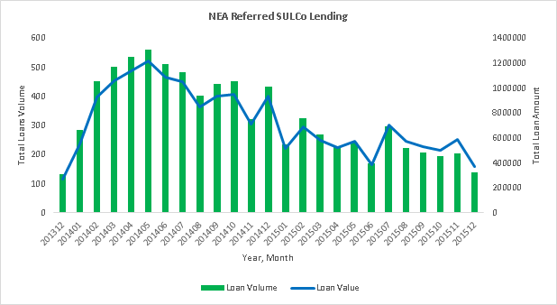
Local Enterprise Partnerships (LEPs)
Growth Hubs
Local Enterprise Partnerships (LEPs) were created to replace the Regional Development Agencies and provide local leadership that was controlled by the individual areas and include business at the heart of their decision making. As such, they tailor the support given to business start-ups according to local priorities.
A Growth Hub is a local public/private sector partnership led by the LEP. Partners include Chambers of Commerce, the Federation of Small Businesses and other business bodies, university/university business schools, other private sector bodies (including local partners delivering national programmes) and national government.

Growth Hubs bring together public and private sector partners to promote, co-ordinate and deliver business support. They provide a mechanism for integrating national and local business support so it is easy for businesses to access. They are locally-driven and locally owned. Government has actively supported their development through funding and creating the right environment for businesses to thrive.
There are currently thirty three Growth Hubs. This means that 88% of registered businesses in England are now able to access business support from a local growth hub. Growth Hubs are an important part of BIS’s plans to make it easier for businesses to start and grow; by ensuring business support is simpler, more joined up and easier to access.
- Simpler - They are a single local access point for all public and private sector business support. Growth hubs and their partners will use information and tools from GOV.UK and use or promote the Business Support Helpline. This will ensure businesses get consistent information whether they look nationally or locally.
- More joined up - They will align local support with national programmes so that businesses receive a seamless journey when seeking business support. Growth Hubs have a key management and strategic role and will work with partners to simplify the local business support offer. They aim to improve co-ordination and reduce duplication of business support, ensuring that the overall offer is simple and easy to understand.
- Easier to access – Growth Hubs will promote business support locally through their own website/telephone number or utilise the national Business Support Helpline; assess a business’s needs and connect them with the right support; and make it easy to contact other businesses for advice, support and mentoring.
Growth Hubs are locally-owned, so have local brands and delivery arrangements. As well as the core features above, some will also provide targeted support to businesses tailored to local needs. Some growth hubs will have a physical presence in the local area for businesses to seek advice and network. All will offer diagnostic and signposting services, and plan to offer networking events and training opportunities to businesses via a range of channels.
http://www.lepnetwork.net/growth-hubs/
LEP Best Practice
Here is a brief summary of some of the focussed work that they deliver for deprived areas.
- Thames Valley Berkshire Business Growth Hub (delivered by VitalSix for Thames Valley Berkshire LEP)
- Regular free drop in clinics delivered by experienced business people at partner locations across Berkshire. Contributing to business start-up programmes delivered by partner organisations such as local authorities where individuals want to take their business to the next stage and need more tailored advice to do so.
- Deliver a programme of free, short training workshops and business networking events across the area that are open to all - these enable easy access to other business people who are facing similar challenges.
- Enterprise stimulation in the Humber.
The Humber has a good track record in stimulating enterprise particularly in deprived areas with recent data from the National Start up loans scheme placing the Humber as one of the top performing areas for loan drawdown in the UK. For example, E-factor was born out of the Local Enterprise Growth Initiative (LEGI) which secured £23m for North East Lincolnshire. The key focus of this programme was to increase business start-ups and foster an enterprise culture particularly in areas recognised to be some of the most deprived in the UK. E-factor continues its valuable business support role to this day largely supported by the income generated by its business incubator units. Equally on the North bank of the Humber the ENRG programme is run by Goodwin Development Trust provides European-funded support to pre-start and start-up businesses, again focusing on the deprived communities within Hull.
Applications for further EU funding to continue the enterprise support theme have been submitted as part of the recent EISF calls.
- Popup Business Cafe activity in areas of deprivation, York, North Yorkshire and East Riding
There are particular barriers for support in more rural areas around locating enterprise support. The York, North Yorkshire and East Riding Growth Hub (How’s Business), uses Popup Business Cafes to deliver low-cost business support in areas of deprivation to businesses including start-ups. To date, it has put on eight Popups in areas of high deprivation, working with 76 volunteer business support experts from the private and public sector to provide a total of 350 hours of business support for free.
The graphic below shows just how effective they have been in using this model to deliver support.
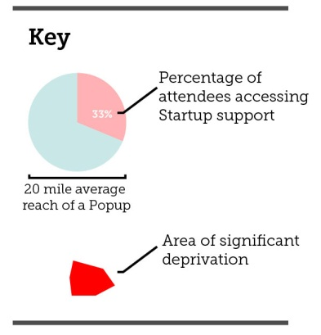
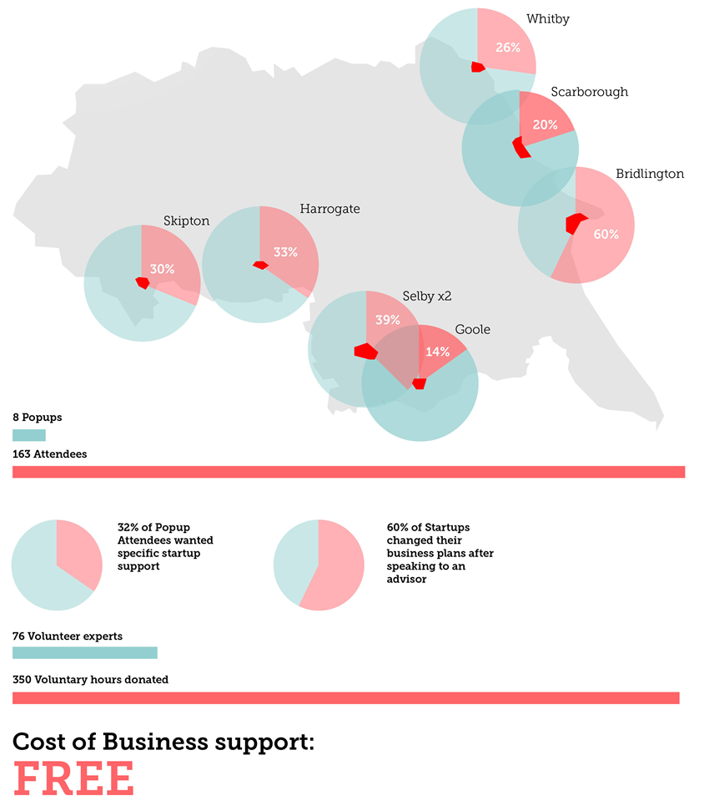
- Greater Cambridge Greater Peterborough Enterprise Partnership (LEP)
The Greater Cambridge Greater Peterborough LEP created a £1m Prize Challenge Fund to help people furthest from the workplace get the skills they need to become work ready and move back into work. The fund is focused on individuals from deprived areas, and those with significant barriers to re-entering the workplace, such as migrant workers or people who are homeless.
- GM LEP (Greater Manchester)
The GM LEP is developing an integrated start up and growth service - to support more residents from disadvantaged areas and groups to start and grow a sustainable business. This would add value to the DWP NEA programme by drawing down European Regional Development Fund (ERDF – that aims to strengthen economic and social cohesion in the European Union by correcting imbalances between its regions) funding that has been ring-fenced by the GM LEP to promote business start-up in deprived areas and amongst underrepresented groups. A total of £3m has been allocated by the GM LEP for this activity until the end of 2018 - representing c£1m per year that could be available to enhance the NEA delivery and to promote business start-up to employed and unemployed residents who are not eligible for NEA support. This approach seeks to build on and enhance the NEA service and support more people, particularly from deprived communities and underrepresented groups, to be able to start a sustainable business.
- Introduction to self-employment sessions would be delivered in a range of community venues across Greater Manchester to enable people to understand whether self-employment might be right for them. Advisors would be on hand to undertake an initial diagnostic with those interested in starting a business and to make them aware of the NEA programme if they are eligible for it. They would identify those who want to start a business but who realistically needed more support to develop their business idea or improve their core skills, and help them to access complementary programmes that could support with ideas generation or Maths and English etc. This could include referrals to colleagues such as Prince’s Trust or local skills / European Social Fund provision (ESF – used to support employment in EU states).
- Help people not suitable / eligible for NEA or other local start-up programmes to start a business. Support would be offered through a mix of workshops and one-to-one support from a dedicated business advisor. The business advisor would support the client both pre-start and once they have started their business, with a key focus on increasing the survival rates and supporting the on-going growth / scale-up of businesses.

Devolved Administrations
- Business Wales
The Welsh Government’s Business Wales service was launched in 2013 to make it easier for Welsh businesses and aspiring entrepreneurs to access the information, advice and support they require to start and grow their businesses. Business Wales offers a single point of contact for businesses and entrepreneurs to information, advice and support from public, private and voluntary sectors, and can be accessed online via http://businesswales.gov.wales and associated social media channels; a dedicated Helpline 03000 6 03000; and through a network of offices located across Wales. Online and face-to-face support is tailored according to client needs, including general business advice, access to finance, innovation, equality, environmental, procurement and international trade support, as well as specialist advice to businesses with high growth potential.
Business Wales aims to encourage an entrepreneurship culture in Wales, as well as supporting individuals to start-up in business and supporting micro-businesses and SMEs to grow and create employment. Business Wales engages across the entrepreneurial cycle, from primary education to established small and medium sized enterprises (SMEs), including social enterprises.
The Welsh Government is committed to tackling poverty in Wales. Aligned to the Programme for Government, Business Wales recognises that self-employment can be a positive route out of unemployment and there is a strong emphasis on engaging with individuals at a community level, who may not normally consider self-employment as an option.
Business Wales support also includes a Participation Fund to help embed the inclusion agenda within the service and to help individuals overcome any barriers they may face in accessing and participating in the service. Activities supported include additional support for disabled people, translation services, childcare and hiring of specialist equipment. The Fund has also supported bespoke workshops for lone parents, women, ethnic minorities and young people.
The Welsh Government support new ways of promoting enterprise in deprived communities, such as the EFFECT project, which is a grassroots approach to building new enterprises. Developed by the Sirolli Institute, the EFFECT model advocates using a community based enterprise facilitator to work with individuals to promote an enterprise culture and encourage self-employment. EFFECT directly targets potential and existing entrepreneurs who might be unlikely to access existing sources of business support. The enterprise facilitator mobilises a diverse group of mentors who in turn use their professional experience to guide, support and add value to the individual business propositions. The Welsh Government, in partnership with Local Authorities, introduced the model in Blaenau Gwent in 2012, and extended to Merthyr, Torfaen, Bridgend and the Severn Valley in 2014.

- Business Gateway Scotland
The Scottish Government is committed to creating a supportive business environment conducive to sustained economic growth for all the people of Scotland to flourish.
The commitment to inclusive growth includes a range of policies in place to support businesses such as supporting Scotland’s local authorities to deliver the Business Gateway service offering a first point of contact for all public sector support to pre-start, early stage and existing businesses with flexibility to offer a localised service to meet business need and opportunity. In addition, Scotland’s Enterprise Agencies ensure focus on those businesses with the potential to grow and those that are important to the economy, helping to create jobs and improve opportunities within the supply chain. These are outlined in Scotland’s Economic Strategy, which focuses Scotland’s ambition to boost economic growth and increase competitiveness alongside a drive to tackle inequality.
Information is available at: http://news.scotland.gov.uk/News/Growing-Scotland-s-Economy-Scotland-aims-to-join-Europe-s-best-16c1.aspx and http://www.gov.scot/Resource/0047/00472389.pdf
Scotland CAN DO is our shared statement of intent to become a world-leading entrepreneurial and innovative nation, working together with our public, private and third sector partners to realise the goals of the framework. Further information is available at: http://www.gov.scot/Publications/2014/04/3454/0.

UnLtd: the foundation for social entrepreneurs www.unltd.org.uk
UnLtd’s job is to reach out and unleash the energies of enterprising people who do good – people it calls social entrepreneurs. UnLtd and its partners support around a thousand people each year to start up or grow social ventures. Its support is built around the journey of the social entrepreneur, from idea to market test, going full-time, building a team and scaling up. It provides a combination of modest amounts of cash with bespoke, one-to-one support. It connects social entrepreneurs to a network of mentors and partners who provide specialist advice, for example on legal issues.
Through a partnership with the Higher Education Funding Council for England, UnLtd has worked with over half of all English Higher Education institutions to help them to support social entrepreneurs within their staff and student bodies. UnLtd also works with business advisers, local authorities, housing associations and community-based organisations to build the ecosystem of support. Through a partnership with Local Trust, UnLtd has worked across the 150 Big Local areas to find, fund and support social entrepreneurs who have the vision and ideas to make their areas even better places to live.
UnLtd also works on the policy environment in which social entrepreneurs operate. It is currently coordinating a group of employers within the BIS Trailblazer process who are developing an apprenticeship for entrepreneurs, including social entrepreneurs. It has developed tools for schools to help teachers to provide their pupils with a taster experience of social entrepreneurship. It is also engaging with careers guidance professionals to promote awareness of social entrepreneurship as a career option.

Apprenticeship in entrepreneurship
In 2014, BIS approved a bid to develop an apprenticeship for entrepreneurs, within its trailblazer process (employer-led groups called ‘trailblazers’ develop apprenticeship standards). This important move recognised entrepreneurship as a viable career choice. It will give those aiming to start their own business or social venture the opportunity to gain experience while building their entrepreneurial skills.
The new apprenticeship reflects the fact that nearly half of people aged 18-30 want to start their own business. However, only a fraction of aspiring entrepreneurs actually start up, with many lacking the skills to begin, or the confidence to succeed. There’s also a growing appetite among young people to make a positive impact on the world. Seven in ten prospective start-ups are influenced by social causes, while 27% would choose to form a social enterprise. The apprenticeship therefore also caters for social entrepreneurs.
Over the last six months, the draft apprenticeship standard has been developed by a group of over a hundred employers and other organisations. The group is chaired by Alberto Masetti-Zannini of Impact Hub Kings Cross and is supported by UnLtd, the UK’s foundation for social entrepreneurs, along with the Federation of Small Businesses and the Centre for Entrepreneurs. Employers backing the bid include Deutsche Bank and a number of SMEs and social enterprises.
Once the apprenticeship standard is approved, it is anticipated that the new apprenticeship will be piloted by employers and apprentices from late 2016. For more information, contact UnLtd www.unltd.org.uk
SFEDI Group
As the UK-government recognised Sector Skills and Standards Setting Body for Enterprise and Enterprise Support, the Small Firms Enterprise Development Initiative (SFEDI) is an entrepreneur led group of organisations responsible for identifying, representing, developing and accrediting enterprise, entrepreneurial and innovation learning and skills.
The Group includes:
· Small Firms Enterprise Development Initiative – which is the government-recognised standards-setting body founded in 1996, part-funded through the UK Commission for Employment and Skills (UKCES);
· The Institute of Enterprise and Entrepreneurs (IOEE) – the UK’s first, dedicated professional learning institute for enterprise, entrepreneurship and enterprise support, recognised by the Secretary of State in 2010 to operate as the only professional UK institute for enterprise and entrepreneurship learning and development;
· SFEDI Awards – the UK’s only OfQual-recognised Awarding Organisation dedicated to awarding qualifications in enterprise, entrepreneurship and enterprise support;
· SFEDI Solutions – providing enterprise research and consultancy, specialising in Further and Higher Education;
· Enterprise Inside – the direct delivery organisation providing operational support in the delivery of national contracts, including the government-backed Startup Loans scheme, Mentor Programme delivery for both the UK government and the British Bankers’ Association
· Apprenticemakers – an online portal for SMEs which has been developed to help apprentice employers across the country to support each other in encouraging a greater take up of Apprenticeships amongst small and medium businesses (SMEs) and was developed following a recommendation in the Holt Review.
The Prince’s Trust
Youth charity The Prince’s Trust gives practical and financial support, developing key workplace skills such as confidence and motivation. It works with 13 to 30 year olds who are unemployed or educational underachievers. The Trust supported over 56,000 young people in 2014/15, 77% of whom moved into work, education, training or volunteering. 93% of young people on Prince’s Trust programmes reported personal development such as confidence or motivation.
The Prince’s Trust’s Business Programme started in 1983 with the aim of helping unemployed young people to start their own businesses through the provision of start-up funding and mentoring. In early 2009 the programme’s success criteria were broadened so that the provision of financial support is no longer the only definition of success. Instead, the programme now supports young people to choose and achieve the outcome which is best for them.
The programme’s aim is to support young people interested in self employment to explore and test their ideas, write plans and start their own businesses or achieve alternative outcomes in education, training, volunteering or work. To more accurately describe this broadened aim, the programme was renamed the Enterprise Programme in April 2010.
The Prince’s Trust’s Enterprise Programme operates throughout the UK and in 2014 helped nearly 9,000 young people aged between 18 and 30. To give an idea of the profile of this cohort, last year 62% of the young people who joined the Enterprise programme were aged 18-25; 24% were educational underachievers (i.e. had not achieved 5 GCSEs A*-C or equivalent); 13% described themselves as disabled; 10% were single parents and 7% were ex-offenders.
Of those young people who decided to start a business with Prince’s Trust support, after 12 months 82% were self-employed and 30% were employed (there may be overlap as young people may have a job alongside running their business).
How the Prince’s Trust’s Enterprise programme works
Stage 1 – the information session. The session aims to tell young people about the programme: its purpose, the support on offer and what The Trust needs from the young people who take part. This will allow the young people to decide whether the programme is for them.
Stage 2 – Explore Enterprise course. Four consecutive days spent in a group of about 10, talking to staff and volunteers, about topics relevant to running a business. The aim of the course is to learn what’s involved in planning and running a business and to work out whether it is what the young people want/could do.
Stage 3 – Next steps sessions. Each young person is offered an average of eight hours one to one support from staff or volunteers to help them think through, choose and plan their next step. For young people who go on to plan and test their business ideas, The Trust can sometimes provide a ‘Will it Work Grant’ to help them, depending on funding constraints and availability in the area. The sessions can be booked on days and at times that suit the young people. In between sessions the young people will need to do some thinking, planning and researching in preparation for their next session.
Stage 4 – Launch your business. Once young people have chosen their next step, The Trust can offer support to help them achieve it. For young people entering a job, education or training, this might be a mentor to help them write a CV or college application. For young people going on to start a business, this is a business mentor for two years, a range of discounted and free support offers and the opportunity to apply for money to help them start their business. Financial support is there for the young people who need it – those that can’t access money elsewhere and who prove their business ideas to be viable
The Pop Up Business School
Pop Up Business School (PUBS), is an enterprise skills provider, working in areas of deprivation with people who are unemployed, single parents, carers or anyone whose life circumstances make it tougher to get going. They describe their approach as “the complete opposite of traditional business support”.
Partnering with housing associations, JCPs, councils and universities, they eschew the traditional business plan based programmes, focusing on an individual’s confidence and the products and services to be sold.
 |   In the Marketing phase we work to tell as many people as we can about the Pop Up Business School. Our job is to find those people that are contemplating enterprise or have already started. |   We 'Pop Up' for a fixed period of time in a space identified by the community. Our job is to give individual-centred high quality support. We run workshops, facilitate peer learning, coach and mentor those people serious about making their own money.
  
  Pre-project we meet key partners and members of the community to create a Pop-Up Business School that will involve and develop people in a way that will best serve the community.
  
  We make a record of our interactions so people can access them after the project has ended. We empower communities to continue the support after the project has ended.

PUBS approach to starting a business:
Build confidence - Start by helping people see it is possible and then believe that they can do it. Everything starts with self-belief and confidence.
Sell something - The quickest way to start a business is to sell something to someone. Don't waste time making it first; go and talk to potential customers.
Ask for the money up front - Most businesses expect you to pay up front before they give you the product. So why do most start-ups do the work first then ask to be paid?
Make a profit - If you sell first and take the money up front you are in profit from day one. You never have to go into debt and the energy that first sale gives you will drive the business forward.
Deliver the product - What you have sold; exceed expectations and delight the customer.
Find more customers - The easiest way to get your second customer is to get another one just like your first. So if your first sale was to a hotel; go and pitch to every other hotel in the area!
Repeat and have fun - Business should be fun, if you don't enjoy it then you aren't going to keep doing it. So let's find a way to have fun and make money at the same time.
Housing Associations
Housing associations have an obligation to support their tenants to improve their life chances. Typically, a housing association will have a wide offer of skills and employment development courses, from apprenticeships, job search support like CV writing and skills classes. Often, they partner with other service providers to deliver these programmes, including enterprise.
Library Enterprise Project
The British Library Business & IP Centre National Network is transforming city libraries into engines of innovation, economic growth and social mobility in the heart of diverse and disadvantaged communities. The Business & IP Centres are physical hubs where people can come together to learn, network and access free and low-cost information and support in protecting and commercialising a business idea. In addition to the London Centre, based in the British Library’s St Pancras building, current Centres are in central libraries in Birmingham, Leeds, Liverpool, Manchester, Newcastle and Sheffield.
The National Network has proven potential to create essential businesses and jobs in devolved cities across the UK at a relatively low cost, due to its effective use of existing resources, knowledge and public buildings, as well as its unique public-private partnership model. All the libraries are part of the Patent Library network, coordinated by the Intellectual Property Office (IPO) and thus have IP collections and expertise, as well as up-to-the minute electronic company, financial and market research data. Information professionals are on hand, all day every day, to help people find the information that they need. The information is supplemented by a regular programme of workshops, events and one-to-one advice, delivered by both library staff and private partners and designed to teach people the vital skills and knowledge they need to set up and run a business.
The project was kick-started in March 2012, with £100,000 from the IPO, which enabled the British Library to develop a blueprint of its model and conduct feasibility studies in five major cities, based on a successful pilot in Newcastle.
Enterprising Libraries was initially a £1.3m partnership between the Department for Communities and Local Government (DCLG), Arts Council England (ACE) and the British Library, which enabled Newcastle Business & IP Centre to sustain its service and another five pilot projects in Birmingham, Leeds, Liverpool, Manchester and Sheffield, to become operational centres. It also supports ten innovative satellite projects to work with the centres in a hub and spoke model. The ten are: Devon, Enfield, Haringey, Hull, Greater Manchester, Middlesborough, Norfolk, Northampton and Wellingborough, Portsmouth and Cultural Community Solutions (covering Harrow, Ealing and Hounslow).
Based on early successes and, in order to sustain the network over 2015/16 and bring on two new pilots from the satellite projects in Northampton and Exeter, DCLG and ACE granted the British Library a further £400,000, in addition to the British Library’s commitment of £253,000 in cash and non-cash resources.
Outcomes achieved
An independent economic impact analysis of the National Network over the period April 2013 – March 2015 revealed that Enterprising Libraries:
- Generated £38 million GVA (Gross Value Added) on investment, with an estimated increase to £214 million by 2018
- Created almost 1,700 new businesses and over 4,200 jobs, with an estimated increase to over 4,100 new businesses and over 22,000 new jobs within the next three years (almost a third in the ‘Northern Powerhouse’)
- Created a payback of £4.50 for every £1 of public money (estimated to grow to £25 payback for every £1 invested by 2018)
- Supported diverse communities: 47% of people who had started a business were women, 26% were BAME, 8% had a disability and 25% had previously been unemployed or made redundant
- Achieved a lower cost per job created and higher GVA leverage, compared with other business support initiatives
Subject to further funding, the British Library plans to have a National Network of twenty centres by 2020, which act as the ‘front door’ to business support for people from all walks of life; these will continue to be backed up by online content, webinars, streamed events and one-to-one advice via Skype.
The Premier League
The Premier League Enterprise Academy programme was set up to help teach 11-19 year-olds the basic principles of business and self-employment. Inspired by a model pioneered at Middlesbrough, the Enterprise Academy has seen 135,000 pupils taking part in its first two years, with more than 1,500 young people securing university entry-level qualifications as a result of the programme.
The work done by Middlesbrough, alongside successful programmes delivered by professional football club community schemes at Blackburn Rovers and Burnley, highlighted an opportunity for other clubs to engage young people in the enterprise agenda.
In 2008, The Premier League, in partnership with BIS, agreed plans for a national roll-out, with Manchester City and Aston Villa running pilot projects. Based around a 10-week course first developed by Middlesbrough, the programme helps 14-16-year-olds understand the basic principles of business through a range of interactive learning opportunities both in the classroom and at football stadia.
With funding from The Premier League Professional Footballers’ Association (PLPFA) Community Fund and the Regional Development Agencies, 12 clubs are now delivering the programme to thousands of young people and giving them an OCR (Oxford Cambridge and RSA Examinations) accreditation.
The results:
- Through the Premier League Enterprise Academies more than £2.5m in funding has been granted to deliver business education to young people in Key Stage 3, 4 and 5
- More than 210 schools are engaged in Premier League enterprise activities
- More than 115,000 children have taken part in the last two years with clubs
- 1,500 OCR Business and Enterprise qualifications were achieved in the last two years
- A further 5,000 children will achieve the qualification in the next three years and
- More than 3,000 young people were involved in the Premier League Enterprise Challenge 2010.
E-Spark
Entrepreneurial Spark (E-Spark) works in collaboration with special mentors, entrepreneurs and professional services businesses. From lawyers to accountants, from manufacturers to investors, they all add great real-time, real-life value to our entrepreneurs. This helps them break down barriers quicker, while joining up the dots in the entrepreneurial ecosystem.
E-Spark bill themselves as “The world’s largest free business accelerator for early stage and growing ventures”. The model focuses on developing the individual into being an entrepreneur rather than just on the particular business proposal they are working on. A total of 352 businesses have been supported as at the end of 2014 – from the first three Scottish ‘Hatcheries’. There is an ambitious expansion underway - seven ‘hatcheries’ are now in operation, with a plan for a total of 13 to be open for business by the start of 2017. Their ambition is to enable over 1,000 entrepreneurs each year, growing to 7,000 over five years.
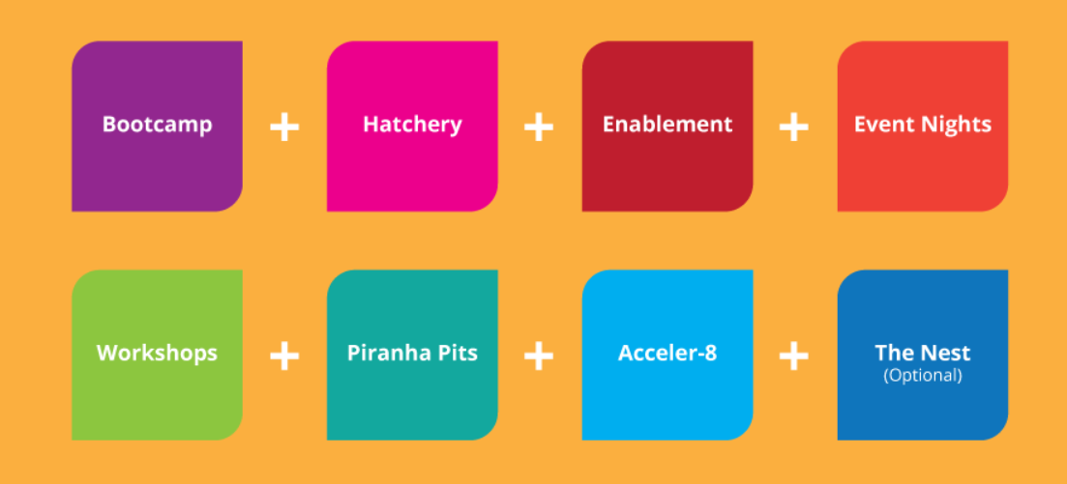
Scottish Edge
Scottish EDGE is a competition aimed at identifying and supporting Scotland’s up-and-coming, innovative, high-growth potential entrepreneurial talent. Scottish EDGE is made up of four categories; Scottish EDGE, for companies of all sectors and stages; Higgs EDGE, a special technology award aimed at entrepreneurs who have an engineering, science or technology based business and have a product, or product under development, which is scalable and capable of globalisation; Young EDGE, for companies where all directors are under the age of 30; and WildCard EDGE, for companies who are currently pre-trading.
Historically the Scottish EDGE was run by Scottish Enterprise and Highlands and Islands Enterprise alongside various partners. However, in August 2014 Sir Tom Hunter and RBS agreed to extend the success of the fund and lead in its delivery going forward.
Winners of Scottish EDGE receive:
- Funding of up to £100,000 with Scottish EDGE or funding of up to £150,000 with Higgs EDGE
- 50% of Scottish EDGE and Higgs EDGE funding is a pure prize, we then expect you to ‘pay it back’ by repaying the 50% loan back to EDGE to help your fellow entrepreneurs on their pathway to success
- Up to £10,000 grant with Young EDGE
- Up to £10,000 grant with Wild Card EDGE
- Mentoring and support from a mature entrepreneur and access to a range of public sector assistance via our partners Business Gateway, Scottish Enterprise and Highlands and Islands Enterprise
- Enrolment into the EDGE Alumni programme where you will become part of the movement to further build entrepreneurial Scotland and gain access to alumni events and showcases including the Scottish Business Award celebration of success.
- Packages of support from leading business organisations such as Harper Macleod, Johnston Carmichael and James Hallam plus have the chance to learn from and connect with experts from world renowned organisations such as Amazon Web Services at the Scottish EDGE Final
- Signposting to alternate funding and funders where appropriate

What needs to change?
There is a record number of businesses operating in Great Britain, but people living in the most deprived communities still face barriers to starting up their own businesses. This review has seen how a core of programmes and organisations are striving to open enterprise opportunities in these areas. These include established and welfare to work providers, some of whom hold NEA and Work Programme contracts, The Princes Trust, to the innovative approaches spearheaded by the likes of Pop Up Business School.
As well as the need to support people from deprived areas with their businesses, there is an important need to acknowledge the positive difference that starting a business in those deprived areas makes. As this Review looks at how to improve the conditions for these businesses to start, we cannot ignore the opportunity to increase overall levels of employment and with them the aspirations of the people who live in deprived areas.
This Review makes a suite of recommendations to boost enterprise in more deprived communities. Some are high level, others propose detailed improvements. Together they are designed to tackle the emotional and material barriers people face to starting up.
Mentoring
The main barriers people face when thinking of starting up in more deprived areas are closely linked: lack of confidence; loneliness; poor networks leading to difficulty finding informal support. These issues can affect people starting up from any background, but this Review finds that they are more prominent in more deprived areas. With almost half as many businesses in deprived areas than average, there are fewer experienced businesses to guide a start-up or to inspire future entrepreneurs. The entrepreneurial networks are weaker.
The BIS research paper “Demand for Mentoring among SMEs” had a number of important and positive findings:
- “Mentors can help to implement change”. A total of 74 per cent of all SMEs agreed with this statement, with seven per cent disagreeing. 87 per cent of those that had ever used mentors agreed with this statement, with six per cent disagreeing. Of these 71 per cent who have never used a mentor agreed with the statement.
- Those using mentors were far more likely to have introduced new or significantly improved product/service or processes in the last 12 months than those that had never used a mentor.
- “Of those currently using mentors, 87 per cent were satisfied, and none were dissatisfied.”
- “Of those who have ever used a mentor, 42 per cent would actively advocate the use of mentors to other business owners and managers. 39 per cent would recommend it if asked. Thus, 81 per cent of those who used a mentor would recommend it.”
It is not surprising that the weight of evidence around the benefits of mentoring is based on the experience of mentees. It is important to explore the effects of mentoring on the mentor, too. There is a mixture of benefits for the volunteer mentor.
Mentoring can give positive emotional outcomes for the mentor; it is hard to argue against the premise that it is good to help or to teach. Some surveys address the question of other rewards of being a mentor. The SFEDI/BIS report on the Get Mentoring programme details that 59 per cent of their mentors found their ability to run their own business was improved and 61 per cent had improved direction and development of their own business as a result of mentoring and the training they had undertaken in that programme. In short, everybody gains.
Recommendation 1: This Review recommends that all entrepreneurs consider how they can pass on their experience and knowledge to help people starting up in business. People can do this through their local NEA provider:
https://www.gov.uk/government/collections/new-enterprise-allowance-information-for-mentors
or through the ‘mentors me’ gateway:
http://www.mentorsme.co.uk/
The New Enterprise Allowance (NEA)

As noted earlier in the report, the NEA has achieved exceptional results, helping create over 75,000 new businesses led by people previously claiming out of work benefits. Of these around 80 per cent are still trading today. It is an effective, essential and value for money programme.

The review heard a number of ways the scheme could be improved. Many providers and participants felt the length of the programme was too short. Whilst there was acknowledgement of the benefits of the ‘payment by results’ nature of the programme, a number of stakeholders reported that the design of the current contracts causes providers to focus on outputs over long-term outcomes for participants, and on quantity over quality.

Many of the businesses created provide the owners with a limited income that leaves them dependent on tax credit income.

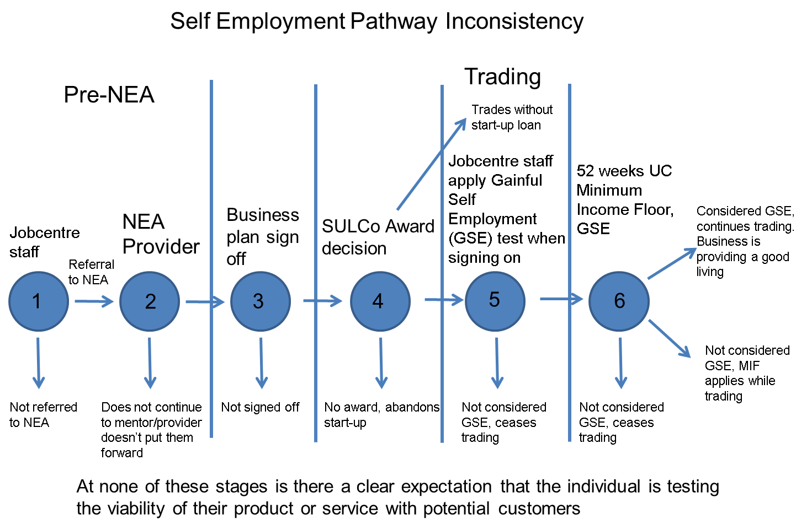
The illustration above shows the critical decisions that might be made during a participant’s journey through the NEA to establish a business and includes the divisions where the providers receive payment (as in previous NEA diagram):
- 10% on accepting a referral
- 30% on producing a signed-off business plan
- 30% on start of a business
- 30% on the business sustaining to 26 weeks
Many of the businesses that are created generate a low income. A total of 58 per cent reported a turnover of less than £1,000 per month and that this would most likely mean that they would not be considered “gainfully self-employed” (GSE) when they are reviewed later by Jobcentre Plus (JCP).
Along this journey, an individual can get the ‘go-ahead’, from
- the JCP Work Coach who refers them to the programme,
- the NEA provider who accepts their proposal, supports their plan and signs it off; and
- SULCo who may lend capital to start up.
Following this series of confirmations, the business person might still end up with a business that provides very little income. If this person is in receipt of UC, they will then face the challenge from their JCP Work Coach that their earnings must increase to the equivalent of a full-time earned income at the National Living Wage by the 12 month point. With support, the aim is that the profitability of their business can be increased to allow them to reach this Minimum Income Floor (MIF). If not, they must decide to either:
- Continue focusing on their business and accept a reduction in their UC which is imposed by the MIF; or
- Continue their business but accept that they must actively seek work in addition; or
- Cease their business and accept a full award of UC and focus on seeking other employment.
Recommendation 2:
i. A Strategic Enterprise Oversight Group (SEOG) should be created, with representatives from DWP responsible for self-employment support in UC, the NEA policy team, the LEP network, SULCo, BIS and the BBB. The role of this group is to align the objectives of the Department’s enterprise programme and its payment structure with the self-employment policy in UC, and with wider external enterprise support. There are existing professional relationships between these teams, but they would benefit from a more formal connection. This group can provide on-going strategic oversight of these different elements of enterprise support. It should meet regularly.
ii. The NEA contract structure should be changed, to align the final outcome payment with the UC MIF. This will create a consistent goal for participants and providers alike, and require both target the creation of truly sustainable businesses. Within the current funding limits, this may result in a lower number of higher quality businesses being created (see Recommendation 7).
iii. a) Self-employment training for JCP staff must be improved, and effective communication products for providers and coaches should be developed. This will help prepare staff to administer the Gainfully Self-Employed test in UC, and must include the MIF as a central consideration. DWP has already begun work on this.
b) Currently, self-employed people with low incomes are supported by Tax Credits. They will be migrated to UC from 2018. Rather than wait for this, HMRC should begin engaging with self-employed tax credit claimants now, to support them ahead of the transition.
There are many examples of high quality business start-up support. Organisations such as Techstars have innovative models to incubate high potential growth business ideas. There is an exciting opportunity to learn how some of the methods of this type of more exclusive start up support can be applied to support for people setting up mainstream businesses, to make a positive change in more deprived areas. Global Entrepreneurship Collective (GEC) provides a fascinating case study from the United States (as detailed in this report p51). A key element of the GEC programme is to challenge people starting up to do extensive pre-trading customer testing. In Britain, the Review saw a similar focus in the Pop Up Business School (PUBS) programme (p34). There are a number of key themes that these models share:
- Focusing on the confidence of the entrepreneur. Usually starting with small groups that start the programme together, the accelerators build confidence by creating a small community of entrepreneurs; introduce them to the basic principles of business and work to increase the individuals’ motivation to succeed and belief in their own abilities.

- A shift from focusing first on detailed business planning to customer testing. As clearly demonstrated by PUBS’ model, before investing valuable time and resources theorising potential markets and growth, they aim to test the product or service to be offered with customers and secure sales as early as possible. The high-end tech accelerators take a similar approach, where entrepreneurs shape their product and might move fluidly between businesses leading up to a set date to pitch their idea to investors.
In more traditional business support models, start-ups focus their time on creating written business plans that are then used to secure capital to further develop the idea and to start trading. Ideally, the entrepreneur would seek and assimilate advice from a range of professional areas, such as accountancy, marketing law, intellectual property and manufacturers, depending on the type of business.
This traditional model could be more challenging for a potential entrepreneur from a deprived area. They might be less likely to have dealt with professional services or to have a strong and diverse network to draw support from that includes successful entrepreneurs. Also, an individual who is more financially secure can afford to spend time to develop a detailed and comprehensive plan or to pay for detailed advice to support it.
PUBS and GEC have designed their approaches to enterprise support for disadvantaged areas and groups. They both tackle issues around confidence and ensure that a complete novice to business will be surrounded by a supportive group. Participants in their programmes have access to experienced entrepreneurs, their networks and professional services when needed. People who complete these programmes leave with a business concept which is tested in practice, rather than just on paper. The NEA programme should incorporate this good practice: as the previous illustration demonstrates, there are a number of critical decision points in the NEA programme but at none of these points is the participant’s service or product necessarily tested.
iv. The Review recommends that customer testing be integrated into the NEA so that participants can be assured of their businesses viability, supporting the aim to create long-term sustainable businesses.
In many cases the NEA may be the only start up support accessible to a benefit claimant. It is welcome that the NEA has been extended to include people on the main sickness benefit, ESA and IS for lone parents . By default, the pre-trading support in the NEA lasts for eight weeks. This can be extended to twelve weeks. The Review heard that eight weeks can be too short a period for some claimants who need more time to prepare. There is a balance to be struck, as while someone is receiving state income support it comes at a cost borne by taxpayers.
Some NEA providers and Jobcentres have created pre-NEA programmes of introductory courses, sessions or presentations that have ensured that participants are better prepared to start the NEA and focus on business development during the 8 week mentoring period.
The Princes Trust’s Enterprise Programme also follows this model, offering information sessions and an Explore Enterprise course before young people commit to developing a business.
The Review has also noted that effective business role models might be more lacking for deprived areas and that an introduction to an established local business is important for inspiring and motivating entrepreneurs.
v. The Review recommends that DWP require NEA providers to facilitate, with JCP, pre-NEA networking and advice sessions using the branding “Link Up: Start Up”.
This pre-NEA activity can help with targeting NEA support. In addition, involvement in this activity will bolster the advisory skills that Work Coaches have. Some claimants will come to the conclusion that they do not wish to pursue self-employment as a result, or their Work Coach may advise that it is not a suitable path. This filtering will reduce the number of referrals that do not result in someone starting to trade.
In order for NEA providers to meet the outcome target for people’s business income to exceed the UC MIF at 12 months, they will incur greater cost. This reflects the higher quality, more intense support they will have to offer. More targeted referrals will help, but this step up in quality will mean a smaller number of people are supported overall, if spending is contained within the current budget.
vi. The Review recommends that future NEA contracts focus on increasing the quality of support, and that Government should accept that this may come with a higher unit cost, and, that as a consequence, there may be a reduction in the number of starts. This will require a more targeted referral process. Link Up: Start Up will help this targeting.
As previously noted, the NEA is a successful, value for money programme, that has a strong set of outcomes. Given its impact, Government should do more to highlight it and encourage participation.
vii. The Review recommends that an annual NEA prize be created that will serve to attract interest in enterprise and will effectively showcase the most inspiring business ideas.
viii. The Review recommends that DWP considers extending the pre-trading period for vulnerable claimants, so that they have up to 12 weeks to complete their business plan by default.
The Review has heard from a number of NEA Providers who have committed to continually improving the service they provide and focus on the quality of mentoring that is delivered.
The NEA provides a regular income while participants are preparing their business plans, with their existing benefit claim continuing. When they begin trading, they are awarded a weekly allowance of £65 for the first 13 weeks, followed by £33 for the next 13 weeks. This helps to support the individual with the normal costs of living and does not affect any other entitlement they may have, for instance, to Housing Benefit, helping them to focus on their new business.
The mentoring provided by the NEA programme is key and means that the participant has access to advice and emotional support to help manage the pressures that come with starting a business. When this is done well, the mentoring provided for a start-up is invaluable and can make the difference between someone starting up successfully or not.
One NEA provider described how they asked for feedback from the participants on the mentoring they received and fed this into regular forums that they held with their mentors. It was noted, though, that this represented good practice from the provider and that is not a requirement of their contract, nor is mentoring performance monitored by DWP.
DWP’s survey on the NEA notes:
“Of those that received support from a mentor, the majority (83 per cent) rated it as helpful in supporting them to develop a business plan.” However, 11 per cent of those surveyed reported that they had received no mentoring at all.
ix. The Review recommends that better monitoring, feedback and evaluation is conducted by all NEA providers and that this should be assured through their contracts.

Outcomes for Entrepreneurs

The Review has heard from dozens of entrepreneurs and organisations who support start-ups. In the main, NEA participants contributing to the Review were those in the process of starting-up or those who had started their business already. There is a lack of understanding about the experience of those NEA participants who decide not to start a business.

DWP’s most recent survey of NEA businesses shares this deficit to an extent, questioning participants about how they found the NEA and their experience following starting-up. The survey was aimed only at those who had a completed business plan and claimed the weekly allowance (between November 2013 and April 2014). This therefore excluded those NEA participants who either did not complete the mentoring and business planning or the majority of those who completed a plan and had the opportunity to start but decided not to. There were a minority of respondents who received the allowance but who did not start trading.

Reasons businesses did not start trading
The 85 respondents whose businesses did not formally start trading were asked to select reasons from a pre-prepared list to explain this, or to state a reason other than that captured by the list. From the options provided, the most common reasons given were ‘finding alternative work as an employee’ and ‘difficulty getting credit or capital to support the business’, with these options each being selected by 23 out of the 85 respondents. Less common options selected were ‘discovering that there was no market for the service/products offered’ (12 respondents), suffering ‘ill health’ (10 respondents) and having problems being able to start the business alongside ‘caring and other family responsibilities’ (2 respondents).
Of the 85 respondents, 31 provided an ‘other’ reason for not commencing trading. These covered a wide range of largely specific and individual reasons, including: practical or logistical considerations (e.g. not having access to a vehicle); issues occurring in peoples’ lives meaning that the business was put on hold and not subsequently started (e.g. death of family member, issues with a landlord, financial or debt issues); issues specific to the planned business such as falling out with intended business partners; not managing to start the business at that point for whatever reason but still planning to do so; and deciding to go back into education.
Interestingly, just over two-thirds of the 85 respondents who had not commenced trading did feel that they would start and run another business in the future (57 out of 85). Only 15 of the 85 stated that they would not, while a further 13 were unsure. This suggests that, for at least some of this group, their experience of the NEA may act as an encouragement to starting a business in the future, perhaps if and when some of the issues preventing the business starting are able to be resolved.
DWP therefore has no robust data to detail why NEA participants chose not to start a business or on barriers to starting up. The only evidence provided in this space came from anecdotal or general feedback from JCP staff involved in the NEA and a broad range of NEA providers.

The latest statistics show that 15,620 businesses started from 36,470 mentoring starts for the period from October 2014 to September 2015, whereas the previous year before saw 24,710 businesses start from 44,310 mentoring starts. This reduction should be considered in the context of the wider labour market. There has been a continuing rise in the levels of employment and a corresponding reduction in benefit claimants that is the base for NEA referrals. Numbers of JSA and UC claimants fell 159,800 to 796,200 in the year to September 2015, a reduction of 16.7 per cent.

The NEA mentoring starts have reduced by around 17% but the number of businesses created has reduced by around 36 per cent. The proportion of mentoring starts that lead to a business being created has fallen from 55 per cent to 42 per cent. The recommendations concerning the NEA aim to reverse this trend.

This Review has also looked at availability of finance for start-ups and NEA participants in particular. Through the NEA programme there is a natural link to SULCo for those that need finance.
A total of 2,732 Start Up loans were issued to NEA businesses in the year up to December 2015, a drop from 5,380 in the previous year; a 51 per cent reduction.

Both of these trends suggest that it is becoming harder for potential entrepreneurs, who are currently claiming benefits, to succeed in starting up. Although a very limited sample, the NEA survey indicates that a significant proportion of those who do not start their business do so because they cannot access finance.

3. Recommendations around Start Up Loans

SULCo is a private sector company that is tasked with delivering the Start Up Loans programme that is given policy parameters set by BIS. BIS in turn is advised on how to best make finance available or where gaps in the market exist by BBB.

We have heard from NEA providers that they have concerns about the regulatory position concerning them directing participants to SULCo for finance. In particular, they feel that a referral risks being interpreted as giving partial financial advice. DWP’s procedures state that participants should be “signposted” to SULCo if their start-up requires finance, however this regulatory ambiguity persists with the likely consequence that NEA providers do not feel confident in their position.

i. The Review recommends that explicit advice is given to NEA providers to give them clarity and confidence to continue to support their clients’ access to Start Up Loans. This should be a priority for the Strategic Enterprise Overview Group (SEOG).

As with most forms of finance provision, there is an element of credit scoring used to assess SULCo’s loans. This is also balanced with an assessment of a start-up’s business plan with the intention that there can be some flexibility where a sound business plan is presented but where the credit score would normally be insufficient.

It is the intention that the NEA business plans can be used to help process Start Up Loan applications, and this results in a lower administration cost for loans processed for NEA participants, compared with the costs of processing non-NEA referred loans. Many SULCo delivery partners report that the business plans that NEA participants present are not detailed or clear enough for their needs.

ii. The Review recommends that work is undertaken by SEOG to align the business planning assessments by SULCo and NEA providers and that DWP considers making this a quality assessment measure.

SULCo was created to fill a market gap where potentially viable businesses could not access commercial start up finance at a reasonable rate. Start Up loans are personal loans that incur interest at a fixed 6%. Interest payments are recycled back into the fund to benefit more entrepreneurs. There is a trade-off between the need to ensure value for money for taxpayers by ensuring loans are prudently issued, and taking a chance to lend to people who are not considered a safe risk by commercial lenders. SULCo’s current objectives do not incorporate a calculation of the wider exchequer benefits that result from improving someone’s life chances when they create a sustainable living out of self-employment, breaking out of benefit dependency.

The reduction in SULCo lending to NEA businesses coincided (but is not the only cause) with SULCo being required to deliver against tightened default targets, so that the programme could stay within its funding envelope. Previously, a portion of NEA referred Start-Up Loans were funded by DWP, which is not the case anymore. The tightening of lending criteria was a result of higher than expected default rates across the programme and particularly in the NEA segment.
The reduction in SULCo lending to NEA businesses coincides with tighter lending instructions being given to SULCo. This is a cause for concern.

Start Up Loans issued to NEA participants cost less for two reasons. Firstly, the fee given to SULCo delivery partners is lower to reflect the preparation the NEA provider makes with the applicant. Secondly, SULCo faces marketing costs to stimulate interest from other sources.
This lower administration cost of lending to NEA participants can be used to tolerate a higher risk profile. As a principle, the value of supporting someone who demonstrates a potentially viable business proposal, that could lift them out of benefit dependency, should be explicit in the objectives given to SULCo.

iii. DWP and BIS officials should work together with the British Business Bank to explore what could be done to incorporate a consideration of how a loan might transform an individual’s life chances in SULCo’s objectives and grant letter, if that individual has a viable business proposal. This reflects the wider social and economic benefits of breaking that person’s benefit dependency. This should be achieved in a way which protects SULCo’s ability to deliver its overall objectives.

4.LEPs

LEPs are well placed to link established local business support to new businesses. It is a key part of their objectives to improve the conditions for local businesses to start and to grow.

As we have heard from a number of LEPs, some areas have made links to the national NEA programme and have designed certain parts of their enterprise support to specifically augment it, recognising the vital role it plays in creating businesses for the unemployed. The general landscape of enterprise support is varied and complex to navigate. For service users, it is an added difficulty to begin their business through the NEA, then, if they should want further support, spend valuable time at the start of their business forging new contacts and support networks.

i. The Review recommends that a seamless handover takes place for all businesses that start through the NEA to the LEP or Growth Hub, so that they can access long term support after the normal NEA programme has ended and that a special focus be made of those NEA start-ups that show the best growth potential.

ii. The Review Recommends that data sharing arrangements should be pursued between NEA providers and their local LEP enterprise support so that start-ups can have the widest access to support possible and LEPs and their Growth Hubs can have the clearest view of entrepreneurial activity in their areas.

iii. The Review recommends also that LEPs, and Growth Hubs where they have been established, should be involved in the pre-NEA activity to introduce established local entrepreneurs and facilitate the recommended networking events.

5. Entrepreneurship and character education
Lord Young’s report on enterprise education shone a light on the value of early experiences of entrepreneurship. Building experiences of entrepreneurship into the school experience helps young people develop the enterprising skills and confidence required to eventually run their own business, as well as those character traits sought after by employers. A taste of social entrepreneurship can be particularly appropriate from the school perspective, and would respond to the burgeoning appetite among young people to combine a career with social action.

The Review applauds the efforts of organisations, including The Premier League and UnLtd, who have created innovative approaches to enterprise education and encourages school leaders, councils and the Department for Education to investigate and incorporate this best practice.

6. Banks
Banks play an important role in enterprise support. The leading retail banks have a variety of enterprise support programmes. More can be achieved. Banks should be involved in creating long term, well-constructed business support that is easily accessible to deprived areas. E-Spark is an example the Review visited, that was created through the support of RBS and has had success creating new businesses (see page 37).

Spurred by this example, I will be working in a personal capacity with leading retail banks to create a nationwide network of bank funded enterprise hubs, independent of Government. Currently, HSBC have committed to identify appropriate locations to pilot this initiative. This project will continue following this Report.

Other issues considered by this Review
- Global Entrepreneurship Collective
Greg Meier, the co-founder of Global Entrepreneurship Collective Inc. (GEC) was a key contributor to the Review. GEC is a not-for-profit organisation that builds and delivers world-class entrepreneurship programmes to disadvantaged communities. GEC trains entrepreneurs and businesses in these communities in the best practices for starting and growing a company. GEC also trains and develops mentors to support these starting and growing enterprises. GEC's practices are embodied in an accelerator format, which involves a concentrated period of intensive training and customer interaction. As one of the highest performing training programmes and accelerators in the world, GEC is a member of the Global Accelerator Network. In addition, GEC is well-known for its application of the best practice for starting businesses in the 21st Century - the Customer Development Methodology/Lean LaunchPad Program (“LLP”). GEC uses the LLP as its core process for teaching entrepreneurship. Their work has been considered pioneering by many, including the LLP's architect, Steve Blank.
Since May 2012, GEC has been collecting metrics that help continually improve outreach to better serve entrepreneurs. Typically, each cohort will train 7-10 start-ups. The team has worked with over 75 start-ups in the last five years, their graduates have raised over $4.5m in total follow-on capital, and created over 150 new jobs.
Greg explained how the most cutting edge start-up programmes, that are normally associated with tech firms, could be used to help disadvantaged communities. Central to their work is testing the market/customer appetite over more traditional business planning. The closest to this approach I have seen in the UK is the Pop Up Business School programme. I believe the NEA and other schemes should learn from GEC’s success, and adapt to incorporate the key elements such as customer testing.

2. Business Link
Business Link was a network of Government funded centres that provided advice to business. It was augmented with by a website that provided a comprehensive range of online guidance.
The Coalition Government announced the cessation of the regional Business Link while retaining its online services, stating:
“Evidence shows that businesses that use external business advice are more likely to thrive and grow and for a number of years Government has been active in the market for advice to business. At £154m per annum, the cost of this support has been high. In the current climate, it is essential that we invest to make services provided by Government as efficient and effective as possible and focus hard on investing to support businesses with the potential to grow and lead the way to recovery.
Our aim is that government interventions should be about developing a stronger private sector-led business service market. There is a large market for business support and we know that businesses generally prefer to seek advice from the people they trust most – usually other business people.
We have concluded that closing the Business Link regional service would enable us to focus government expenditure on increasing the number of high growth businesses that create the most jobs and wealth and on improving the information and guidance to business provided online and over the phone. The regional Business Link service will therefore close on 25th November 2011. We intend to establish a streamlined system of providing information and guidance to businesses and people looking to start up.”
It had mixed reviews on its effectiveness but was certainly a well known organisation and fulfilled the important role of providing a clear gateway to business advice.
- Childcare
Childcare is a concern for all working parents and without childcare support many businesses might never take off. The announcements from the Government are to be welcomed, committing an extra £300m annually to increase childcare funding. This is how that funding looks broken down for a self-employed individual and what is still to come:
The Government offer:
Tax Credits
Tax credits currently provide support for up to 70 per cent of childcare costs up to a maximum cost (so the child element provides up to £122.50 extra on benefits per week for 1 child, or £210 extra for two or more children). To be eligible you have to work at least 16 hours per week, by declaration for self-employed. You have to forecast your average childcare costs across a future tax year.
Universal Credit
UC currently provides support for up to 70 per cent of childcare costs up to a maximum cost, which equates to £532.29 per month for one child and £912.50 per month for two or more children. This will rise to 85% in April 2016 to up to £646.35 for one child and up to £1108.04 per month for two or more children. Under UC both parents normally need to be in work. There is no requirement to work 16 hours. Childcare costs are reported and reimbursed monthly in arrears.
Free childcare and education for 2 to 4-year-olds (England)
All 3 and 4 year-olds in England are entitled to 15 hours free early education each year. This is also available to the most disadvantaged 2 year-olds. From September 2017, the free childcare entitlement in England will be doubled to 30 hours a week for working parents of 3 and 4 year-olds, where each parent earns, on average, a weekly minimum, equivalent to 16 hours at national minimum wage or national living wage, and less than £100,000 per year. This free childcare is worth around £5,000 a year per child, including £2,500 from the existing 15 hours.
Tax free childcare
Tax free childcare (TFC) will be available from early 2017. For every 80p paid into a newly-created Childcare Account, the Government will contribute 20p. The Government will top up the account with 20% of childcare costs up to a total of £10,000 per year, the equivalent of £2,000 for each child (£4,000 for disabled children).
The scheme will be available for children up to the age of 12 (17 years for children with disabilities) where the working single parent or couple has an income of not more than £100,000 per year. It will be available to both employed and self-employed parents.
The existing Employer Supported Childcare scheme (childcare vouchers), available for employed earners, will be open to new entrants until TFC is launched. Parents who wish to remain in the scheme once TFC is launched will be able to, while their current employer continues to offer the voucher scheme.
- Education
Education is the best place to ensure the skills and drive of all workers. If a child sees the good that comes from hard work and can see the opportunities and reward that follow then the most important lessons of work have already been learned. I fully believe that enterprise has a place in all schools’ curriculum, especially in deprived areas where it’s much more likely that successful business will seem out of reach. As Lord Young noted in his report Enterprise for All:
“Enterprise means more than just the ability to become an entrepreneur. It is that quality that gives an individual a positive outlook, an ability to see the glass as half full rather than half empty, and is a valuable attribute for the whole of life. It is a quality many bring with them on starting primary school but far too many leave secondary school without…That is why I am recommending that all courses should include a core module on starting a business so that all graduates will leave with the necessary skills.”
I support his findings.
- Late Payments
SMEs are owed a total of £32.4bn in late payment. On average, small businesses are waiting for £31,900 in overdue payments. The Government’s focus to resolve this issue has been to produce means of mediating, highlighting best practice and publicly reporting to act as a deterrent.

Small Business Commissioner
Through the Enterprise Bill, BIS is introducing a Small Business Commissioner to help small businesses resolve business-to-business disputes, tackling, in particular, late payment issues in three key ways:
- Enable small businesses to resolve disputes and avoid future issues through general advice and information
- Signpost to appropriate services e.g. sector ombudsmen or regulators, existing independent advice services, approved alternative dispute resolution (ADR) providers or the Commissioner’s own complaints handling function
- Consider complaints by small business suppliers about payment issues with larger businesses that they supply.

SBEE Act Reporting Requirement
The Government legislated in the Small Business, Employment and Enterprise Act 2015 to introduce a tough and transparent new reporting requirement for the UK’s largest companies to report on their payment practices and performance. Large companies will be required to report half-yearly on a series of narrative components and a comprehensive basket of metrics including, the proportion of invoices paid beyond agreed terms. This information will have to be published to a central digital location and will be made publically available. The purpose of this report will be to subject companies’ payment performance to full public scrutiny, give small businesses the information they need to negotiate fairer terms and challenge and encourage companies to improve payment practices. This measure will come into force in 2016.

Prompt Payment Code
We have strengthened the Prompt Payment Code to introduce 30 day payment terms as a norm and a maximum term of 60 days for all signatories. The new Code Compliance Board will rigorously monitor the Code and ensure the highest standards are met by all signatories.

- Franchising
Franchising is one of the most recognisable forms of self-employment. We often think of franchising with the big obvious companies, such as McDonald’s or Subway but the reality is a wide and varied scene. Franchising offers individuals a chance to access a tested business model and the support from the franchisor. Franchising is where the owner of a franchise system (‘the franchisor’) agrees to license the use of its operating systems, brand and other Intellectual Property, and provide training and on going support to enable another person (‘the franchisee’) to start up and run an identical business elsewhere. Franchisees of well-established franchise systems benefit from:
- Businesses based on existing models with proven track-records,
- Initial training and ongoing support (which also make franchise businesses more accessible to those without work experience or skills),
- Better access to bank lending to finance the purchase and start-up costs,
- Economies of scale and greater purchasing power that derive from being part of a larger business network.
Franchisees go into business for themselves, not by themselves. Franchising can therefore be described as supported self-employment. 90% of franchise businesses are still operating after 5 years. They are therefore a very sustainable form of self-employment. Many franchise businesses can be started with little experience, training and cost. Franchising is well-established in the UK, where there are almost 37,000 franchise businesses, employing over half a million people and generating £12.4bn in revenue. With 900 franchises to choose from, franchising includes not only well-known fast-food and retail brands, but also many that provide services directly to private consumers in their homes or to other businesses using the franchising model.

FranchisingWorks is an innovative social enterprise that tackles unemployment, redundancy and career transition by helping create new businesses and jobs through franchising. It provides independent advice and practical support to people interested in exploring franchising as a way into self-employment. The Programme is currently based in Greater Manchester and operates throughout the UK supporting people into franchise businesses. The majority of the people the programme has supported would not have started a business without the education, support and advice that the programme consistently delivers.
To date FranchisingWorks UK has supported:
- 3,000 + enquiries
- 1,500 + Attended our Find Out About Franchising Workshop/ Webinar
- 500 + Accessed our 1:1 Support Programme
- 100 + People Supported into starting business
- 50 + Supported with zero capital to invest
FranchisingWorks has access to sources of finance to help meet the start-up costs for successful candidates with insufficient financial resources of their own.

Annex A: From the Business population estimate 2015

Annex B
NEA Figures
Take up of New Enterprise Allowance New Enterprise Allowance: Mentor starts |  | New Enterprise Allowance: Business starts
Total | 152,880 |  | 76,960
Apr-Jun 2011 | 480 |  | 140
Jul-Sept 2011 | 3,840 |  | 770
Oct-Dec 2011 | 4,960 |  | 2,330
Jan-Mar 2012 | 5,890 |  | 3,470
Apr-Jun 2012 | 5,330 |  | 3,580
Jul-Sept 2012 | 6,630 |  | 3,230
Oct-Dec 2012 | 8,270 |  | 3,850
Jan-Mar 2013 | 11,640 |  | 5,520
Apr-Jun 2013 | 12,330 |  | 6,870
Jul-Sept 2013 | 12,730 |  | 6,860
Oct-Dec 2013 | 10,800 |  | 5,870
Jan-Mar 2014 | 11,940 |  | 6,110
Apr 2014 | 4,060 |  | 2,340
May 2014 | 3,670 |  | 2,210
Jun 2014 | 3,650 |  | 2,250
Jul 2014 | 3,910 |  | 2,120
Aug 2014 | 3,080 |  | 1,840
Sep 2014 | 3,200 |  | 1,970
Oct 2014 | 3,370 |  | 1,870
Nov 2014 | 2,970 |  | 1,630
Dec 2014 | 2,220 |  | 1,170
Jan 2015 | 2,870 |  | 1,310
Feb 2015 | 3,040 |  | 1,250
Mar 2015 | 3,790 |  | 1,270
Apr 2015 | 3,150 |  | 1,380
May 2015 | 2,880 |  | 1,140
Jun 2015 | 3,460 |  | 1,370
Jul 2015 | 3,190 |  | 1,210
Aug 2015 | 2,620 |  | 1,010
Sep 2015 | 2,910 |  | 1,010

Annex C - Technical note on analysis for the Review
This note describes the analysis undertaken to explore whether the proportion of people who are self-employed differs in deprived areas compared with the country as a whole. Proportions of people in employment are also provided for comparison.
The analysis is intended to give a broad indication of the patterns of self-employment across different types of areas, rather than enabling detailed comparisons between specific groups. In particular, the analysis does not examine the characteristics of the self-employed people or the deprived areas, and it does not tell us whether there is a causal relationship between the two.
Deprivation in this analysis is measured by the index of multiple deprivation (IMD). This index measures the level of multiple deprivation experienced by individuals in small areas. This is an aggregate measure produced by combing distinct dimensions of deprivation such as income, employment, education and health. There are separate indices for each country (England, Scotland and Wales) as they use slightly different methodologies. Differences in the indicators used, the time periods covered and the sizes of their small areas mean that it is not possible to make direct comparisons between these indices. This also means it is not possible to produce a single ranking for the whole of the Great Britain. More details on the methods used, and links to the published indices, can be found at the following link:
http://www.neighbourhood.statistics.gov.uk/dissemination/Info.do?page=analysisandguidance/analysisarticles/indices-of-deprivation.htm
For England and Wales the geographical level of IMD is at the lower layer super output area (LSOA). This is an area covering around 1600-1700 people. There are 32,844 English LSOAs and 1,909 Welsh LSOAs.
The Scottish IMD are provided at ‘data zone’ level. This is a smaller geographical area than LSOA. There are 6,505 in total with an average population size of around 800 people. The smaller geographical coverage of data zones means that the Scottish IMD has the potential to pick up on smaller pockets of deprivation.
Self-employment and employment definitions used here follow those used by the Office for National Statistics in their monthly Labour Market Statistics bulletin: Employment includes anyone who did paid work (as an employee or self-employed), those who had a job that they were temporarily away from, those engaged in work-related activities on government-supported training and employment programmes, and those doing unpaid work for a family business. Estimates are taken from the Labour Force Survey (LFS), and the distinction between employees and self-employed people is self-reported.
The analysis here is based on the Annual Population Survey (APS), a sample-boosted version of the Labour Force Survey commonly used for local level estimates, such as those published on the Nomis website. It relates to 2014, the latest complete calendar year for which APS data is available. Proportions are expressed as a per centage of the population aged 16-64 who are resident in each group of areas.
The methodology used for this analysis was based on grouping the areas by degree of deprivation and using APS data to measure self-employment within each group.
Within each country (England, Scotland and Wales) the LSOAs / data zones were ranked according to their score on the Index of Multiple Deprivation, and then divided into 10 groups, or “deciles”, each containing the same number of areas. So, for example, the first group contained the 10% of areas that were the most deprived on this index; the second group contained the 10% of areas that were the next most deprived; and so on, until the tenth group which contained the 10% of areas that were least deprived.
Please note that although each decile group represents 10% of the areas, they do not necessarily represent 10% of the people in each country. Variations from area to area mean that in practice each decile contains between 8.6% and 12.5% of the 16-64 population in the survey for that country.
An indicator of the decile of deprivation in each area was combined with the Annual Population Survey data on individuals’ employment activity. For a given decile, the self-employment proportion was calculated as the number of self-employed people divided by the 16-64 population living in all of the areas in that decile combined. Employment proportions were calculated in the same way.
The results of this analysis are summarised in Table A below.
Care should be taken when interpreting the results. As noted above, they give a broad indication of the patterns of self-employment, but do not tell us whether there is a causal relationship between the two.
In particular, small differences between neighbouring deciles, or between different countries, cannot be attributed to a specific cause and may be driven by factors unrelated to deprivation, or indeed by random variation in the survey data. The potential impact from latter can be estimated using a ‘95% confidence interval’ – a range of values that we can be 95% certain the true self-employment proportion lies within. Using approximate calculations, we have estimated that the self-employment proportion has 95% confidence intervals of nearly +/- 1 per centage point for English deciles, up to +/- 3 per centage points for Scottish deciles, and up to +/- 4 per centage points for Welsh deciles.
For whatever reason, people living the two to three most deprived deciles in each country appear to be notably less likely to be self-employed, and this is more pronounced than the pattern for total employment. The relationship is less clear across the less deprived areas.
Any patterns in the data may be affected by the small geographical level of the analysis. Small areas are necessary in order to get a representative measure of deprivation. Larger areas can contain a mixture of deprived and less-deprived areas that would be masked by the overall index for the larger area. However, a person’s likelihood of being self-employed might be influenced by factors from outside of the small area in which they live. Neighbouring areas (or even more distant ones, depending on transport links) with different levels of deprivation may offer different self-employment opportunities (such as premises, suppliers or customers), but this is not reflected in the deprivation indices. The fact that the data zones used for Scotland are smaller than the LSOAs used for England and Wales may mean that results for Scotland pick up more concentrated pockets of deprivation, so are not directly comparable.
Please note that the estimates provided in this report for Great Britain are based on the deciles calculated separately for each country. For example, estimates for the “lowest decile” of Great Britain are a weighted average across the 16-64 population in the 10% most deprived areas in England, the 10% most deprived areas in Scotland and the 10% most deprived areas in Wales. These are not necessarily the 10% most deprived areas in Great Britain.

Table A: Self-employment by decile of multiple deprivation in area of residence
See Technical Annex C for full notes, definitions and sources
England
Deprivation index | Population | Self-employed | Employment
English decile | aged 16-64 | proportion | proportion
(1 = most deprived) | (thousands) | (%) | (%)
1 | 3,368 | 5.6% | 55.7%
2 | 3,552 | 7.6% | 63.8%
3 | 3,553 | 8.6% | 69.2%
4 | 3,520 | 10.5% | 71.8%
5 | 3,419 | 11.0% | 75.2%
6 | 3,487 | 12.4% | 76.9%
7 | 3,307 | 11.6% | 76.9%
8 | 3,351 | 12.3% | 79.2%
9 | 3,297 | 12.3% | 78.9%
10 | 3,281 | 11.2% | 78.5%
Total | 34,135 | 10.3% | 72.5%

Scotland
Deprivation index | Population | Self-employed | Employment
Scottish decile | aged 16-64 | proportion | proportion
(1 = most deprived) | (thousands) | (%) | (%)
1 | 426 | 3.9% | 56.9%
2 | 387 | 4.8% | 64.5%
3 | 336 | 6.4% | 69.4%
4 | 332 | 7.7% | 73.3%
5 | 305 | 9.7% | 79.2%
6 | 309 | 11.4% | 77.0%
7 | 292 | 10.5% | 78.5%
8 | 319 | 9.5% | 78.1%
9 | 342 | 9.0% | 79.3%
10 | 367 | 8.9% | 76.7%
Total | 3,414 | 8.0% | 72.6%

Wales
Deprivation index | Population | Self-employed | Employment
Welsh decile | aged 16-64 | proportion | proportion
(1 = most deprived) | (thousands) | (%) | (%)
1 | 233 | 5.0% | 56.8%
2 | 199 | 4.8% | 63.1%
3 | 193 | 6.2% | 66.2%
4 | 179 | 8.7% | 70.2%
5 | 176 | 11.3% | 68.7%
6 | 173 | 11.8% | 71.7%
7 | 176 | 14.7% | 74.9%
8 | 196 | 10.7% | 72.8%
9 | 174 | 8.9% | 76.4%
10 | 216 | 9.8% | 77.1%
Total | 1,913 | 9.0% | 69.5%

Acknowledgements
This review was made possible by the contributions of many individuals and organisations. It is not possible to provide an exhaustive list but particular thanks go to:
Zulfiqar Ahmed, UnLtd
Sir Rod Aldridge, Aldridge Foundation
Heidi Allen MP
Kavandeep Aujla, DWP
Grant Batty, Pixel Rain
Colin Bell, North East LEP
Julie Ann Bilotti, Scottish Government
Matt Blades, Westminster City Council
John Booth, Stockport Business Innovation Centre
Malcolm Brabon, Coast to Capital
Jon Bradford, Techstars
Sol Campbell, FBC
Claudia Castillo, London Small Business Centre (LSBC)
Maruf Chowdhury, LSBC
Jason Clark, Pool Innovation Centre
James Cliffe, HSBC
Chris Cousins, DWP
Alan Cowie, New Anglia Growth Hub
Michaela Cozens, Gloucestershire Enterprise Ltd
Leann Crumb, Merthyr Tydfil Jobcentre Plus
Helen Davies, Merthyr Tydfil Jobcentre Plus
Julie Devonshire, UnLtd
Alan Donegan, Pop Up Business School
Matthew Dooley, PeoplePlus
Jim Duffy, Entrepreneurial Spark
Susan Elliott, Vitalsix Ltd
Darren Farnell, Barclays
Claire Ferguson, London Youth Support Trust
Mark Florman, Time Partners Ltd
Matt Fountain, Freedom Bakery
Tom Fox, UnLtd
Andrew Fraser, Harper Macleod
Euan Fraser, AMO Consulting
Rob Freeman, SULCo
Lord Freud
Jessica George, DWP
Steve Gibson, Middlesbrough Football Club in the Community (MFCIC)
Jonathan Girling, LSBC
Phil Glover, Humber LEP
Irene Graham, British Banking Association
Anthony Gray, SULCo
Brace Griffiths, Welsh Government
Julia Groves, UK Crowdfunding Association
Theodora Hadjimichael, CDFA
Karen Halford, Scottish Government
Paul Hancock, BIS
Nathan Hardwick, FIOEE
Claire Harris, Cornwall and Isles of Scilly LEP
Claudia Harris, The Careers and Enterprise Company
Neil Heselwood, Jobcentre Plus
Penny Higgins, DWP
Nicholas Hill, SULCo
Joanna Hill, SULCo
Kevin Holt, Gloucestershire Enterprise Ltd
Chris Hooker, Sunderland AFC
Ben Hughes, Community Development Finance Association
Gareth Jones, Innovation Centre for Enterprise
David Kaye, Harper Macleod
Dominic Kelly DWP
Fraser Kelly, Social Enterprise Scotland
Simon King, York, North Yorkshire & East Riding Enterprise Partnership
Paul Langlois, CDFA
Karen Leigh, BIS
Kate Longcliffe, The Real Sewing Co.
Ruth Lowbridge MBE, SFEDI
Gary MacDonald, Laurieston Jobcentre Plus
Heidi Maher, The Prince’s Trust
Vanessa Mazonowicz, ArtBreak
Helen McArdle, h-gap
Karen McGregor, Firstport
Greg Meier, Global Entrepreneurship Collective
Gordon Merrylees, RBS
Zain Miah, UnLtd
Emma Morse, Emmas Helping Hands
John Musham, Newcastle City Council
David Nash, Federation of Small Businesses
Carolyn Norton, Penzance Jobcentre Plus
Alex Nurnberg, Google
Isabel Oswell, The British Library
Lindsay Owen, The Prince’s Trust
Sarah Pagan, CW Growth Hub
Toby Parkins, Cornwall Chamber of Commerce
Gary Pennington, Business Finance Solutions
Chris Pichon, National Enterprise Network
Jim Price, LSBC
Adele Reynolds, New Economy
Richard Rigby, The Prince’s Trust
Duncan Robertson, RBS
Ben Rogers, FranchiseWorks
Dr Sandra Rothwell, Cornwall and Isles of Scilly LEP
Pete Schonbeck, LSBC
Leigh Sear, SFEDI
Richard Scutt, Pool Innovation Centre
Danny Shine, PeoplePlus
Allen Simpson, Barclays
Paula Skinner, Harper Macleod
Annie Smith, Manchester Growth Company
Janine Smith, Manchester Growth Company
Matt Smith, the Centre for Entrepreneurs
Lesley Spuhler, Sunderland AFC
James Stancombe, SEMLEP
Andy Stephenson, Weekend Box
Ian Stuart, HSBC
Christina Taylor, Aim Sky High
Jen Tippin, Lloyds
Lisa Tudor, Welsh Government
Saif Ullah, SULCo
Victoria Verbi, PeoplePlus
Iain Walsh, DWP
Grace Watson, The Work Company
Laura Welham-Halstead, Greater Cambridge Greater Peterborough Enterprise Partnership
Helen Wilding, Greater Manchester LEP
Madge Williamson
Becky Wilson, Google
Paul Windle, Clitheroe
Max Yoshika, Centre for Entrepreneurs

A special thank you goes to the large number of people who responded to the #betheboss twitter campaign with their observations and ideas.

DWP Secretariat team:

Mark Swindells
Nicholas Sim
Anita Lisac

See technical annex
See annex A
https://www.gov.uk/government/uploads/system/uploads/attachment_data/file/493383/rr915-new-enterprise-allowance-survey.pdf
https://www.gov.uk/government/uploads/system/uploads/attachment_data/file/493383/rr915-new-enterprise-allowance-survey.pdf
Estimates for the most deprived in Great Britain are based on self-employment across the most deprived 10% of areas in each of England, Scotland and Wales. These are not necessarily the most deprived 10% of areas in Great Britain as a whole. See technical annex.
See technical annex.
See footnote 1.
December 2013 https://www.gov.uk/government/uploads/system/uploads/attachment_data/file/263226/demand_for_mentoring_among_SMEs.pdf
https://www.gov.uk/government/uploads/system/uploads/attachment_data/file/493383/rr915-new-enterprise-allowance-survey.pdf
ibid
https://www.gov.uk/government/uploads/system/uploads/attachment_data/file/493383/rr915-new-enterprise-allowance-survey.pdf
https://www.gov.uk/government/uploads/system/uploads/attachment_data/file/493383/rr915-new-enterprise-allowance-survey.pdf
https://www.gov.uk/government/uploads/system/uploads/attachment_data/file/493383/rr915-new-enterprise-allowance-survey.pdf
https://www.gov.uk/government/uploads/system/uploads/attachment_data/file/485412/nea-official-stats-to-sept-2015.pdf
LMS October 2015. Used as the most up to date NEA data ends in September 2015 and this LMS contains claimant count data for September also.
UK Franchising Facts (Source: Natwest/BFA Survey 2013 & 2015)
http://www.ons.gov.uk/ons/publications/all-releases.html?definition=tcm%3A77-21589
https://www.nomisweb.co.uk/

