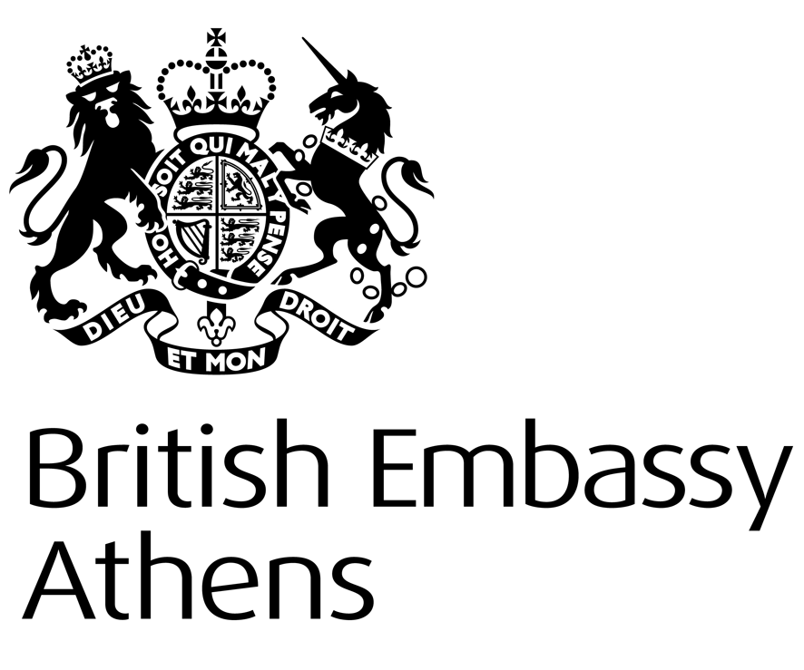
British Embassy
https://www.gov.uk/government/world/organisations/british-embassy-athens

INFORMATION NOTE:

UK WATERSPORTS DIPLOMAS

‘TO WHOM IT MAY CONCERN
This is to confirm that the British Embassy no longer issues certificates confirming that water sports diplomas have been issued by recognised governing bodies of sport in the UK nor do we certify any water sports diplomas as genuine.
Water sports diplomas issued by recognised governing bodies accredited to Sport England can be legalised at the Legalisation Office in UK if they have previously been certified by a UK solicitor or Notary Public.
Useful links:
www.gov.uk/get-document-legalised
solicitors in England and Wales
notaries public in England and Wales
solicitors and notaries public in Scotland
solicitors and notaries public in Northern Ireland

This information contained in this Note is general and should not be taken as a definitive statement of law’.

Consular Section
British Embassy Athens

