UK Standards for Microbiology Investigations

Investigation of Nasal Samples

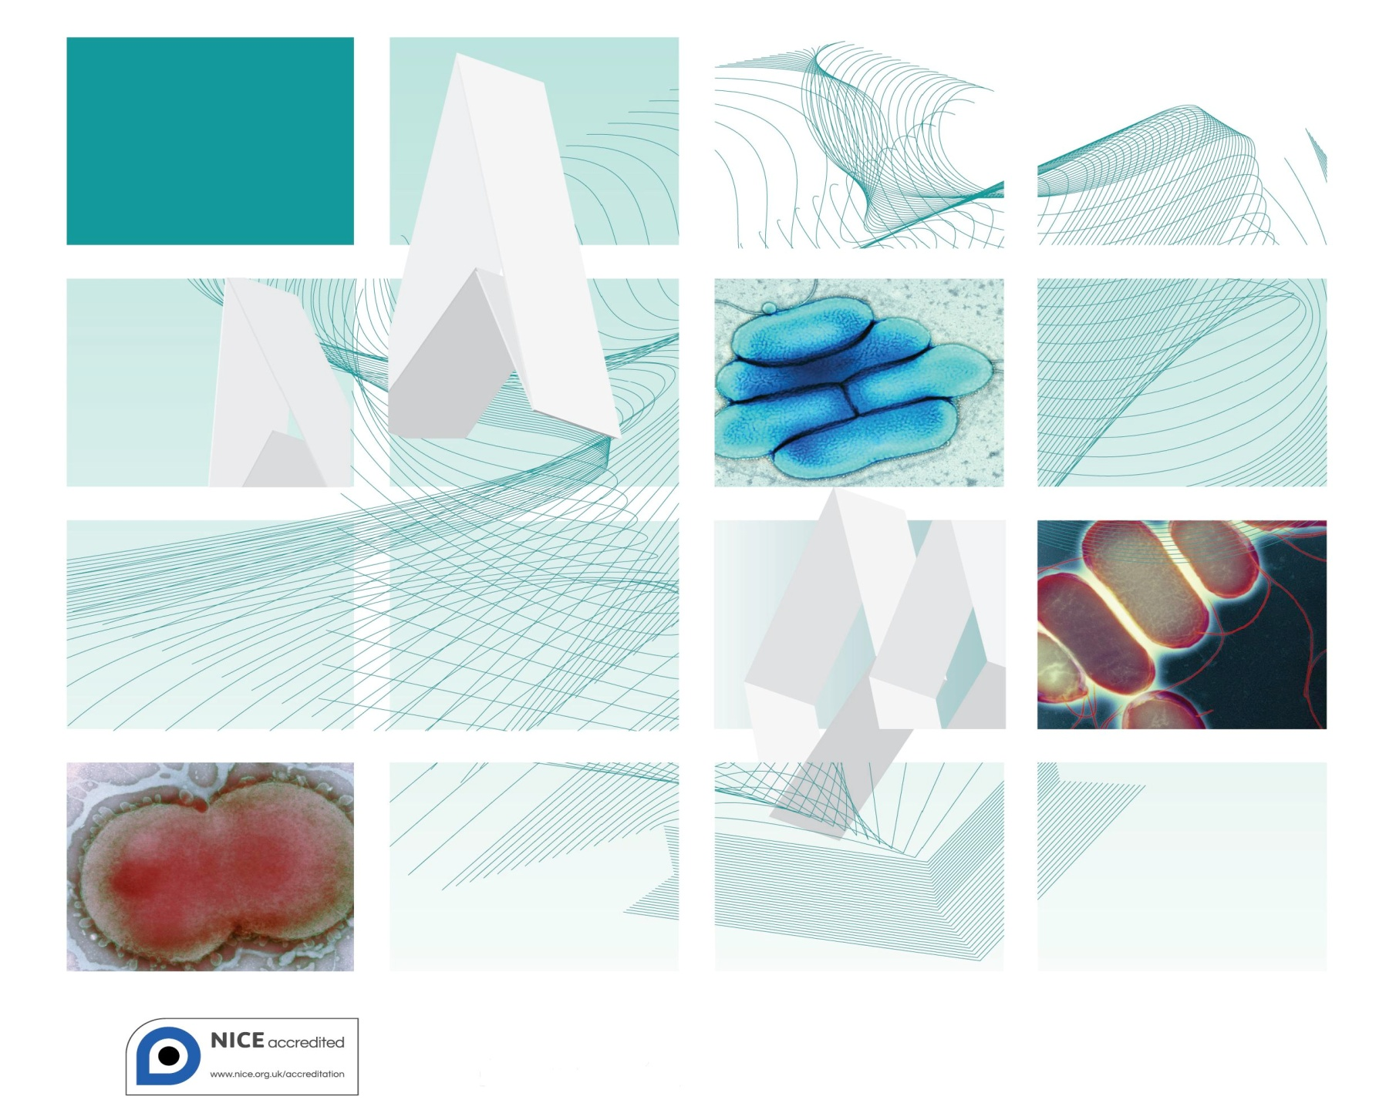

Acknowledgments
UK Standards for Microbiology Investigations (SMIs) are developed under the auspices of Public Health England (PHE) working in partnership with the National Health Service (NHS), Public Health Wales and with the professional organisations whose logos are displayed below and listed on the website https://www.gov.uk/uk-standards-for-microbiology-investigations-smi-quality-and-consistency-in-clinical-laboratories. SMIs are developed, reviewed and revised by various working groups which are overseen by a steering committee (see https://www.gov.uk/government/groups/standards-for-microbiology-investigations-steering-committee).
The contributions of many individuals in clinical, specialist and reference laboratories who have provided information and comments during the development of this document are acknowledged. We are grateful to the Medical Editors for editing the medical content.
For further information please contact us at:
Standards Unit
Microbiology Services
Public Health England
61 Colindale Avenue
London NW9 5EQ
E-mail: standards@phe.gov.uk
Website: https://www.gov.uk/uk-standards-for-microbiology-investigations-smi-quality-and-consistency-in-clinical-laboratories
UK Standards for Microbiology Investigations are produced in association with:
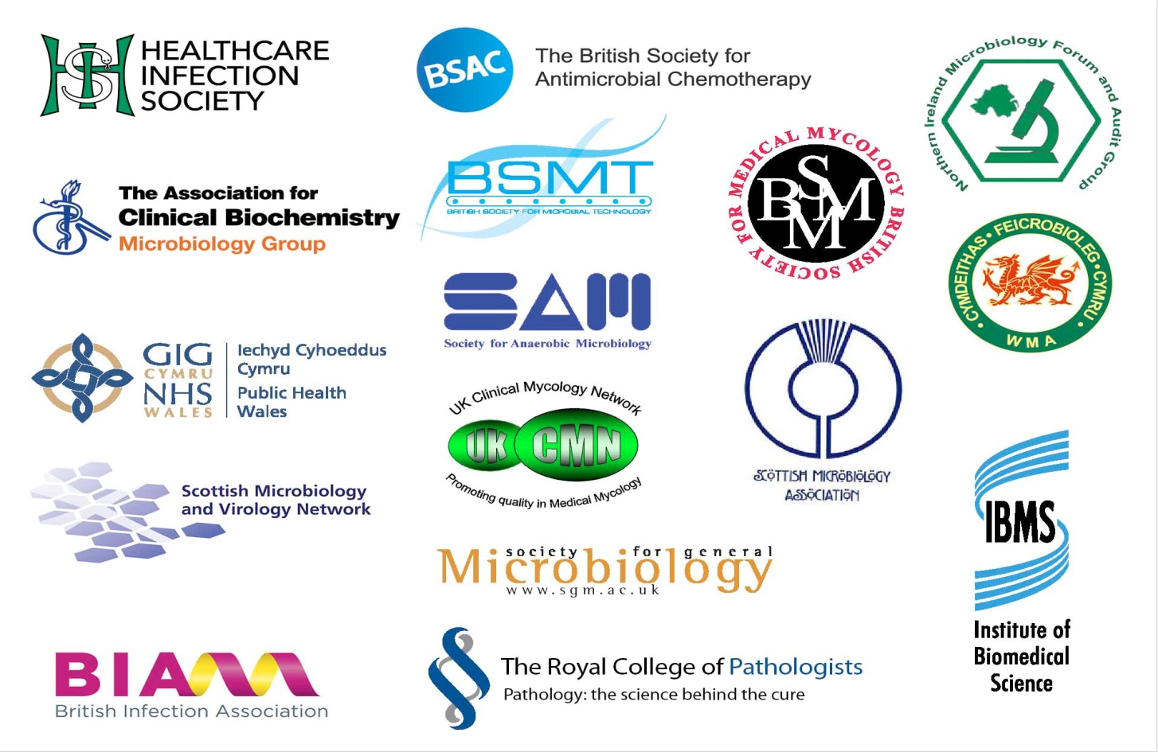
Logos correct at time of publishing.
Contents
Acknowledgments 2
Amendment Table 4
UK SMI: Scope and Purpose 5
Scope of Document 7
Scope 7
Introduction 7
Technical Information/Limitations 9
1 Safety Considerations 10
2 Specimen Collection 10
3 Specimen Transport and Storage 11
4 Specimen Processing/Procedure 11
5 Reporting Procedure 15
6 Notification to PHE or Equivalent in the Devolved Administrations 15
Appendix 1: Investigation of Nasal Samples 17
References 18

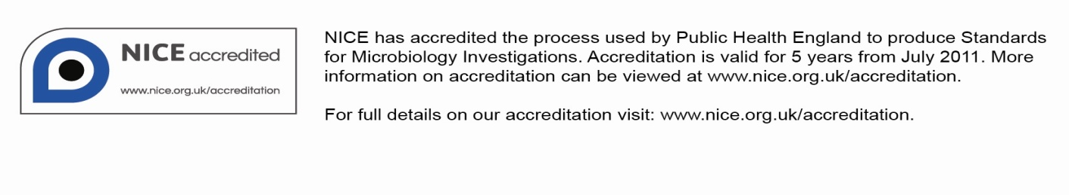
Amendment Table
Each SMI method has an individual record of amendments. The current amendments are listed on this page. The amendment history is available from standards@phe.gov.uk.
New or revised documents should be controlled within the laboratory in accordance with the local quality management system.
Amendment No/Date. | 11/12.01.15
Issue no. discarded. | 7
Insert Issue no. | 7.1
Section(s) involved | Amendment
Appendix 1. | Typing error amended.

Amendment No/Date. | 10/29.12.14
Issue no. discarded. | 6.3
Insert Issue no. | 7
Section(s) involved | Amendment

Whole document. | Hyperlinks updated to gov.uk.
Page 2. | Updated logos added.
Whole document. | The documents B 5 – Investigation of nose swabs and B 19 – Investigation of sinus aspirates have been merged to create a new B 5 – Investigation of nasal samples.
Types of specimen. | Has been expanded to meet new title needs.
Introduction. | Rewritten to include more information on nasal infections.
Flowchart. | Redesigned to reflect the Specimen table.
References. | Reviewed and updated were necessary.

UK SMI#: Scope and Purpose
Users of SMIs
Primarily, SMIs are intended as a general resource for practising professionals operating in the field of laboratory medicine and infection specialties in the UK. SMIs also provide clinicians with information about the available test repertoire and the standard of laboratory services they should expect for the investigation of infection in their patients, as well as providing information that aids the electronic ordering of appropriate tests. The documents also provide commissioners of healthcare services with the appropriateness and standard of microbiology investigations they should be seeking as part of the clinical and public health care package for their population.
Background to SMIs
SMIs comprise a collection of recommended algorithms and procedures covering all stages of the investigative process in microbiology from the pre-analytical (clinical syndrome) stage to the analytical (laboratory testing) and post analytical (result interpretation and reporting) stages. Syndromic algorithms are supported by more detailed documents containing advice on the investigation of specific diseases and infections. Guidance notes cover the clinical background, differential diagnosis, and appropriate investigation of particular clinical conditions. Quality guidance notes describe laboratory processes which underpin quality, for example assay validation.
Standardisation of the diagnostic process through the application of SMIs helps to assure the equivalence of investigation strategies in different laboratories across the UK and is essential for public health surveillance, research and development activities.
Equal Partnership Working
SMIs are developed in equal partnership with PHE, NHS, Royal College of Pathologists and professional societies. The list of participating societies may be found at https://www.gov.uk/uk-standards-for-microbiology-investigations-smi-quality-and-consistency-in-clinical-laboratories. Inclusion of a logo in an SMI indicates participation of the society in equal partnership and support for the objectives and process of preparing SMIs. Nominees of professional societies are members of the Steering Committee and Working Groups which develop SMIs. The views of nominees cannot be rigorously representative of the members of their nominating organisations nor the corporate views of their organisations. Nominees act as a conduit for two way reporting and dialogue. Representative views are sought through the consultation process. SMIs are developed, reviewed and updated through a wide consultation process.
Quality Assurance
NICE has accredited the process used by the SMI Working Groups to produce SMIs. The accreditation is applicable to all guidance produced since October 2009. The process for the development of SMIs is certified to ISO 9001:2008. SMIs represent a good standard of practice to which all clinical and public health microbiology laboratories in the UK are expected to work. SMIs are NICE accredited and represent neither minimum standards of practice nor the highest level of complex laboratory investigation possible. In using SMIs, laboratories should take account of local requirements and undertake additional investigations where appropriate. SMIs help laboratories to meet accreditation requirements by promoting high quality practices which are auditable. SMIs also provide a reference point for method development. The performance of SMIs depends on competent staff and appropriate quality reagents and equipment. Laboratories should ensure that all commercial and in-house tests have been validated and shown to be fit for purpose. Laboratories should participate in external quality assessment schemes and undertake relevant internal quality control procedures.
Patient and Public Involvement
The SMI Working Groups are committed to patient and public involvement in the development of SMIs. By involving the public, health professionals, scientists and voluntary organisations the resulting SMI will be robust and meet the needs of the user. An opportunity is given to members of the public to contribute to consultations through our open access website.
Information Governance and Equality
PHE is a Caldicott compliant organisation. It seeks to take every possible precaution to prevent unauthorised disclosure of patient details and to ensure that patient-related records are kept under secure conditions. The development of SMIs are subject to PHE Equality objectives https://www.gov.uk/government/organisations/public-health-england/about/equality-and-diversity.
The SMI Working Groups are committed to achieving the equality objectives by effective consultation with members of the public, partners, stakeholders and specialist interest groups.
Legal Statement
Whilst every care has been taken in the preparation of SMIs, PHE and any supporting organisation, shall, to the greatest extent possible under any applicable law, exclude liability for all losses, costs, claims, damages or expenses arising out of or connected with the use of an SMI or any information contained therein. If alterations are made to an SMI, it must be made clear where and by whom such changes have been made.
The evidence base and microbial taxonomy for the SMI is as complete as possible at the time of issue. Any omissions and new material will be considered at the next review. These standards can only be superseded by revisions of the standard, legislative action, or by NICE accredited guidance.
SMIs are Crown copyright which should be acknowledged where appropriate.
Suggested Citation for this Document
Public Health England. (2015). Investigation of Nasal Samples. UK Standards for Microbiology Investigations. B 5 Issue 7.1. https://www.gov.uk/uk-standards-for-microbiology-investigations-smi-quality-and-consistency-in-clinical-laboratories

Scope of Document
Type of Specimen
Nose swab, antral washout, sinus aspirate and sinus washout
Scope
This SMI describes the examination of sinus aspirate and associated specimens for the detection and recovery of the organisms that cause the various forms of sinusitis and nose infections. The document does not cover viral causes or allergic and toxin origins.
This SMI should be used in conjunction with other SMIs.
Introduction
Nasal Carriage
Nose swabs may be used to investigate carriage of Lancefield group A streptococcus and Meticillin Resistant Staphylococcus aureus (MRSA) (B 29 - Investigation of Specimens for Screening for MRSA). It may also be appropriate to screen for MSSA carriage in certain patient groups such as those pending surgery. For oncology patients it may also be appropriate to screen for Candida species.
Nose swabs are not a suitable sample type for the identification of sinusitis and should only be used for carriage detection.
Sinusitis
Sinusitis usually refers to an infection of one or more of the paranasal sinuses; maxillary, ethmoid, frontal and sphenoid¹. Factors that predispose an individual to sinusitis include impaired mucociliary function, obstruction of the sinus entrance (eg by nasotracheal intubation or by mucosal oedema as a result of viral infection) and defects in the immune system². The sinus cavities are usually sterile or may contain small numbers of bacteria that are continuously removed by the mucociliary system.
Specimens should be obtained by careful aspiration of the sinus cavity avoiding contamination by upper respiratory tract flora and will be collected by an ear, nose and throat surgeon.
Acute Sinusitis
Acute sinusitis can be community or nosocomially acquired. The aetiology of community acquired infections can be viral, bacterial, mixed (viral and bacterial), or occasionally fungal.
Viral upper respiratory tract infection is an important cause of acute sinusitis. Viruses such as rhinoviruses, influenza virus, parainfluenza virus and adenovirus may cause infection (see G 8 - Respiratory Viruses).

Community Sinusitis
The most common bacteria isolated from cases of acute community acquired sinusitis are Streptococcus pneumoniae and non-encapsulated Haemophilus influenzae¹. Other organisms isolated are streptococci of the “anginosus” group (Streptococcus anginosus, Streptococcus constellatus and Streptococcus intermedius), group A streptococcus, other α-haemolytic streptococci, Staphylococcus aureus, Moraxella catarrhalis (which is more prevalent in children than adults) and anaerobic bacteria (which are infrequent in children)³.
Nosocomial Sinusitis
Nosocomial sinusitis is often a complication of endotracheal intubation and mechanical ventilation and often shows no clinical signs of infection⁴. The most common bacterial isolates in nosocomial sinusitis are S. aureus, Pseudomonas aeruginosa, Serratia marcescens, Klebsiella pneumoniae, Enterobacter species and Proteus mirabilis ⁵. The condition is often polymicrobial⁶. Similar pathogens and polymicrobial infections have been identified in children with more anaerobes being isolated⁷.
Close collaboration among physicians, ENT surgeons, microbiologists and histopathologists is necessary to reach a diagnosis. Superficial swabs are likely to be inadequate; scrapings or biopsy material are most likely to yield the diagnosis.
Chronic Sinusitis
Chronic sinusitis can be classified as pre or post surgical and may be a feature of some congenital immunodeficiency syndromes and disorders of mucociliary function, although most patients do not have these conditions. Sinus outflow obstruction, eg by nasal polyps, can also lead to chronic sinusitis. Chronic conditions can persist in some patients who have undergone unsuccessful surgery. Organisms isolated include
S. pneumoniae, H. influenzae, streptococci of the “anginosus” group, M. catarrhalis,
S. aureus, Pseudomonas species, and anaerobic organisms including Peptostreptococcus species, Propionibacterium species, Fusobacterium species and Prevotella species and other anaerobic Gram negative bacteria.
S. aureus and anaerobes are recovered from children with severe sinus symptoms requiring surgical intervention, or with protracted sinusitis (lasting over one year)⁸. Complications can be life-threatening. The most common complication is orbital infection. Intracranial infections are less common, but may cause significant morbidity and mortality. S. aureus and anaerobes are the predominant isolates from such cases⁸. Another rare complication is osteomyelitis (see B 42 - Investigation of Bone), usually staphylococcal, involving the frontal bone (Pott’s puffy tumour).
Fungal Sinusitis
Fungal infections are usually due to filamentous fungi. Probably the most common causes are Aspergillus species (especially Aspergillus flavus), Rhizopus and Mucor species. Several other species have been implicated, including Sporothrix schenkii and Scedosporium apiospermum (previously known as Pseudallescheria boydii)⁹. In patients who are immunocompromised and hospitalised, filamentous fungi may cause life-threatening infections. Fungal sinusitis in such individuals is usually locally invasive. Bone marrow transplant recipients and patients with neutropenia are at risk of invasive sinusitis caused by Aspergillus species². Patients with diabetic ketoacidosis or prolonged neutropenia are at particular risk of rhinocerebral mucormycosis, most commonly caused by Rhizopus species (although other fungi are sometimes implicated). Infection spreads directly from the involved sinuses and is to be regarded as a medical emergency. Aggressive surgical debridement is often required in addition to systematic antifungal therapy and treatment of the underlying cause. Candida species and Cryptococcus neoformans are also causes of infection in patients who are immunocompromised.
Chronic fungal sinusitis in apparently normal hosts is probably more common in the UK than is supposed, and a variety of saprophytic fungi have been isolated. Infection may take the form of a fungus ball in the sinus, allergic fungal sinusitis or, rarely, locally invasive infection which may be confused with Wegener’s granulomatosis or squamous cell carcinoma. Examination of tissue rather than pus is important in fungal sinusitis. Close co-operation among the surgeon, microbiologist and histopathologist is also necessary. Community-acquired chronic fungal sinusitis is a relatively common problem in some tropical and subtropical countries, eg in Africa and India, and imported cases may be encountered. The commonest cause overall is A. flavus. In some instances invasive disease will develop.
Other fungi should be considered in relation to the country of origin and travel history of the patient.
Technical Information/Limitations
Limitations of UK SMIs
The recommendations made in UK SMIs are based on evidence (eg sensitivity and specificity) where available, expert opinion and pragmatism, with consideration also being given to available resources. Laboratories should take account of local requirements and undertake additional investigations where appropriate. Prior to use, laboratories should ensure that all commercial and in-house tests have been validated and are fit for purpose.
Selective Media in Screening Procedures
Selective media which does not support the growth of all circulating strains of organisms may be recommended based on the evidence available. A balance therefore must be sought between available evidence, and available resources required if more than one media plate is used.
Specimen Containers^{10,11}
SMIs use the term “CE marked leak proof container” to describe containers bearing the CE marking used for the collection and transport of clinical specimens. The requirements for specimen containers are given in the EU in vitro Diagnostic Medical Devices Directive (98/79/EC Annex 1 B 2.1) which states: “The design must allow easy handling and, where necessary, reduce as far as possible contamination of, and leakage from, the device during use and, in the case of specimen receptacles, the risk of contamination of the specimen. The manufacturing processes must be appropriate for these purposes”.
1 Safety Considerations¹⁰⁻²⁶
  - Specimen Collection, Transport and Storage¹⁰⁻¹⁵
Use aseptic technique.
Collect specimens in appropriate CE marked leak proof containers and transport in sealed plastic bags.
Collect swabs into appropriate transport medium and transport in sealed plastic bags.
Compliance with postal, transport and storage regulations is essential.
1.2 Specimen Processing¹⁰⁻²⁶
The processing of most diagnostic work can be carried out at Containment Level 2.
Where Hazard Group 3 organisms, eg, Paracoccoides brasiliensis are suspected, all specimens must be processed in a microbiological safety cabinet under full containment level 3 conditions. Sealed containers such as screw-capped bottles should be used for culture. Plates are not suitable.
Any laboratory procedures that give rise to infectious aerosols must be conducted in a microbiological safety cabinet¹⁸.
Centrifugation must be carried out in sealed buckets which are subsequently opened in a microbiological safety cabinet.
Specimen containers must also be placed in a suitable holder.
Refer to current guidance on the safe handling of all organisms documented in this SMI.
The above guidance should be supplemented with local COSHH and risk assessments.
2 Specimen Collection
2.1 Type of Specimens
Nose swab, antral washout, sinus aspirate and sinus washout
2.2 Optimal Time and Method of Collection²⁷
For safety considerations refer to Section 1.1.
Collect specimens before antimicrobial therapy where possible²⁷.
Unless otherwise stated, swabs for bacterial and fungal culture should then be placed in appropriate transport medium²⁸⁻³².
Collect specimens other than swabs into appropriate CE marked leak proof containers and place in sealed plastic bags.
The washout or swab specimen will be collected by a specialist ENT surgeon.
2.3 Adequate Quantity and Appropriate Number of Specimens²⁷
Ideally, a minimum volume of 1mL for washouts. One swab for other conditions.
Numbers and frequency of specimen collection are dependent on clinical condition of patient.
3 Specimen Transport and Storage^{10,11}
3.1 Optimal Transport and Storage Conditions
For safety considerations refer to Section 1.1.
Specimens should be transported and processed as soon as possible²⁷.
The volume of specimen influences the transport time that is acceptable. Large volumes of purulent material maintain the viability of anaerobes for longer.
The recovery of anaerobes in particular is compromised if the transport time is delayed.
Samples should be kept at room temperature and processed immediately²⁷. If processing is delayed, refrigeration is preferable to storage at ambient temperature.
4 Specimen Processing/Procedure^{10,11}
4.1 Test Selection
Divide specimen on receipt for virology and bacteriology depending on clinical details.
4.2 Appearance
N/A
4.3 Sample Preparation
Standard
Non-mucoid sinus or antral washouts are processed as follows:
- Centrifuge specimen (for antral washouts), unless very mucoid, at 1200 x g for 10 minutes
- Discard most of the supernatant, leaving approximately 0.5mL
- Resuspend the centrifuged deposit in the remaining fluid
- Carry out microscopy and culture
Mucoid specimens are processed by digestion as follows:
- Carry out microscopy
- Add equal volume of a 0.1% solution of N-acetyl cysteine to specimen
- Agitate gently for approximately 10 seconds
- Incubation at 35-37°C for 15 minutes followed by gentle agitation for approximately 15 seconds will assist homogenisation
- Inoculate plates

4.4 Microscopy
Refer to TP 39 - Staining Procedures.
4.4.1 Standard

For mucoid specimens
Using a sterile loop select the most purulent or blood-stained portion of specimen and make a thin smear on a clean microscope slide for Gram staining.

For non-mucoid specimens
Using a sterile pipette place one drop of centrifuged deposit (see Section 4.5.1) or neat specimen on to a clean microscope slide. Spread this with a sterile loop to make a thin smear for Gram staining.
Note: If fungal infection is suspected or seen in the Gram stain carry out the supplementary.
4.4.2 Supplementary
Using a sterile pipette place one drop of centrifuged deposit (see Section 4.5.1) or neat specimen on a clean microscope slide.
Examine at x10 magnification using calcofluor white or blankophor white staining for fungal hyphae (see TP 39 – Staining Procedures).
4.5 Culture and Investigation
Using a sterile loop inoculate each agar plate with centrifuged deposit (see Q 5 - Inoculation of Culture Media for Bacteriology).

4.5.1 Culture media, conditions and organisms
Clinical details/  conditions | Specimen | Standard media | Incubation |  |  | Cultures read | Target organism(s)
 |  |  | Temp °C | Atmos | Time
S. aureus carriage  For example Boils | Swab | Blood agar | 35-37 | 5-10% CO₂ | 16-24hr | 16hr | S. aureus
Lancefield group A strep  carriage | Swab | Blood agar | 35-37 | 5-10% CO₂ | 16-24hr | 16hr | Lancefield group A streptococcus
Clinical details/  conditions | Specimen | Supplementary media | Incubation |  |  | Cultures read | Target organism(s)
 |  |  | Temp °C | Atmos | Time
Oncology patients | Antral washout, sinus aspirate and sinus washout | Sabaroud plate | 35-37 | 5-10% CO₂ | 16-24hr | 40hr | Fungi
Sinusitis | Antral washout, sinus aspirate and sinus washout | Chocolate agar* | 35-37 | 5-10% CO₂ | 40-48hr | daily | β-haemolytic  streptococci  Enterobacteriaceae  H. influenzae  M.catarrhalis  Pseudomonads  S. aureus  S. anginosis group  S. pneumoniae
 | Antral washout, sinus aspirate and sinus washout | Fastidious anaerobe agar with 5µg metronidazole disc | 35-37 | anaerobic | 5-7 d | ≥48hr | Fusobacterium species  Peptostreptococcus species  Propionibacterium species  Prevotella species
 | Antral washout, sinus aspirate and sinus washout | Sabouraud Agar | 30 and 35-37 | Air | 5 d | ≥40hr and up to 5 d | Fungi
*may include either a bacitracin 10 unit disc or bacitracin incorporated in the agar.
If microscopy is suggestive of organisms not listed in target list additional and/or other media may be required.
4.6 Identification
Refer to individual SMIs for organism identification.
4.6.1 Minimum level of identification in the laboratory
Peptostreptococcus species | “anaerobes” level
Propionibacterium species | “anaerobes” level
Fusobacterium species | anaerobes” level
Prevotella species | “anaerobes” level
β-haemolytic streptococci | Lancefield group level
Enterobacteriaceae | species level
Fungi | genus level
H. influenzae | species level
M. catarrhalis | species level
Pseudomonas species | species level
S. aureus | species level
S. anginosus | S. anginosus group level
S. pneumoniae | species level
Organisms may be further identified if this is clinically or epidemiologically indicated.
4.7 Antimicrobial Susceptibility Testing
Refer to British Society for Antimicrobial Chemotherapy (BSAC) and/or EUCAST guidelines. Prudent use of antimicrobials according to local and national protocols is recommended.
4.8 Referral for Outbreak Investigations
N/A
4.9 Referral to Reference Laboratories
For information on the tests offered, turnaround times, transport procedure and the other requirements of the reference laboratory click here for user manuals and request forms.
Organisms with unusual or unexpected resistance, and whenever there is a laboratory or clinical problem, or anomaly that requires elucidation should be sent to the appropriate reference laboratory.
Contact appropriate devolved national reference laboratory for information on the tests available, turnaround times, transport procedure and any other requirements for sample submission:

England and Wales
https://www.gov.uk/specialist-and-reference-microbiology-laboratory-tests-and-services
Scotland
http://www.hps.scot.nhs.uk/reflab/index.aspx
Northern Ireland
http://www.publichealth.hscni.net/directorate-public-health/health-protection
5 Reporting Procedure
5.1 Microscopy
Report on WBCs and organisms detected.
Report on fungal hyphae detected.
5.1.1 Microscopy reporting time
Urgent microscopy results to be telephoned or sent electronically when available.
Written report, 16–72hr.
5.2 Culture
Report isolation of clinically significant organisms isolated or
Report other growth, eg, Mixed upper respiratory tract flora or
Report absence of growth.
Also, report results of supplementary investigations.
5.2.1 Culture reporting time
Clinically urgent culture results to be telephoned or sent electronically when available.
Written report, 16–72hr stating, if appropriate, that a further report will be issued.
Supplementary investigations see appropriate SMIs.
5.3 Antimicrobial Susceptibility Testing
Report susceptibilities as clinically indicated. Prudent use of antimicrobials according to local and national protocols is recommended.
6 Notification to PHE^{33,34} or Equivalent in the Devolved Administrations³⁵⁻³⁸
The Health Protection (Notification) regulations 2010 require diagnostic laboratories to notify Public Health England (PHE) when they identify the causative agents that are listed in Schedule 2 of the Regulations. Notifications must be provided in writing, on paper or electronically, within seven days. Urgent cases should be notified orally and as soon as possible, recommended within 24 hours. These should be followed up by written notification within seven days.
For the purposes of the Notification Regulations, the recipient of laboratory notifications is the local PHE Health Protection Team. If a case has already been notified by a registered medical practitioner, the diagnostic laboratory is still required to notify the case if they identify any evidence of an infection caused by a notifiable causative agent.
Notification under the Health Protection (Notification) Regulations 2010 does not replace voluntary reporting to PHE. The vast majority of NHS laboratories voluntarily report a wide range of laboratory diagnoses of causative agents to PHE and many PHE Health protection Teams have agreements with local laboratories for urgent reporting of some infections. This should continue.
Note: The Health Protection Legislation Guidance (2010) includes reporting of Human Immunodeficiency Virus (HIV) & Sexually Transmitted Infections (STIs), Healthcare Associated Infections (HCAIs) and Creutzfeldt–Jakob disease (CJD) under ‘Notification Duties of Registered Medical Practitioners’: it is not noted under ‘Notification Duties of Diagnostic Laboratories’.
https://www.gov.uk/government/organisations/public-health-england/about/our-governance#health-protection-regulations-2010
Other arrangements exist in Scotland^{35,36}, Wales³⁷ and Northern Ireland³⁸.

Appendix 1: Investigation of Nasal Samples
If microscopy is suggestive of organisms not listed in target list additional and/or other media may be required.

References

1. Haug RH. Microorganisms of the nose and paranasal sinuses. Oral Maxillofac Surg Clin North Am 2012;24:191-viii.
2. Polacheck I, Nagler A, Okon E, Drakos P, Plaskowitz J, Kwon-Chung KJ. Aspergillus quadrilineatus, a new causative agent of fungal sinusitis. J Clin Microbiol 1992;30:3290-3.
3. Brook I. Acute and chronic bacterial sinusitis. Infect Dis Clin North Am 2007;21:427-48, vii.
4. Bert F, Lambert-Zechovsky N. Sinusitis in mechanically ventilated patients and its role in the pathogenesis of nosocomial pneumonia. Eur J Clin Microbiol Infect Dis 1996;15:533-44.
5. Wald ER. Microbiology of acute and chronic sinusitis in children and adults. Am J Med Sci 1998;316:13-20.
6. Bert F, Lambert-Zechovsky N. Microbiology of nosocomial sinusitis in intensive care unit patients. J Infect 1995;31:5-8.
7. Brook I. Microbiology of nosocomial sinusitis in mechanically ventilated children. Arch Otolaryngol Head Neck Surg 1998;124:35-8.
8. Wald ER. Sinusitis in children. Isr J Med Sci 1994;30:403-7.
9. Washburn RG. Fungal sinusitis. Curr Clin Top Infect Dis 1998;18:60-74.
10. European Parliament. UK Standards for Microbiology Investigations (SMIs) use the term "CE marked leak proof container" to describe containers bearing the CE marking used for the collection and transport of clinical specimens. The requirements for specimen containers are given in the EU in vitro Diagnostic Medical Devices Directive (98/79/EC Annex 1 B 2.1) which states: "The design must allow easy handling and, where necessary, reduce as far as possible contamination of, and leakage from, the device during use and, in the case of specimen receptacles, the risk of contamination of the specimen. The manufacturing processes must be appropriate for these purposes".
11. Official Journal of the European Communities. Directive 98/79/EC of the European Parliament and of the Council of 27 October 1998 on in vitro diagnostic medical devices. 7-12-1998. p. 1-37.
12. Health and Safety Executive. Safe use of pneumatic air tube transport systems for pathology specimens. 9/99.
13. Department for transport. Transport of Infectious Substances, 2011 Revision 5. 2011.
14. World Health Organization. Guidance on regulations for the Transport of Infectious Substances 2013-2014. 2012.
15. Home Office. Anti-terrorism, Crime and Security Act. 2001 (as amended).
16. Advisory Committee on Dangerous Pathogens. The Approved List of Biological Agents. Health and Safety Executive. 2013. p. 1-32
17. Advisory Committee on Dangerous Pathogens. Infections at work: Controlling the risks. Her Majesty's Stationery Office. 2003.
18. Advisory Committee on Dangerous Pathogens. Biological agents: Managing the risks in laboratories and healthcare premises. Health and Safety Executive. 2005.
19. Advisory Committee on Dangerous Pathogens. Biological Agents: Managing the Risks in Laboratories and Healthcare Premises. Appendix 1.2 Transport of Infectious Substances - Revision. Health and Safety Executive. 2008.
20. Centers for Disease Control and Prevention. Guidelines for Safe Work Practices in Human and Animal Medical Diagnostic Laboratories. MMWR Surveill Summ 2012;61:1-102.
21. Health and Safety Executive. Control of Substances Hazardous to Health Regulations. The Control of Substances Hazardous to Health Regulations 2002. 5th ed. HSE Books; 2002.
22. Health and Safety Executive. Five Steps to Risk Assessment: A Step by Step Guide to a Safer and Healthier Workplace. HSE Books. 2002.
23. Health and Safety Executive. A Guide to Risk Assessment Requirements: Common Provisions in Health and Safety Law. HSE Books. 2002.
24. Health Services Advisory Committee. Safe Working and the Prevention of Infection in Clinical Laboratories and Similar Facilities. HSE Books. 2003.
25. British Standards Institution (BSI). BS EN12469 - Biotechnology - performance criteria for microbiological safety cabinets. 2000.
26. British Standards Institution (BSI). BS 5726:2005 - Microbiological safety cabinets. Information to be supplied by the purchaser and to the vendor and to the installer, and siting and use of cabinets. Recommendations and guidance. 24-3-2005. p. 1-14
27. Baron EJ, Miller JM, Weinstein MP, Richter SS, Gilligan PH, Thomson RB, Jr., et al. A Guide to Utilization of the Microbiology Laboratory for Diagnosis of Infectious Diseases: 2013 Recommendations by the Infectious Diseases Society of America (IDSA) and the American Society for Microbiology (ASM). Clin Infect Dis 2013;57:e22-e121.
28. Rishmawi N, Ghneim R, Kattan R, Ghneim R, Zoughbi M, Abu-Diab A, et al. Survival of fastidious and nonfastidious aerobic bacteria in three bacterial transport swab systems. J Clin Microbiol 2007;45:1278-83.
29. Barber S, Lawson PJ, Grove DI. Evaluation of bacteriological transport swabs. Pathology 1998;30:179-82.
30. Van Horn KG, Audette CD, Sebeck D, Tucker KA. Comparison of the Copan ESwab system with two Amies agar swab transport systems for maintenance of microorganism viability. J Clin Microbiol 2008;46:1655-8.
31. Nys S, Vijgen S, Magerman K, Cartuyvels R. Comparison of Copan eSwab with the Copan Venturi Transystem for the quantitative survival of Escherichia coli, Streptococcus agalactiae and Candida albicans. Eur J Clin Microbiol Infect Dis 2010;29:453-6.
32. Tano E, Melhus A. Evaluation of three swab transport systems for the maintenance of clinically important bacteria in simulated mono- and polymicrobial samples. APMIS 2011;119:198-203.
33. Public Health England. Laboratory Reporting to Public Health England: A Guide for Diagnostic Laboratories. 2013. p. 1-37.
34. Department of Health. Health Protection Legislation (England) Guidance. 2010. p. 1-112.
35. Scottish Government. Public Health (Scotland) Act. 2008 (as amended).
36. Scottish Government. Public Health etc. (Scotland) Act 2008. Implementation of Part 2: Notifiable Diseases, Organisms and Health Risk States. 2009.
37. The Welsh Assembly Government. Health Protection Legislation (Wales) Guidance. 2010.
38. Home Office. Public Health Act (Northern Ireland) 1967 Chapter 36. 1967 (as amended).

# Microbiology is used as a generic term to include the two GMC-recognised specialties of Medical Microbiology (which includes Bacteriology, Mycology and Parasitology) and Medical Virology.

