

Appendix 1:
Desktop investigation of the London 2012 Team GB and domestic league players

June 2014
Prepared by the TOP Foundation for Ofsted

- Introduction

Appendix 1 provides a summary of the school data for the national athletes who competed in the 2012 London Olympic and Paralympic Games as well as the senior domestic leagues for 5 sports.

The report is split into three sections:

- English Domestic National Leagues
Data was collected for English players competing in the senior domestic leagues in 2012 for 5 specific sports:
- Football - English Premier League (men) and English Super League (women)
- Hockey - English National League Premier Division’s (men and women)
- Rugby Union - English Premiership (men and women)
- Cricket - County Championship (division 1) (men only – limited data was found for women, so this was excluded from the analysis)
- Netball - English Premier League 1 (women only)

- Great British Olympic Team
Data was sourced on the British Olympic athletes competing at the London 2012 Games.

- Great British Paralympic Team
Data was sourced on the British Paralympic athletes competing at the London 2012 Games.

2.0 Method

For all of the sections, the names of the athletes were found online through official team websites, as well as match reports in the case of some teams in the domestic competitions. Three collections of player data were made through desktop research. These utilised a number of sources, primarily player profile information on the team websites or international team website. However, when the appropriate information could not be found, other internet sources were used, for example LinkedIn profiles, newspaper articles and school websites.

In this study, state and independent schooled athletes are defined as athletes who attended both a state and independent school through their education.

Section A: English Domestic National Leagues
The following analysis of the data concerns the information about the English players competing in the 2012 versions of the male and female senior domestic competitions for football, hockey, rugby union, men’s cricket and women’s netball.

3.0 Description of the data

Out of the 1,400 players competing in all of the domestic leagues, 760 (54%) were English; 533 were male and 227 were female.

Of the 760 English competitors, the name and type of school attended by 543 players were found (71%); that included 420 males (77%) and 123 females (23%). The following table illustrates the availability of the school data in accordance with each league.

Figure 3.0. The availability of school data for English players in 8 domestic leagues.
League | Total number of players | English players |  | Data available for English players
Football - men | 455 | 167 | 36.7% | 118 | 70.7%
Football - women | 112 | 81 | 72.3% | 34 | 42.0%
Hockey - men | 90 | 59 | 65.5% | 33 | 55.9%
Hockey - women | 70 | 49 | 70.0% | 29 | 59.2%
Rugby Union - men | 299 | 176 | 58.9% | 148 | 84.1%
Rugby Union - women | 52 | 38 | 55.0% | 33 | 86.8%
Cricket - men | 200 | 131 | 65.5% | 121 | 92.4%
Netball - women | 122 | 59 | 48.4% | 27 | 45.8%
Total = | 1,400 | 760 | - | 543 | -
% of the total = | - | 54.3% | - | 71.4% | -

At the outset of the investigation, the women’s national cricket league was excluded from the dataset as only a very limited amount of school data was available on the players.

3.1 School type by sport

In the total athlete cohort, 67% of players attended state schools, 30% attended independent schools, while 4% were educated at both type of school (figures 3.1a and 3.1b). This does not reflect the national average percentages of school type for children, which stands at 93% for state schools (under 16s).

Figure 3.1a. The type of school attended by players in all 8 leagues.
 | Only state schools | State and independent schools | Only independent schools | N
Total = | 361 | 21 | 161 | 543
Percentage = | 66.5% | 3.9% | 29.7% | 100.0%
Figure 3.1b. The type of school attended by players in all 8 leagues.
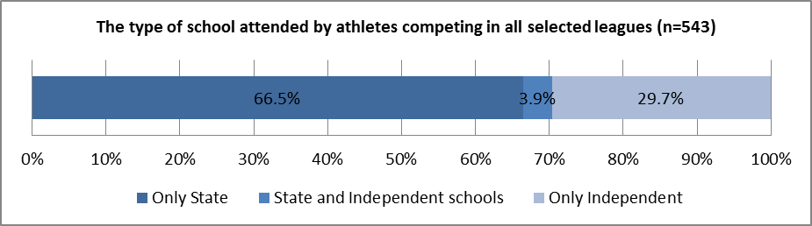

This data can also be broken down by each domestic league. The following graph (figure 3.1c) indicates that of the 8 leagues, the athletes from men and women’s football had the highest state educated percentages, whilst women’s hockey and men’s rugby union had the highest percentages of privately educated athletes.
Figure 3.1c. The type of school attended by players in each individual league.
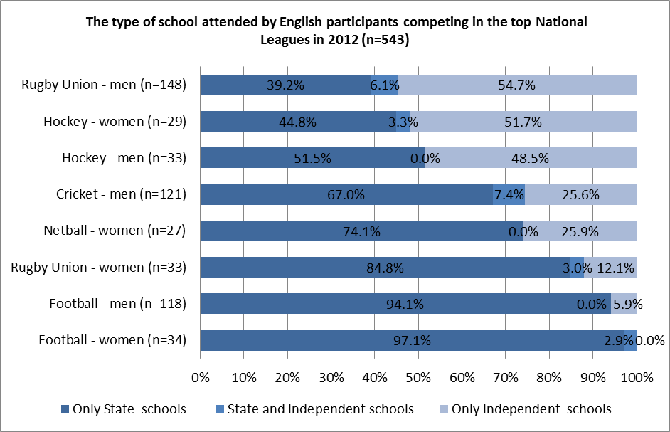

Any comparison of the figures for women’s netball and women’s football should be treated with a degree of caution as only 46% and 42% of the player’s schools were identified.

3.2 School type by gender

Analysis was performed on the data regarding the schools attended by each gender. Figure 3.2a and figure 3.2b show that females competing in all domestic national leagues are more likely to have been educated at state schools than their male counterparts. The difference is 13%.

Figure 3.2a. The type of school attended by athletes in all 8 leagues by gender.
Leagues | Only state schools | State and independent schools | Only independent schools | N
Female total | 94 | 3 | 26 | 123
Female percentage | 76.4% | 2.4% | 21.1% | 100.0%
Male total | 267 | 18 | 135 | 420
Male percentage | 63.6% | 4.3% | 32.1% | 100.0%

Figure 3.2b. The type of school attended by athletes in all 8 leagues by gender.
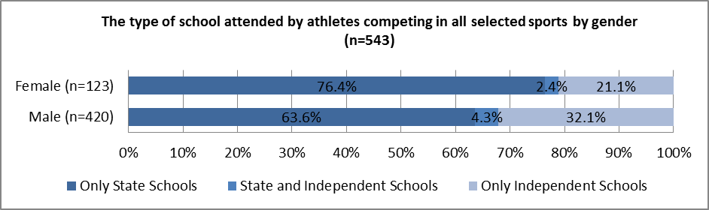
It was more difficult to locate the schools of female players in comparison to male players; from the available data the study was only able to find 23% of sportswomen, compared to 77% of sportsmen. When interpreting the data caution should be taken due to the variability in the amount of information available, therefore any conclusions should identify possible inaccuracies.

Analysis was performed on all leagues minus those for men’s cricket and women’s netball, as this allowed a direct comparison of all genders to be compared (figures 3.2c, and 3.2d).

Figure 3.2c. The type of school attended by males in the football, rugby union and hockey leagues (n=299).
League | Only state schools |  | State and independent schools |  | Only independent schools |  | N
Football - men (n=118) | 111 | 94.1% | 0 | 0.0% | 7 | 5.9% | 118
Rugby Union - men (n=148) | 58 | 39.2% | 9 | 6.1% | 81 | 54.7% | 148
Hockey - men (n=33) | 17 | 51.5% | 0 | 0.0% | 16 | 48.5% | 33
Total = | 186 | - | 9 | - | 104 | - | 299
% of total = | 62.2% | - | 3.0% | - | 34.8% | - | -
Mean % = | - | 61.6% | - | 2.0% | - | 36.4% | -

Figure 3.2d The type of school attended by females in the football, rugby union and hockey leagues (n=96).
League | Only state schools |  | State and independent schools |  | Only independent schools |  | N
Football - women (n=34) | 33 | 97.1% | 1 | 2.9% | 0 | 0.0% | 34
Rugby Union - women (n=33) | 28 | 84.8% | 1 | 3.0% | 4 | 12.1% | 33
Hockey - women (n=29) | 13 | 44.8% | 1 | 3.4% | 15 | 51.7% | 29
Total = | 74 | - | 3 | - | 19 | - | 96
% of total = | 77.1% | - | 3.1% | - | 19.8% | - | -
Mean % = | - | 75.6% | - | 3.1% | - | 21.3% | -

A comparison of the 2 variables reveals that regardless of the presence or otherwise of men’s cricket and women’s netball, the percentage of state schooled athletes is higher for females than it is for males.

3.3 School type with categorisation of league status

Analysis was also conducted on the school data by category of league. For this study, the leagues categorised as fully professional were men’s football, cricket and rugby union (figure 3.3a). These were compared against the remaining leagues for men’s hockey and women’s football, netball, hockey and rugby union (figure 3.3b).
Figure 3.3a. The type of school attended by athletes in 3 professional leagues (n=387).
League | Only state schools | State and independent schools | Only independent schools | N
Football - men (n=118) | 111 | 0 | 7 | 118
Cricket - men (n=121) | 81 | 9 | 31 | 121
Rugby Union - men (n=148) | 58 | 9 | 81 | 148
Total = | 250 | 18 | 119 | 387
% of total = | 64.6% | 4.7% | 30.7% | 100.0%

Figure 3.3b. The type of school attended by athletes in 5 semi-professional leagues (n=156).
League | Only state schools | State and independent schools | Only independent schools | N
Football - women (n=34) | 33 | 1 | 0 | 34
Rugby Union - women (n=33) | 28 | 1 | 4 | 33
Netball - women (n=27) | 20 | 0 | 7 | 27
Hockey - men (n=33) | 17 | 0 | 16 | 33
Hockey - women (n=29) | 13 | 1 | 15 | 29
Total = | 111 | 3 | 42 | 156
% of total = | 71.2% | 1.9% | 26.9% | 100.0%

Figure 3.3c illustrates there is no marked difference between the type of schools attended by athletes competing in the two league categories.

Figure 3.3c. The type of school attended by players in all 8 leagues, in accordance with the categorisation of professionalism.
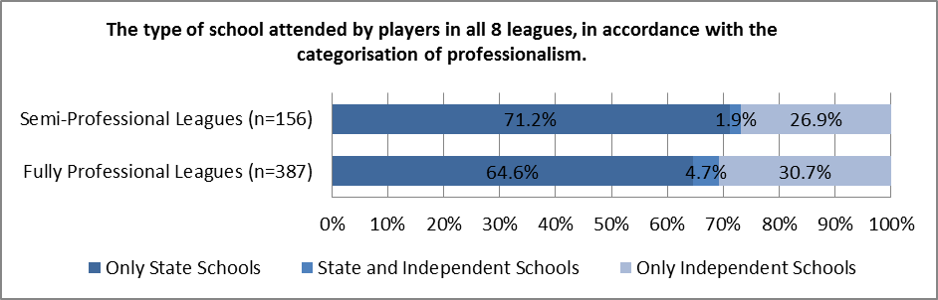

3.4 Schools list for athletes

The following tables illustrate the most frequent schools attended by athletes. That is, the schools (including sixth form colleges) which multiple athletes attended from all of the 8 leagues.
Figure 3.4a. The most frequently attended schools for female athletes.
Female
1 | Bramhall High School | State | 2 - Hockey & Rugby Union
1= | Colston's School | Independent | 2 - Rugby Union
1= | Fallibroome Sixth Form College | State | 2 - Rugby Union
1= | Gateshead College | State | 2 - Football
1= | Nelson and Colne College Sixth Form | State | 2 - Football & Netball
1= | Oakham School | Independent | 2 - Hockey
1= | Repton School | Independent | 2 - Hockey
1= | Rickmansworth School | State | 2 - Rugby Union
1= | Roundround Park School | State | 2 - Football & Rugby Union
1= | Sheffield High School | Independent | 2 - Netball
1= | South Gloucestershire and Stroud College | State | 2 - Football
1= | West Bridgford | State | 2 - Football & Hockey
1= | Wycombe High School | State | 2 - Hockey & Netball

Figure 3.4b. The most frequently attended schools for male athletes.
Male
1 | Millfield School | Independent | 8 - 3 Cricket, 3 Rugby Union & 2 Hockey
2 | Whitgift School | Independent | 6 - 3 Cricket & 3 Rugby Union
3 | Bromsgrove School | Independent | 5 - 1 Cricket & 4 Rugby Union
4 | Colston's Collegiate School | Independent | 5 - Rugby Union
5 | Barnard Castle | Independent | 4 - Rugby Union
5= | Wellington College | Independent | 4 - 1 Hockey & 3 Rugby Union
6 | Dean Close School | Independent | 3 - 1 Hockey & 2 Rugby Union
6= | Hampton School | Independent | 3 - 2 Cricket & 1 Rugby Union
6= | St John Fisher Catholic HS | State | 3 - Rugby Union
6= | Worksop College | Independent | 3 - Hockey

Figure 3.4c. The most frequently attended schools for all athletes.
All
1 | Millfield School | Independent | 8 - 3 Cricket, 3 Rugby Union & 2 Hockey - all males.
2 | Colston's Collegiate School | Independent | 7 - 7 Rugby Union - 2 females & 5 males
3 | Whitgift School | Independent | 6 - 3 Cricket & 3 Rugby Union - all males.
4 | Bromsgrove School | Independent | 5 - 1 Cricket & 4 Rugby Union - all males
5 | Barnard Castle School | Independent | 4 - Rugby Union - all males.
5= | Oakham School | Independent | 4 - 1 Cricket (male), 2 Hockey (females) & 1 Rugby Union (male).
5= | Wellington College | Independent | 4 - 1 Hockey & 3 Rugby Union - all males.
6 | Dean Close School | Independent | 3 - 1 Hockey & 2 Rugby Union - all males.
6= | Hampton School | Independent | 3 - 2 Cricket & 1 Rugby Union - all males.
6= | St John Fisher Catholic HS | State | 3 - Rugby Union - all males.
6= | Worksop College | Independent | 3 - Hockey - all males.
These lists illustrate that of the most frequent 13 schools attended for females, 9 were state and 4 were independent. Of the most frequent 10 schools attended for males, 1 was state and 9 were independent. Finally, of the 11 most frequently attended schools for both genders, 1 was state and 10 were independent.
3.5 Summary

To summarise, across the cohort, the largest school type percentage belongs to state schools. When this analysis is broken down into the individual leagues, only women’s hockey and men’s rugby union have their largest school percentage of independent schooling.

Furthermore, a higher percentage of females attended state schools than males, and semi-professional league athletes were more likely to be state educated than those competing in professional leagues. Of the overall most frequently attended school list, 1 school out of 11 was state, the remaining 10 were independent.

Section B: Great British Olympic Team
The following analysis of the data concerns the information regarding the British Olympic athletes who competed at the London 2012 Games. Please note: The figures for the following sports have been merged, and will be used throughout the analysis: Canoe Slalom and Sprint - now labelled "Canoeing"; Cycling BMX, Mountain Bike, Road and Track - now labelled "Cycling"; Equestrian Dressage, Eventing and Jumping - now labelled "Equestrian"; Gymnastics Artistic, Rhythmic and Trampoline - now labelled "Gymnastics"; and Indoor Volleyball and Beach Volleyball - now labelled "Volleyball".

4.0 Description of the data

Data was collected for a total of 537 athletes from 29 sports. For analysis purposes, this dataset was split into 3 groups:
- Sports with a school data availability rate of 25% or above.
- Sports with a school data availability rate of below 25%.
- Sports with no school data availability, which are classified as ‘other’, therefore have not been included in the analysis.

Figure 4.0a. The availability of school data for British players in Olympic sports in group 1 (n=21 sports).
Sport | Total number of Olympians | Data available
Athletics | 73 | 38 | 52.1%
Badminton | 4 | 3 | 75.0%
Basketball | 24 | 15 | 62.5%
Boxing | 10 | 7 | 70.0%
Canoeing | 15 | 9 | 60.0%
Cycling | 27 | 22 | 81.5%
Diving | 12 | 7 | 58.3%
Equestrian | 13 | 11 | 84.6%
Fencing | 10 | 6 | 60.0%
Football | 36 | 20 | 55.6%
Gymnastics | 18 | 11 | 61.1%
Hockey | 32 | 31 | 96.9%
Judo | 14 | 4 | 28.6%
Modern Pentathlon | 4 | 1 | 25.0%
Rowing | 47 | 37 | 78.7%
Sailing | 16 | 12 | 75.0%
Swimming | 44 | 15 | 34.1%
Taekwondo | 4 | 3 | 75.0%
Tennis | 8 | 5 | 62.5%
Triathlon | 6 | 4 | 66.7%
Water Polo | 26 | 13 | 50.0%
Total = | 443 | 274 | 61.9%

Figure 4.0b. The availability of school data for British players in Olympic sports in group 2 (n=2 sports).
Sport | Total number of Olympians | Data available
Shooting | 11 | 2 | 18.2%
Volleyball | 28 | 3 | 10.7%
Total = | 39 | 5 | 12.8%

Figure 4.0c. The availability of school data for British players in Olympic sports in group 3 (n=6 sports).
Sport | Total number of Olympians | Data available
Archery | 6 | 0 | 0.0%
Handball | 28 | 0 | 0.0%
Synchronised Swimming | 9 | 0 | 0.0%
Table Tennis | 6 | 0 | 0.0%
Weightlifting | 5 | 0 | 0.0%
Wrestling Freestyle | 1 | 0 | 0.0%
Total = | 55 | 0 | 0.0%

Of the 537 British Olympians, school data for 279 of these athletes was located and used in the analysis (figure 4.0a and b). The total availability of the school data for this group is 52%.

4.1 School type by sport

Of the total athlete cohort (group 1 and 2 combined), who have school data available (n=279), 65% of the Olympians attended state schools, 28% attended independent schools, 1% attended both a state and independent school, and 6% attended schools overseas (figure 4.1a and 4.1b). Where reference is made to all sports, this includes both group 1 and group 2 throughout (n=279).

For the sports with a 25% school data availability or above (n=274), the figures change slightly; 66% of the athletes attended state schools, 27% attended independent schools, 1% attended both a state and independent school, and 6% attended schools overseas (figures 4.1a and 4.1b).

Figure 4.1a A group comparison of the schools attended by all athletes, and those in group 1.
Group | Only state schools | State and independent schooling | Only independent schools | Overseas schooling
25% availability rate or above (n=274) | 66.1% | 1.1% | 27.4% | 5.5%
All Sports (n=279) | 65.2% | 1.1% | 28.0% | 5.7%

Figure 4.1b A group comparison of the schools attended by all athletes, and those in group 1.
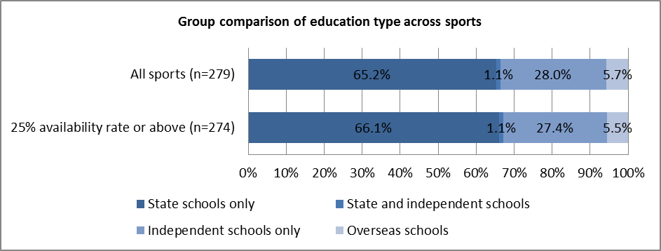

This data can also be observed in accordance with each sport. The following graph (figure 4.1c) illustrates the education split for each sport in the 25% availability rate or above group.

This data illustrates that:
- Although there were low numbers of athletes for the following sports, 100% of the Olympians were state educated; badminton, taekwondo, boxing, judo and modern pentathlon.
- Sports with high numbers of athletes, which also had high percentages of state educated Olympians were football and cycling.
- Sports with higher percentages of independently educated athletes than state educated were rowing, equestrian and tennis.
- Triathlon and fencing had the equivalent percentage of athletes coming from state only and independent only schools.
- Finally, there were high percentages of overseas schooled athletes for basketball.

Figure 4.1c. The type of school attended by Olympians in accordance with sports in group 1 (25% availability rates or above) (n=274)
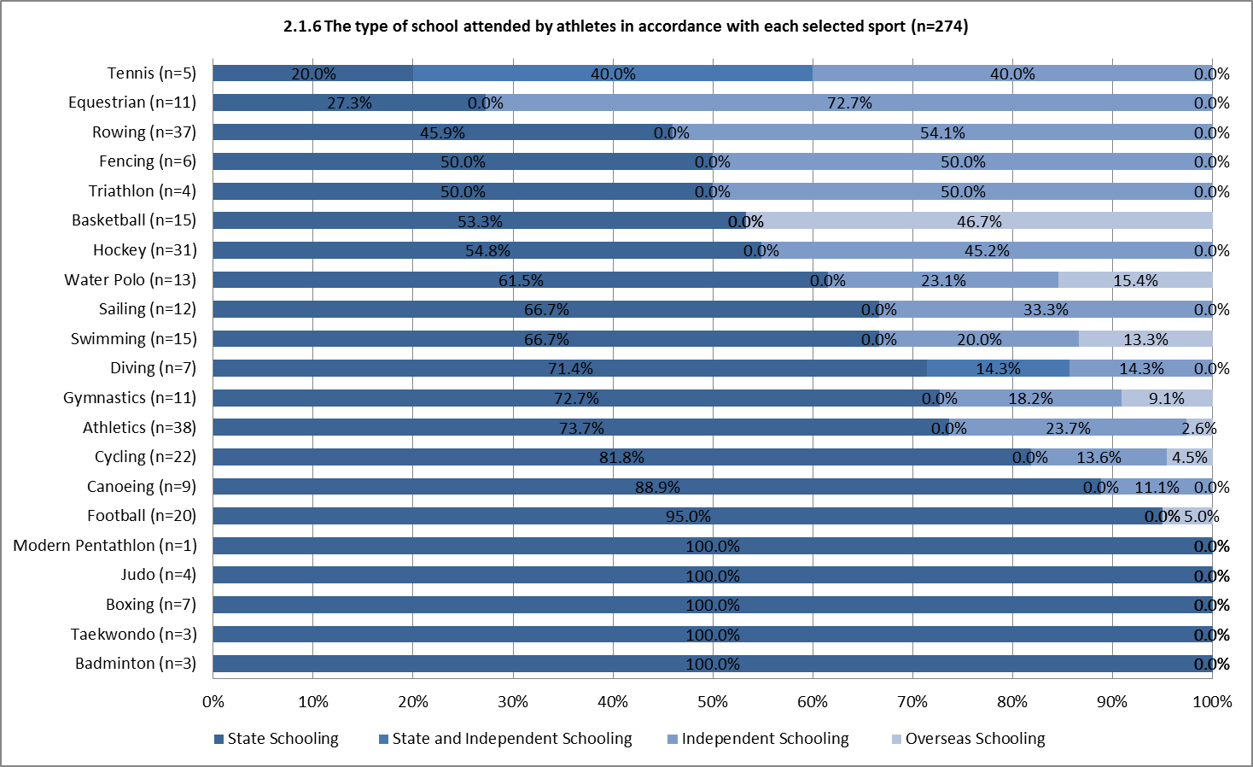

4.2 School type by gender
Analysis was performed on the data regarding the schools attended by each gender. Figures 4.2a and 4.2b illustrate that males competing in all sports, as well as those with 25% or above availability rates, were more likely to have been educated at state schools than their female counterparts. The difference is approximately 6% for all sports and approximately 7% for those sports with 25% or more availability.

Figure 4.2a. A comparison of the type of school attended by Olympians in all sports and those sports with 25% availability rate or above, by gender.
 | Only state schooling | State and independent schooling | Only independent schooling | Overseas schooling
All sports - Male (n=167) | 68.9% | 0.0% | 25.1% | 6.0%
25% availability rate  or above - Male (n=164) | 70.1% | 0.0% | 24.4% | 5.5%
All sports - Female (n=112) | 63.4% | 0.0% | 31.3% | 5.4%
25% availability rate or  above – Female (n=110) | 63.6% | 0.0% | 30.9% | 5.5%

Figure 4.2b. The type of school attended by Olympians in all sports and those in group 1 by gender.
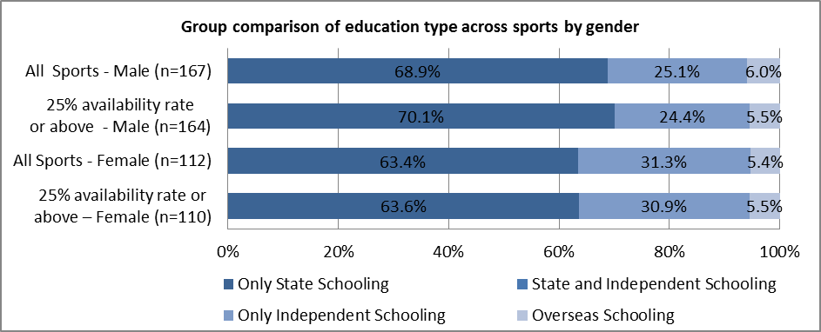

Here, it should be noted that in the “all sports” category, the school types of 40% of the males and 57% of the females could not be located. Whereas, for the “25% availability or above” category, the unknown school type percentage dropped to 30% for males and 47% for females. It is important to note that regardless of the category, across the total cohort of Olympians (n=537), at least 48% of the school types were missing; therefore any conclusions drawn should take this into account.

4.3 Schools list for Olympians

The following tables illustrate the most frequent schools attended by athletes who competed. That is, the schools which multiple athletes attended from all of the Olympic sports.
Figure 4.3a The most frequently attended schools for female athletes.
Female
1 | GDST (Girls’ Day School Trust) | Independent | 2 - Athletics & fencing
2 | Norwich High School | Independent | 2 - Cycling (road) & fencing

Figure 4.3b The most frequently attended schools for male athletes.
Male
1 | Coleraine Academical Institution for Boys | Independent | 3 - Rowing
2 | Eton College | Independent | 3 - Athletics, equestrian and rowing
3 | Bradford Grammar School | Independent | 2 - Triathlon
4 | Dunblane High School | State | 2 - Tennis
5 | King School, Chester | Independent | 2 - Rowing
6 | Millfield School | Independent | 2 - Shooting & swimming
7 | Pangbourne College | Independent | 2 - Sailing
8 | The Southport School, Australia | Overseas | 2 - Swimming

Figure 4.3c. The most frequently attended schools for all athletes.
All
1 | Coleraine Academical Institution for Boys | Independent | 3 - Rowing - all males.
2 | Eton College | Independent | 3 - Athletics, equestrian and rowing - all male.
3 | King School, Chester | Independent | 3 - Rowing - 2 males, 1 female.
4 | Millfield School | Independent | 3 - Shooting & swimming - male, fencing - female.
5 | Bradford Grammar School | Independent | 2 - Triathlon - both males.
6 | Dunblane High School | State | 2 - Tennis - both males.
7 | GDST (Girls' Day School Trust) | Independent | 2 - Athletics & fencing - both females
8 | George Abbot School | State | 2 - Canoe Sprint - 1 male & 1 female.
9 | Norwich High School | Independent | 2 - Cycling (road) & fencing - both female.
10 | Pangbourne College | Independent | 2 - Sailing - both males.
11 | Queen Elizabeth School, Cumbria | State | 2 - Waterpolo -1 male and 1 female.
12 | The Southport School, Australia | Overseas | 2 - Swimming - both males.

These lists illustrate that both of the most frequently attended schools for females were independent. Of the 8 most frequently attended schools for males, 1 was state, 6 were independent and 1 was overseas. Finally, of the 12 most frequently attended schools for both genders, 3 were state, 8 were independent and 1 was overseas.
4.4 Summary

To summarise, of the total athlete cohort (n=279), 65% were state educated, 28% attended independent schools, 1% attended both a state and independent school, and 6% attended schools overseas. Males were more likely to be state educated than females; however, there was a lot of information unknown for the sportswomen. Finally, of the overall top school list, 3 of the 12 schools were state schools, 8 were independent schools and 1 was an overseas school.

5.0 Olympic medallists’ data

The following analysis of the data concerns the information regarding the British Olympic medallists at the London 2012 Games.

Please note that the figures for the some Olympic sports have been merged (canoeing, cycling, equestrian, gymnastics and volleyball).

5.1 Description of the data

Data was collected for a total of 115 British Olympic medallists from 17 sports. As the availability rate was over 25% for all of these, the following analysis will refer to the whole cohort.

Figure 5.1. The availability of school data for the British medallists in each sport (n=17 sports).
Sport | Total number of medallists | Data available
Athletics | 5 | 5 | 100.0%
Boxing | 5 | 4 | 80.0%
Canoeing | 8 | 8 | 100.0%
Cycling | 14 | 14 | 100.0%
Diving | 1 | 1 | 100.0%
Equestrian | 12 | 11 | 91.7%
Gymnastics | 6 | 6 | 100.0%
Hockey | 16 | 16 | 100.0%
Judo | 2 | 2 | 100.0%
Modern Pentathlon | 1 | 1 | 100.0%
Rowing | 28 | 25 | 89.3%
Sailing | 8 | 8 | 100.0%
Shooting | 1 | 1 | 100.0%
Swimming | 2 | 2 | 100.0%
Taekwondo | 2 | 2 | 100.0%
Tennis | 2 | 2 | 100.0%
Triathlon | 2 | 2 | 100.0%
Total = | 115 | 110 | 96.5%

Of the 115 British Olympic medallists, the total availability rate for the data was 96%. Seventy of the medallists were male and 45 were female. The total availability for school data for each gender was 94% (66 males) and 98% (44 females) respectively.

5.2 School type by sport

Of the total cohort, 58% attended state schools, 39% attended independent schools, 2% attended both a state and independent school, and 1% attended a school overseas (figures 5.2a and 5.2b).
Figure 5.2a. The type of school attended by British medallists for all medal winning sports.
 | Only state schooling | State and independent schooling | Only independent schooling | Overseas schooling | N
Total = | 64 | 2 | 43 | 1 | 110
Percentage = | 58.2% | 1.8% | 39.1% | 0.9% | 100.0%

Figure 5.2b The type of school attended by British medallists in all medal winning sports (n=110).
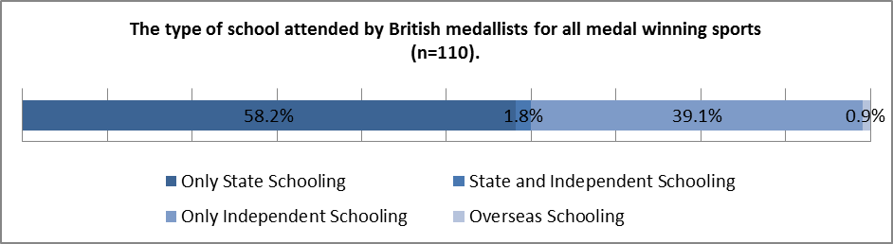
This data can also be observed in accordance with each of the individual medal winning sports.
Figure 5.2c illustrates that:
- Medallists competing in athletics, boxing, judo, modern pentathlon, swimming and taekwondo were all state educated.
- Canoeing, gymnastics and cycling all also had high percentages of state educated athletes.
- All medallists for shooting and the triathlon were independent schooled.
- Sports with high percentages of independently school athletes also included rowing and equestrian.
- Sailing and hockey were both split 50:50 for only state schooled and only independent schooled.
- Whilst diving only consisted of 1 medallist, this person was educated at both state and independent schools.
- 7% of cycling attended a school overseas.

Whilst there was a high availability of data for the total cohort of medallists, the number of athletes per sport was generally quite low due to the exclusivity of winning an Olympic medal, with the exceptions of rowing, cycling, hockey, equestrian, sailing, canoeing and gymnastics. In this way, although athletes from 6 sports were 100% state schools, there were no more than 5 athletes to each of the groups.

Figure 5.2c The type of school attended by the British medallists for each Olympic medal winning sport (n=110).
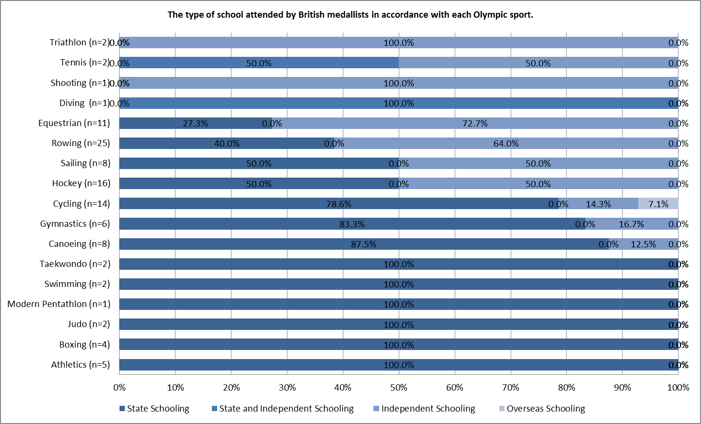
5.3 School type by gender

Analysis was also performed on the data regarding the schools attended by medallists in accordance with each gender.
Figure 5.3a. The type of school attended by British medallists, by gender.
 | Only state schooling | State and independent schooling | Only independent schooling | Overseas schooling | N
Female Total | 26 | 0 | 18 | 0 | 44
Female Percentage | 59.1% | 0.0% | 40.9% | 0.0% | 100.0%
Male Total | 39 | 1 | 25 | 1 | 68
Male Percentage | 59.1% | 1.5% | 37.9% | 1.5% | 100.0%

Figure 5.3b The type of school attended by British medallists, by gender
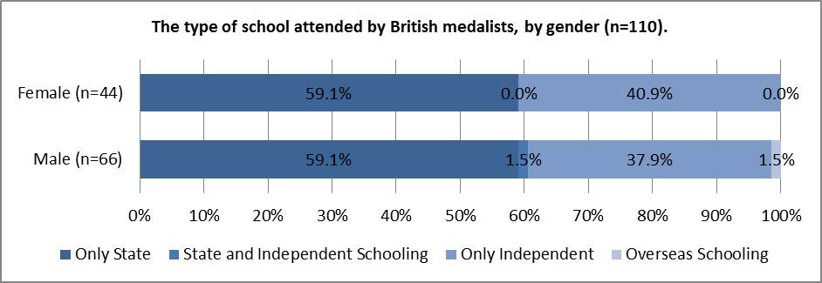
Figure 5.3a and 5.3b illustrate that the school backgrounds for male and females medallists were similar.
5.4 Summary

To summarise, of the total cohort, 58% attended state schools, 39% attended independent schools, 2% attended both a state and independent school, and 1% attended a school overseas. There were 6 sports with 100% state educated athletes and 3 others with high percentages of state educated Olympians. Additionally, there were 2 sports with 100% privately educated members, and 2 others with high percentages of athletes who attended independent schools. Cycling had 7% of its members who were schooled overseas. Finally, males and females had the same likelihood of being state educated.

Section C: Great British Paralympic Team
The following analysis of the data concerns the information regarding the British Paralympic athletes who competed at the London 2012 Games.

Please note that the figures for the following sport have been merged:
- VI and CP football – now labelled “football". This will be used throughout the analysis and the rest of the document.

6.0 Description of the data

Data was collected for a total of 291 athletes from 19 sports. For analysis purposes, this dataset was split into 3 groups:
- Sports with a school data availability rate of 25% or above.
- Sports with a school data availability rate of below 25%.
- Sports with no school data availability, which is classified as ‘other’ and therefore has not been included in the analysis.

Figure 6.0a The availability of school data for British Paralympians in group 1 (n=12 sports).
Sport | Total number of Paralympians | Data available
Athletics | 48 | 15 | 31.3%
Boccia | 9 | 6 | 66.7%
Cycling | 16 | 8 | 50.0%
Equestrian | 5 | 3 | 60.0%
Goalball | 11 | 5 | 45.5%
Judo | 5 | 2 | 40.0%
Rowing | 8 | 6 | 75.0%
Sailing | 6 | 4 | 66.7%
Sitting Volleyball | 22 | 10 | 45.5%
Swimming | 44 | 24 | 54.5%
Table Tennis | 13 | 5 | 38.5%
Wheelchair Rugby | 11 | 6 | 54.5%
Total = | 198 | 94 | 47.5%

Figure 6.0b The availability of school data for British Paralympians in group 2 (n=5 sports).
Sport | Total number of Paralympians | Data available
Football | 22 | 5 | 22.7%
Powerlifting | 5 | 1 | 20.0%
Shooting | 12 | 2 | 16.7%
Wheelchair Basketball | 24 | 2 | 8.3%
Wheelchair Tennis | 10 | 2 | 20.0%
Total = | 73 | 12 | 16.4%

Figure 6.0c The availability of school data for British Paralympians in group 3 (n=2 sports).
Sport | Total number of Paralympians | Data available
Archery | 13 | 0 | 0.0%
Wheelchair Fencing | 7 | 0 | 0.0%
Total = | 20 | 0 | 0.0%

Of the 291 British Paralympians, 271 have been used for the following analysis (figures 6.0a and 6.0b). The total availability of the school data was 93%.
6.1 School type by sport

Of the total athlete cohort (group 1 and 2 combined) (n=106), 83% of the Paralympians attended state schools, 16% attended independent schools and 1% attended schools overseas (figures 6.1a and 6.1b).
For the sports with a 25% school data availability or above (n=94), the figures are the only marginally different; 83% attended state schools, 16% attended independent schools and 1% attended schools overseas (figures 6.1a and b).
Figure 6.1a A comparison of the type of school attended by athletes in all sports and those sports with a 25% availability rate or above.
Group | Only state schooling | State and independent schooling | Only independent schooling | Overseas schooling
25% availability rate or above (n=94) | 83.0% | 0.0% | 16.0% | 1.1%
All Sports (n=106) | 83.0% | 0.0% | 16.0% | 0.9%

Figure 6.1b The type of school attended by all athletes, and those in group 1.
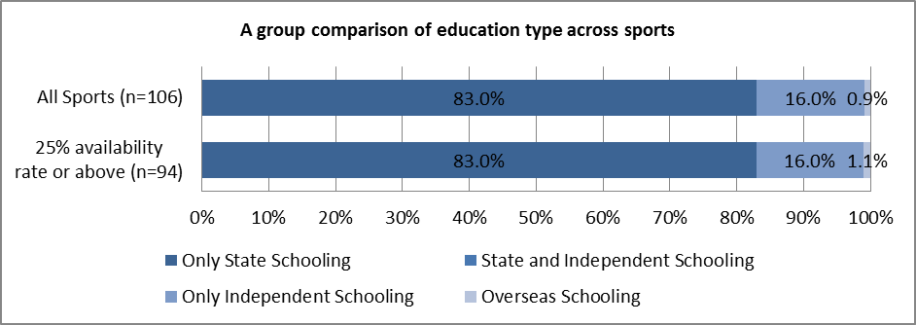

This data can also be observed in accordance with each individual sport. Figure 6.1c illustrates the education split for each sport in the 25% availability rate or above group. The results indicate that:
- 100% of athletes competing in table tennis, judo, equestrian, cycling and boccia attended state schools, although all of these sports did contain low numbers of Olympians.
- 70-83% of athletes in rowing, swimming, wheelchair rugby, athletics, goalball and sitting volleyball attended state schools.
- Sailing had the highest percentage of Olympians educated at independent schools (75%).
- Sitting volleyball was the only sport which contained an athlete who attended a school overseas.
- There were no athletes in any sport who attended both a state and independent school.

However, these figures should be treated with a degree of caution, as the school data for 53% of athletes from the sports collectively, could not be found.
Figure 6.1c. The type of school attended by Paralympians with sports in group 1 (25% availability rates or above) (n=94).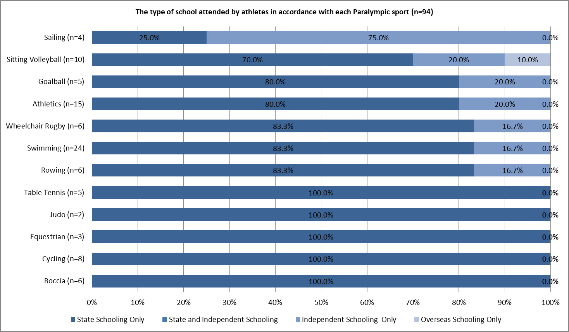
6.2 School type by gender

Analysis was performed on the data regarding the schools attended by each gender. Figure 6.2a and 6.2b illustrate that males competing in all sports (85%), as well as those with 25% or above availability rates (86%), were more likely to have been educated at state schools than their female counterparts (80% and 79%). This trend was reversed for those athletes who attended an independent school, with females being more likely to attend than males.

Figure 6.2a. A comparison of the type of school attended by Paralympic athletes in all sports and those sports with 25% availability rate or above, by gender.
 | Only state schooling | State and independent schooling | Only independent schooling | Overseas schooling
All Sports - Male (n=60) | 85.0% | 0.0% | 13.3% | 1.7%
25% availability rate or above - Male (n=51) | 86.3% | 0.0% | 11.8% | 2.0%
All Sports - Female (n=46) | 80.4% | 0.0% | 19.6% | 0.0%
25% availability rate or above – Female (n=43) | 79.1% | 0.0% | 20.9% | 0.0%

Figure 6.2b The type of school attended by Paralympic athletes in all sports and those in group 1 by gender.
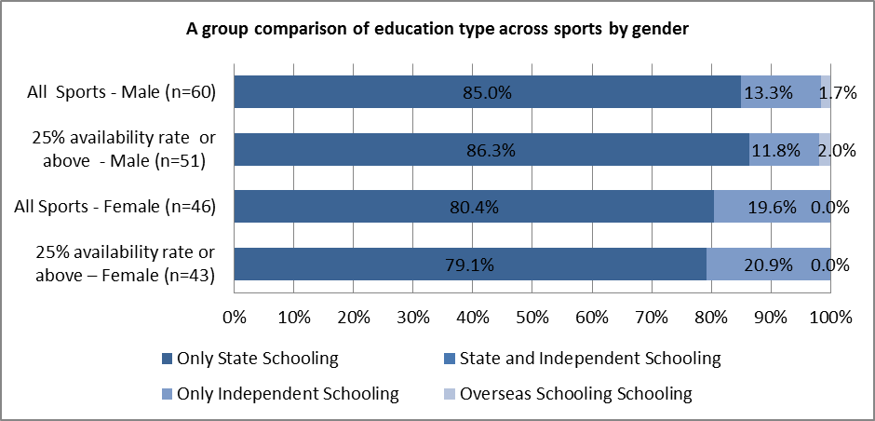
It should be noted that in the "all sports" category, the school types of 67% of the males and 59% of the females could not be located. Whereas, for the "25% availability or above" category, the unknown school type percentage dropped to 56% for males and 49% for females. Nonetheless, regardless of the category, at least 64% of the school types were missing, which is problematic.

6.3 Schools list for Olympians

None of the schools attended by Paralympians (of any grouping) were replicated.

6.4 Summary

To summarise, of the total athlete cohort, 83% attended state schools, 16% were privately educated, and 1% were schooled overseas. There were 5 sports with 100% state schooled athletes and 6 sports with between 70-83% of athletes who were state schooled. Sailing had the highest percentage of privately educated athletes, and sitting volleyball had the only British member of Team GB who was schooled overseas. Finally, males were more likely to be state educated (85%) than females (80%), whilst females (20%) had a higher likelihood of attending independent schools than males (13%).

7.0 Paralympic medallists’ data

The following analysis of the data concerns the information regarding the British Paralympic medallists who won at the London 2012 Games.

7.1 Description of the data

Data was collected for a total of 77 British Paralympic medallists from 11 sports. For analysis purposes, this dataset was split into 2 groups:
- Sports with a school data availability rate of 25% or above.
- 1 sport (archery [n=1]) had no school data availability, which has been classified as ‘other’, and has therefore has not been included in the analysis.

Figure 7.1a The availability of school data for British medallists in Olympic sports in group 1.
Sport | Total number of medallists | Data available
Athletics | 19 | 6 | 31.6%
Cycling | 10 | 5 | 50.0%
Equestrian | 5 | 3 | 60.0%
Judo | 2 | 1 | 50.0%
Powerlifting | 1 | 1 | 100.0%
Rowing | 5 | 4 | 80.0%
Sailing | 3 | 3 | 100.0%
Shooting | 2 | 1 | 50.0%
Swimming | 23 | 14 | 60.9%
Table Tennis | 6 | 3 | 50.0%
Total = | 76 | 41 | 53.9%

Of the 77 British medallists, 76 have been used for analysis (figure 7.1a). These can be split into 41 male and 36 females. The total availability of the school data for this group is 54%. For further reference, these will be referred to as “all sports” as this group were the sports where school data was available above 25%.

7.2 School type by sport

Of the all sports cohort, 85% attended state schools, 15% attended independent schools and 0% attended either a school overseas or both a state and independent school (figure 7.2a and 7.2b).

Figure 7.2a The type of school attended by British Paralympic medallists for all medal winning sports (n=41).
 | Only state schooling | State and independent schooling | Only independent schooling | Overseas schooling | N
Total = | 35 | 0 | 6 | 0 | 41
Percentage = | 85.4% | 0.0% | 14.6% | 0.0% | 100.0%

Figure 7.2b The type of school attended by British Paralympic medallists for all medal winning sports (n=41).
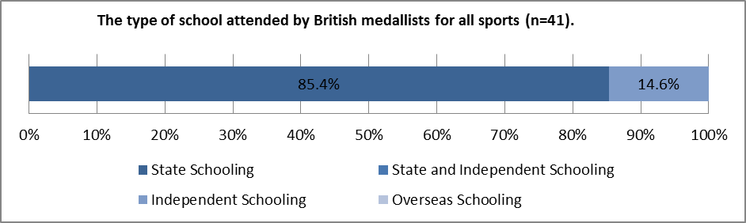

This data can also be observed in accordance with each of the individual medal winning sports.

Figure 7.2c illustrates that:
- Medallists competing in cycling, equestrian, judo, powerlifting, shooting and table tennis were all state educated.
- Rowing, athletics and swimming had between 75-85% of athletes who were state educated.
- Sailing held the highest percentage of privately educated medallists (67%).

Figure 7.2c. The type of school attended by the British medallists for each Paralympic medal winning sport.
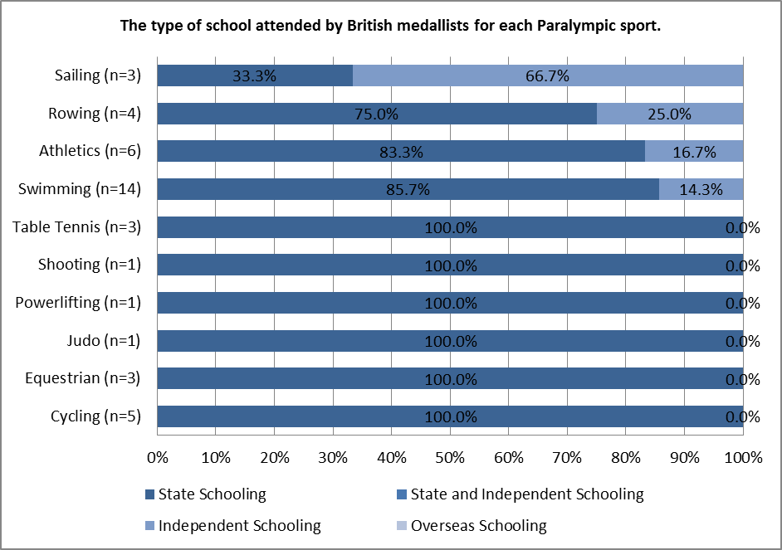
It should be noted that data on these sports represent a small number of athletes and a total of 47% of the school data for these sports as a collective whole were not located. Therefore, these figures should be treated with a degree of caution.

7.3 School type by gender

Analysis was also performed on the data regarding the schools attended by medallists, by gender.

Figure 7.3a The type of school attended by English medallists, by gender.
 | Only state schooling | State and independent schooling | Only independent schooling | Overseas schooling | N
Female Total | 16 | 0 | 5 | 0 | 21
Female Percentage | 76.2% | 0.0% | 23.8% | 0.0% | 100.0%
Male Total | 19 | 0 | 1 | 0 | 20
Male Percentage | 95.0% | 0.0% | 5.0% | 0.0% | 100.0%

Figure 7.3b The type of school attended by British medallists by gender.
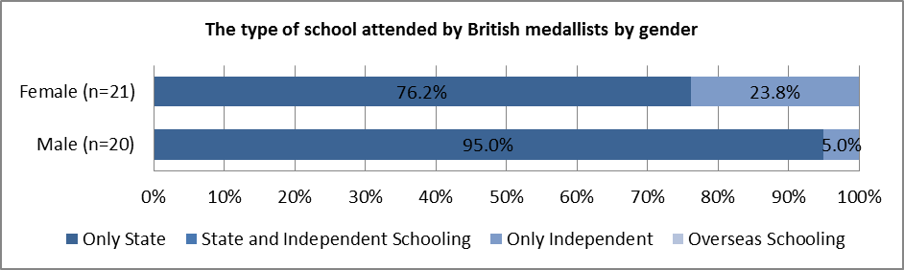
Figure 7.3a and 7.3b illustrate that male Paralympic medallists had a higher likelihood of attending state schools than females, whilst females had a higher likelihood of attending independent schools than males.
School data could not be located for 50% of males and 42% of females. Therefore, these figures should be treated with a degree of caution.
7.4 Summary

To summarise, 85% of medallists attended state schools, whilst 15% were privately educated. Nine out of 10 sports had higher percentages of athletes who attended state schools, as opposed to independent schools. Finally, males were more likely to attend state schools than females, whilst females had a higher likelihood of attending independent schools than males.
END

This figure has been estimated from 2 sources: the Independent Schools Council’s 2013 Census, [http://www.isc.co.uk/] and the Department for Education’s 2013 Statistical First Release on Pupils and their Characteristics [https://www.gov.uk/]. A comparison of these indicates a potential error of +/-1% for the under 16s data and a possible +/-3% error for the over 16s data.

