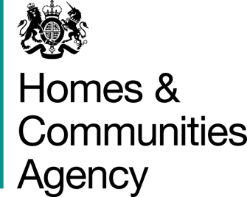
The Social Housing Regulator

14 August 2014

Dear Chief Executive

Submission of Annual Accounts

We thought it would be helpful to write to all providers to remind them of the importance of submitting their annual accounts on a timely basis to the regulator. The accounts are one of our key sources of regulatory assurance and an important document for all your stakeholders.

Providers must submit their accounts within six months of their year end as specified under Section 128 of the Housing and Regeneration Act 2008. For the majority of providers this means by the end of September. Guidance on submission of accounts, is available on the HCA website and is reproduced below.

The Regulator considers that submission of accurate, complete and timely returns is a fundamental responsibility of providers and a key part of the co-regulatory system. We stressed the seriousness with which we regard late or poor quality returns in the Regulating the Standards document (re)published in January 2014 and letters sent to provider chief executives in March 2014. Those documents set out that the Regulator may reflect the submission of poor quality or late returns in its regulatory judgements on providers.

In addition, in autumn 2014, the Regulator will introduce a system whereby those providers that have failed to submit their accounts in line with their statutory obligations will be publicised. That may be by issue of a Regulatory Notice applicable to an individual provider or by publication of a list of providers to the Regulator’s website.

Should you have any queries relating to the submission of accounts please contact the Referrals & Regulatory Enquiries Team at mail@homesandcommunities.co.uk Tel: 0300 1234 500

Yours faithfully,

Jonathan Walters
Deputy Director, Strategy and Performance, (Regulation)

