UK Standards for Microbiology Investigations

Type SMI Title front cover here <tab+enter>


Acknowledgments
UK Standards for Microbiology Investigations (SMIs) are developed under the auspices of Public Health England (PHE) working in partnership with the National Health Service (NHS), Public Health Wales and with the professional organisations whose logos are displayed below and listed on the website http://www.hpa.org.uk/SMI/Partnerships. SMIs are developed, reviewed and revised by various working groups which are overseen by a steering committee (see http://www.hpa.org.uk/SMI/WorkingGroups).
The contributions of many individuals in clinical, specialist and reference laboratories who have provided information and comments during the development of this document are acknowledged. We are grateful to the Medical Editors for editing the medical content.
For further information please contact us at:
Standards Unit
Microbiology Services
Public Health England
61 Colindale Avenue
London NW9 5EQ
E-mail: standards@phe.gov.uk
Website: http://www.hpa.org.uk/SMI
UK Standards for Microbiology Investigations are produced in association with:


Contents
Acknowledgments 2
Amendment Table 4
UK Standards for Microbiology Investigations: Scope and Purpose 5
Scope of Document 8
Introduction 8
Technical Information/Limitations 8
1 Safety Considerations 9
2 Specimen Collection 9
3 Specimen Transport and Storage 10
4 Equipment and Reagents 10
5 Specimen Processing/Procedure 10
6 Quality Assurance 11
7 Limitations 11
8 Reporting Procedure 12
9 Notification to PHE or Equivalent in the Devolved Administrations 12
Appendix 13
References 14

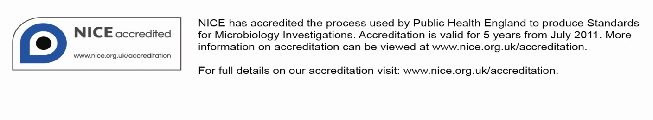
Amendment Table
Each SMI method has an individual record of amendments. The current amendments are listed on this page. The amendment history is available from standards@phe.gov.uk.
New or revised documents should be controlled within the laboratory in accordance with the local quality management system.
Amendment No/Date. | 6/dd.mm.yy <tab+enter>
Issue no. discarded. | #.# <tab+enter>
Insert Issue no. | #.# <tab+enter>
Section(s) involved | Amendment
Whole document. | Document has been transferred to a new template to reflect the Health Protection Agency’s transition to Public Health England.  Front page has been redesigned.  Status page has been renamed as Scope and Purpose and updated as appropriate.  Professional body logos have been reviewed and updated.  Standard safety references have been reviewed and updated.  Scientific content remains unchanged.

Amendment No/Date. | # <tab+enter>/dd.mm.yy <tab+enter>
Issue no. discarded. | #.# <tab+enter>
Insert Issue no. | #.# <tab+enter>
Section(s) involved | Amendment
Whole document. | Amendment to template.

UK Standards for Microbiology Investigations#: Scope and Purpose
Users of SMIs
- SMIs are primarily intended as a general resource for practising professionals operating in the field of laboratory medicine and infection specialties in the UK.
- SMIs provide clinicians with information about the available test repertoire and the standard of laboratory services they should expect for the investigation of infection in their patients, as well as providing information that aids the electronic ordering of appropriate tests.
- SMIs provide commissioners of healthcare services with the appropriateness and standard of microbiology investigations they should be seeking as part of the clinical and public health care package for their population.
Background to SMIs
SMIs comprise a collection of recommended algorithms and procedures covering all stages of the investigative process in microbiology from the pre-analytical (clinical syndrome) stage to the analytical (laboratory testing) and post analytical (result interpretation and reporting) stages.
Syndromic algorithms are supported by more detailed documents containing advice on the investigation of specific diseases and infections. Guidance notes cover the clinical background, differential diagnosis, and appropriate investigation of particular clinical conditions. Quality guidance notes describe laboratory processes which underpin quality, for example assay validation.
Standardisation of the diagnostic process through the application of SMIs helps to assure the equivalence of investigation strategies in different laboratories across the UK and is essential for public health surveillance, research and development activities.
Equal Partnership Working
SMIs are developed in equal partnership with PHE, NHS, Royal College of Pathologists and professional societies.
The list of participating societies may be found at http://www.hpa.org.uk/SMI/Partnerships. Inclusion of a logo in an SMI indicates participation of the society in equal partnership and support for the objectives and process of preparing SMIs. Nominees of professional societies are members of the Steering Committee and Working Groups which develop SMIs. The views of nominees cannot be rigorously representative of the members of their nominating organisations nor the corporate views of their organisations. Nominees act as a conduit for two way reporting and dialogue. Representative views are sought through the consultation process.
SMIs are developed, reviewed and updated through a wide consultation process.
Quality Assurance
NICE has accredited the process used by the SMI Working Groups to produce SMIs. The accreditation is applicable to all guidance produced since October 2009. The process for the development of SMIs is certified to ISO 9001:2008.
SMIs represent a good standard of practice to which all clinical and public health microbiology laboratories in the UK are expected to work. SMIs are NICE accredited and represent neither minimum standards of practice nor the highest level of complex laboratory investigation possible. In using SMIs, laboratories should take account of local requirements and undertake additional investigations where appropriate. SMIs help laboratories to meet accreditation requirements by promoting high quality practices which are auditable. SMIs also provide a reference point for method development.
The performance of SMIs depends on competent staff and appropriate quality reagents and equipment. Laboratories should ensure that all commercial and in-house tests have been validated and shown to be fit for purpose. Laboratories should participate in external quality assessment schemes and undertake relevant internal quality control procedures.
Patient and Public Involvement
The SMI Working Groups are committed to patient and public involvement in the development of SMIs. By involving the public, health professionals, scientists and voluntary organisations the resulting SMI will be robust and meet the needs of the user. An opportunity is given to members of the public to contribute to consultations through our open access website.
Information Governance and Equality
PHE is a Caldicott compliant organisation. It seeks to take every possible precaution to prevent unauthorised disclosure of patient details and to ensure that patient-related records are kept under secure conditions.
The development of SMIs are subject to PHE Equality objectives http://www.hpa.org.uk/webc/HPAwebFile/HPAweb_C/1317133470313. The SMI Working Groups are committed to achieving the equality objectives by effective consultation with members of the public, partners, stakeholders and specialist interest groups.
Legal Statement
Whilst every care has been taken in the preparation of SMIs, PHE and any supporting organisation, shall, to the greatest extent possible under any applicable law, exclude liability for all losses, costs, claims, damages or expenses arising out of or connected with the use of an SMI or any information contained therein. If alterations are made to an SMI, it must be made clear where and by whom such changes have been made.
The evidence base and microbial taxonomy for the SMI is as complete as possible at the time of issue. Any omissions and new material will be considered at the next review. These standards can only be superseded by revisions of the standard, legislative action, or by NICE accredited guidance.
SMIs are Crown copyright which should be acknowledged where appropriate.
Suggested Citation for this Document
Public Health England. (YYYY <tab+enter>). Type SMI Title here <tab+enter>. UK Standards for Microbiology Investigations. V # <tab+enter> Issue #.# <tab+enter>. http://www.hpa.org.uk/SMI/pdf.

Scope of Document
The SMI describes the isolation and identification of herpes simplex virus (HSV) from genital specimens.
This SMI should be used in conjunction with other SMIs.
Introduction
Background
Genital herpes is a common disease. In the UK genito-urinary medicine clinics reported 21,698 new cases during 2006¹.
HSV is classified into types 1 and 2 both of which may result in genital herpes infection. HSV type 1 is common throughout the community and classically causes oral herpes although many infections are asymptomatic. HSV type 2 is spread mainly via sexual contact. After infection, both types move to the dorsal root ganglion, specific to the affected epithelium, where the virus becomes latent. Antiviral therapy will not eradicate latent virus. Reactivation may lead to a recurrence of symptoms or to asymptomatic viral shedding. Infections caused by HSV type 2 have a higher rate of reactivation.
With the advent of effective antiviral drugs against HSV, accurate diagnosis has assumed greater importance². The diagnostic procedure of choice has been virus culture for many years, although PCR methods are increasingly used these days. Tissue culture is relatively quick, sensitive, allows typing of isolates, and the determination of antiviral susceptibility testing when required³.
The accurate diagnosis of herpes genitalis in pregnant patients is of particular importance, especially when the patient has no previous history of genital herpes. Pregnant women are at risk of developing severe, systemic complications and fatal infections have been described^{4,5}. Independent of the clinical severity in the mother there is a risk of infection being passed to the foetus⁶. In the first two trimesters, infection may lead to intrauterine growth retardation and/or an increased risk of abortion. During the third trimester and especially during the perinatal period, maternal infection can cause serious even fatal infection of the neonate³.
Technical Information/Limitations
N/A

1 Safety Considerations⁷⁻²³
1.1 Specimen Collection^{7,8}
Appropriate hazard labelling according to local policy.
1.2 Specimen Transport and Storage⁷⁻¹²
Compliance with current postal and transportation regulations is essential.
A suitable virus transport system (VTM) must be used and the specimen placed in a sealed plastic bag.
Appropriate hazard labelling according to local policy should be applied.
1.3 Specimen Processing⁷⁻²³
HSV is a Hazard Group 2 organism. Refer to current guidance on the safe handling of Hazard Group 2 organisms¹³.
Pregnant women with no prior history of herpes simplex virus infection may be at risk of passing the infection to the foetus. Therefore, staff with no known history of herpes simplex virus infection, who are, or may be pregnant shall be made aware of the risks involved.
Laboratory procedures that may give rise to infectious aerosols must be conducted in a microbiological safety cabinet.
When permissive cells are used for culture of specimens from HIV positive patients, tubes should only be opened in a safety cabinet at Containment Level 3 because of the potential possibility of also cultivating the HIV virus.
The above guidance should be supplemented with local COSHH and risk assessments.
2 Specimen Collection
2.1 Type of Specimens
Labial swabs, genital ulcer swabs, cervical swabs, urethral swabs, endocervical swabs, scrapings from genital ulcers, high vaginal swabs, rectal swabs, vaginal swabs
2.2 Optimal Time of Specimen Collection
Swabs or scrapings should be taken as soon as possible after symptoms appear, samples from active lesions should be put immediately into virus transport medium²⁴. Swabs need to scrape the base of the lesion to obtain a good sample. Repeat sampling is not usually necessary.
All specimens should be taken before anti-viral chemotherapy is started.
2.3 Correct Specimen Type and Method of Collection
N/A

2.4 Adequate Quantity and Appropriate Number of Specimens
N/A
3 Specimen Transport and Storage^{7,8}
3.1 Time between Specimen Collection and Processing
Specimens should be processed as soon as possible.
As far as possible, specimens should arrive in the laboratory within 24 hours.
3.2 Special Considerations to Minimise Deterioration
Samples should be placed in VTM immediately after collection.
When there is a delay in processing, samples should be refrigerated at 4°C. For long-term storage, freeze samples at –70°C.
4 Equipment and Reagents
4.1 Equipment
N/A
4.2 Reagents
N/A
5 Specimen Processing/Procedure^{7,8}
5.1 Test Selection
Where a more rapid result is required, immunofluorescence (IF) or a commercial antigen detection assay may be used to provide a rapid interim report but this result should always be confirmed by culture^{25,26}. Virus culture remains a useful method. HSV PCR is an alternative to virus culture.
5.2 Microscopy Technique
Immunofluorescence microscopy slides should be made with material taken directly from the lesion. When necessary, material expressed from a swab may be used, or in the case of scrapings, a portion of the transport fluid should be centrifuged and the cell deposit used to make preparations for staining.
Preparation and staining of samples for IF should be carried out strictly in accordance with the instructions of the manufacturer of the reagents.
5.3 Culture and Investigation
5.3.1 Pre-treatment
N/A

5.3.2 Specimen processing
Swabs should be agitated to release material into the VTM, taking care not to produce aerosols. Alternatively, material may be expressed into the VTM by gently compressing the swab with sterile forceps.
5.3.3 Isolation
Many of the cell lines in routine use for virus isolation are susceptible to infection with HSV. Of the cell lines commonly used, human diploid fibroblasts, such as the MRC-5 cell line, have been shown to be the most susceptible to infection and to show cytopathic changes more rapidly than other cell lines. If MRC-5 cells are not available, Vero cells are a suitable alternative^{27,28}.
Inoculate 0.2mL of VTM containing the clinical material into each of two cell culture tubes containing the selected cell line. The cells should be incubated at 35-37°C, with or without rolling, for seven days (minimum recommendation). Ideally, cell cultures should be examined microscopically every day for the appearance of cytopathic changes characteristic of HSV. Alternatively, laboratories should examine cell cultures at 24 hours and 48 hours, then every other day.
5.4 Identification
5.4.1 Within the laboratory
The growth of HSV in cell culture may be identified through the appearance of characteristic cytopathic changes (see appendix). Failure to grow in one of the two tubes is probably dose-related.
Serotyping of HSV isolates should be performed using direct or indirect immunofluorescence with type-specific monoclonal antibodies.
5.4.2 Referral to Reference Laboratories
N/A
6 Quality Assurance
6.1 Assessment of Preparation
Only cell lines proven to be susceptible to HSV infection should be used and susceptibility should be checked on acquisition and at regular intervals while in use. Cells removed from liquid nitrogen storage should be checked for susceptibility before use.
6.2 Internal and External Quality Assurance²⁹
N/A
7 Limitations³⁰
Successful isolation of organisms depends on correct specimen collection, transport, storage and processing; the quality and range of cell lines used and the use of correct conditions for culture and the provision of adequate/suitable clinical information.
Susceptibility should be checked on acquisition and at regular intervals while in use.
Cells removed from liquid nitrogen should be checked for sensitivity prior to use.
8 Reporting Procedure
8.1 Reports
Negative specimens should be reported as “virus not isolated”.
Positive specimens should be reported as “herpes simplex virus isolated”.
If typing is carried out, the result may be reported as “herpes simplex virus type … isolated”.
9 Notification to PHE^{31,32} or Equivalent in the Devolved Administrations³³⁻³⁶
The Health Protection (Notification) regulations 2010 require diagnostic laboratories to notify Public Health England (PHE) when they identify the causative agents that are listed in Schedule 2 of the Regulations. Notifications must be provided in writing, on paper or electronically, within seven days. Urgent cases should be notified orally and as soon as possible, recommended within 24 hours. These should be followed up by written notification within seven days. For the purposes of the Notification Regulations, the recipient of laboratory notifications is the local PHE Health Protection Team. If a case has already been notified by a registered medical practitioner, the diagnostic laboratory is still required to notify the case if they identify any evidence of an infection caused by a notifiable causative agent.
Notification under the Health Protection (Notification) Regulations 2010 does not replace voluntary reporting to PHE. The vast majority of NHS laboratories voluntarily report a wide range of laboratory diagnoses of causative agents to PHE and many PHE Health Protection Teams have agreements with local laboratories for urgent reporting of some infections. This should continue.
Note: The Health Protection Legislation Guidance (2010) includes reporting of HIV & STIs, HCAIs and CJD under ‘Notification Duties of Registered Medical Practitioners’: it is not noted under ‘Notification Duties of Diagnostic Laboratories’.
Other arrangements exist in Scotland^{33,34}, Wales³⁵ and Northern Ireland³⁶.

Appendix
Figure 1. Micrograph of uninfected MRC-5 cell line (objective lens mag. X 4).
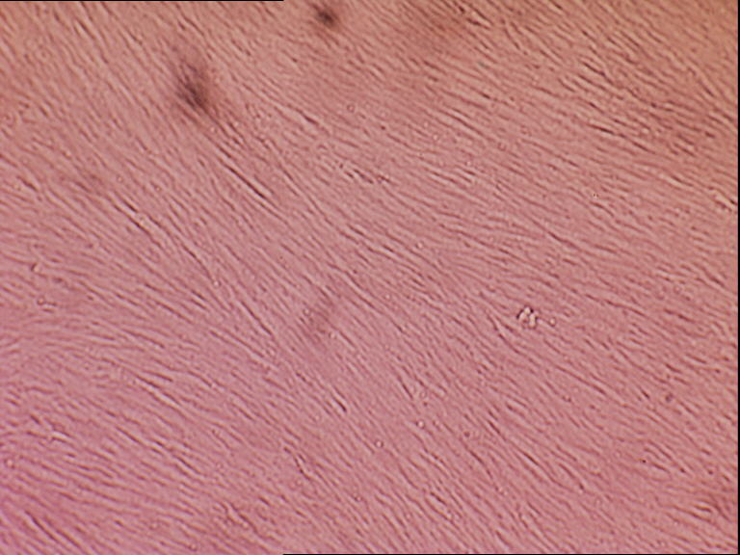
Figure 2. Micrograph of MRC-5 cell line infected with herpes simplex virus (objective lens mag. X 4).
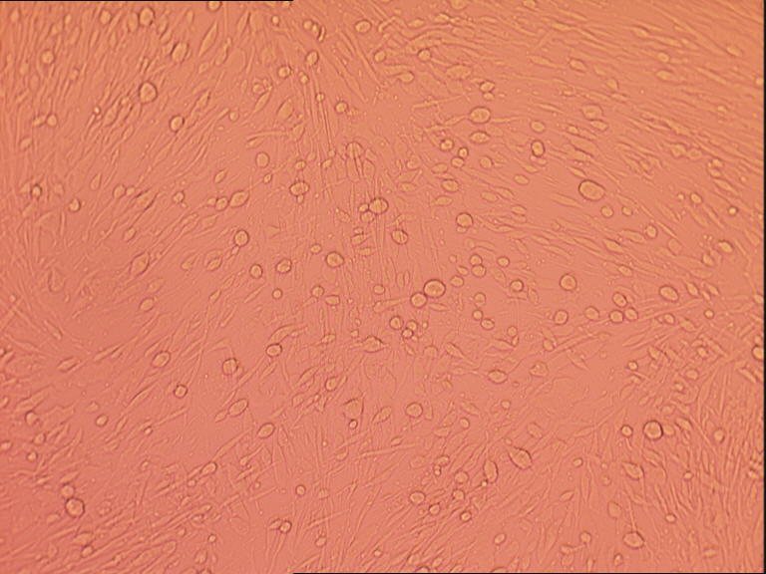
(Photographs kindly donated by Dr Vivienne James, UK NEQAS, Public Health England, Colindale).
References

1. Health Protection Agency. Epidemiological Data- Genital Herpes. 2007.
2. British Association for Sexual Health and HIV. National Guidelines for the Management of Genital Herpes. 2007.
3. Taylor S, Drake S, Pillay D. Genital herpes, "the new paradigm". J Clin Pathol 1999;52:1-4.
4. Wertheim RA, Brooks BJ, Jr., Rodriguez FH, Jr., Lesesne HR, Jennette JC. Fatal herpetic hepatitis in pregnancy. Obstet Gynecol 1983;62:38s-42s.
5. Brown ZA, Vontver LA, Benedetti J, Critchlow CW, Sells CJ, Berry S, et al. Effects on infants of a first episode of genital herpes during pregnancy. N Engl J Med 1987;317:1246-51.
6. Peacock JE, Jr., Sarubbi FA. Disseminated Herpes simplex virus infection during pregnancy. Obstet Gynecol 1983;61:13S-8S.
7. European Parliament. UK Standards for Microbiology Investigations (SMIs) use the term "CE marked leak proof container" to describe containers bearing the CE marking used for the collection and transport of clinical specimens. The requirements for specimen containers are given in the EU in vitro Diagnostic Medical Devices Directive (98/79/EC Annex 1 B 2.1) which states: "The design must allow easy handling and, where necessary, reduce as far as possible contamination of, and leakage from, the device during use and, in the case of specimen receptacles, the risk of contamination of the specimen. The manufacturing processes must be appropriate for these purposes".
8. Official Journal of the European Communities. Directive 98/79/EC of the European Parliament and of the Council of 27 October 1998 on in vitro diagnostic medical devices. 7-12-1998. p. 1-37.
9. Health and Safety Executive. Safe use of pneumatic air tube transport systems for pathology specimens. 9/99.
10. Department for transport. Transport of Infectious Substances, 2011 Revision 5. 2011.
11. World Health Organization. Guidance on regulations for the Transport of Infectious Substances 2013-2014. 2012.
12. Home Office. Anti-terrorism, Crime and Security Act. 2001 (as amended).
13. Advisory Committee on Dangerous Pathogens. The Approved List of Biological Agents. Health and Safety Executive. 2013. p. 1-32
14. Advisory Committee on Dangerous Pathogens. Infections at work: Controlling the risks. Her Majesty's Stationery Office. 2003.
15. Advisory Committee on Dangerous Pathogens. Biological agents: Managing the risks in laboratories and healthcare premises. Health and Safety Executive. 2005.
16. Advisory Committee on Dangerous Pathogens. Biological Agents: Managing the Risks in Laboratories and Healthcare Premises. Appendix 1.2 Transport of Infectious Substances - Revision. Health and Safety Executive. 2008.
17. Centers for Disease Control and Prevention. Guidelines for Safe Work Practices in Human and Animal Medical Diagnostic Laboratories. MMWR Surveill Summ 2012;61:1-102.
18. Health and Safety Executive. Control of Substances Hazardous to Health Regulations. The Control of Substances Hazardous to Health Regulations 2002. 5th ed. HSE Books; 2002.
19. Health and Safety Executive. Five Steps to Risk Assessment: A Step by Step Guide to a Safer and Healthier Workplace. HSE Books. 2002.
20. Health and Safety Executive. A Guide to Risk Assessment Requirements: Common Provisions in Health and Safety Law. HSE Books. 2002.
21. Health Services Advisory Committee. Safe Working and the Prevention of Infection in Clinical Laboratories and Similar Facilities. HSE Books. 2003.
22. British Standards Institution (BSI). BS EN12469 - Biotechnology - performance criteria for microbiological safety cabinets. 2000.
23. British Standards Institution (BSI). BS 5726:2005 - Microbiological safety cabinets. Information to be supplied by the purchaser and to the vendor and to the installer, and siting and use of cabinets. Recommendations and guidance. 24-3-2005. p. 1-14
24. Whitley RJ. Herpes simplex virus. In: Fields BN, Knipe DM, Howley PM, editors. "Fields" Virology. 4th ed. Vol 2. Philadelphia: Lippincott Williams and Wilkins; 2001. p. 2493.
25. Gray JJ. Herpes simplex virus. In: Caul EO, editor. Immunofluorescence: Antigen detection techniques in diagnostic microbiology. London: Public Health Laboratory Service; 1992. p. 75-84.
26. Kudesia G, Van Hegan A, Wake S, Van Hegan RJ, Kinghorn GR. Comparison of cell culture with an amplified enzyme immunoassay for diagnosing genital herpes simplex infection. J Clin Pathol 1991;44:778-80.
27. Griffiths JB, Thornton B, McEntee I. The development and use of microcarrier and glass sphere culture techniques for the production of herpes simplex viruses. Dev Biol Stand 1981;50:103-10.
28. Hossain A, Bakir TF, Siddiqui MA, Khawaja MM, De Silva S, Sengupta BS, et al. Genital herpes simplex virus infections: laboratory confirmation in diverse patient groups. Int J Gynaecol Obstet 1989;29:51-6.
29. Curry A, Ashley CR. Quality assurance in electron microscopy. In: Snell JJS, Brown DFJ, Roberts C, editors. Quality Assurance Principles and Practice in the Microbiology Laboratory. London: Public Health Laboratory Service; 1999. p. 221-30.
30. Clinical Pathology Accreditation (UK) Ltd. Standards for the Medical Laboratory. Clinical Pathology Accreditation (UK) Ltd. Sheffield: 2004. p. 1-56.
31. Public Health England. Laboratory Reporting to Public Health England: A Guide for Diagnostic Laboratories. 2013. p. 1-37
32. Department of Health. Health Protection Legislation (England) Guidance. 2010. p. 1-112.
33. Scottish Government. Public Health (Scotland) Act. 2008 (as amended).
34. Scottish Government. Public Health etc. (Scotland) Act 2008. Implementation of Part 2: Notifiable Diseases, Organisms and Health Risk States. 2009.
35. The Welsh Assembly Government. Health Protection Legislation (Wales) Guidance. 2010.
36. Home Office. Public Health Act (Northern Ireland) 1967 Chapter 36. 1967 (as amended).

Microbiology is used as a generic term to include the two GMC-recognised specialties of Medical Microbiology (which includes Bacteriology, Mycology and Parasitology) and Medical Virology.

