UK Standards for Microbiology Investigations

Type SMI Title front cover here <tab+enter>

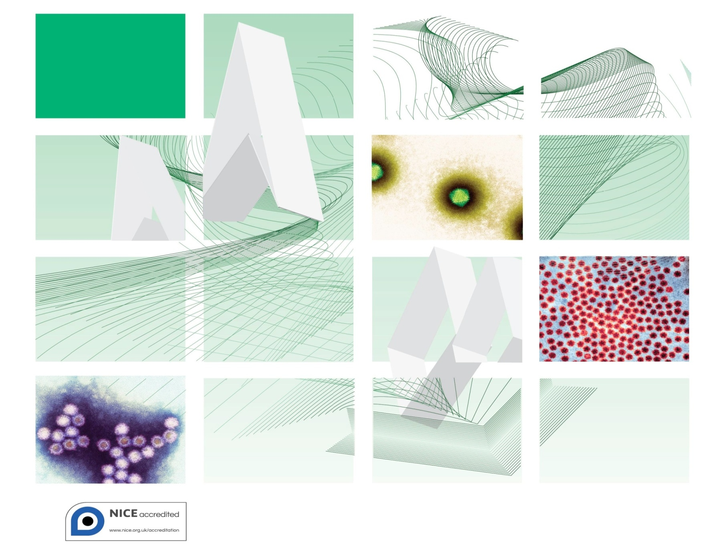

Acknowledgments
UK Standards for Microbiology Investigations (SMIs) are developed under the auspices of Public Health England (PHE) working in partnership with the National Health Service (NHS), Public Health Wales and with the professional organisations whose logos are displayed below and listed on the website http://www.hpa.org.uk/SMI/Partnerships. SMIs are developed, reviewed and revised by various working groups which are overseen by a steering committee (see http://www.hpa.org.uk/SMI/WorkingGroups).
The contributions of many individuals in clinical, specialist and reference laboratories who have provided information and comments during the development of this document are acknowledged. We are grateful to the Medical Editors for editing the medical content.
For further information please contact us at:
Standards Unit
Microbiology Services
Public Health England
61 Colindale Avenue
London NW9 5EQ
E-mail: standards@phe.gov.uk
Website: http://www.hpa.org.uk/SMI
UK Standards for Microbiology Investigations are produced in association with:



Contents
Acknowledgments 2
Amendment Table 4
UK Standards for Microbiology Investigations: Scope and Purpose 5
Scope of Document 8
Introduction 8
Technical Information/Limitations 8
1 Safety Considerations 9
2 Specimen Collection 10
3 Specimen Transport and Storage 11
4 Equipment and Reagents 11
5 Specimen Processing/Procedure 12
6 Quality Assurance 14
7 Limitations 14
8 Reporting Procedure 14
9 Notification to PHE or Equivalent in the Devolved Administrations 15
Appendix 16
References 17

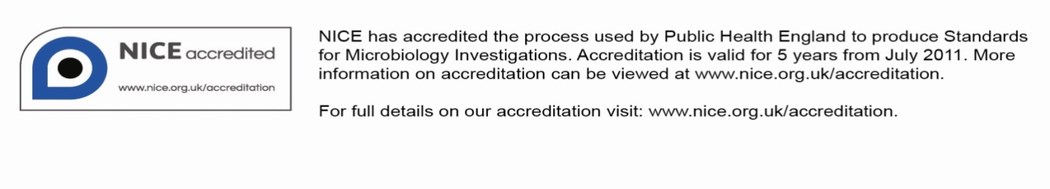
Amendment Table
Each SMI method has an individual record of amendments. The current amendments are listed on this page. The amendment history is available from standards@phe.gov.uk.
New or revised documents should be controlled within the laboratory in accordance with the local quality management system.
Amendment No/Date. | 11/dd.mm.yy <tab+enter>
Issue no. discarded. | #.# <tab+enter>
Insert Issue no. | #.# <tab+enter>
Section(s) involved | Amendment
Whole document. | Document has been transferred to a new template to reflect the Health Protection Agency’s transition to Public Health England.  Front page has been redesigned.  Status page has been renamed as Scope and Purpose and updated as appropriate.  Professional body logos have been reviewed and updated.  Standard safety and notification references have been reviewed and updated.  Scientific content remains unchanged.

Amendment No/Date. | # <tab+enter>/dd.mm.yy <tab+enter>
Issue no. discarded. | #.# <tab+enter>
Insert Issue no. | #.# <tab+enter>
Section(s) involved | Amendment
Whole document. | Amendment to template.

UK Standards for Microbiology Investigations#: Scope and Purpose
Users of SMIs
- SMIs are primarily intended as a general resource for practising professionals operating in the field of laboratory medicine and infection specialties in the UK.
- SMIs provide clinicians with information about the available test repertoire and the standard of laboratory services they should expect for the investigation of infection in their patients, as well as providing information that aids the electronic ordering of appropriate tests.
- SMIs provide commissioners of healthcare services with the appropriateness and standard of microbiology investigations they should be seeking as part of the clinical and public health care package for their population.
Background to SMIs
SMIs comprise a collection of recommended algorithms and procedures covering all stages of the investigative process in microbiology from the pre-analytical (clinical syndrome) stage to the analytical (laboratory testing) and post analytical (result interpretation and reporting) stages.
Syndromic algorithms are supported by more detailed documents containing advice on the investigation of specific diseases and infections. Guidance notes cover the clinical background, differential diagnosis, and appropriate investigation of particular clinical conditions. Quality guidance notes describe laboratory processes which underpin quality, for example assay validation.
Standardisation of the diagnostic process through the application of SMIs helps to assure the equivalence of investigation strategies in different laboratories across the UK and is essential for public health surveillance, research and development activities.
Equal Partnership Working
SMIs are developed in equal partnership with PHE, NHS, Royal College of Pathologists and professional societies.
The list of participating societies may be found at http://www.hpa.org.uk/SMI/Partnerships. Inclusion of a logo in an SMI indicates participation of the society in equal partnership and support for the objectives and process of preparing SMIs. Nominees of professional societies are members of the Steering Committee and Working Groups which develop SMIs. The views of nominees cannot be rigorously representative of the members of their nominating organisations nor the corporate views of their organisations. Nominees act as a conduit for two way reporting and dialogue. Representative views are sought through the consultation process.
SMIs are developed, reviewed and updated through a wide consultation process.
Quality Assurance
NICE has accredited the process used by the SMI Working Groups to produce SMIs. The accreditation is applicable to all guidance produced since October 2009. The process for the development of SMIs is certified to ISO 9001:2008.
SMIs represent a good standard of practice to which all clinical and public health microbiology laboratories in the UK are expected to work. SMIs are NICE accredited and represent neither minimum standards of practice nor the highest level of complex laboratory investigation possible. In using SMIs, laboratories should take account of local requirements and undertake additional investigations where appropriate. SMIs help laboratories to meet accreditation requirements by promoting high quality practices which are auditable. SMIs also provide a reference point for method development.
The performance of SMIs depends on competent staff and appropriate quality reagents and equipment. Laboratories should ensure that all commercial and in-house tests have been validated and shown to be fit for purpose. Laboratories should participate in external quality assessment schemes and undertake relevant internal quality control procedures.
Patient and Public Involvement
The SMI Working Groups are committed to patient and public involvement in the development of SMIs. By involving the public, health professionals, scientists and voluntary organisations the resulting SMI will be robust and meet the needs of the user. An opportunity is given to members of the public to contribute to consultations through our open access website.
Information Governance and Equality
PHE is a Caldicott compliant organisation. It seeks to take every possible precaution to prevent unauthorised disclosure of patient details and to ensure that patient-related records are kept under secure conditions.
The development of SMIs are subject to PHE Equality objectives http://www.hpa.org.uk/webc/HPAwebFile/HPAweb_C/1317133470313. The SMI Working Groups are committed to achieving the equality objectives by effective consultation with members of the public, partners, stakeholders and specialist interest groups.
Legal Statement
Whilst every care has been taken in the preparation of SMIs, PHE and any supporting organisation, shall, to the greatest extent possible under any applicable law, exclude liability for all losses, costs, claims, damages or expenses arising out of or connected with the use of an SMI or any information contained therein. If alterations are made to an SMI, it must be made clear where and by whom such changes have been made.
The evidence base and microbial taxonomy for the SMI is as complete as possible at the time of issue. Any omissions and new material will be considered at the next review. These standards can only be superseded by revisions of the standard, legislative action, or by NICE accredited guidance.
SMIs are Crown copyright which should be acknowledged where appropriate.
Suggested Citation for this Document
Public Health England. (YYYY <tab+enter>). Type SMI Title here <tab+enter>. UK Standards for Microbiology Investigations. V # <tab+enter> Issue #.# <tab+enter>. http://www.hpa.org.uk/SMI/pdf.

Scope of Document
This procedure describes the concentration of virus using differential centrifugation before grid preparation.
This method has been found to be suitable for the examination of faecal specimens, urine specimens, tissue biopsy homogenates and the examination of cell cultures for the presence of viruses.
This SMI should be used in conjunction with other SMIs.
Introduction
Background
A homogenised specimen is centrifuged at low speed to remove large debris and bacteria. The clarified suspension is then subjected to one or more cycles of ultracentrifugation to recover any virus particles present. The procedure can be used to concentrate viruses from any type of specimen that can be homogenised in suspension. It is useful in any situation where there is sufficient extract to allow concentration to be performed (minimum volume of 1mL).
It is currently recommended that ultracentrifugation, ammonium sulphate precipitation (V 15 – Electron Microscopy: Ammonium Sulphate Precipitation), or immune capture (V 16 – Electron Microscopy Using Solid Phase Immune Electron Microscopy) is used for all faecal specimens from outbreaks of gastroenteritis.
Technical Information/Limitations
Specimen Containers^{1,2}
SMIs use the term “CE marked leak proof container” to describe containers bearing the CE marking used for the collection and transport of clinical specimens. The requirements for specimen containers are given in the EU in vitro Diagnostic Medical Devices Directive (98/79/EC Annex 1 B 2.1) which states: “The design must allow easy handling and, where necessary, reduce as far as possible contamination of, and leakage from, the device during use and, in the case of specimen receptacles, the risk of contamination of the specimen. The manufacturing processes must be appropriate for these purposes”.
1 Safety Considerations¹⁻¹⁷
1.1 Specimen Collection^{1,2}
Appropriate hazard labelling according to local policy.
1.2 Specimen Transport and Storage^{1,2,4-6,18}
Sterile leakproof container in a sealed plastic bag.
1.3 Specimen Processing^{1,2,4-18}
- Bacteria, viruses, fungi or parasites, encountered unexpectedly, can cause severe and sometimes fatal disease. Laboratory acquired infections have been reported. Guidance on vaccination is given in the Public Health England immunisation policy. Processing must be carried out by trained laboratory personnel in a properly equipped laboratory and under the supervision of a qualified microbiologist. Disposable gloves should be worn during all procedures
- Where the clinical features may indicate a Hazard Group 3 infection sample processing should only be carried out with appropriate containment conditions. It is recommended that faecal specimens from patients with bloody diarrhoea or haemolytic uraemic syndrome (Escherichia coli O157) are not processed until bacteriology results are available. Suspected Hazard Group 4 samples should only be processed for electron microscopy after inactivation
- Staff who are pregnant and susceptible to varicella/zoster, rubella or parvovirus should not handle any clinical material likely to contain these viruses
- Other samples may be handled as Hazard Group 2. Processing in a microbiological safety cabinet is not mandatory but is advisable. Some specimens may contain pathogenic bacteria or parasites
- Laboratory procedures that give rise to infectious aerosols must be conducted in a microbiological safety cabinet. Vortexing containers creates aerosols that can be released when the container is opened. Containers should be resistant to breakage (polypropylene, not glass or polystyrene), and containers that have been vortexed should only be opened within a laboratory safety cabinet
- Refer to current guidance on the safe handling of all Hazard Group 2 organisms documented in this method
- Prepared grids may be infectious prior to examination in the Electron Microscopy. Dispose of used grids by autoclaving.
- It is recommended that any grids prepared from body fluids from patients who are HIV or HBV positive are inactivated with a drop of fixative (see Appendix)
- Compliance with packing, postal and transport regulations is essential
- Arklone (1, 1, 2-Trichlorotrifluoroethane) has the capacity, like other fluorinated hydrocarbons, to cause ozone depletion and should be used in minimal quantities. It may be replaced with Vertrel® XF manufactured by Dupont™, which is not implicated in ozone depletion
- Use caution when handling forceps. Forceps should be decontaminated after use
1.3.1 Ultracentrifugation
Ultracentrifugation presents particular safety hazards associated with the high rotational forces generated. Staff should be made aware of the dangers and instructed in their use. A service company or the manufacturer should regularly maintain the centrifuges and rotors. Laboratories should have their own maintenance protocols, in accordance with the manufacturer’s recommendations.
1.3.2 Chemical handling
Phosphotungstic acid is corrosive. Gloves and eye protection should be worn when making the non-pH adjusted solution.
The above guidance should be supplemented with local COSHH and risk assessments.
2 Specimen Collection
2.1 Type of Specimens
See specimens listed below.
2.2 Optimal Time of Specimen Collection
Faecal specimens
A minimum of 1g of faeces is required, which should be collected directly into a clean container.
Successful demonstration of virus particles by electron microscopy requires specimens that are taken during the acute phase of the illness. Best results are obtained with specimens collected within 48 hours of the onset of symptoms.
Urine
At least 5mL of urine are required in a sterile leakproof container. The number of virus particles excreted in urine is directly related to the amount of urine produced. Experience indicates that the most consistent results are obtained from specimens of early-morning urine.
Biopsy samples
Biopsy material should be removed into a sterile clear bottle. The material must not be fixed. Separate specimens should be removed into appropriate fixative for histological investigation if required. Sufficient material should be removed to ensure a reasonable amount of the lesion is examined. Approximately 1mm³ of lesion is required.
Cell cultures
Cell cultures that are suspected of containing viruses should be sent for examination if required. The specimen must contain both cell culture fluid and cells. Approximately 1mL of cell/fluid suspension is required.

2.3 Correct Specimen Type and Method of Collection
As above.
2.4 Adequate Quantity and Appropriate Number of Specimens
As above.
3 Specimen Transport and Storage^{1,2}
3.1 Time between Specimen Collection and Processing
Specimens should be transported and processed as soon as possible.
3.2 Special Considerations to Minimise Deterioration
Specimens should be stored at +4°C if processing cannot be performed within 24 hours.
Note: Faecal specimens must not be frozen.
4 Equipment and Reagents
4.1 Equipment
- Bench centrifuge capable of producing 2,000 to 3,000x g
- Preparative ultracentrifuge and rotor capable of producing at least 25,000x g with a minimum sample volume of 1mL
- Fine-point jeweller’s forceps, eg dumont forceps number 5. A separate pair of forceps is required for each sample processed. Forceps must be decontaminated after use
- Coated electron microscope grids (V 12 – Preparation of Coated Grids for Electron Microscopy)
- Hydrophobic surface, eg ‘BenchKote’, Parafilm or a Petri-Dish
- Strips of clean filter paper about 1cm x 2.5cm in size
- Clean 5mL bottles or plastic tubes
- Clean glass microscope slides
- Disposable transfer pipettes
- Griffiths Tube glass homogenisers (optional)
4.2 Reagents
- Negative stain: The negative stain that is most widely used for viruses in electron microscopy is phosphotungstic acid. Alternatives are available
- Specimen diluent: deionised or glass distilled water, sterile phosphate-buffered-saline (PBS) and sterile single-strength minimal essential medium have all been used as a sample diluent. Broad-spectrum antibiotics and a fungicide may be incorporated into the sample diluent
- Deionised or glass distilled water
- Arklone (1,1,2-Trichlorotrifluoroethane) or Vertrel® XF
5 Specimen Processing/Procedure^{1,2}
5.1 Test Selection
N/A
5.2 Culture and Investigation
N/A
5.3 Preparation of Clinical Specimens
Faeces
- Dilute faecal specimens to 10-20% weight/volume in the specimen diluent. The faecal extract must be thoroughly emulsified. If samples are mixed by shaking, or preferably vortexing, the emulsion must be enclosed within a sealed bottle which must be opened within a laboratory safety cabinet, and remain unopened for at least 30 minutes to allow aerosols to settle
- Clarify the suspension by centrifuging (2,000 to 3,000x g for up to 30 minutes) in a sealed-bucket rotor
- Alternatively, dilute the faecal specimen to 10-20% weight/volume in a 1:1 mixture of specimen diluent and Arklone or Vertrel® XF. This helps to release virus bound to membranes, and remove lipids which interfere with attachment of the sample to the EM grid. Emulsify thoroughly, preferably by vortexing. Stand the sealed container at 4°C for 30 minutes. Centrifuge (2,000 to 3,000x g for up to 30 minutes) in a sealed-bucket rotor and harvest the upper aqueous layer
Urines
- Subject approximately 1mL of the urine to two freeze/thaw cycles to disrupt any cellular material present in the specimen, and to release virus particles into the suspension
- Clarify any cloudy urines by centrifuging (2,000 to 3,000x g for up to 30 minutes) in a sealed-bucket rotor
Biopsy material
- Disrupt biopsy material in about 1mL of deionised water or glass distilled water in a suitable homogeniser (eg Griffiths tube)
- Clarify the suspension by centrifuging (2,000 to 3,000x g for up to 30 minutes) in a sealed-bucket rotor
Cell cultures
- Disruption of cell material to release virus may be achieved by freeze-thawing or by lysis in distilled water
- Clarify the suspension by centrifuging (2,000 to 3,000x g for up to 30 minutes) in a sealed-bucket rotor
5.4 Concentration by Centrifugation
- Load from 1-10mL (dependent on the type of rotor used) of clarified supernatant from the first spin into an ultracentrifuge tube. Forces in excess of 25,000x g should be used to pellet virus and the times needed to efficiently pellet virus should be established by trials or calculated from rotor k factors (see appendix). A sucrose layer can optionally be used to give a partial purification of the pellet. Up to one tenth of the tube volume of 20%-30% weight/volume sucrose (dissolved in phosphate buffer or water) is carefully layered into the bottom of the tube before high-speed centrifugation
- Discard the entire supernatant, including any sucrose solution
- Resuspend the pellet in a small volume of sample diluent (30-150µl depending on the starting volume). It can be beneficial at this stage to add a small quantity of Arklone or Vertrel® XF if not already used, and vortex. This helps to release virus bound to membranes. A third slow speed centrifugation (up to 2,500x g) may be necessary if the resuspended pellet is too turbid, and is essential if Arklone or Vertrel® XF has been added in order to separate the solvent phase from the virus containing supernatant
5.5 Preparation and Staining of Grids
- Spot the prepared specimen onto a hydrophobic surface, pre-labelled with the specimen number. Specimen drops must be at least 1cm apart to minimise the risk of sample-to-sample contamination
- Place a grid coated with a suitable support film, support side down, onto the surface of the drop using clean forceps and incubate at room temperature. The precise adsorption time varies depending on the number of virus particles expected in the preparation and the amount of ‘debris’ present in the sample and is best determined by experiment and experience
- Pick up the grid, and blot to remove excess fluid by touching a piece of filter paper to the edge of the grid. Transfer the grid to a drop of a suitable negative stain. After staining (staining time is variable and depends on experience, but should be a minimum of about five seconds); the grid is blotted to remove all but a thin film of stain, and is air dried, support film side up, on a clean piece of filter paper. An optional washing stage, in which the inoculated grid is transferred onto a drop of deionised or glass distilled water for a few seconds, may precede the staining if required
- Alternatively, equal volumes of stain and sample can be mixed with the grid applied as above
- Examine in the electron microscope using a screen magnification of approximately x50,000
5.6 Identification
Viruses are identified by their characteristic morphology.
6 Quality Assurance
6.1 Assessment of Preparation
Grids should be examined for at least five minutes before being considered ‘negative’. Grids with damaged support films should be repeated, as insufficient grid surface will not permit the minimum required examination. Grids that are over-stained, or have too much adherent material to be easily readable, should be repeated with a more dilute or re-clarified extract.
6.2 Internal and External Quality Assurance
Laboratories should participate in any external quality assurance schemes that may become available for electron microscopy¹⁹.
7 Limitations
Successful detection of viruses depends on skill and experience of the microscopist, collection of specimens at the appropriate time, transport, storage and processing and the provision of adequate/suitable clinical information.
Viruses will not be detected unless there are sufficient numbers in the sample, which is usually considered to be 10⁶-10⁹ particles/mL.
The procedure(s) in this document aim to describe good microbiological standard methods for the specimen types specified. Other procedures may be required and professional interpretation by qualified staff is essential. Please note that knowledge of infectious diseases changes constantly and although this SMI is regularly reviewed it may not include emerging pathogens.
8 Reporting Procedure
8.1 Reports
Negative samples should be reported as, ‘No virus particles seen.’
Positive samples should be reported as, eg ‘Astrovirus particles present.’
Some workers may wish to provide an estimate of the amount of virus present. Accurate quantitative assessment requires the application of specialist procedures, but a well-tried scheme that gives consistent results is as follows:
+++ equates to one or more virus particles in each of four randomly selected fields.
++ equates to 10 or more virus particles seen in each of four grid-squares examined.
+ equates to between 1-10 virus particles seen in each of four grid-squares examined.
+/- equates to between 1-10 virus particles seen in total.
8.2 Reporting Time
Urgent requests Telephone as soon as results are available.
Written reports Normally available the next working day or in accordance with local reporting policy.
9 Notification to PHE^{20,21} or Equivalent in the Devolved Administrations²²⁻²⁵
The Health Protection (Notification) regulations 2010 require diagnostic laboratories to notify Public Health England (PHE) when they identify the causative agents that are listed in Schedule 2 of the Regulations. Notifications must be provided in writing, on paper or electronically, within seven days. Urgent cases should be notified orally and as soon as possible, recommended within 24 hours. These should be followed up by written notification within seven days. For the purposes of the Notification Regulations, the recipient of laboratory notifications is the local PHE Health Protection Team. If a case has already been notified by a registered medical practitioner, the diagnostic laboratory is still required to notify the case if they identify any evidence of an infection caused by a notifiable causative agent.
Notification under the Health Protection (Notification) Regulations 2010 does not replace voluntary reporting to PHE. The vast majority of NHS laboratories voluntarily report a wide range of laboratory diagnoses of causative agents to PHE and many PHE Health Protection Teams have agreements with local laboratories for urgent reporting of some infections. This should continue.
Note: The Health Protection Legislation Guidance (2010) includes reporting of Human Immunodeficiency Virus (HIV) & Sexually Transmitted Infections (STIs), Healthcare Associated Infections (HCAIs) and Creutzfeldt–Jakob disease (CJD) under ‘Notification Duties of Registered Medical Practitioners’: it is not noted under ‘Notification Duties of Diagnostic Laboratories’.
http://www.hpa.org.uk/Topics/InfectiousDiseases/InfectionsAZ/HealthProtectionRegulations/
Other arrangements exist in Scotland^{22,23}, Wales²⁴ and Northern Ireland²⁵.

Appendix
Phosphotungstic Acid - this is used at a concentration of 1%-3% by weight in deionised water. The exact concentration used is a matter for personal preference. The pH is adjusted to approximately 6.5 (+/-0.1) by the addition of sodium hydroxide or potassium hydroxide. The ready-to-use stain is relatively stable at room temperature but the pH must be checked regularly.
Fixation of grids prior to negative staining - transfer the inoculated grid from the specimen to a drop of fixative (eg, buffered formalin). Leave at room temperature for at least 2 min. Stain as above on a drop of phosphotungstic acid. This procedure may adversely affect the morphology of some common viruses.
Notes on centrifugation times - the time taken to pellet a given particle depend on the k factor of the rotor, the speed used and the sedimentation coefficient of the particle and can be calculated by the formula t=k/s (s=the sedimentation coefficient in Svedberg units, t=time). The k factors for rotors are usually given by the manufacturer or can be calculated from a formula. The k factor varies widely from around 25 for a rotor running tubes with a short path length at very high maximum speeds, to as much as 800 for tubes with a long path length at low maximum speeds. The time taken to pellet Poliovirus (S = 156) in the first example would be t=25/156, = 0.16hr; in the second example would be t=800/156, = 5.12hr.
Adherence of samples to grids - Some samples do not adhere well to the grid. This is a problem particularly for samples which have been inactivated prior to processing for electron microscopy. There are various methods for enhancing adherence. The simplest is to add bovine plasma albumin or bacitracin to the sample or stain at a final concentration of 0.05%. Alternatively, grids may be pre-treated with 1% Alcian blue G800 or 1% poly-L-lysine, or submitted to glow discharge in a vacuum coating unit if suitable equipment is available.

References
1. European Parliament. UK Standards for Microbiology Investigations (SMIs) use the term "CE marked leak proof container" to describe containers bearing the CE marking used for the collection and transport of clinical specimens. The requirements for specimen containers are given in the EU in vitro Diagnostic Medical Devices Directive (98/79/EC Annex 1 B 2.1) which states: "The design must allow easy handling and, where necessary, reduce as far as possible contamination of, and leakage from, the device during use and, in the case of specimen receptacles, the risk of contamination of the specimen. The manufacturing processes must be appropriate for these purposes".
2. Official Journal of the European Communities. Directive 98/79/EC of the European Parliament and of the Council of 27 October 1998 on in vitro diagnostic medical devices. 7-12-1998. p. 1-37.
3. Health and Safety Executive. Safe use of pneumatic air tube transport systems for pathology specimens. 9/99.
4. Department for transport. Transport of Infectious Substances, 2011 Revision 5. 2011.
5. World Health Organization. Guidance on regulations for the Transport of Infectious Substances 2013-2014. 2012.
6. Home Office. Anti-terrorism, Crime and Security Act. 2001 (as amended).
7. Advisory Committee on Dangerous Pathogens. The Approved List of Biological Agents. Health and Safety Executive. 2013. p. 1-32
8. Advisory Committee on Dangerous Pathogens. Infections at work: Controlling the risks. Her Majesty's Stationery Office. 2003.
9. Advisory Committee on Dangerous Pathogens. Biological agents: Managing the risks in laboratories and healthcare premises. Health and Safety Executive. 2005.
10. Advisory Committee on Dangerous Pathogens. Biological Agents: Managing the Risks in Laboratories and Healthcare Premises. Appendix 1.2 Transport of Infectious Substances - Revision. Health and Safety Executive. 2008.
11. Centers for Disease Control and Prevention. Guidelines for Safe Work Practices in Human and Animal Medical Diagnostic Laboratories. MMWR Surveill Summ 2012;61:1-102.
12. Health and Safety Executive. Control of Substances Hazardous to Health Regulations. The Control of Substances Hazardous to Health Regulations 2002. 5th ed. HSE Books; 2002.
13. Health and Safety Executive. Five Steps to Risk Assessment: A Step by Step Guide to a Safer and Healthier Workplace. HSE Books. 2002.
14. Health and Safety Executive. A Guide to Risk Assessment Requirements: Common Provisions in Health and Safety Law. HSE Books. 2002.
15. Health Services Advisory Committee. Safe Working and the Prevention of Infection in Clinical Laboratories and Similar Facilities. HSE Books. 2003.
16. British Standards Institution (BSI). BS EN12469 - Biotechnology - performance criteria for microbiological safety cabinets. 2000.
17. British Standards Institution (BSI). BS 5726:2005 - Microbiological safety cabinets. Information to be supplied by the purchaser and to the vendor and to the installer, and siting and use of cabinets. Recommendations and guidance. 24-3-2005. p. 1-14
18. Health and Safety Executive. Safe use of pneumatic air tube transport systems for pathology specimens. 9/99.
19. Curry A, Ashley CR. Quality assurance in electron microscopy. In: Snell JJS, Brown DFJ, Roberts C, editors. Quality Assurance Principles and Practice in the Microbiology Laboratory. London: Public Health Laboratory Service; 1999. p. 221-30.
20. Public Health England. Laboratory Reporting to Public Health England: A Guide for Diagnostic Laboratories. 2013. p. 1-37.
21. Department of Health. Health Protection Legislation (England) Guidance. 2010. p. 1-112.
22. Scottish Government. Public Health (Scotland) Act. 2008 (as amended).
23. Scottish Government. Public Health etc. (Scotland) Act 2008. Implementation of Part 2: Notifiable Diseases, Organisms and Health Risk States. 2009.
24. The Welsh Assembly Government. Health Protection Legislation (Wales) Guidance. 2010.
25. Home Office. Public Health Act (Northern Ireland) 1967 Chapter 36. 1967 (as amended).

Microbiology is used as a generic term to include the two GMC-recognised specialties of Medical Microbiology (which includes Bacteriology, Mycology and Parasitology) and Medical Virology.

