0

Scheduled Monuments
& nationally important but non-scheduled monuments

October 2013

Contents

Introduction………………………………………….…………...…………...……3

1: Identifying & protecting nationally important monuments…….....……4

2: Conserving & investigating Scheduled Monuments ……………...........7

Annex 1: Principles of selection for Scheduled Monuments ..……..…...10

Annex 2: The scope of scheduling…....……..…...…………...………....…..12

Annex 3: The distribution of Scheduled Monuments………...…….....…..13

Annex 4: Q&A..................................................……....…………..………..…..14

Introduction

- England is renowned for the richness and depth of its archaeological heritage: a tangible – and often highly evocative – link with our prehistoric and historic past that has the potential to transform knowledge and understanding of the lives of our predecessors during the last 900,000 years, including how they sought to respond to and influence their changing environment.

- In addition to their intrinsic value, ancient monuments can contribute to our perceptions of cultural identity and spirit of place, including the character of our landscapes and seascapes. In doing so they provide unique opportunities for research, education, leisure and tourism, delivering social benefits and contributing to economic growth.

- Unfortunately this finite, fragile and irreplaceable legacy is subject to a growing range of threats and pressures, both due to human interventions (including development or other forms of land use) and natural processes (such as climate change or coastal erosion). It can also be endangered by criminal or irresponsible behaviour, or simply by neglect.

- This statement sets out current Government policy on the identification, protection, conservation and investigation of nationally important ancient monuments for the benefit of current and future generations – including Scheduled Monuments. Together with the domestic legal framework that underpins them, this policy helps to fulfil our obligations under the terms of the 1992 European Convention on the Protection of the Archaeological Heritage and the 1972 Convention Concerning the Protection of the World Cultural and Natural Heritage.

1. Identifying & protecting nationally important monuments

- The United Kingdom has had legislation in place to help safeguard the future of its cultural heritage since the passing of the Ancient Monuments Protection Act 1882. In England the current legislation is the Ancient Monuments and Archaeological Areas Act 1979.

- Under the terms of the 1979 Act the Secretary of State has a duty to compile and maintain a schedule of ancient monuments of national importance, the purpose being to help preserve them, so far as possible, in the state in which they have come down to us today. The Act creates criminal offences in respect of unauthorised works to, or the destruction or damage of, Scheduled Monuments.

- The Secretary of State has discretion to include monuments of national importance in the Schedule. The policy of the Secretary of State is to select Scheduled Monuments on the basis of their archaeological or historical interest, plus their management needs, guided by non-statutory Principles of Selection (see Annex 1). Consequently the content of the Schedule currently includes monuments ranging in date from early prehistory to the recent past. It continues to evolve as:
- new investigations and unexpected finds lead to the discovery of previously unknown monuments; and
- new knowledge and understanding prompts reappraisal of the significance and vulnerability of monuments that are already known.

- Prior to updating the Schedule the Secretary of State is required to consult English Heritage. In practice, the Secretary of State usually considers recommendations put forward by English Heritage, together with the implications of designating Scheduled Monuments. These implications include, but are not limited to:
- highlighting the significance of nationally important ancient monuments;
- securing their legal protection in situ;
- regulating potentially harmful interventions; and
- providing the opportunity for the ongoing involvement of English Heritage in their conservation and management.

- The fact that a monument is not designated as a Scheduled Monument does not necessarily imply that it is not of national importance. Nationally important but non-scheduled monuments can include:
- those positively identified by English Heritage as being capable of designation under the terms of the 1979 Act, having regard to the Principles of Selection at Annex 1, but which the Secretary of State has chosen not to designate; and
- those potentially capable of being designated under the terms of the 1979 Act, having regard to the Principles of Selection at Annex 1, but which have still to be formally assessed by English Heritage.

- In some cases sites of national importance have been positively identified by English Heritage, but are incapable of being designated as Scheduled Monuments under the terms of the 1979 Act because their physical nature is outside the scope of its present definition of a monument (see Annex 2).

- In exercising discretion not to designate Scheduled Monuments the Secretary of State has regard to the fact that some monuments can be effectively protected by:
- other forms of heritage designation (such as Protected Wreck Sites);
- regulating potentially harmful activities through the planning system or other controls (such as the marine licensing regime);
- promoting beneficial stewardship by land managers, including through targeted grant aid; or by
- being located in places that have legal protection for other reasons – such as their biodiversity or geodiversity value (including Sites of Special Scientific Interest or Marine Conservation Zones) – provided that the prevailing management regime is conducive to this.

- Discoveries of human remains or metallic objects on the site of nationally important ancient monuments should be screened to determine if they are subject to the terms of the Burial Acts or the Treasure Act 1996, respectively.

- Some relatively recent buildings are currently designated as both Scheduled Monuments and Listed Buildings (under the terms of the Planning (Listed Buildings and Conservation Areas) Act 1990). If the Secretary of State considers it appropriate to so, such buildings will be ‘de-scheduled’ in favour of management through the listing regime.

- English Heritage, local authorities, the Police and the Crown Prosecution Service operate in partnership to prevent, investigate and tackle criminal offences and anti-social behaviour relating to heritage assets, including Scheduled Monuments and nationally important but non-scheduled monuments. If a criminal offence is suspected to have taken place the relevant authorities will work together to understand the impact and consider appropriate enforcement action, if any. On conviction, such offences can result in fines or imprisonment.

2. Conserving & investigating Scheduled Monuments

- The preservation of Scheduled Monuments often requires little or no direct intervention, but on occasion this is necessary and / or desirable. To help protect them from uncontrolled change or unauthorised geophysical surveys, the 1979 Act introduced two dedicated consent regimes: Scheduled Monument Consent and Section 42 licences.

Scheduled Monument Consent

- It is a criminal offence to demolish, destroy, damage, remove, repair, alter or add to a Scheduled Monument, or to undertake flooding or tipping operations on land in, on or under which there is a Scheduled Monument, unless prior consent has been obtained from the Secretary of State in the form of Scheduled Monument Consent (SMC). It is also an offence to fail to comply with the terms of such consents.

- SMC is required irrespective of other permissions that have been granted or other legal requirement that are being followed – except in the following circumstances:
- certain classes of works to Scheduled Monuments have been granted deemed consent under the terms of the Ancient Monuments (Class Consents) Order 1994;
- development that is likely to affect Scheduled Monuments or their setting that forms part of a nationally significant infrastructure project under the terms of the Planning Act 2008, and which is subject to an application for a Development Consent Order, does not require SMC to be obtained too, but should not commence unless and until that Order has been granted and any pre-commencement conditions appended to it have been fully complied with; and
- Crown development that would impact on Scheduled Monuments is exempt from SMC controls, but is subject to a parallel non-statutory regime known as ‘Scheduled Monument Clearance’.
Persons unsure if SMC is required should contact English Heritage prior to commencing works to Scheduled Monuments.
- In determining if requests for SMC should be granted (conditionally or unconditionally) or refused the Secretary of State gives great weight to the conservation of Scheduled Monuments.

- In cases where works involving harm to, or loss of, the significance of a Scheduled Monument are proposed for research-related purposes, the Secretary of State has particular regard to whether:
- preservation of the monument in situ is reasonably practicable;
- it is demonstrated both that the potential increase in knowledge and understanding of our past cannot be achieved using non-destructive techniques, and that it is unlikely to be achieved with less harm or loss at another place; and
- the potential increase in knowledge and understanding is predicted to decisively outweigh the harm or loss.

- In the remainder of cases, including works proposed for development-, conservation- or presentation-related purposes, the Secretary of State has particular regard to the following principles:
- only in wholly exceptional cases will consent be granted for works that could result in substantial harm to, or loss of, the significance of a Scheduled Monument; and
- in cases that would lead to less than substantial harm to the significance of a Scheduled Monument the harm will be weighed against the public benefits of the proposal.
Though relevant, the potential to record evidence of the past is not considered by the Secretary of State to be an important factor in determining if SMC should be granted in such circumstances. Consequently it will normally be given little weight.

- If consent is granted for works that could result in harm to, or loss of, the significance of a Scheduled Monument the Secretary of State is likely to impose conditions to require this to be captured and recorded in a manner proportionate to the likely harm or loss, thereby realising the monument’s potential contribution to knowledge and understanding of our past. These conditions are likely to be tailored to ensure that:
- the project design seeks to further the objectives of relevant international or national research frameworks;
- use is made of appropriately skilled teams with the resources to fully implement the project design to relevant professional standards (such as those published by the Institute for Archaeologists);
- the project design provides for the full analysis, publication and dissemination of the results, including the deposition of reports in the relevant Historic Environment Record (HER), to a set timetable; and
- provision is made in the project design for the conservation and deposition of the site archive with a local museum or other public depository willing to receive it.
It may also be appropriate to impose a condition to require the conservation of any elements of the monument left exposed following the completion of consented works.

- If it is beneficial to do so, the Secretary of State may choose to grant SMC for repetitive works to a Scheduled Monument, or for identical works to a group of Scheduled Monuments in single ownership. Conversely, existing consents (including those granted following a request for SMC or deemed to have been granted by a Class Consent) may be varied or revoked.

- Prior to determining requests for SMC the Secretary of State consults English Heritage.

- In certain circumstances English Heritage can offer ‘funding of last resort’ to help ensure the recording of unexpected discoveries of national importance that are threatened by imminent damage or destruction – including those identified during the implementation of SMC.

Section 42 licenses

- It is a criminal offence to
- use a metal detector (defined as any device designed or adapted for detecting or locating any metal or mineral in the ground) on the site of a Scheduled Monument; or to
- remove objects of archaeological or historic interest from the site of a Scheduled Monument that have been discovered though the use of such equipment;
unless prior consent has been obtained from English Heritage in the form of a Section 42 licence.

Annex 1:
Principles of Selection for
Scheduled Monuments

The significance of ancient monuments derives not only from their physical presence, but also from their setting.

Not all monuments are of equal significance. Their importance can be gauged by the level of heritage interest they hold for current and future generations. This is defined in terms of their archaeological, architectural, artistic, historic or traditional interest, particularly their:
- Archaeological interest
Interest in carrying out expert investigations at some point into the evidence places hold, or potentially may hold, of past human activity.
Monuments with archaeological interest form a primary source of evidence relating to the substance and evolution of places, plus the people and cultures that made them.
- Historic interest
Interest in how the present can be connected through a place to past people, events and aspects of life.
Monuments with historic interest provide a material record of our nation’s prehistory and history, whether by association or through illustration.

The Secretary of State has regard to the following principles to help select nationally important ancient monuments for designation as Scheduled Monuments:
- Period
All classes of monuments that characterise a category or period should be considered for preservation.
- Rarity
There are some classes of monuments that are so scarce that all surviving examples that still retain some significance should be preserved; in general, however, a selection must be made of those monuments which best portray the typical and commonplace as well as the rare; this process should take account of all aspects of the distribution of particular classes of monument, both in a national and a regional context.
- Documentation / finds
The significance of monuments may be enhanced by the existence of records of previous investigations or, in the case of more recent monuments, by the supporting evidence of contemporary records or representations; conversely, the absence of documentation contemporary to a monument can make its potential more important as the only means of developing our understanding. Similarly, their significance can be enhanced by the existence of related artefacts or ecofacts, such as those held in museums or other public depositories.

- Group value
The significance of a single monument may be greatly enhanced by its association with related contemporary monuments and / or those of different periods; in such cases it is sometimes preferable to protect the complete group of monuments, including associated and adjacent land, rather than to protect isolated monuments within the group.
- Survival / condition
The survival of a monument’s significance, both above and below ground or underwater, is a particularly important consideration and should be assessed in relation to its present condition plus its surviving features.
- Fragility / vulnerability
The significance of some monuments can be destroyed by a single ploughing or unsympathetic treatment, while there are standing structures of particular form or complexity whose significance can be severely reduced by neglect or careless treatment; vulnerable monuments of this nature could particularly benefit from the legal protection that scheduling confers.
- Diversity
Some monuments may be selected for designation because they possess a combination of high quality features, others because of a single important attribute.
- Potential
On occasion, the nature of the archaeological interest of a monument cannot be specified precisely, but it may still be possible to document reasons anticipating the existence and importance of such evidence, and so to demonstrate the justification for designation; the greater the likelihood that such evidence would be revealed through expert investigation, the stronger will be the justification for designation.

These principles should not be considered definitive, but as indicators that contribute to a broader judgment based on individual circumstances. Other factors, such as the contribution of monuments to the character of today’s landscape or the historic landscape, can also be important considerations.

Annex 2: The scope of scheduling

The 1979 Act defines the types of nationally important ancient monuments that can be designated as Scheduled Monuments as:
- any building, structure or work, whether above or below the surface of the land, and any cave or excavation;
- any site comprising the remains of any such building, structure or work or of any cave or excavation; or
- any site comprising, or comprising the remains of, any vehicle, vessel, aircraft or other moveable structure or part thereof which neither constitutes nor forms part of a monument as defined above.

The following types of monuments are specifically prevented from being designated as Scheduled Monuments under the terms of the 1979 Act, though the land or seabed beneath them can be:
- ecclesiastical buildings in ecclesiastical use or occupied dwelling houses; or
- sites designated under section 1 of the Protection of Wrecks Act 1973.

By default, sites that comprise only groups of objects (artefacts or ecofacts) or other deposits that provide evidence of human activity during early prehistory cannot usually be designated as Scheduled Monuments because they do not satisfy the 1979 Act’s definition of a monument, despite potentially being of high significance and national or international importance.

Annex 3:
The distribution of Scheduled Monuments

To date c.20,000 ancient monuments in England or English territorial waters have been designated as Scheduled Monuments, representing a diverse range of chronological and geographical sites. The chart below gives an indication of the relative density of Scheduled Monuments between local authorities.

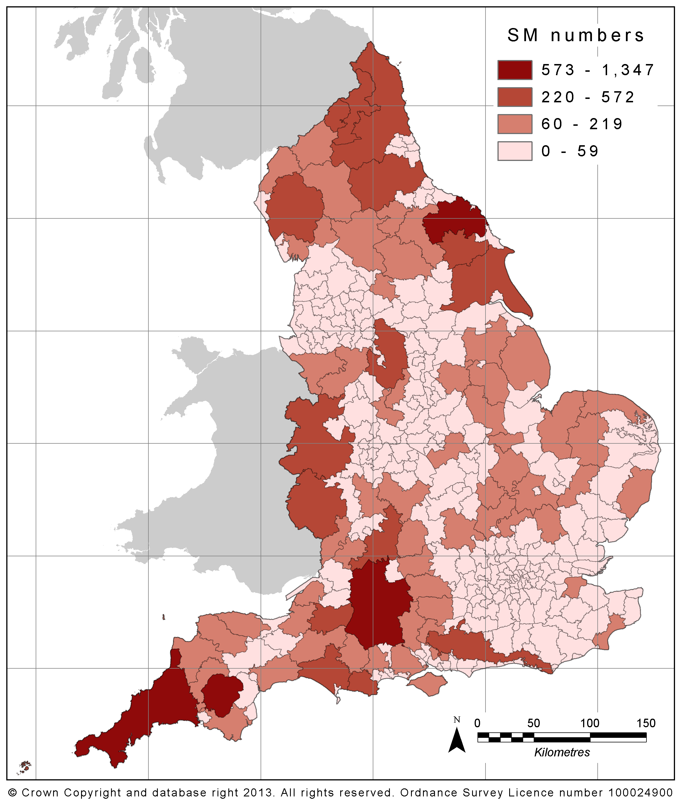

Annex 4:
Q&A

How can I find details of nationally important ancient monuments?
Details of Scheduled Monuments in England or English territorial waters can be found in the National Heritage List for England.
Details of non-scheduled monuments in England or English territorial waters that have been positively identified by English Heritage as being of national importance can be found on the Heritage Gateway.
Further information relating to such monuments can be found in the Historic Environment Records (HERs) kept by or on behalf of local planning authorities. The curation of HERs is the subject or regular discussions between English Heritage and the Association of Local Government Archaeological Services.

How are potential changes to the content of the Schedule identified?
English Heritage advises the Secretary of State on proposals to update the Schedule, including those identified through implementation of its National Heritage Protection Plan (NHPP). .

How can I comment on proposals to update the Schedule?
Unless it could potentially endanger the preservation of the monument in question to do so, the preparation of English Heritage’s recommendation to the Secretary of State to update the Schedule includes consultation with its owners – and, if relevant, its occupiers – plus the relevant local planning authority and HER. It also takes into consideration any other representations that have been received and may on occasion consult more widely. Following the Secretary of State decision on a scheduling proposal, English Heritage notifies relevant parties, including those previously consulted. If relevant, it also notifies the Local Land Charges Register.

How can I seek a review of a scheduling decision?
Details of the circumstances in which reviews of scheduling decisions can be sought, together with information about how to request them, can be found on the GOV.UK portal.

Is the condition of nationally important monuments regularly monitored?
The condition of Scheduled Monuments is monitored as part of English Heritage’s Heritage at Risk programme. Local government archaeological services, plus independent national & local heritage organisations and community groups, can also play important roles in their curation, plus that of non-scheduled but nationally important monuments.
The Secretary of State has powers to repair Scheduled Monuments and to compulsorily acquire ancient monuments deemed to be at risk.

How can I apply for Scheduled Monument Consent?
Requests for SMC should be submitted to the relevant English Heritage local office using the SMC application form. To streamline the decision making process it is helpful if sufficient information is provided to enable the impact of the proposed works on the significance of the Scheduled Monument(s) in question to be fully understood.
English Heritage encourages pre-application discussion and welcomes approaches to its local Development Management Teams.

How can I comment on an application for SMC?
Before recommending to the Secretary of State if a request for SMC should be granted, granted conditionally or refused, English Heritage consults the owner(s) – and, if relevant, the occupier(s) – of the Scheduled Monument concerned. Following the determination of requests for SMC by the Secretary of State, English Heritage notifies relevant parties, including those previously consulted, plus the relevant HER.

Is SMC required for works in the setting of a Scheduled Monument?
The significance of Scheduled Monuments may be affected by direct physical changes or by change in their setting (the surroundings in which they are experienced). Works impacting on the setting of a Scheduled Monument, but not the monument itself, do not require SMC but may require other consents, such as planning permission, development consent or a marine licence.

Can I appeal an SMC decision?
There is no statutory right of appeal. However, if the Secretary of State proposes to grant consent with conditions or to refuse consent, English Heritage issues a provisional view to the applicant, plus other interested parties. If agreement cannot be reached, the Secretary of State either causes a public inquiry to be held or offers the applicant the opportunity of a hearing. The final decision on the Inquiry Inspector’s recommendations is taken by the Secretary of State. Provisional views will be issued within 13 weeks or less of the information necessary for the impact of the proposed works to be fully understood being provided to English Heritage.

How does SMC relate to planning permission?
SMC is separate from the statutory planning process. However, the two processes can run in parallel if planning permission is also required for proposed works to a Scheduled Monument. If so, they are often best handled if both applications are prepared at the same time.
4th Floor, 100 Parliament Street
London SW1A 2BQ
www.gov.uk/dcms

Factual overviews of frequently encountered types of ancient monument can be found in English Heritage’s Introductions to Heritage Assets (IHAs) series.
The rationale for English Heritage’s scheduling recommendations is set out in its Scheduling Selection Guides. Except where it could endanger the preservation of the monuments concerned to do so, the preparation of these recommendations includes consultation with their owner(s) / occupier(s) and the relevant local authority(s).
Policy on the conservation of nationally important but non-scheduled monuments through the planning system is set out in the National Planning Policy Framework and the UK Marine Policy Statement, plus National Policy Statements (for nationally significant infrastructure projects): they should be treated the same as Scheduled Monuments. The impact of development on the significance of monuments of lessor importance is also a consideration in the planning process (please see National Planning Practice Guidance). Occasionally understanding of the significance of such monuments can change following evaluation, leading to them being considered under policies relating to nationally important but non-scheduled monuments.
Policy on conservation of nationally important but non-scheduled monuments located in areas subject to the marine licencing regime is set out in the UK Marine Policy Statement.
Guidance on the exhumation of human remains for archaeological purposes is published by the Ministry of Justice.
Guidance on the reporting of finds of Treasure or other archaeological objects by members of the public is published by the Portable Antiquities Scheme. Comparable industry-specific protocols promote the reporting of discoveries by commercial operators.
_____________________________________________________________________________________________ Further to the procedures set out in the 1994 Class Consents Order: - persons proposing to undertake works under class consent 5 (urgent works necessary for health and safety reasons) should, wherever practicable, discuss their proposals with English Heritage in advance; and - written specifications of works proposed under class consent 7 (works of archaeological evaluation) should generally be submitted to English Heritage for approval rather than the Secretary of State. Certain types of agricultural works are permitted under class consent 1, but are restricted by cross compliance rules that apply to recipients of payments under Common Agricultural Policy (CAP) support schemes or Rural Development Programme schemes.
Guidance on the operation of the Scheduled Monument Clearance regime is published by English Heritage’s Government Historic Estate Unit.
English Heritage policy on the issuing of Section 42 licences is set out in the publication Our Portable Past.
Such buildings can instead be considered for designation under section 1 of the Planning (Listed Buildings and Conservation Areas) Act 1990.
For further details please see the English Heritage Scheduling Selection Guide for ‘Sites of Early Human Activity’.
The distribution of Scheduled Monuments is not necessarily representative of the distribution of nationally important but non-scheduled monuments.
____________________________________________________________________________________________ In relation to monuments located in English territorial waters English Heritage also consults the Marine Management Organisation plus other relevant bodies (such as the Crown Estate or the Receiver of Wreck).

