 |  |  | www.justice.gov.uk
 | Our Reference: 82754 |  | June 2013

Freedom of Information Request

You asked for the following information from the Ministry of Justice (MoJ):

I wish to know about how those private companies are contracted with the government and funded to manage the private prisons, and what are the financial assistance and non-financial assistance offered and subsidized to the private sector from the government.
Your request has been handled under the Freedom of Information Act 2000 (FOIA).

I can confirm that the department holds information that you have asked for, and I am pleased to provide this to you.

The Ministry of Justice operates 14 prisons through prison contracts serviced by the private sector, known as ‘Private Prison’ contracts. These contracts fall into 2 main categories:

1. Design, Construct, Manage & Finance (DCMF) contracts also known as ‘Private Finance Initiatives’ (PFI)
With DCMF contracts, the private sector is asked to fund the construction of a brand new prison as well as provide custodial services. A consortium is formed of financers, constructors and the operator, and together they form a special purpose company or ‘vehicle’ known as an ‘SPV’. The Sectary of State contracts with the SPV who, in turn, subcontracts the construction and the operation of the prison accordingly. These contracts are typically 25 years long – see typical SPV model in figure 1 below:

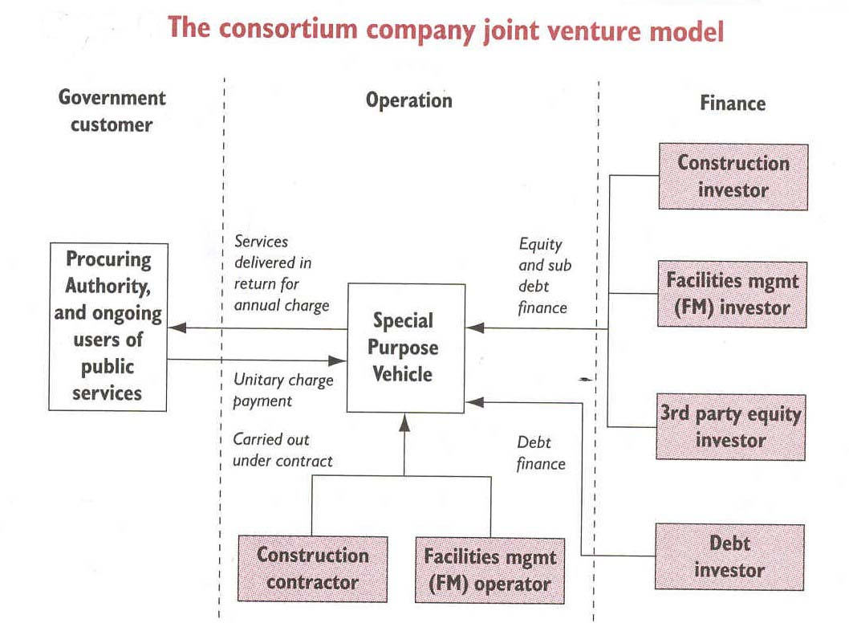
Figure 1 – Special Purpose Vehicle Model

2. Manage & Maintain contracts
With manage-and-maintain contracts, the department leases an existing prison site to a private operator with whom it contracts directly to run the prison and maintain the buildings and infrastructure. These contracts are typically 15 years long.

Specific data relating to Private Prison contracts is set out in Figure 2 below:

Prison | Contract Type | Operator | Original  Contract Term (Yrs) | Approx. Total Contract Value (£M)* | Comments
HMP Altcourse | DCMF | G4S | 25 | £919
HMP Ashfield | DCMF | Serco | 25 | £658
HMP Birmingham | Manage & Maintain | G4S | 15 | £453
HMP Bronzefield | DCMF | Sodexo | 25 | £757
HMP Doncaster | Manage & Maintain | Serco | 15 | £368
HMP Dovegate | DCMF | Serco | 25 | £782
HMP Forest Bank | DCMF | Sodexo | 25 | £659
HMP Lowdham Grange | DCMF | Serco | 25 | £484
HMP Oakwood | Manage & Maintain | G4S | 15 | £349
HMP Parc | DCMF | G4S | 25 | £880
HMP Peterborough | DCMF | Sodexo | 25 | £918
HMP Rye Hill | DCMF | G4S | 25 | £549
HMP Thameside | DCMF | Serco | 25 | £931
HMP Wolds | Manage & Maintain (market test) | G4S | 10 | £90 | This contract expires in July 2013 and returns to the public sector
*Original Treasury or MoJ projection Figure 2: Private Prison Contracts
In respect of financial and non-financial assistance to private prison operators, there are no general provisions for assistance made by government.

There are no special tax arrangements for private prison contracts. Normal tax rules apply.

You can also find more information by reading the full text of the Act (available at http://www.legislation.gov.uk/ukpga/2000/36/contents).

You have the right to appeal our decision if you think it is incorrect. Details can be found in the ‘How to Appeal’ section attached at the end of this letter.

Disclosure Log
​
You can also view information that the Ministry of Justice has disclosed in response to previous Freedom of Information requests. Responses are anonymised and published on our on-line disclosure log which can be found on the MoJ website:
http://www.justice.gov.uk/information-access-rights/foi-requests/latest-moj-disclosure-log
​
The published information is categorised by subject area and in alphabetical order.

