International Development Sector Transparency Panel
DFID, London, 15 May 2013

Paper 3: DFID Aid Transparency – Future Priorities

Aid transparency has the potential to transform the way aid is delivered and to improve its impact. Greater transparency increases the evidence base on what works and what doesn’t, driving efficiencies and better development outcomes.

Significant progress has been made. The Busan High Level Forum recognised that aid transparency is an essential building block for aid effectiveness and set out firm time bound commitments. Over 130 organisations are publishing more reusable information thanks to the International Aid Transparency Initiative and related campaigns. Nonetheless the enormous potential of aid transparency remains untapped. The challenge now is to find ways of using open data to improve aid effectiveness and unlock better development outcomes.

This paper gives an overview of DFIDs proposed future priorities, and the principles underpinning them. The Panel is invited to note these and to decide/discuss:

- How should we make choices between priorities?
- How should we meet the key challenge of using open data to improve development outcomes?
- What are the other key challenges and risks?
- What should be our future priorities?
- What are the gaps in our current plans?
- How can the Panel influence others to do more?

Principles

Four principles guide DFIDs approach to aid transparency:

- Traceability – maximise level of traceability of aid spending through the system from donor to recipient
- Accountability – people should be able to see what our aid is intended to achieve so they can hold us and others to account for delivery
- Efficiency – information should be released once, in open and freely reusable format, reducing bureaucratic reporting requirements; improving decision making and increasing value for money
- Effectiveness – information on DFID aid projects should drive improved development outcomes

Our open data model

Our vision reflects a donor and international stakeholder perspective.
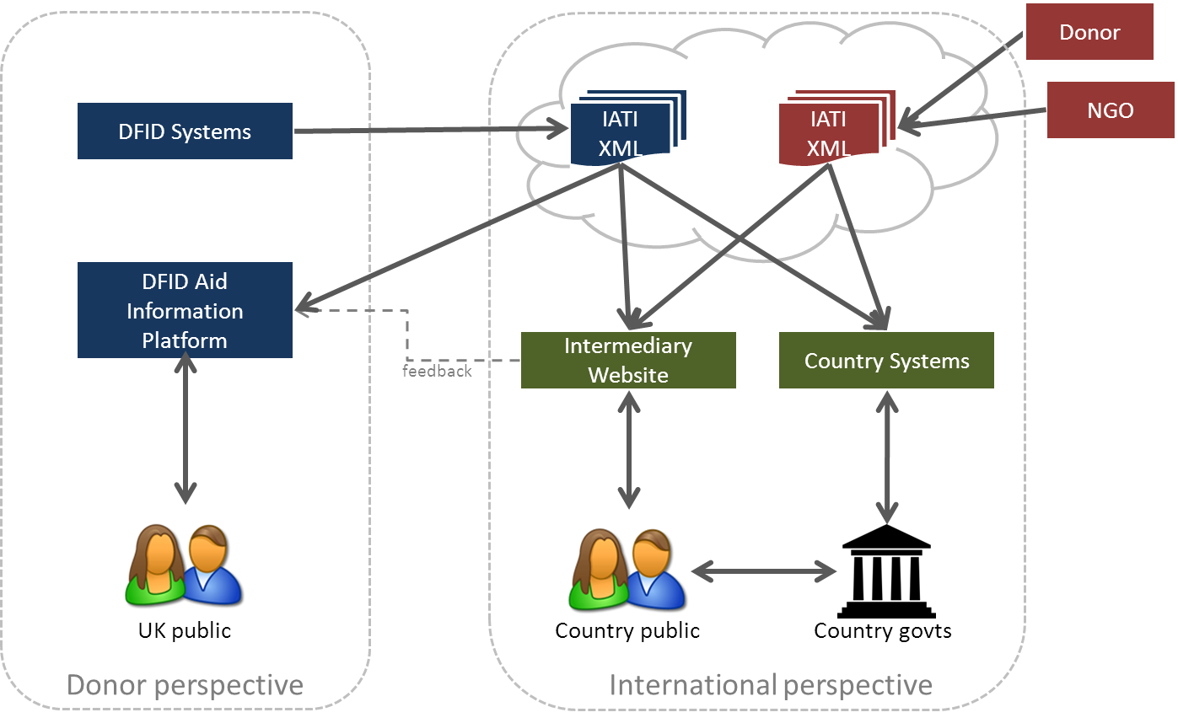
IATI XML refers to data on aid activities in the International Aid Transparency Initiative (IATI) open data format.

From a donor perspective, we publish data on DFID activities so the UK public can understand how taxpayers’ money has been used.

From an international perspective, we publish data in a format others can easily access and re-use. Examples include a civil society organisation mapping aid flows to a developing country or a developing country government managing aid budgets.

Our future priorities

Area | Activities | Comments
Traceability | Pilot geocoding and traceability methodologies  Apply methodologies to all new projects by April 2014  Consult implementing partners on challenges of adhering to IATI standard | Requiring implementing partners to publish to IATI standard and use unique identifiers.  How do we ensure the requirement is not an unreasonable barrier to accessing DFID funding?
Data linkage | Establish methodology for linking DFID aid data with partner country budget data | Building on IATI study and piloting methodology on behalf of IATI.
Data use | Establish fund to help develop tools that support:  - Traceability  - Partner country use of data  - Linking aid data with partner country budget data | How do we stimulate greater data use? By whom?  What do we want the fund to achieve?  What are the key problems we want any new tools to address?
Improving development outcomes | Monitor impact of IATI in small sample of partner countries to better understand how transparency can drive improved development outcomes | Key studies note absence of clear expected outcomes and mechanisms for monitoring benefits of IATI in particular, and transparency initiatives more widely.  How should we monitor and evaluate the benefits of aid transparency?

