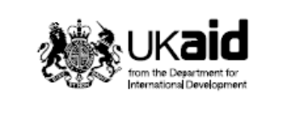
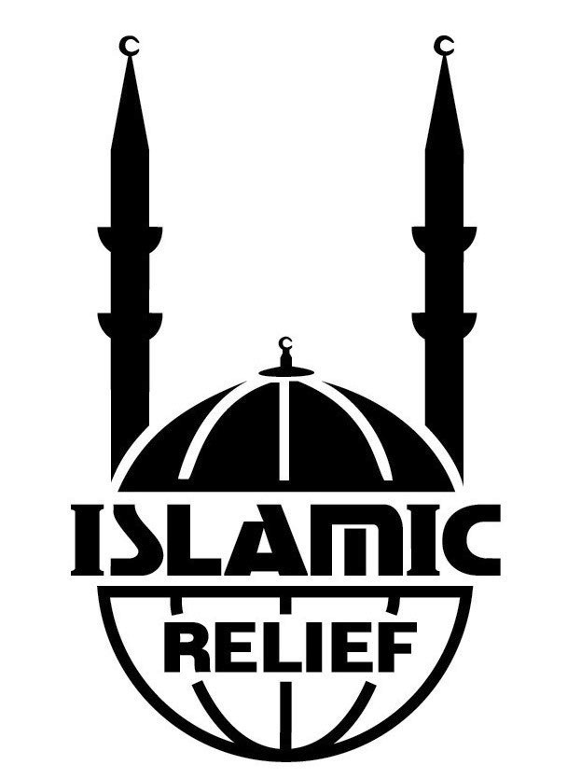
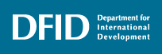

Department for International Development
Partnership Programme Agreement 2008-2011

Islamic Relief Worldwide
Self Assessment Review April 09-March 2010

Islamic Relief Worldwide
19 Rea St South
Birmingham
UK
B5 6LB
Charity Reg : 328158
PPA Self-Assessment Review
Complete areas within white boxes only

Reporting Year | April 2009- March 2010

Part A – Basic Information

PPA partner | Islamic Relief Worldwide (IRW)

Niche statement | With headquarters based in Birmingham UK, IR now has presence in over 35 countries worldwide.  Inspired by Islamic humanitarian values, Islamic Relief Worldwide aims to help meet the needs of vulnerable people and empower them to become self-reliant so that they can live with dignity and confidence. We help individuals, groups and institutions to develop safe and caring communities and make it possible for those who wish to support others to reach people in need of their help. We provide help where it is needed most and wherever we are best placed to assist. We do this regardless of race, colour, political affiliation, gender or belief and without expecting anything in return. We work to mitigate the effects of disasters, preparing for their occurrence where possible and responding with emergency relief and rehabilitation. We promote sustainable development through our work in the sectors of education, health and nutrition, water and sanitation, and livelihoods.  Our work is guided by the core values of accountability, humanitarianism, neutrality and impartiality, inclusiveness. Integrity and co-operation, all of which are also integral to the Islamic faith.

 | 2004/5 | 2005/6 | 2006/7 | 2007/8 | 2008/9 | 2009/10 | 2010/11
PPA funding (£) | N/A | N/A | 562,500 | 750,000 | 770,000 | 800,000 | 820,000
As % of total organisational income | N/A | N/A | 1.49% | 1.79% | 1.53% | 1.37% | N/A

 | 2004/5 | 2005/6 |  | 2006/7 | 2007/8 | 2008/9 | 2009/10 | 2010/11
Other DFID funding (£) | 252,154 | 639,846 | 250,297 |  | 678,720 | 336,377 | 600,618 | N/A

Summary of partnership with DFID and other DFID funding (see)
Since 1993 Islamic Relief and DFID have had a strong project-based funding relationship. During this period DFID has supported programmes in Pakistan, Afghanistan, Mali and the occupied Palestinian Territories, to name but a few (Annex B). As well as developing communities in poverty the funding supported the capacity building of IRW into the agency it is today. Over time, this project-based funding relationship created and consolidated mutual trust. This trust made it possible to expand both the number and size of DFID-funded projects. It also led to new and more sensitive types of cooperation. The PPA is an example of that: without trust and common priorities , DFID would not have provided this PPA. It is through this support that IRW has been able to engage in areas that maybe of risk to a Muslim faith based organisation (FBO) such as HIV/Aids, reproductive health and gender.

Not all cooperation has a financial dimension. Annex A lists non-financial contacts between DFID and us, ranging from joint panel discussions and other public appearances in the UK and elsewhere, to closed-door briefings and consultations. This includes providing feedback to DFID plans for Bangladesh, Ethiopia, Sudan, Yemen and oPT. To commemorate IRWs 25th anniversary joint receptions with British government officials in Albania, Bosnia, Ethiopia, Kenya, Pakistan and Sri Lanka were held. These events illustrated the strong partnership that exists between IRW and DFID.

Approximate % of total organisational expenditure allocated by sector or theme
Our 2009 financial statement allocates our expenditures as follows:
Advocacy & Policy | 2%
education & Vocational Training | 6%
Emergency Relief | 32%
Food Aid (Ramadan & Qurbani) | 11%
Health and Nutrition | 12%
Orphans & Vulnerable children | 24%
Sustainable Livelihoods | 7%
Water & Sanitation | 5%

Part B - Progress against PPA Strategic Objectives

Progress to date against PPA purpose statement
‘Inspired by Islamic humanitarian values, IRW will utilise its global partnerships, expertise and experience to promote and contribute to poverty reduction by specifically focusing on development projects in the horn of Africa and raising development awareness amongst UK Muslim based communities.’

The first objective is in line with our traditional focus on down-stream work on health and sustainable development. The PPA has been responsible for the systematic gathering of baselines and the subsequent measuring of impact. Projects in the target areas of Ethiopia, Sudan and Kenya have resulted in increases in household assets, increased immunisation levels and a reduction in child mortality.

Until our PPA, we usually refrained from making statements or implementing projects in sensitive fields of work, lest we upset either our institutional partners or segments of our Muslim supporters. The PPA funding changed that risk-averse attitude as it enabled us to invest in ‘having an informed opinion.’ We now freely, confidently and publically conduct research, discuss, lecture and write about issues that are controversial in Muslim circles: gender issues, reproductive health and HIV/Aids. In line with the PPA’s second and third objective, we do so in academic circles, the wider development sector, and segments of the Muslim communities in the UK. This is new amongst Muslim NGOs: until we uploaded our first policy stances on these matters, no other UK-based Muslim organisation had publically available policy stances on any of these issues. The PPA focus on these areas was important as the public discourse on gender, reproductive health and HIV/Aids did not just change the extent but the nature of our impact. Today, our work is no longer limited to our programme beneficiaries but breaks taboos, counters stereotypical perceptions and fosters innovative thinking – and thus helps other Muslim organisations to address these issues in the comfort of not having been the first. Muslim Hands, Muslim Aid and several other Muslim NGOs now report on HIV-related activities. Prior to 2007, even the word HIV did not appear on any of their websites.

Muslim FBOs have traditionally seen the UK Muslim community as a fundraising market. The impact of this has been significant emergency funds but limited understanding of development approaches and therefore limited development funds. The PPA has enabled IRW to reach schools and focus the development message to young people.

Progress has been in line with the various verifiable indicators. Irrespective of the extent to which the verifiable indicators have been met, this PPA has made this breakthrough possible and, as such, has been a major success for DFID, IR, and the wider development sector.

Progress against PPA Performance Framework by each Strategic Objective

Strategic Objective 1:
Child mortality and poverty of targeted households reduced in Sudan (Blue Nile), Ethiopia (Afar) and Kenya (Mandera).
Please explain choice of indicators reported on below

We have reported on all indicators. After discussions with DFID indicator five is no longer relevant due to it being an activity and indicator one target has been deemed to be unrealistic and therefore has been revised to be more in line with MDG targets.

The review period. Because the following is largely based on the baseline and progress surveys, there is a discrepancy between the period assumed by the indicators (April 2008-March 2011) and the period covered in this self assessment (early 2009 – mid 2010). In some of the indicators, this 1 ½ year time span is too short to allow for meaningful results, although progress can be shown. We will undertake another report to judge overall PPA impact in Marc h 2011.

Attribution. Lack of diversification opportunities, poor technical know-how and life skills in the three regions forced the communities to depend on fragile livelihood mechanisms with very weak coping strategies. A consequence is that impact by external factors such as rain can be significant. Repeated drought strikes are common in the Afar Region and in Mandera district, and that adds to their vulnerability as it results in sometimes massive loss of livestock and an escalation of food prices.

The communities. In Afar and Mandera, we work with communities that are almost exclusively pastoral. In Sudan, the economic profile is more diverse.

Indicator 1: Reduction from 150/'000 to 112/'000 in child mortality (25%) reduction in child mortality (under 5) in targeted communities by March 2011

Progress achieved and challenges faced
In all countries, mortality rates have decreased

Worldwide, some 70 percent of the under-5 mortality is caused by diarrhoeal diseases, acute respiratory infections (ARI), malaria, preventable childhood diseases and malnutrition. In the Horn of Africa, that percentage is much higher – indeed, our survey in Ewa found that almost 70 percent of the child deaths was caused by ARI alone.

The root causes are not dissimilar from the causes in other parts of the developing world (e.g., food availability and quality, dietary habits, poor health, intra-family distribution) but one factor is worth highlighting for the communities we work in Mandera and Afar. These are pastoral communities, and mortality have varied year on year because of the erratic rains of the past decade. In communities with so few alternative livelihood options, our most impactful type of projects would probably be in the field of economic diversification – and that is indeed what we focus much of our attention to. An implication is that the effects of these programmes are necessarily long term, and attributing mortality-related successes to our work in a little over year would not be credible.

 | 2005 | Early 2009 | Mid 2010
Afar : infant mortality (<1) | 125/1000 | Not available | 108/1000 (127 for boys and 92 for girls
Afar: child mortality mortality (<1) |  | 148/1000 | Not available
Mandera: child mortality (<5) |  | 124/1000 | 115/1000
Blue Nile: child mortality (<5) |  | 179/1000 | 11/1000 (but the survey method is a little unclear)
Consolidated child mortality (using <1 Afar) |  | 75/1000

Note on data.
- In Mandera and Afar, the data gathering process was aided by the usual tools (e.g., ‘flick-a-bottle’ sampling, seasonal calendars for people with no affinity with months and years) but was nonetheless particularly challenging. Because of the volatility we employed a 90-day emergency calculation formula in Mandera. In Afar, we moved from researching child (<5) mortality in 2009 to infant (<1) mortality in 2010 for ethical reasons: customarily, people are reluctant to discuss or even remember about their deceased loved-ones.
- In Blue Nile, the survey method might require revision, and the findings may not be reliable or at minimum an anomaly.
- The key lesson we have learnt when undertaking such regional surveys is that the TORs and expectations from the survey team must be identical. This appears to be an area of weakness and will be addressed for the surveys undertaken in 2011.

Note on attribution. The table presents ‘evidence of the situation’. This is attributed to programmes that IRW have undertaken. In Afar IRW used the Eua river to implement a irrigation project which improved livelihoods. In Mandera IRW has implemented nutrition programmes targeting severly and moderately malnourished people supported by a water, sanitation and hygiene promotion programme. In the Blue Nile Sudan IRW constructed 5 health centres and supplied them with medicines, 4104 people have been reached with hygiene and sanitation promotion messages in close collaboration with the state ministry of health The situation for the communities has also ben helped by increased rain and government food support programmes.
List any documentary evidence of achievements
- Case Studies
- Project Reports (available on request as too numerous to mention)
- Mohamed.I (2010), IRW PPA Baseline Progress 2010: Africa Child mortality & Household poverty, August 2010
Indicator 2: Increase from 538/1000 children immunized to 893/1000 children immunized (66 % increase) in children (under 1) in targeted communities by March 2011
Progress achieved and challenges faced
We are getting close in Mandera. In Afar and Blue Nile there is very substantial progress but still a long way to go.

In Mandera in Kenya, the most common reasons parents gave for not sending their children for vaccinations were that they were unaware of the importance or obligation (31%), the vaccination centres were too far (18%), their children were too young (5%), unavailability of the vaccinations (4%), and other or no specific reasons (42%).

It is important to know these reasons when designing vaccinations programmes, and this has been one of the many benefits of these baseline surveys. The result of our programmes was that the vaccination rates increased between early 2009 and mid 2010:

 | Type of vaccination | % in early 2009 | % in mid 2010
Afar | Overall figure | 26 | 50
 | Measles | 26 | 53
 | BCG | 3 | 49
 | DPT3, H1B, HB | 1 | 50
 | Polio | 56 | 76
Mandera | Measles | 67 | 88
Blue Nile | Comprehensive immunisation | - | 65
 | Comprehensive and partial immunisation | 75 | 86

There are striking differences in localities that are situated fairly close to each other. For example: the Blue Nile 2010 survey found that 88% of the households in Kurmuck but only 45% of the households in Geissan were fully immunised. This is one of the many uses of these surveys: they allow us to focus our efforts.

In Blue Nile IRW has partnered in the national polio campaigns by providing transportation as well as being part of the team planning and implementing these campaigns. IR has constructed five health centers in the Blue Nile and equipped three of them with cold chains for vaccine storage. 64,000 children under five has been immunized in the Blue Nile state including IRW operational areas in Kurmuck and Geissan localities. IRW in Kenya (Mandera) has provided basic medical care (Vitamin A Supplementation, Deworming and Immunization) to mitigate high childhood illness. IRW has partnered with the national government to ensure the Expanded Programme for Immunization (EPI). We seconding IRW Registered Nurses to work with Ministry of Health Outreach team to give immunization to children under five; provided logistical support that includes transport to the site and ambulance services to pregnant/lactating mothers.
List any documentary evidence of achievements
- Case Studies
- Project Reports (available on request as too numerous to mention)
- Mohamed.I (2010), IRW PPA Baseline Progress 2010: Africa Child mortality & Household poverty, August 2010
Indicator 3: increase in average household assets from $223 to $297 per household (33 % increase) in targeted communities by March 2011
Progress achieved and challenges faced
In Mandera, the household assets’ value increased with more than aim of 33 percent.

Our data shows:

 | Per capital cash income |  | Household assets
 | Early 2009 | Mid 2010 | Early 2009 | Mid 2010
Afar | 3,237 Birr | 2,790 Birr
Mandera |  |  | $220 | $400
Blue Nile | Reported on in itemised format, which is useful on the ground but impossible to report on concisely

Because of the inherent volatility of pastoral life, the absence of well-functioning markets, the figures for Mandera and Afar do not say what they seem to say. Specifically:

Household assets. In the communities we work with, drought leads to distress sales, and such sales lead to plummeting livestock and asset values – which means that the asset value goes down when they become relevant as a survival asset. The reason the household assets have increased in value is that there have been rains, which means that the ‘distress market’ no longer exists, for now.

Cash income. In Afar, it was also the rains that came after a long (2003-2008) period of drought that have led to a very fast restocking of cattle (30 percent in less than 1 ½ year). These cattle have led people to reduce their involvement in the labour intensive work programmes of the governments. The proportion of households that utilised these PWP possibilities went down from 97 to only 78 percent, and the average PWP income went down from almost 2,000 to only 652 Birr. In this particular community, the reduction in cash income is a good sign.

As an indictor rather than valuing assets it would have been more useful to analyse absolute numbers of livestock or land holding as a useful indicator of progress. Asset values tend to rise and fall based on the prevalent drought/economic situation

Attribution: In Afar IRW has implemented a livelihood project that supports the irrigated farming and livestock. The irrigation depends on the River Ewa where 200 farmers were trained on cooperative and organized in six cooperative groups. They were provided with seeds and tools and 6 water pumps. With regards to the livestock, 40 community based animal health workers were trained and one animal health post was constructed and equipped. In Mandera IRW has been implementing Micro-Credit and Livelihood projects that have been geared towards diversifying sources of income generation. In Blue Nile 180 families were provided with a total of 900 goats as live stocking intervention. 18 women microcredit groups were trained and 2160 women received loans and run small business. 4 brick making groups were formed trained and are functional. Community based animal health workers were trained and four veterinary pharmacies were established and supplied with vet drugs. Vocational training on carpentry, electric works and construction was organized for 60 youth. The main objective of this training is to reduce the percentage of the unemployment in the area which is common among the youth and school defaulters. IR implemented a fishery project that supported 155 fishermen with training and fishing equipment. 35 beneficiaries including 15 women have been trained on fish drying as a method of preservation of fish for food and selling.
List any documentary evidence of achievements
Case Studies
Project Reports (available on request as too numerous to mention)
Mohamed.I (2010), IRW PPA Baseline Progress 2010: Africa Child mortality & Household poverty, August 2010
Indicator 4: Reduction in global acute malnutrition to below 15% in targeted communities by March 2011

Progress achieved and challenges faced
In the reporting period, GAM went up in Afar and Mandera instead of down, and is now far beyond what WHO considers the ‘emergency threshold of 15 percent.

 | Early 2009 | Mid 2010
Afar | 13.1 | 20.5
Mandera | 25.4 | 28.8
Blue Nile | 17.4 | 17

These GAM levels would have been even higher without the considerable food support that the Kenyan and Ethiopian governments have provided (in the surveyed area in Afar this support amounted to 300 kg per household per year; conversely, in Blue Nile WFP food support was actually reduced – something that led to an increase in school drop-out rates).

Disaggregating the data for Afar (which is the only survey that gathered disaggregated information) shows a more positive picture:

 | Wasting |  | Stunting |  | Underweight
 | Early 2009 | Mid 2010 | Early 2009 | Mid 2010 | Early 2009 | Mid 2010
All children | 12.8 | 20.5 | 78.0 | 61.4 | 43.4 | 45.1
Boys | 17.4 | 20.5 | 75.8 | 62.5 | 41.6 | 45.6
Girls | 8.1 | 20.5 | 80.1 | 60.4 | 45.3 | 44.6

These figures show that there long term nutritional status has improved. This is confirmed by the food insecurity data: the proportion of households that reported food shortages in the preceding 12 months went down from 76% in early 2009 to ‘only’ 29% in mid 2010.

Government interventions have been complemented by IRW programmes in the sectors of nutrition, water, sanitation, hygiene promotion and livelihoods.

Most of the above mentioned interventions contribute to reducing the global acute malnutrition either directly through provision of food or indirectly through improving the families’ livelihood which will be reflected in the children nutritional status. However external factors such as droughts have a significant impact on such communities.
List any documentary evidence of achievements
Case Studies
Project Reports (available on request as too numerous to mention)
Mohamed.I (2010), IRW PPA Baseline Progress 2010: Africa Child mortality & Household poverty, August 2010
What is the likelihood that Strategic Objective 1 will be achieved? Rate 1 to 5 | 2

Strategic Objective 2:
Increased awareness and commitment to international development. The focus will be on young people and the Muslim-based communities within the UK.
Please explain choice of indicators reported on below
Reported on all indicators. Measuring impact using baselines represented a challenge to not only IRW but many NGOs. Innovation is needed in this area and to that extent discussions took place within a development education umbrella organisation called DEAof which we are members.

Indicator 1: Develop and train a cadre of international development speakers with at least 30 core speakers by March 2011

Progress achieved and challenges faced
We trained volunteer speakers however retaining them was a challenge.

From January 2009 until March 2010, staff members and volunteers jointly conducted some 200 MDG-related speaking events across the country. Anecdotal feedback is positive.

Reaching this number of events was a challenge. In London and the West Midlands in particular, demand far outstripped our capacity. There would have been a ‘market’ for many more events, but animated and knowledgeable speakers proved to be in short supply.

We had not anticipated that shortage, as we had assumed we could build upon our long tradition with volunteering. Optimistically, we invested time and effort to train volunteers (10 in Birmingham and 10 in London during the 2009 Ramadan, for example) and arranged for them to lead school assemblies. But it did not turn out to be the success we had hoped for: many volunteers feared public speaking and the ones that did not were young and mobile and exchanged their voluntary role for paid work the moment an opportunity arose. We did consider paying a ‘stipend’ to such volunteers but decided this was neither cost effective or sustainable.

After a few attempts, we accepted that we can train but not truly depend on and retain volunteer speakers, and we moved to other ways of working. For the coming period the three most obvious options are:

- Continue to rely on two staff members who work exclusively in the field of development education. They are supported by a few well-spoken and knowledgeable staff members who occasionally speak at our development education events.
- Recruit additional staff to focus exclusively on the speakers’ project with the aim of mobilising, retaining and administering the volunteers.
- Team up with organisations such as the Three Faiths Forum and Mosaic, which have a track record of successfully mobilising volunteers for school assemblies.

We will be adopting option 2 for the coming period.
List any documentary evidence of achievements
- http://www.islamic-relief.org.uk/Volunteering.aspx

Indicator 2: Establish an active working relationship with at least 30 educational institutions nationally, and with at least 10 Muslim based organizations by March 2011

Progress achieved and challenges faced
In the course of the year, we were active in some 55 primary and secondary schools.

On educational institutes. With only two staff members dedicated to development education, there were two options: we could either develop genuine ‘relationships’ with only a few schools, giving them an in-depth but single-faith perspective, or we could opt to be part of a multi-NGO landscape where we fill the particular niche of the ‘Muslim NGO’. That second scenario provides less depth but gives the pupils a more diverse and richer development-related exposure – and it is the one we opted for.

Consequently, we have had a single or only a few contacts with 55 schools, rather than genuine ‘relations’ with only a few of them. In a few cases, our activities were explicitly framed in an inter-faith context, such as our contribution to the Oh My God It’s Hot! A Christian, Muslim, and a Jew Speak About The Environment event at Cliff College in the Peak District. The added value of such inter-faith cooperation is obvious: it is no longer simply about ‘development’ but also about inter-faith understanding and cooperation.

On Muslim NGOs. We are the largest and most visible Muslim NGO in the UK. In a competitive environment, this means that we are considered with some suspicion, and attempting to lead on an inter-agency Muslim NGO initiative would be very risky. Instead, we established and co-funded, jointly with a few other Muslim NGOs, the Muslim Charity Forum. It is early days and success is limited to meaningful conversations in a cooperative spirit (which, in itself, is not a given and thus a bit of an achievement).

There are no such sensitivities with organisations that do not work in the same fields as we, and it was relatively easy to develop joint activities with seven Islamic schools, and with the Muslim Council of Britain, Al Nida Trust, the Muslim Teachers’ Group, the Oxford Islamic Learning Centre, and Mosaic.

List any documentary evidence of achievements
We did not gather systematic feedback (something we will start doing in 2011) but anecdotal evidence is consistently positive and generally similar to these two examples:

Feedback, Ms Howes, Teacher at Moseley School  The workshop fitted perfectly into our plans and the work the children were doing. They responded very well to the varied stimulus and opportunity to learn about a charity they were familiar with. Mr Sultan gave students opportunity to share their ideas and experiences and drew this information from the children. The students enjoyed the session and learnt a lot. We would be keen to work with Islamic Relief and Mr Sultan again. | Feedback, Ms Mayglothling, Head RE at Wigmore School  Hamayoon delivered a workshop three times throughout the day and was very professional in his approach. He was keen to ensure his input was focused and used activities that would engage with pupils. Although I did not attend all of Hamayoon’s sessions, when I was in his workshop he was very keen to help students to understand what was important about Islam for him and was very clear in his delivery. Hamayoon was so enthusiastic it was infectious. He was prompt in answering queries and appeared extremely reliable.

Dev Ed lecture and discussion -Oxford 5th August 2009.pdf
Repeat Visit schools in Birmingham
Development Education assemblies -Ar Risala Schools.pdf
Development Education assemblies -Morgans JMI School Hertford.pdf
Development Education assemblies -Pelham Primary School.pdf

Indicator 3: Stage at least one major Dev Ed awareness event per year, in partnership with other agencies e.g. with One World Week

Progress achieved and challenges faced
Events ranged from a conference for specialists to setting up a mock refugees camp in the UK – which activity is more ‘major’ depends on one’s focus and priorities.

In-house, we consider our January 2010 conference on Islamic micro-credit to be our ‘major’ Dev Ed event. The ‘educational’ dimension rested in the nature of the audience: the event was not just attended by development experts but by bankers and city lawyers, and it led to new forms of engagement between the financial sector and the development community. We presented this as an approach which can have a significant impact on gender empowerment. Specifically with vulnerable groups that suffer from social stigmas such as divorced and widowed women.

Also significant were the two seminars we had developed jointly with the Jubilee Debt Campaign and the Global Poverty Project, at the City Circle (which is a group of young Muslim professionals).

Much more visible to the public eye was our mock refugee camp, which stood in Birmingham for a few days and was meant to enable passers-by to get a feel of ‘what it is like.’

Each of these activities is successful in terms of ‘meeting the indicator’, but they all share the same drawback: it is all but impossible to measure their impact. In the context of your Value for Money efforts, we would much appreciate your advice on impact measurement of this type of activities.

List any documentary evidence of achievements
Micro finance conference - http://www.islamic-relief.org.uk/NewsDetails2.aspx?id=176
City Circle
Islamic Relief Micro Finance conference summary.pdf

Indicator 4: Incorporate and promote MDGs and the wider Dev Ed message across all aspects of IRUk’s fundraising and campaigning work.

Progress achieved and challenges faced
In the course of past few years, MDGs have been ‘in the picture’ a great deal more than ever before, but a large scale emergency instantly shifts the focus back to our more traditional focus on disaster relief activities.

Development Education is not new to us: we have had our quarterly Partnership magazine (which we deliver to every household in our database), our mock refugee camps and our school presentations for years. But this period is the first one where we moved away from a near-exclusive focus on the issues that have most immediate ‘Muslim appeal’ (orphans, water projects), and instead aligned our Dev Ed activities to the MDGs.

That required two things. First, we trained our campaigners on MDG-related concepts and relevant IR examples of good practice. Second, we developed a resource that our campaigners could routinely refer to and utilise: our Development Education website. The Global poverty project partnership of which we are members is a key resource for this.

The efforts show mixed results. On the one hand, MDGs really are ‘in the picture’ and some of our activities are exclusively devoted to them (e.g., we had MDG-focused education catalogues, events, online presentations, posters, material such as jigsaws and calendars, leaflets and a booklet that provides examples of MDG-related fundraising techniques.) On the other hand, all goes overboard when there are immediate emergencies to respond to, and a glance at our website in the aftermath of a large-scale disaster shows an instant move away from the MDGs and back to our more traditional focus of emergency relief activities.

List any documentary evidence of achievements
City Circle-JDC and Islamic Relief -Debt in Muslim Countries.pdf

The Islamic Relief Development Education website
http://www.islamic-relief.org.uk/Development_Education_Home_Page.aspx

Since March 2009 to date:

- 5731 visitors
- 1076 Books/Leaflets page
- 1094 Material/Primary page
- 665 Materials/Secondary page
- 273 Materials/Higher page

Our online resources can be downloaded from this page
http://www.islamic-relief.org.uk/Presentations.aspx

Indicator 5: Increase in the number of written development articles in Muslim media from 0 to 18 articles by March 2011
Progress achieved and challenges faced
We were never but are now a regular contributor to the printed Muslim media.

The articles we got published are simultaneously development-focused and empowering locally, focusing on women more than men and on people’s own resourcefulness more than on external support. They cover issues that makes the Muslim reader proud (‘things Islam can teach the world about finance’) but also issues that must have made many Muslims feel uncomfortable because of the taboos they addressed head on (we were interviewed and wrote part of an Emel special issue on HIV, for example).

This is a new field of work, where we feel watched closely by both our traditional Muslim supporters, our ‘competition’ within the development and relief sector, and by our Christian and secular partners. Understandably, we proceed cautiously and await the level of criticism we receive before moving on to the next taboo or potentially explosive issue.
List any documentary evidence of achievements
- Emel – IslamicRelief MF.pdf
- IslamicRelief women and empowernment.pdf
- http://www.newstatesman.com/blogs/the-faith-column/2009/04/charity-islam-muslims-relief
- We have also had articles published such as in Ausaf Newspaper, The Nation, UK Times and had relevant stories in the media with satellite/TV outlets such as Islam Channel, ARY, GEO and NTV-Bangla.

What is the likelihood that Strategic Objective 2 will be achieved? Rate 1 to 5. | 2

Strategic Objective 3:
Contribute an Islamic perspective to policy and research on a range of humanitarian and development issues with specific focus on HIV/Aids, reproductive health, debt & finance and gender justice.

During this reporting period the policy unit has undergone restructuring due to the organisational change process. We are now re building the capacity of the unit. The existing capacity has been utlised in the important task of supporting the development of the IRW strategy for the coming 5 years. An indicator to our commitment to policy engagement is the recent recruitment of WATSAN and sustainable livelihood advisors and prominent role advocacy, policy and campaigning takes in our new strategy.

Indicator 1: Increased inclusion of Islamic perspectives seen in UN, Dfid discussion/dialogue/ conferences with regards to HIV/Aids, reproductive Health, debt/ finance and gender justice.

Progress achieved and challenges faced
Progress. After a period of self-development, we entered the discourse arena in 2007. We contributed frequently to meetings and in one-to-one conversations with UN and DFID officials (see attachment). In addition and in a more public manner, we contributed to:

- A UNAIDS conference on Faith and HIV that took place in Geneva, in April 2008. Our role exceeded the usual workshop participation and included a plenary presentation on the ‘state of affairs’; advice on the conference’s invitees; and a review of the conference and post-conference material.
- A UNDP work shop for religious leaders, which took place in the Fayyoum in Egypt, in June 2008. We presented our HIV-related work to a familiar audience: most of this event’s participants had attended our International Consultations on Islam and HIV/Aids in South Africa.
- A UNFPA conference on reproductive health in Istanbul, in October 2008, where our CEO led one of the sessions and proposed closer collaboration between the two organisations (leading to a Memorandum of Understanding in 2009 – see under the 4th indicator).
- A White Paper regional consultation meeting in Birmingham, in April 2009, when an Islamic Relief representative reflected on DFID’s work in the previous years.
- A lecture series on Faith and Development, together with Oxfam, World Vision and DFID, late 2009.

Learning : Without concomitant field programmes, we will gradually lose our credibility in these fields of discourse. This is challenging, as programmes require funding. In issues such as HIV and reproductive health, institutional donor agencies are reluctant to fund faith-based interventions, and our traditional supporters continue to focus their donations for more traditional fields of work such as humanitarian interventions and orphans’ support.
List any documentary evidence of achievements
http://www.islamic-relief.com/Indepth/articles.aspx?assignedID=s1

Indicator 2: Six high quality policy/briefing papers published by March 2009

Progress achieved and challenges faced
Six new or revised policy stances and ten briefing papers were uploaded onto the ‘In-depth’ section our website.

Achieved see: http://www.islamic-relief.com/Indepth/Default.aspx?depID=6

Progress. From early 2008 until March 2010, we enriched the ‘In-depth’ section of our website with six new or modified policies (including our policies on debt, HIV and reproductive health). The positive feedback encouraged us to enter additional fields of discourse, and our briefing papers from this period cover new issues such as corruption, education and refugees.

Partly simply because we fill the ‘Muslim vacuum’ in some of these fields, our papers have sparked considerable interest. In the field of Reproductive Health, for example:

- Georgetown’s University approached us as a potential partner in the context of a collaborative effort of faith-based organisations in the field of reproductive health.
- The Faculty of Sexual and Reproductive Health in London invited us to join their International Working Group that provides RH-related expertise to NGOs.
- MSF is utilising our RH policy in an attempt to increase the uptake of their reproductive health services in Islamic communities.

Learning: Visits to the ‘In-depth’ section of our website amounted to only 2,300 per month from April 2009 to March 2010. This confirms our impression that only a tiny fraction of our visitors take a real interest in discourse. That illustrates tension that currently exists within the organisation: we would like to invest in learning, innovation and meaningful discourse contributions, but the vast majority of our traditional supporters expect us to concentrate on direct implementation of a limited range of downstream projects.

List any documentary evidence of achievements
Publically available documents

- Our policies on Debt, HIV, Reproductive Health, Poverty, the Environment, and Trade.
- Our briefing papers on Corruption, Education, Islamic Microfinance (and a different briefing paper here), Charitable Giving, History of Charitable Giving in Islam, Translating Faith into Development, Debt, Fair Trade, and Refugees.
- Policy hits on IRW website

Google search on 18 September 2010:

- “Islamic Relief”+”HIV”: 42,400 hits
- “Islamic Relief”+”reproductive health”: 16,700 hits
- “Islamic Relief”+gender: 47,200 hits (but this does not really count as it is nearly impossible to write anything in the field of development without using the word ‘gender’)
- “Islamic Relief”+debt: 17,500 hits
- “Islamic Relief”+microfinance or microcredit: 13,500 hits

Indicator 3: Increased inclusion of Islamic perspectives seen in academic journals/ discussions and conferences with regards to HIV/Aids, reproductive Health, debt/ finance and gender justice.

Progress achieved and challenges faced
We made conference contributions and published articles. In both types of work, we now need to move from a reactive approach (get invited and oblige) to a pro-active approach (seek opportunities and utilise them).

Progress. Until very recently, we almost never published in journals and academic books, and only a few senior colleagues contributed to conferences regularly. That changed because of this PPA contract: for the first time, we could afford to invest time and resources into research. Articles on Reproductive Health, Gender Justice and Debt / Finance have been produced and published internally and externally. These have been cited by a number of external publications. IR have also attended and presented at several academic conferences on Debt / Finance and Gender Justice. We have regularly contributed to RAD http://www.rad.bham.ac.uk/index.php?section=1 and were one of the key partners in a series of lectures entitled ‘New perspectives on faith and development series of lectures by Oxfam, DFID, World Vision, Islamic Relief’. Jan 2009 Discussion regarding Islamic Relief and its role in the humanitarian sector with Michael Barnett (University of Minnesota) and Dr Janice Stein (University of Toronto)

Learning. All our publications have been reactive: people ask us to write articles after they have seen us making conference contributions, or because they chanced upon our policies and website papers – and we oblige. We now need to learn how to seek out high-impact journals and submit articles on our own initiative.

List any documentary evidence of achievements
Relevant Islamic Relief publications in the reporting period

- Eekelen, W van (2008); When Faith Leaders and People Living with HIV Come Together, World Disaster Report; focus on HIV and Aids, IFRC, Geneva, pp. 155-156.
- Eekelen, W van and Mould, H (accepted in 2009 and forthcoming); Muslim NGOs and the Reality of HIV and Aids; in Haar, G. ter; Religion and Development, Hurst&Co, London.
- Hamri, N (2010); Approaches to family planning in Muslim communities; Journal of Family Planning and Reproductive Health Care, Vol 36, Nr 1, pp. 27-31.
- Kirmani, N (accepted and forthcoming), Engaging with Islam to Promote Women's Rights: Exploring Opportunities and Challenging Assumptions, Progress in Development Studies

Other IR publications

- Eekelen, W van (2009); The Pros and Cons of Complete Transparency; Change at Islamic Relief Worldwide, EPD annual conference, Gatwick, 13-15 May 2009.
- Khan, AK and Eekelen, W. van (2008); Institutional Funding, the Penny Box and Innovation; Dialogue No. 5, pp 6-8. (Note that, when this text talks about the potentially innovative role of institutional funding, it is talking about IR’s PPA)
- Kirmani, N and Khan, AK; Does Faith Matter: An Examination of Islamic Relief's Work with Refugees and Internally Displaced Persons; Refugee Survey Quarterly, Vol 27, Issue 2, pp 41-50.

Conferences

We organised conferences on:
- Islam and HIV, in South Africa, in 2007
- Islam and Development, in Germany, in 2009
- Islamic microfinance, in the UK, in 2010

In addition, we contributed to conferences on Reproductive Health (London, 2008), faith and development (Cairo, 2008), HIV (Bangkok, 2008), microfinance (Amman, 2009), and Change management (London, 2009).
- Please also see the number of hits on our policy site which shows the priority areas as per visits.

Indicator 4: Active participation and contribution to UN policy teams/forums in relevant areas at least once a year

Progress achieved and challenges faced
After a learning process that took years, we built up the confidence required to meaningfully and publically engage in these sensitive PPA areas. We have started doing to in 2007, and managed to fill the ‘Muslim vacuum’ in these fields of work.

Progress. We are one of only a few sizeable Muslim NGOs in the development and humanitarian community and, if only for that reason, many UN organisations would like to engage with us at the policy level. But policy engagement requires opinions, and opinions require research and internal discussions. In the PPA fields of gender, reproductive health and HIV, we were not ready for that until very recently.

Once we entered these fields, it was encouraging to see how very eagerly the various UN agencies have welcomed us. Seven different UN agencies flew from around the world to participate in our first-ever international conference (the one on HIV), all paying for their own costs and three paying for the costs of other participants. Since then, and not counting the various conference contributions that we mentioned before, we:

- Meaningfully and frequently engaged with UNAIDS (e.g., visits, sharing networks, commenting on each other’s documents).
- Signed a Memorandum of Understanding (MoU) with UNFPA, which has opened the door to increased dialogue and programmatic cooperation.
- Negotiated an agreement with the WHO which focuses on populations in crisis and post conflict settings.

Learning. These engagements require courage and careful risk management. Our MoU with UNFPA serves as an example of IR’s courage: it led to aggressive criticism from conservative Muslims, which we had anticipated and dealt with in the form of an immediately issued press statement. We are willing to take this type of risks, and recognise that it is part and parcel of being a thought leader in a community in which taboos need to be broken. We are however also aware that the current need vacuum that exists with regards a Muslim FBO view is great and filling that is a challenge.

List any documentary evidence of achievements
http://www.islamic-relief.com/Indepth/articles.aspx?assignedID=s1

Indicator 5: Active participation and contribution to DFID policy teams in relevant areas at least once a year
Progress achieved and challenges faced
Policy contact between IR and DFID needs to be further developed

The partnership between DFID and IR strengthens the positive image of both organisations. Andrew Mitchell’s visit to an IR shop, project visits in various countries and DFID’s participation in IR’s 25th Anniversary events around the globe all provide ‘photo opportunities’ that benefit both organisations. Similarly, DFID-IR contacts about humanitarian emergencies are frequent and useful, both in the UK (DFID humanitarian directors meeting) and abroad. IRW active contribution in the Wilton Park meeting surrounding regarding Yemen in Jan 2010 should be specifically noted as it tackled the policy issue of conflict transformation in Yemen.

Conversely, policy-related communication with DFID has been much more challenging – compared with the other types of contact but also compared to IR’s communication with the UN system, universities, other NGOs and umbrella organisations. We have not received significant feedback to our own policy drafts, and our own feedback to the White Paper (of 2006, not 2009) and several other consultation documents was met with generic responses only. As you will know and frustratingly, the ‘Mutual Accountability Framework’ has failed to take off.

List any documentary evidence of achievements
Micro finance conference - http://www.islamic-relief.org.uk/NewsDetails2.aspx?id=176
City Circle
Islamic Relief Mirco Finance conference summary.pdf
http://www.islamic-relief.com/Indepth/articles.aspx?assignedID=s1
http://www.wiltonpark.org.uk/resources/en/pdf/22290903/22291297/wp1014-report - Wilton park meeting on conflict transformation

What is the likelihood that Strategic Objective 3 will be achieved? Rate 1 to 5. | 3

Part C – Lessons Learned

What lessons are being learned from this PPA?
Knowledge Generation & dissemination of knowledge – The PPA has enabled us to focus particularly in two areas that had been underdeveloped in IRW, namely Development education and Policy. The organisation has also learnt much from undertaking of baseline surveys.

Externally, the Policy and Research Unit enjoyed considerable credibility and visibility. Conversely, internally, the unit had virtually no visibility and thus no meaningful impact on any of the organisation’s functions. This was partly simply because of the unit’s newness, and partly because of the unit’s position and relations within the organisation.

To enhance the internal relevance, we have experimented with the location, dynamics and agenda of policy-related work. Its initial location was in a separate building, its position under a non-executive ‘President’ and its agenda set by a workshop that had taken place years before. After it had been relocated to fall under the CEO, it continued to be isolated as the unit had no formal links with the organisation’s evaluation, HR or programme functions. Then, in 2008-2009, the organisation’s ambitious change programme led to two major changes. First, policy work became part of the division that also covered the evaluation and learning & development functions. Second, policy work became the responsibility of any mid-level and senior staff member rather than of a small group of isolated individuals, and was incorporated in each division’s KPIs.

As a consequence of this learning process, today’s role of ‘policy’ is incomparable to the minimal role it played only a few years ago. By means of illustration:

- The word ‘policy’ appeared 9 times in our 2007-2009 strategy, and 104 times in the latest draft of the 2011-2014 strategy.
- In our 2007-2009 strategy, the issue of ‘policy engagement’ did not appear. In our 2011-2014 strategy, ‘policy engagement’ is one of the guiding ‘strategic themes’.

The restructuring and the evolving dynamics around policy and research were part of a trial and error process of learning that inevitable took a few years. Without PPA, we might not have continued the search for a meaningful internal role.

Project preparation

A core PPA principle is that it aims to enhance the partner NGO’s ability to verifiably achieve value for money. In that regards, our PPA has been an unambiguous success: our first objective required us to conduct thorough baseline surveys and we have learned much from the experience.

These surveys are unlikely to be replicated in any except for our very largest projects, as they were of high quality but disproportionately costly and time consuming. But the organisation did become committed to the principle of the systematic gathering of baseline data, and after initial experimenting in East Africa the practice is currently being generalised in other regions too.

Organisations Impact

The PPA support has enabled us to have an impact in all our strategic objectives as shown by the progress section of this report, however approaches to measuring impact can be improved and learning will result in further development. This is particularly true in the areas of development education and policy. Its interesting to note that challenge of measuring impact in the areas of development education and policy are not restricted to just IRW, it’s a much wider sectoral challenge and in this regard we are working with the DEA (http://www.dea.org.uk/) to try to look at development education approaches and with other peer organisations to see how they measure policy impact.

Although we believe greater impact could be achieved with an increased PPA financial contribution the present role such flexible funding plays should not be underestimated. The PPA has clearly supported the debate on impact and that of supporting non-traditional Islamic relief sectors. As one of the leading Muslim faith based agencies this discussion is also now filtering out to other Muslim FBOs such as those who work with us in the Muslim charities forum.

Sector learning

We would not have been able to invest in policy development and research around gender, RH and HIV. Fundraising for work on these issues is almost impossible, as most institutional donors are afraid of the outcome of any such work done by a Muslim agency, and the traditional sponsors tend to focus their donations for more down-stream programmes. That means that, without PPA, none of the policies and briefing papers, the conferences that we organised or contributed to, or publications and inter-agency engagements would have been possible without this PPA, none of the taboos would have been broken and none of the other agencies would have followed suit.

Note that the PPA impact has been substantial and strategic, but that does not mean that nothing would have happened without our PPA. Our work on microfinance is an example of work that has enjoyed the interest of both the Programme Division and some of our Muslim donors. Without the PPA the work we have done would have not have been different in nature or less in volume.

Relationships with others

Developing cross sectoral relationships are very important and we achieved this by engaging in various forums and networks. Islamic Relief is not only a member of BOND but is also engaged at trustee level. We are members of a range of cross PPA agency forums such as the recently funded DFID project ‘consortium of British humanitarian agencies’ , BOND, NGO VOICE, DEC and the ‘keep children safe coalition’. We are also founder members of the Muslim charities forum (http://www.muslimcharitiesforum.org.uk/) and The humanitarian forum (http://www.humanitarianforum.org/) . We have a very close working relationship with CAFOD and Christian Aid and a range of strategic agreements ( UNHCR, WFP, ECHO, IOM, UNFPA).

Islamic Relief is a member of the DEA alongside other charities who also work in Development Education. DEA have hosted a number of meetings where we have shared experience and expertise. Through the DEA we have received some training on monitoring and evaluation, updates on global learning in schools which has aided us to think about which resources to produce. In addition, working with DIFD has also led to more interfaith work, with round table discussions at Lambeth Palace and the series of lectures on faith and development with The Tony Blair foundation and others.
Specifically describe innovative learning, e.g. specific knowledge generation about new issues encountered or discovery of new means of solving specific problems
Without PPA, we would not have known that:

- When we break taboos intelligently, other agencies follow and the taboos seize to be taboos.
- Our traditional sponsors continue to earmark their donations to a limited range of ‘traditional’ programmes but, to our relief, we have found that they do not stop donating when we enter other and controversial fields of work.
- When we develop our policies in a separate unit and in relative isolation, our policy work remains irrelevant to the wider organisation. To be meaningful, policies have to be developed as a part time responsibility of many, not as a full time responsibility of a few.
- In some areas, the stances of different stake holders within the organisation are fundamentally incompatible. In such cases, discussions are still useful and its only through such difficult discussions that we can continually move forward.
- There is a ‘Muslim vacuum’ in the humanitarian and development discourse. The implication of the scarcity of Muslim NGOs in this field of work is that, once it became known that we were engaging substantively, we got invited for many things – and these things were generally interesting and useful but typically unremunerated. Our next learning would have to be on how other NGOs fund their policy and discourse work, as it is not yet clear how we could maintain this level of engagement in absence of a PPA or PPA equivalent.
- Baselines survey although expensive are a good ay of showing the strategic impact of our projects
- Although the UK Muslim community has immense ‘energy’ around charity giving mobilising committed volunteers to support development education is a challenge that will need innovation.

Part D – Partnership with DFID

Partnership with DFID
Annex A & B detail the formal interaction with DFID. DFID and IRW engagement can be categorised as the following

- There are lots of top level encounters (shop and project visits). In addition:
- DFID acknowledges our ability to work effectively in difficult circumstances, and often consults with our country teams. Conversely:
- Policy-related communication with DFID has been minimal and attempts to rectify that (the Mutual Accountability Framework and Dr. MacDonalds’ recommendations to introduce regular IR meetings with DFID policy teams) have failed to take off.

In an attempt to further develop the depth of this relationship we will perhaps limit the policy-level contacts to be specifically in line with our organisational strategy and will build capacity in our London office to enable more consistent interaction.

Other issues worth noting are:

- Compared to other PPA holders, our PPA income is minimal, both in absolute terms and relative to our total income.
- For entirely understandable reasons, the PPA’s nature has been organically developing. We hope there will be more stability in future PPAs.
- 2009 was an important year for Islamic Relief as it was out 25th anniversary. We appreciated the very strong and active support that DFID provided us with.
- The DFID/BOND PPA groups have been a useful mechanism for coordinating DFID PPA/NGO dialogue
- Development within DFID on ‘faith’ has been positive and encouraging.
- The DFID focus on impact and value for money although challenging is a positive direction for the sector. But its a challenge for the whole sector including DFID and we need to move forward together.

Part E – Corporate Governance and Organisational Change

Provide evidence of how your organisation demonstrates good corporate governance, whether this has changed as a result of the PPA, and if so how.
Islamic Relief worldwide is striving to improve organisational performance through a trustee led development process in the areas of:

Governance – To finalise a governance framework for the Islamic Relief family based in the North and South. This will entail the agreement of an international assembly along with national organisations in the north working through established field offices which are based on the basis of single management leadership in the field. (See annex C for the model that we have adopted). We are now in the process of implementing the plans.

Organisational change – The international headquarters in Birmingham and the UK headquarters in London have been restructured to be more inline with current trends. This includes a greater focus on accountability and learning. (see annex D for organogram)

Strategy – A process for the development of the new strategy covering 2011-2015 started in Jan 2010 and we expect a draft to be available by Nov 2010.

All of the above three process are based on the fact that we are committed to an organisation that is focused on impact, accountability and learning. We are committed to the standards such as Sphere, IFRC code of conduct and People in Aid. We are also annually part of the DEC accountability framework and are part of the keep children safe coalition. Islamic Relief is an Equal opportunities employer, and this is made clear on all our recruitment literature, policies and publicity. CRB Checks and POVA checks are conducted on all people working with children and vulnerable people. IRW is audited annually to ensure compliance with Charity commission regulations.
Please provide any evidence to show how PPA funding allows you to take risks and innovate (if at all).

Part F – Cross –cutting issues

Describe any work your organisation has done on Gender and Faith if applicable (this question will be limited for the period 2008-2011)

Gender – We have our feet in very different types of communities. On the one hand, we understand and can contribute to the discourse on gender issues within the UK-based and international development sector. On the other hand, and this is one of our greatest assets, we have credibility, partly just because of our name, in some of the most segregated communities in the world.

Our ability to talk the sector’s lingo and to implement effective gender programmes in regions where most NGOs are not even tolerated enables us to cross-fertilise between discourse and reality. We have only just started to utilise this unique position with a first publication titled ‘Engaging with Islam to Promote Women's Rights: Exploring Opportunities and Challenging Assumptions’ (forthcoming). When it comes to our internal policies and practices, our own internal diversity forms a real challenge.

That does not mean that our internal gender dynamics are stagnant. Working from home, flexible hours and part time work have become possible and will become more common in the future, and this is likely to have an impact on our ability to recruit and retain high-calibre women. Similarly, we have recruited our first-ever female senior manager and director earlier this year (though decidedly not because they were female but because they were the best possible candidates for these positions).

Faith - Our contribution to Islamic and inter-faith discourse has been covered throughout this document, and boils down to this:

- Our conferences, publications, lectures, development education and other forms of discourse and awareness raising have often focused on the links between faith and development.
- There is an inter-faith dimension to many of our:
  - Inter-agency programmes (dozens and throughout the world),
  - Long term partnerships (with Christian Aid and CAFOD, among others),
  - Short term engagements (the launch of the Global Poverty Project, ‘1.4 billion reasons to fight poverty’, with the Arch Bishop of Canterbury; the faith and development lecture series with the Tony Blair Foundation), and
  - Research contributions (and in particular our involvement in the international Faith and Development research programme that is led by the University of Birmingham).

There is a drawback to the prominence of our faith-related thinking and our inter-faith cooperation, and this PPA is an example of that: faith is what is often seen as our most interesting dimension. That is unfortunate as we also have a great deal to contribute as, quite simply, a professional development and humanitarian NGO. The demand for a faith perspective is also immense and is growing, IRW at present does not have the resources or capacity to meet such demand in a systematic strategic manner.

Annex A: DFID/IRW interaction

The below list is not exhaustive but picks up on core meetings in UK and abroad
Date & Location | DFID | Reason for meeting
20th May 2009  (London) | DFID London + BHC | Regarding Gaza humanitarian situation
25th June 2009  (IRUK, Bradford) | Shadow International development secretary – Andrew Mitchell | Visit to IR shop and meeting with volunteers
6th July 2009  (London) | Mike Foster , DFID permanent under secretary of state | Briefing and roundtable discussion on the Pakistan humanitarian response
9th July 2009  (IRW, Birmingham) | Mike Foster , DFID permanent under secretary of state | General meeting with IRW senior management to discuss issue relating to Overseas development
13th July 2009  (DFID, London) | Mike Foster , DFID permanent under secretary of state | DFID's new Bangladesh Country Plan
15th July 2009  (London) | Douglas Alexander, DFID Secretary of state | Launching of DFID white paper
25th August 2009  (Dhaka, Bangladesh) | DFID Bangladesh | Presentation of DFID white paper
7th Sept-12th Nov 2009  (London) | DFID faith department | New perspectives on faith and development series of lectures by Oxfam, DFID, World Vision, Islamic Relief
1st Oct 2009  (Khartoum, Sudan) | Sandra Pepera & Shaun Hughes, DFID, Khartoum, Sudan | Islamic Relief country director and head of programmes gave a presentation on IR Sudan to DFID
7th October 2009  (London) | DFID PPA | Discuss PPA direction and impact measurement
20th October 2009  (Indonesia) | DFID CHASE | Discussion with team in Indonesia for earthquake response purposes
4th November 2009  (Dhaka, Bangladesh) | The UK Parliamentary International Development Committee (IDC) | The UK Parliament’s International Development Committee visit to Bangladesh as part of their inquiry into the UK development programme. Please see the attached note for more information on the Committee and their interests. Roundtable discussion to discuss the challenges Bangladesh faces and the role of the UK and other donors in meeting those challenges.
23rd November 2009  (Jerusalem) | DFID Jerusalem | IRW Jerusalem Rep met DFID Representative and also consul general of British Government to Jerusalem to discuss Islamic Relief
25th November 2009  (IRUK, London) | Gareth Thomas, Minister of state for international development | General meeting with IRW senior management to discuss issue relating to Overseas development
10th December 2009 | DFID Civil Society Faith section | Discussion and follow up based on meeting as part of Muslim Charities forum
December 2009  ( Albania, Bosnia, Ethiopia, Kenya (joint reception held with IR Somalia), Pakistan, Sudan, Sri Lanka) | British Embassies/ High Commissions (DFID) | Jointly hosted receptions with British Embassies/ High Commissions (DFID) to commemorate 25th anniversary of IRW ( Albania, Bosnia, Ethiopia, Kenya (joint reception held with IR Somalia), Pakistan,Sri Lanka)
17th December 2009  (London, UK) | Gareth Thomas, Minister of state for international development | Attended 25th anniversary of Islamic Relief and joint press conference
14th Jan 2010  (London, UK) | Mike Foster , DFID permanent under secretary of state | Briefing and roundtable discussion on the Haiti response
20th January 2010  (Yemen) | DFID Yemen | Discuss upcoming Wilton park meeting
10th Feb 2010  (London, UK) | DFID Civil Society Review | Workshop on the Review of DFID Support for Civil Society
15-17th February 2010  (London, UK) | Yemen Wilton Park meeting –DFID etc | Discuss issues surrounding Yemen
16 th March 2010  (DFIOD, London) | Howard Taylor , Head of DFID Ethiopia, London | INGO meeting on Ethiopia
25th March 2010  (IRW,Birmingham) | Shadow International development secretary – Andrew Mitchell | General meeting with IRW senior management to discuss issue relating to Overseas development

Note: There have been many meetings with other parts of the UK Govt and they are too numerous to mention here.

Annex B: DFID funded projects since 1997

Project Name | Country | Contract Sign Date
MOTHER AND CHILD CARE | Bangladesh | 01/06/1999
BANGLADESH FLOODS 1998 | Bangladesh | 11/09/1998
DEIR EL BALAH REFUGEE CAMP - EDUCATION ENHANCEMENT CENTRE | occupied Palestinian territories | 11/06/1998
NEELUM VALLEY HEALTH PROGRAMME | Pakistan | 22/12/2000
GHOURMA RHAROUS COMMUNITY DEVELOPMENT PROJECT | Mali | 01/04/2001
AFGHAN CRISIS RELIEF PROGRAMME 2001 | Afghanistan | 15/10/2001
REHABILITATION OF EDUCATION INFRASTRUCTURE | Afghanistan | 05/02/2002
RECONSTRUCTION OF KANDAHAR TEACHER TRAINING HIGH SCHOOL | Afghanistan | 22/09/2002
DFID SRI LANKA TSUNAMI RELIEF PROJECT | Sri Lanka | 11/02/2005
BLUE NILE SOCIETY DEVELOPMENT PROGRAMME | Sudan | 23/06/2005
EMERGENCY PRIMARY HEALTH CARE PROJECT | Niger | 26/07/2005
DFID PPA phase 1 | Various
CHAD IDP EMERGENCY ASSISTANCE PROGRAMME | Chad | 27/06/2007
INTERNATIONAL CONSULTAION ON ISLAM AND AIDS | South Africa | 21/09/2007
BALOCHISTAN FLOOD RELIEF OPERATION | Pakistan | 26/07/2007
DFID Phase 2 | Various | 12/08/2008
ISLAMIC RELIEF - GAZA 2009 | occupied Palestinian territories | 08/08/2009
ENHANCING THE SURGE CAPACITY OF ISLAMIC RELIEF - This is a project based on the Consortium for British Humanitarian Agencies (CBHA) with Save the Children as the lead for the consortium | Various | Oct 2009

Annex C: Governance model – Islamic Relief Worldwide

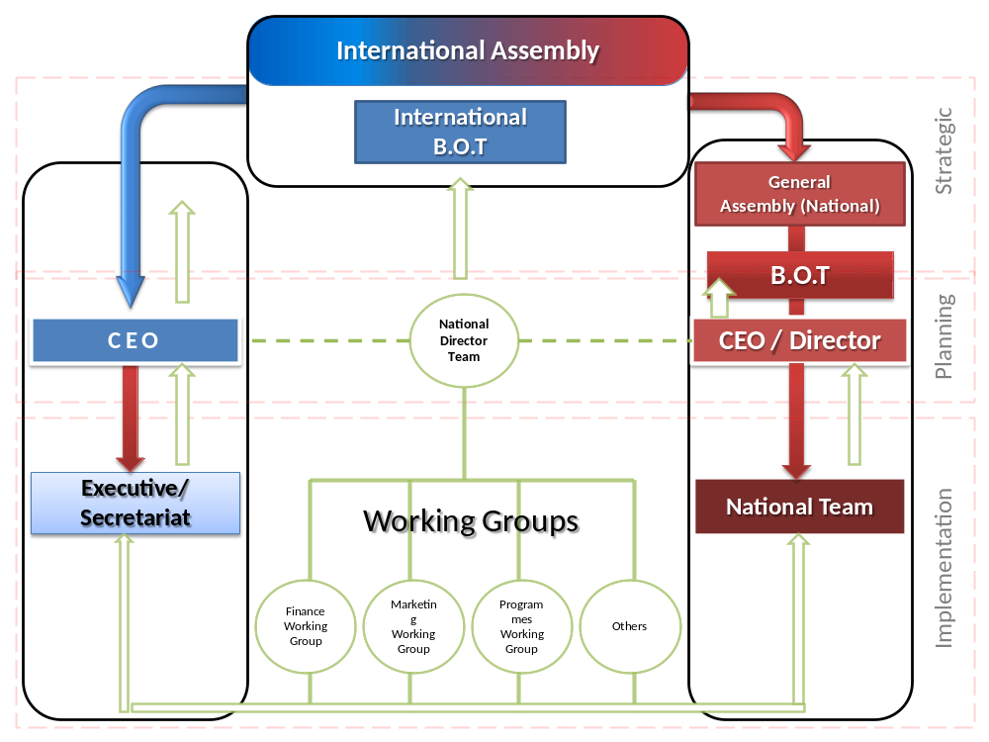

Annex D: Organisational structure : Islamic Relief Worldwide (Birmingham) & Islamic Relief UK (London)

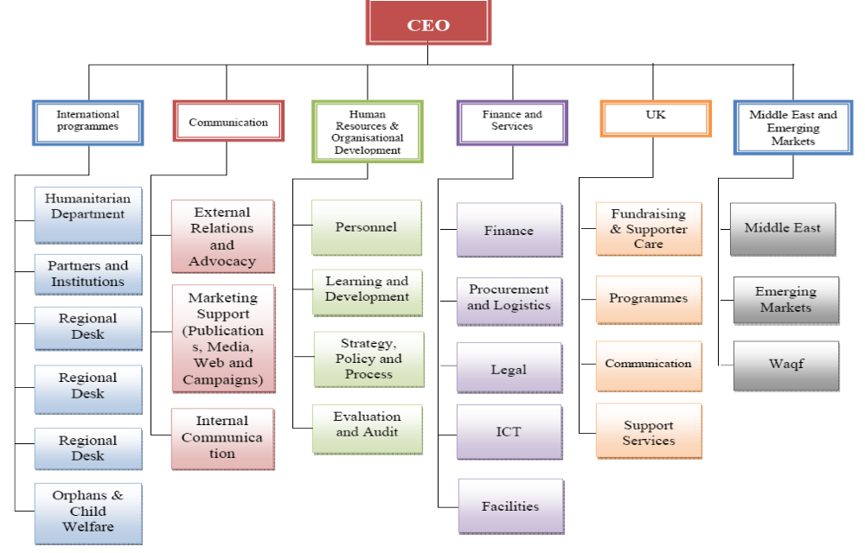

Annex E : Africa (SO1) – Case Studies

Fishing a living- Blue Nile

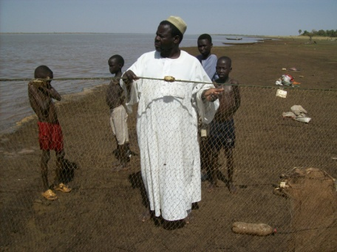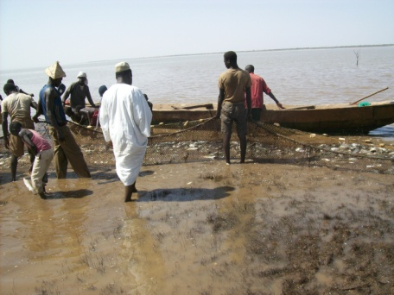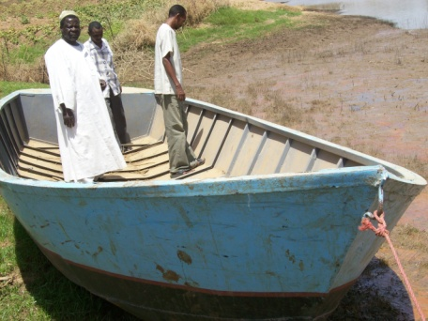

Profile
Bala Mohamed Eisa is 50 year old, unmarried; he is living in Alregiba village of Geissan locality. He has two wives, 4 sons and 8 daughters. He did not attend any formal education. Bala is working as a traditional fisherman.

Bala has experience in fishing which he leaned form his father. He used the traditional ways in fishing. He is working with traders in packing fish. His tools such as the net and boat are of low quality as they were made locally without following any standards or specifications.

Impact
Bala was selected by Islamic Relief to benefit from our Blue Nile fisheries project in the Sudan. He was trained in modern fishing equipments, making of nets, fish salting and fish drying methods. He has become the focal person for the fishermen association of 70 members. The project provided him with fishing tools and materials, boats, and containers for storage.

Bala is now using the modern fishing methods and increased his revenue and provision of food for his household. He received a certificate from government fishery department which has helped in the marketing processes. Bala disseminates the knowledge he has about fishing to the community members. Working as a group has protected the fishermen from traders who offer low prices for fish. The network helped them to standardize the market price and stabilize their incomes.
Irrigation project
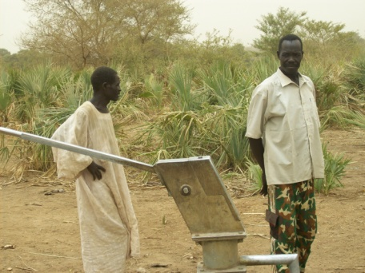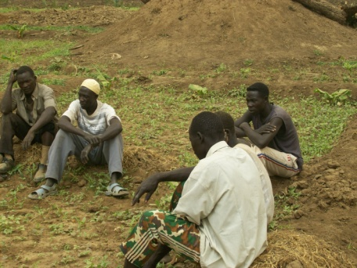

Profile
Hussain Abdelrahman Barashangi is 53 years, married with 17 sons and daughters. He is living in Murmuz Eljabel in Geissan, Blue Nile, Sudan. He left school earlier because of family constraints. Before the project, there were no services provided in the village by the government or any outsider. The people suffered from lack of services. People were working separately and not pulling together

Impact
IRW encouraged people to work together as a collective team. Training was provided and skills of many participants were improved. IRW provided the community with irrigation equipment, soft and hardware. The community cleaned the land and prepared it for cultivation.
Hussain received training in management, vegetable cultivation, leadership, peace building, education, and problem solving and conflict resolution.

He used his knowledge and skills to improve his family living conditions and nutritional status as well as to help and support others. He was assigned as the head of the agriculture committee. He is very pleased to be working for his community.
Dealing with the drought – Mandera

Profile
Hasna Issack Kassim is 27 years old and she has 4 children under the age of 10. She lives in Hareri, Mandera, Kenya with her husband. Her day is usually comprised of milking goats looking for water, searching for firewood and various farming activities. The drought in Mandera has been severe and it has affected there source of income and nutrition namely livestock.

Impact
Islamic relief provided pump sets and other farming inputs as well as encouraging us to work together. The family now do not solely rely on livestock and she is a member of a cooperative society that has been formed to help tackle issues at the community level

Profile
Mude Abdinoor aged 40 lives with his wife and 4 children in Arabia, Mandera, Kenya. The drought in Mandera has been severe and it has affected there source of income and nutrition namely livestock. It devastated the livestock his family owned hence they went looking for aid and found Islamic Relief. Mude was fortunate to be selected for Islamic Relief micro credit programme and received 150 Euros

Impact
With this loan he opened a small retail shop and repaid his loan. With the savings he then bought a tailoring machine which his wife operates and earns a living from. He is now able to send his children to school and provide a good meal to his family

Annex F: Development education (SO2) evidence

Annex F.1: School Visits

- City Road Primary School
- Al Furqan Primary School
- Al Furqan Secondary School
- Shaw Hill Primary School
- Oldknow Junior School
- Adderley Primary School
- Ladypool Primary School
- Bordesley Green Girls Secondary School
- Abu Bakr Girls Secondary School,
- Walsall Park View Secondary School Lyndon Secondary School
- Leigh Primary School Highfield Primary School Park
- Hill Primary School Palfrey Girls Secondary School,
- Walsall St Benedicts Primary School
- Swanshurst Girls Secondary School
- Moseley Secondary School
- Highters Heath Primary School
- Marlborough Infants School
- Iqra Slough Islamic Primary School
- The Oaklands Primary School
- Washwood Heath Secondary School
- Southam College, Leamington Wheelers Lane Primary School
- Montgomery Primary School Mordiford CofE Primary School,
- Herefordshire Cowplain Community School, Waterlooville

Annex G : Hits on IRW policy site

 | Top 15 indepth pages including percentage of visits and bounce rate
order |  | page |  | Views | % views | bounce rate
1 |  | indepth |  | 27,655 | 46.14% | 56.63%
2 |  | Charitable |  | 3,250 | 5.42% | 78.70%
3 |  | Humanitarianism |  | 2,165 | 3.61% | 71.98%
4 |  | Translating-faith |  | 2,117 | 3.53% | 74.66%
5 |  | Research Articles |  | 2,057 | 3.43% | 53.19%
6 |  | Corruption |  | 1,454 | 2.43% | 73.21%
7 |  | Education |  | 1,391 | 2.32% | 79.93%
8 |  | HIV + Aids |  | 1,209 | 2.02% | 76.71%
9 |  | Policy + Stances |  | 1,060 | 1.77% | 33.33%
10 |  | MLR |  | 1,013 | 1.69% | 57.14%
11 |  | Reprohealth |  | 831 | 1.39% | 83.93%
12 |  | Microfinance |  | 829 | 1.38% | 67.61%
13 |  | Influcence of Faith on Islamic Microfinance |  | 686 | 1.15% | 79.37%
14 |  | Islam-Refugee |  | 676 | 1.13% | 77.23%
15 |  | IR-Beliefs |  | 663 | 1.11% | 50%
Greatest visit increase |  |  |  |  | 1st April 09 – Mar 31st 10

 |  | Top 15 landing pages including percentage of visits and bounce rate
order | page |  |  | visits | % visits | bounce rate
1 | indepth |  |  | 17,545 | 59.27% | 56.63%
2 | Charitable |  |  | 2,099 | 7.09% | 78.70%
3 | Humanitarian |  |  | 1,155 | 3.90% | 71.98%
4 | Corruption |  |  | 992 | 3.35% | 73.21%
5 | Translating faith |  |  | 976 | 3.30% | 74.66%
6 | education |  |  | 881 | 3.29% | 79.93%
7 | HIV + Aids |  |  | 878 | 2.97% | 76.71%
8 | Influence of faith on Islamic Microfinance programmes |  |  | 586 | 1.98% | 79.37%
9 | Reprohealth |  |  | 294 | 1.00% | 83.93%
10 | Islam Refugee |  |  | 266 | 0.90% | 77.23%
11 | Environment |  |  | 255 | 0.86% | 80.40%
12 | Research Articles |  |  | 247 | 0.84% | 53.19%
13 | Poverty |  |  | 203 | 0.68% | 84.42%
14 | Microfinance |  |  | 154 | 0.63% | 67.61%
15 | Trade |  |  | 166 | 0.56% | 73.02%
Greatest visit increase |  |  |  |  | 1st April 09 – Mar 31st 10

IRW’s financial year is from January until December; figures are based on proportional allocation to enable comparison.
This should provide an indication of your overall organisational allocations by sector or theme (i.e. not limited to your PPA). The % breakdown may change from year to year and is intended to reflect key organisational priorities for the Reporting Year under assessment.
An overview of IR’s work in each of these three and other manners is provided in the sections that cover the PPA’s second and third strategic objective.
Death Rate =n/[(n+M1+M2)/2], with n=# of deaths; M1=# of <5 alive during past 90 days; and M2=# of <5 alive at time of survey.
Note that girls’ vaccination was slightly less common than boys’ vaccination.
This can also be used as an opportunity to provide DFID with case studies, YouTube clips etc for ‘building support for development’.
As an important indication for pastoral communities: there is almost no cash market for dairy and hides.
This can also be used as an opportunity to provide DFID with case studies, YouTube clips etc for ‘building support for development’.
Indicate the period referred to: in some cases it may be artificial to focus just on the prior year, and a focus on overall progress may be more helpful
Wasting is a sign of short term nutritional deficiency and can be periodic. Stunting is an indicator of cumulative growth deficiency. Underweight is a composite measure.
This can also be used as an opportunity to provide DFID with case studies, YouTube clips etc for ‘building support for development’.
Having the ratings at the end of each section puts more emphasis on the earlier narrative and qualitative information, rather than on the quantitative rating. Ratings to be applied: 1. = Likely to be completely achieved, i.e. well on the way to completion (or completed) 2. = Likely to be largely achieved, i.e. good progress made 3. = Likely to be partly achieved, i.e. partial progress made 4. = Only likely to be achieved to a very limited extent 5. = Unlikely to be achieved
http://www.dea.org.uk/ & http://www.dea.org.uk/members/ngos.asp?alpha=I&mt=5&r=&sf=
Note that we intend to gather more systematic feedback starting 2011.
Contacts help: local RE Advisor Ms Simone Whitehouse routinely recommends Islamic Relief to interested schools in the Midlands, and links with the Borough of Merton Head Teachers caused a similar interest amongst schools in London.
Currently consisting of Human Appeal International, Human Relief Foundation, Muslim Hands and Islamic Relief.
http://www.globalpovertyproject.com/
http://www.globalpovertyproject.com/partners/
We left this section fairly open to interpretation. Additionally, it’s an opportunity to show the reach and value PPA money has.
In addition to all that was mentioned under the third objective, we have formal partnerships with IOM, UNHCR, WFP and ECHO; are members of the Keep Children Safe Coalition, DEC and the Consortium of British Humanitarian Agencies; hold trustee positions at Bond and People In Aid; are founding members of the Humanitarian Forum and the Muslim Charities Forum; engage in interfaith work with round table discussions at a range of universities and (among other things) Lambeth Palace and the faith and development lecture series with the Tony Blair Foundation; and regularly lecture at the University of Birmingham.

