Application Decision
Site visit made on 2 May 2023
by R J Perrins MA
an Inspector appointed by the Secretary of State for Environment, Food and Rural Affairs
Decision date: 24 May 2023

Application Ref: COM/3311859
Westside Common, Land adjacent to the River Great Ouse, Godmanchester, Cambridgeshire.
Register Unit No: CL15
Commons Registration Authority: Cambridgeshire County Council
- The application, dated 10 November 2022, is made under section 16 of the Commons Act 2006 (‘the 2006 Act’) to deregister and exchange land registered as common land.
- The application is made by Mr & Mrs Gordon Christopher & Lorraine Peggy.
- The release land comprises a total of 1940m² and is part of the RGE Group factory buildings.
- The replacement land comprises 16187m² of land adjacent to the Eastside Common (CL16) and the River Great Ouse.

Decision
- Consent is granted and an Order of Exchange given in accordance with the application dated 10 November 2022, to deregister and exchange common land at Westside Common, Land adjacent to the River Great Ouse, Godmanchester, Cambridgeshire. As part of the Order of Exchange a copy of the application plans (Drawings A and B) showing the areas for deregistration and exchange are attached to these decisions.

Preliminary Matters
- I carried out an inspection of the release land, the exchange land and a good part of nearby Common on Tuesday 2 May 2023 in the company of the applicant and representatives from Rapleys LLP, and those attending on behalf of the objectors, Freemen of Godmanchester. The tenant farmer who currently manages grazing at Westside Common and the proposed exchange land was also in attendance.

- Following advertisement of the applications, representations were received from the Freemen of Godmanchester. No other representations were received.
- The application has been determined on the basis of the written evidence and my own observations of the sites and surrounds.
- In determining the application, I have had regard to the latest edition of Defra’s Common Land Consents Policy (‘the 2015 Policy’) which has been published for the guidance of both the Planning Inspectorate and applicants. However, every application will be considered on its merits and a determination will depart from the policy if it appears appropriate to do so. In such cases, the decision will explain why it has departed from the policy.
- Westside Common lies south-east of Huntingdon and north of Godmanchester and is divided by a disused railway. The River Great Ouse passes through it and forms its north-westerly boundary. The common is predominantly grassland with hedgerows defining field boundaries with a fairly consistent appearance maintained through grazing.

Main Issues
- Section 16 (1) of the 2006 Act provides, amongst other things, that the owner of any land registered as common land may apply for the land (‘the release land’) to cease to be so registered. If the area of the release land is greater than 200m² a proposal must be made to replace it with other land to be registered as common land (‘the replacement land’).
- I am required by section 16(6) of the 2006 Act to have regard to the following in determining this application:

(a) the interests of persons having rights in relation to, or occupying, the release land;

(b) the interests of the neighbourhood;

(c) the public interest, which includes the interest in nature conservation, conservation of the landscape, protection of public rights of access and the protection of archaeological remains and features of historic interest;

(d) any other matter considered to be relevant.

Reasons

Background
- There are two parcels of land subject to the application referred to as the ‘northern parcel’ and the ‘southern parcel’ in the application documents. For consistency I will refer to them in the same manner. There is no dispute that the northern parcel has been used for industrial purposes for some 50 years and is currently being used as industrial use/warehousing. That use has planning permission granted in various stages since 1976. The southern parcel is located to the south of a public car park and the land is inaccessible being fenced and overgrown with vegetation.
- The factory site has been fenced off for safety reasons for a number of years and the southern parcel fenced from the car park. Therefore, both sites have been inaccessible to the public for some time. The application has been made as the wider factory site is allocated for housing in Huntingdonshire District Council’s Huntingdonshire’s Local Plan to 2036 (Ref: HU 14) and the intention is that the release land will be developed for housing.

The application
- The application is made to deregister two areas marked in red on drawing No 526/315/1_SLP01 consisting of the northern and southern parcels amounting to 1940m².
- The release land is as set out above and I was able to see that the northern parcel is mostly covered by the factory site and industrial buildings, there is no public access and the southern parcel which was mostly covered in nettles with a few trees and shrubs was fenced on one side with river on the other and as such inaccessible. Thus, my site visit confirmed there is no safe, useful, access and it is clear the general public do not use it for any purposeful activity, if at all.
- The replacement land is some 16187 m² hectares in size. A rectangular piece of land currently used for grazing which abuts Eastside Common.

Assessment

The interests of those occupying or having rights over the land
- The existing common land currently has rights for grazing. At present, as set out above, the two parcels are not available for grazing should a commoner want to exercise their rights. There is nothing before me to counter the view that both parcels have not been accessible for grazing for a considerable period of time and so the removal of these parcels from the common would not affect those with rights of grazing.
- I say that having considered the representations of the Freemen of Godmanchester (the Freemen) who have grazing rights over the land. The Freemen raise concerns that the area proposed as replacement land would need to be fenced for grazing purposes and the cost for that, and its maintenance would fall to the Freemen along with setting up and negotiation grazing contracts for the new area of land. Also, the boundary of the exchange land would be difficult to determine in the future such that the Freemen may lose out in respect of the amount of land available to them for grazing. That is to say the exchange land could be reduced in time if it is not delineated by a hedge and/or fence.
- However, in the short term there is an acceptance that the current tenant farmer would continue to manage the common and exchange land as he does now. To that end the installation of a fence or hedge between the two parcels may well hinder the current management of the land. Nevertheless, if the current tenancy agreement was not in place, I see no reason to doubt that the applicant, who would have ownership of the exchange land would, as set out, erect a fence or hedge if it proved necessary.
- The Freemen would not own the replacement land such that any costs of negotiating grazing would not fall to them, and maintenance issues would be for the owner of the land. Moreover, such land ownership and maintenance matters are for the owner, tenant and those who have rights to graze on the Common. It is not unusual for boundaries of Common land to be unfenced and the plans showing the replacement land are clear and would ensure no land is lost in the future.
- Therefore, whilst I recognise the concerns, I do not consider that whether or not the exchange land is fenced immediately should be fatal to the application. It is clear, in any event, that the exchange land would be larger, far more accessible and would not result in the diminishment of any grazing rights or other interest in the land. Overall, there is nothing to indicate that any party occupying or having rights over the release land would be adversely affected by the application to any significant extent.

The interests of the neighbourhood
- The 2015 policy indicates that the issues to be considered in this context includes whether the exchange would prevent local people from using the common in the way they are used to, and whether or not there would be an interference with the future use and enjoyment of the common.
- Given the historic lack of access and use, the loss of either parcel would not have any adverse effects upon the way in which local people would be able to use the common. The areas are simply not used, although the southern parcel does provide a green splash between river and car park. Nevertheless, the application states that this parcel would remain as a green space. I see no reason to disagree given the difficulty of developing riverbanks. Thus, the release of this land would have minimal, if any, effect on general use of the common or any amenity currently provided by the southern parcel.
- The 2015 policy also sets out that the outcome of proposed works on common land may add something that would positively benefit the neighbourhood. There can be no doubt that the exchange land would have much more access to it than the two parcels. It would be an extension of Eastside Common, would be much larger than the areas it would be replacing, and there would be no hindrance to access. It would therefore be a new local resource for recreation. I find therefore that the scheme would be in the interests of the neighbourhood.

The public interest

The protection of public rights of access
- The application form is unclear as to whether the release land is subject to access rights under section 193 of the Law of Property Act 1925. Even if there were I am satisfied that such rights would be difficult to carry out given the current use of the sites and restrictive boundary treatment. There is nothing to indicate that access to the replacement land would be restricted, and the land is served by public access via the Ouse Valley Way from the east and west and over existing common land.
- The proposal would not diminish the total stock of access land available to the public given the replacement land is currently unused without any access informal or otherwise. For these reasons I am satisfied that the application would protect the public rights of access and the right to air and exercise.

Nature conservation
- NE have been consulted on the application and do not raise any concerns in respect of nature conservation. There is nothing before me by way of evidence, or from what I saw on site, to suggest there would be any harm to any nature conservation interest. I am satisfied that the nature conservation value of the commons and surrounding land would be safeguarded.

Conservation of the landscape
- There can be no doubt that the common is a valuable part of the local landscape along with the river. As one leaves the adjacent built-up area the common provides delineation between the built and natural form. The common’s contribution to the landscape is undisputed.
- Again, from the information before me and what I saw on site, there is nothing to suggest the landscape would be harmed by the proposed exchange. I recognise that the factory site is allocated for housing and any contribution the two parcels have within that, and any future effect on the landscape of setting of the common, would form part of the planning process in any event.
- For these reasons I do not consider that the exchange would have any unacceptable effect on the landscape of the common.

Archaeological remains and features of historic interest
- No reference has been made to archaeological remains in this area. I am satisfied therefore that there would be no overall harm with regard to archaeological remains or historic features arising from the proposal.

Any other matters
- No other matters fall to be considered.

Conclusion
- Having regard to all other matters, and to the criteria in section 16(6) of the 2006 Act, I have found the exchange land to be more than sufficient. I therefore conclude that granting the application would not be against the interests of those having rights in relation to the release land, or the public interest with regard to nature or landscape conservation, or the protection of archaeological remains, or features of historic interest. No issues have been raised which would lead me to conclude that the exchange should not take place.
- The application will be allowed.

Richard Perrins

Inspector

Order

On behalf of the Secretary of State for Environment, Food and Rural Affairs and pursuant to section 17(1) and (2) of the Commons Act 2006, I HEREBY ORDER Cambridgeshire County Council, as commons registration authority for the area in which the release land and the replacement land are situated:
- to remove the release land from its register of common land, by amending register unit CL15 to exclude the release land;
- to register the replacement land as common land, by amending register unit CL15 to include the replacement land; and
- to register as exercisable over the replacement land (in addition to remaining exercisable over the remainder of the land comprised in register unit CL15) any rights of common which, immediately before the date on which the release land is removed from the register, are registered as exercisable over the release land and the remainder of the land comprised in register unit CL15.

First Schedule – the release land

Colour On Plan | Description | Extent
Edged red | Land forming part of register unit CL15 and comprising two parcels; the northern parcel being part of the existing RGE Group factory buildings to the east of The Avenue, Godmanchester and the southern parcel being land to the south of the existing Council car park site. The land is located to the north of the A1307 (former A14) viaduct and forms the banks of the Cooks Backwater. | 1940m²

Second Schedule – the replacement land

Colour On Plan | Description | Extent
Edged green | Land adjacent to Eastside Common (CL16) and the River Great Ouse. The land is located opposite the Hartford Marina and adjacent to the Godmanchester Nature Reserve and Woolpack Fishery. | 16187m²

Richard Perrins

Inspector

Drawing A – Release Land (Not to scale)

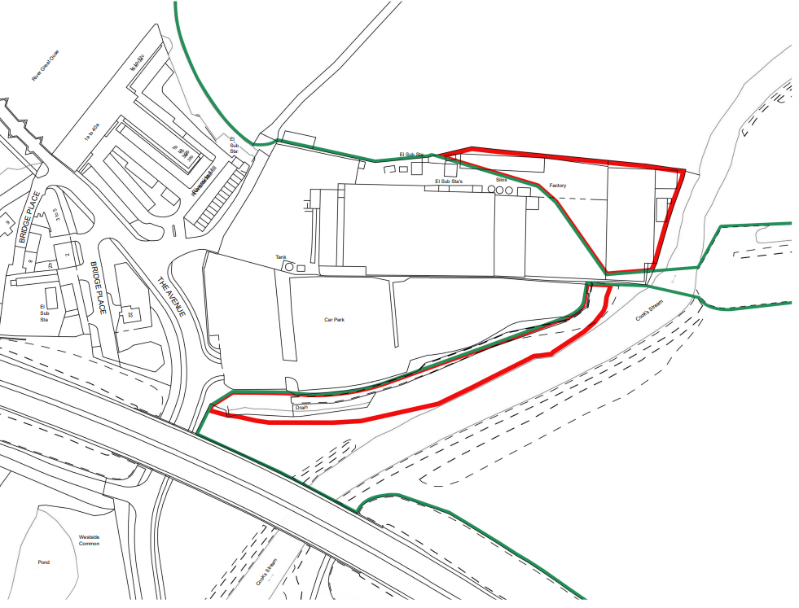

Drawing B – Replacement Land (Not to scale)

