Red squirrels and forestry operations in England – Operations Note 65, diagrams

Figure 1: Decision key for planning and harvesting to minimise impacts on red squirrels (after FCS Guidance note 33)
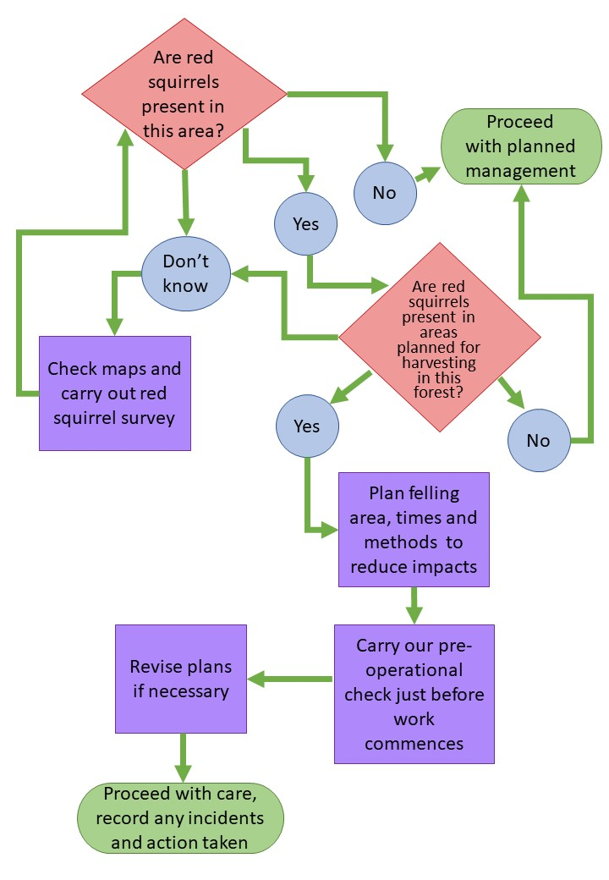

Figure 2: The UK red squirrel range by 2010 (Red Squirrel Survival Trust) the mainland distribution of red squirrels in England by 2021 (after Red Squirrels Northern England and Northern Red Squirrels, 2021)



