


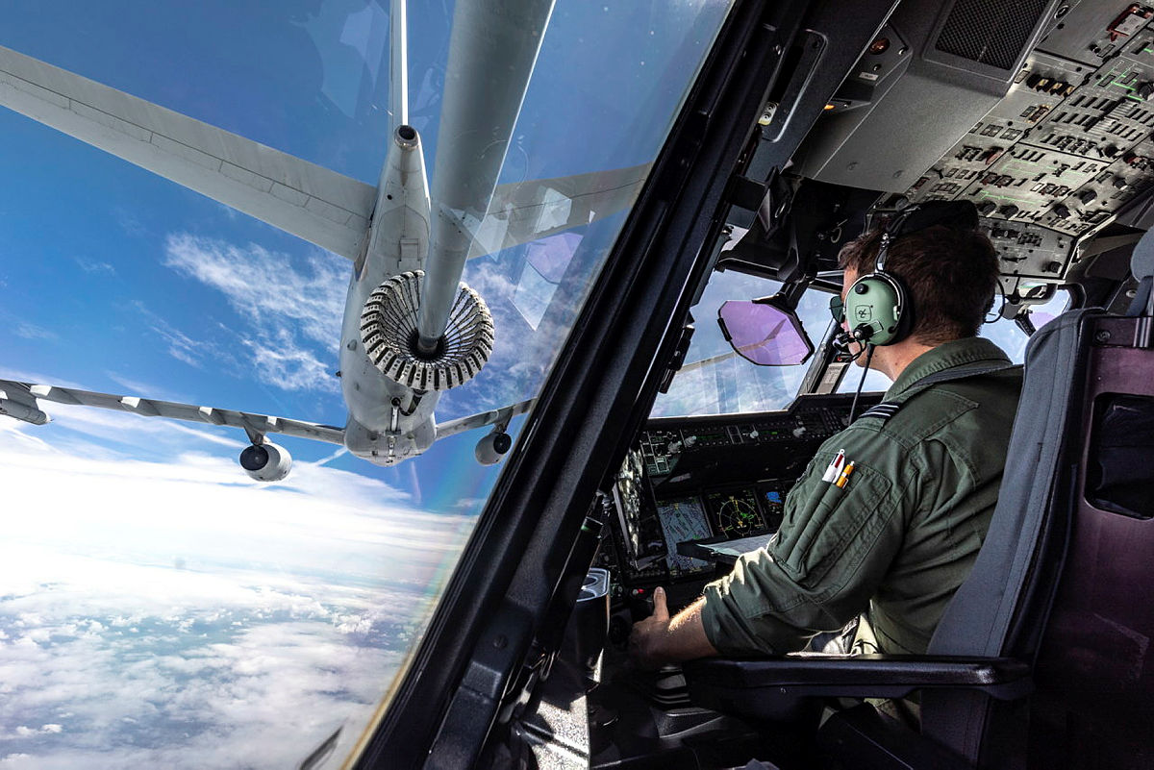
Sub-title or short context to document

Sub-title or short context to document

The Defence Equipment Plan
2022-2032


UK Ministry of Defence © Crown copyright 2022
This publication is licensed under the terms of the Open Government Licence v3.0 except where otherwise stated. To view this licence, visit nationalarchives.gov.uk/doc/open-government-licence/version/3

Secretary of State Foreword

The 2022 Equipment Plan comes at a pivotal point in time for Defence, one where we are entering a new age of warfare and defensive planning. The Ministry of Defence has become increasingly in the spotlight over the last year, as have our spending plans and capability investments been scrutinised in the wake of the Ukraine Russia conflict.
The events of the last few months have demonstrated the instability and unpredictability of the threat to our nation’s security but have also exemplified the ability Defence has to react and adapt rapidly to those emerging risks. Despite the turbulent climate, we are confident that the spending decisions outlined in the following Plan remain relevant and resilient to the changing nature of Defence.
The uplift received from the 2020 Spending Review meant we were able to rectify an existing deficit and instil stability and confidence in current and future spending forecasts. This has enabled us to invest in cutting edge capabilities that ensure we are threat ready and resilient against emerging risks. Within this Plan, we have continued the task of developing investment decisions from the integrated review into detailed spending plans. The 2021 Equipment Plan was the first in five years that was not described as unaffordable by the National Audit Office (NAO). We have retained an affordable position for the 2022 Plan and continue to hold a contingency to ensure resilience against emerging financial pressures.
There has been significant change, both in Defence and the world since the publication of the last Plan. We are experiencing a period of rising inflation, we are witnessing large scale conflict in Ukraine, and we have welcomed two new Prime Ministers. It is paramount therefore that the decisions reported each year are sustainable and resilient against current and future pressures. While this report is based on data that closed in March, and so will not reflect for the most part the impact of recent pressures, we nonetheless remain aware and responsive to their significance, particularly as we move forward into the next planning cycle.
In the Autumn Statement the Government has recognised the need to increase Defence spending. The case for this will be set out in the Integrated Review which will consider the response to the emerging threat. The outcome of this will be represented in future Equipment Plans.
The Plan is not immune to risk, we have set ambitious savings targets and made hard decisions in spending priorities across the Commands. We are confident however that the capabilities we are investing in, and spending decisions made in the last year, remain in line with the developing defence landscape and ensure we have a stable financial footing for this and future Plans.


The Rt Hon Ben Wallace MP, Secretary of State for Defence
November 2022

Contents
Secretary of State Foreword 3
Executive Summary 6
Strategic Context 8
Key Background 8
Aims and Priorities in the Context of the Integrated Review 9
New and Emerging Threats Affecting Defence 10
Affordability and Financial Risk 12
Overall Planning Picture 12
Budget Planning Assumptions 13
Forecast Cost of Equipment Spending 14
Risks to Affordability 16
Levers to Manage Affordability 17
Changes to Management of the Plan and Recommendation Updates 20
Improvement Process: In Year Progress 20
Recommendation Updates 23
Sector / Key Project Updates 24
High Level TLB Summaries 24
Navy Command 26
Army Command 29
Air Command 32
UK Strategic Command 37
Defence Nuclear Organisation 39
Strategic Programmes 41
Annex A: Project Performance Summary Table 44
Project Performance Summary Table 2022 44
Annex B: NAO and PAC Recommendations Progress Table 47
NAO Recommendations Table 47
PAC Recommendations Table 57

Executive Summary

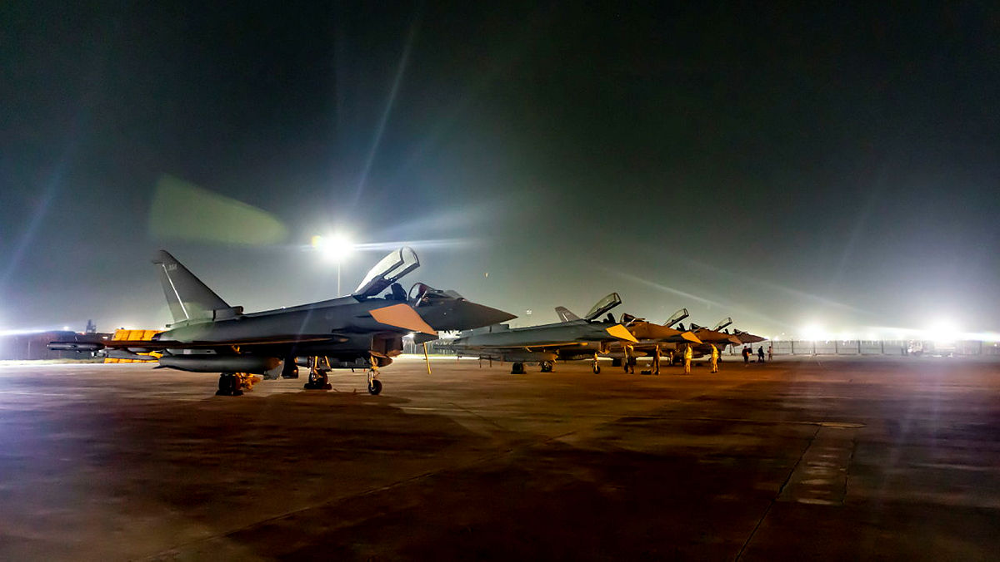
Typhoon Fighter Jets 2022

This year’s Equipment Plan continues to reflect the spending commitments made as a result of the 2020 Spending Review, and priorities remain consistent with those aims outlined in the Integrated Review in 2021.
The publication of this report comes at a decisive point for Defence and a period of rising inflation for the country. Although these pressures will have an eventual and significant effect on Defence spending, their full likely impact are not contained in this report due to the March 2022 closing point of the aligned Annual Budgeting Cycle.
The Department has a rolling ten-year Equipment Plan which balances spending priorities with budgeting parameters. Over the ten years from 22/23 we plan to spend £242 billion on equipment procurement and support, compared to £238 billion planned in last year’s update. At April 2022, we assessed the cost of our plans to be £240 billion over ten years resulting in £2.6 billion headroom.
The Equipment Plan is a reporting document, presenting a picture in time aligned to the period covered by the aligned Annual Budgeting Cycle. While the forecasts and spending decisions outlined in the following report are taken at the close of the cycle, the Department’s planning process is not static and can flex to meet emerging threats and shifting priorities.
With the purpose of creating a more efficient and streamlined document, the Department agreed with the National Audit Office at the beginning of this cycle to reduce the scope of the following report. To this end, the report will be focused on significant updates and noteworthy changes that have occurred since the 2021 budgeting cycle.
Part two of the report provides an analysis of affordability and financial risk of the Plan in a like for like format with that of the previous publication. Within this, we have included detail of the CAAS report which provides an independent cost estimate of our reported planning assumptions.
While the Plan contains risk, we judge this manageable in line with contingency we are holding and layered risk provisions within budgets. We have an ambitious set of plans, aligned to the commitment of modernising our forces, which will be challenging but achievable to deliver.
We remain committed to the continual improvement of the management of the Plan and the implementation of recommendations to aid in its development. To this end, we have updated our in-year progress against these in section three and within a supplementary annex.
The Plan provides a representative picture across the Department and has been built using input from across the Commands. The outcome of these contributions are presented in section four, which includes high level updates from across the Top Level Budgets.

Strategic Context

Key Background

The MOD’s annual Equipment Plan report has been published since 2012. It provides a transparent picture to Parliament and the public on how Defence plans to manage its funding to deliver its equipment programmes. The report sets out the Department’s cost and budget forecasts, provides an update on progress in delivery of key programmes, and explains how the Department is making improvements to the management of the Plan. The report is published in parallel with a review by the National Audit Office (NAO), who review our plans each year and provide feedback on areas for improvement. The NAO’s report can be found on their website.

Time Period Covered by the Report
Defence forecasts its costs and budgets across a ten-year planning window. The ten-year spending forecasts and assessment of affordability in this report cover the period from April 2022 to March 2032. Given the fast-moving external context, background included within the strategic context section provides a more up to date narrative on Defence spending and emerging threats.

The Scope of this Equipment Plan
Defence’s spending is split across three areas: the Equipment Plan, the Infrastructure Plan, and operating cost spending, including workforce. The Equipment Plan, which is the focus of this report, is further divided between procurement and support costs, referred to as the ‘Equipment Procurement Plan’ and ‘Equipment Support Plan’ respectively.

It was agreed with the NAO at the start of this reporting cycle to decrease the scope of the Equipment Plan to produce a more streamlined document. To this end, the focus of this report is on high level updates that have occurred since the last publication. In addition, while there is an explicit awareness of emerging risks, such as inflation and the conflict in Ukraine, their impact will not be reflected in the affordability analysis of this Equipment Plan due to the March close out position of the aligned budgeting cycle.

The Key Organisations Described in this Report
There are many organisations involved in the planning and delivery of the Equipment Plan, but these can be simplified into three key groups. Their roles and responsibilities are as follows:

- Head Office: Sets direction through strategy and policy, sets budgets, and provides oversight. Within head office several teams feed into these processes, including those with responsibility for financial planning, scrutiny and approvals of programmes, military capability planning, operations and strategy. Head office teams also support Ministers and the Department’s Permanent Secretary.

- Top Level Budget (TLB) Holders: There are six TLBs with responsibility for the Equipment Plan: Navy, Army, Air, UK Strategic Command; the Defence Nuclear Organisation; and Strategic Programmes. Four of the TLBs are also military commands. The TLBs are responsible for delivering the outcomes directed by head office within their delegated budgets. Responsibility for managing the Equipment Plan is within this delegated authority, although TLBs will work closely with head office and ministers on significant or contentious changes.

- Delivery Organisations: These organisations manage relationships with industrial suppliers and provide commercial support to TLBs. They run commercial and procurement activity on behalf of the TLBs and provide costing data to TLBs. These delivery organisations are Defence Equipment and Support (DE&S), Defence Digital, the Submarine Delivery Agency (SDA), the Defence Infrastructure Organisation, and the Warhead Delivery Team, which is part of the Defence Nuclear Organisation (DNO).

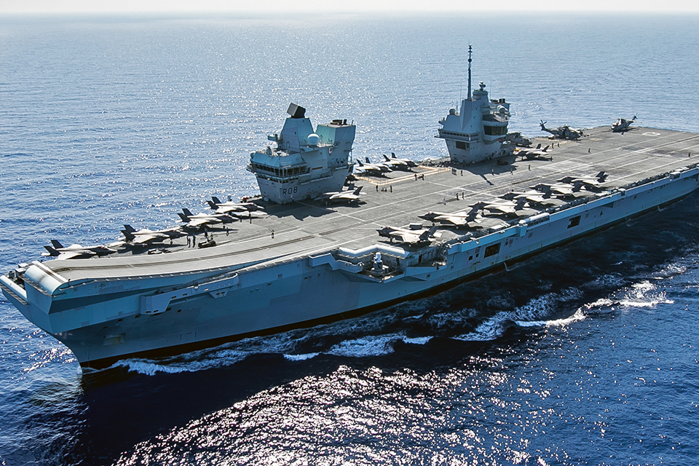

HMS Queen Elizabeth 2022

Aims and Priorities in the Context of the Integrated Review

Spending decisions outlined within the Equipment Plan 2022 continue to be made with consideration to and in line with aims and priorities outlined in the Integrated Review, published in March 2021. The paper set out the Government’s current assessment of the major trends that will shape the national security and international environment to 2030. It describes the nature and distribution of global power changing as we move towards a more competitive and multipolar world. With this in mind, the Department remains confident that spending plans detailed within this report remain reflective of requirements outlined within the IR.

Key Priorities for Defence in a Competitive Age
Capability modernisation and retiring older legacy equipment
Maximising investment in new equipment which can meet the threat in a competitive age
A highly skilled workforce, more spent on availability and focussed on forward presence
Agile and digitally enabled to support multi domain operations
Investment across five domains – including a new domain in space
Focus on investment in Research & Development (R&D)
Renewing the deterrent

New and Emerging Threats Affecting Defence

There have been several significant changes influencing the landscape of Defence since the publication of the Equipment Plan 2021.
The impact of inflation and the conflict in Ukraine will have an explicit effect on spending plans in equipment procurement and support, both in terms of capability planning and achieving value for money. While the Department has a good understanding of these emerging pressures, the impact will not be reflected in the affordability analysis for this report as the Plan reflects the position when the Annual Budgeting Cycle was completed in March 2022. The below sections of the report will demonstrate the Department’s awareness of these threats and the mechanisms we have in place to mitigate against their potential impact with the caveat that this will be a greater focus in the next Equipment Plan.

Ukraine and the EP
Defence is playing a central role in the UK’s response to Putin’s invasion of Ukraine under Operation SCORPIUS. Alongside our Allies and Partners, the UK is responding decisively to provide military and humanitarian assistance. Our robust response has been illustrated by £2.3bn of military support to Ukraine, funded through Treasury reserves and so not part of the Equipment Plan programme. UK has established an International Fund for Ukraine (IFU), an agile funding mechanism that will use contributions from partners to procure priority military assistance at pace. Defence’s continued commitment to support Ukraine therefore represents an immediate continuing priority for the Department and wider government.
We remain resolved in the commitment to our Allies and Partners to preserve our security and prosperity in the Euro-Atlantic region and are ready to defend and deter threats emanating from our adversaries in a deteriorating global security environment. We are actively capturing insights from the conflict in Ukraine. Defence has established a Russia and Ukraine Insights Hub to ensure lessons are feeding our force development process today and influencing our capability priorities. Some of these insights will start to feed into changes to the Equipment Plan from next year and are not only changing what capability we need but how we use, sustain and acquire that equipment. Although the conflict will not at this time have an impact on the affordability analysis of this Equipment Plan, the Department is considering the implications for future Defence spending.
Global economic pressures arising from the COVID-19 pandemic and Russia’s invasion of Ukraine have driven a challenging delivery context: rising inflation, supply chain disruption, and energy insecurity are contributing to instability and increased state competition. Through these challenges we continue to deliver modernisation across the armed forces whilst working closely with industry to replenish stockpiles and delivering equipment to Ukraine, helping Defence realise its outcomes for the future, as well as in the present.

Inflation
Inflation is a pressing concern and we are taking steps to manage it. Even before the Autumn Statement in November, the Office for Budget Responsibility’s Fiscal Risks and Sustainability report provided an assessment of between £0.6BN and £2.1BN of cost pressures to the MOD in 2022/23, based on their March 2022 forecasts of the GDP deflator and CPI respectively. Cost pressure to the Department is not perfectly represented by either the GDP deflator or CPI, making accurate estimates difficult, but we are monitoring the impact and will be able to provide an estimate of the pressure as part of next year’s Equipment Plan.
The Department has already introduced several changes to commercial policy to manage the impact of inflation. We are making greater use of index-linked fixed price contracts to prevent firms from either applying high premia on firm price bids or not bidding entirely. We are also ensuring early engagement with key suppliers to discuss how inflation will be treated in future contracts, including our view of what is reasonable for payroll costs. Although these controls will not cover the full extent of inflationary pressure, they will offer some protection. Similarly, our unreserved contingency funding will also aid in offsetting some of this pressure.
While the Department remains vigilant to emerging risks, it is important to reiterate that the Equipment Plan provides a picture of a particular point in time. Although the impact of inflation is not felt in force for this planning cycle, the Department does have an understanding of the developing risk and has existing and new controls in place that will limit exposure in the short term. However, without additional funding it is clear that difficult decisions will be required to reduce the scope of the plan and funding profiles may need to be reshaped to align the delivery of key military equipment with objectives.

Affordability and Financial Risk

Overall Planning Picture

This section of the report explains the costing and budgeting assumptions for the forward-looking Equipment Plan, our approach to managing uncertainty and risk and how we will improve this through changes to our finance strategy and culture. The affordability analysis covered in the following section is aligned to the Annual Budgeting Cycle that closed at the end of March 2022. This will mean that elements of emerging risks, such as Ukraine and inflation, will not be covered here due to the timing of close out.
Over the ten years from 22/23 we plan to spend £242 billion on equipment procurement and support, compared to £238 billion planned in last year’s update. At April 2022, we assessed the cost of our plans to be £240 billion over ten years resulting in £2.6 billion headroom. This compares with a £4.3 billion of headroom reported last year. Headroom has slightly reduced as we have reduced the levels of risk being held within the Defence EP and have matured our plans embedding the delivery of the IR.
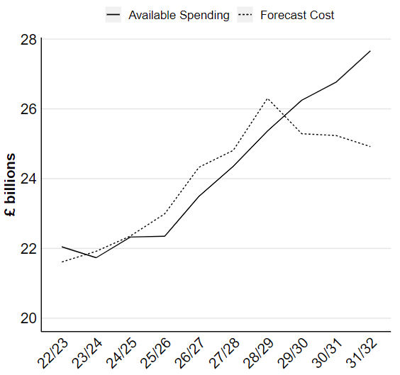
Figure 1: Forecast Equipment Plan cost and available budget over ten years

The 2021 Equipment Plan was the first time in five years where the NAO did not describe it as unaffordable. We have maintained this affordable position over the next ten-year period 2022-2032, and are we are continuing work to assess the correct level of contingency holdings. The level of EP contingency overall has reduced since EP21. This is because we have used the contingency to partially offset emerging pressures and risks within the TLBs’ financial position. We have also reduced the level of risk we are holding, having embedded further the changes to the plan made through the IR. We will continue this work through the 2023 Equipment Plan, smoothing delivery schedules, rebalancing across other parts of the Defence programme and, if necessary, looking at further savings measures. We are continuing to work with programmes within the Equipment Plan that are at different stages of maturity to understand their delivery schedules. We have levers to manage changes in forecast cost if they materialise, while continuing to deliver the priorities of the Integrated Review. Overall, we have confidence that we have a plan to deliver the ambitions set out in the Defence Command Paper within the budget available and that we have the necessary flexibility to manage risks. Our priority is to continue to deliver these plans and use the new investment in Defence as effectively as possible. This has been evidenced through a large investment in the Future Combat Air System (£1,150m) over 2022-2025, and other sizeable investments in National Cyber Security Programme (£1,008m) and Research and Development (£989m).

Budget Planning Assumptions

The Spending Review in December 2021 updated the Department’s budget for the three remaining years of our SR20 settlement from 22/23 to 24/25. The Department’s settlement includes access to up to a further £2.2 billion of RDEL across the three years to provide relief for inflationary pressures and also a reprofiling of R&D funding from FY23/24 to 24/25. For the seven years beyond 24/25, the Department continues to have a planning assumption of 0.5% real growth in the core budget. In line with our plans to invest more in equipment and reduce running costs, we have assumed most of this growth will be in our capital budget, with our resource budget remaining flat in real terms. We recognise that future governments may choose to make different assumptions and that a broad range of potential outcomes are possible. Within the total budget the Department has allocated £242 billion over ten years to spending on equipment procurement and support through the annual budget planning process. Consistent with last year this allocation is 46% of the total Defence budget with a slight increase of 1%, £4 billion, from last year.

From 2025/26 onward, the Department is holding a further £4.4 billion to allow us to exploit the investment we are making in research and development and to continue to develop new and innovative capability. This is held in addition to the available funding in this report. It has been set aside in recognition of the pace of technological change and to ensure that Defence has the flexibility to address emerging capability requirements without having to make cuts to existing programmes.

Deployment of Inflatable Raiding Crafts from a Royal Navy submarine

Forecast Cost of Equipment Spending

To assess affordability, we compare the budgeting assumptions explained in the previous section with our assessment of the cost of the programme. This section explains the cost assumptions and how they have changed over the last year. The forecast cost of equipment procurement and support over the ten years from April 2022 is £240 billion, an increase from the Defence Equipment Plan 2021 of £6.2 billion over the ten years. This leaves £2.6 billion of headroom against the £242 billion equipment budget explained in the previous section. The cost forecast is made up of estimates for many hundreds of individual projects. The ten-year cost of the Equipment Plan is presented in figure 2 below which is followed by more detail on each component.

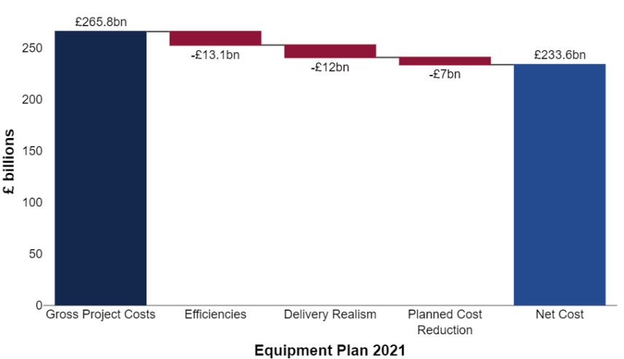
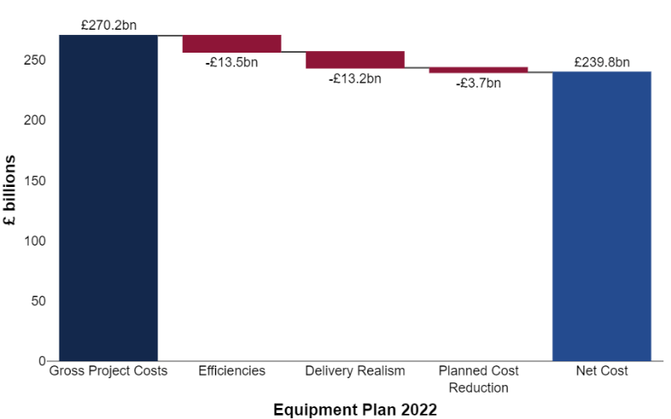

Figure 2: Ten-year forecast cost of the Equipment Plan compared to assumptions in last year’s report

Net Programme Cost, £239.8 billion
The net programme cost is £239.8 billion and is based on gross project costs of £270.2 billion minus cost reductions totalling £30.4 billion over ten years. Cost reductions reflect our plans for further savings and efficiencies based on our analysis of spend and previous outturn. This ensures that the Department incentivises further efficiencies and has a taut but realistic spending plan. Planned Cost reductions held by TLBs have reduced by £3.3 billion in comparison to last year, this shows further progress in embedding IR saving decisions and reduces the risk to the Department.

Gross Project Costings, £270.2 billion
The total cost of the Equipment Plan projects (before the adjustments set out below) is £270.2 billion, increased from £265.8 billion last year. £2 billion of the gross cost changes relates to the change in accounting treatment for operating leases (implementation of IFRS16).

Adjustments for Delivery Realism, -£13.2 billion
The programme includes £13.2 billion of adjustments to reduce cost forecast for judgements about delivery schedules and industry capacity, increased from £12 billion last year, but still stable as a proportion of the costed programme. As IR decisions are continuing to develop and embed into delivery agents underlying plans, TLBs are reassessing the levels of MAR (management adjustment for realism) appropriate to hold. Where the programmes are at a lower level of maturity TLBs have increased the level of MAR.

Savings Measures not yet managed by Delivery Agents, -£3.7 billion
TLBs have planned £3.7 billion of cost reductions not yet implemented into project costings. This has decreased from £7 billion last year. This is largely because TLBs have taken action in EP22 to implement savings measures and the descoping of projects agreed through the IR. These include embedding the decisions on out of service dates for Hawk T1 and Typhoon Tranche 1 platforms and the descoping of the E7 platform reducing from 5 to 3 airframes. There has also been a small proportion of re-categorising planned savings to adjustments for realisms explained in the paragraph above.

Efficiency in the Equipment Plan, -£13.5 billion
The Department continues to drive for efficiency and to seek additional opportunities in its programme. The Department is working with a strengthened approach to tracking efficiency. This enables it to better identify, develop, and deliver opportunities for efficiencies in the Equipment Plan. The Department has a standard approach for developing the maturity of individual efficiency initiatives identified across the programme.
Efficiency initiatives consist of higher confidence initiatives, which are embedded within individual programme forecasts, and lower confidence initiatives that are still in development and are not yet included in individual programme forecasts. The value of higher confidence initiatives has decreased slightly from £10.3 billion last year to £10.1 billion, driven by the change in period, a relatively lower forecast in year ten, and some reprofiling since last year to increase realism and account for risk. The Department’s pipeline of lower confidence initiatives is growing and has increased from £2.8 billion last year to £3.4 billion this year. This demonstrates how the Department is continuing to identify future efficiency opportunities. Forecast efficiencies are shown in figure 3.
 | EP22 ten-year total | EP21 ten-year total | Change from EP21
Total forecast benefits | 13.5 | 13.1 | 0.4
High confidence initiatives included in forecast costs | 10.1 | 10.3 | -0.2
Lower confidence initiatives included in forecast costs | 3.4 | 2.8 | 0.5

Figure 3: Expected efficiency delivery against the Equipment Plan. EP22 ten-year period is 22/23-31/32. EP21 ten-year period is 21/22-30/31. Positive values are savings or increases in savings. Numbers do not all sum due to rounding.
The cost forecast reflects the expected impact of efficiency delivery. For example, as part of the wider DE&S efficiency programme, DE&S regularly drives effective contract negotiations to generate efficiencies. When contracting for the Maritime Patrol Aircraft Lossiemouth Buildings, successful negotiations enabled an equitable share of building construction costs to be agreed, delivering £55m of savings.

Risks to Affordability

This section describes the financial risks to the Equipment Plan and the mitigations and levers available to them.
Figure 4 below shows our assessment of the risk and opportunities in the Equipment Plan. Each of these judgements are then explained in the following section. These judgements imply a range between £7.0 billion surplus and a £7.3 billion pressure for the Equipment Plan, compared to a surplus of £7.4 billion and pressure of £7.2 billion last year.

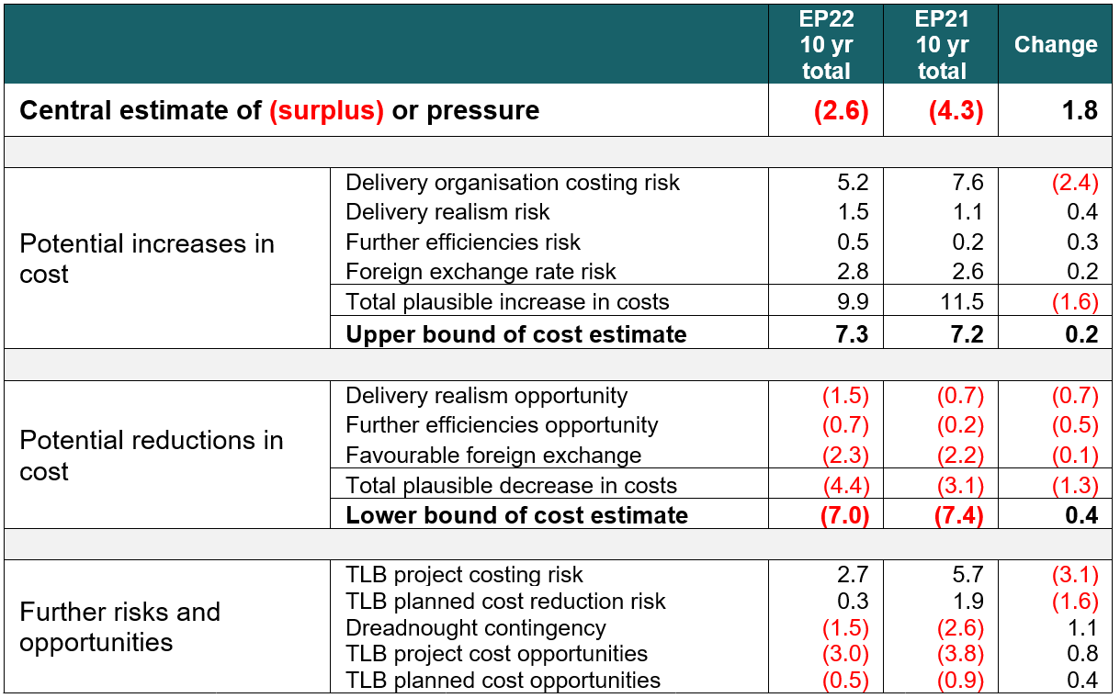
Figure 4: Potential sources of cost risk in the Equipment Plan, £ billions

Cost Growth in Project Costings
To inform our analysis of cost risk, the Department continues to run a rigorous annual process to review and challenge a sample of delivery teams’ costings through an independent assessment by our Cost Assurance and Analysis Service (CAAS). During 21/22, CAAS produced Independent Cost Estimates (ICEs) for 22 of the largest EPP projects, and 39 of the largest ESP projects. CAAS ICE coverage over the whole EP for ABC22 is 53% of the total cost over the next 10 years. For projects outside of the ICE scope (the ‘Remainder’), CAAS has used the Delivery Team (DT) estimates to provide the indicative forecast for the complete Equipment Plan. While the projects being assessed are not inclusive of all those in the Equipment Plan, those with higher risk have been reviewed; for example, CAAS is less likely to select those programmes which are already on a firm price contract.
This year’s analysis found £5.2 billion of costing risk in the projects examined, compared to £7.6 billion last year. While we must be cautious about drawing direct comparisons across the annual reports, this a comparatively better position than last year and indicates a more stable financial footing for the Department.
Of the total, a third, £1.6 billion, is attributable to the Dreadnought programme, which has special funding arrangements. Unlike other projects in the Equipment Plan, the financial risk to the Dreadnought programme is partly carried by HM Treasury through a contingency facility established at the 2015 Spending Review, which allocated £10 billion for contingency on top of the £31 billion programme expected to be funded in the Defence budget. The contingency is available to ensure that the programme can be delivered to schedule, by allowing for changes in the spending profile or total funding without resorting to cutting spend in the wider Defence programme. The 2020 Spending Review confirmed that the contingency arrangement would continue.
Based upon the findings of the ABC22 ICEs, CAAS believe that the Equipment Plan (not including the Dreadnought programme) may exceed the ABC22 DT forecasts over the next 10 years (financial years 2022/2023 to 2031/32) by £3.6 billion; however, this excess appears to be manageable within the centrally-held Equipment Plan Contingency of £4.3 billion.

Foreign Exchange Risk
The Department uses large volumes of foreign currency in any given year, particularly US Dollars and Euros. We carefully monitor fluctuations in currency markets and take steps to protect our budget from short term volatility, including through forward purchase arrangements, which mitigate this such that only around 20% of foreign currency purchases are fully exposed to exchange rate changes. We will continue to review the impact of foreign exchange risk through EP23 and adjust our risk calculations accordingly.

Under-delivery Against Realism Assumptions and Efficiencies
Failure to deliver the cost reduction assumptions described in the affordability analysis will result in additional cost pressure. We have included risks for cost changes resulting from under or over delivery against our realism and efficiency assumptions in the range analysis above. In addition to the savings in the Equipment Plan, there are savings assumed in other parts of the Defence programme, such as in workforce costs, which could impact the affordability of the wider Defence programme if not delivered. These are not included in this analysis.

Levers to Manage Affordability

While some changes will offset each other, we recognise that the cumulative impact of risks can result in significant increases in costs. In order for Defence to be able to continue to accommodate change, without resorting to poorer value for money measures or cuts to capability, we have built on the existing levers available to the Department. These include:

Layering risk within budgets
Projects hold their own risk provisions of £13.2 billion; head office holds a further contingency of £4.3 billion for the Equipment Plan, and additional contingency for the wider Defence programme. In previous years we released our Equipment Plan contingency holdings for the approaching financial year; however, similar to last financial year, we have entered financial year 22/23 with a funded contingency. The profile of the contingency holdings has developed through this planning round, in the SR period, where we have more certainty on the risks that have materialised in TLBs spending plans. We have partially mitigated these cost increases by releasing contingency where it has been appropriate to do so. The middle years remain higher due to the greater uncertainty and in the later years we have reduced the contingency holdings as the headroom against our budget is much higher and risk remains lower. These assumptions are shown in figure 5 below.

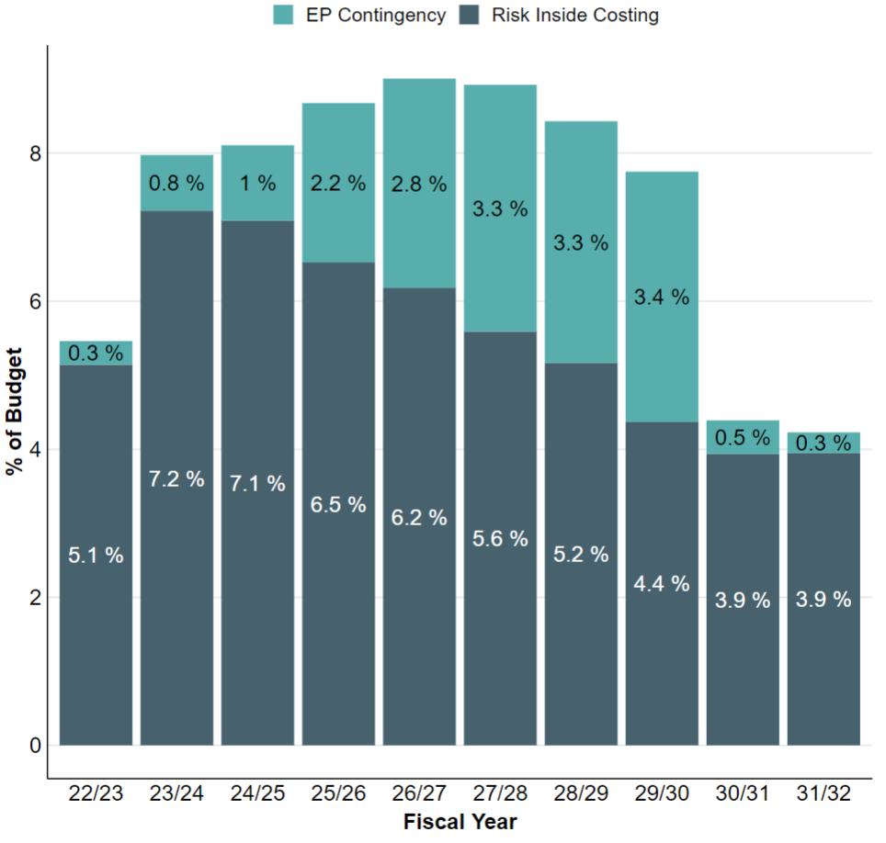
Figure 5: Risk provisions included in costing and corporate contingency as proportion of planned spend

Ensuring flexibility in delivery schedules
This year we continued the process we set up last year to identify choices to bring forward capital spend to support the Department to deliver its large year on year increase in capital budget in the event of over-optimistic schedules in the current programme.
Approvals Process
Our approvals process continues to provide a lever to monitor and control the financial performance of programmes. We continue to streamline our approvals process to ensure we have the right balance between providing the correct level of oversight and governance, both internally and externally, while ensuring we get equipment and services to the front line as expeditiously as possible. Setting an affordable programme means the relationship between approvals limits and budgeting can be strengthened.
Foreign Exchange Risk
The Department continues to mitigate its exposure to foreign exchange risk through forward purchases of Euros and US Dollars as explained in the above section.
Uncommitted Funding
The Department maintains a proportion of planned spend which has not yet been committed (e.g. through a contract with a supplier), this has remained at 70%, meaning we have maintained the greater flexibility we developed through the Spending Review to adapt spending plans if required.
In addition to the headroom in the equipment plan, the Department has set aside £4.5 billion of funding outside the Equipment Plan from 25/26 onward to allow us to continue and exploit the investment we are making in research and development and to continue to develop new and innovative capability without having to make cuts to existing programmes.
The Department also holds contingency outside of the Equipment Plan to support the rest of the Defence Plan and we will continue to review the proportions allocated to the Equipment Plan annually based on known risks and programme certainty.



Royal Air Force Typhoon and a Chinook helicopter

Changes to Management of the Plan and Recommendation Updates

Improvement Process: In Year Progress

Since the publication of the last report the Department has made significant progress both against PAC/NAO recommendations and in improvements to the production of the Equipment Plan. We have revised guidance to improve realism judgments, strengthened our assessment of affordability and ensured closer engagement between TLBs and Head Office finance and capability risks. We have also implemented 9 NAO recommendations and 5 PAC recommendations and continue to monitor progress in those outstanding.
This section of the report provides an update on the progress we have made since the publication of the last report, and the further work planned for coming years.

Financial Skills
The Department is making significant progress with its commitment to improving financial professionalism, recognising that this is vital to improving financial outcomes. We are taking time to train personnel and the Department works with the professional bodies and academic providers to tailor programmes to the diverse needs of individuals.
The Department remains committed to promoting the importance of professional development with over 500 personnel studying a professional finance qualification. With around 150 finance apprentices, the Department is providing a balance between gaining the professional qualification and relevant work experience. We are committed to the Government Finance Function ambition of ensuring at least 60% of the finance profession are qualified and are working to be in the top quartile in both capability and broader departmental performance. As of June 2022, 86% of the SCS within the profession were qualified, as were 72% of the G7/G6 community; the overall departmental position remains at 42%.
The Department continues to develop a range of interventions to improve workforce retention and enable effective and efficient study. Implementing the Government Finance Function Career Framework will help us measure our success against specific roles where qualifications are required and our progress against these requirements, rather than an arbitrary universal figure. As part of this work, the Department is establishing a more nuanced understanding of the enabling roles within the Finance Function; these roles do not need Finance qualifications but are critical enablers within the Finance Function and Profession.
Overall, HM Treasury has agreed that the Department is progressing on the right trajectory. The Finance Function achieved a Substantial Assurance rating (previously Limited) for the first time in the 2022-23 Annual Assurance Review, an assessment that was reviewed by both the Executive and Audit, Risk and Assurance Committees.

Defence Security and Industrial Strategy: One Year On
The Defence and Security Industrial Strategy (DSIS) was published in March 2021 and set the framework for a more strategic relationship with industry. On 18 May 2022, the Minister for Defence Procurement provided an update to Parliament on DSIS implementation, The Defence and Security Industrial Strategy: Update. Over 50 activities were announced in the strategy and significant progress has been achieved in several key areas, as well as changing ways of working and challenging long-standing patterns of thinking, to reflect the new strategic approach and policy.
DSIS principles of transparency, communication, and a longer-term view of MOD priorities were also reflected in the publication of the Defence Capability Framework, which provides greater transparency on the Department’s future plans.
Beyond publishing segment strategies including most recently the Land Industrial strategy and the Defence AI strategy. Other progress includes the publication of the small and medium sized enterprises (SME) Action Plan that sets out how MOD will maximise opportunities for SMEs to do business with us, the implementation of the Social Value Model within Defence and the Joint Economic Data Hub achieving Full Operating Capability, with the first annual economic report published on 21 March 2022. We are also working with project and programme teams to implement DSIS’ new approaches ahead of investment decisions and we are already seeing a shift in how industrial implications are considered beyond existing areas of good practice.

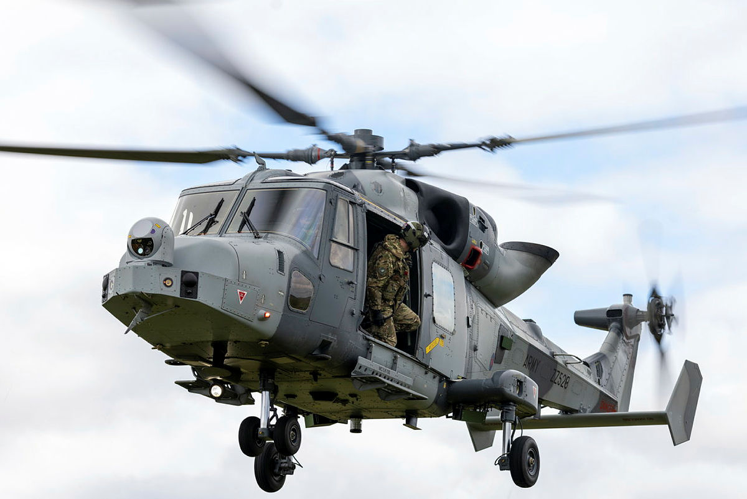

Wildcat Reconnaissance Helicopter 2022

Acquisition Reform
Through acquisition and approvals transformation we have delivered a range of practical interventions to set capability programmes up for success from the outset. A key achievement this year has been the roll out from April 22 of a new pan-Defence Risk and Complexity Assessment to help Senior Responsible Owners (SROs) better understand and address strategic programme challenges at an early stage.
We have introduced a new digital workflow tool to improve tracking and management of our investment decisions, developed tools to support agile delivery and continued to implement pan-Defence category management. We have also progressed a range of initiatives to increase the capacity and capability of our SROs and ensure they are supported by skilled and experienced teams.
Acquisition Reform is a key enabler of DSIS. We are building on achievements to date and going further to drive increased pace and accuracy into MOD’s acquisition system, to provide the right capability to the front line when it is needed to meet emerging threats. We have an ambitious continuous improvement agenda under five Acquisition Reform themes: improving cost estimating and cost control; improving relationships with industry; delivering strategic intent and Defence priorities through our requirements; empowering and enabling programme leadership; streamlining processes and addressing project resourcing challenges.

Risk Reporting
We have completed phase one of our workstream to improve risk reporting and have issued guidance as part of this. The guidance provides clarity on the quantification of risk to inform the forecasting of financial risk exposure and enable credible and robust forecasts while also ensuring consistency across the Department. We have detailed how Rick Inside Costings (RIC), Risk Outside Costings (ROC) and other elements of the Department’s risk exposure should be calculated using quantitative risk modelling (e.g. Monte Carlo) methods whenever possible. We are now working through phase two, where we will consider broad implementation and adoption of the proposed instruction and guidance.

Recommendation Updates

We are committed to the implementation of all PAC and NAO Equipment Plan recommendations and continue to make substantial progress against all those outstanding. Working with the NAO, the Department has reviewed the outstanding recommendations to identify and agree where recommendations have been completed or superseded by later additions. This exercise has provided clarity over the key issues remaining, allowing for more streamlined responses and a focused plan for further progress. Together with the NAO, we have included an annex detailing the agreed improvements for both current and historic recommendations. A summary of this position for EP21 and EP22 is shown in the tables below. Since the publication of the last Equipment Plan, we have implemented 9 recommendations leaving 8 as ‘work in progress’. To note, the NAO has introduced only one new recommendation this year, last report there were 7.

NAO Recommendations - Position at Equipment Plan 2022

Report | Number of NAO Recommendations | Closed / Superseded | Implemented | Work in Progress
EP16 | 5 |  | 5
EP17 | 8 | 1 | 7
EP18 | 7 | 3 | 4
EP19 | 6 | 3 | 2 | 1
EP20 | 8 |  | 3 | 5
EP21 | 7 |  | 5 | 2
Total | 41 | 7 | 26 | 8

Sector / Key Project Updates

High Level TLB Summaries

Responsibility for managing most equipment spending is delegated to Top Level Budget (TLB) areas. This section of the report will cover high level updates from areas across the organisation, and significant changes to large scale projects and programmes.
Figures 6 and 7 show the breakdown of the Equipment Plan by TLB and Operating Centre (OC) respectively. There is a mixture of increases and decreases in planned spend across the TLBs. The nuclear enterprise remains the single largest area of planned spend. Navy have seen the biggest spending increase since 2021, rising a total of 3 billion.
Further detail on TLB spending priorities and progress on major projects is included in the following sections.
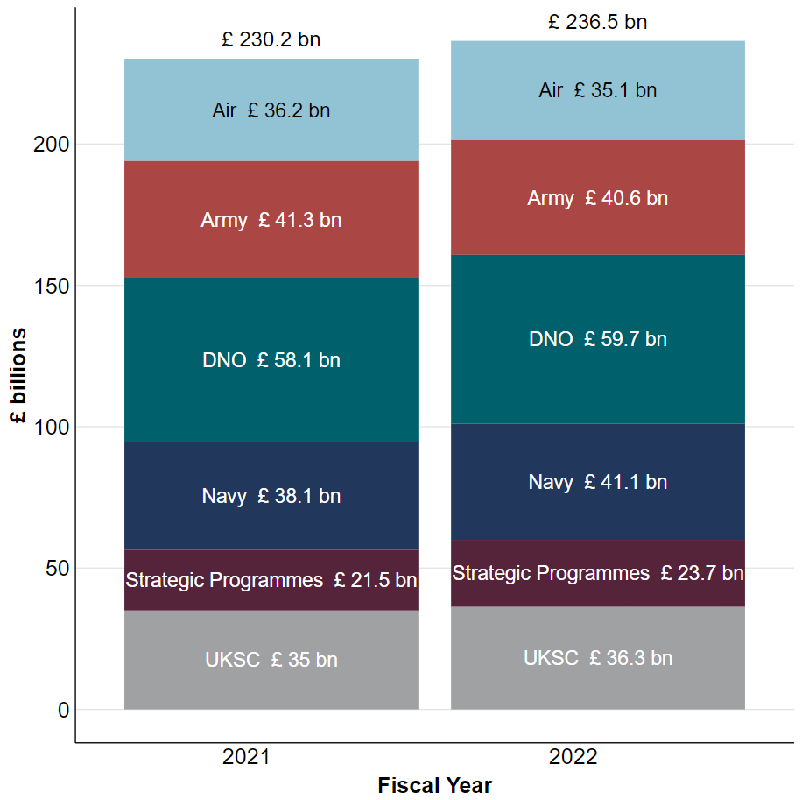
Figure 6: Chart showing change in ten-year total spending by TLB

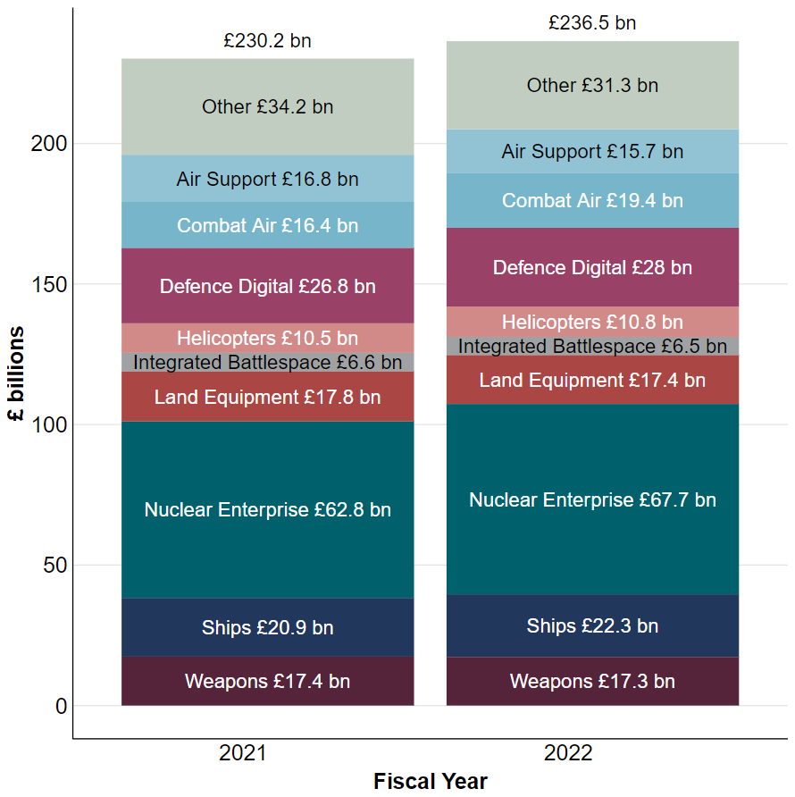
Figure 7: Chart showing change in ten-year total spending by OC

Navy Command

Navy Command is responsible for the procurement and support of surface warships, auxiliaries and maritime helicopters, as well as elements of submarine support, although the major submarine build programmes are the responsibility of the Defence Nuclear Organisation.
Navy Command plan to spend £41.1 billion in the Equipment Plan over the next ten years compared to £38.1 billion at the end of the previous planning period. The breakdown of this spend is shown in figure 8.

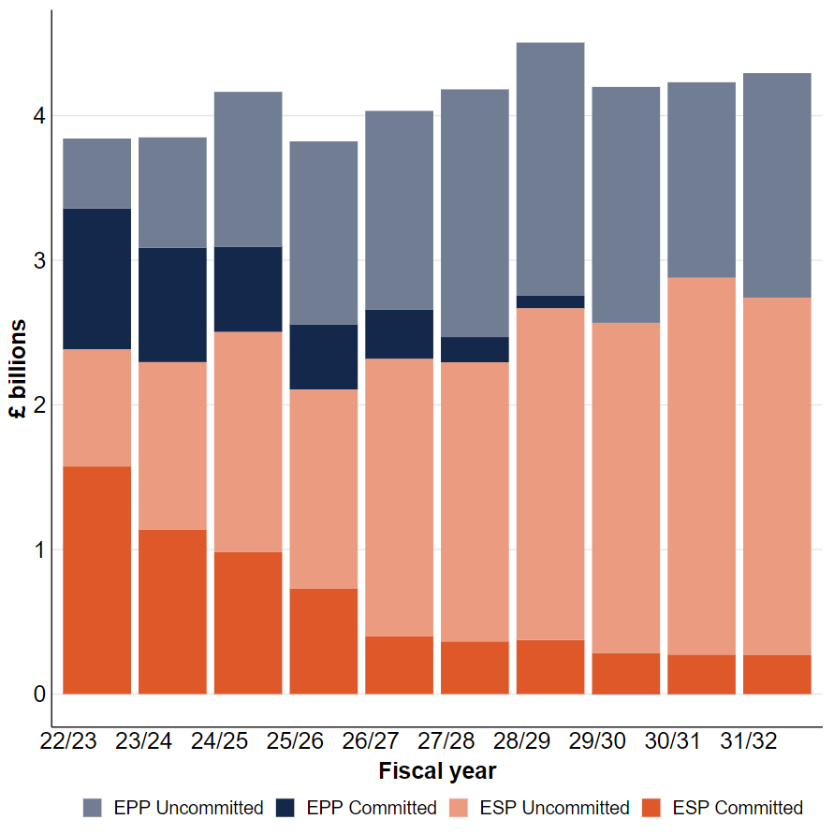
Figure 8: Navy Equipment Plan breakdown

Navy continues to benefit from the significant investment in the shipbuilding pipeline as a result of decisions outlined within the Integrated Review. This strategic and long-term investment remains on track and will increase the capability and size of the Royal Navy’s surface fleet, including procurement of three Fleet Solid Support Ships, a Multi-Role Ocean Surveillance Capability, Multi-Role Support Ships and Type 26, Type 31 and Type 32 frigates. Outside the shipbuilding pipeline, Navy Command is delivering a number of system and equipment programmes, including the transition from crewed to autonomous Mine Hunting Capability (the MHC programme), and the Maritime Electronic Warfare Programme.
Recent pressures have caused some challenges to the procurement and support of naval equipment, namely the impact of a volatile supply chain, due to the inflationary economic environment, and a reduced output from Delivery Agents, largely due to existing gapping issues caused by recruiting issues and exacerbated by COVID 19. Despite this, Navy have accomplished several significant achievements since the publication of the last Equipment Plan, notably in advancements being made across various capability programmes including Type 26, and 31.

Programme | Background | Progress
Type 26 | The Type 26 Global Combat Ship Programme will procure eight Anti-Submarine Warfare ships to protect both our Carrier Strike Group and Continuous At Sea Deterrent.  The programme, alongside sustaining the UK’s ability to manufacture complex warships, will deliver world class ships which will have increased survivability against global threats whilst maintaining a high level of availability.  They will operable globally, enhancing the UK’s ability to contribute to sea control, including through maritime force projection and command and control. | The build of the first Type 26 (HMS GLASGOW) continued and all 3 of the first batch (HM Ships CARDIFF and HMS BELFAST) are now under construction. Good progress has been made with the detailed design now complete and technical difficulties which led to programme slippage now resolved.  COVID-19 working restrictions have been lifted and the first Type 26 is planned to enter the water by the end of 2022. Procurement of long lead items in support of the second batch of 5 ships has continued and negotiations with BAES for the full manufacturing contract for these ships have successfully completed, with 8 ships now on contract. The outcome of negotiations includes include further investment in BAES’s shipyards and production processes.  Work to deliver an in-service support solution for the class under the Common Support Model has also continued, including early integration in the Future Maritime Support Programme.  Following the export success of the baseline T26 design to Australia and Canada the T26 Programme has further developed MOD’s strong links with our allies through tri-lateral sharing of shipbuilding and capability lessons.
Type 31 | The Type 31 General Purpose Frigate Programme is procuring five ships to replace the general-purpose variant of Type 23 frigate. They will provide forward presence around the world, promoting UK interests and being ready to respond to crisis.  Type 31 is the pathfinder programme for the National Shipbuilding Strategy and succeeded in reintroducing competitive tension into the UK warship building market. The ships will be deployable at high readiness and capable of providing a credible maritime security presence worldwide.  The Type 31 will be interoperable with joint UK allied, coalition and civil forces, whilst maintaining the UK’s freedom of action to operate independently. | Production of the first of five Type 31 Frigates has commenced with the Department making significant progress in modernising the Rosyth shipyard with the completion of the Venturer outfitting hall and fabrication facilities.  The success of the Type 31 programme has been marked by increased export interest and opportunities from Poland and Indonesia.
Mine Hunting Capability | The MHC programme is procuring up to 6 Mine Countermeasures (MCM) Maritime Autonomous Mission Systems (MAS), up to 4 MCM (LSV) and a UK MCM (OSV) from the spot market.  The Mission Systems and LSVs will deliver a global MCM effect, while the OSV will enable UK offshore operations. The programme will replace the Hunt and Sandown Class MCMVs, exploit its MAS capability and to achieve rapid MCM effect at range without the requirement for personnel to enter minefields. It is designed to rapidly exploit advances in technology within a quickly evolving sector.  The Mission Systems can be deployed at pace by air, land and sea and will eventually be capability of operating from a number of RN, RFA or suitable commercial vessels; including T26 and T32 frigates and the Multi-Role Support Ship (MRSS). | Despite challenges with supplier performance, MHC will deploy the first Operational Evaluation Unit to the Gulf before the end of the year, maintaining the schedule through proactive risk mitigation measures taken at programme level. Work is ongoing to stabilise and, DE&S are holding suppliers to account to ensure schedule adherence in accordance with contractual agreements.  The initial Operational Evaluation systems will commence operations in the UK in 2022 and overseas by the summer of 2023.  The UK OSV is scheduled to enter RFA service in April 2023. UK Sweep has already achieved export success and there is significant Global interest in the FR/UK Maritime MCM mine hunting capability.

Army Command

Army Command is responsible for: armoured fighting vehicles; ground-based air defence; artillery systems; protected and support vehicles; battlefield helicopters; certain unmanned air systems; soldier fighting systems; and communications and information systems in the land environment.
Army Command plan to spend £40.6 billion in the Equipment Plan over the next ten years compared to £41.3 billion at the end of the previous planning period. The breakdown of this spend is shown in figure 9.

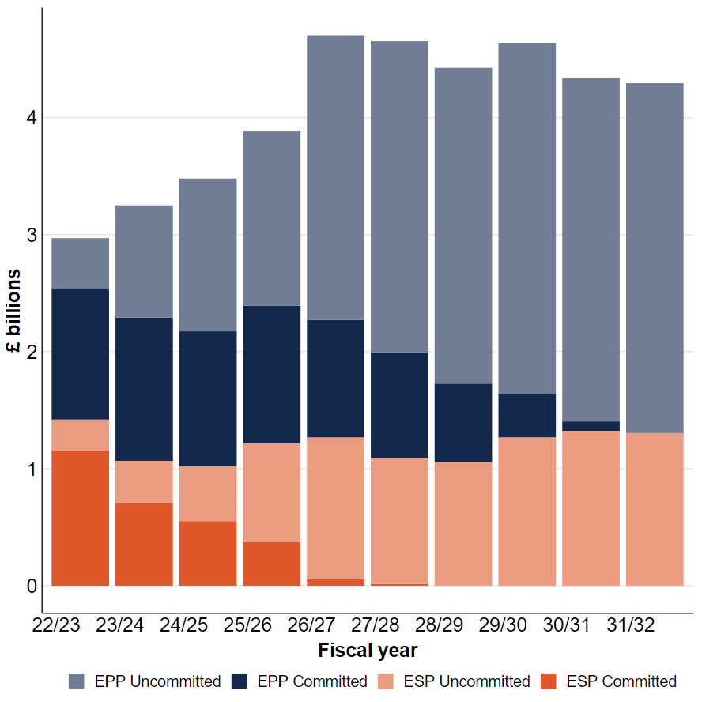
Figure 9: Army Equipment Plan breakdown

The Army has re-baselined the risk landscape against warfighting through the Capability Audit Process and steps are now being taken to ensure that the programme of record is optimised to deliver Future Soldier and, where possible, draws on lessons from the Ukrainian conflict. In the immediate term this will be achieved by prioritising areas including Air Defence; Long Range Fires; Unmanned Aerial Systems; Electronic Warfare and Signals Intelligence; and logistic capabilities and stockpiles. To realise the modernisation of the force the Army continues to progress directed investments through the approvals pathway and, where possible, is seeking to accelerate capabilities. Concurrently, through Operation MOBILISE, the Army is responding to the heightened security threat in Europe and the requirements to protect, project and promote the UK’s interests and influence globally, support NATO and deter in Europe in the short term.

Programme | Background | Progress
Ajax | Ajax equipment project is being delivered as part of the Armoured Cavalry Programme. The aim of the programme is to deliver a versatile and agile multi-role capability, operating at the heart of the Deep Reconnaissance Strike and Armoured Combat Brigades, that have the capability to succeed in future operating environments.  Ajax will transform the way the Army conducts Deep Ground Reconnaissance and underpins the Army's ability to war fight at the divisional level through its inclusion in the Armoured Brigade Combat Teams.  The Ajax fleet will have extensive capabilities, including increased lethality through a new 40mm stabilised cannon able to fire on the move, acoustic detectors, a laser warning system, a local situational awareness system, a high-performance power pack, and best in class protection. | The well-publicised technical issues with noise and vibration have resulted in delays to the Armoured Cavalry Programme. The focus for the MOD and General Dynamics remains on progressing to demonstration phase trials to test the durability and reliability if the platform and systems, and on production to commence on Drop 3 vehicles to provide a deployable capability for the Army. The programme remains challenging; however, progress has been made.  Following a pause in dynamic testing and training in June 2021, trials at the independent Millbrook Proving Ground from September to March were carried out to investigate the vehicles’ noise and vibration characteristics and to assess the efficacy of General Dynamic’s proposed modifications. In October 2022, User Validation Trials with Army crews were conducted to provide the evidence to support the safe resumption of wider trials and training activity and also assess the effectiveness of the modifications.  MOD and General Dynamics are both fully committed to delivering this vital capability. Work to recover the Programme is well underway and is expected to be taken forward for formal approval to reset the programme, following the effective resolution of the noise and vibration concerns.
Boxer | The Mechanised Infantry Programme delivers new ground manoeuvre capability based around Boxer, an all-terrain armoured vehicle which can deploy soldiers quickly and reliably over long operational distances, with minimal logistics and high tactical mobility to deter, constrain and defeat threats.  The Boxer Armoured Vehicle will modernise the Army under the ‘Future Soldier’ concept, central to its new Brigade Combat Team structures transforming how it will operate in future. | The programme is being delivered at pace, adopting a largely “off the shelf” purchase approach and limiting modifications to meet specific UK capability requirements.  The number of Boxer vehicles purchased has recently been uplifted from 523 (2019) to 623 (2022), following priorities outlined in the Integrated Review.  Defence is considering further Boxer fleet enhancements, uplifts, and potential new variants for a number of programmes for capability coherence in the Brigade Combat Teams, Land Industrial Strategy opportunity, and longer-term strategic planning.
Morpheus | MORPHEUS will be a computing and information system for deployed, tactical users in all three Services operating in the land environment. It will provide new applications and software, new computers, and new radios (and other ‘bearer’ types) to link nodes together.  It will be optimized for warfighting, ruggedized both electromagnetically and physically, and will form the core of MOD’s future Tactical Communication and Information Systems (TacCIS) capability. | MORPHEUS is one of several programmes working to deliver the next generation of tactical military communications for land operations. Progress has fallen short and we are reviewing next steps on how to best achieve our objectives.  The Department is reviewing next steps on how to best achieve the objectives.

Air Command

The Royal Air Force is responsible for Combat Air, including fast jets and weapons; Intelligence Surveillance and Reconnaissance (ISR), including large ISR aircraft, remotely piloted aircraft and their enablers; strategic and tactical air transport; air-to-air refuelling aircraft; air platform protection; training aircraft; and training systems, including synthetics such as augmented and virtual reality.
Air Command plan to spend £35.1 billion in the Equipment Plan over the next ten years compared to £36.2 billion at the end of the previous planning period. The breakdown of this spend is shown in figure 10.
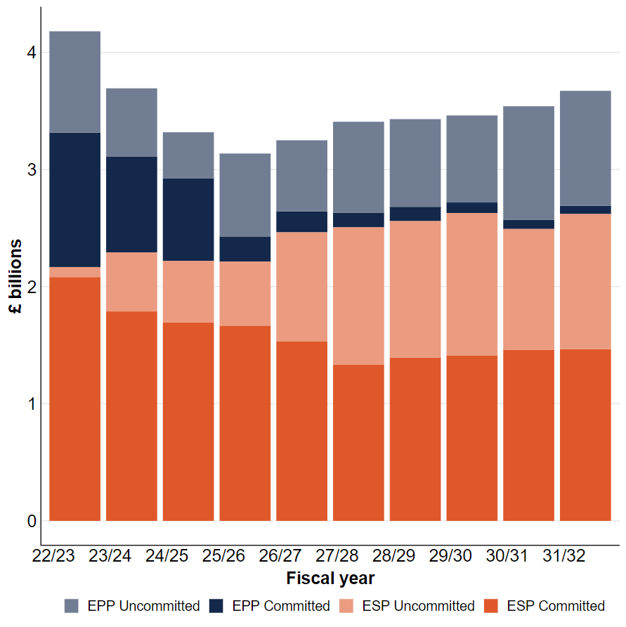
Figure 10: Air Equipment Plan breakdown

In line with aims and priorities outlined within the Integrated Review, the Royal Air Force will become an increasingly digitally empowered force, investing in new platforms, whilst retiring legacy equipment with increasingly limited utility in the future operating environment. With the aim of remaining credible and capable, the Royal Air Force will be rationalising older fleets to improve efficiency, retiring Typhoon Tranche 1, and Hawk T1 over the coming years. It will enhance the new military flying training system with further investment in synthetic training that will deliver more capable crews more quickly and more efficiently. The next generation airborne command and control aircraft, E7 Wedgetail, will provide airborne surveillance, command, and control capabilities relevant to current and expected threats alongside the P8 Poseidon Maritime Patrol aircraft. Air will also retire the C130 Hercules to make way for the A400M Atlas force to increase its capacity and capability, operating alongside C-17 Globemaster and Voyager transport aircraft and tankers.

Programme | Background | Progress
Marshall | The Marshall programme will deliver a sustainable military Air Traffic Management (ATM) capability at MOD-operated airfields and flying ranges within the UK and overseas. It will also provide a deployed ATM capability in support of expeditionary operations.  The programme was initiated in October 2014 and will deliver services for a period of 22 years, until 2037. It is structured around the delivery of Technical Services rather than simply upgrading equipment but also replaces ageing military ATM equipment and will ensure compliance with mandatory international regulations such as 8.33KHz Frequency Radio Spacing and Mode S Radar Capability.  Marshall will transform the current military capability into a modern, efficient and world-class ATM service. | The programme is currently in its seventh year of delivery, providing ATM services via legacy systems, and rolling out new equipment in parallel across the MOD estate.  Under MARSHALL, terminal radar services in some locations will be delivered from a hub unit. Three clusters will be created, centred on RAF Brize Norton, RAF Coningsby and RAF Marham. Transition to the new configurations has commenced with the first unit (RAF Waddington) successfully transitioning into the first hub (RAF Coningsby) in Apr 22.
Poseidon MRA Mk1 | The Poseidon provides detection, location, identification, tracking and attack of above and below-water targets, contributing to: UK Anti-Submarine Warfare (ASW) and Anti Surface Unit Warfare (ASuW); and securing British territory against physical incursions. It also contributes to Maritime Counter-Terrorism activity, Joint Personnel Recovery and long-range Search and Rescue operations.  Poseidon is equipped with the Mk 54 Lightweight ASW torpedo to enable it to attack sub-surface targets. | On 11 April 2022, the Programme achieved Ready for Training in the UK, marking the point at which the RAF took on the responsibility of delivering all Poseidon training from RAF Lossiemouth in the UK.  Additionally, on 30 June 2022, Air Command was able to declare the Interim Capability Milestone for the Poseidon; this follows on from the declaration of Initial Operating Capability on 1 April 2020 and marks another achievement in force growth and step towards Full Operating Capability in 2024.
E-7 Wedgetail AEW Mk1 | E-7 Wedgetail is the most technologically advanced airborne early warning and control (AEW&C) system available and will provide UK Defence with the ability to see far beyond ground-based systems and fighter aircraft sensors. A force multiplier, it can generate a 360-degree view of the airspace and provide advanced warning of approaching threats to enable commanders to fight the battle effectively.  Capable of fulfilling multiple different missions, E-7 can provide high fidelity and accurate target information utilising its cutting-edge Multi-role Electronically Scanned Array (MESA) sensor, housed in a distinctive fin on the spine of the aircraft.  The Integrated Review reduced the scope of the Wedgetail Programme from five to three aircraft, a change that has since been negotiated with Boeing and implemented formally through the Annual Budgetary Cycle Option process. | The Programme is currently in the manufacture stage with two UK Wedgetail aircraft in modification at STS Aviation, Birmingham Airport. The third aircraft is arrived for induction with STS Aviation in July this year.  Cost inflation is being experienced throughout the Programme, including construction, procurement of aircraft parts and exchange rate uncertainty. The final costs for the Wedgetail Programme will be presented in a full business case expected for submission in Q2 2023.  An announcement that the United States intends to procure E-7 has the potential to keep costs down on the Programme.
F-35B Lightning II | The F-35B Lightning II aircraft is an advanced, fifth generation aircraft. The Lightning Force is provisioned with a joint Royal Air Force and Royal Navy workforce and capable of operating from the land and sea domains and forms an integral part of Carrier Strike, operating from the UK Queen Elizabeth Class aircraft carriers. It is a multi-role combat aircraft, meaning a single aircraft can conduct the roles and missions of different aircraft types simultaneously.  These include air-to-air and air-to-surface operations, as well as intelligence gathering. The low-observable technology along with organic electronic attack capabilities that Lightning contains allows the air system to be more survivable than fourth generation aircraft types in high threat counter air environments.  The aircraft has been designed for growth and expansion of its capabilities which will continue to be developed through life to ensure we stay ahead of emerging threats. SDSR 15 accelerated the purchase of Lightning aircraft to generate two front-line squadrons from 2023.  The inaugural deployment of the Carrier Strike Group in 2021 to the Indo-Pacific region showcased the UK’s ability to project global influence, and more recently, the Lightning operations in support of NATO operations have highlighted the UK as a key fifth generation operator. | Following the success of Carrier Strike Group 21, the Lightning Force is focussed on Force Generation and Growth while providing support to the NATO mission in Europe.  The next milestone is the formation of 809 Naval Air Squadron which is planned for FY23/24; this provides a vital step to FOC which is planned for 31 Mar 25 and will provide UK Defence with two deployable Lightning Squadrons.
ECRS Radar | The European Common RADAR Standard Mark 2 (ECRS Mk2) is vital to enabling UK Freedom of Action and Control of the Air, providing critical Electronic Attack (EA) and Electronic Warfare (EW) capabilities applicable to the increasingly contested and degraded environment. ECRS Mk2 will result in an electronically scanned (ESCAN) RADAR embodiment onto Tranche 3 aircraft as well as software/hardware updates to the mechanically scanned (MSCAN) RADAR on Tranche 2 aircraft.  ECRS Mk2 investment sustains a highly specialised, world-leading UK industry base and ensures advanced technical skills and expertise in complex sensors are available for the Future Combat Air System (FCAS) programme. Delivering ECRS Mk2 into service demonstrates the UK’s cutting-edge technological capabilities and builds international confidence in UK industrial capability. Integrating ECRS Mk2 onto Typhoon ensures that it remains competitive for winning new export orders and work for retrofitting the RADAR onto current Typhoon export customers’ aircraft.  The Phase 4 Enhancements (P4E) package is the only delivery vehicle for successfully integrating ECRS Mk2 RADAR onto Typhoon and sustaining a common baseline across the Eurofighter (EF) Partner Nations (PN). P4E will include a range of complementary and essential regulatory upgrades required for Typhoon in the same timeframe as ECRS Mk2. P4E also provides the opportunity to field additional key UK capabilities and weapons. P4E is thus a critical upgrade without which the capabilities of ECRS Mk2 cannot be exploited. | ECRS Mk2 continues to make progress with industry focused on completing the production system design and prototype ground testing. The ECRS Mk2 RADAR Specification has been approved and signed by Eurofighter which is a major milestone for the joint team and provides a key input for P4E.  Contract negotiation for the next 5 years of ECRS Mk2 hardware and software development and initial long lead P4E activity is being managed by Typhoon DT, working with BAE Systems, Leonardo UK and NETMA, with work focussed on finalising statements of work and an integrated delivery plan.  Leonardo UK will deliver a first flight-test ECRS Mk2 radar to BAES Warton in the coming months. Following the completion of integration activity and ground-based testing, the AESA system is expected to undergo flight-testing from late 2023.

UK Strategic Command

UK Strategic Command is responsible for command, control, communications, computers, intelligence, surveillance, targeting, acquisition and reconnaissance systems and capabilities (C4ISTAR) in both operational and business environments; special projects including procurement for UK Special Forces and Joint Force Protection capabilities; pan-Defence logistics systems; capabilities to support Defence operations and activities; and medical capabilities.
Strategic Command plan to spend £36.3 billion in the Equipment Plan over the next ten years compared to £35 billion at the end of the previous planning period. The breakdown of this spend is shown in figure 11.

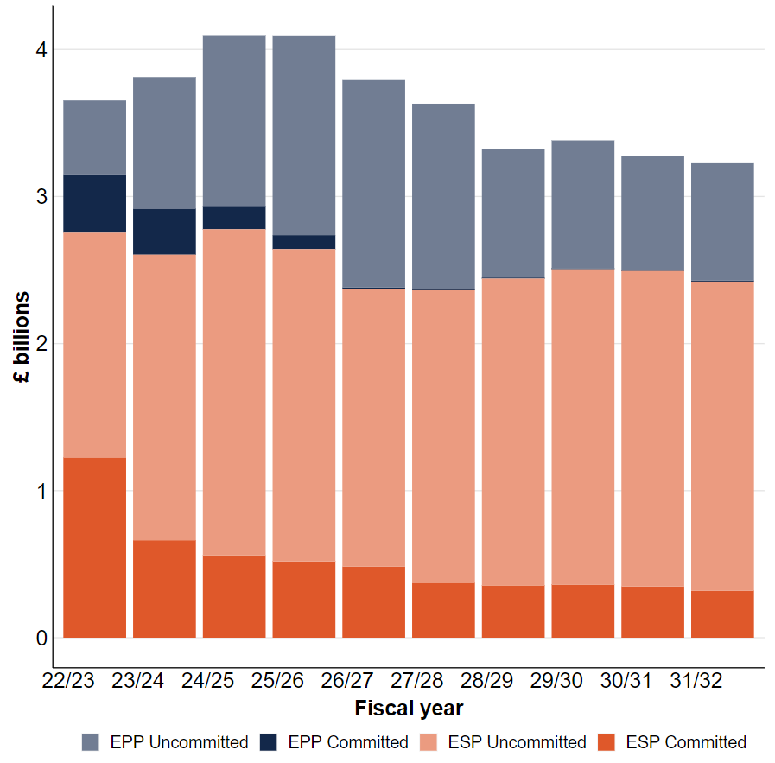
Figure 11: UK Strategic Command Equipment Plan breakdown

The UK Strategic Command projected equipment spending remains shaped by the outcome of the Integrated Review. Since the publication of the last Equipment Plan, the command has seen the establishment of several projects that were initiated as a result of the Review, particularly within the Digital programme. The Intelligence, Reconnaissance and Surveillance (ISR) Review has been concluded and, pending final Ministerial approval, it has made several recommendations for the Equipment Plan that will need developing and assessing for affordability and deliverability for inclusion in the later years’ programme.
A number of risks to deliverability of the Integrated Review ambition remain, most notable of these are workforce pressures felt across the Command, and a gap in specialist expertise. The most recent budgeting cycle was characterised by a series of changes necessary to embed Integrated Review decisions and enact modest re-balancing of the Command’s overall position. Balancing affordability and delivery realism, set against the context existing and emerging challenges, will likely result in re-profiled projects across the Equipment Plan, although headline ambition from the Integrated Review is not considered at risk.

Programme | Background | Progress
New Style of IT | The New Style of IT (Deployed) programme is delivering operationally deployable UK Secret, Mission Secret and Official information and communications technology to the Land and Maritime environments. The next generation system will be known as OpNET and will replace numerous, divergent and obsolete legacy systems delivered by multiple suppliers. The Integrated Review has provided the opportunity to increase the scaling of this critical new military capability. | The New Style of IT (Deployed) programme has successfully delivered OpNET to both QEC carriers, leading to the declaration of Maritime IOC and OpNET ISD on schedule in Dec 21, and will soon be rolling out to the remainder of the fleet. Land trials are also underway, with presenting challenges being mitigated appropriately. It is anticipated that Land delivery will slip into EP23; overall delivery remains on target for 2028.
FBLOS Skynet | The purpose of the SKYNET 6 programme is to provide and sustain a space-based communications capability, thereby delivering information to enable MOD’s information advantage anywhere, anytime. This includes enabling strategic, operational and tactical communications to static and deployed forces, overseas territories, areas of Strategic Interest and the UK. SKYNET 6 consists of three main workstreams: the first new satellite, SKYNET 6A; ground services within the Service Delivery Wrap; and the future space and ground solutions, known as Enduring Capability. | SKYNET 6A is now in the design and manufacture stage. The planned launch date is late 2025.  The SKYNET Service Delivery Wrap has concluded its competitive procurement and is awaiting completion of its approvals before preferred bidder is announced.  The contract will not only replenish some of the ground equipment but provide SATCOM services for 5 years, starting in March 2024.  The SKYNET Enduring Capability project will provide not only future SATCOM service delivery after 2029 but will also procure a number of satellites for launch in the later part of the decade and early 2030’s.

Defence Nuclear Organisation

The Defence Nuclear Organisation (DNO) is responsible for: procurement and disposal of all the UK's submarines, through the Submarine Delivery Agency; and nuclear warheads and Trident missiles for the UK's nuclear deterrent.
DNO plans to spend £59.7 billion in the Equipment Plan over the next ten years compared to £58.1 billion at the end of the previous planning period. The breakdown of this spend is shown in figure 12.
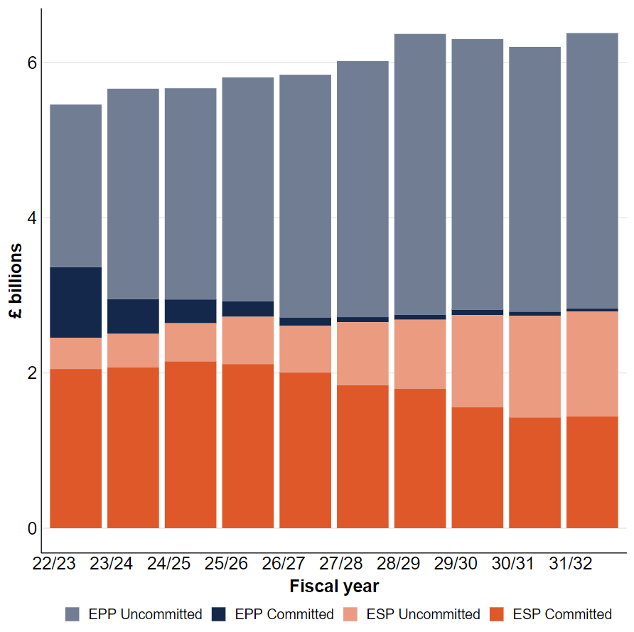
Figure 12: DNO Equipment Plan breakdown

The Government have committed to a once-in-two-generations programme to modernise our nuclear forces. This will include replacing the current Vanguard Class submarines with four new Dreadnought Class submarines. Designed and built in the UK, these new submarines will be some of the most advanced machines ever built, employing world-leading and cutting-edge technology to deliver an extremely capable and intensely formidable capability. DNO will also replace the UK’s nuclear warheads to ensure we maintain an effective deterrent throughout the commission of the Dreadnought Class, working closely with the US so that our new sovereign warhead remains compatible with the Mk7 aeroshell and Trident Strategic Weapon System.

Programme | Background | Progress
Dreadnought | The Dreadnought Class is the future submarine platform of the UK’s strategic nuclear deterrent. Replacing the Vanguard Class, they will be the largest submarines ever operated by the Royal Navy.  Dreadnought is a new design with a number of new systems and equipment improvements which will provide the necessary increase in capability and performance to address the advances being made in the underwater battlespace by the UK’s potential peer level adversaries. | The Dreadnought programme has moved into Delivery Phase 3. Investment during this phase is valued at £10Bn, starting with over £2Bn in contracts awarded to BAE Systems and Rolls Royce at the end of March 2022.  The first of Class, HMS Dreadnought, reaches the mid-point in construction at Summer 2022, including all missile tubes delivered, with the second of Class, HMS Valiant, well underway and third of class, HMS Warspite, to start construction from Autumn 2022.  The Dreadnought programme is leading the development and implementation of Dreadnought in-service capabilities and support arrangements, with some early investments proposed to moderate Continuous At Sea Deterrent transition from the Vanguard class.  The design, development and implementation of the support arrangements is underway. This work will facilitate the transition into service of the Dreadnought class and the handover from the Vanguard class in the 2030s.
Astute 5-7 | Astute submarines are the largest, most advanced and powerful attack submarines ever operated by the Royal Navy, combining world-leading sensors, design and weaponry in a versatile vessel. The state-of-the-art submarines are nuclear powered and armed with Spearfish torpedoes and Tomahawk land cruise missiles  Astute submarines are designed to be adaptable throughout their life with modular systems to reduce the cost of upgrades. | The build and commissioning of the remaining Astute Class submarines remains a hugely complex endeavour, relying on a highly skilled workforce and a large and diverse supply chain. Both have been challenged by the Covid-19 pandemic and the competition for a suitably qualified and experienced personnel, particularly in engineering. In the period, however, the programme has delivered boat 4 into service following 12 months of acceptance sea trials and continues to make steady progress with boats 5 – 7, with boat 5 likely to sail in the near term.

Strategic Programmes

Strategic Programmes is responsible for the procurement of Defence’s complex weapons portfolio, test and evaluation and training services. In addition to this, the Combat Air Director holds the new funding for the next phase of the Future Combat Air System programme.
Strategic Programmes plans to spend £23.7 billion in the Equipment Plan over the next ten years compared to £21.5 billion at the end of the previous planning period. The breakdown of this spend is shown in figure 13.
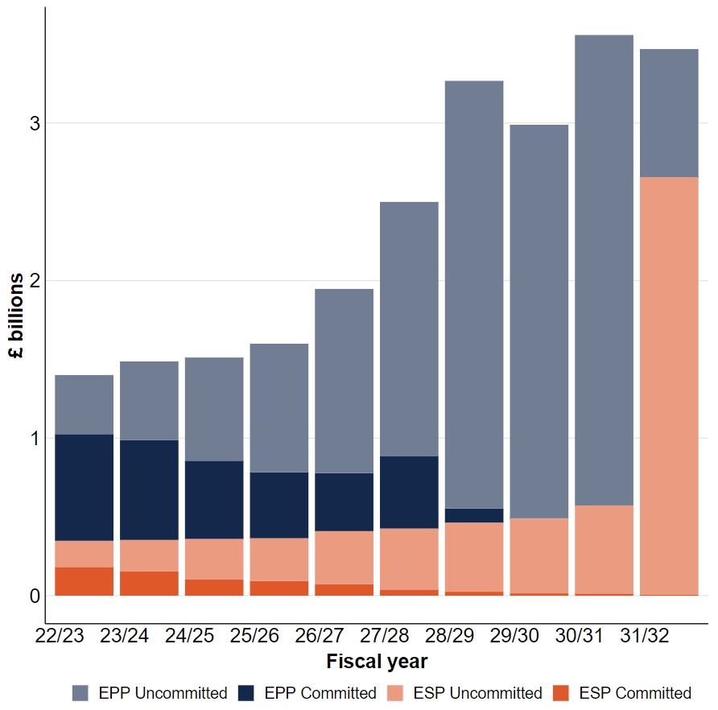
Figure 13: Strategic Programmes Equipment Plan breakdown

Programme | Background | Progress
Future Combat Air System | The Future Combat Air System (FCAS) programme is developing concepts for a next-generation capability designed to secure information advantage and outmatch adversaries, even in the most highly contested environments.  It will keep ahead of the threat posed by rapid technological advances and the proliferation of modern technologies. Key to this is an emphasis on truly twenty-first century capabilities, including modularity and rapid upgradability, exploitation of machine learning to augment and support human operators, and the use of digital networks and data to ensure operational advantage.  We are exploring means to deliver FCAS through international partnerships, thereby strengthening global relationships and sharing expertise and costs. At home, work on FCAS has supported substantial investment in skills and R&D in key combat air hubs such as the north-west and south-west of England and Edinburgh. | In line with the Integrated Review, we have continued to develop concepts and technologies for FCAS with international partners. The programme is proceeding at pace and we are undertaking important work in the Concept and Assessment phase to define and begin design of the system, mature technologies, invest in the skilled workforce and secure digital and physical infrastructure to underpin cutting-edge digital engineering. This will enable us to progress quickly towards a targeted in-service date of 2035, significantly faster than previous combat air programmes. This is being enabled by early investment in R&D, concepting and transformative industrial technologies.  As announced during the 2022 Farnborough International Airshow, the UK has been conducting joint concept analysis with close partners Japan and Italy to understand areas of shared interest and to explore potential Future Combat Air partnership options, while continuing to remain open to exploring wider partnerships. It was also announced that MOD and Team Tempest industry partners (BAE Systems, Rolls-Royce, Leonardo UK and MBDA UK) are developing a crewed next generation flying demonstrator that we expect to take to the skies within the next five years. We have made great progress with Japan and Italy, including joint work with Japan on jet engine technologies and advanced sensors, and collaboration with Italy on core concept designs. This has enabled us to maximise our shared expertise and develop our respective industrial capabilities.
Complex Weapons Portfolio | The Complex Weapons Portfolio initiative is based on meeting the UK’s enduring requirement to have battle-winning military capability through the use of Complex Weapons and to retain the ability to develop leading-edge Complex Weapons technologies.  Within this context, the initiative aims to deliver: Improved, adaptable and flexible Complex Weapons that can be shaped to meet current and future military capability needs; and freedom of action and operational advantage in our Complex Weapons through a sustained indigenous industrial construct. | Since EP21 The Complex Weapons portfolio has implemented all of the Integrated Review measures including bringing Sea Viper Evolution onto contract and descoping Brimstone 3B from Apache. To enhance the scrutiny of the larger and more complicated programmes with the portfolio, six programmes have been broken out for reporting purposes and added to the Government Major Projects Portfolio. The three Capability Demonstrators for Novel Weapons have been placed on contract with Defence approval to sustain the existing capabilities and direction to take forward the top 5 capabilities. Assessment Phase of the Future Complex Weapons Portfolio structure is progressing with both MBDA and Thales. Both are due to be completed at the end of 2022.  During EP22 Complex Weapons Portfolio encountered cost pressures within delivery of several key programmes. Collaborative working between MOD and industry primes (MBDA and Thales) is ongoing to mitigate these pressures across the 10-year window.  There are significant opportunities at a portfolio level which are being progressed to drive efficiencies and cost saving into the programme of work. These are anticipated to mature in EP23 and due to the nature of the accounting treatment will have an enduring impact. These efficiencies will be used to address cost pressure and promote further investment in future capabilities.

Annex A: Project Performance Summary Table

Project Performance Summary Table 2022

The Project Performance Summary Table (PPST) provides an overview of the delivery performance of a limited population of some of the Department’s largest and most complex equipment procurement projects. Each project has passed the Full Business Case (or previously the Main Gate) investment decision point to proceed to the demonstration and/or manufacture phases. For each project, the forecast for cost, time and in meeting Key User Requirements (KURs) is reflective of the position as of 31st March 2022.
Independent validation of the data is conducted by the Department’s Cost Assurance & Analysis Service (CAAS), who review evidence provided by a sample of the projects in the population to support in-year cost, time, and KUR variations.


+1.1% increase in forecast costs, of which is primarily as a result of buying a greater number of 100 Boxer vehicles as an outcome of the Integrated Review.


+69 months increase in forecast time, 26 months of which was attributable to factors outside the Delivery Organisations control, due Integrated Review outcomes and revised time estimates.
99% of Key User Requirements (144 out of 146) forecast to be met



Figure 14: PPST Key Findings

Changes to the PPST Population
In total there are 19 projects within the PPST population for 2022. Two PPST 21 projects, Lightning II (Fighter/Attack Aircraft) and P-8A Poseidon (Maritime Patrol Aircraft) have been removed having successfully met their In-Service Date (ISD). No new projects have entered the population.

Forecast Cost
There were significant reductions in forecast costs reported in E7 Wedgetail (-£194 million) due the reduction of fleet size from five to three aircrafts to enact the Integrated Review decision. Skynet 6A reported a (-£28 million) reduction in forecast costs, due to efficiencies claimed. The (-£19 million) reduction in forecast costs for Marshall was due to future end-user changes no longer being taken forward by the Programme. Due to favourable Foreign Exchange Rates (FOREX) movements both Protector (-£15 million) and Challenger Life Extension Programme (-£14 million) reported reductions in forecast costs.
During the 2021/22 financial year, the aggregate forecast costs of the 19 projects increased by +1.1% (+£647 million), this is a total cost variance of only +2.8% since the original Full Business Case and are largely as a result of reflecting Integrated Review outcomes into the project costings. The most significant increases were associated with Mechanised Infantry Vehicles (+£543 million), Type 26 (+£259 million), Core Production Capability (+£46 million) and New Style of IT (+£35 million). The increases attributable to the Mechanised Infantry Vehicles programme were primarily due to additional costs associated with delivering an additional 100 Boxer Vehicles in line with Integrated Review outcomes. Type 26 Frigate batch 1 forecast cost increases were caused by a combination of contractor performance issues, supply chain problems and COVID-19 delays, alongside changes to risk and escalation estimates. Technical issues relating to the ongoing challenges with development and transition into production contributed to the Core Production Capability forecast cost increase. The acceleration of the rollout of new information and communications technology (OpNET) to the Navy, changes in capability requirements, an increase in software license requirements and technical issues were all factors that contributed to the New Style of IT forecast cost increase.

Foreign Exchange Rates
Where projects are contracted in currencies other than £ Sterling, they may experience fluctuations in the Foreign Exchange Rates over the life of the contract. There is a risk that these fluctuations will have an impact on a programme’s long-term affordability. To mitigate this risk, projects are allocated a Foreign Exchange Rate (FOREX) risk provision so that minor or transitory changes in rates that cause cost fluctuation will not necessitate a re-approval. Depending on the level of foreign exchange risk exposure, and in discussion with the scrutiny community, projects will either be allocated a FOREX risk within the Approved Budgetary Level (ABL), a separate additional FOREX risk allocation outside the ABL, or both. There are a total of eight projects within the PPST 22 population that hold a FOREX risk allocation outside of the ABL, which can be found highlighted within the table footnotes.

Forecast Time
Eight of the 19 projects with an approved in service date (ISD) reported no in-year change to their forecast ISD. Seven projects reported a combined project increase of +73 months. Significant time increases were reported by Marshall (+19 months) due to safety and technical concerns resulting in the customer agreeing a revised rollout plan. Marshall has now achieved its Initial Operating Capability. Due to safety critical software assurance delays, a schedule risk analysis was conducted and resulted in a (+14 months) time increase to the Brimstone Capability Sustainment Programme. The issues with Batch 1 contractor performance, supply chain problems and COVID-19 induced delays also contributed to the Type 26 time increase of +12 months. The Apache time increase (+13 months) was partly due to technical issues (+4 months) resulting in a delay to the manufacture of the helicopters, with an additional 9 months as a result of a challenge from the Integrated Review to find £100 million in cost savings. These savings were negotiated into the Long-Term Training and Support Services (LTTSS) contract but delayed contract placement which was a dependency for IOC. The ongoing noise and vibration issues with Ajax resulted in the (+9 months) forecast increase as at 31 March 22. Testing is now underway to verify the effectiveness of modifications proposed by General Dynamics to mitigate the noise and vibration issues to a safe and acceptable level. Until a suitable suite of design modifications has been identified, tested, and demonstrated, it is not possible to determine a realistic timescale for the introduction of Ajax vehicles into operational service with the Army.
New Style of IT reported a (-4 month) in-year decrease, this was due to the accelerated rollout of (OpNET) to Navy which resulted in the project achieving ISD four months ahead of schedule. This reduced the overall PPST time forecast variation to +69 months.

Key Performance Measures
For PPST 22 there has been no in-year change to the projected forecast of meeting Key Performance Requirements (KURs) for our major acquisition programmes. The forecasted delivery is at 99% with 144 out of 146 KURs being met. As in previous years some projects within the population are outside the scope for reporting on KURs in the PPST due security reasons.

Comparison of Performance between PPST 21 and PPST 22
A direct comparison should not be drawn between PPST 22 and prior years due to differing projects entering and leaving the population and projects which have received uplifts in their approval. Concise record of overall Cost, Time and KUR performance reported in previous Defence Equipment Plan publications is provided below.

Year | Number of projects | In-year cost forecast variation | Time forecast variation | Forecast achievement of performance measures (KURs)
2022 | 19 | +£647m | + 69 months | 99%
2021 | 21 | -£219m | + 58 months | 98%
2020 | 21 | -£1,135m | +12 months | 98%
2019 | 27 | -£20m | +69 months | 100%
2018 | 27 | +£783m | +62 months | 99%
2017 | 28 | +£224m | +57 months | 99%
2016 | 22 | +£237m | +34 months | 99%

Annex B: NAO and PAC Recommendations Progress Table

NAO Recommendations Table

The below table includes a breakdown of all NAO recommendations following the publication of the Equipment Plan 2021, and all other recommendations outstanding from previous years. The table also shows the progress the Department has made in response to each recommendation to date, and the next steps we will be implementing to fulfil outstanding aims.

Date | Recommendation | Progress | Status
2021-a | The Department has not yet fixed its long-standing problems in managing the Plan. It will struggle to do so unless its Head Office, working with the TLBs, makes a fundamental change to the way it builds, and reports on, the Plan.  In particular, the Department should: ensure all components of the Plan’s budgets and costs are prepared on a consistent basis between TLBs and across years, including for example on contingency, apportionment of defence budget shortfalls, and the basis for calculating the range which expresses affordability.  This would provide comparability and enable stakeholders to track progress and variability of performance. | The Equipment Plan 2021 was the first plan in five years that the NAO have not described as unaffordable. This is a significant moment and should instil a sense of confidence that improvements are being made to the management of the plan. The Department will continue to work closely with TLBs when working towards Equipment Plan 2022, ensuring all components of the Plan’s budgets and costs are prepared on a consistent basis between TLBs and across years. The Department recognises the importance of ensuring close collaboration with the TLBs and will continue to prioritise this for Equipment Plan 2022 and future plans. | Implemented
2021-b | As part of the process of putting the Plan together, clearly set out the respective roles and responsibilities of TLBs and Head Office, including  clarifying who is in charge of each part of the process.  The objective of this would be to build a shared focus on creating the right incentives for maximising long-term value for money, such as how Head Office takes factors such as quality of cost information, historical delivery of efficiencies or forecasting accuracy into account when allocating budgets and future savings targets to TLBs. | The Department recognises the importance of early and consistent engagement with the TLBs and have ensured that key roles and responsibilities were outlined from the outset of preparatory processes for the Equipment Plan 2022.  The Equipment Plan 2022 addresses the need to set out the roles and responsibilities of TLBs and Head Office, and does this through a dedicated section within the report.  Revisions to ABC guidance carried out this year, which sets our requirements for TLBs has also be useful in providing clarity on TLB expectations and surrounding processes. Further improvements to the ABC processes include closer engagement with TLBs, a change which has received positive feedback in the NAO/TLB interviews this year.  The Department has also demonstrated a commitment to a greater focus on TLB plans in testing assumptions underpinning cost forecasts and spending plans. This has been evidenced through greater engagement in understanding the level of risk across the organisation. | Implemented
2021-c | If total forecast spending exceeds overall control totals in any year, include a section within its Equipment Plan report explaining why the accounting officer is satisfied that this outcome is compliant with Managing Public Money’s standards of regularity, propriety and value for money. | We are confident in our spending assessments and have lived within budget for the last year and have forecasted the same for the upcoming year(s). The Department is committed to monitoring expenditure closely, evidenced by the fact we lived within CT’s last year. Should the situation arise where total forecast spending exceeds overall control totals, we would project that AO discharges his duties over public money.  Further detail of TLB risk adjustments and variances has been included in the ‘affordability and financial risk’ section of the Equipment Plan 2022. | Implemented
2021-d | In reporting on future assumed or targeted cost reductions within the Plan, make a clear distinction between those which are supported by a clear plan to achieve them, and those which represent an additional target, and provide supporting evidence. | We are introducing a new adjustment category in our forecasting system. This will enable us to understand where TLBs have savings initiatives planned and where is an ambition to deliver future savings but no current programme initiatives.  We will work this through in future budgeting cycles whether it can be included and how far it should be incorporated into the Cloud accounting software being developed. | In Progress
2021-e | In order to give more assurance on the completeness of the Plan, carry out regular audits of capability gaps across TLBs and, subject to national security constraints, publish a high-level summary of the results, such as whether gaps are closing or widening over time. | The Department considers the Defence Capability (Risk) Assessment Register activity evidence of this recommendation already being performed.  The DCAR is a consolidated capability risk assessment held at SECRET. It would therefore pose a security risk to share the top-level findings in the equipment plan publication. The DCAR is also wider than the Equipment Plan publication’s remit as it considers all DLODS and a longer time period than the Equipment Plan.  We are producing an updated DCAR based on the TLB assessment of their plans and outcomes directed through the Integrated Review and Defence Command Paper. This is an annual process and as well as TLB audits includes evidence from other sources too such as Defence experimentation and force development.  The results feed into our ABC process and equipment decisions and will impact future Plans. Once completed we will share our top level assessment with the NAO to inform their Equipment Plan assessment, noting the DCAR is much broader than purely equipment risk.  To note, NAO team for the Equipment Plan 2022 have also received a brief on the DCAR purpose and process as part of this year’s audit. | Implemented
2021-f | Explore the inter-dependencies between the three plans that make up the  overall defence plan (the Equipment Plan, Infrastructure Plan, and the plan for operating costs).  Using this analysis, it should assess the delivery risks of the infrastructure and operating costs plans and how these may affect the affordability of the Equipment Plan over the next 10 years and include this in its report on the Equipment Plan. | The Equipment Plan considers a range of factors across the organisation and provides a representative and balanced picture from across the organisation.  In the wider ABC process that links into the production of the Equipment Plan, TLBs develop their own command plans, factoring in the impact of workforce, estate etc. Those judgements are fed into and agreed with Head Office.  It is important to note here that while external and contributing factors are considered in the affordability analysis, the focus of the Equipment Plan scope will remain on equipment and will not at this time cover all elements across Defence. | Implemented
2021-g | HM Treasury should define the purpose of the Dreadnought contingency and establish new governance arrangements, including the conditions under which additional funds will be provided to the Department.  This work should be undertaken with the aim of incentivising the Department to complete submarine-building on time and in a way that represents value for money. | The department continues to work with HMT colleagues on funding arrangements for the replacement warhead programme and on the future governance of the Dreadnought contingency. HMT is expected to write to the Committee with further information on the updated governance processes aligned to Defence’s access to contingency funding. | In Progress
2020-a | The Department needs to develop a comprehensive and realistic  assessment of the affordability of its 10-year equipment and support  programme.  It should improve the consistency of judgements that underpin its budget and assessments of future costs. In doing so, it should ensure all adjustments to cost forecasts are fully evidenced, transparent and supported by a clear rationale.  Forecast savings and future efficiency initiatives should not be deducted from budgets until there is a high-quality audit trail to provide confidence in their deliverability. | We are introducing a new adjustment category in our forecasting system and provided TLBs with guidance on how to use this. This will enable us to understand where TLBs have efficiency initiatives planned and where there is an ambition to deliver future efficiency but no current programme initiatives.  The Department’s position was reset at Spending Review 2020. We have adopted a new approach to setting targets based on an assessment with TLBs on the value of efficiency initiatives deliverable over the period.  In parallel, we have introduced a series of measures to improve how efficiencies are tracked across the Department. This includes both work to improve the Department’s systems as well as better reflecting efficiency through our Annual Budget Cycle. | In Progress
2020-b | The Department should include funding provision across the later years of the Plan to make it more adaptable to future needs to develop new military capabilities. This would allow more flexibility to adapt the equipment programme to changes in the strategic environment and make it less vulnerable to repeated short-notice exercises to reduce investment in existing projects. | The Department considers this recommendation complete. The Equipment Plan 2021 has £4.3 billion headroom over ten-years and, from 2025/26 onward the department has set aside a further £4.1 billion to develop and exploit emerging technology. As programmes mature this funding will enable us to continue to develop new and innovative capability, prioritising our investment against relative threats and opportunities to have best effect.  The Department considers the level of funding provision it is holding as an adequate contingency to avoid reducing investment in existing projects. | Implemented
2020-c | The Department should re-assess its approach to assessing risk and how this affects future costs. It should consider how to improve the quality of risk analysis, including whether strategic risks are fully assessed in the Plan’s affordability analysis. | The Department recognises the importance of improving the quality of risk analysis and has taken significant steps in improving this assessment since the publication of the last Equipment Plan.  We have completed phase one of our workstream to improve accuracy in risk forecasting to better inform and support financial decision making and have issued guidance as part of this.  The guidance provides clarity and information on the quantification of risk to inform the forecasting of financial risk exposure and enable credible and robust forecasts whilst also ensuring consistency across the Department. We have detailed how RIC, ROC and other elements of the Department’s risk exposure should be calculated using quantitative risk modelling (e.g. Monte Carlo) methods whenever possible, and ceasing the use of existing Deterministic Methods (i.e., Weighted Deterministic, Expected Monetary Value) unless agreed by exception.  In addition to this, we have also introduced MAR guidance which seeks to standardise the use of MAR and ensure that adjustment forecast are based on experience and should take into account: known risks (RIC and ROC), potential project delays, capacity issues, production/industrial challenges, refinement of costs, efficiency delivery, and historical trends. | In Progress
2020-d | The Department should explore a more complete range of outcomes in its affordability analysis by improving its understanding of uncertainty in project costs, reflecting the potential additional cost pressure of new capabilities, undertaking more detailed testing of project cost forecasts and considering the level of certainty in its budget over the 10-year period. | Communication between stakeholder teams has been improved and continue to be focussed on to allow understanding of uncertainty in general to be identified, raised and discussed in good time. Planning forums held by Def Res with TLB's feature throughout the Annual Budget Cycle process and allow for a wide range of areas to be addressed at both working and senior level.  We are introducing a new adjustment category in our forecasting system. This will enable us to understand where TLBs have savings initiatives planned and where is an ambition to deliver future savings but no current programme initiatives.  We have refined the basis for which possible variation of cost adjustments are provided. This ensures that there is less overlap between different variation bands, such as the previous bands of 10-25% and 25-50% and allows TLBs to deem the variation of certain adjustments to be 0% when there is a sound reason for this. The intention is to present this overall variance as a range next year.  In addition to this, with the intention of providing a more transparent picture of the Department’s priorities and plans for military capability development, a new paper has been produced and published this year to provide the public with greater insight and detail on planned investment within the current Equipment Plan. | In Progress
2020-e | The Head Office team should review and define its role in producing the  Equipment Plan, and ensure it is capable of delivering its remit.  In doing so, it should determine its role and responsibilities, in terms of providing a reliable departmental statement on the affordability challenge and engaging with the TLBs to challenge the basis of their cost forecasts and manage funding challenges.  At the very least, the central finance team should: provide robust quality assurance to ensure the Plan is based on reliable data, including consistent management adjustments and a sound evidential basis.  It should provide meaningful challenge to the TLBs on the robustness and consistency of their costed plans and adjustments to forecast costs. | Head Office has a distinct role in the development and subsequent publication of the Equipment Plan. The Department is confident in its affordability analysis of the Equipment Plan and has seen notable improvements in its production and development within this budgeting cycle, improving the reliability of outlined assumptions.  Defence Resources works closely with DE&S and CAAS teams to ensure the robust quality assurance and reliable data. There is a robust process in place in engaging with TLBs to better understand their cost forecasts and Head Office is committed to working with these teams in addressing and managing funding challenges. TLBs are challenged on their costed plans to ensure accurate and reliable reporting. The Department recognises the importance of these processes and so will ensure a high level of accuracy in the reporting and analysis of TLB cost plans.  We have completed the initial stages our workstream to improve accuracy in risk forecasting to better inform and support financial decision making and have issued guidance as part of this. The renewed guidance provides greater clarity and insight into the quantification of risk to inform the forecasting of financial risk exposure. It also enables credible and robust forecasts whilst also ensuring consistency across the Department.  We have now got a robust workbook set up which we can use each year which makes it easier to generate outputs reliably. We can focus on refinements rather than building the tables from scratch each time.  We undertake thorough reviews of TLB costings at each submission point in the Annual Budget Cycle and make numerous adjustments to resolve errors. This includes a cost adjustment review tailored to the Equipment Plan (which has been shared with the NAO) done at year end where we question the basis for adjustments including MAR.  We have staff dedicated to engaging with TLBs to understand their costings in detail during the Annual Budget Cycle. We are looking to increase the capacity of the team in this area. | Implemented
2020-f | The Department should better understand past performance, undertaking detailed reviews of outturn against forecasts to improve the rigour of cost forecasting. For example, conducting analysis on its efficiencies programme would give a more realistic view on what is achievable and the future cost of the Plan. | We continually improve our central efficiency analysis and reporting processes.  We have revised the central quarterly efficiency returns process to enable more granular analysis of data and regular detailed review of efficiency performance. While historic processes provided overall forecast positions in aggregate, we have moved to collecting data on individual activities, including maturity levels and forecast values broken down by programme. This supports our understanding of the value and types of efficiencies in progress across the Department. Continual review and improvement will allow for future reviews of the reliability of forecasts through retrospective comparisons.  In 2020, DE&S introduced an improved tool to streamline the capture and monitoring of DE&S-led efficiency data. This gives TLBs and the centre granular detail on DE&S-led Equipment Plan efficiencies. | In Progress
2020-g | The Department should continue to improve the integrity of the cost forecasts and establish consistency between TLBs’ plans. Building on its recent reviews of realism and risk, it should use the lessons it has learned to ensure all parts of the Department apply best practice. | Assessing and managing risk with regards to confidence in costings, was previously identified as a weakness through lessons from experience tasks. Action was taken to better record the sources of data and its quality in the financial model (allowing for better audit trail of the quality of costings). Also, to improve communication around risk, regular check points now feature in throughout the planning process and allow for checking of risk register as a priority. In direct address of improving consistency between TLB plans pre-submission engagement meetings have been introduced (in addition to post submission bi-lats) with TLBs, thus allowing potential inconsistencies and concerns to be discussed in a timely manner.  During Annual Budget Cycle 22, we undertook detailed reviews of the risk, including realism, which TLBs were including in their plans and made adjustments to improve consistency across TLBs.  The introduction of a new adjustment category in our forecasting system will also lead to greater understanding of where TLBS have planned saving initiatives. Additionally, we have improved our efficiency progress and MAR and Annual Budget Cycle guidance to ensure judgements are robust and evidence based. | Implemented
2020-h | The Department needs to focus on strengthening its analytical capacity.  Continuing to develop staff with financial qualifications and improve its use of data would help it more effectively produce and analyse the Equipment Plan.  It should identify and exploit opportunities for more effective data analysis  and sharing. It should make its data – such as records of reasons for project cost changes, detailed outturn data and breakdowns of forecast efficiencies – more accessible to finance and planning staff throughout the Department, reducing the need for Head Office to commission bespoke reports. | The Department recognises that professionalism and skills are vital to improving financial outcomes and we are committed to achieving a target of 60% of the finance profession holding a qualification and filling outstanding gaps in key financial positions. As of December 2021, the overall number of qualified staff (CCAB/CGMA and AAT) within the finance profession is 1,236 (43%); representing a slight increase from 1,211 (43%) in March 2021. A further 523 (18%) are currently studying for professional qualifications, of which 159 (5%) are on apprenticeship programmes.  This is an increase from March 2021, where 396 (14%) were studying, with 119 (4%) on apprenticeship. While the overall level of qualified staff is short of the 60% target, rates of qualification increase at middle and senior management e.g., at Grade 7/6 there are 326 (75%) with qualifications. Implementing the new Government Finance Function Career framework will help us measure our success against this target by providing a more nuanced understanding of where qualifications are required. | In Progress
2019-a | The Department should improve consistency of judgements by embedding a common methodology for adjustments to the budget and cost forecasts. The methodology should be capable of being tailored to individual TLBs but be based on consistent principles and an analytical, evidence-based approach. | We have an agreed methodology for cost adjustments as per the Annual Budget Cycle 22 instructions. We did specific work in Annual Budget Cycle 22 to clarify the best approach to MAR and RIC and ROC, and are continuing to work through the work on risk. We annually review TLBs’ cost adjustments to ensure that they are applying the agreed methodologies while also tailoring these sensibly to their programmes.  We have ensured increased consistency with TLB returns through renewed Annual Budget Cycle guidance, which has also provided additional clarity and information on the quantification of risk. The guidance has provided a common basis for returns, leading to a greater overall consistency across categories. | In Progress
2019-b | Head Office should strengthen the process for producing the Plan, given the amount of data needed to compile the Plan, the number of people involved across the TLBs and the need for manual input. It should establish a new financial control framework which clearly sets out the risks, controls and responsibilities. | As referenced in the 2020 recommendation, there has been significant progress in within the Equipment Plan 2022 reporting cycle in establishing the roles and responsibilities of TLBs and Head Office in producing the Plan. Further clarity on this has been included in the Equipment Plan report.  In addition, revisions to Annual Budget Cycle guidance carried out this year have seen substantial progress in providing clarity on TLB expectations and surrounding processes. Further improvements to the Annual Budget Cycle processes include closer engagement with TLBs, a change which has received positive feedback in the NAO/TLB interviews this year.  Further evidence of progress in these areas can be seen through the commitment to a greater focus on TLB plans in testing assumptions underpinning cost forecasts and spending plans. The Department has achieved greater engagement in understanding the level of risk across the organisation. | Implemented
2019-c | The Department should provide a fuller reconciliation of the affordability assessment in its report to compare against the previous year.  This would enable readers to understand the basis of the current assessment and main movements. | With the publication of the Equipment Plan 2022-32 the Department considers this recommendation complete.  The 2022 report has included a detailed reconciliation of the affordability assessment, ensuring a greater understanding of the current position and comparative record across years. | Implemented

PAC Recommendations Table

The Department provides a response to the Public Account Committee’s report recommendations which is known as the Treasury Minutes. As of November 2022, 6 recommendations are in progress, and 5 have been implemented since the publication of the last Equipment Plan. The Department provides an update on the status of the recommendations (twice a year). The next publication of the Treasury Minutes Progress Report will be published week commencing 5 December 2022 on gov.uk.

Date | Recommendation | Progress | Status
2021-1 | The next Equipment Plan should include an additional section explaining the specific changes the Department has made to reflect developments since it last reported (including changes in international relations and emerging technologies) | The Ministry of Defence (the Department) recognises the potential impact the conflict in Ukraine has had for future thinking on equipment spending and procurement and this is being examined. The Department remains confident that the Equipment Plan 2021- 2031 (EP21) retains relevance despite emerging and unpredicted threats and was produced in line with aims and priorities outlined in the Integrated Review.  The Equipment Plan has to balance competing priorities, but it is the Department’s view that the EP21 successfully addressed and rectified a previous deficit, whilst ensuring increased investment in new capabilities and research and development. The Plan therefore balances short term need and long term aims to ensure it remains resilient to emerging threats.  Future Equipment Plans will include an additional section explaining changes made and plans to address emerging developments. | In Progress
2021-2 | The Department should write to the Committee within the next three months to detail the current cost of the Dreadnought, Replacement Warhead and FCAS programmes and set out how it intends to control the costs of these programmes in future. | The Department is committed to transparency, and already publishes information about the cost of the Dreadnought programme in its annual update to Parliament on the UK’s future nuclear deterrent, in the Equipment Plan and in Major Projects Portfolio data. Whilst it is too early to provide cost estimates for the Replacement Warhead programme, the Department is working with HM Treasury on cost estimates and funding arrangements for the programme. Subject to security considerations, cost information will then be included in these publications.  The Future Combat Air System Concept and Assessment phase involving government and industry concludes in 2024. It will provide the evidence and a degree of maturity on the programme specification, schedule, and associated costs. The Department is also separately engaging with international partners on cost share and industrial benefits, which will also contribute toward the UK’s affordability position. Further detail will be shared as appropriate in future Equipment Plans and Major Projects Portfolio data. | Closed
2021-3 | We recommend that there should be a clearly defined purpose for the Dreadnought contingency and any proposals for a warhead contingency, and that Government should have a robust arrangement in place, including conditions which would have to be met, before HM Treasury would consider providing any additional funds from the contingency. The Department should write to the Committee within the next three months outlining the proposed lines for governance and the timetable in which they will be agreed. | The purpose of the Dreadnought contingency is clearly defined. It was established in recognition of the difficulties in accurately forecasting the costs of such complex programmes. It allows for changes in the spending profile or total funding without resorting to spending cuts in the wider Defence programme, so that the Dreadnought programme, critical to the Department’s continued national security, can be delivered on schedule.  The Department’s access to Dreadnought contingency funding to date has been negotiated with HM Treasury and each request for contingency funding is subject to HM Treasury scrutiny and approval.  Discussions are already underway between the Department and HM Treasury to agree the future governance of the Dreadnought contingency. As the holder of that contingency, HM Treasury will write to the Committee in due course.  Work is also underway between the Department and HM Treasury on funding arrangements for the Replacement Warhead programme. Our current assumptions it that any contingency that may be agreed for that programme would be separate from the Dreadnought contingency. | In Progress
2021-4 | The Department should urgently set TLBs targets to develop and implement concrete plans to achieve the cost reductions allocated to them in the Plan. | This has been implemented and TLBs have targets and plans to achieve these savings.  As outlined in the Equipment Plan 2021- 2031 (EP21), the Department’s top level budget holders (TLBs) have planned £7 billion of cost reductions over ten years. The Department closely monitors and scrutinises TLB planned cost reductions in the Annual Budget Cycle. If there are concerns about the deliverability of these savings the Department would work with TLBs to identify remedial action.  As explained in EP21, the Department considers that the savings are achievable. This was demonstrated in financial year 2020-21 when the Department held spending to within budget without the need for a centrally directed savings exercise.  Further information on TLB cost reductions will be included in the upcoming Equipment Plan 2022 due to be published in Autumn 2022. | Implemented
2021-5 | The next Equipment Plan report must clearly set out the quantified realistic affordability risk to it posed by the Department’s plans for its other areas of spending. | The Department recognises the importance of managing risks to affordability, particularly from challenges in areas such as workforce and estates.  The Equipment Plan 21 set out an affordable plan for 2021-2031, providing detail of levers in place to protect against the risk of overspend and unaffordability. The 2020 Spending Review uplift, alongside savings measures, enabled the Department to address a pre-existing deficit whilst also holding contingency to mitigate against unforeseen risks.  A major focus of the Equipment Plan 22 has been the affordability picture for 2022-32, how the Department is ensuring a sustainable plan and the reliability of data and assumptions behind this. The Department will describe the range of risk factors, whilst setting out how it plans to address these to maintain an affordable Plan.  However, the scope of the Plan and associated report will remain focused on equipment procurement and support, not on defence spending as a whole. | In Progress
2021-6 | The Department should accelerate its efforts to increase its financial skills by making a career in finance more attractive and making qualifying easier. It should aim to be in the top quartile of financial capability within government departments within 3 years and set out a credible plan to achieve this. | The Department is committed to improving financial professionalism recognising that this is vital to improving financial outcomes. It takes time to train personnel and the Department works with the professional bodies and academic providers to tailor programmes to individual’s needs, recognising the diverse needs of the profession. The Department is committed to supporting professional development with over 500 personnel studying a professional qualification. With around 200 finance apprentices, the Department is committed to providing a balance between gaining the professional qualification and relevant work experience.  The Department is fully committed to the Government Finance Function (GFF) ambition of ensuring at least 60% of the finance profession are qualified and is working to be in the top quartile in both capability and broader departmental performance. The Department’s progress is on the right trajectory, achieving substantive assurance for the finance function in 2021-22 and improved positioning on In-Year forecasting performance. | In Progress
2021-7 | Within three months the Department should set out when and how it is going to implement the outstanding NAO and PAC Equipment Plan recommendations made in their reports since 2015. At the same time, it should write to the Committee on how it intends to change the culture within equipment procurement and support to make it more open and realistic about performance. | The Department monitors progress of National Audit Office’s (NAO’s) Value for Money recommendations including Equipment Plan report recommendations.  The status of the recommendations is reviewed annually. A summary of progress made on NAO and PAC recommendations is provided to the Department’s Audit Assurance and Risk Committee (DARAC) on a quarterly basis.  The Department provided an update on the Equipment Plan PAC recommendations through refreshed Treasury Minutes, published on 9 June 2022. One recommendation remains in progress under the Defence Equipment Plan 2020.  The Department’s Acquisition Reform agenda includes work to promote critical acquisition behaviours and culture. This includes a ‘one team’ approach encouraging greater transparency on performance across organisational boundaries; applying judgement to tailor approaches based on ‘appropriate risk’ in support of timely evidence-based decisions; and embedding a ‘learning culture’.  Significant progress has been made in the use of management information, with data dashboards providing a single version of the truth being shared widely. | In Progress
2020-1 | In its next Equipment Plan report, the Department must demonstrate that its Plan is affordable and has the resilience to absorb financial pressures—like cost inflation—and respond to changing capability needs. | The Department considers this recommendation complete. The Defence Equipment Plan 2021 sets out that following Spending Review 2020, the Department has an affordable Equipment Plan made up of £238 billion of spending on Defence over the next ten years. The additional funding generated through the Spending Review (SR20) has enabled the Department to invest in cutting edge new capabilities, outlined in an affordable long-term plan in line with priorities and aims outlined in the Integrated Review.  The Plan highlights a range of complex programmes and ambitious modernisation plans, including next generation fighter jets and more ships for the Royal Navy, that will ensure the Armed Forces have cutting-edge resources to meet future threats. The Department has taken difficult decisions to deliver savings across the forward-looking Equipment Plan, ensuring headroom that mitigates against risks to affordability. The Department will continue to keep changing capability needs and risks, such as inflation, under close review. | Implemented
2020-2 | After the Department has translated the decisions in the Integrated Review into a balanced investment programme, it should write to the Committee setting out the key principles of how it will make future investment decisions and manage its equipment budget to achieve value for money. | The Department has written letters to the Committee on 22 June 2021 and 14 September 2021, which outlined further details of the investments and savings taken through the Integrated Review.  The Defence Equipment Plan 2021 (published 21 February 2022) sets out how military capability will evolve to meet new threats within an affordable financial envelope. It outlined the steps the Department is taking to ensure that the Equipment Plan remains affordable and delivers value for money.  The Department recently published the Defence Capability Framework which outlined future military capability development priorities and challenges; including key principles to guide future investment decisions on Military Capability. | Implemented
2020-3 | The Department should undertake a comprehensive study to better understand the drivers of defence costs inflation. This should not merely be a statistical exercise but should look at attitudes and behaviours within the defence acquisition system, and how commercial realities and competition with other nations drive up costs. It should report the results to the Committee. | The Department considers this recommendation complete with the recent publication of the ‘Evidence Summary: The Drivers of Defence Cost Inflation’ report, which was published alongside the Department’s Equipment Plan in February 2022. The report provided a comprehensive summary of the two main factors contributing to Defence Cost Inflation: cost escalation (cost increase over time) and cost growth (cost increase within a project).  The report provides a detailed insight into cost growth, its impact on the affordability of the annual Equipment Plan and how the Department is addressing both the causes and impact of cost growth and escalation. | Implemented
2020-4 | The Department should strengthen its approach to assessing risk in long-term projects , liaising with other government departments to establish and draw on best practice. In the next Equipment Plan report, it should explain the improvements made and set out how it has tested confidence in its ability to deliver planned efficiency savings, including those for 2021–22. | As outlined in the Defence Equipment Plan 2021, the Department is committed to further improvement through continual review of targets against which the Department tracks delivery of efficiency benefits, so that the Department focuses its efforts on incentivising new efficiency delivery rather than continuing to track an ever-increasing volume of delivered reductions against legacy targets.  Also outlined in the Equipment Plan 2021, is the Department’s approach to assessing risk in long-term projects, where new guidance has been developed which directs the use of standardised methodologies when calculating risk costings. The expectation is that this should produce more accurate risk forecasts, therefore better informing financial decision-making and control.  The Department has improved central governance, scrutiny, and assurance of the efficiency pipeline. The Department recognises that this is an area it needs to keep under review to continue to monitor and improve delivery. | Implemented
2020-5 | The Department should re-assess the role of its Head Office team in providing assurance on the affordability of the Equipment Plan and strengthen financial capabilities across the Department, ensuring that TLBs have adequate capacity and capability to make reliable and consistent assessments of future costs. | The Department recognises that professionalism and skills are vital to improving financial outcomes and is committed to achieving a target of 60% of the finance profession holding a qualification. 84% of the Finance SCS profession are qualified, with 11% studying. 73% of Grade 7/6 personnel have relevant qualifications to ensure the necessary expertise and oversight. The Department continues to support professional development with over 500 personnel studying for a professional qualification, of which 202 are apprenticeships. Embedding the Government Finance Function’s Career Framework, detailing roles requiring professional qualifications, will inform the employee value proposition.  The Department continues to strengthen its financial capabilities more broadly. Complementing established Finance Skills Certificate training, available to all staff, the Department has launched a suite of webinars focussing on key finance topics. Budget Holder training has been developed, tested, and is embedded in the learning and development portfolio. The Department has developed a suite of non-functional training to improve general business skills. | In Progress
2019-1 | The government’s promised Integrated Review must balance ambitions for future military capabilities with an affordable long-term investment programme. Given the Review has been delayed, in the interim, the government should provide as much certainty as possible on as many defence programmes as possible. | Following the Spending Review 2020-21, the Department has now set out an affordable plan in the Equipment Plan 2021 (published 21 February 2022). The Department has balanced spending decisions to ensure it has addressed an existing deficit whilst also investing in new capabilities in line with priorities and aims outlined in the Integrated Review. The Department’s Equipment Plan outlines £238 billion of spending on Defence over the next ten years. The Plan highlights a range of complex programmes and ambitious modernisation plans, including next generation fighter jets and more ships for the Royal Navy, that will ensure the Armed Forces have cutting-edge resources to meet future threats. | Implemented
2018-1 | As soon as possible, government must produce an affordable Equipment Plan by: Providing clarity on its priorities and the subsequent decisions made to stop, delay, and scale back areas of the defence programme to make the Equipment Plan affordable. | The Defence Equipment Plan 2021 (published 21 February 2022) explains how the Ministry for Defence (the Department) has used the 2020 spending review settlement to construct a programme that is affordable over the ten-year planning period, whilst clarifying priorities and spending dependent on emerging needs and investing in appropriate capabilities. The Plan summarises the new investments the Department has undertaken as well as the savings and reprofiling it has implemented to ensure affordability. | Implemented

https://www.nao.org.uk
Internally referred to as the ‘Top Level Budget Plan’
These roles will be discounted from Finance Professional statistics as they are aligned to other Government professions, for example HR and Project Delivery
https://questions-statements.parliament.uk/written-statements/detail/2022-05-18/hcws36
Operating centres group projects by the major areas within each delivery agent, covering digital, infrastructure, nuclear, and equipment. Equipment operating centres are broken further by Directorates within the Front Line Commands.
Lightning II achieved ISD in December 2018 and P-8A Poseidon achieved ISD in April 2020

