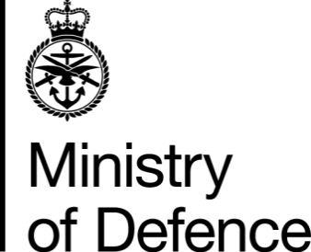

Armed Forces Pension Scheme
Ill-Health Tier Award Reviews –
Customer Journey
Note: Should customers require assistance at any point during their Review, this may be obtained from Veterans UK Helpline: UK – 0800 085 3600 or Overseas - +44 141 224 3600 or by e-mail to: DBS-afpsi-authority@mod.gov.uk

Note: Customers should expect to know the outcome of the decision, in writing, within 40 working days of Veterans UK receiving the request for review. If, for any reason, Veterans UK cannot meet this timescale, they will write to the customer explaining the reason and the date they expect to make a final determination.

- Start - Submit letter requesting a review to Veterans UK.
- Veterans UK acknowledge receipt, usually within 5 working days.
- Caseworker reviews the case to determine whether further medical evidence is required.

- Caseworker will contact the customer if further medical evidence is required.

- Caseworker will contact 3rd parties for further medical evidence if required (customer’s General Practitioner, Hospital etc.). Holding responses will be issued to the customer every 4 weeks until the appeal has been completed.

- Once all additional medical evidence has been received, the Caseworker will refer the case to a Medical Advisor.

- Medical Advisor will review the case, along with all available medical evidence.

- Caseworker will consider whether there is sufficient evidence to indicate that the Ill-Health Tier Award should be increased or not.

- Caseworker will write to the customer with the outcome of their review and provide further details regarding the decision.

- If the customer disagrees with the decision, they can appeal this under the Internal Dispute Resolution Procedure (IDRP) – End of Process.

